PYTHON PROGRAMMING
ASSIGNMENT 5 - CO5
DATA ACQUISITION, CLEANING, ANALYSIS
AND AI APPLICATIONS
Case Study: City Air-Quality Monitoring Network

Student Details | Information
Name | J. Hutson Kanth
Register Number | 1921260129
Course | Python Programming (CSA08)
Course Outcome | CO5 - Data acquisition, cleaning, analysis and AI applications
Python version for included run | Python 3.13.5
Total Marks | 50

Project Overview
This project turns raw station CSV files and citizen complaint text into cleaned, stored and queryable information. It follows the workflow Acquire -> Inspect -> Clean -> Normalise -> Store -> Query -> Visualise -> Profile -> Interpret.
For a compact download the sample groups October into one CSV per station. The sample dataset contains 12 simulated Chennai stations with hourly PM2.5, PM10, NO2 and temperature readings for October 2026. Two stations use Fahrenheit. The input deliberately includes missing values, NA text, negative and impossible readings, a duplicate key, one malformed date and inconsistent station formatting. A separate file contains 51 synthetic citizen complaints.
Data note: the records and complaints are simulated teaching data generated by the included script; they are not official city measurements or real citizen submissions.

Project Files
Folder / file | Purpose
TaskA1-A5 | Part A design, schema, cleaning rules, charts, debugging/profiling and AI design.
TaskB1 | Cleaning implementation, completed TODO program, SQLite database, summary and four charts.
TaskB2 | Adversarial file, encoding, delimiter, SQL injection and sentiment tests.
TaskB3 | Year-scale data generator, Python/pandas/SQLite benchmarks and cProfile output.
TaskB4 | 51-complaint sentiment evaluation, summary, chatbot and index test.
data/raw | Twelve sample station CSV files.
tests | Automated regression tests.
README.md / requirements.txt | Run instructions and dependency versions.

PART A - DATA AND PROGRAM DESIGN (25 MARKS)

A1 - Design the Data Acquisition (7 marks)
The board can send one station/day CSV with one row per hour and columns station, date, hour, pm25, pm10, no2, temperature and temp_unit. For compact downloading, the supplied fixture groups one month per station in a single CSV; the pipeline scans multiple daily files with the same schema. Expected issues include missing columns/values, NA strings, negative sensor values, out-of-range readings, duplicate station-date-hour records, mixed station spelling/case, malformed date/hour values, alternate encodings/delimiters and Fahrenheit temperatures.

SQLite Storage Model
stations(station_id INTEGER PRIMARY KEY, station_name TEXT UNIQUE NOT NULL)
readings(station_id INTEGER REFERENCES stations, day TEXT, hour INTEGER,
pm25 REAL, pm10 REAL, no2 REAL, temperature_c REAL,
PRIMARY KEY(station_id, day, hour))
The station name maps to the stations table. The date, hour, pollutant readings and temperature converted to Celsius map to readings. The composite primary key prevents a duplicate hourly observation.
Board question | CSV approach | SQLite approach
Adyar October mean PM2.5 | Read and parse all files, filter Adyar and October, average values (O(n) per question). | Parameterised filter on station/date and AVG; indexed filtering supports repeated queries.
Rank stations by monthly mean | Scan every row and update station totals/counts. | GROUP BY station and ORDER BY AVG(pm25).
Worst hours of the day | Scan each row and aggregate by hour. | GROUP BY hour and order by AVG(pm25) descending.

A pandas DataFrame loaded for every question also requires an O(n) scan and O(n) memory. SQLite has a one-time ingestion cost, persistent disk storage and indexed queries for repeated use.

Algorithm A1 - Import Station Files
BEGIN
INPUT station CSV folder
CREATE station and reading tables
FOR each CSV file
OPEN with UTF-8 and validate required headers
FOR each row
NORMALISE station, date and hour
CONVERT Fahrenheit to Celsius and validate measurements
CHECK duplicate key; insert valid station and reading with placeholders
RECORD invalid or duplicate rows in rejected log
END FOR
END FOR
COMMIT transaction and close database
END

A2 - Design Cleaning and Normalisation (5 marks)
Problem | Rule | Reason
Blank / NA | Treat as missing; fill with station median, then global median if needed. | Median is robust to pollution spikes.
Negative / impossible | PM2.5 0-999; PM10 0-2000; NO2 0-1000; mark out-of-range values missing. | Sensor faults must not be treated as real readings.
Fahrenheit | Convert (F - 32) * 5 / 9 before validation. | Store one standard unit.
Duplicate key | Keep first station/date/hour and log later copies. | One station has one hourly reading.
Malformed date/hour | Reject with file, line and reason. | Invalid keys cannot be grouped reliably.

Min-max normalisation: x' = (x - min) / (max - min), useful for a bounded 0-1 scale. Return zero when max equals min. Z-score: z = (x - mean) / population standard deviation, useful for comparing deviation from the mean; return zero for zero standard deviation. Dates use YYYY-MM-DD, station names are trimmed/title-cased, hours are integers 0-23 and temperature is stored in Celsius.
Dropping missing data costs O(n) time and O(1) extra streaming space but can bias averages if missingness is systematic. Forward fill is O(n). Median by sorting is O(n log n) time and O(n) storage. This design uses station medians and records imputed/rejected counts.

A3 - Design Analysis and Visualisation (5 marks)
Question | Chart | Justification
PM2.5 monthly trend | Line | Shows chronological movement and peaks.
Station comparison | Bar | Makes mean concentration ranking clear.
Temperature vs PM2.5 | Scatter | Shows association and outliers without claiming causation.
Hours with worst air | Bar by hour | Highlights recurring high-exposure periods.

The daily summary table contains station, date, minimum, maximum, mean PM2.5 and valid-reading count. SQL produces it with MIN, MAX, AVG, COUNT and GROUP BY station_id, day. A Python dictionary of running min/max/sum/count is O(n) time and O(g) space for g station-day groups.

A4 - Debugging and Profiling Plan (4 marks)
- Print a few rows at parsing boundaries during development; avoid frequent production printing.
- Use assert for internal invariants such as hour range, non-negative clean values and unique keys. Assertions do not replace input validation.
- Use logging levels: DEBUG for details, INFO for counts, WARNING for repaired/rejected records. Raise the level to WARNING in production.
- Use pdb or breakpoint() to inspect local variables and step through the first invalid record.
- Use time.perf_counter() around full stages, timeit for repeated functions and cProfile for cumulative function time/call counts.
The included debugging demo processed 10,000 values in about 0.0022 seconds for one perf_counter run; ten timeit runs took about 0.0153 seconds in this environment. The cProfile output is included. Thousands of print calls can add formatting and terminal I/O overhead; logging is configurable and a debugger is used only at selected breakpoints.

A5 - AI Application for Citizen Complaints (4 marks)
The lexicon assigns +1 to positive words and -1 to negative words. A preceding negator flips the next word's sign. The total maps to positive, negative or neutral. The extractive summariser counts important words after stop-word removal, scores each original sentence by those frequencies and returns the top k sentences.
The rule-based chatbot detects PM2.5 and a station name in a question and queries SQLite using a parameterised statement for the latest date in the sample. Limitations include sarcasm, mixed opinions, double negation, out-of-vocabulary words, fixed question phrasing, no multi-turn context and non-live data. A trained Naive Bayes or language model may capture context better but requires labelled data and more memory/compute; it must be validated on representative local complaints.

PART B - IMPLEMENTATION AND EXPERIMENTAL INVESTIGATION (25 MARKS)

B1 - Implement and Validate the Cleaning Pipeline (7 marks)
The full pipeline parsed 8,639 valid-key rows, retained 8,639 cleaned rows, imputed 6 numeric cells and rejected 2 records (one duplicate and one malformed date). It converts Fahrenheit before range checks, fills missing values with station medians, writes a rejected-row CSV and loads SQLite using executemany.

Completed TODO Program - Observed Output
[('Adyar', '2026-10-01', 48.0), ('Guindy', '2026-10-01', 95.0), ('Guindy', '2026-10-03', 121.0)]
[0.0, 0.644, 1.0]
The output matches the expected three records and min-max values in the assignment. The database answers three example queries: Adyar October mean PM2.5 = 36.50; the highest station means are Sholinganallur (60.70), Chromepet (58.34) and Porur (56.27); the top hours are 09:00 (55.43), 08:00 (55.05), 07:00 (54.96), 10:00 (54.76) and 19:00 (52.55).
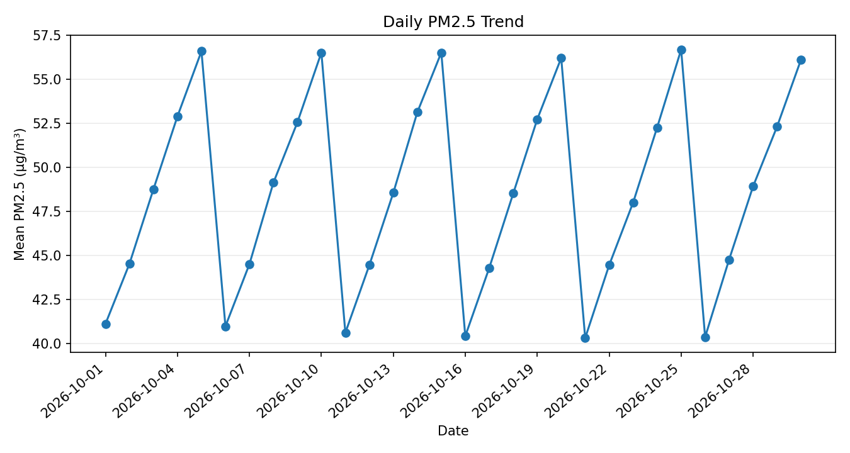  Daily PM2.5 trend | 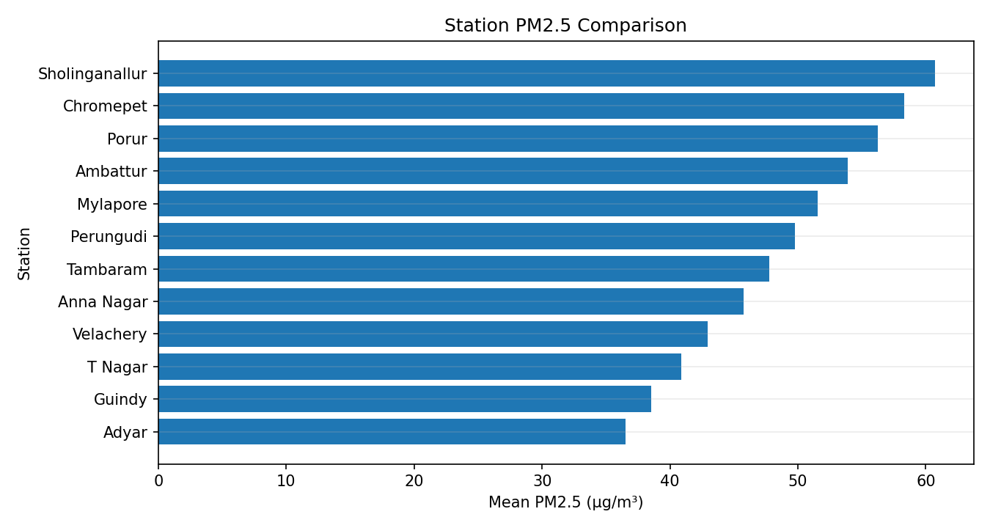  Station comparison
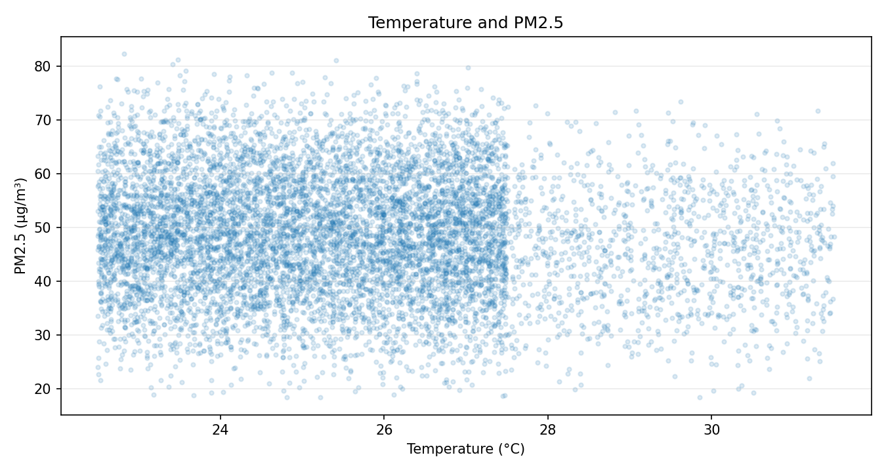  Temperature vs PM2.5 | 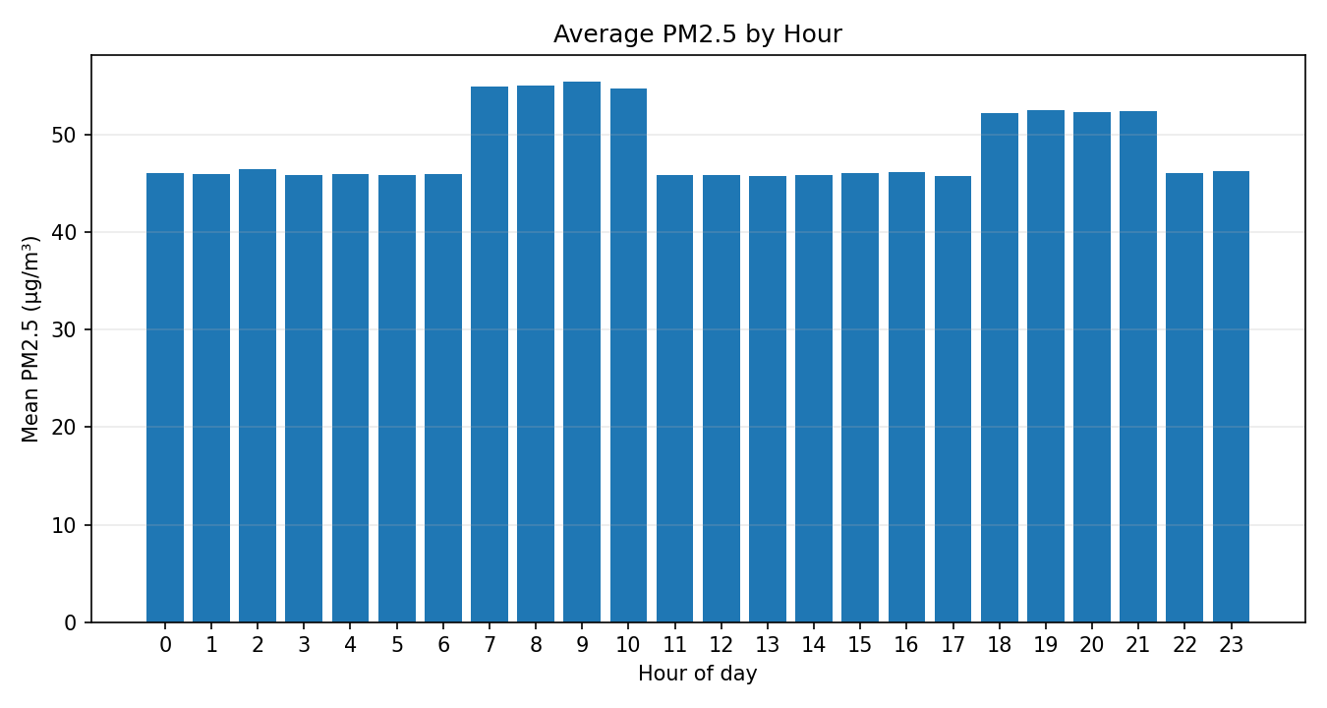  Average PM2.5 by hour
Interpretation: the daily trend shows day-to-day variation; the station bars rank Sholinganallur highest in this simulated sample; the scatter plot shows spread rather than causation; the hourly bars show morning hours as the highest average period.

CSV Streaming vs pandas Measurements
Rows | CSV time | CSV peak bytes | pandas time | pandas frame bytes
1,000 | 0.0077 s | 45,253 | 0.0107 s | 119,132
100,000 | 0.8898 s | 49,038 | 0.0892 s | 11,900,132
1,000,000 | 9.7882 s | 48,958 | 0.9942 s | 119,000,132

The streaming loop keeps only station totals/counts, so additional memory remains nearly constant. pandas is faster for the larger vectorised operation but holds the full DataFrame. Measurements are specific to the included Python environment.

B2 - Engineer Adversarial Data (5 marks)
Test input | Observed response
Missing pm25 column | Rejected as invalid header.
Semicolon delimiter | Sniffer detects semicolon and reads the row.
Latin-1 file | UTF-8 decode fails; Latin-1 fallback reads it.
Empty file | Reported as empty without parser crash.

Unsafe SQL concatenation with Adyar' OR '1'='1 returns all demo rows. The parameterised WHERE station = ? query treats the complete payload as one value and returns no match. The lexicon returns neutral for sarcasm, double negation and mixed opinions in the adversarial examples; these results reveal the limitations of the simple one-token negation rule. The completed B2 SQL TODO prints 54.0 108.0 and None for the injection payload.

B3 - Loops vs Libraries vs SQL (8 marks)
The benchmark generator creates 365 × 24 = 8,760 hourly records per station. Python loop, pandas groupby and SQLite GROUP BY results agreed within 1e-9 at all three sizes.
Stations | Rows | Python loop | pandas | SQLite load | SQLite query
1 | 8,760 | 0.0260 s | 0.0551 s | 0.0283 s | 0.0045 s
12 | 105,120 | 0.3125 s | 0.3766 s | 0.5729 s | 0.0957 s
120 | 1,051,200 | 2.6126 s | 1.3510 s | 3.2221 s | 0.8419 s

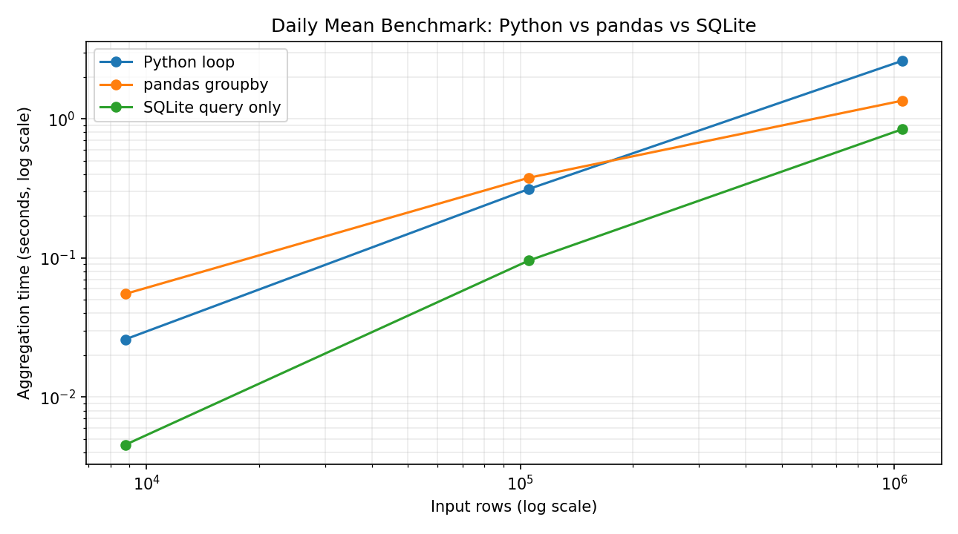
SQLite loading is shown separately because it is a one-time or incremental ingestion cost; later queries reuse the stored database. At the largest size pandas was faster than the plain loop. cProfile reported 631,329 calls in 0.570 seconds for the 12-station profile; python_group used 0.570 cumulative seconds and csv.DictReader.__next__ used 0.413 cumulative seconds, identifying row parsing as the main cost.
A running-sum/count dictionary is O(n) time and O(stations × days) space. Storing all values then calling statistics.mean is O(n) time and O(n) memory. The running aggregate is preferable if only means are needed.

B4 - Final Engineering Decision (5 marks)
The completed sentiment TODO reproduces the assignment examples with labels positive, negative, negative and positive. The 51-complaint sample achieved 46/51 agreement (90.2%) between the lexicon and the reference labels. This is a prepared sample, not a city-wide accuracy estimate. The extractive summary is saved in TaskB4/outputs/complaint_summary.txt. The chatbot returned the latest Adyar sample: 44.2 µg/m³ on 2026-10-30. For the alternative first-five baseline, top-15 important-term coverage was 13/15 (86.7%), compared with 9/15 (60.0%) for frequency selection on this sample. The result is dataset-specific; first-k is O(1) for fixed k, while frequency scoring is O(W) in the number of words.
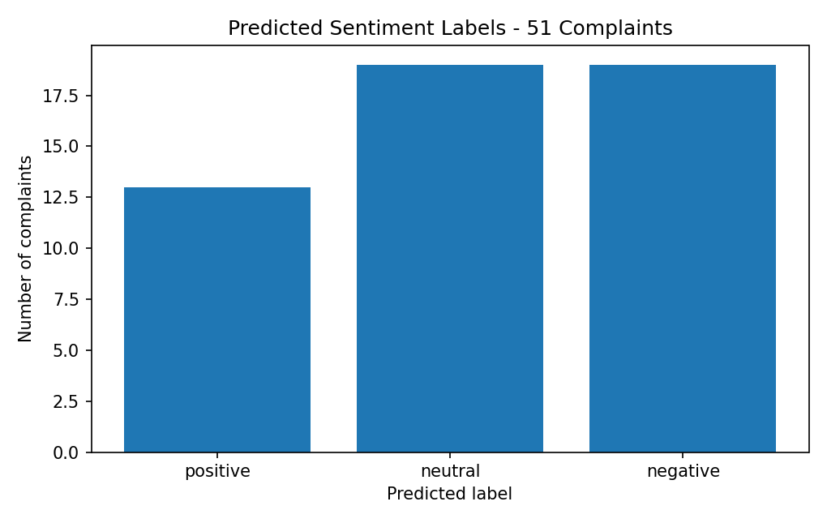
The station/day query averaged 0.1284 ms before the explicit index and 0.1381 ms after. The query plan already used SQLite's primary-key autoindex on station_id, day, hour, so the additional index overlaps and did not improve this query; it may add storage/write overhead. This small timing result is cache-sensitive.
One hundred new stations reporting every 15 minutes generate 100 × 96 = 9,600 readings/day (about 3.50 million/year). The practical design is incremental ingestion, schema/unit/range validation, deduplication by station/time, repair/rejection audit logs, SQLite for the current scale with indexed queries and backups, SQL for scheduled aggregation, pandas for exploration, and a trained model evaluated on representative complaints with human escalation for safety-related reports.

Validation and Submission Notes
Thirteen automated regression tests passed in the included Python 3.13.5 environment. The project contains source CSVs, complaint data, the generated SQLite database, cleaned and normalised outputs, daily summaries, charts, adversarial results, benchmark CSVs and profile output. The GitHub link must be added after creating CSA08-1921260129-Assignment5. The synthetic data and benchmark timings are environment-specific. Review the manual complaint reference labels, rerun locally if required, and disclose AI assistance according to institutional rules.

