PYTHON PROGRAMMING
ASSIGNMENT 3 - CO3
Python Data Structures and Data Manipulation
Student Name: J. Hutson Kanth
Register Number: 1921260129
Course: Python Programming
Python Version: 3.13.5

Objective and method
This assignment applies lists, tuples, dictionaries, sets and comprehensions to seven data-handling problems. Each question follows the sequence design, implementation, analysis and evaluation. Programs use reproducible synthetic or sample inputs; benchmark scripts write raw observations to CSV files. The included timings are from Python 3.13.5 in the build environment and should be re-measured locally if the instructor requires device-specific evidence.

Q1 - Lists and slicing: daily rainfall records (6 marks)
One list stores a daily rainfall value. Weekly totals are calculated using seven-value slices; the final week is partial if the number of readings is not divisible by seven. The maximum/minimum positions among complete weeks and dry days are reported; a final partial group is displayed separately. Empty lists and inputs shorter than seven readings return no moving averages.

Moving-average pseudocode
if number of readings < 7: return []
sum the first 7 readings; append sum / 7
for each next day i: add readings[i]; subtract readings[i - 7]; append sum / 7
readings[7:14] returns indexes 7 through 13; readings[-7:] returns the last seven values; readings[::7] selects every seventh value from index zero. Typical list costs: append amortised O(1), insert/pop near the front O(n), pop at the end O(1), sort O(n log n).
Naive moving average: 7(n-6) additions. Running sum: 7 initial additions, then n-7 additions and n-7 subtractions. Both produce n-6 averages; with fixed window 7, the running method is O(n).
Days | Windows | Naive adds | Rolling adds | Rolling subs | Naive s | Running s
365 | 359 | 2513 | 365 | 358 | 0.000067 | 0.000023
36500 | 36494 | 255458 | 36500 | 36493 | 0.009367 | 0.003282
365000 | 364994 | 2554958 | 365000 | 364993 | 0.116968 | 0.040334

A deque(maxlen=7) supports streaming updates with O(1) end operations and O(7) window space. Before appending to a full deque, subtract its oldest value from the running total; append the new value, add it, and emit the average. A date-keyed dictionary gives average O(1) date lookup but needs O(n log n) sorting before chronological averaging and O(n) storage. Interior list insertion is O(n).
from collections import deque
window = deque(maxlen=7); total = 0.0
for value in readings:
if len(window) == 7: total -= window[0]
window.append(value); total += value
if len(window) == 7: averages.append(total / 7)
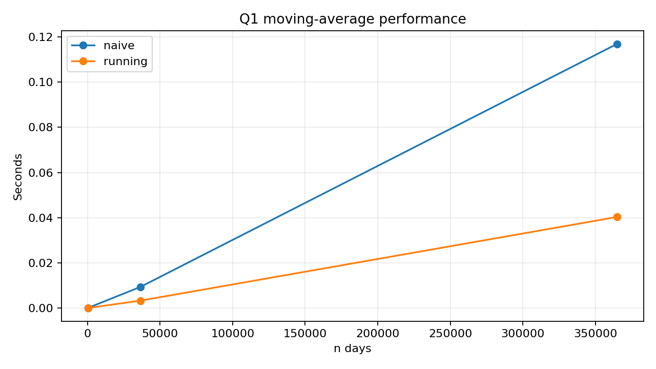
Figure 1. Measured naive and running-sum moving-average times.

Q2 - Tuples, mutability and copying (7 marks)
A coordinate tuple such as (13.0827, 80.2707) can be a dictionary key because its elements are hashable. A list cannot be a key because it is mutable and unhashable. The expression [[0] * cols] * rows repeats references to one row; a nested list comprehension creates distinct row objects.
good = [[0 for _ in range(cols)] for _ in range(rows)]
Aliasing means two names point to one object. A shallow copy duplicates the outer list only; nested lists remain shared. A deep copy recursively copies nested objects. A function mutating a list argument changes the caller-visible object. A tuple containing a list does not allow replacing the tuple slot, but the inner list can still be mutated.
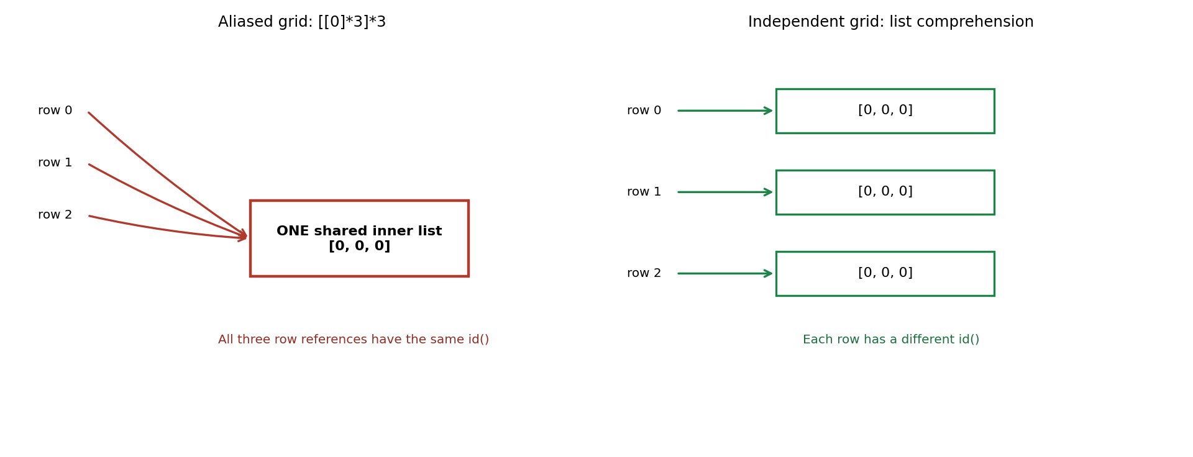
Figure 2. Repeated row references versus independent row objects.
Values | List shallow bytes | Tuple shallow bytes | List create s | Tuple create s | List indexing s | Tuple indexing s
1,000,000 | 8,000,056 | 8,000,040 | 0.045160 | 0.036213 | 0.001440 | 0.001390

sys.getsizeof reports shallow container size and excludes referenced integer objects. Indexing is O(1) for both tuples and lists. Tuples suit fixed data; lists suit data that must be updated. A sparse dictionary keyed by (row, col) uses O(k) space for k occupied zones instead of O(rows × columns), with average O(1) access and extra hash/key overhead.
passengers[(r, c)] = passengers.get((r, c), 0) + count

Q3 - Dictionaries: farmer helpline complaint analysis (7 marks)
Complaint text is normalised to lowercase and punctuation is replaced with spaces. One frequency function uses dict.get(); another uses setdefault(). District and crop grouping use dictionaries of lists. Top-k words are sorted by descending count, then alphabetically.
[('seeds', 3), ('price', 2), ('received', 2)]
Price precedes received because both have count 2 and alphabetical order breaks the tie. Dictionary lookup is average O(1), so one pass through n words is O(n). Repeated list.count() for d distinct words is O(n·d). Counter is also a one-pass frequency tool. Dictionary insertion order is guaranteed from Python 3.7; keys(), values() and items() provide dynamic views.
Complaints | Distinct | dict s | Counter s | list.count s | dict=Counter | dict=list
1000 | 20 | 0.005067 | 0.001173 | 0.006659 | True | True
10000 | 20 | 0.036214 | 0.016935 | 0.085559 | True | True
100000 | 20 | 0.585254 | 0.218161 | 0.684327 | True | True

The benchmark uses a fixed synthetic vocabulary to keep list.count tractable. Dictionary and Counter counting are average O(n) time with O(d) count storage for d distinct words; list.count for every distinct word is O(n*d). Counter was fastest in these measurements; a dictionary remains useful for custom filtering/grouping.
from collections import Counter
counts_counter = Counter(all_words)
counts_list = {word: all_words.count(word) for word in set(all_words)}

Q4 - Sets: elective registration clash detection (7 marks)
Elective registration numbers are stored in sets, removing duplicates. Intersection (&) gives students in both courses; symmetric difference (^) gives students in exactly one; subtracting the union from all_students gives students in neither. The same results are computed using set methods.
clash: ['192311004', '192311009']
exactly one: ['192311001', '192311002', '192311007', '192311010']
neither: ['192311003', '192311005', '192311006', '192311008']
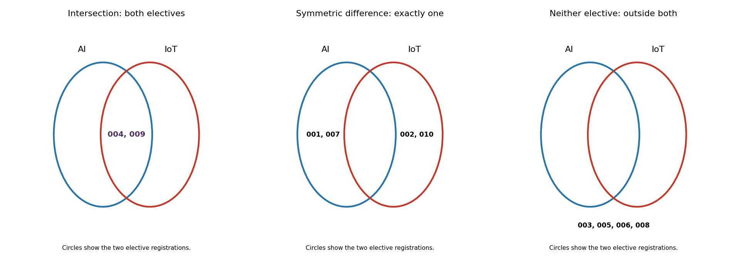
Figure 3. Venn diagrams for both electives, exactly one elective and neither elective.
List membership is O(n), while average set membership is O(1). A set discards duplicates and positional order. Tuples of hashable items can be set elements; lists cannot. Nested-loop matching is O(n·m), sorting and merging is O(n log n + m log m), and set operations average O(n+m).
Students | List membership s | Set membership s
10000 | 0.006118 | 0.000002
100000 | 0.054403 | 0.000003
1000000 | 0.601165 | 0.000002

For 800 by 900 sample sets, nested-loop matching took 0.025610s and set intersection took 0.000095s; outputs matched. A sorted-list alternative sorts both inputs and walks them with two indexes in O(n log n + m log m) time and O(n+m) additional space when copies are made; nested loops take O(n*m) time.
i = j = 0
while i < len(a) and j < len(b):
if a[i] == b[j]: record match; i += 1; j += 1
elif a[i] < b[j]: i += 1
else: j += 1

Q5 - List comprehension: cleaning sensor readings (6 marks)
Readings outside -50°C to 50°C are treated as sensor errors. Valid readings are converted to Celsius/Fahrenheit pairs using a for-loop with append, a list comprehension, and map/filter with lambda. enumerate(start=1) gives minute numbers outside the operating interval 2°C to 8°C. The program also demonstrates dictionary and set comprehensions.
[expression for item in iterable if condition]
A generator expression produces values lazily and avoids storing the full result list. In this run the list comprehension was fastest at all three sizes, although timings depend on the machine and data. Both approaches take O(n) time; the list stores O(n) result values, while the generator uses O(1) additional iterator state.
valid_celsius = (c for c in readings if -50 <= c <= 50)
Readings | Loop s | Comprehension s | Map/filter s | Same result
10000 | 0.002786 | 0.001798 | 0.002012 | True
100000 | 0.024962 | 0.018205 | 0.029333 | True
1000000 | 0.295579 | 0.261635 | 0.295116 | True

Both list and generator iteration are O(n) in time. The materialised result list uses O(n) result memory; a generator uses O(1) iteration state, not counting its source. sys.getsizeof gives only the shallow object size.
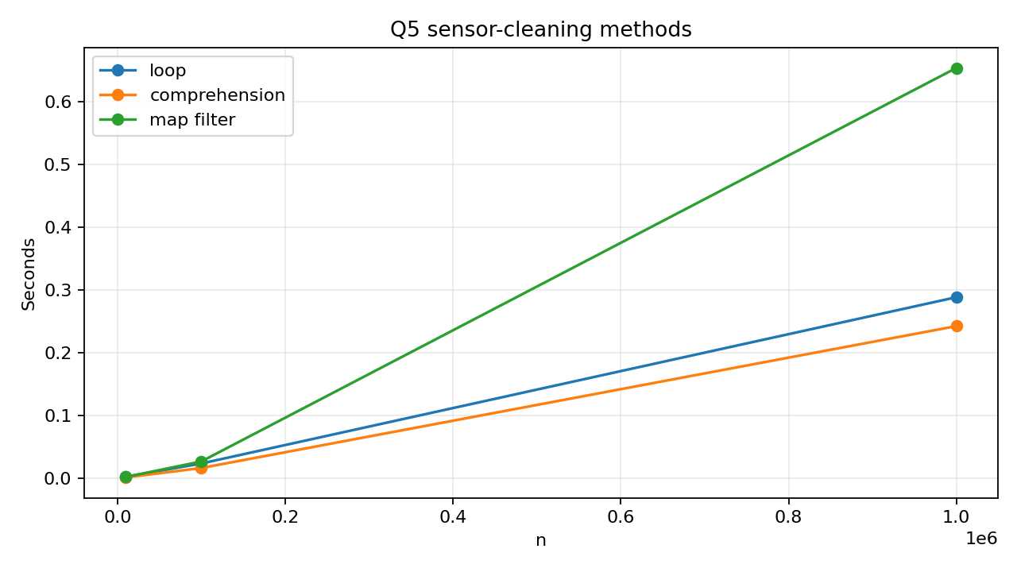
Figure 4. Sensor cleaning benchmark.

Q6 - Nested data: railway timetable (7 marks)
The timetable is a dictionary keyed by train number. Each train entry contains a name, an ordered list of station tuples and a set of running days. The third stop departure expression is TIMETABLE['12601']['stops'][2][2]. The station index maps a station to trains visiting it; the day is checked in each train’s set and results are sorted by departure using sorted() and key=lambda.
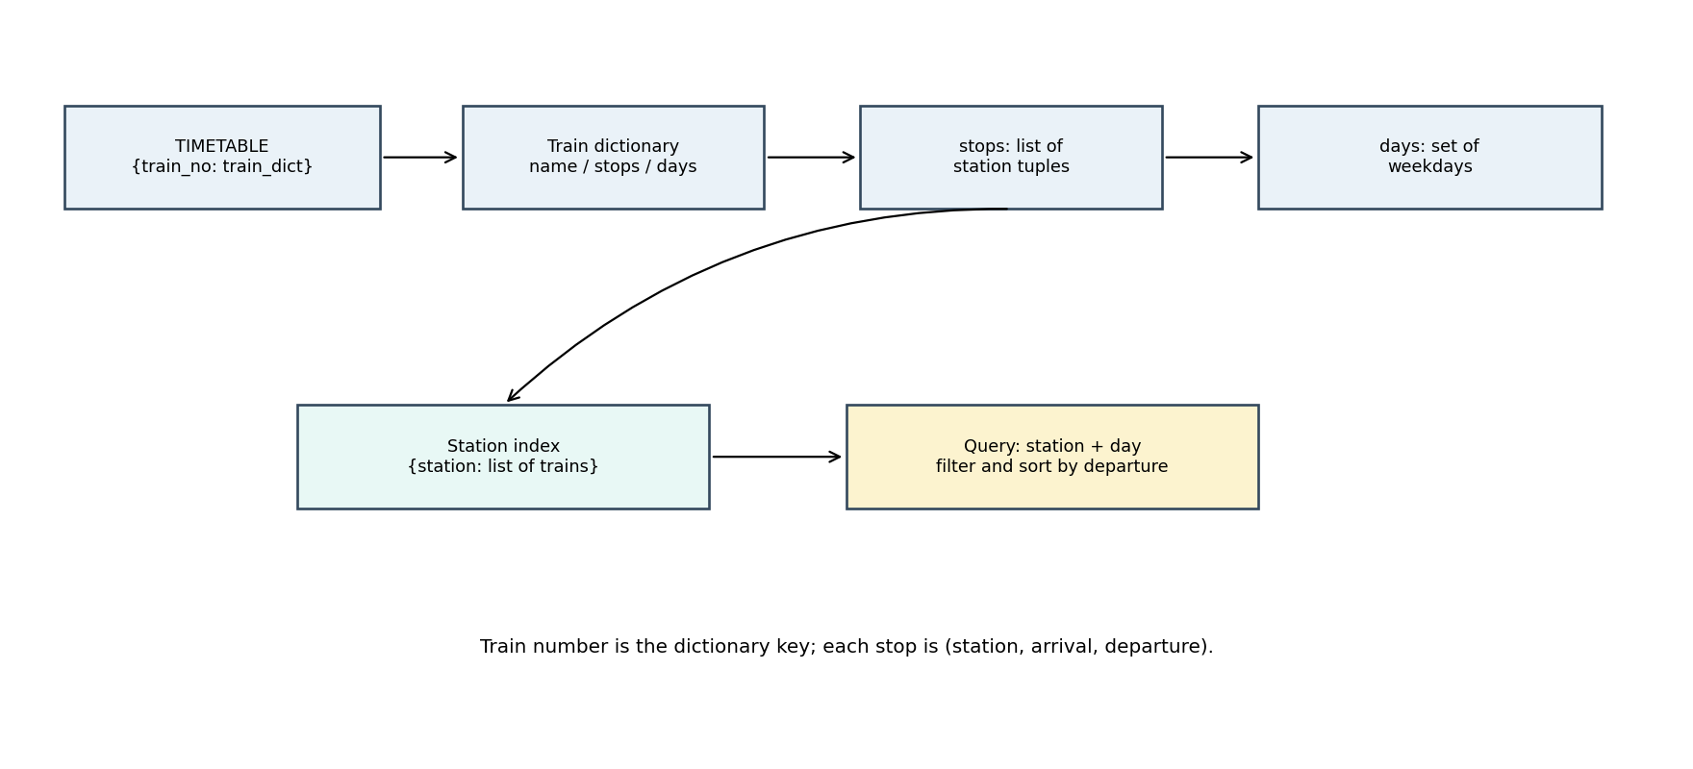
Figure 5. Nested timetable and station index structure.
Trains | Direct scan s | Indexed query s | Index bytes | Same results
100 | 0.000030 | 0.000004 | 137,688 | True
1000 | 0.000414 | 0.000048 | 1,338,480 | True
10000 | 0.004725 | 0.001219 | 13,398,472 | True

An index speeds repeat queries by limiting the candidate list to trains that visit the station; it consumes extra memory and must be maintained when stops/days change. Direct scan is O(total stops); an indexed query approaches O(trains at the station) after O(total stops) index construction.

Q7 - Design a contact-merging program from first principles (10 marks)
The input is a collection of contacts from two phones and a SIM. Each entry may contain a name, one or more phone numbers and e-mail addresses. The output is a set of contact groups, each with all recognised names, canonical numbers and e-mails. Phone values are normalised to digits and the Indian country prefix is removed from 12-digit values; e-mails are stripped and case-folded.
Measurable requirements: (1) normalise each non-empty phone to a digit-only canonical form; (2) merge records when at least one normalised phone or e-mail matches; (3) preserve all non-empty names, phones and e-mails without duplicates; (4) keep different phone identities separate when names match; and (5) retain records with neither phone nor e-mail as separate unmatched contacts.
A dictionary maps each normalised phone key to a contact group. Sets collect names, phones and e-mails without duplicates. E-mail is a fallback key when a phone is absent; a record with neither remains unmatched. Different people with the same name remain separate when their numbers differ.

Pseudocode
create groups, number_index and email_index
for each contact: normalise numbers and e-mails
find existing groups by all matching keys; merge multiple matches
otherwise create a new group using phone, then e-mail, then unique fallback
update name, phone and e-mail sets and lookup indexes
return groups in stable order
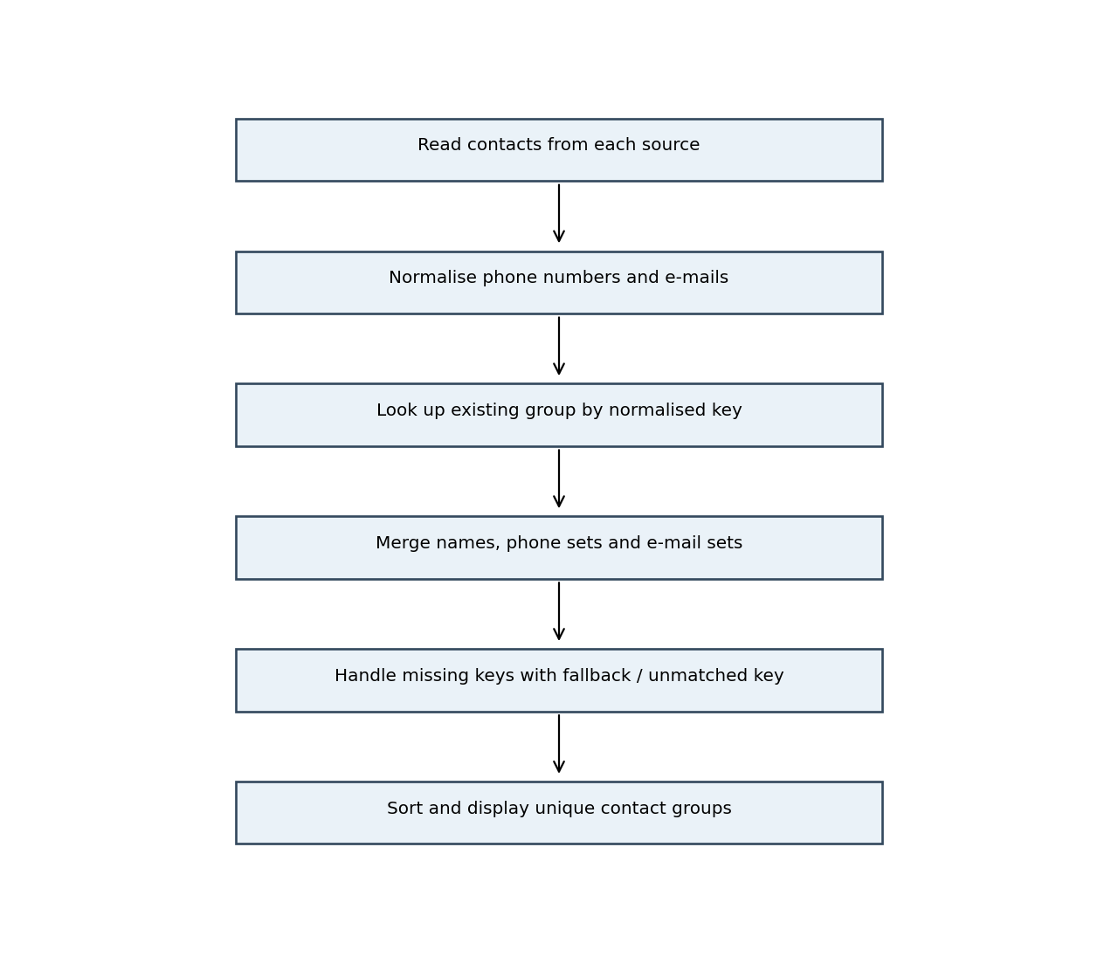
Figure 6. Contact merge process.
Input contacts | Dictionary merge s | Merged groups
1000 | 0.013958 | 500
100000 | 2.074669 | 50000

The pairwise alternative was measured on 1,000 records at 0.020464s. Its 100,000-record value (204.84s) is a quadratic extrapolation, not a measurement. The dictionary method was run at both 1,000 and 100,000 records. Dictionary merging is average O(n*p) for n contacts with p phone entries; pairwise comparison is O(n^2). A limitation is that records with no shared number or e-mail cannot safely be identified as the same person using the available fields.
for i in range(n):
for j in range(i + 1, n):
if phone_keys[i] & phone_keys[j] or email_keys[i] & email_keys[j]:
record_possible_duplicate(i, j)
Dictionary grouping uses O(n) additional space for groups and lookup indexes and average O(n*p) time for p identifiers per contact. Pairwise comparison takes O(n^2) time and can use O(1) extra space if pairs are processed immediately, or O(n) if identifiers are materialised. Manual verification merged the Ravi, Meena and Arun pairs by shared normalised phone numbers; the office-only and no-identifier records remain separate.
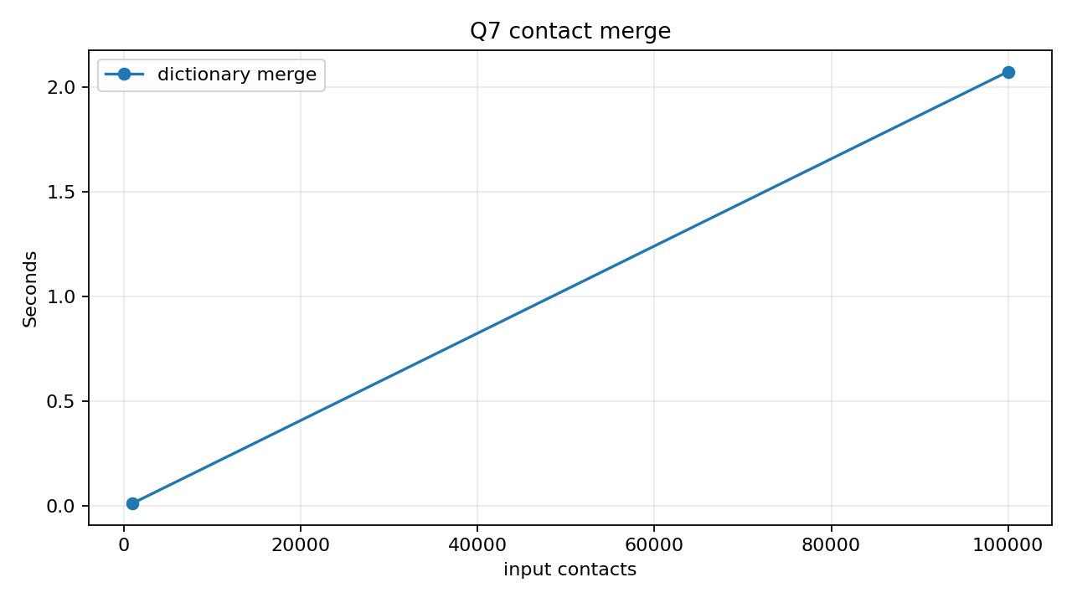
Figure 7. Dictionary contact merge timing.

Automated tests and conclusion
The test suite contains 16 checks covering moving averages, edge cases, tuple/grid behavior, dictionary counts, set operations, sensor transforms, timetable indexing and contact merging. The successful run output is available in evidence/all_tests.txt and evidence/all_tests.png.
The tasks show that lists support ordered readings, tuples protect fixed records, dictionaries provide keyed aggregation, sets provide uniqueness and set algebra, comprehensions support concise filtering and transformation, and nested dictionaries/lists/tuples/sets model timetables and contact data. Indexes and hash-based lookup trade additional memory for faster repeated queries.

References
Python Software Foundation, Built-in Types - list, tuple, set and dict, Python 3.13: https://docs.python.org/3.13/library/stdtypes.html
Python Software Foundation, Data Model - mutability and object identity: https://docs.python.org/3.13/reference/datamodel.html
Python Software Foundation, collections - deque and Counter: https://docs.python.org/3.13/library/collections.html
Python Software Foundation, copy - shallow and deep copying: https://docs.python.org/3.13/library/copy.html
Python Software Foundation, time - performance counter: https://docs.python.org/3.13/library/time.html
Python Software Foundation, sys.getsizeof: https://docs.python.org/3.13/library/sys.html#sys.getsizeof

Appendix - execution evidence

Q1 rainfall output
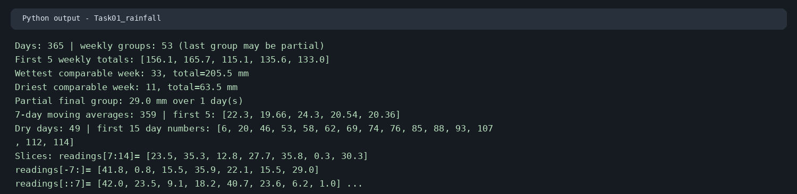

Q2 tuple and copy output
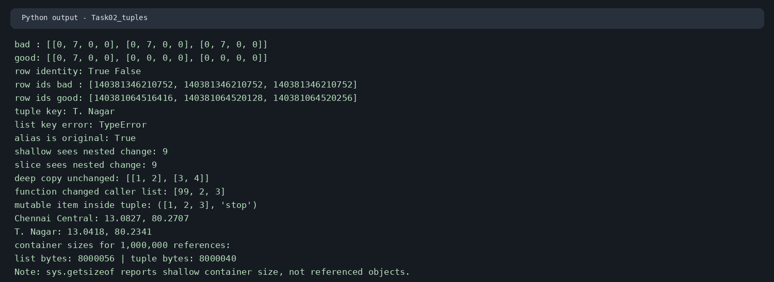

Q3 complaint output
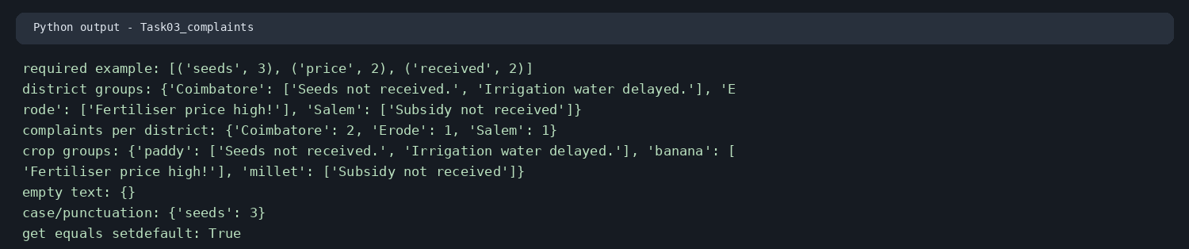

Q4 set output
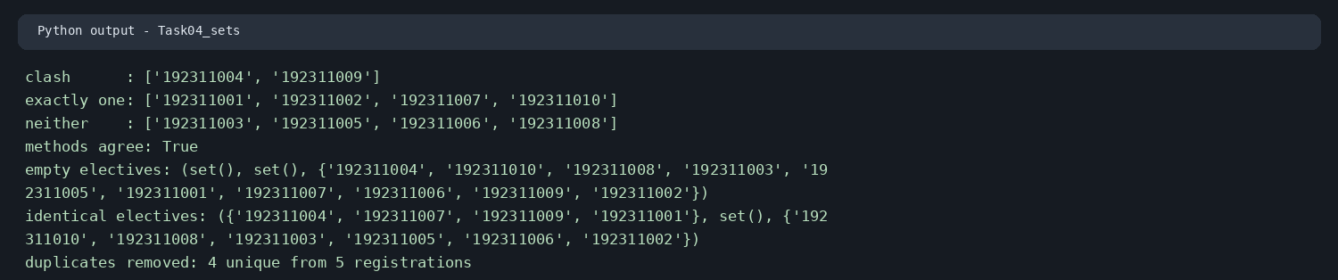

Q5 sensor output
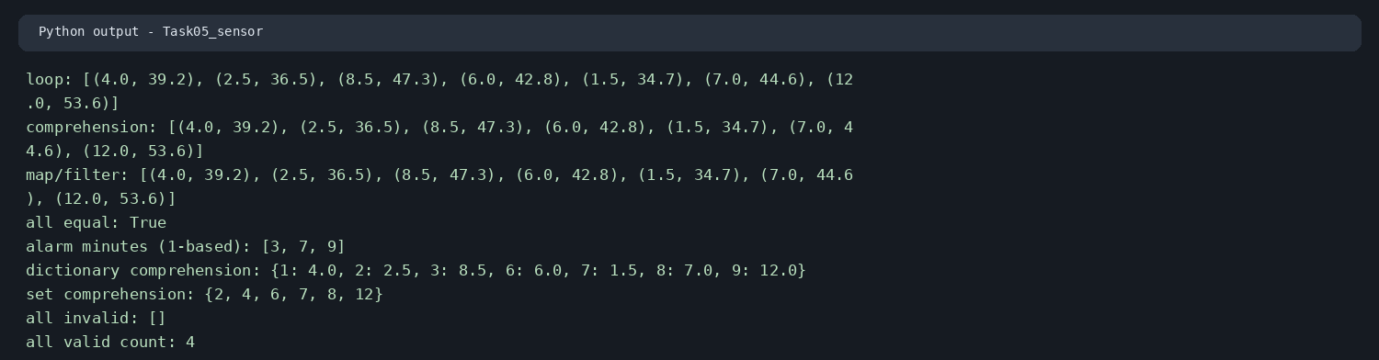

Q6 timetable output
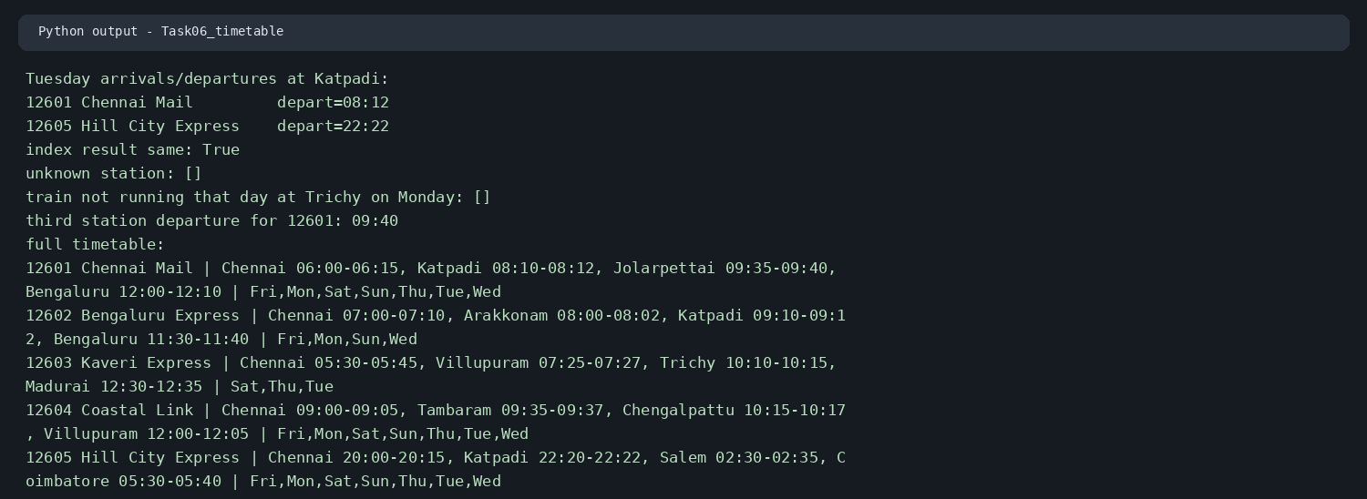

Q7 contact output
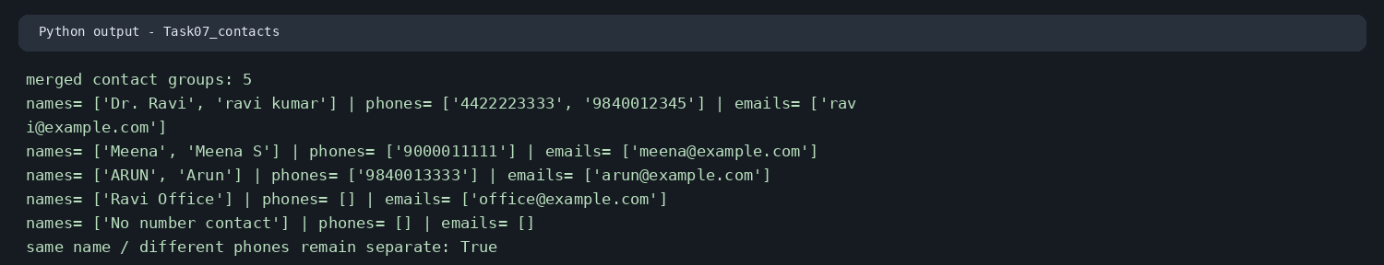

Automated test output


