PYTHON PROGRAMMING
ASSIGNMENT 4 – CO4
ROBUST DATA PROCESSING WITH FILES, EXCEPTIONS, MODULES AND PACKAGES
Student: J. Hutson Kanth
Register number: 1921260129
Course: Python Programming (CSA08)
Total marks: 50

Objective
Design reliable Python programs that process real files, validate records, handle expected failures, write reports safely, and organise reusable operations into scripts, modules and packages.

Task 1 – File-processing design review (6 marks)

1.1 Diagnose the original script
Deficiency | Possible office consequence
Hard-coded path | Fails when moved to another computer or folder.
File not closed | Can retain an open handle and risk incomplete buffered output.
Whole file read at once | Memory grows with the complete file size.
Bare except with pass | Hides malformed data and programming errors.
int() for money | Rejects bills containing paise.
Repeated string concatenation | Can repeatedly copy earlier report text.
Trailing blank line | Creates an unnecessary malformed row.
No rejected-line log | Staff cannot audit or correct skipped bills.
No field validation | Missing or extra columns may be handled incorrectly.

1.2 Repaired design
Task01/repair_mess.py accepts the filename as a parameter, uses a with statement and line-by-line iteration, validates three CSV fields, uses Decimal for money, stores report rows in a list, and records rejected rows with their line number, raw text and reason.

1.3 Design defence (under 100 words)
The repaired version is safer for 50,000 lines because it processes one line at a time and does not keep the complete file in memory. The with statement closes the file even if an exception occurs. Decimal preserves paise. Specific validation records malformed rows instead of hiding them, so the office can audit and correct rejected entries. A list collects report rows efficiently.

Alternative and complexity
Both streaming and read()/readlines() inspect input in O(n) time. Reading the whole file uses O(file size) memory, while line iteration uses O(maximum line length) working memory, excluding retained output/rejection collections. Writing report rows immediately keeps additional working memory close to one line.

Task 2 – Biometric attendance file design (8 marks)

2.1 Data model
Each UTF-8 daily CSV row contains register_number,date,status (P or A). A dictionary maps register numbers to present and absent counts. Outputs are attendance_summary.csv, below_75_percent.csv and damaged_lines.csv containing filename, line number, reason and raw text.

2.2 File operations
Use pathlib to find CSV files. Open inputs in r mode with UTF-8 and iterate line by line; write final CSV reports in w mode with csv.writer; use a mode for persistent logs. read() is unnecessary for daily processing because iteration records line numbers and bounds working memory.

2.3 Pseudocode
START
counts ← empty dictionary; damaged ← empty list
FOR each daily CSV file in sorted order
TRY open UTF-8 file in read mode
FOR each line and line number
parse register, date and status
IF field count is not 3 OR status not P/A: log bad line; CONTINUE
initialise counts[register] if needed; increment P or A
CATCH file-level error: log it and continue
WRITE attendance summary, below-75 report and damaged-line report
STOP

2.4 Trace
The row 192311003,2026-10-02,X has three fields but invalid status X. No counter changes; the filename, line number, reason and raw row enter the damaged-line report. Processing continues.

Alternative and complexity
Repeatedly scanning all f files with l lines for each of s students costs O(s·f·l). One pass with a dictionary costs expected O(f·l) time and O(s) accumulator space, plus the damaged-row log.

Task 3 – Exception handling (9 marks)

3.1 Failure table
Failure | Exception / condition | Handling
Missing folder/file | FileNotFoundError | Report path; skip file or stop batch cleanly.
Permission denied | PermissionError | Log and continue where possible.
Wrong encoding | UnicodeDecodeError | Record decode problem.
Malformed row | InvalidRecord (custom) | Catch per line and record it.
Bad conversion | ValueError | Validate and record row.
Missing field access | IndexError | Check field count before indexing.
Empty file | No exception | Return zero counts.
Disk or file system error | OSError | Record operation and cause.

3.2 Custom exception
InvalidRecord is raised in parse_line() for wrong field count, missing required values or status other than P/A. It is caught around the individual row, so the rest of the file is processed. AttendanceFileError wraps file-level failures with raise ... from exc to preserve the original cause.

3.3 Complete try statement
The implementation uses try, specific except clauses, else on the success path, and finally for cleanup documentation. The with statement closes the file whether processing succeeds or fails.

3.4 Misuse experiment
misuse_demo.py deliberately misspells total as totla and catches Exception: pass. The NameError is swallowed, the function returns None and the defect becomes invisible. Broad silent handlers are unsafe.

Alternative and complexity
Both validation styles are O(1) work per short row and O(n) across n rows. Exceptions have a higher constant cost on invalid rows; when errors are common, explicit if checks are often clearer. Both must retain a rejected-row log.

Task 4 – File and exception forensics (7 marks)

4.1 Defects
Opening returns.log with w truncates earlier days. Missing newline characters join book titles. If write() raises before close(), close is skipped and the handle may remain open until runtime cleanup; buffered data may not flush reliably. The input file is also not managed by with.

4.2 Test evidence
The broken writer is reproduced for three sample day files. The log demonstrates that only the last day remains and that its titles are concatenated without line separators.

4.3 Repair
library_returns.py uses with for both files, append mode a, explicit newline characters and a separate errors.log. Expected file/encoding errors are recorded and do not stop later files.

4.4 Prevention and alternative
Rules: (1) use with open() for every managed file; (2) choose w/a/r deliberately and include record delimiters. Manual open with try/finally has the same O(B) time and O(1) working memory as with; correct finally closes handles, while omission can leak them. A with block closes automatically.

Task 5 – Four code organisations (7 marks)
Organisation | Files | Files changed for second report | Evaluation
Single script | single_script.py | 1 | Simple but tightly coupled.
One module + main | attendance_utils.py, main.py | 2 | Reusable but one module still groups all functions.
Three modules | reader.py, stats.py, report.py, main.py | 2 | Clear separation and easier isolated testing.
Package | attendance/__init__.py and submodules | 2 | Best reuse and navigation as project grows.

The second report lists students absent for three consecutive days. The change counts describe this included implementation, where statistics and report output are separated; other designs can require a different number of files.
import attendance.stats keeps access through attendance.stats. from attendance import stats imports the submodule name. from attendance.stats import percentage imports the function directly and may cause a local naming conflict.
A single script avoids module setup. A package has a one-time import/load cost; modules are cached in sys.modules. This uses some namespace/module memory but improves reuse, readability, testing and locating code. Core processing remains O(n) records.

Task 6 – College fest registration desk (13 marks)

Stage 1 – Requirements
Read department CSV files with register number, name, department, e-mail and semicolon-separated events. Produce a clean master list, one file per event, a summary and an error log. Valid duplicates merge once by register number; invalid e-mails and damaged rows are logged; a missing department file must not stop remaining files.

Stage 2 – Processing flow
START → list expected files → open each file → parse and validate row
→ invalid? log filename/line/reason and continue
→ register seen? merge e-mail and event sets : create contact
→ write master CSV → write event-wise files → summary + error log → STOP

Stage 3 – Critical decisions
Register number is the merge key because different people may share a name. E-mail validation uses string operations: one @, non-empty local part, dot in domain, no spaces, and no leading/trailing domain dot. This checks basic form, not whether the mailbox exists. Duplicate valid e-mails and events are merged using sets.

Stage 4 – Package design
fest/parser.py normalises and validates; fest/processor.py reads files, merges contacts and records errors; fest/writer.py writes the master list, event participant files, summary and error log; run_fest.py is the entry point.

Pseudocode
START
contacts ← empty dictionary; errors ← empty list
FOR every expected department file
TRY open file and read each line with line number
TRY validate 5 fields, register number, e-mail and events
IF invalid THEN log file/line/reason and CONTINUE
IF register exists THEN merge e-mail/event sets ELSE insert contact
CATCH missing/permission/decoding/I/O error: log and continue
WRITE clean master CSV
FOR every event: WRITE matching participants
WRITE summary and error log
STOP

Stage 5 – Demonstration and alternative
The sample files include a duplicate register number, invalid e-mail, damaged row and a deliberately missing CIVIL.csv. The package merges the duplicate, rejects invalid rows, logs the missing file, and still writes outputs. Searching a list of previous registrations is O(n²) in the worst case; dictionary lookup is O(1) average and a complete pass is O(n) average. Both store O(n) contacts.

Testing and evidence
The project includes example files, generated reports and error logs, terminal-style output captures and automated tests. The test log is included in evidence/.
Execution note: generated evidence uses Python 3.13.5 in the build environment. Timings vary by PC. Re-run locally and capture your own screenshots if required by the instructor. In Task 6, CIVIL.csv is intentionally absent to demonstrate missing-file recovery.

References and acknowledgement
Python Software Foundation, Python 3 Library Reference (csv, decimal, pathlib, tempfile, datetime, argparse and file objects), https://docs.python.org/3/library/ . Python Software Foundation, The Python Tutorial (input/output, exceptions and modules), https://docs.python.org/3/tutorial/ . AI assistance was used to prepare a starter implementation and report draft; review, execute, understand, verify and adapt the work, and disclose assistance according to institutional policy.

Measured run and output evidence
The 50,000-row benchmark creates the same input data for both methods and repeats each method three times. Both methods returned Rs.62,525,000.00. The measured times in Python 3.13.5 were:
Method | Three runs (seconds) | Average (seconds)
Streaming iteration | 0.024790, 0.026315, 0.023903 | 0.025003
Read whole file | 0.026150, 0.020897, 0.025142 | 0.024063
The measurements are noisy and environment-specific. Both implementations are O(n) in time; streaming reduces file-reading working memory from O(file size) to O(one line), before accounting for retained report rows and rejected entries.

Task 6 – processing flow
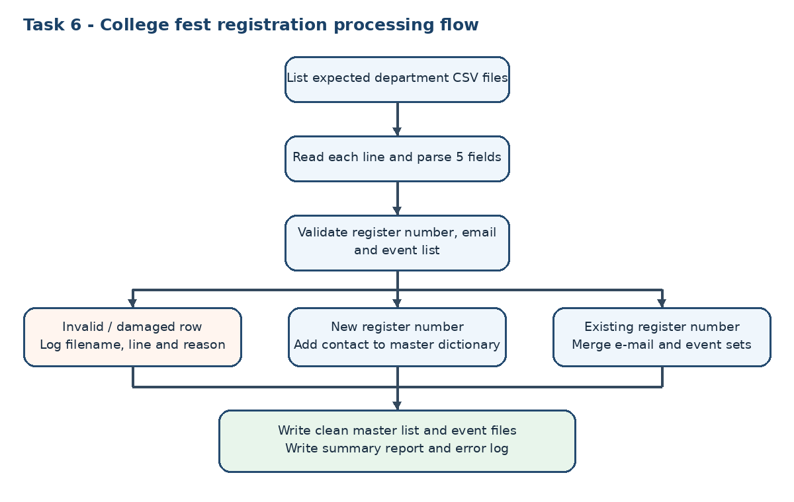

Observed sample-run results
Task | Observed result | Evidence file
Task 1 | Rs.4,081.25 total; 2 rejected rows | evidence/task01_output.txt
Task 2 | 4 students; 1 damaged row | evidence/task02_output.txt
Task 3 | 1 present, 1 absent; 2 invalid rows | evidence/task03_output.txt
Task 4 | 5 books appended; missing file recorded | evidence/task04_output.txt
Task 5 | Four organisations produce both reports | evidence/task05_package.txt
Task 6 | 7 valid lines; 1 duplicate; 6 unique contacts; 3 errors | evidence/task06_output.txt
Unit tests | 7 tests passed | evidence/test_results.txt

