The logisim file shows the digital clock.

The digital clock has Hh Mm Ss format. There will be four counters (2, 6, 10, and 23). Counter 10 for s and m. Counter 6 for S and M. Counter 2 for H and counter 23 for h.

When s or m is 9, reset s or m and increase M or S by 1. When M or S is 5, reset M or S and increase h by 1. When h is 0, increase H by 1. When H is 2 and h is 3, reset the clock.

At first, I use the counters to take the binary numbers of Hh Mm Ss. Then I transfer the binary numbers to 7-bit segment.

The picture below shows state diagram and state table of counter 10.

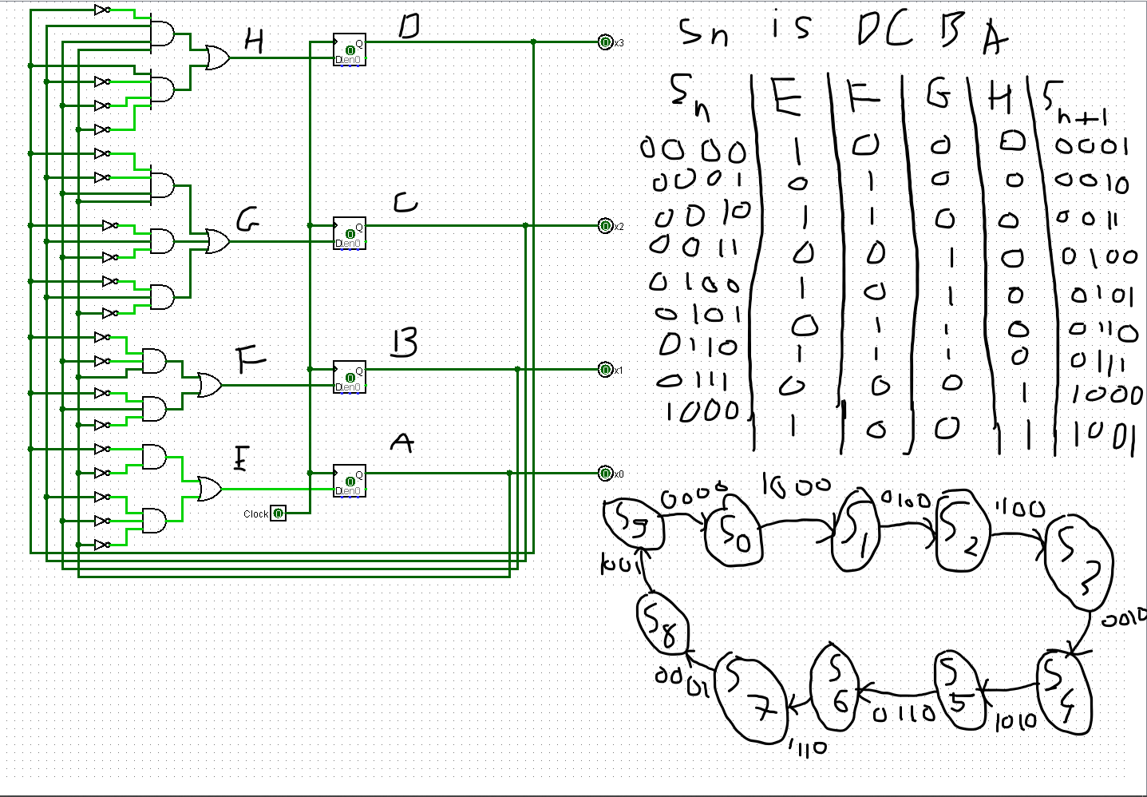

The picture below shows the state diagram and state table of counter 6:

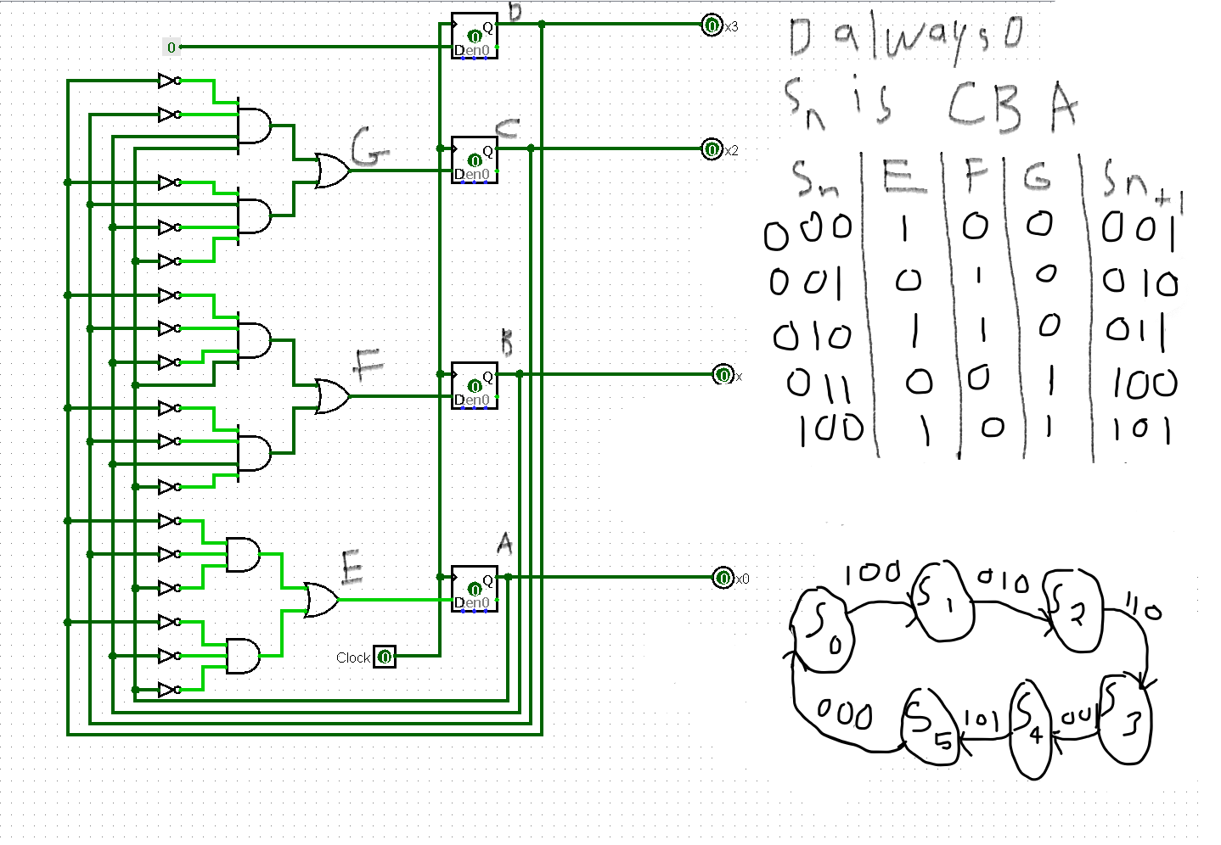

The picture below shows the state table and state diagram of counter 2: