**Assignment 5**

**Due, Sunday, November 18, 2018 for maximum 100**

**Monday, November 19, 2018 for maximum 90**

**Tuesday, November 20, 2018 for maximum 80**

**Wednesday, November 21, 2018 for maximum 70**

**Deliverables**

To complete this assignment you must submit your **compressed Netbeans project** to Webcourses.

**Project description**

Based on how the real game is played we have the following physical objects to model:

* Two players
* Scorecard
* Dice
* The game

The relationship between the objects is as follows:

* Yahtzee has
  + A game, which has
    - Two players
      * Scorecard
      * Name
    - Five dice
    - Thirteen rounds

**Tasks**

|  |  |
| --- | --- |
| Activity | |
| Yahtzee class | 1. Add creating an instance of class YahtzeeUi |
| userInterface package | Create class **GameUi** |
|  | Create class **LowerSectionUi** |
|  | Create class **PlayerUi** |
|  | Create class **RollUi** |
|  | Create class **ScoreCardUi** |
|  | Create class **UpperSectionUi** |
|  | Create class **YahtzeeUi** |
| GameUi.java | 1. Extend class JPanel 2. Declare member variables:    1. JLabel **round**    2. JLabel **gameTurn**    3. JLabel **logo**    4. A layout manager 3. Override default no-argument constructor; it should call method **initComponents**(); 4. Define method **initComponents** (); it should do the following:    1. void return type    2. empty parameter list    3. instantiate instances of the member variables    4. add UI components to the class |
| LowerSectionUi.java | 1. Extend class JPanel 2. Declare member variables:    1. JLabel **round**    2. ArrayList<JButton> **categories** or seven individual JButtons for the categories of the lower section    3. ArrayList<JLabel> **scores** or seven individual JLabels for the score of the categories of the lower section    4. JLabel **totalLower**;    5. JLabel **totalUpper**;    6. JLabel **grandTotal**;    7. A layout manager 3. Override default no-argument constructor; it should call method **initComponents**(); 4. Define method **initComponents** (); it should do the following:    1. void return type    2. empty parameter list    3. instantiate instances of the member variables    4. add UI components to the class |
| PlayerUi.java | 1. Extend class JPanel 2. Declare member variables:    1. JLabel **playerName**;    2. JLabel **playerScore**;    3. A layout manager 3. Override default no-argument constructor; it should call method **initComponents**(); 4. Define method **initComponents** (); it should do the following:    1. void return type    2. empty parameter list    3. instantiate instances of the member variables    4. add UI components to the class |
| RollUi.java | 1. Extend class JPanel 2. Declare member variables:    1. ArrayList<JButton> **dice** or five individual JButtons for the dice    2. JButton **roll**;    3. A layout manager 3. Override default no-argument constructor; it should call method **initComponents**(); 4. Define method **initComponents** (); it should do the following:    1. void return type    2. empty parameter list    3. instantiate instances of the member variables    4. add UI components to the class |
| ScoreCardUi.java | 1. Extend class JPanel 2. Declare member variables:    1. JLabel **grandTotal**;    2. LowerSectionUi **lowerUi**;    3. UpperSectionUi **upperUi**;    4. A layout manager 3. Override default no-argument constructor; it should call method **initComponents**(); 4. Define method **initComponents** (); it should do the following:    1. void return type    2. empty parameter list    3. instantiate instances of the member variables    4. add UI components to the class |
| UpperSectionUi.java | 1. Extend class JPanel 2. Declare member variables: 3. ArrayList<JButton> **categories** or seven individual JButtons for the categories of the lower section 4. ArrayList<JLabel> **scores** or seven individual JLabels for the score of the categories of the lower section 5. JLabel **total**; 6. JLabel **bonus**; 7. JLabel **totalScore**; 8. A layout manager 9. Override default no-argument constructor; it should call method **initComponents**(); 10. Define method **initComponents** (); it should do the following:     1. void return type     2. empty parameter list     3. instantiate instances of the member variables     4. add UI components to the class |
| YahtzeeUi.java | 1. Declare member variables: 2. GameUi **gameUi**; 3. PlayerUi **playerUi**; 4. RollUi **rollUi**; 5. ScoreCardUi **scoreCardUi**; 6. JFrame **frame**; 7. JMenuBar **menuBar**; 8. JMenu **game**; 9. JMenuItem **exit**; 10. JMenuItem **newGame**; 11. JPanel **rightPanel**; 12. A layout manager 13. Override default no-argument constructor; it should call method **initComponents**(); 14. Define method **initComponents** (); it should do the following:     1. void return type     2. empty parameter list     3. instantiate instances of the member variables     4. add UI components to the class |
| Yahtzee application |  |
| Test Case 1 | Test Case 1 passes |
| Test Case 2 | Test Case 2 passes |
| Test Case 3 | Test Case 3 passes |
|  | Source compiles with no errors |
|  | Source runs with no errors |
|  | Source includes comments |
| Total |  |

**Perform the following test cases**

|  |  |  |
| --- | --- | --- |
| Test Cases | | |
|  | **Action** | **Expected outcome** |
| Test Case 1 | **Project view** | Completed project view should look like figure 1 |
| Test case 2 | **Run application** | UI display should look like figure 2 |
| Test case 3 | **Run application** | Menu display should look like figure 3 |

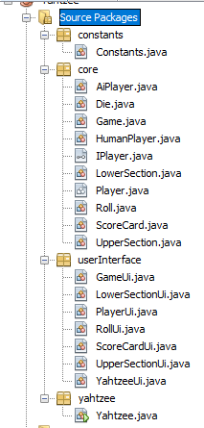

Figure 1 Project View

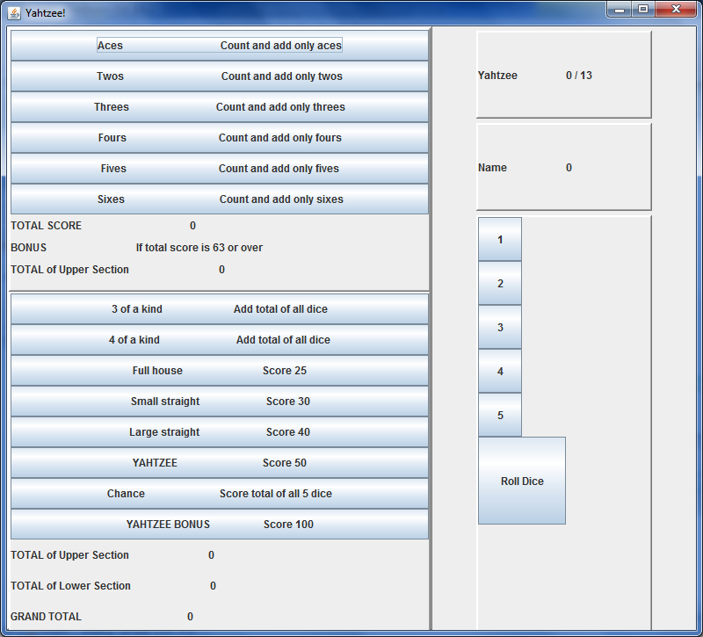

Figure 2 UI Display

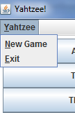

Figure 3 Menu Display