**APPLIANCES**

- Appliances is the general name for electrical products that have the function to support household functions such as cooking, cooling, food preservation, entertainment... Appliances help the family become comfortable and more convenient, meeting the needs of daily living for a family.

- With extremely essential utilities, appliances are almost indispensable devices in every family. They have many types to serve the essential needs of people.

**1. Geysers**

* Geyser is a device used in every family's bathroom. It is a type of electric water heater. The basic function of a water heater is to heat the water before it goes to the faucet. This device helps to balance the water temperature for bathing or family activities.
* List of products:

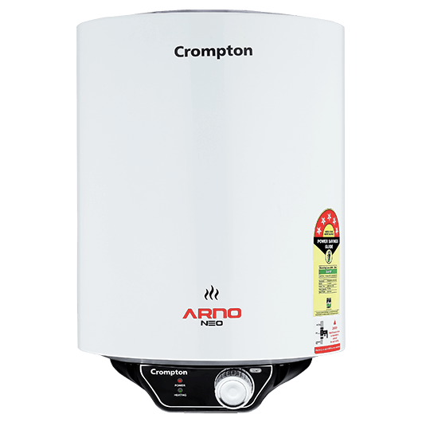**No.1:** Crompton Arno Neo 6 Ltr Storage Geysers

Price: Rs. 5625 (~~Rs. 7500~~)

This Crompton Arno Neo 6 Ltr Storage Geysers is designed with artistic excellence and provides you the hot water within minutes. This storage geyser is equipped with innovative features like LED indicators for safe usage, stainless steel inner tank, easy operation and many more. It is ideal for large families for bathing purpose.

**PRODUCT SPECIFICATION**

|  |  |
| --- | --- |
| **Brand** | Crompton |
| **Product Category** | Storage Geysers |
| **Model Name** | Arno Neo |
| **Capacity** | 6 Ltr |
| **Power** | 2000 W |
| **Voltage** | 230 V |
| **Maximum Working Pressure** | 8 Bars |
| **Colour** | White |
| **Mounting Type** | Wall Mounted |
| **Heating Element** | Copper (NC) |
| **Body** | Plastic + Sheet Metal |
| **Package Contents** | 1 Water Heater, Manual, Warranty Card |
| **Certification** | 5 Star Rated |
| **Warranty** | 5 Years on tank, 2 Years on heating element, 2 Years comprehensive warranty |

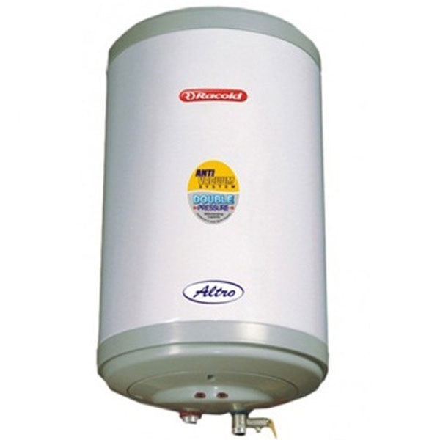**No.2:** Racold Altro 10 Ltr Storage Geyser

Price: Rs. 5950 (~~Rs. 7360~~)

This Racold Altro 10 Ltr Storage Geyser is designed with artistic excellence and provides you the hot water within minutes. This storage geyser is equipped with innovative features like LED indicators for safe usage, stainless steel inner tank, easy operation and many more. It is ideal for large families for bathing purpose. Unique polymer protective coating technology for inner container resists corrosion from hard water.

**PRODUCT SPECIFICATION**

|  |  |
| --- | --- |
| **Brand** | Racold |
| **Product Category** | Storage Geysers |
| **Model Name** | Altro |
| **Capacity** | 10 Ltr |
| **Power** | 2000 W |
| **Voltage** | 230 V |
| **Maximum Working Pressure** | 8 Bars |
| **Colour** | Grey/Brown |
| **Mounting Type** | Wall Mounted |
| **Package Contents** | 1 Water Heater, Manual, Warranty Card |
| **Certification** | BEE Star Rated |
| **Warranty** | 7 Years on tank, 4 Years on heating element, 2 Years comprehensive warranty |

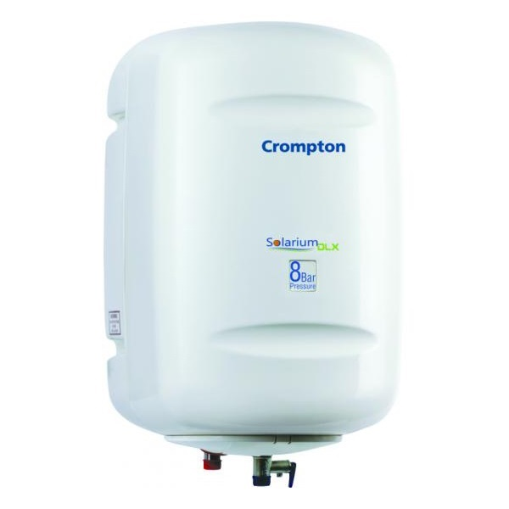**No.3:** Crompton Solarium Deluxe 10 Ltr Storage Geyser

Price: Rs. 6310

This Crompton Solarium Deluxe 10 Ltr Storage Geyser is designed with artistic excellence and provides you the hot water within minutes. This storage geyser is equipped with innovative features like LED indicators for safe usage, stainless steel inner tank, easy operation and many more. It is ideal for large families for bathing purpose.

**PRODUCT SPECIFICATION**

|  |  |
| --- | --- |
| **Brand** | Crompton |
| **Product Category** | Storage Geysers |
| **Model Name** | Solarium Deluxe |
| **Capacity** | 10 Ltr |
| **Power** | 2000 W |
| **Voltage** | 230 V |
| **Maximum Working Pressure** | 8 Bars |
| **Colour** | Ivory |
| **Mounting Type** | Wall Mounted |
| **Heating Element** | Copper (NC) |
| **Body** | ABS Molded |
| **Package Contents** | 1 Water Heater, Manual, Warranty Card |
| **Certification** | 5 Star Rated |
| **Warranty** | 5 Years on tank, 2 Years on heating element, 2 Years comprehensive warranty |

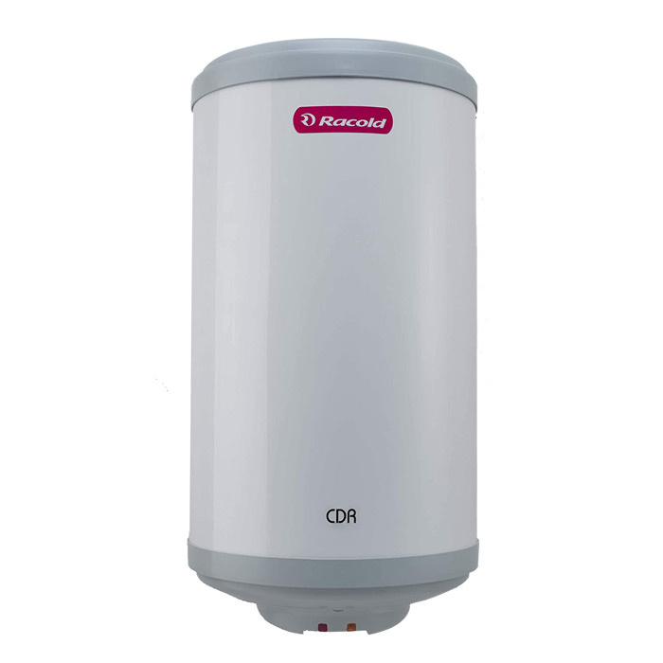**No.4:** Racold CDR 10 Ltr Vertical Storage Geyser

Price: Rs. 7719 (~~Rs. 8125~~)

At Racold, we create products that are long lasting and efficient. The CDR range of electric storage water heaters feature Racold’s specially designed SPHP inner tank that ensures corrosion resistance, high pressure withstanding capacity and high energy efficiency.

**PRODUCT SPECIFICATION**

|  |  |
| --- | --- |
| **Brand** | Racold |
| **Product Category** | Storage Geysers |
| **Model Name** | CDR |
| **Capacity** | 10 Ltr |
| **Power** | 2000 W |
| **Voltage** | 230 V |
| **Maximum Working Pressure** | 8 Bars |
| **Colour** | Metallic Blue/Metallic Brown |
| **Mounting Type** | Wall Mounted |
| **Package Contents** | 1 Water Heater, Manual, Warranty Card |
| **Certification** | BEE Star Rated |
| **Warranty** | 5 Years on tank, 2 Years on heating element, 2 Years comprehensive warranty |

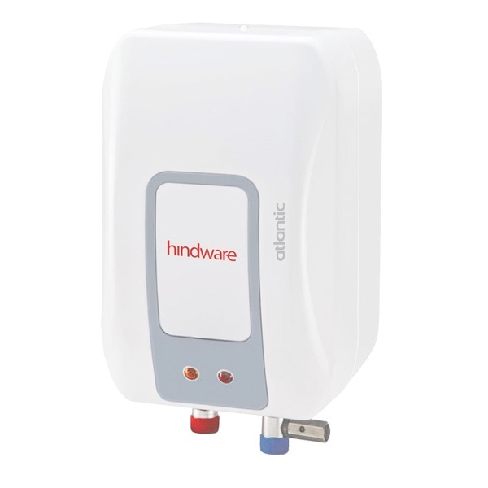**No.5:** Atlantic 1 Ltr Instant Geyser

Price: Rs. 2849 (~~Rs. 3490~~)

This compact and sleek designed Atlantic 1 Ltr Instant Geyser comes with intelligent heating system that saves power/energy without affecting heating. Its robust construction ensures enhanced life of the heater. Bring this to your home today and enjoy hot water bath instantly anytime.

**PRODUCT SPECIFICATION**

|  |  |
| --- | --- |
| **Brand** | Atlantic |
| **Product Category** | Instant Geysers |
| **Model Name** | HI01PDW30 |
| **Capacity** | 1 Ltr |
| **Power** | 3000 W |
| **Voltage** | 230 V |
| **Maximum Working Pressure** | 6.5 Bars |
| **Colour** | White |
| **Mounting Type** | Wall Mounted |
| **Ingress Protection** | IP X1 |
| **Package Contents** | 1 Water Heater, Manual, Warranty Card |
| **Certification** | BEE Star Rated |
| **Warranty** | 2 Years on tank, 2 Years on heating element, 2 Years comprehensive warranty |

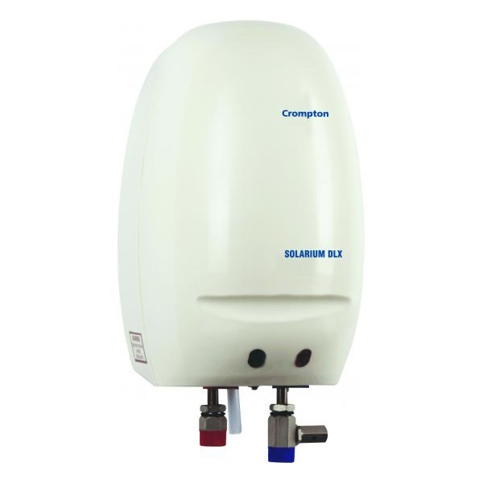**No.6:** Crompton Solarium Deluxe 1 Ltr Instant Geyser

Price: Rs. 2511 (~~Rs. 2511~~)

This compact and sleek designed Crompton Solarium Deluxe 1 Ltr Instant Geyser comes with intelligent heating system that saves power/energy without affecting heating. Its robust construction ensures enhanced life of the heater. Bring this to your home today and enjoy hot water bath instantly anytime.

**PRODUCT SPECIFICATION**

|  |  |
| --- | --- |
| **Brand** | Crompton |
| **Product Category** | Instant Geysers |
| **Model Name** | Solarium Deluxe |
| **Capacity** | 1 Ltr |
| **Power** | 3000 W |
| **Voltage** | 230 V |
| **Maximum Working Pressure** | 6.5 Bars |
| **Colour** | Ivory |
| **Mounting Type** | Wall Mounted |
| **Heating Element** | Copper (NC) |
| **Body** | ABS |
| **Package Contents** | 1 Water Heater, Manual, Warranty Card |
| **Warranty** | 2 Years comprehensive warranty |

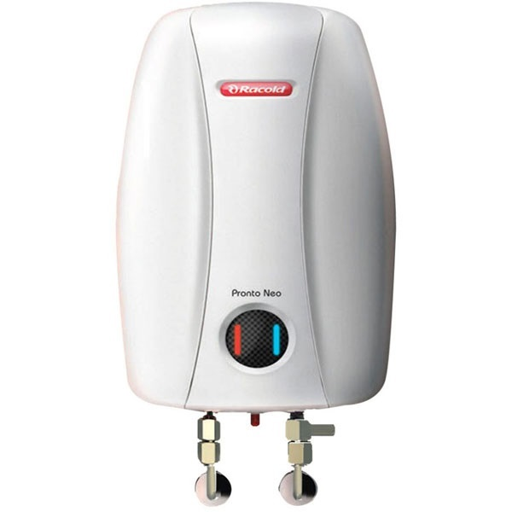**No.7:** Racold Pronto Neo 1 Ltr Instant Geyser

Price: Rs. 3087 (~~Rs. 3250~~)

This compact and sleek designed Racold Pronto Neo 1 Ltr Instant Geyser comes with intelligent heating system that saves power/energy without affecting heating. Its robust construction ensures enhanced life of the heater. Bring this to your home today and enjoy hot water bath instantly anytime. Unique polymer protective coating technology for inner container resists corrosion from hard water.

**PRODUCT SPECIFICATION**

|  |  |
| --- | --- |
| **Brand** | Racold |
| **Product Category** | Instant Geysers |
| **Model Name** | Pronto Neo |
| **Capacity** | 1 Ltr |
| **Power** | 3000 W |
| **Voltage** | 230 V |
| **Maximum Working Pressure** | 6.5 Bars |
| **Colour** | White |
| **Thermostat Type** | Adjustable Thermostat |
| **Mounting Type** | Wall Mounted |
| **Package Contents** | 1 Water Heater, Manual, Warranty Card |
| **Certification** | BEE Star Rated |
| **Warranty** | 5 Years on tank, 2 Years on heating element, 2 Years comprehensive warranty |

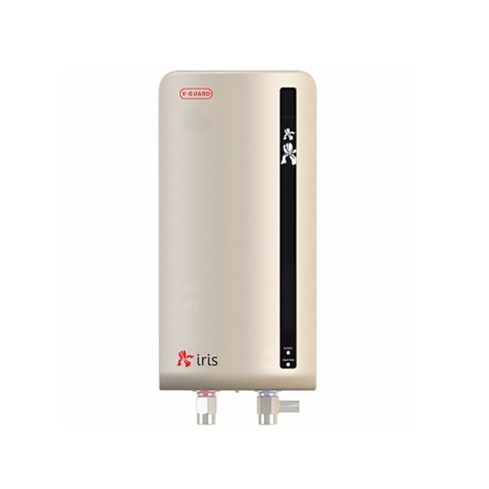**No.8:** V-Guard Iris 3 Ltr Instant Geyser

Price: Rs. 4950 (~~Rs. 5100~~)

This compact and sleek designed V-Guard Iris 3 Ltr Instant Geyser comes with intelligent heating system that saves power/energy without affecting heating. Its robust construction ensures enhanced life of the heater. Bring this to your home today and enjoy hot water bath instantly anytime.

**PRODUCT SPECIFICATION**

|  |  |
| --- | --- |
| **Brand** | V-Guard |
| **Product Category** | Instant Geysers |
| **Model Name** | Iris |
| **Capacity** | 3 Ltr |
| **Power** | 3000 W |
| **Voltage** | 230 V |
| **Maximum Working Pressure** | 6.5 Bars |
| **Colour** | Ivory |
| **Mounting Type** | Wall Mounted |
| **Body** | ABS outer body |
| **Package Contents** | 1 Water Heater, Manual, Warranty Card |
| **Warranty** | 5 Years on tank, 2 Years comprehensive warranty |

**2. Irons**

* An iron is an electrical device used to smooth clothes and prevent them from wrinkling. Help people become more neat and polite when working or communicating.
* With its compact and easy-to-use design, the iron has become one of the most commonly used applications in every home.
* List of products:

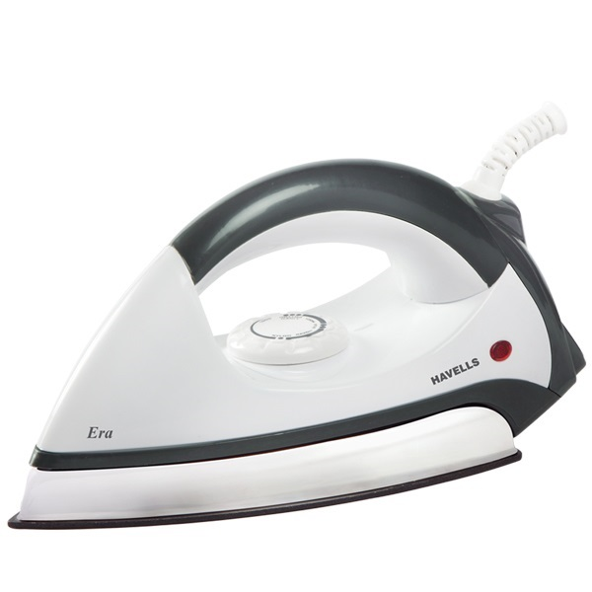**No.1:** Havells Era Dry Iron

Price: Rs. 950 (~~Rs. 1055~~)

This Havells Era Dry Iron is not only effective in its tasks such as removing wrinkles but also make them look sparkling new. Its a versatile appliance for your home, some of its features are:

* Non-stick coating plate(protects your clothes from accidental burns)
* Comfortable hand grip
* Lightweight
* Thermal fuse for additional safety

This Havells Era Dry Iron is a reliable product from the house of havells for your home. It is a light weight iron that enables you to iron clothes comfortably.

**PRODUCT SPECIFICATION**

|  |  |
| --- | --- |
| **Brand** | Havells |
| **Product Category** | Dry Irons |
| **Model Name** | Era |
| **Plate** | Aluminium Dicasted soleplate with DuPont registered American Heritage coating for smooth gliding |
| **Power** | 1000 W |
| **Voltage** | 240 V |
| **Temperature Settings** | Temperature control dial for various fabrics |
| **Indicator Light** | Yes |
| **Fuse** | Thermal fuse to protect from Overheating of Iron in case if Thermostat fails to operate |
| **Warranty** | 2 Years (against manufacturing defects) |

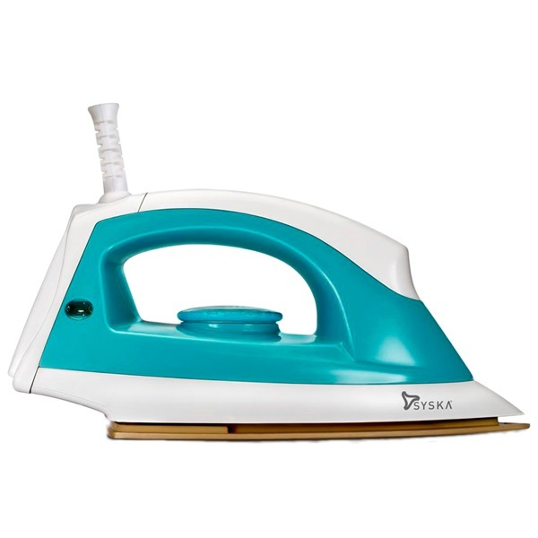**No.2:** Syska SDI-07 Dry Iron

Price: Rs. 610 (~~Rs. 749~~)

This Syska SDI-07 Dry Iron is not only effective in its tasks such as removing wrinkles but also make them look sparkling new. Its a versatile appliance for your home, some of its features are:

* Non-stick coating plate(protects your clothes from accidental burns)
* Comfortable hand grip
* Lightweight

**PRODUCT SPECIFICATION**

|  |  |
| --- | --- |
| **Brand** | Syska |
| **Product Category** | Dry Irons |
| **Model Name** | SDI-07 |
| **Power** | 1000 W |
| **Voltage** | 240 V |
| **Plate** | Golden American Heritage Soleplate, Multi fabric Select |
| **Temperature Settings** | Temperature control dial for various fabrics |
| **Indicator Light** | Yes |
| **Fuse** | Thermal fuse to protect from Overheating of Iron in case if Thermostat fails to operate |
| **Warranty** | 2 Years (against manufacturing defects) |

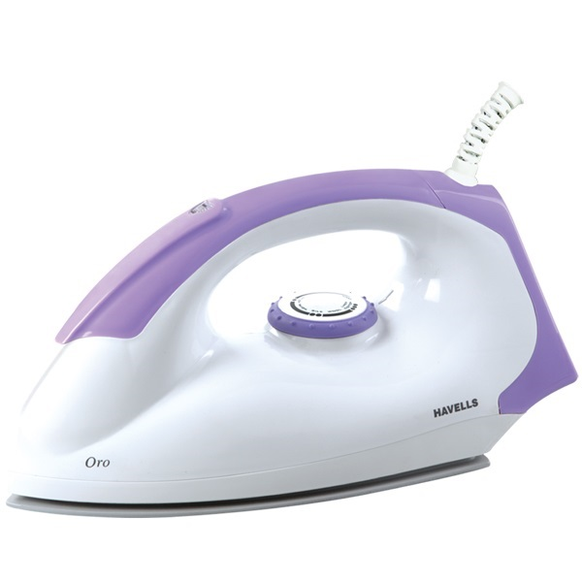**No.3:** Havells Oro Dry Iron

Price: Rs. 1256 (~~Rs. 1395~~)

This Havells Oro Dry Iron is not only effective in its tasks such as removing wrinkles but also make them look sparkling new. Its a versatile appliance for your home, some of its features are:

* Non-stick coating plate(protects your clothes from accidental burns)
* Comfortable hand grip
* Lightweight
* Thermal fuse for additional safety

This Havells Oro Dry Iron is a reliable product from the house of havells for your home. It is a light weight iron that enables you to iron clothes comfortably

**PRODUCT SPECIFICATION**

|  |  |
| --- | --- |
| **Brand** | Havells |
| **Product Category** | Dry Irons |
| **Model Name** | Oro |
| **Plate** | Aluminium Di-casted with DuPont Teflon classic PTFE coating |
| **Power** | 1000 W |
| **Voltage** | 240 V |
| **Temperature Settings** | Temperature control dial for various fabrics |
| **Indicator Light** | Yes |
| **Fuse** | Thermal fuse to protect from Overheating of Iron in case if Thermostat fails to operate |
| **Warranty** | 2 Years (against manufacturing defects) |

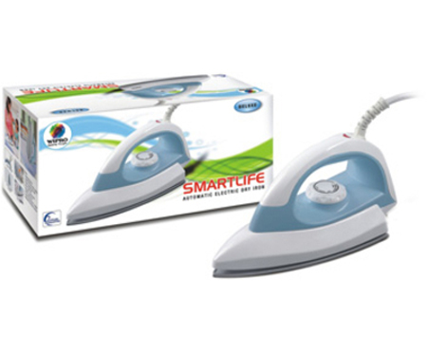**No.4:** Wipro Deluxe W10002 Dry Iron

Price: Rs. 1256 (~~Rs. 1395~~)

This Wipro Super Deluxe W100012 Dry Iron is not only effective in its tasks such as removing wrinkles but also make them look sparkling new. It is a light weight iron that enables you to iron clothes comfortably. Its a versatile appliance for your home, some of its features are:

* Non-stick coating plate(protects your clothes from accidental burns)
* Comfortable hand grip
* Lightweight
* Thermal fuse for additional safety

**PRODUCT SPECIFICATION**

|  |  |
| --- | --- |
| **Brand** | Wipro |
| **Product Category** | Dry Irons |
| **Model Name** | W10002 |
| **Plate** | Dupont Teflon Non-Stick Coating |
| **Power** | 1000 W |
| **Voltage** | 240 V |
| **Temperature Settings** | Adjustable thermostatic control |
| **Indicator Light** | Yes |
| **Warranty** | 2 Years (against manufacturing defects) |

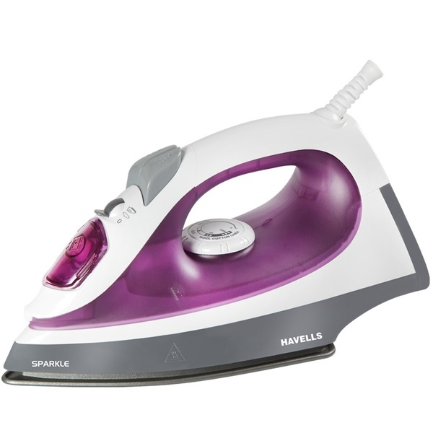**No.5:** Havells Sparkle Steam Iron

Price: Rs. 1886 (~~Rs. 2095~~)

This Havells Sparkle Steam Iron is a lightweight iron with a comfortable grip, offering you an easy ironing experience at home. It comprises of non stick coated soleplate and has many other features (below) that make it more efficient:

* Glides easily
* Vertical ironing
* Steam burst and water spray
* Thermal fuse
* Quick heating
* Self cleaning facility

This Havells Sparkle Steam Iron is a reliable product from the house of havells for your home. It is a light weight iron that enables you to iron clothes comfortably.

**PRODUCT SPECIFICATION**

|  |  |
| --- | --- |
| **Brand** | Havells |
| **Product Category** | Steam Irons |
| **Model Name** | Sparkle |
| **Plate** | PTFE non stick coated sole plate |
| **Power** | 1250 W |
| **Voltage** | 240 V |
| **Temperature Settings** | Adjustable thermostatic control |
| **Indicator Light** | Yes |
| **Water Tank Capacity** | 230 ml |
| **Variable Steam Settings** | Yes |
| **Cleaning Option** | Yes |
| **Vertical Steam** | Yes |
| **Warranty** | 2 Years (against manufacturing defects) |

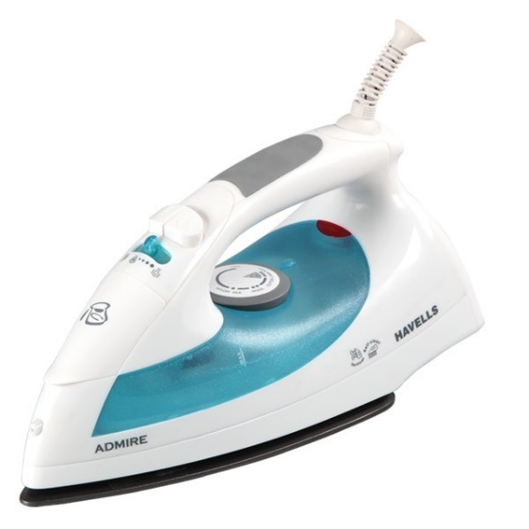**No.6:** Havells Admire Blue Steam Iron

Price: Rs. 2606 (~~Rs. 2895~~)

This Havells Admire Blue Steam Iron is a lightweight iron with a comfortable grip, offering you an easy ironing experience at home. It comprises of non stick coated soleplate and has many other features (below) that make it more efficient:

* Glides easily
* Vertical ironing
* Steam burst and water spray
* Thermal fuse
* Quick heating
* Self cleaning facility

This Havells Admire Blue Steam Iron is a reliable product from the house of Havells for your home. It is a light weight iron that enables you to iron clothes comfortably.

**PRODUCT SPECIFICATION**

|  |  |
| --- | --- |
| **Brand** | Havells |
| **Product Category** | Steam Irons |
| **Model Name** | Sparkle |
| **Plate** | PTFE non stick coated sole plate |
| **Power** | 1250 W |
| **Voltage** | 240 V |
| **Temperature Settings** | Adjustable thermostatic control |
| **Indicator Light** | Yes |
| **Water Tank Capacity** | 230 ml |
| **Variable Steam Settings** | Yes |
| **Cleaning Option** | Yes |
| **Vertical Steam** | Yes |
| **Warranty** | 2 Years (against manufacturing defects) |

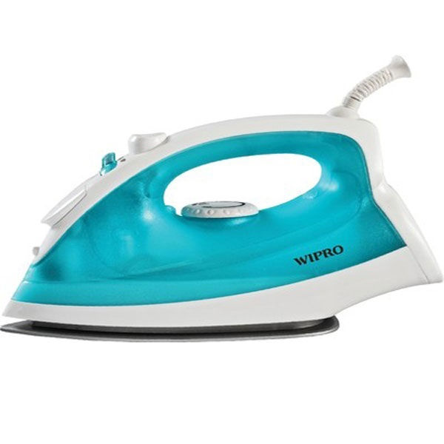**No.7:** Wipro W10004 Steam Iron

Price: Rs. 1375 (~~Rs. 1795~~)

This Wipro W10004 Steam Iron is a lightweight iron with a comfortable grip, offering you an easy ironing experience at home. It comprises of non stick coated soleplate and has many other features (below) that make it more efficient:

* Glides easily
* Vertical ironing
* Steam burst and water spray
* Thermal fuse
* Quick heating
* Self cleaning facility

**PRODUCT SPECIFICATION**

|  |  |
| --- | --- |
| **Brand** | Wipro |
| **Product Category** | Steam Irons |
| **Model Name** | W10004 |
| **Plate** | Dupont Teflon Non-Stick Coating |
| **Power** | 1000 W |
| **Voltage** | 240 V |
| **Temperature Settings** | Adjustable thermostatic control |
| **Indicator Light** | Yes |
| **Vertical Steam** | Yes |
| **Warranty** | 2 Years (against manufacturing defects) |

**3. Cooking**

* Cooking are products that convert electrical energy into heat for cooking. With safety features (some devices can also automatically turn off), these products become popular and gradually replace fuel-powered appliances (such as wood, coal).With its compact and easy-to-use design, the iron has become one of the most commonly used applications in every home.
* List of products:

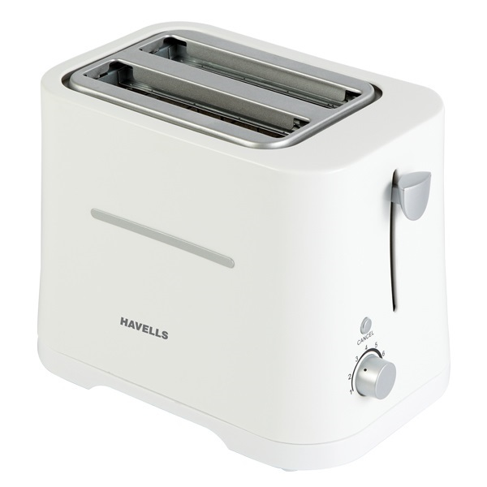**No.1:** Havells Crisp Pop Up Toaster

Price: Rs. 1976 (~~Rs. 2195~~)

This pop up toaster from the house of Havells is a perfect fit for your kitchen and can toast up to two bread slices simultaneously. It can be kept easily in the kitchen as it occupies a very small footprint. This toaster comes with different levels of browning controls that enables to get the toast of your choice and preference.

**PRODUCT SPECIFICATION**

|  |  |
| --- | --- |
| **Brand** | Havells |
| **Product Category** | Pop Up Toasters |
| **Model Name** | Crisp |
| **Functions** | Toasting |
| **Power** | 700 W |
| **Voltage** | 240 V |
| **Temperature Settings** | Yes |
| **Toasting Slot** | Auto bread centering |
| **Time Settings** | Yes |
| **Colour** | White |
| **Body** | Heat-resistant, cool-touch body |
| **Auto Shut-Off** | Yes |
| **Removable Crumb Tray** | Yes |
| **Electronic Variable Browing Control** | Yes |
| **Warranty** | 2 Years on motor |

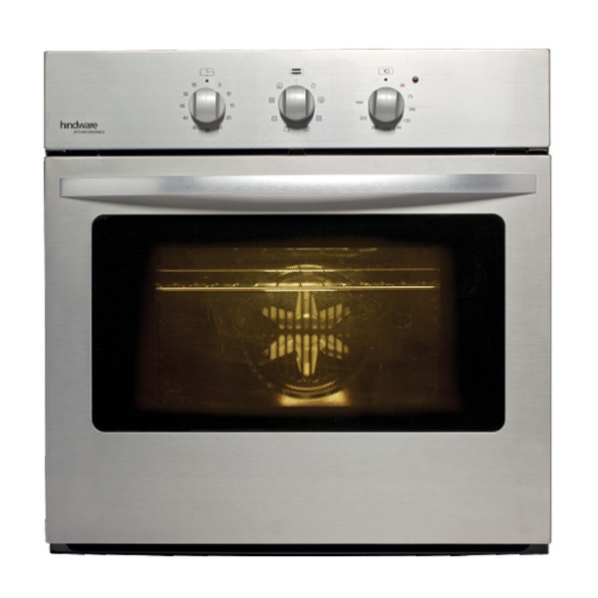**No.2:** Hindware ROYAL PLUS Oven

Price: Rs. 39599 (~~Rs. 37990~~)

This Hindware ROYAL PLUS Oven is equipped with a host of useful heating functions, which enables the kitchen enthusiasts to bake, cook or roast vegetables with maximum ease and comfort. It has mechanical knobs and digital display that enables you to adjust the power, temperature and clock setting as per your needs. This oven facilitates convenient installation and hassle-free cleaning.

More information:

* Mechanical controls with minute minder
* 56 litres capacity
* Multi-function oven with rotisserie
* Fan defrost
* Dual grill
* Catalytic Liners, fast heat mode (150ºC in 4min), Deep baking pan, Push-pull illuminated controls, Electronic programmer, Child/safety lock, Double glazed door, Pizza function, Adjustable grill for easy cleaning
* Double glazed oven door, light in the oven, base fan, cooling fan

**PRODUCT SPECIFICATION**

|  |  |
| --- | --- |
| **Brand** | Hindware |
| **Product Category** | Oven |
| **Model Name** | Royal Plus |
| **Capacity** | 56 Ltrs |
| **Control Type** | Mechanical controls with minute minder |
| **Functions** | Multi function oven with rotisserie, Fan defrost, Dual grill |
| **Warranty** | 1 Year (against manufacturing defects) |

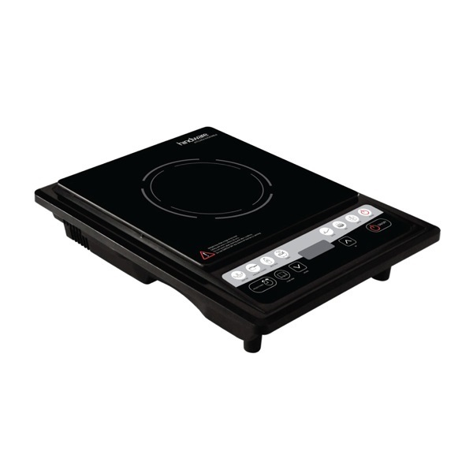**No.3:** Hindware Dino Induction Cooktop

Price: Rs. 3511 (~~Rs. 3990~~)

This Hindware Dino Induction Cooktop from Hindware goes extra mile in making your cooking simpler. It has an elegant design and comes with a push button that enables you to control its functions with ease. Now, prepare a wide variety of dishes for your family with this elegantly designed electric cooktop, without standing in kitchen for a long time.

**PRODUCT SPECIFICATION**

|  |  |
| --- | --- |
| **Brand** | Hindware |
| **Product Category** | Induction Cooktops |
| **Model Name** | Dino |
| **Functions** | Cooking |
| **Power** | 1900W |
| **Voltage** | 240 V |
| **Temperature Settings** | Variable temperature settings |
| **Time Settings** | 24 Hrs |
| **Indicator Light** | Digital LED display |
| **Control Type** | Soft Touch Control |
| **Suitable For** | Stainless Steel Pots, Stainless Steel Rice Cookers, Cast Iron Frying Pots, Oil Boiling Pots, Stainless Steel Water Jugs, Grilling Iron Plates |
| **Cooking Modes** | 7 Cooking Functions |
| **Portability** | Easy to carry and use |
| **Low Maintenance** | Flat cooking surface for easy cleaning |
| **Auto Shut-Off** | Automatic switch off at high temperature |
| **Warranty** | 1 Year (against manufacturing defects) |

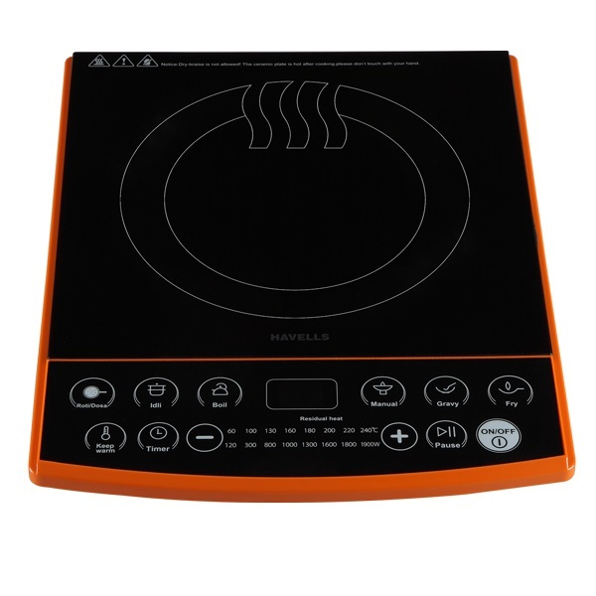**No.4:** Havells Insta Cook ET-X Induction Cooktop

Price: Rs. 4244 (~~Rs. 4715~~)

This Havells Insta Cook ET-X Induction Cooktop from Havells goes extra mile in making your cooking simpler. It has an elegant design and comes with a push button that enables you to control its functions with ease. Now, prepare a wide variety of dishes for your family with this elegantly designed electric cooktop, without standing in kitchen for a long time.

**PRODUCT SPECIFICATION**

|  |  |
| --- | --- |
| **Brand** | Havells |
| **Product Category** | Induction Cooktops |
| **Model Name** | Insta Cook |
| **Functions** | Cooking |
| **Power** | 1900W |
| **Voltage** | 240 V |
| **Temperature Settings** | Variable temperature settings |
| **Time Settings** | 3 hour preset timer |
| **Indicator Light** | Digital LED display |
| **Body** | Micro-crytsal plate main body |
| **Control Type** | Soft touch sensor |
| **Suitable For** | Stainless Steel Pots, Stainless Steel Rice Cookers, Cast Iron Frying Pots, Oil Boiling Pots, Stainless Steel Water Jugs, Grilling Iron Plates |
| **Cooking Modes** | 9 different intelligent cooking modes for temperature and power settings |
| **Automatic Pan Detection** | Yes |
| **Portability** | Easy to carry and use |
| **Low Maintenance** | Flat cooking surface for easy cleaning |
| **Enclosure For Anti Repellent Pills** | Yes |
| **Energy Saving** | Direct and quick heat to ensure minimal loss of energyAutomatic switch off at high temperature |
| **Auto Shut-Off** | Automatic switch off at high temperature |
| **Child Lock For Extra Safety** | Yes |
| **Warranty** | 2 Years on motor |

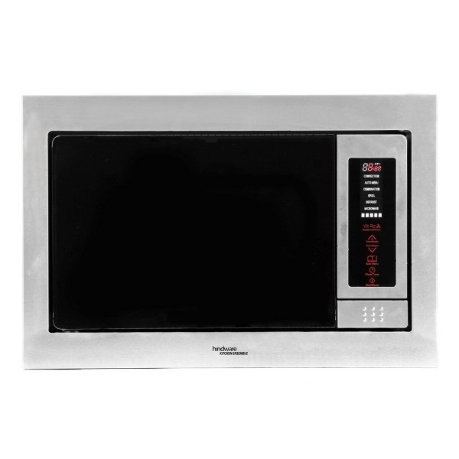**No.5:** Hindware SAVIO Microwave oven

Price: Rs. 31899 (~~Rs. 30990~~)

Get rid of hassles of heating your food on gas with this new SAVIO Microwave oven from Hindware. You can use large microwave crockery because of its large capacity. The touch screen options are very clear, which enable you to choose from a host of heating options, hence making your cooking simple.

* Capacity 27 Liters
* Features Sensor Touch Control
* 5 Power Setting
* Convection Grill Stainless Steel
* 90 Min Digital Timer
* Digital Display
* Push button door
* Defrost Setting
* Cooking End Signal
* Child Safety Lock
* Stainless Steel Body

**PRODUCT SPECIFICATION**

|  |  |
| --- | --- |
| **Brand** | Hindware |
| **Product Category** | Microwave Ovens |
| **Model Name** | Savio |
| **Capacity** | 27 Ltrs |
| **Control Type** | Features Sensor Touch Control |
| **Body** | Convection Grill Stainless Steel |
| **Display** | Digital Display |
| **Timer** | 90 Min Digital Timer |
| **Warranty** | 1 Year (against manufacturing defects) |

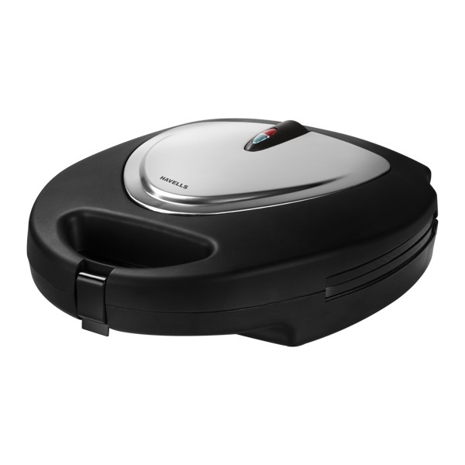**No.6:** Havells Toastino Multigrill Sandwich Toaster

Price: Rs. 4496 (~~Rs. 4995~~)

If you are looking for a delicious and healthy sandwich maker, then this Havells Toastino Multigrill Sandwich Toaster is an ideal choice. Its outstanding features are:

* Easy to operate
* Easy to clean
* Safe to handle
* Preheat and cool touch body
* Non-stick coating
* Compact shape

This easy to use sandwich maker from the house of Havells enables you to make toasted and grilled sandwiches conveniently in your kitchen.

**PRODUCT SPECIFICATION**

|  |  |
| --- | --- |
| **Brand** | Havells |
| **Product Category** | Sandwich Maker |
| **Model Name** | Toastino |
| **Functions** | Toasting |
| **Power** | 800 W |
| **Voltage** | 240 V |
| **Plate Coating** | Non-stick coated plates |
| **Handle** | Cool-touch handle |
| **Colour** | Glossy black, brush finish metal cover |
| **Body** | Non-skid feet |
| **Auto Shut-Off** | Yes |
| **Warranty** | 2 Years on motor |