**FANS**

# 1. CEILING FANS

* Ceiling fan is a familiar electrical appliance with a cooling function used in the home and is often hung on the ceiling of a living room or bedroom.
* Depending on the type of classic or modern fan, there will be additional utilities such as remote control, timer mode, decorative lights, lights, etc. Based on the above comparison table, we can easily see it. that the more blades the fan, the more the price will be set and the fan weight is also different. However, according to the actual feedback from customers, the more blades the fan has, the cooler it will be compared to the fan with fewer blades. The fan durability depends on the fan manufacturer and the electricity bill compared to the power consumption of the fans is not much different.
* List of products:

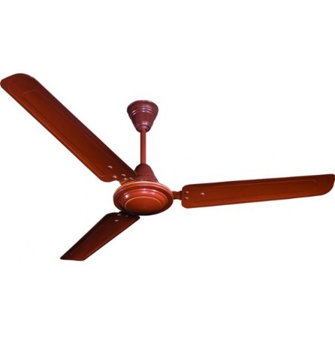

**No**1.Crompton Briz Air 24" Brown Ceiling Fans

Selling Price: Rs. 1460

You Save: Rs. 540.00 (27.00%)

(Price Inclusive of GST)

* MULTI-SPEED REVERSIBLE FAN MOTOR: Whisper Wind motor delivers ultra-powerful airflow with quiet performance; Change the direction from downdraft mode during the summer to updraft mode during the winter
* ROOP PLACEMENT: Indoor/outdoor fan is height adjustable, via the included 5" and 3" downrods, to ensure proper distance from the ceiling and optimize air movement; Damp-rated for use in covered porches, patios, sunrooms, living room, and bedroom

|  |  |
| --- | --- |
| **Brand** | Crompton |
| **Product Category** | Standard |
| **Model Name** | Briz air |
| **Colour** | Brown |
| **Sweep** | 600 mm (24") |
| **Power** | 62 W |
| **Voltage** | 240 V |
| **R.P.M.** | 850 |
| **Air Capacity/Air Delivery (C.F.M.)** | 4061.19 |
| **Air Capacity/Air Delivery (M3H)** | 6900 |
| **No of Blade** | 3 |
| **Height of Rod** | 9"-11" |
| **Package Contents** | 1 Rod, 3 Blades, 1 Motor, 1 Ceiling Cap, Manual, Warranty Card |
| **Suitable For** | Indoor/Outdoor |
| **Warranty** | 3 Years on motor |

**PRODUCT SPECIFICATION**

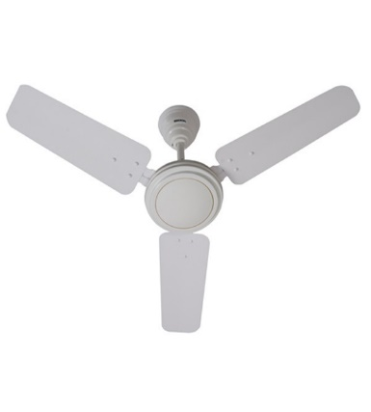**No**2.Usha Ace-Ex 36" White Ceiling Fans

Selling Price: Rs. 1512

You Save: Rs. 108.00 (6.67%)

(Price Inclusive of GST)

* High Lift Angle of Blade for wide air spread.
* High speed
* Superior high permeability grade electric steel lamination for improved life.
* Glossy powder coated paint for superior finish and longer life.
* Performs well even at low voltage.
* Available in 1200mm sweep.

Usha has introduced Ace Ex series of power saver standard economic fans. This energy saving ceiling fan with finer ball components and high quality steel lamination is certified for durability and minimum power consumption.

**PRODUCT SPECIFICATION**

|  |  |
| --- | --- |
| **Brand** | Usha |
| **Product Category** | Standard |
| **Model Name** | Ace Ex |
| **Sweep** | 900 mm (36") |
| **Power** | 60 W |
| **Voltage** | 240 V |
| **R.P.M.** | 390 |
| **Air Capacity/Air Delivery (C.F.M.)** | 4485 |
| **Air Capacity/Air Delivery (M3H)** | 7620 |
| **No of Blade** | 3 |
| **Height of Rod** | 9"-11" |
| **Package Contents** | 1 Rod, 3 Blades, 1 Motor, 1 Ceiling Cap, Manual, Warranty Card |
| **Material** | Superior high permeability grade electric steel lamination for improved life. Glossy powder coated paint for superior finish and longer life. |
| **Suitable For** | Indoor/Outdoor |
| **Warranty** | 2 Years on motor |

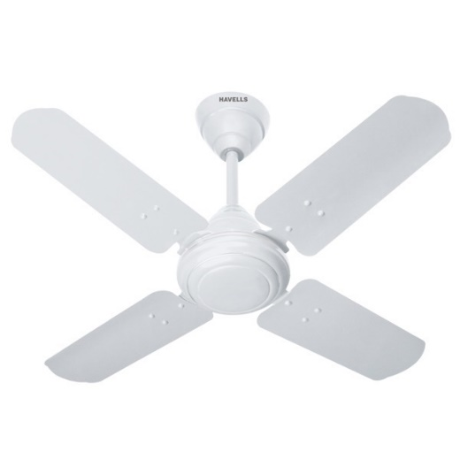**No**3.Havells Speedster 30" White Ceiling Fans

Selling Price: Rs. 2736

You Save: Rs. 409.00 (13.00%)

(Price Inclusive of GST)

* PERFECT SIZE: This ceiling fan is the perfect fit for up-beat living rooms, bedrooms, dens and common areas and any area up to approximately 400 square feet, allowing you to maintain your comfort without sacrificing style
* QUIET MOTOR: Conveniently quiet, 3 speed, reversible motor (motor size 153 x 15 ss). Downdraft mode and updraft mode for optimal airflow. Control the temperature of your space with ease
* WARRANTY: We want you to be completely satisfied with your ceiling fan, and to better ensure that this fan comes with a limited lifetime warranty

**PRODUCT SPECIFICATION**

|  |  |
| --- | --- |
| **Brand** | Havells |
| **Product Category** | Standard |
| **Model Name** | Speedster |
| **Sweep** | 750 mm (30") |
| **Power** | 68 W |
| **Voltage** | 240 V |
| **R.P.M.** | 800 |
| **Air Capacity/Air Delivery (C.F.M.)** | 5297 |
| **Air Capacity/Air Delivery (M3H)** | 9000 |
| **No of Blade** | 4 |
| **Height of Rod** | 10"-12" |
| **Suitable For** | Indoor |
| **Warranty** | 2 Years on motor |

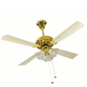**No4**.Crompton Uranus 48" Ivory Ceiling Fans

Selling Price: Rs. 6344

You Save: Rs. 1586.00 (20.00%)

(Price Inclusive of GST)

* MULTI-SPEED REVERSIBLE FAN MOTOR: Whisper Wind motor delivers ultra-powerful airflow with quiet performance; Change the direction from downdraft mode during the summer to updraft mode during the winter
* LED LIGHT KIT: Energy-efficient dimmable LED light bulbs let you control the lighting and ambiance of the living space; The long lasting bulbs have longer lifespan than traditional bulbs
* PULL CHAIN CONTROL: Turn the white ceiling fan on/off and adjust the speed quickly and easily with the pull chain
* ROOM PLACEMENT: Indoor fan is designed to be used in rooms with low ceilings, the low-profile housing fits flush to the ceiling; Ideal fan for living room, lounge, bedroom, children's room and nursery

**PRODUCT SPECIFICATION**

|  |  |
| --- | --- |
| **Brand** | Crompton |
| **Product Category** | Underlight |
| **Model Name** | Uranus |
| **Sweep** | 1200 mm (48") |
| **Power** | 72 W |
| **Voltage** | 240 V |
| **R.P.M.** | 320 |
| **Air Capacity/Air Delivery (C.F.M.)** | 7062.93 |
| **Air Capacity/Air Delivery (M3H)** | 12000 |
| **No of Blade** | 4 |
| **Height of Rod** | 9"-11" |
| **Package Contents** | 1 Rod, 4 Blades, 1 Motor, 1 Ceiling Cap, Warranty Card, Manual |
| **Suitable For** | Indoor/Outdoor |
| **Warranty** | 3 Years on motor |

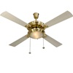**No5.** Usha Fontana One Gold Ivory 51" Ceiling Fans

Selling Price: Rs. 7600

You Save: Rs. 500.00 (6.17%)

(Price Inclusive of GST)

* Wide tip blades for high air delivery and air spread.
* Separate chain cords for light and speed controls.
* Stylish high gloss electroplated motor with removable under light.
* Superior high permeability grade electric steel lamination for improved life.
* Performs well even at low voltage.
* 3 speed pull cord control fpr speed regulation.
* Available in 1270mm (51”) sweep.

**PRODUCT SPECIFICATION**

|  |  |
| --- | --- |
| **Brand** | Usha |
| **Product Category** | Underlight |
| **Model Name** | Fontana One |
| **Sweep** | 1270 mm (51") |
| **Power** | 70 W |
| **Voltage** | 240 V |
| **R.P.M.** | 310 |
| **Air Capacity/Air Delivery (C.F.M.)** | 7239.5 |
| **Air Capacity/Air Delivery (M3H)** | 12300 |
| **No of Blade** | 4 |
| **Height of Rod** | 9"-11" |
| **Material** | Grade Electric Steel |
| **Suitable For** | Indoor |
| **Warranty** | 2 Years on motor |

# No5. Crompton Aura Designer 2D 48" Pearl White Ceiling Fans

Selling Price: Rs. 3962

You Save: Rs. 1118.00 (22.01%)

(Price Inclusive of GST)

* CEILING FAN ONLY: The contemporary Dempsey mounted fan does not include any light, and comes with blonde oak/fresh white reversible blades only that will keep home interior and exterior current and inspired; Measures 52 x 52 x 11 Inch
* Rated for indoor spaces only, Includes Handheld Remote for easy speed and lighting adjustment from anywhere in the room
* 13 degree blade pitch optimized to ensure ideal air movement and peak performance and Reversible, 3-speed WhisperWind motor delivers ultra-powerful air movement with whisper-quiet performance so you get the cooling power you want without the noise you don't

**PRODUCT SPECIFICATION**

|  |  |
| --- | --- |
| **Brand** | Crompton |
| **Product Category** | Decorative |
| **Model Name** | Aura |
| **Colour** | White |
| **Sweep** | 1200 mm (48") |
| **Power** | 74 W |
| **Voltage** | 240 V |
| **R.P.M.** | 380 |
| **Air Capacity/Air Delivery (C.F.M.)** | 8122.37 |
| **Air Capacity/Air Delivery (M3H)** | 13800 |
| **No of Blade** | 3 |
| **Height of Rod** | 9"-11" |
| **Package Contents** | 1 Rod, 3 Blades, 1 Motor, 1 Ceiling Cap, Manual, Warranty Card |
| **Material** | Iron |
| **Suitable For** | Indoor/Outdoor |
| **Warranty** | 5 Years on motor |

# 2. PEDESTAL FANS

* Standing Fans are fans used on a flat surface such as the floor. The fan is designed to create horizontal airflow.The fan usually has 3 wind speeds adjusted by the button on the fan body.
* The standing fan moves flexibly to the position of use. Designed higher than the table fan, creating a much larger cooling range. Another advantage is that it can be disassembled and cleaned very conveniently, this helps people use save time cleaning
* List of products:

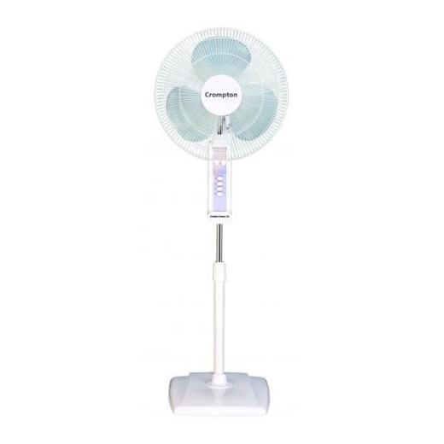**No1**.Crompton High Flo Wave Plus Pedestal Fan

Selling Price: Rs. 2860

You Save: Rs. 760.00 (20.99%)

(Price Inclusive of GST)

* The 16 inch Crompton Supreme Oscillating Stand Fan with Remote is made to serve any home, greenhouse or shop's air movement needs; conveniently control speed and oscillation with the included battery-powered remote
* 4-SPEEDS: This quiet, yet powerful, 4-speed motor fan runs at 1201 CFM and 1350 RPM; provides 90° side-to-side oscillation or can be locked in non-oscillating position
* DURABLE & SAFE: The sturdy base provided additional stability for the fan during its operation. The built-in overheat protection automatically switches the fan off when the motor overheats.

**PRODUCT SPECIFICATION**

|  |  |
| --- | --- |
| **Brand** | Crompton |
| **Product Category** | Domestic Pedestal Fans |
| **Model Name** | High Flo Wave |
| **Sweep** | 400 mm (16") |
| **Power** | 60 W |
| **Voltage** | 240 V |
| **R.P.M.** | 1350 |
| **Air Capacity/Air Delivery (C.F.M.)** | 3002 |
| **Air Capacity/Air Delivery (M3H)** | 5100 |
| **Speed Setting** | 3 |
| **No of Blade** | 3 |
| **Package Contents** | 1 Fan, Manual, Warranty Card |
| **Suitable For** | Indoor/Outdoor |
| **Warranty** | 3 Years on motor |

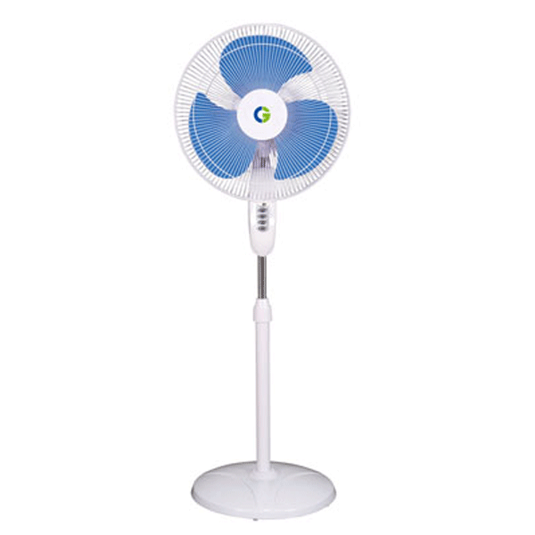**No2.** Crompton Wind Flo (Hi-Speed) Pedestal Fan

Selling Price: Rs. 3375

You Save: Rs. 375.00 (10.00%)

(Price Inclusive of GST)

* NEW VERSION: Upgraded Pelonis pedestal fan is equipped with a more powerful motor and high-quality blades, it makes cooling more efficient and energy-saving. This standing fan with 3 speed settings and 7-hour timer with Auto Shut-off for wide area cooling in medium to large rooms. It generates strong airflow to boost the cooling effect while operating at a low noise level in any room in your home.
* WIDE ANGLE OSCILLATION: The 85° wide oscillation angle provides versatility for personal or the entire family's use. The direction of the airflow could aim anywhere between the floor and the ceiling through tilting the angle of fan head. The wide-angle oscillation can accelerate air circulation and quickly cool the room in your home helping to increase your comfort.
* ADJUSTABLE & EASY TO USE: The user-friendly front operation panel and remote control makes it possible to obtain full range control over our product, and provides a unique and customizable experience. The height of the fan can be adjusted between 3.5 to 4 feet and the tilt-back head allows you direct the airflow where you need it to provide comfort throughout your home or office.

**PRODUCT SPECIFICATION**

|  |  |
| --- | --- |
| **Brand** | Crompton |
| **Product Category** | Domestic Pedestal Fans |
| **Model Name** | Windflo |
| **Sweep** | 400 mm (16") |
| **Power** | 110 W |
| **Voltage** | 240 V |
| **R.P.M.** | 1900 |
| **Air Capacity/Air Delivery (C.F.M.)** | 3002 |
| **Air Capacity/Air Delivery (M3H)** | 5100 |
| **Speed Setting** | 3 |
| **No of Blade** | 3 |
| **Package Contents** | 1 Fan, Manual, Warranty Card |
| **Suitable For** | Indoor/Outdoor |
| **Warranty** | 3 Years on motor |

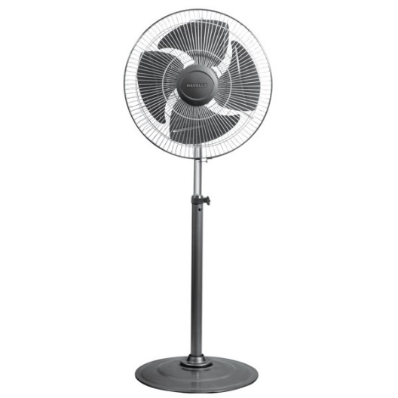**No3.** Havells Windstorm 18" Black Industrial Pedestal Fans

Selling Price: Rs. 3693

You Save: Rs. 552.00 (13.00%)

(Price Inclusive of GST)

* ULTRA QUIET & ENERGY EFFICIENCY: Equipped with DC silent motor, the Pelonis pedestal fan is engineered for quiet operation (as low as 38 dB) which is less than half as loud as most standard fans. It is perfect for your bedroom or nursing room. The DC motor also offers greater energy efficiency and save up to 35% of the energy cost than its AC counterpart
* POWERFUL WIND & WIDE OSCILLATION ANGLE: 12 speed settings and 12-hour timer design allow you to customize your breeze needs in your house, living room and office. With 5 high-quality blades and a strong motor, this Pelonis oscillation fan could provide strong wind to boost the cooling effect when using with air conditioner. The 85° oscillation angle and 24° tilt angle will extend wind the coverage to every corner of the room
* SAFETY FIRST: The big and heavy-duty base could provide additional stability for the fan during its operation. The built-in overheat protection would automatically switch off the fan when the motor overheats. The kid friendly safety grid will create a safe and cool environment for every member of the family

**PRODUCT SPECIFICATION**

|  |  |
| --- | --- |
| **Brand** | Havells |
| **Product Category** | Industrial Pedestal Fans |
| **Model Name** | Windstrom |
| **Sweep** | 450 mm (18") |
| **Power** | 190 W |
| **Voltage** | 240 V |
| **R.P.M.** | 1350 |
| **Air Capacity/Air Delivery (C.F.M.)** | 4550 |
| **Air Capacity/Air Delivery (M3H)** | 7800 |
| **No of Blade** | 3 |
| **Suitable For** | Indoor/Outdoor |
| **Warranty** | 2 Years on motor |

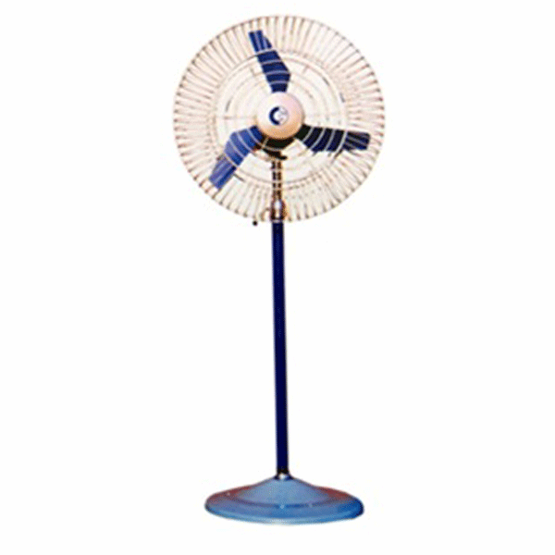**No4**. Crompton 450 mm Industrial Pedestal Air Circulator Fans

Selling Price: Rs. 6999

You Save: Rs. 1861.00 (21.00%)

(Price Inclusive of GST)

* High Velocity Air Circulator - With a heavy duty 3-speed motor making our High-Power fan the most powerful Pedestal Standing Fan on the market. It came with Simple Deluxe Newest Technology of Dual Ball Bearing while most of the other competitors on the market are using Sleeve Bearing.
* 3 Adjustable Speeds: Different speeds make our pedestal fan ideal for different places. There are low, medium and high wind speed for you to choose according to different situations and temperature. Different wind speeds make our pedestal fan ideal for many places like office, home and so on.
* Stable and Safe Performance : Sealed motor housing protects the motor from workshop debris and all other dust. Simple Deluxe' s new technology reduces the noise level by 40% making it one of the quietest fan on the market. dB Levels of Sounds – Less than 60db.
* Stable and Safe Performance : Sealed motor housing protects the motor from workshop debris and all other dust. Simple Deluxe' s ne
* technology reduces the noise level by 40% making it one of the quietest fan on the market. dB Levels of Sounds – Less than 60db.

**PRODUCT SPECIFICATION**

|  |  |
| --- | --- |
| **Brand** | Crompton |
| **Product Category** | Industrial Pedestal Fans |
| **Model Name** | Pedestal Air Circulator |
| **Sweep** | 450 mm (18") |
| **Power** | 100 W |
| **Voltage** | 240 V |
| **R.P.M.** | 1440 |
| **Air Capacity/Air Delivery (C.F.M.)** | 4410 |
| **Air Capacity/Air Delivery (M3H)** | 7500 |
| **Speed Setting** | 3 |
| **No of Blade** | 3 |
| **Package Contents** | 1 Fan, Manual, Warranty Card |
| **Suitable For** | Indoor/Outdoor |
| **Warranty** | 3 Years on motor |

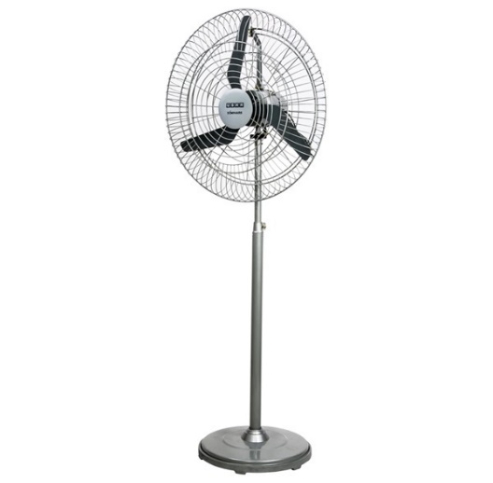**No5**. USHA Dominaire 750 mm Industrial Pedestal Air Circulator Fans

Selling Price: Rs. 9999

You Save: Rs. 981.00 (8.93%)

(Price Inclusive of GST)

* Aerodynamically designed aluminium alloy single piece blade for high air delivery
* Heavy duty motor performs well even at low voltage
* Heavy and robust cast iron base for greater stability
* Precision-built oscillating mechanism with indexing option and 90 degree oscillation
* Powder coated paint in metallic finish, protect the fan from corrosion
* Performance confirms to IS: 2997-1964 standard
* Available in 450,600 & 750 mm sweeps

**PRODUCT SPECIFICATION**

|  |  |
| --- | --- |
| **Brand** | Almonard |
| **Product Category** | Industrial Pedestal Fans |
| **Model Name** | Tempest |
| **Sweep** | 750 mm (30") |
| **Power** | 250 W |
| **Voltage** | 240 V |
| **R.P.M.** | 1400 |
| **Air Capacity/Air Delivery (C.F.M.)** | 13867 |
| **Air Capacity/Air Delivery (M3H)** | 23584 |
| **Speed Setting** | 3 |
| **No of Blade** | 3 |
| **Material** | Aluminium Alloy |
| **Package Contents** | 1 Fan, Manual, Warranty Card |
| **Suitable For** | Indoor/Outdoor |
| **Warranty** | 3 Years on motor |