**Switches & Automation**

**1. Modular Switches**

* Switches are the most prominent electrical accessory that we see in a house. Technically a switch is an electrical component that can break electrical circuit by interrupting the current or diverting it from one conductor to another. There are different types of electrical switches based on Current (Ampere) rating varying for 6A to 32A. Today modular switches are available in different colours and designs to go with our modular home or office.
* List of products:

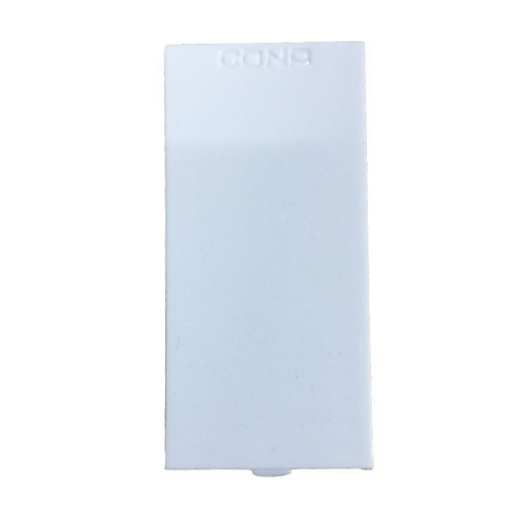**No1:** Cona Status 1M Blank Plate

Selling Price: Rs. 15

You Save: Rs. 8.00 (34.78%)

(Price Inclusive of GST)

Discover a whole new complete solution for all your electrical needs with customer centric CONA products.

**PRODUCT SPECIFICATION**

|  |  |
| --- | --- |
| **Brand** | Cona |
| **Product Category** | Blank Plate |
| **Series** | Cona Status |
| **Colour** | White |
| **Warranty** | 2 Years (against manufacturing defects) |
| **Material** | Polycarbonate |

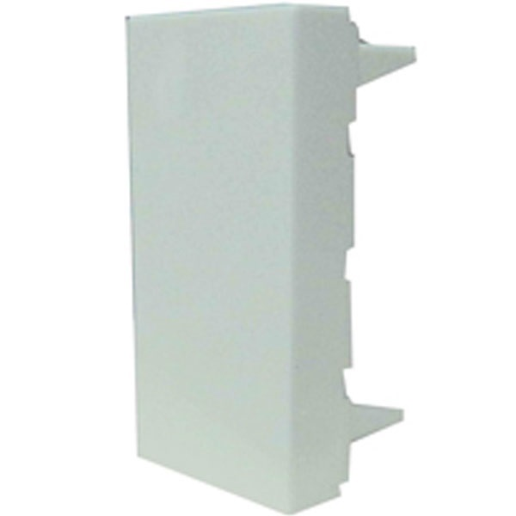**No.2:** Legrand Arteor 573449 1M White Blank Plates

Selling Price: Rs. 24

You Save: Rs. 26.00 (52.00%)

(Price Inclusive of GST)

Arteor is an innovative solution for modern buildings all over the world.

**PRODUCT SPECIFICATION**

|  |  |
| --- | --- |
| **Brand** | Legrand |
| **Product Category** | Blank Plate |
| **Series** | Legrand Arteor |
| **No. of Modules** | 1 Module |
| **Colour** | White |
| **Material** | Polycarbonate |
| **Warranty** | 1 Year (against manufacturing defects) |

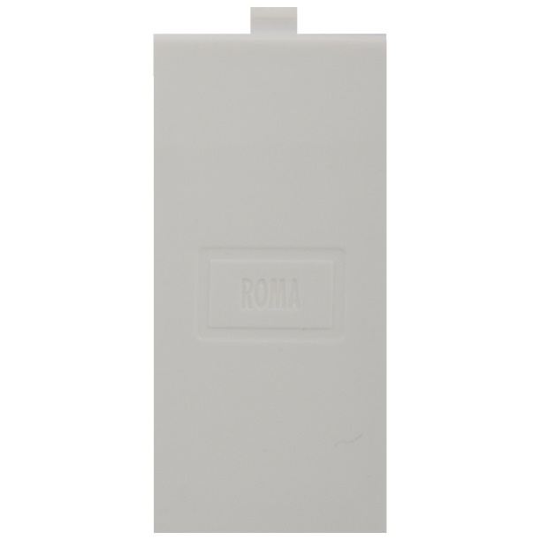**No3:** Legrand Mylinc 675590 1M Blank Plate

Selling Price: Rs. 24

You Save: Rs. 18.00 (42.86%)

(Price Inclusive of GST)

Clear uncluttered modular design with more space for wiring.

**PRODUCT SPECIFICATION**

|  |  |
| --- | --- |
| **Brand** | Legrand |
| **Product Category** | Blank Plate |
| **Series** | Legrand Mylinc |
| **No. of Modules** | 1 Module |
| **Colour** | White |
| **Material** | Polycarbonate |
| **Warranty** | 1 Year (against manufacturing defects) |

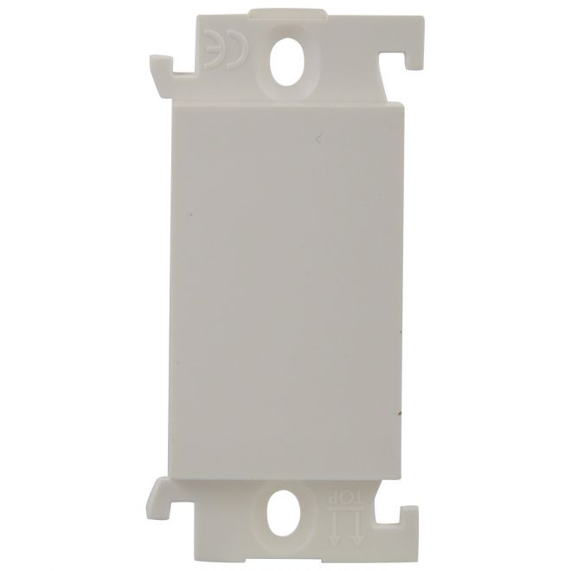**No4:** Anchor Roma 21598 Blank Plate

Selling Price: Rs. 25

You Save: Rs. 7.00 (21.88%)

(Price Inclusive of GST)

Specialty range available for residential, commercial and hospitality use

**PRODUCT SPECIFICATION**

|  |  |
| --- | --- |
| **Brand** | Anchor |
| **Product Category** | Blank Plate |
| **Series** | Anchor Roma |
| **No. of Modules** | 1 Module |
| **Colour** | White |
| **Material** | Polycarbonate |
| **Warranty** | 1 Year (against manufacturing defects) |

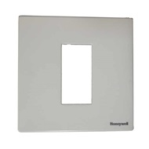**No5:** MK Citric CW441WHI 1M Blank Plate

Selling Price: Rs. 26

You Save: Rs. 14.00 (35.00%)

(Price Inclusive of GST)

MK modular switches are stylish, appealing and designed to complement the interiors of the home and office as well. Its versatile design makes it a good fit for every design and people wish to opt for. People in the process of building new homes, or renovating their existing homes can shortlist this range of products.

**PRODUCT SPECIFICATION**

|  |  |
| --- | --- |
| **Brand** | MK |
| **Product Category** | Blank Plate |
| **Series** | MK Citric |
| **No. of Modules** | 1 Module |
| **Colour** | White |
| **Material** | Polycarbonate |
| **Warranty** | 1 Year (against manufacturing defects) |

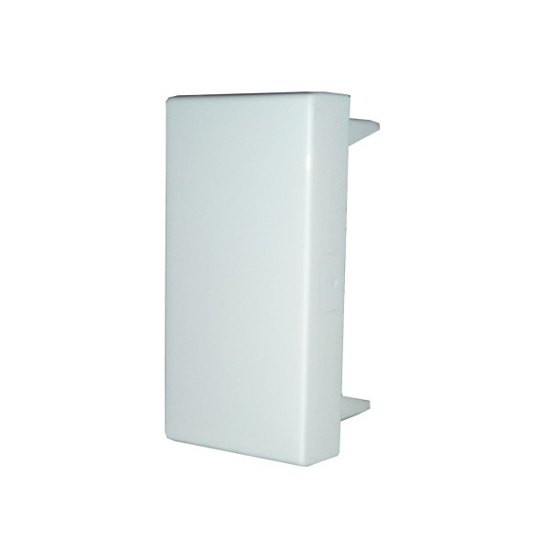**NO6:** Legrand Mosiac 674591 1M Blank Plate

Selling Price: Rs. 26

You Save: Rs. 20.00 (43.48%)

(Price Inclusive of GST)

Legrand is a French company that specializes in electrical and digital building infrastructure and thrives with the objective of energizing every household

**PRODUCT SPECIFICATION**

|  |  |
| --- | --- |
| **Brand** | Legrand |
| **Product Category** | Blank Plate |
| **Series** | Legrand Mosiac |
| **No. of Modules** | 1 Module |
| **Colour** | White |
| **Material** | Polycarbonate |
| **Warranty** | 1 Year (against manufacturing defects) |

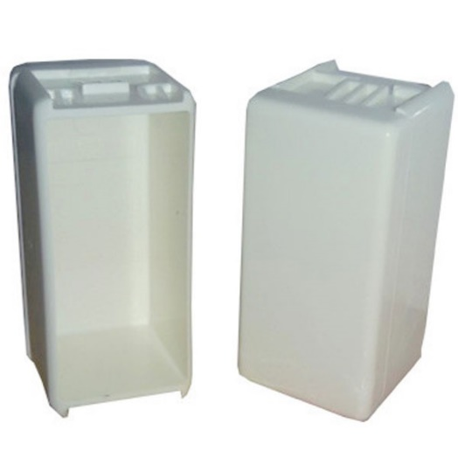**no.7** C&S Waterproof Blank Plate

Selling Price: Rs. 27

You Save: Rs. 5.00 (15.63%)

(Price Inclusive of GST)

Wall-mounting enclosures and modular components

**PRODUCT SPECIFICATION**

|  |  |
| --- | --- |
| **Brand** | C&S |
| **Product Category** | Blank Plate |
| **No. of Modules** | 1 Module |
| **Colour** | White |
| **Material** | Polycarbonate |
| **Warranty** | 1 Year (against manufacturing defects) |

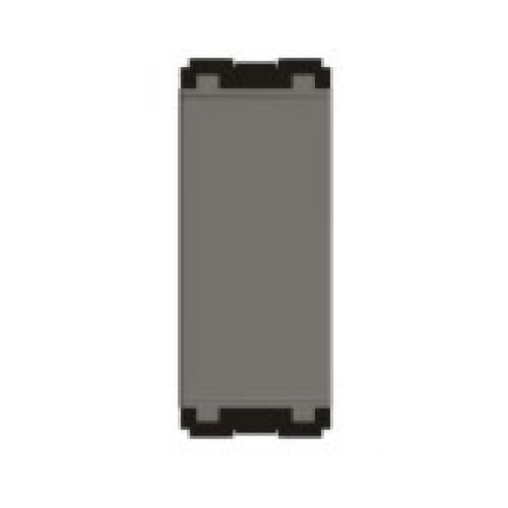**No.8:** Norisys Cube C5700.01 Blank Plate

Selling Price: Rs. 27

You Save: Rs. 20.00 (42.55%)

(Price Inclusive of GST)

CUBE Series marks the evolution of Norisys' research as it once again focuses on engineering design

**PRODUCT SPECIFICATION**

|  |  |
| --- | --- |
| **Brand** | Norisys |
| **Product Category** | Blank Plate |
| **Series** | Norisys Cube |
| **No. of Modules** | 1 Module |
| **Colour** | White |
| **Material** | Polycarbonate |
| **Warranty** | 1 Year (against manufacturing defects) |

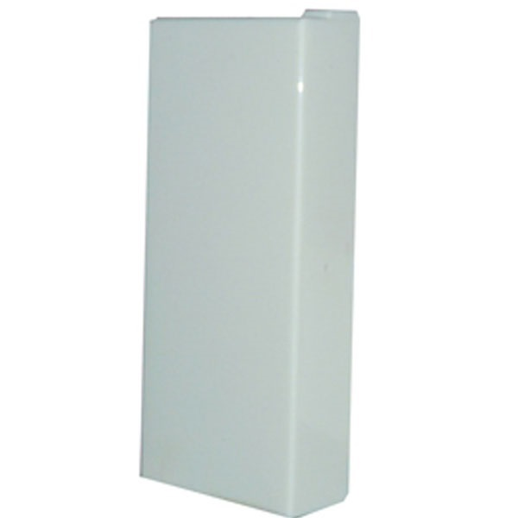**NO9:** ABB Blank Plate

Selling Price: Rs. 27

You Save: Rs. 23.00 (46.00%)

(Price Inclusive of GST)

Fire retardant, Generator friendly

**PRODUCT SPECIFICATION**

|  |  |
| --- | --- |
| **Brand** | ABB |
| **Product Category** | Blank Plate |
| **Series** | ABB Snieo |
| **No. of Modules** | 1 Module |
| **Colour** | White |
| **Material** | Polycarbonate |
| **Warranty** | 1 Year (against manufacturing defects) |

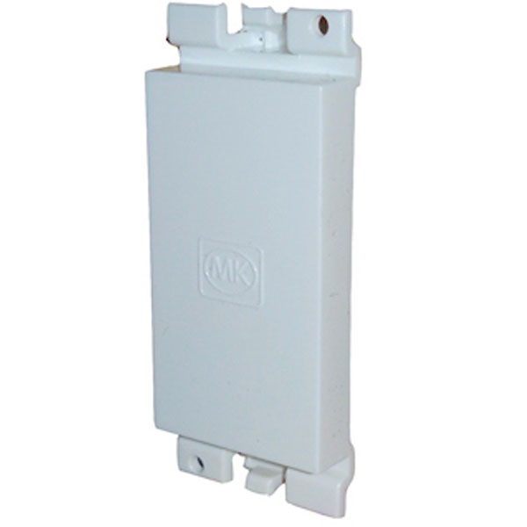**NO10:** MK Blenze DW441WHI 1M White Blank Plate

Selling Price: Rs. 27

You Save: Rs. 21.00 (43.75%)

(Price Inclusive of GST)

MK modular switches are stylish, appealing and designed to complement the interiors of the home and office as well. Its versatile design makes it a good fit for every design and people wish to opt for. People in the process of building new homes, or renovating their existing homes can shortlist this range of products.

**PRODUCT SPECIFICATION**

|  |  |
| --- | --- |
| **Brand** | MK |
| **Product Category** | Blank Plate |
| **Series** | MK Blenze |
| **No. of Modules** | 1 Module |
| **Colour** | White |
| **Material** | Polycarbonate |
| **Warranty** | 1 Year (against manufacturing defects) |

**NO11:** Legrand Arteor 573649 1M Magnesium Blank Plates

Selling Price: Rs. 27

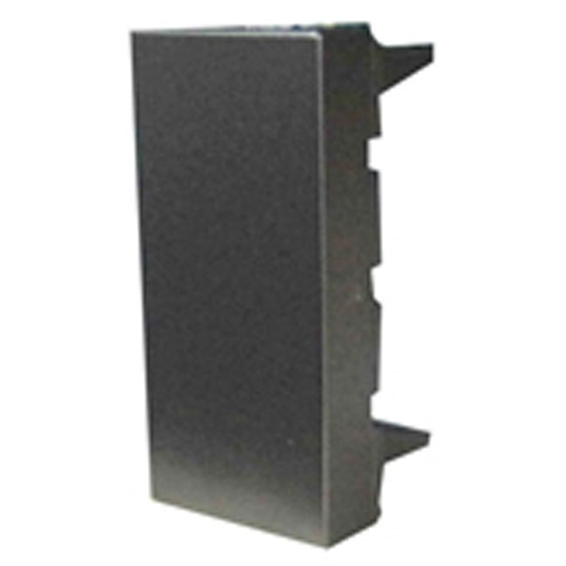You Save: Rs. 23.00 (46.00%)

(Price Inclusive of GST)

Legrand is a French company that specializes in electrical and digital building infrastructure and thrives with the objective of energizing every household

**PRODUCT SPECIFICATION**

|  |  |
| --- | --- |
| **Brand** | Legrand |
| **Product Category** | Blank Plate |
| **Series** | Legrand Arteor |
| **No. of Modules** | 1 Module |
| **Colour** | Magnesium |
| **Material** | Polycarbonate |
| **Warranty** | 1 Year (against manufacturing defects) |

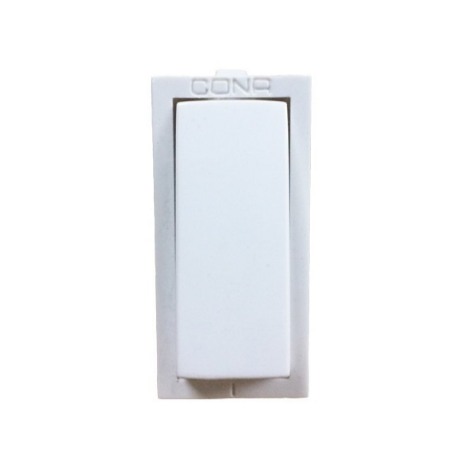**NO.12:** Cona Status 6A One Way Switch

Selling Price: Rs. 31

You Save: Rs. 17.00 (35.42%)

(Price Inclusive of GST)

Discover a whole new complete solution for all your electrical needs with customer centric CONA products

**PRODUCT SPECIFICATION**

|  |  |
| --- | --- |
| **Brand** | Cona |
| **Product Category** | 6A Switches |
| **Series** | Cona Status |
| **No. of Modules** | 1 Module |
| **Switch Type** | 1 Way |
| **Voltage** | 240 V |
| **Colour** | White |
| **Material** | Polycarbonate |
| **Warranty** | 2 Years (against manufacturing defects) |

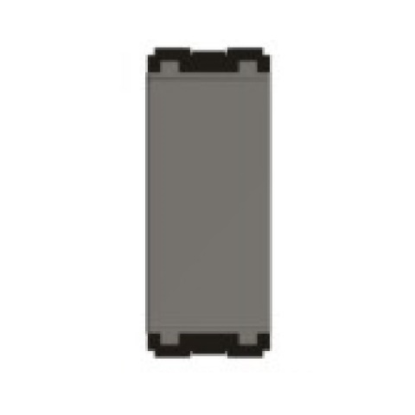**NO13:** Norisys Cube C5700.02 Grey Blank Plate

Selling Price: Rs. 33

You Save: Rs. 25.00 (43.10%)

(Price Inclusive of GST)

CUBE Series marks the evolution of Norisys' research as it once again focuses on engineering design

**PRODUCT SPECIFICATION**

|  |  |
| --- | --- |
| **Brand** | Norisys |
| **Product Category** | Blank Plate |
| **Series** | Norisys Cube |
| **No. of Modules** | 1 Module |
| **Colour** | Grey |
| **Material** | Polycarbonate |
| **Warranty** | 1 Year (against manufacturing defects) |

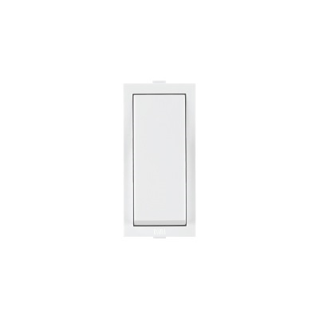**NO14:** Anchor Roma 21011 6A One Way Switch

Selling Price: Rs. 52

You Save: Rs. 15.00 (22.39%)

(Price Inclusive of GST)

Roma 1-Way Switch 21011 Switches used in residential, commercial and hospitality use

**PRODUCT SPECIFICATION**

|  |  |
| --- | --- |
| **Brand** | Anchor |
| **Product Category** | 6A Switches |
| **Series** | Anchor Roma |
| **No. of Modules** | 1 Module |
| **Switch Type** | 1 Way |
| **Voltage** | 230 V |
| **Colour** | White |
| **Material** | Polycarbonate |
| **Warranty** | 2 Years (against manufacturing defects) |

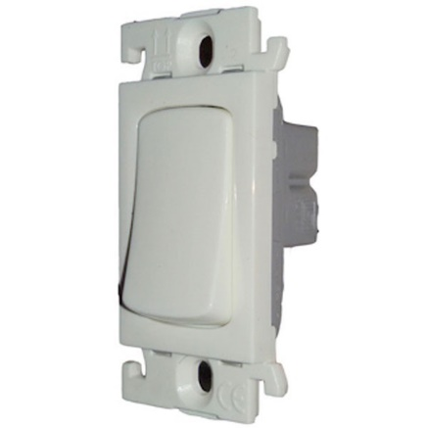**NO15:** Legrand Mylinc 675501 6A One Way Switch

Selling Price: Rs. 54

You Save: Rs. 42.00 (43.75%)

(Price Inclusive of GST)

Clear uncluttered modular design with more space for wiring.

**PRODUCT SPECIFICATION**

|  |  |
| --- | --- |
| **Brand** | Legrand |
| **Product Category** | 6A Switches |
| **Series** | Legrand Mylinc |
| **No. of Modules** | 1 Module |
| **Switch Type** | 1 Way |
| **Voltage** | 230 V |
| **Colour** | White |
| **Material** | Polycarbonate |
| **Warranty** | 2 Years (against manufacturing defects) |

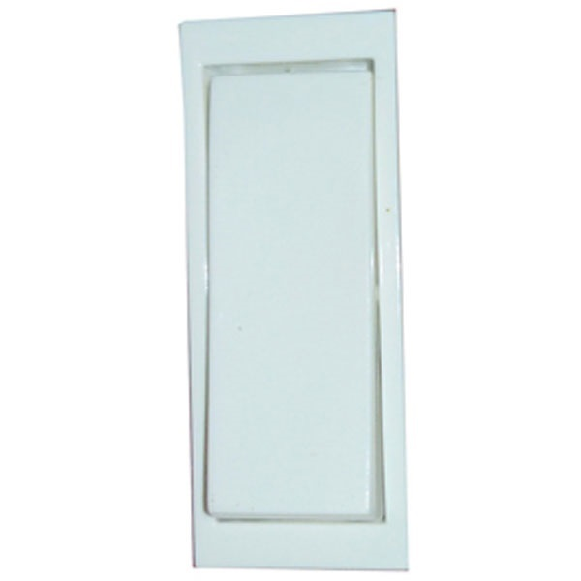**NO.16:** MK Wraparound W26401A 6A One Way White Switch

Selling Price: Rs. 62

You Save: Rs. 50.00 (44.64%)

(Price Inclusive of GST)

MK modular switches are stylish, appealing and designed to complement the interiors of the home and office as well

**PRODUCT SPECIFICATION**

|  |  |
| --- | --- |
| **Brand** | MK |
| **Product Category** | 6A Switches |
| **Series** | MK Wraparound |
| **No. of Modules** | 1 Module |
| **Switch Type** | 1 Way |
| **Voltage** | 230 V |
| **Colour** | White |
| **Material** | Polycarbonate |
| **Warranty** | 2 Years (against manufacturing defects) |

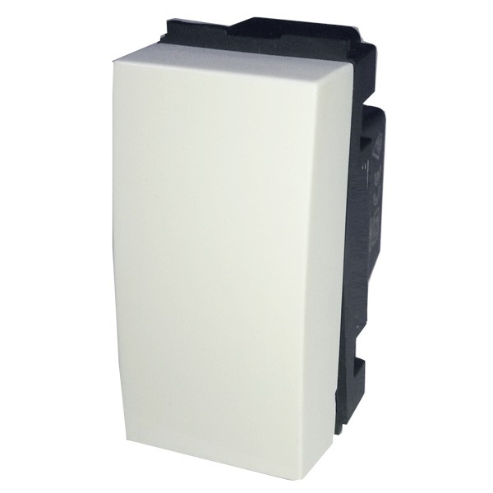**NO17:** GM AA1001 10A One Way White Switch

Selling Price: Rs. 61

You Save: Rs. 9.00 (12.86%)

(Price Inclusive of GST)

Modular type flush mounting, Requires electrician for installation.

**PRODUCT SPECIFICATION**

|  |  |
| --- | --- |
| **Brand** | GM |
| **Product Category** | 6A Switches |
| **Series** | GM FOURFIVE |
| **No. of Modules** | 1 Module |
| **Switch Type** | 1 Way |
| **Voltage** | 240 V |
| **Colour** | White |
| **Material** | Polycarbonate |
| **Warranty** | 2 Years (against manufacturing defects) |

**NO.18:** GM AA1401 6A One Way White Switch

Selling Price: Rs. 61

You Save: Rs. 9.00 (12.86%)

(Price Inclusive of GST)

Modular type flush mounting, Requires electrician for installation.

**PRODUCT SPECIFICATION**

|  |  |
| --- | --- |
| **Brand** | GM |
| **Product Category** | 6A Switches |
| **Series** | GM FOURFIVE |
| **No. of Modules** | 1 Module |
| **Switch Type** | 1 Way |
| **Voltage** | 240 V |
| **Colour** | White |
| **Material** | Polycarbonate |
| **Warranty** | 2 Years (against manufacturing defects) |

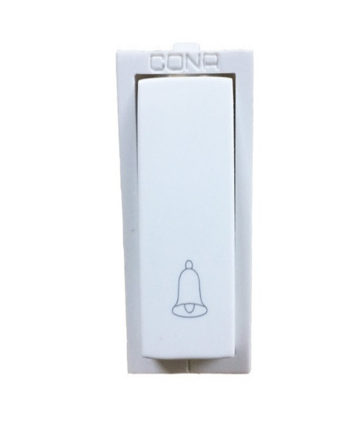**NO19:** Cona Status 6A Bell Push Switch

Selling Price: Rs. 64

You Save: Rs. 35.00 (35.35%)

(Price Inclusive of GST)

Modular type flush mounting, Requires electrician for installation.

**PRODUCT SPECIFICATION**

|  |  |
| --- | --- |
| **Brand** | Cona |
| **Product Category** | Bell Push |
| **Series** | Cona Status |
| **No. of Modules** | 1 Module |
| **Switch Type** | 1 Way |
| **Voltage** | 240 V |
| **Colour** | White |
| **Material** | Polycarbonate |
| **Warranty** | 2 Years (against manufacturing defects) |

**2. Modular Sockets**

* **Electrical socket** is a device where an electrical plug can be inserted to make a connection in a circuit. **Power socket** is used for higher currents like 16A or above and light sockets for standard 6A. For electronic objects like refrigerator a 16A Socket is recommend where for an Air Conditioner a heavier 25A or 32A power socket is used. A new socket available is 6A/13A International socket, which offers compatibility to Indian as well as International Gadgets plug tops.
* List of products:

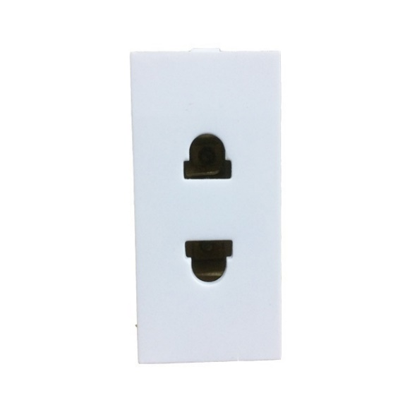**No**1.Cona Status 6A 2 Pin Multi Socket

Selling Price: Rs. 45

You Save: Rs. 24.00 (34.78%)

(Price Inclusive of GST)

Presenting STATUS series 2 pin Multi Socket 6A made from high quality Polycarbonate material with smooth finish and classic design and white that adds to the overall look of your house

**PRODUCT SPECIFICATION**

|  |  |
| --- | --- |
| **Brand** | Cona |
| **Product Category** | 6A Sockets |
| **Series** | Cona Status |
| **No. of Modules** | 1 Module |
| **Pins** | 2 Pins |
| **Colour** | White |
| **Voltage** | 240 V |
| **Material** | Polycarbonate |
| **Warranty** | 2 Years (against manufacturing defects) |

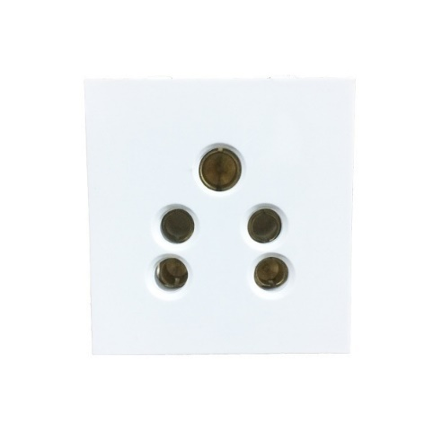**No2:** Cona Status 6A 2 in 1 Socket

Selling Price: Rs. 51

You Save: Rs. 27.00 (34.62%)

(Price Inclusive of GST)

It is easy to insert and withdraw with low power consumption.

**PRODUCT SPECIFICATION**

|  |  |
| --- | --- |
| **Brand** | Cona |
| **Product Category** | 6A Sockets |
| **Series** | Cona Status |
| **No. of Modules** | 2 Module |
| **Pins** | 5 Pins |
| **Colour** | White |
| **Voltage** | 240 V |
| **Material** | Polycarbonate |
| **Warranty** | 2 Years (against manufacturing defects) |

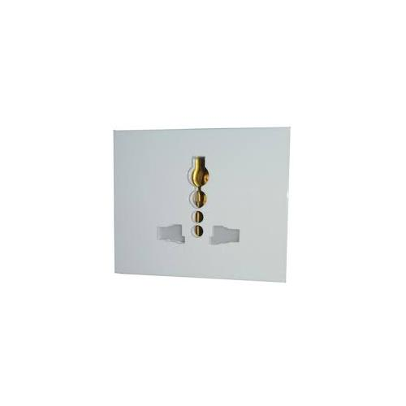

**No3:** MK Wraparound W26420 6A White Socket With Safety Shuter

Selling Price: Rs. 95

You Save: Rs. 27.00 (34.62%)

(Price Inclusive of GST)

MK modular switches are stylish, appealing and designed to complement the interiors of the home and office as well.

**PRODUCT SPECIFICATION**

|  |  |
| --- | --- |
| **Brand** | MK |
| **Product Category** | 6A Sockets |
| **Series** | MK Wraparound |
| **No. of Modules** | 2 Module |
| **Voltage** | 230 V |
| **Pins** | 2+3 Pins |
| **Colour** | White |
| **Material** | Polycarbonate |
| **Warranty** | 2 Years (against manufacturing defects) |

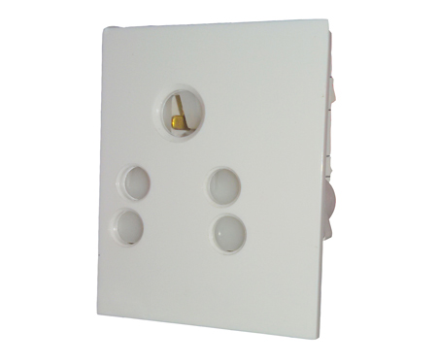**No4:** MK Wraparound W26423 6A White Shuttered Socket

Selling Price: Rs. 95

You Save: Rs. 77.00 (44.77%)

(Price Inclusive of GST)

MK modular switches are stylish, appealing and designed to complement the interiors of the home and office as well. Its versatile design makes it a good fit for every design and people wish to opt for. People in the process of building new homes, or renovating their existing homes can shortlist this range of products.

**PRODUCT SPECIFICATION**

|  |  |
| --- | --- |
| **Brand** | MK |
| **Product Category** | 6A Sockets |
| **Series** | MK Wraparound |
| **No. of Modules** | 2 Module |
| **Voltage** | 230 V |
| **Pins** | 2+3 Pins |
| **Colour** | White |
| **Material** | Polycarbonate |
| **Warranty** | 2 Years (against manufacturing defects) |

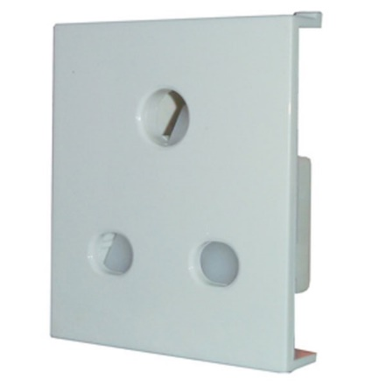**No5:** ABB 6A 3 Pin 2M Socket

Selling Price: Rs. 106

You Save: Rs. 94.00 (47.00%)

(Price Inclusive of GST)

Compatible with ABB Snieo modular frames only, Pack of 2 units.

**PRODUCT SPECIFICATION**

|  |  |
| --- | --- |
| **Brand** | ABB |
| **Product Category** | 6A Sockets |
| **Series** | ABB Snieo |
| **No. of Modules** | 2 Module |
| **Voltage** | 230 V |
| **Pins** | 3 Pins |
| **Colour** | White |
| **Material** | Polycarbonate |
| **Warranty** | 2 Years (against manufacturing defects) |

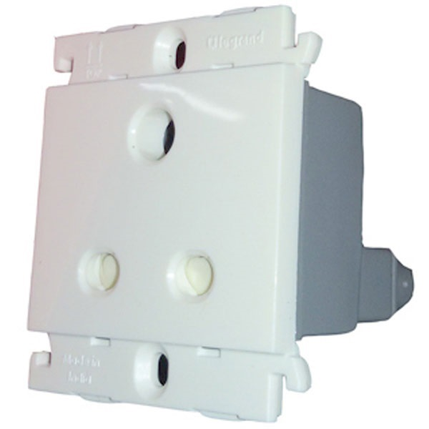**No6:** Legrand Mylinc 675550 6A 2+3 Pin Combined White Sockets

Selling Price: Rs. 107

You Save: Rs. 87.00 (44.85%)

(Price Inclusive of GST)

Clear uncluttered modular design with more space for wiring.

**PRODUCT SPECIFICATION**

|  |  |
| --- | --- |
| **Brand** | Legrand |
| **Product Category** | 6A Sockets |
| **Series** | Legrand Mylinc |
| **No. of Modules** | 2 Module |
| **Voltage** | 230 V |
| **Pins** | 3 Pins |
| **Colour** | White |
| **Material** | Polycarbonate |
| **Warranty** | 2 Years (against manufacturing defects) |

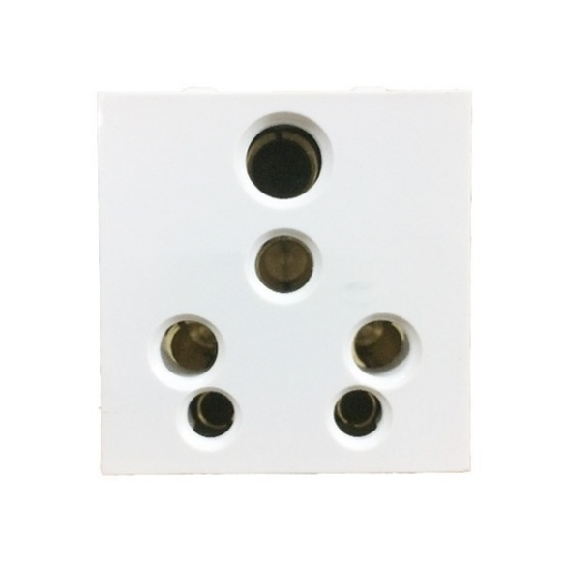**No7:** Cona Status 6-16A Universal Socket

Selling Price: Rs. 110

You Save: Rs. 59.00 (34.91%)

(Price Inclusive of GST)

Best Sellers Rank: #278,226 in Home Improvement

**PRODUCT SPECIFICATION**

|  |  |
| --- | --- |
| **Brand** | Cona |
| **Product Category** | 16A Sockets |
| **Series** | Cona Status |
| **No. of Modules** | 2 Module |
| **Pins** | 3 Pins |
| **Colour** | White |
| **Voltage** | 240 V |
| **Material** | Polycarbonate |
| **Warranty** | 2 Years (against manufacturing defects) |

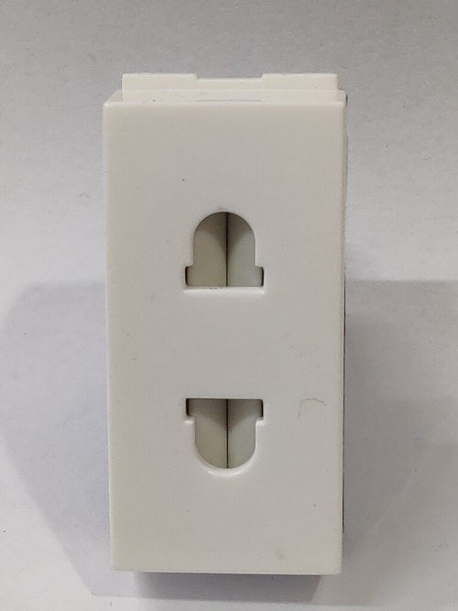**No8:** GM AA1028 6A 2 Pin White Socket

Selling Price: Rs. 112

You Save: Rs. 17.00 (13.18%)

(Price Inclusive of GST)

GM products and accessories are designed in a way to meet the contemporary luxuries of the world

**PRODUCT SPECIFICATION**

|  |  |
| --- | --- |
| **Brand** | GM |
| **Product Category** | 6A Sockets |
| **No. of Modules** | 1 Module |
| **Series** | GM FOURFIVE |
| **Pins** | 2 Pins |
| **Colour** | White |
| **Voltage** | 230 V |
| **Material** | Polycarbonate |
| **Warranty** | 1 Year (against manufacturing defects) |

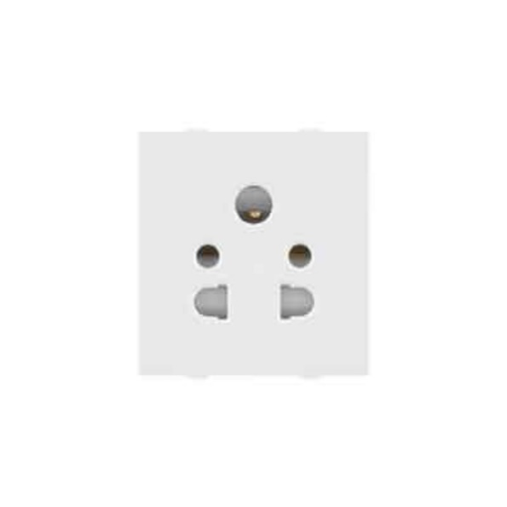**No9:** Anchor Roma 30373 6A 2+3 Pin Socket With Safety Shuter

Selling Price: Rs. 116

You Save: Rs. 35.00 (23.18%)

(Price Inclusive of GST)

**PRODUCT SPECIFICATION**

|  |  |
| --- | --- |
| **Brand** | Anchor |
| **Product Category** | 6A Sockets |
| **Series** | Anchor Roma |
| **No. of Modules** | 2 Module |
| **Voltage** | 230 V |
| **Pins** | 5 Pins |
| **Colour** | White |
| **Material** | Polycarbonate |
| **Warranty** | 2 Years (against manufacturing defects) |

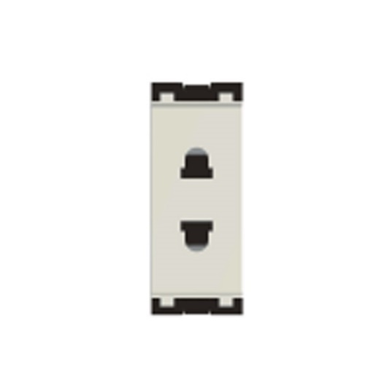**No10:** Norisys Cube C5010.01 6A 2 Pin Socket

Selling Price: Rs. 119

You Save: Rs. 90.00 (43.06%)

(Price Inclusive of GST)

**PRODUCT SPECIFICATION**

|  |  |
| --- | --- |
| **Brand** | Norisys |
| **Product Category** | 6A Sockets |
| **Series** | Norisys Cube |
| **No. of Modules** | 1 Module |
| **Pins** | 2 Pins |
| **Colour** | White |
| **Voltage** | 230 V |
| **Material** | Polycarbonate |
| **Warranty** | 2 Years (against manufacturing defects) |

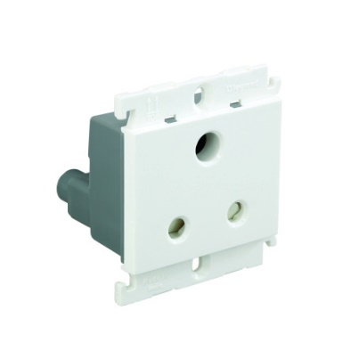

**No11:** Legrand Mylinc 675551 6A 3 Pin White Sockets

Selling Price: Rs. 119

You Save: Rs. 97.00 (44.91%)

(Price Inclusive of GST)

**PRODUCT SPECIFICATION**

|  |  |
| --- | --- |
| **Brand** | Legrand |
| **Product Category** | 6A Sockets |
| **Series** | Legrand Mylinc |
| **No. of Modules** | 2 Module |
| **Pins** | 3 Pins |
| **Voltage** | 230 V |
| **Colour** | White |
| **Material** | Polycarbonate |
| **Warranty** | 2 Years (against manufacturing defects) |

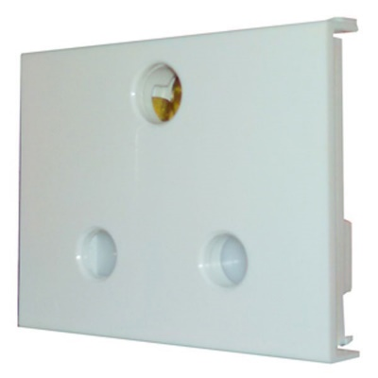**No12:** ABB 25A 3 Pin Socket

Selling Price: Rs. 130

You Save: Rs. 125.00 (49.02%)

(Price Inclusive of GST)

**PRODUCT SPECIFICATION**

|  |  |
| --- | --- |
| **Brand** | ABB |
| **Product Category** | 25A Sockets |
| **Series** | ABB Snieo |
| **No. of Modules** | 3 Module |
| **Voltage** | 230 V |
| **Pins** | 3 Pins |
| **Colour** | White |
| **Material** | Polycarbonate |
| **Warranty** | 2 Years (against manufacturing defects) |

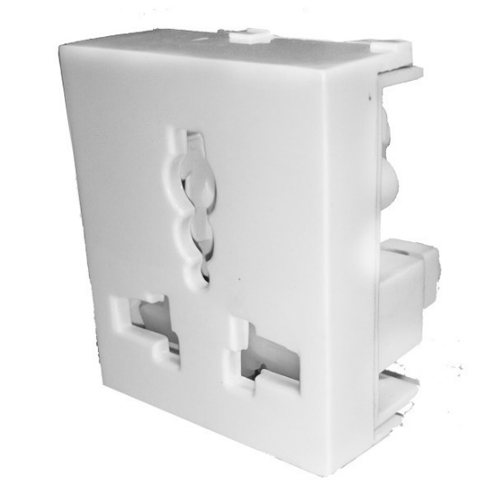**No13:** ABB 13A International Socket

Selling Price: Rs. 130

You Save: Rs. 125.00 (49.02%)

(Price Inclusive of GST)

Millenium offers high quality complete sets. Each unique reference contains mechanism, frame and mounting plate

**PRODUCT SPECIFICATION**

|  |  |
| --- | --- |
| **Brand** | ABB |
| **Product Category** | 13A Sockets |
| **Series** | ABB Snieo |
| **No. of Modules** | 2 Module |
| **Voltage** | 230 V |
| **Pins** | 3 Pins |
| **Colour** | White |
| **Material** | Polycarbonate |
| **Warranty** | 2 Years (against manufacturing defects) |

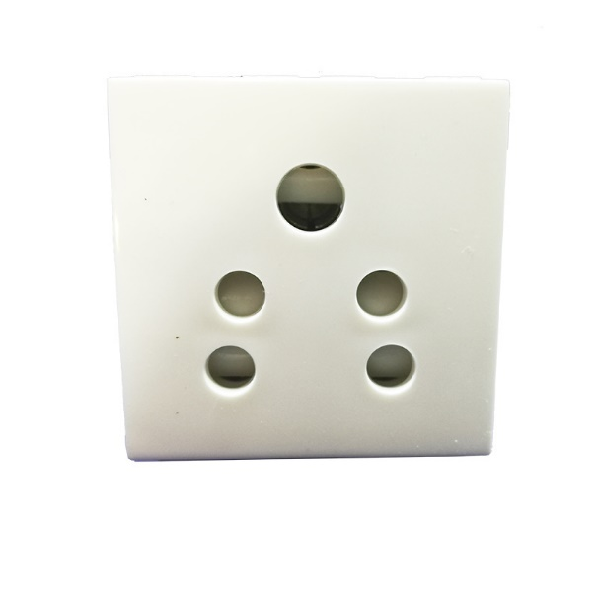

**No14:** GM AA2136 6A 2M 2 in 1 White Socket

Selling Price: Rs. 131

You Save: Rs. 20.00 (13.25%)

(Price Inclusive of GST)

**PRODUCT SPECIFICATION**

|  |  |
| --- | --- |
| **Brand** | GM |
| **Product Category** | 6A Sockets |
| **Series** | GM FOURFIVE |
| **No. of Modules** | 2 Module |
| **Voltage** | 230 V |
| **Pins** | 5 Pins |
| **Colour** | White |
| **Warranty** | 1 Year (against manufacturing defects) |

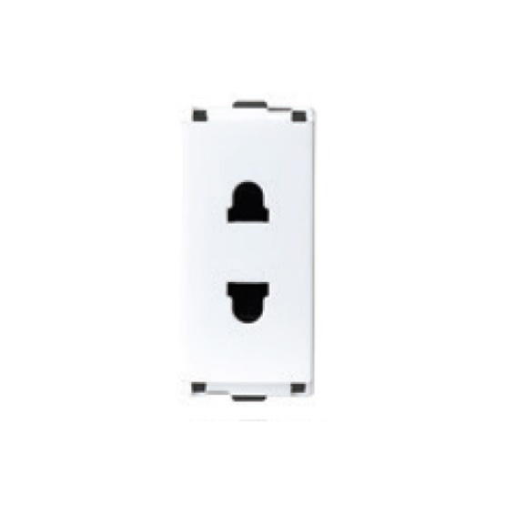**No15:** L&T Englaze CB92101CW06 6A 2Pin 1M Snow White Socket

Selling Price: Rs. 138

You Save: Rs. 113.00 (45.02%)

(Price Inclusive of GST)

**PRODUCT SPECIFICATION**

|  |  |
| --- | --- |
| **Brand** | L&T |
| **Product Category** | 6A Sockets |
| **Series** | L&T Englaze |
| **No. of Modules** | 1 Module |
| **Voltage** | 230 V |
| **Colour** | White |
| **Material** | Polycarbonate |
| **Warranty** | 2 Years (against manufacturing defects) |

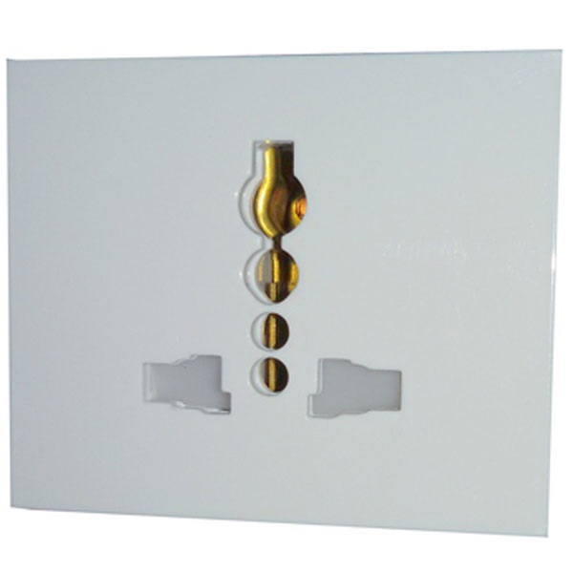**No16:** MK Wraparound W26426 6A-13A White Socket

Selling Price: Rs. 141

You Save: Rs. 115.00 (44.92%)

(Price Inclusive of GST)

MK modular switches are stylish, appealing and designed to complement the interiors of the home and office as well. Its versatile design makes it a good fit for every design and people wish to opt for. People in the process of building new homes, or renovating their existing homes can shortlist this range of products.

**PRODUCT SPECIFICATION**

|  |  |
| --- | --- |
| **Brand** | MK |
| **Product Category** | 13A Sockets |
| **Series** | MK Wraparound |
| **No. of Modules** | 3 Module |
| **Voltage** | 230 V |
| **Pins** | 3 Pins |
| **Colour** | White |
| **Material** | Polycarbonate |
| **Warranty** | 2 Years (against manufacturing defects) |