**PROGRAMING THE FPGA BOARD**

1/ **Tools 🡪 Programmer**

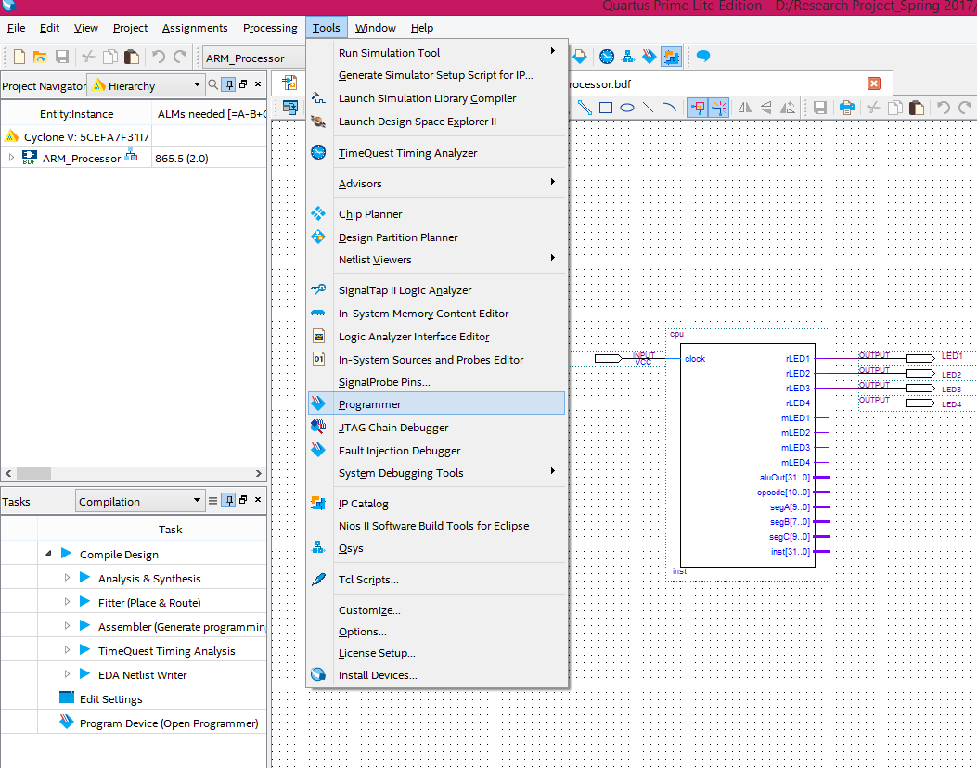

2/ When the new windows pop up, click on **Hardware Setup**

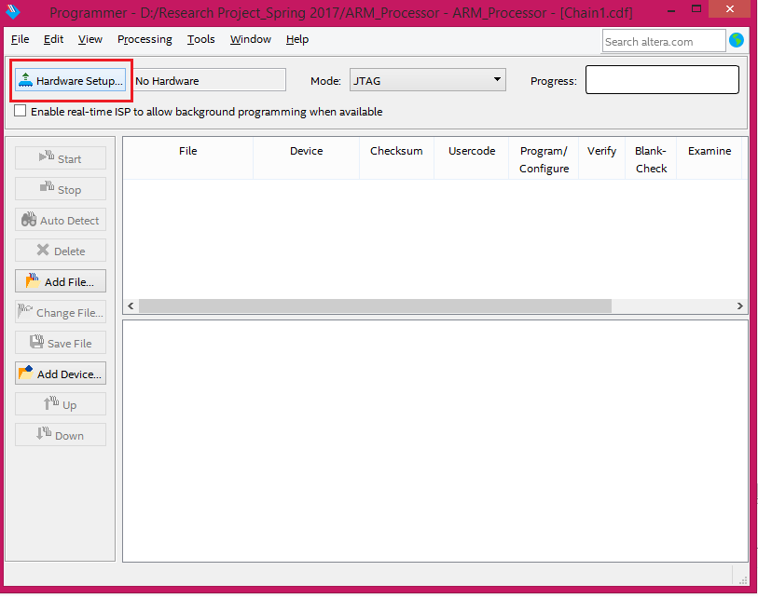

3/ Make sure **USB-BlasterII** is selected, then click Close

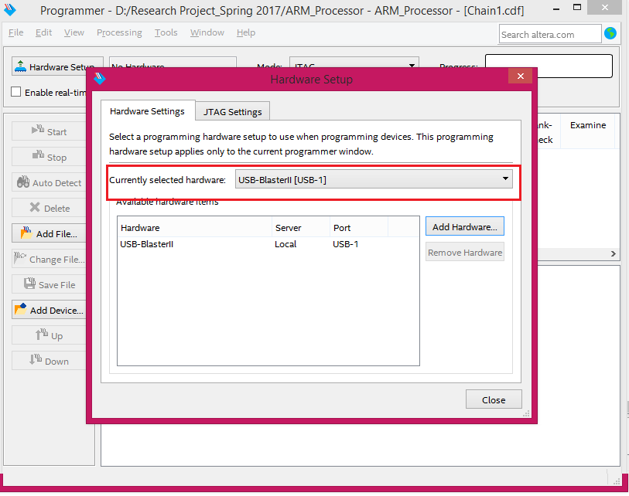

4/ On the left side, click on **Auto Detect**, and then select **5CEFA7**

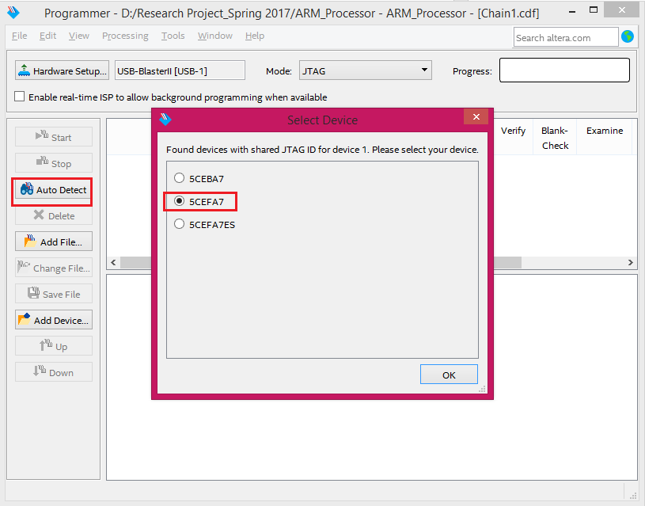

5/ Left click on the **5M221OZ** to select it and then press Delete key

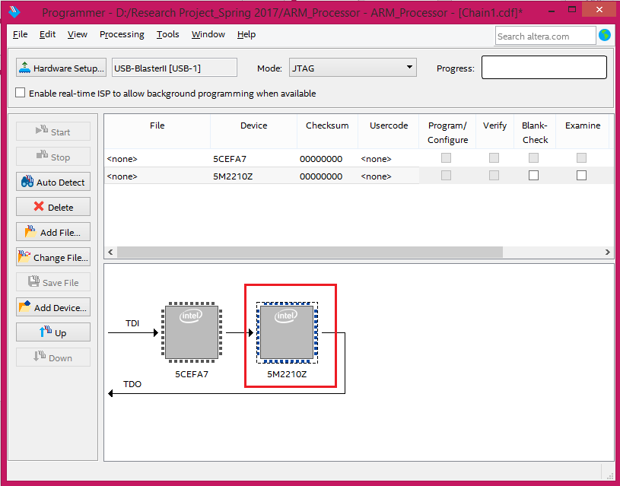

6/ Select the **5CEFA7** and left click then **Edit 🡪 Add File**

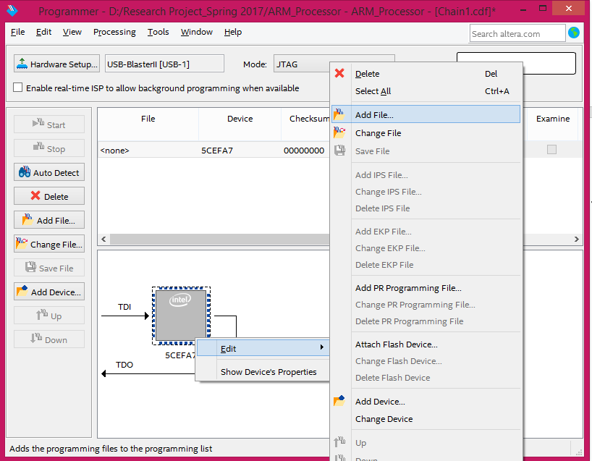

7/ In the output_files folder, select the .sof file that was generated then click open. (Make sure the path is correct)

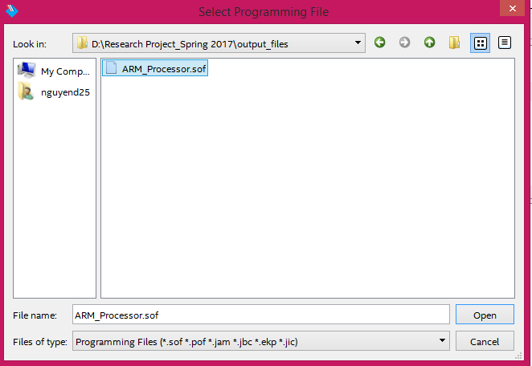

8/ Now press Start, and the progress bar should go to 100%

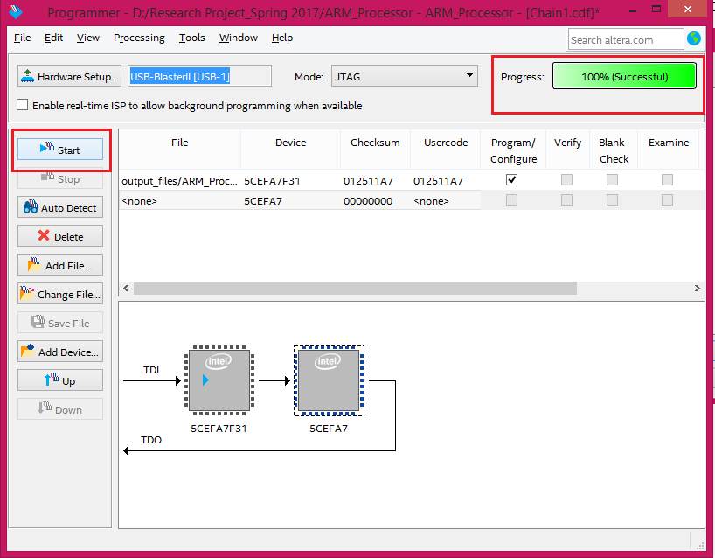

**USING SIGNALTAP II**

1/ **Tools 🡪 SignalTap II Logic Analyzer**

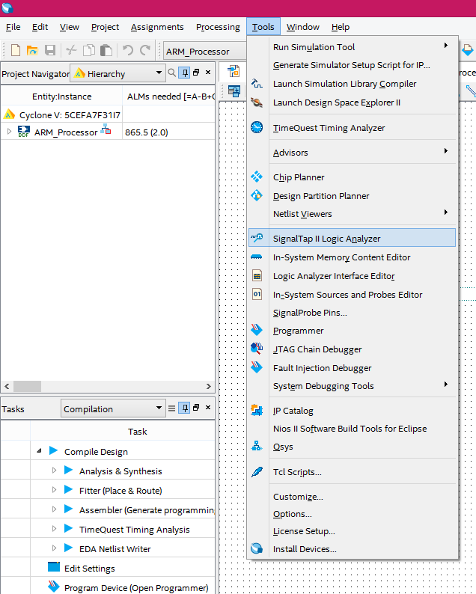

2/ Choose the .sof file by clicking on the “…” button on the far right

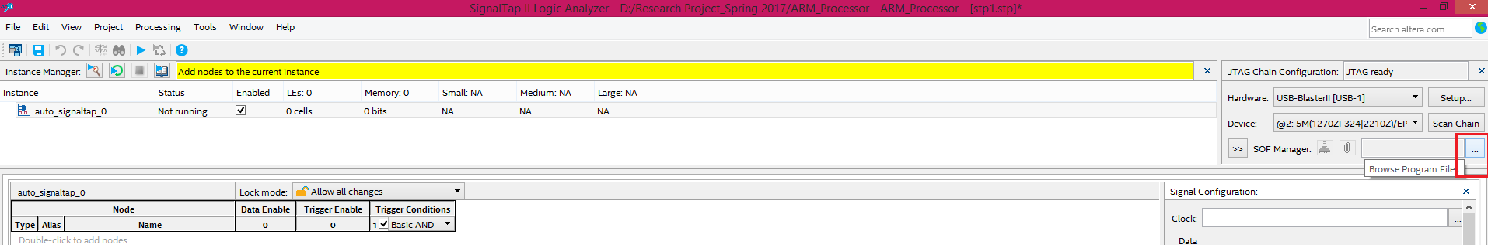

3/ Then select the clock and add in the signal you want to observe in the box below.

For more detail: <https://www.youtube.com/watch?v=vhkzxCEXuaA>

ftp://ftp.altera.com/up/pub/Altera_Material/12.1/Tutorials/Verilog/SignalTap.pdf