FIPILOT
AI-POWERED CV-TO-INTERVIEW SYSTEM
GRADUATION PROJECT REPORT

Software Engineering and Artificial Intelligence Project
Quy Nhon, August 2026

Acknowledgement
This report records the design and implementation of FiPilot as a graduation software project. The work combines document processing, web application development, language-model integration, knowledge retrieval, interview orchestration, speech interaction, persistence, and software verification. The authors acknowledge the guidance of lecturers, reviewers, and collaborators who supported the project. Personal names are intentionally omitted from this repository edition so that they can be inserted by the submitting team in the institutional cover and approval pages.

Abstract
FiPilot is a web-based system that converts a PDF or DOCX Resume into a structured Candidate Profile and uses that profile to conduct a personalized technical interview. The implemented workflow validates the uploaded document, performs native extraction with OCR fallback when necessary, requests a schema-constrained profile from Gemini, normalizes the result, and persists it under the authenticated user. The interview service then retrieves role-relevant knowledge from the local Knowledge catalog, creates an Interview Plan, generates questions, evaluates answers, applies deterministic continuation and difficulty rules, stores the session, and produces a final report.
The system supports both text and voice interaction. Text answers use authenticated REST operations. Voice sessions use an authenticated WebSocket, voice activity detection, speech-to-text, the shared answer-processing service, and streamed text-to-speech. The frontend is implemented with React and TypeScript; the active backend is a FastAPI modular monolith; persistence is provided through repository adapters; Firebase supplies identity verification; and Vertex AI Gemini supplies the language operations used by the application.
This document is an as-built report. It explains only components connected to the application workflow and avoids presenting research-only alternatives as system features. Software validation for the inspected revision completed 286 backend tests and 119 frontend tests, together with backend compilation, frontend type checking, linting, and a production frontend build. These results verify software behavior covered by the test suites; they are not a claim that automated interview scores replace professional human judgment.

List of Abbreviations
Abbreviation | Meaning
AI | Artificial Intelligence
API | Application Programming Interface
CV | Curriculum Vitae / Resume
DOCX | Office Open XML document format
ETag | HTTP entity tag
HTTP | Hypertext Transfer Protocol
JSON | JavaScript Object Notation
LLM | Large Language Model
NLP | Natural Language Processing
OCR | Optical Character Recognition
PDF | Portable Document Format
PII | Personally Identifiable Information
RAG | Retrieval-Augmented Generation
REST | Representational State Transfer
STT | Speech-to-Text
TTS | Text-to-Speech
UI | User Interface
VAD | Voice Activity Detection
WebSocket | Full-duplex communication protocol over one connection

Table of Contents
Right-click and choose Update Field in Word

List of Figures
Figure 1. FiPilot system context and connected external boundaries.
Figure 2. Connected runtime pipeline from Resume upload to interview report.
Figure 3. Resume validation, extraction, OCR fallback, and profile creation.
Figure 4. Candidate Profile as the shared contract between Resume review and interview preparation.
Figure 5. Local lexical retrieval used to curate planner context.
Figure 6. Model-assisted services and deterministic orchestration boundaries.
Figure 7. Shared answer processing for text submissions and voice transcripts.
Figure 8. Production frontend routes and their backend interactions.
Figure 9. Text interview request sequence.
Figure 10. Voice channel and convergence with the shared answer service.
Figure 11. Principal persisted resources and ownership relationships.
Figure 12. Identity verification and ownership-scoped resource access.
Figure 13. Software verification layers used by the project.

List of Tables
Table 1. Project overview information.
Table 2. Implemented scope and present limitations.
Table 3. Repository work areas and deliverables.
Table 4. Project risk matrix.
Table 5. Quality gates used by the project.
Table 6. Structured language operations used by FiPilot.
Table 7. Technology choices and their system responsibilities.
Table 8. Canonical Candidate Profile fields.
Table 9. Connected language-service operations.
Table 10. Active application interfaces.
Table 11. Actors and connected systems.
Table 12. Implemented functional requirements.
Table 13. Quality requirements and implementation mechanisms.
Table 14. Representative backend test areas.
Table 15. Frontend verification commands.
Table 16. Current software verification result.
Table 17. Selected acceptance scenarios.
Table 18. Repository deliverables.
Table 19. Candidate Profile nested structure.
Table 20. Principal source locations supporting the report.

CHAPTER I. PROJECT INTRODUCTION

I.1 Overview

I.1.1 Project information
FiPilot is an AI-assisted web application for technical interview practice. Its defining input is a candidate Resume, and its defining output is a completed interview record with structured feedback. The application does not operate as a general conversation page. It maintains authenticated resources, a Candidate Profile, an Interview Plan, ordered turns, answer evaluations, adaptive decisions, and a final report.
Table I.1: Project overview information.
Item | Description
Project name | FiPilot
Product type | Web-based CV-to-interview application
Primary users | Candidates practising information-technology interviews
Input | One authenticated PDF or DOCX Resume and subsequent text or voice answers
Core output | Structured Candidate Profile, interview session, per-turn feedback, and final report
Frontend | React, TypeScript, Vite, React Router, TanStack Query, and Zustand
Backend | FastAPI gateway, application services, interview orchestrator, and infrastructure adapters
Language service | Vertex AI Gemini accessed through the backend integration layer
Default knowledge retrieval | Deterministic weighted lexical retrieval over the local Knowledge catalog
Identity | Firebase Authentication with server-side token verification
Persistence | SQLite or Firestore through a common repository contract
Interaction channels | HTTPS REST for text workflows and WebSocket for voice sessions

I.1.2 Product overview
The user signs in, uploads a Resume, and receives a structured Candidate Profile. The application uses this committed profile when preparing an interview. A local knowledge retriever selects technical topics related to the candidate's role, specialization, skills, and evidence. The planning service combines the profile, configuration, and retrieved context to produce an Interview Plan. The question service generates one question at a time from the current plan round. After the candidate answers, the evaluation service produces structured scores and feedback, and a deterministic decision service chooses whether to ask a follow-up, adjust difficulty, continue the plan, or complete the session.
The text and voice experiences share the same interview state. In text mode, answers arrive through an authenticated REST request. In voice mode, PCM audio reaches an authenticated WebSocket; speech components detect voice activity and produce a transcript; the transcript then enters the same answer service used by text mode. This shared boundary prevents the two channels from developing different scoring and progression rules.
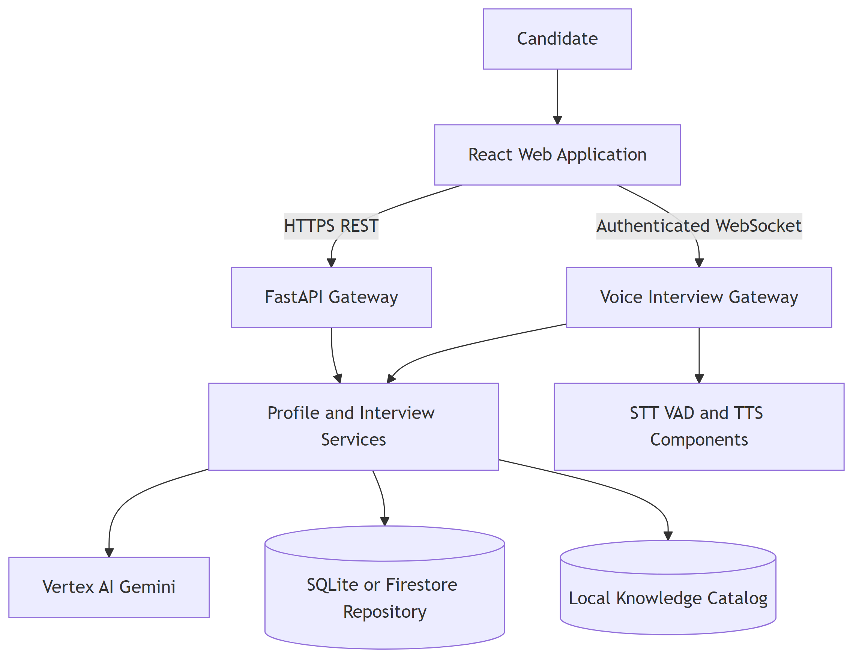
Figure I.1: FiPilot system context and connected external boundaries.

I.2 Project context
Technical interviews require candidates to connect conceptual knowledge with concrete experience. A static list of questions cannot adapt to a Resume, while an unconstrained chat cannot reliably provide ownership, state recovery, repeatable data contracts, or a durable report. Resume documents also vary in layout, format, text quality, and completeness. The application therefore needs both flexible language interpretation and deterministic software controls.
FiPilot addresses this context through a staged workflow. Document bytes are validated before extraction. Language output is accepted only through defined schemas. Knowledge selection is performed before planning. Interview state is persisted rather than left in a browser conversation. User identity is resolved by the server, and every candidate/session/report operation is scoped to that identity. These controls allow the application to use language models without delegating authentication, persistence, or workflow authority to them.

I.3 Objectives
The implemented objectives are:
- accept one PDF or DOCX Resume, reject invalid structures, extract native text, and use OCR when a PDF does not contain enough readable text;
- transform extracted text into the canonical Candidate Profile used by the application;
- calculate structured profile-readiness information for the user interface;
- select relevant technical topics from the local Knowledge catalog using deterministic lexical scoring;
- create a structured Interview Plan and generate candidate-specific questions;
- evaluate text or transcribed voice answers and apply deterministic continuation rules;
- persist interview history and generate a final report;
- protect user resources through Firebase identity verification and ownership-scoped repository operations; and
- provide a responsive React interface for upload, profile review, text interview, voice interview, history, settings, and reports.

I.4 Problem statement
The central engineering problem is a sequence of transformations with different trust levels:
Resume → Profile → Plan → Question → Answer → Evaluation → Report
Document content is untrusted input. Profile fields are model-assisted interpretations that require structural validation. Retrieved knowledge is technical context and must not be confused with a candidate claim. A model-generated score is an application signal and must not directly control persistence or ownership. The architecture must preserve these distinctions throughout a multi-turn session.
A second problem is continuity. A technical interview can contain retries, browser refreshes, double submissions, slow external calls, and voice disconnections. FiPilot therefore stores sessions and turns, uses an idempotent answer-claim mechanism, and returns server state to the client. The workflow is stateful even though individual AI operations are request-response calls.
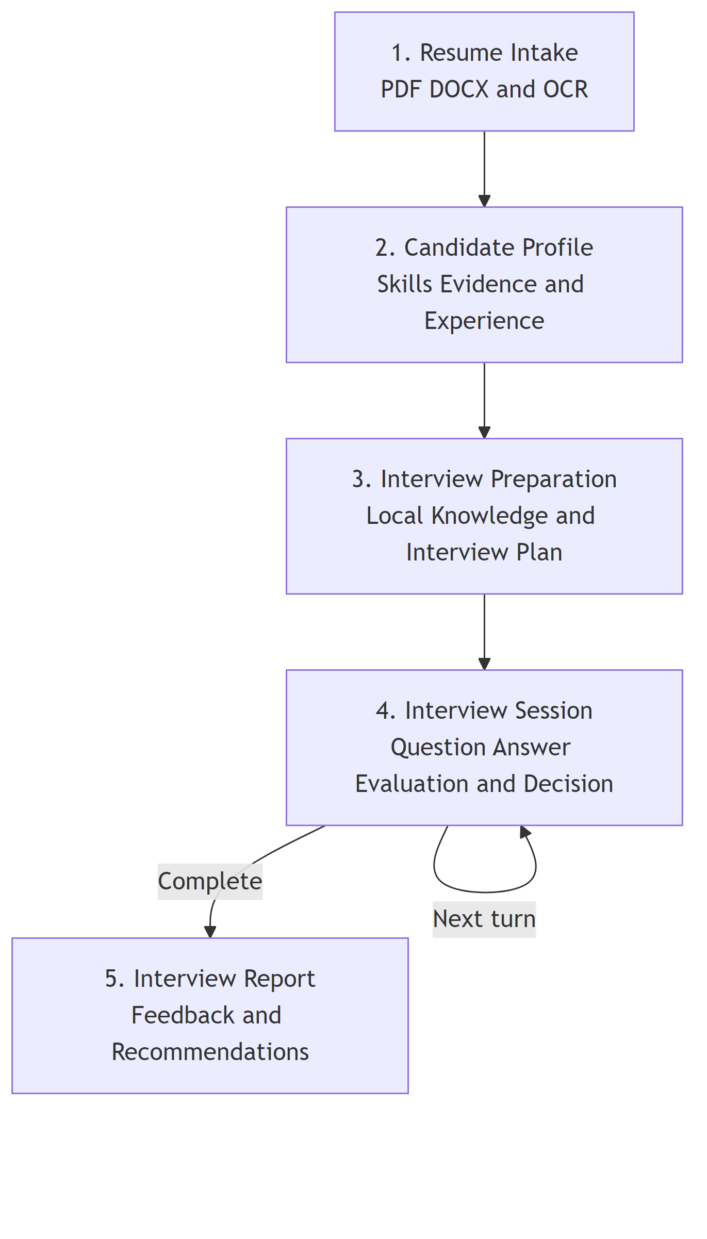
Figure I.2: Connected runtime pipeline from Resume upload to interview report.

I.5 Significance
The project demonstrates how language services can be integrated into a governed application instead of exposed as an unrestricted chat box. Candidate evidence, technical knowledge, plan structure, interview state, and evaluation output are separate domain objects. This separation makes the code testable and lets the frontend display explicit progress and errors.
The project is also significant as a full-stack integration. Resume parsing, OCR, typed model output, retrieval, orchestration, REST, WebSocket audio, authentication, two persistence adapters, and a React UI operate behind one product workflow. The resulting system is suitable for demonstrating software architecture and applied AI integration, provided that its automated feedback remains advisory.

I.6 Scope and limitations
Table I.2: Implemented scope and present limitations.
Included in the application | Present limitation
PDF and DOCX validation and extraction | Unusual layouts can still produce imperfect reading order.
OCR fallback for sparse/image PDFs | No broad real-document OCR accuracy claim is made.
Canonical Candidate Profile | Complete field-level source provenance is not exposed to the user.
Readiness information on profile responses | Start operations do not yet use readiness as a server-side rejection rule.
Local lexical knowledge retrieval | Returned planner strings do not expose a user-facing citation score.
Text and voice interview sessions | Voice quality depends on microphone, language, and speech components.
Answer evaluation and feedback | Scores are advisory and are not a substitute for a professional interviewer.
SQLite and Firestore repositories | Operational deployment state is environment-specific.
Firebase authentication and ownership checks | This report is not a security certification.
Final report generation | Historical profile consistency is constrained by the current report service behavior.

The report intentionally limits itself to the connected application. Alternative retrieval studies, disconnected prototypes, and specification-only features are outside the described system.

CHAPTER II. PROJECT DEVELOPMENT AND MANAGEMENT

II.1 Development organization
The repository is organized around responsibility boundaries rather than one large application module. The frontend, gateway, shared schemas, domain services, orchestrator, infrastructure adapters, speech service, tests, Knowledge catalog, documentation, and scripts form distinct work areas. This organization provides a practical work-breakdown structure even when contributors work across more than one area.
Table II.1: Repository work areas and deliverables.
Work area | Main responsibility | Repository deliverable
Product interface | Routes, forms, text/voice experiences, report views | frontend/src
HTTP boundary | Authentication, request validation, response contracts | backend/gateway
Domain contracts | Canonical Pydantic request and response models | backend/shared/schemas
Application services | Profile, readiness, planning, questions, evaluation, reports | backend/services
Workflow control | Session progression and answer decisions | backend/orchestrator
Infrastructure | Documents, Firebase, Gemini, speech, repositories | backend/infrastructure
Speech process | Optional independently started speech service | backend/speech_service
Knowledge | Role/topic/level Markdown documents and catalog | Knowledge and catalog builder
Verification | Backend and frontend behavior checks | backend/app/tests and frontend test files
Architecture records | ADRs, behavior specifications, deep dives | docs

II.2 Change management
Changes to a domain contract require reading the repository context, applicable specifications, testing seams, risk documents, and architecture decisions. Runtime source remains authoritative for what the current application does, while ADRs explain why a boundary exists. This distinction prevents a detailed proposal from being reported as completed behavior.
Canonical names are controlled centrally. For example, the Candidate Profile uses name, years_experience, recent_role, specialization, skills, skill_evidence, projects, experiences, and education. A change that introduces a parallel alias affects schemas, routes, repositories, tests, and UI state, so it must be reviewed as a domain change rather than a local convenience.
Small implementation changes are verified with focused tests before broader suites. Final validation includes backend tests and compilation, frontend type checking, lint, tests, and production build. No source-control commit is created automatically by report generation.

II.3 Risk management
Table II.2: Project risk matrix.
Risk | Impact | Implemented control
Unsupported Resume field | Incorrect personalization | File/text separation, schema-constrained profile output, normalization, and source reconciliation.
Malformed document | Parser failure or resource waste | Type, signature, size, container, timeout, and extraction checks.
Cross-user resource access | Privacy and integrity breach | Firebase token verification and ownership-scoped repository calls.
Invalid language response | Application contract failure | Pydantic validation and bounded integration retry behavior.
Duplicate answer submission | Repeated cost and inconsistent state | Persistent turn claim, request hash, stored result, and replay behavior.
Slow external response | Poor interaction quality | Timeouts, question prefetch, progress state, and structured errors.
Voice overload | Memory pressure | Bounded audio queues, message limits, endpoint detection, and session cleanup.
Inconsistent text/voice logic | Different evaluation outcomes | Final transcript enters the shared answer service.
Sensitive logging | Disclosure of Resume or answer content | Structured metadata logging; raw audio is not intentionally persisted.
Configuration confusion | Wrong process settings | Repository helper loads backend/.env.local or BACKEND_ENV_FILE.

II.4 Quality management
Quality controls are applied at four levels. Static contracts define types and allowed fields. Deterministic tests verify parsing, readiness, decisions, ownership, persistence, and error responses. Integration tests replace external services with controlled dependencies to exercise application behavior. Build checks ensure that the frontend and active backend packages remain executable.
Table II.3: Quality gates used by the project.
Gate | Purpose | Evidence
Schema validation | Reject malformed request/model output | Shared Pydantic models and schema tests
Ownership tests | Prevent cross-user disclosure | API and repository ownership scenarios
Repository parity | Preserve application behavior across adapters | SQLite/Firestore contract tests
Document tests | Verify valid, corrupt, mismatched, OCR, and timeout paths | Document-processing test module
Workflow tests | Verify start, answer, completion, and report behavior | Interview/orchestrator/API tests
Voice tests | Verify WebSocket, STT/TTS, interruption, and cleanup contracts | Voice service and gateway tests
Frontend tests | Verify routes, forms, errors, interaction, and accessibility behavior | React Testing Library suites
Release checks | Reject syntax/type/lint/build failures | Python compilation and frontend build commands

II.5 Documentation management
The report uses local source paths as traceability notes for implementation details. It does not reproduce environment secret values or private Resume content. Architecture figures are generated from report-owned Mermaid sources so their content can be reviewed and re-rendered. The build script regenerates figures, compiles the document, resolves the bibliography, and rejects missing references or major layout overflow.

CHAPTER III. EXISTING SYSTEMS AND THEORETICAL BACKGROUND

III.1 Domain overview
An interview-practice system must perform more than question generation. It needs a representation of the candidate, an interview objective, technical knowledge, controlled progression, answer interpretation, feedback, and a durable history. FiPilot treats these elements as application objects so that each operation has explicit input and output.
Traditional question banks offer predictable content but little personalization. General AI chat provides flexible language but weak resource ownership and workflow control. FiPilot combines deterministic application state with language operations. The language service interprets and generates text; the application controls files, identity, schemas, state, persistence, and error handling.

III.2 Natural language processing and Transformers
Natural language processing covers computational methods for analysing and producing human language. Resume interpretation, question wording, answer feedback, and report synthesis are NLP tasks because their meaning cannot be captured reliably by fixed field positions alone.
Modern language models commonly use the Transformer architecture. Its attention mechanism lets a token representation incorporate information from other positions in the sequence [1]. For queries Q, keys K, values V, and key dimension d_k, scaled dot-product attention is
Attention(Q, K, V) = softmax(QKᵀ / √dₖ) V
FiPilot accesses managed Gemini models through an application adapter. Transformer internals explain the language capability supplied by that external service, while FiPilot's repository is responsible for the surrounding application controls.

III.3 Structured language output
Free-form text is inconvenient for a typed application. FiPilot therefore requests JSON that follows a response schema and validates it with Pydantic. The primary structured objects are Candidate Profile, Interview Plan, Interview Question, Answer Evaluation, and Interview Report. If the output cannot be validated, the application does not treat it as a domain object.
This separation improves controllability in three ways. First, routes and services receive known fields instead of parsing prose. Second, bounds such as score types and required nested objects can be checked. Third, malformed output becomes an explicit integration failure rather than silently changing interview state. Structural validity still does not guarantee factual correctness, so Resume normalization and source reconciliation remain necessary.
Table III.1: Structured language operations used by FiPilot.
Operation | Main input | Validated output | Application consumer
Resume interpretation | Extracted Resume text | Candidate Profile fields | Profile service and repository
Interview planning | Profile, configuration, retrieved topics | Interview Plan and rounds | Interview orchestrator
Question generation | Profile, current round, history | Interview Question | Current turn
Answer evaluation | Question, expected points, answer | Scores and feedback | Decision service and session
Report generation | Profile and completed turns | Interview Report | Report route and frontend

III.4 Retrieval-Augmented Generation
RAG combines a generative operation with external knowledge selected at request time [2]. In FiPilot, the local Knowledge catalog is the external source and retrieval occurs before interview planning. The planner receives a bounded list of technical topics together with the Candidate Profile and interview configuration. The Question Generator subsequently receives the planned round; it does not independently search the full catalog for each turn.
The implemented retriever is lexical. It normalizes profile strings into tokens, removes stop words, scores domain overlap, scores topic overlap, applies an exact-title bonus, sorts deterministically, and selects up to eight topics. This approach is suitable for a curated hierarchy because it is local, explainable, fast, and stable. It can miss paraphrases that share few tokens, which is recorded as a system limitation rather than replaced in this report by an unused mechanism.

III.5 Adaptive interview state
Adaptive behavior is implemented as state plus deterministic policy. The model produces an Answer Evaluation, including a follow-up signal and score. The decision service prioritizes clarification when required. If no clarification is needed and the score reaches the configured threshold, difficulty can increase within the plan. Otherwise the session continues at the current level or completes when its question budget is reached.
This mechanism is not an unrestricted model decision. The application owns the state transition and persists it. The distinction matters because the same evaluation must lead to the same application rule in text and voice modes.

III.6 Document extraction technologies
PDF stores positioned page content and does not guarantee reading order. DOCX is a zipped document format containing paragraphs, tables, relationships, and styling. FiPilot uses dedicated parsers for these formats. A PDF with too little native text enters an OCR path in which pages are rendered and processed by RapidOCR. A DOCX path reads paragraphs and top-level tables. Both paths produce normalized text for the same profile service.
OCR is a fallback because image recognition is slower and less reliable than reading embedded text. The document layer limits size, validates file signatures, bounds processing time, and returns structured warnings/errors. These controls protect the language service from receiving an arbitrary malformed container.

III.7 Speech recognition and synthesis
Voice mode introduces three functions. Silero VAD detects voice activity and endpoints. Faster-whisper converts audio into partial and final transcripts. VieNeu-TTS synthesizes the next question into streamed audio. The gateway uses bounded queues and separates binary PCM frames from JSON control events.
The final transcript becomes a normal candidate answer. This architectural choice keeps the interview evaluator and decision service independent of the input medium. Raw audio is transient application data and is not intentionally written to the interview repository.

III.8 LLM-as-a-Judge limitations
FiPilot uses a language model to produce structured answer evaluation. LLM judges can apply a rubric consistently at application scale, but published research identifies sensitivity to prompt framing, verbosity, position, and model-family effects [3]. Accordingly, FiPilot feedback is advisory. The system stores evidence and scores for review; it does not establish an autonomous employment decision.

III.9 Technology selection summary
Table III.2: Technology choices and their system responsibilities.
Technology | Responsibility | Selection rationale
React/TypeScript | Browser routes and interaction | Typed component ecosystem and testable state
FastAPI/Pydantic | HTTP/WebSocket boundary and schemas | Explicit validation and dependency composition
Gemini via Vertex AI | Language interpretation and generation | Managed task-specific JSON generation
Local lexical retrieval | Planner knowledge context | Deterministic local ranking over curated topics
SQLite/Firestore adapters | Durable user/session/report data | Local development and configurable cloud persistence
Firebase Authentication | User identity | Server-verifiable browser identity token
RapidOCR | Image-PDF fallback | Extract text when native PDF text is insufficient
Faster-whisper, Silero, and VieNeu | Voice input/output | Streaming transcript, endpoint detection, and speech response

CHAPTER IV. AI METHODOLOGY AND SOLUTION

IV.1 Method overview
FiPilot uses language services inside a controlled application pipeline. The model is responsible for interpreting Resume text and producing schema-constrained content. Application code remains responsible for file validation, identity, ownership, retrieval, workflow state, retries, persistence, and report access. This division is central to the solution: probabilistic output is used where language interpretation is useful, while deterministic rules protect the product contract.
The connected AI-assisted operations are Resume profiling, interview planning, question generation, answer evaluation, and report generation. Each operation has its own prompt and response schema. The backend converts validation failures and provider failures into application errors instead of passing incomplete model output directly to the client.

IV.2 Resume understanding

IV.2.1 Document admission and extraction
The upload boundary accepts one PDF or DOCX document. The service checks the declared media type, file extension, size, and document signature before extraction. PDF extraction first uses the document's text layer. If the extracted text is too sparse, the service renders pages for OCR. DOCX extraction reads document paragraphs and tables. This sequence avoids unnecessary OCR while retaining a recovery path for scanned documents.
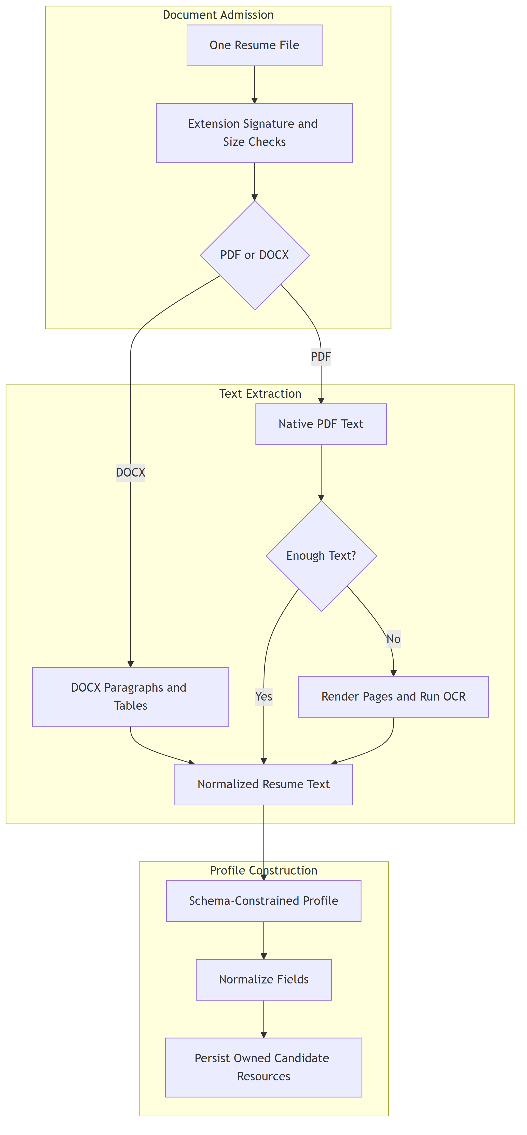
Figure IV.1: Resume validation, extraction, OCR fallback, and profile creation.

The extracted text remains untrusted. It can contain malformed characters, instructions addressed to a model, or incomplete information. The profile scanner receives a system-defined task, the Resume text as data, and a strict response schema. Pydantic validation then converts accepted output to the canonical profile type.

IV.2.2 Canonical Candidate Profile
The profile is the application representation of candidate information. It prevents later services from inventing their own field names or repeatedly parsing the original document. Its editable top-level fields are listed in the referenced table.
Table IV.1: Canonical Candidate Profile fields.
Field | Purpose
name | Candidate display name.
years_experience | Normalized experience duration when supported by the document.
recent_role | Most recent professional role.
specialization | Technical direction used by planning and retrieval.
skills | Normalized skill list.
skill_evidence | Skill-to-evidence items derived from Resume statements.
projects | Structured project descriptions, technologies, and role.
experiences | Structured employment history.
education | Legacy text or explicitly structured education entries.

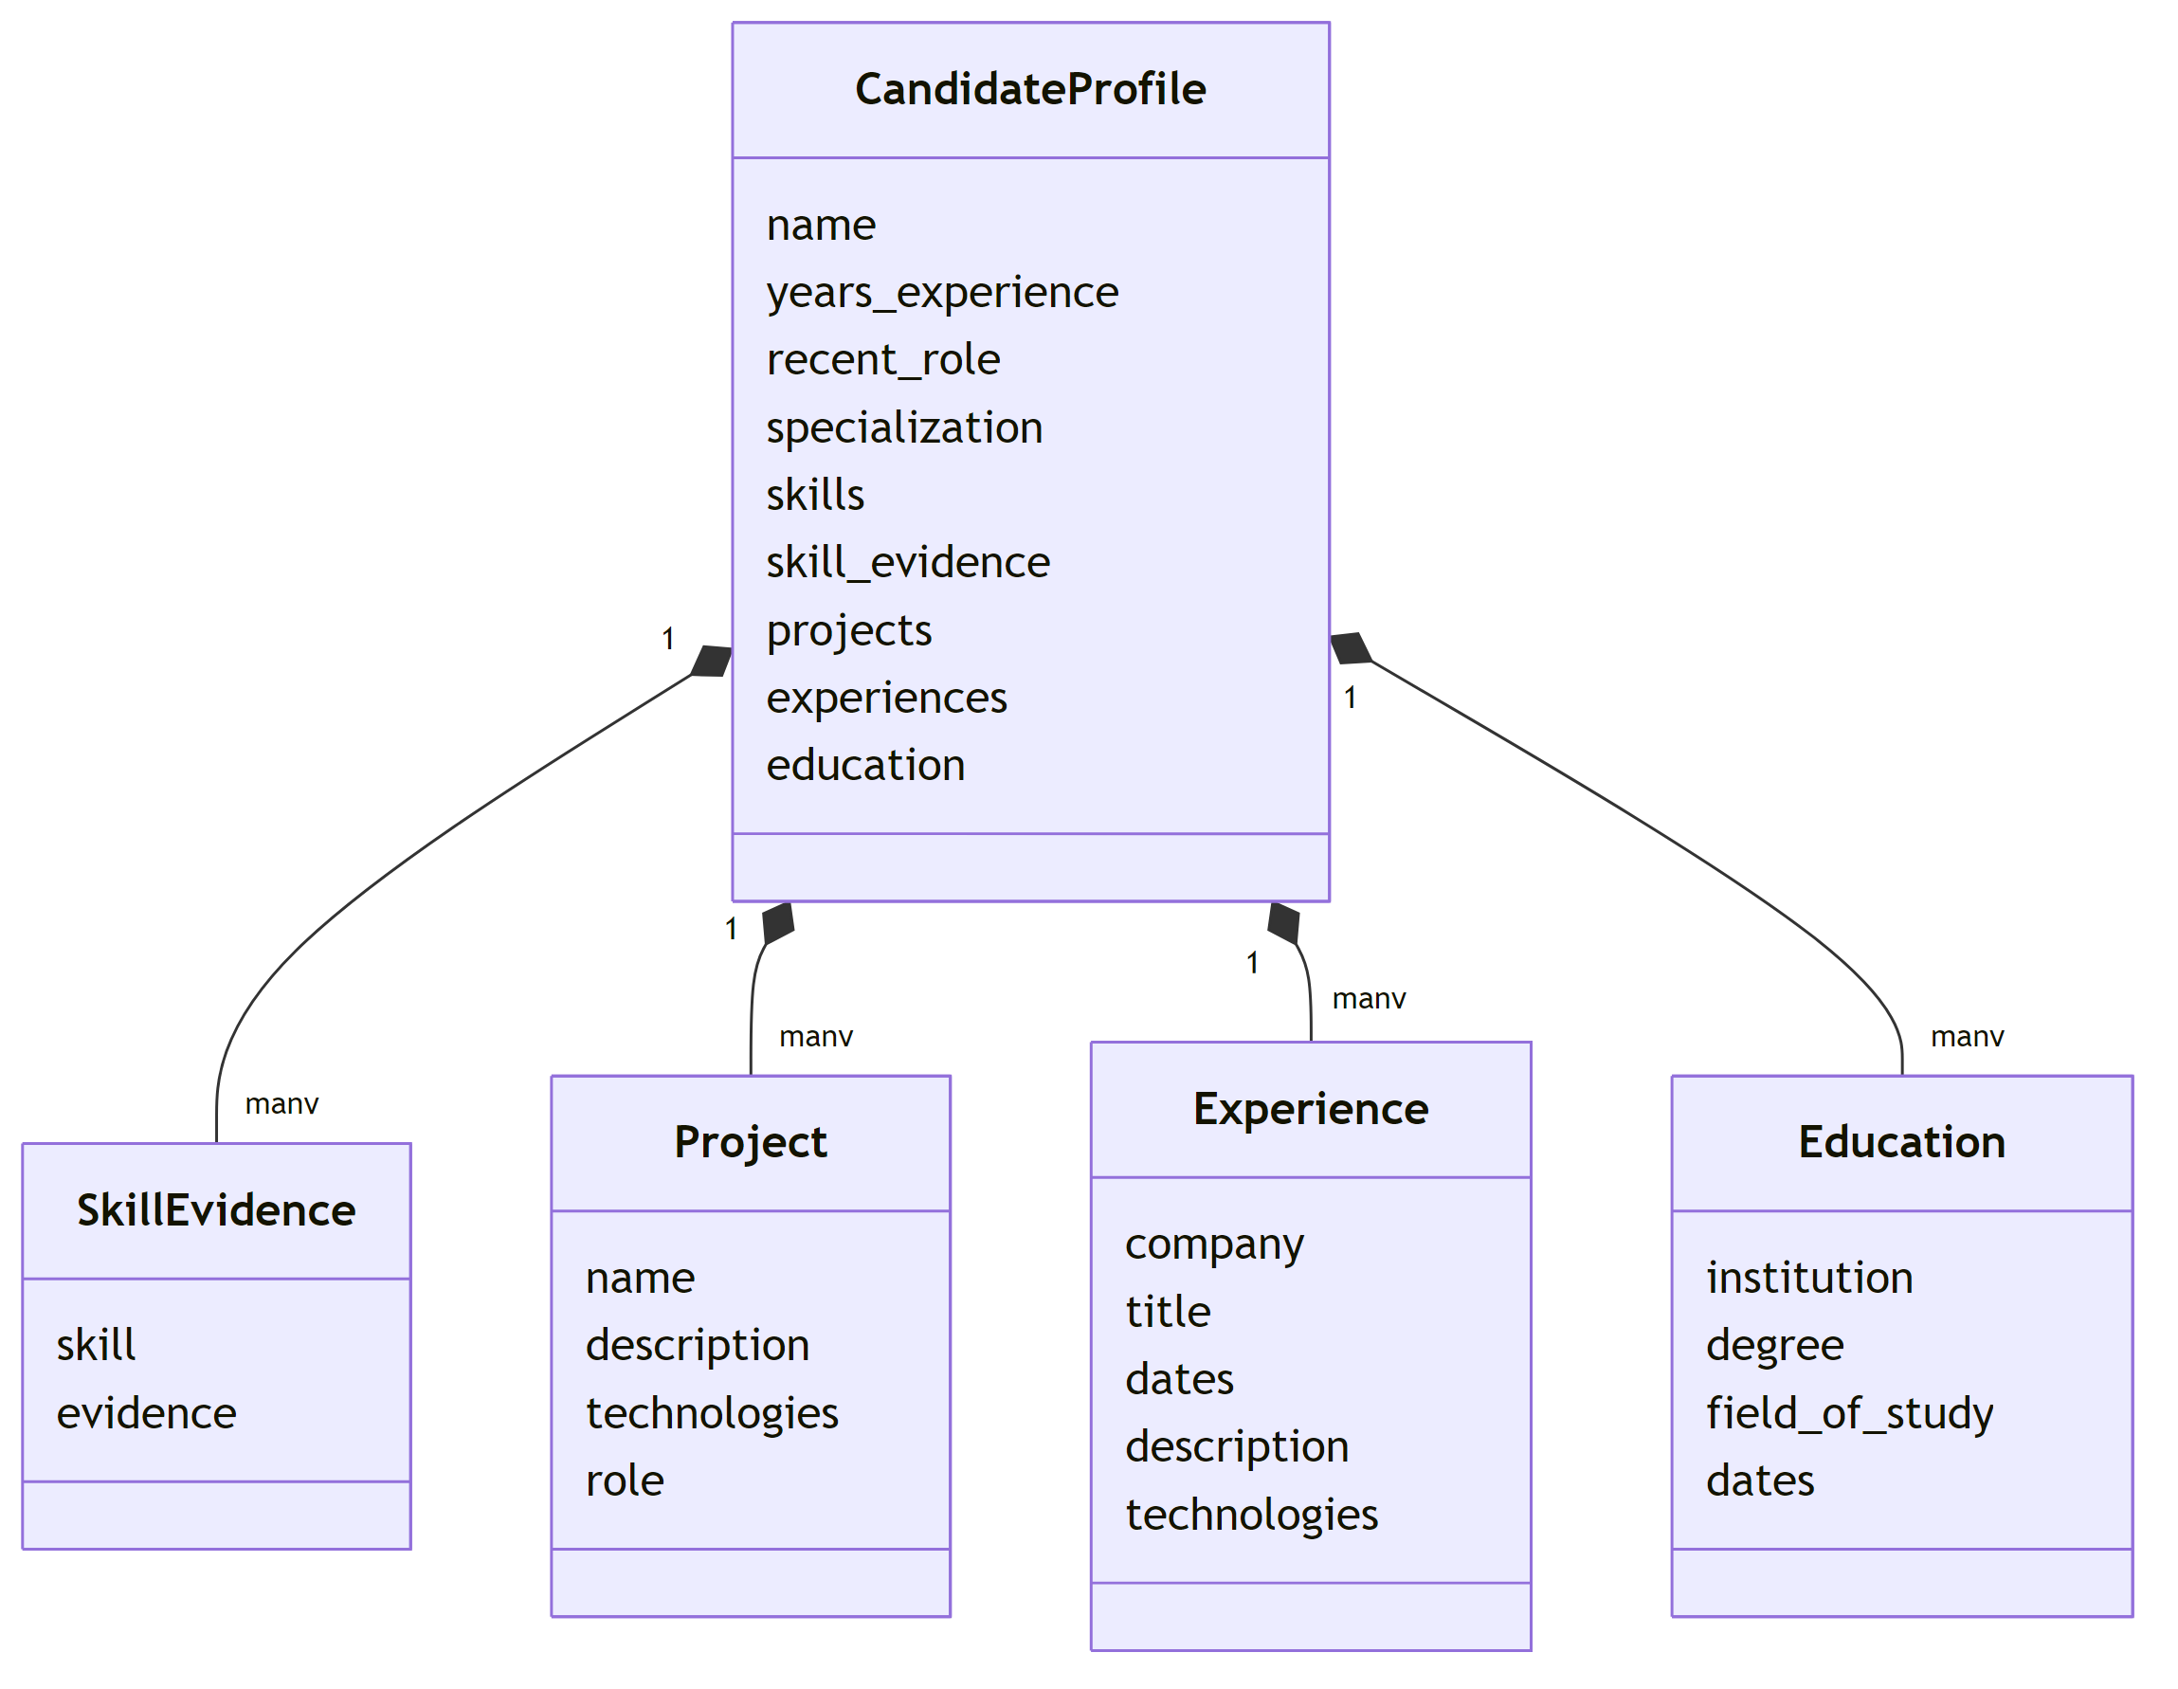
Figure IV.2: Candidate Profile as the shared contract between Resume review and interview preparation.

The profile response also carries server-generated metadata such as its identifier, version, and readiness information. These values are not model-authored editable fields. Keeping them outside the editable allowlist protects ownership, concurrency, and application decisions.

IV.3 Knowledge selection

IV.3.1 Knowledge catalog
The repository includes a local catalog of technical topics. Entries are grouped by role and contain a topic title, hierarchical path, and anchor concepts. A separate level guide describes the expected depth for candidate levels. At runtime, the catalog loader turns these source records into compact planner context; it does not expose the complete catalog to every model request.

IV.3.2 Deterministic lexical retrieval
The default retriever compares normalized query terms with catalog titles, paths, and anchors. Query terms originate from the Candidate Profile and Interview Configuration. Weighted exact and partial lexical matches produce a deterministic score, and the highest ranked eight records are supplied to the planner. Stable tie handling makes the same catalog and query repeatable.
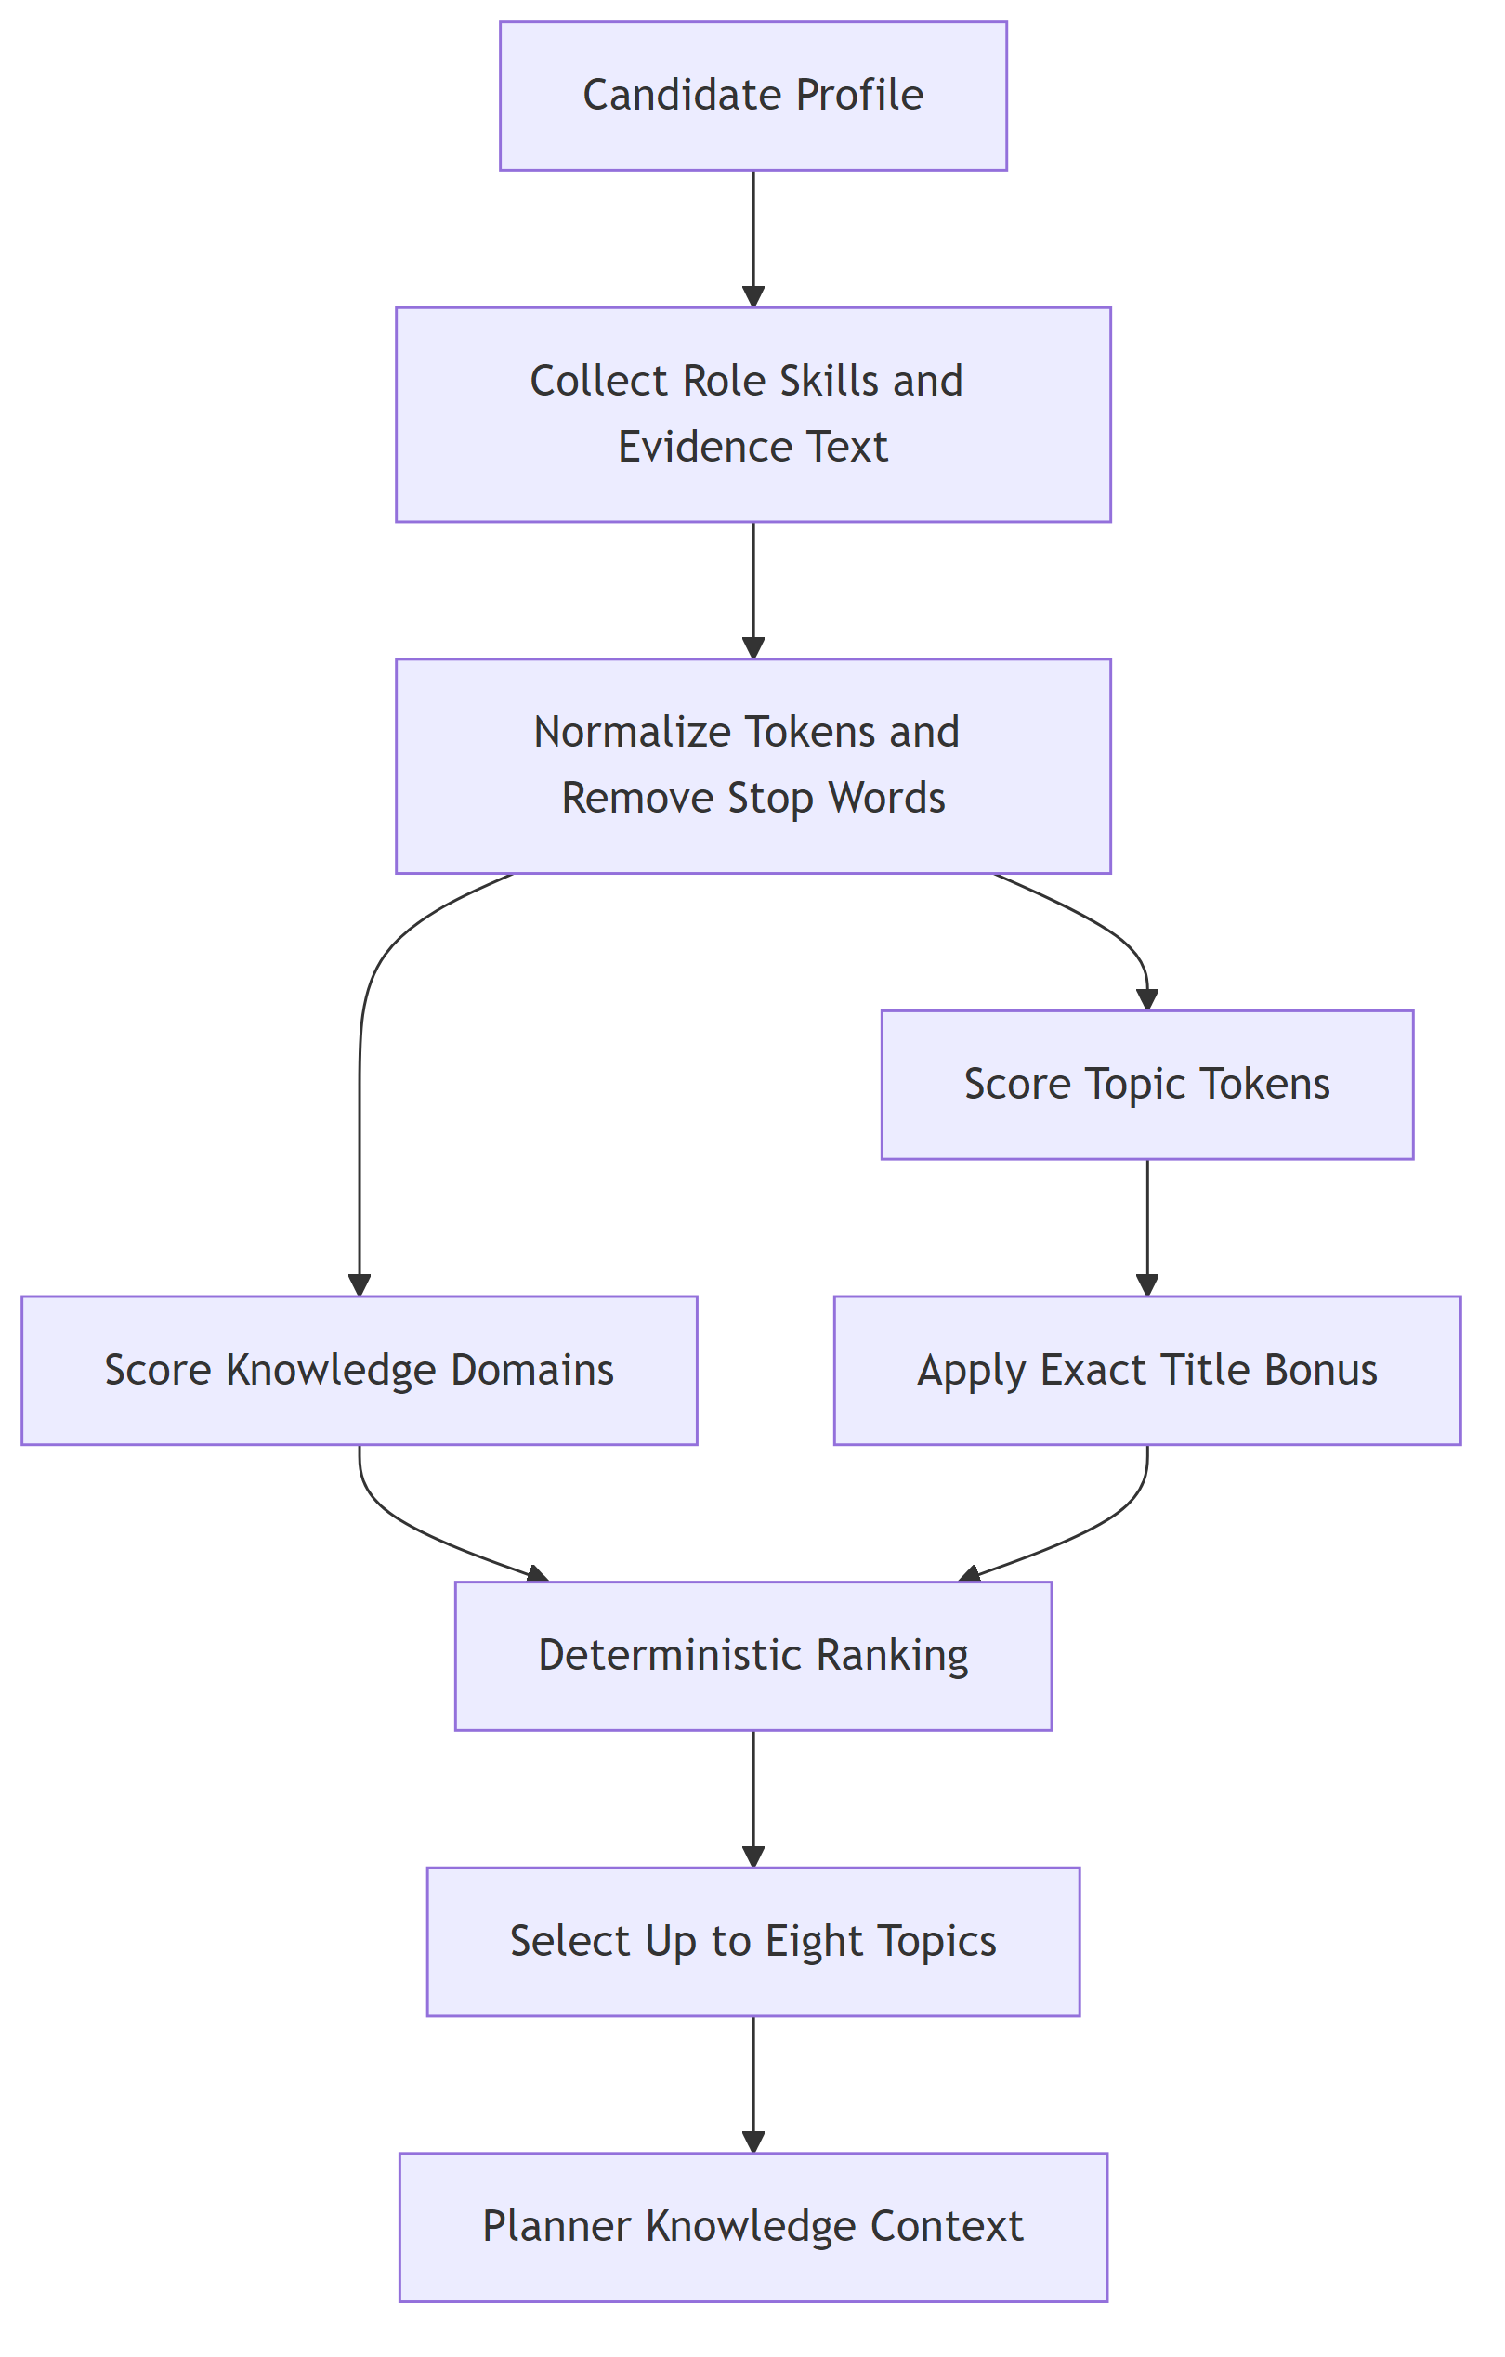
Figure IV.3: Local lexical retrieval used to curate planner context.

This design has three useful properties. First, the knowledge source can be reviewed in the repository. Second, retrieval can be tested without a network call. Third, technical context remains distinct from Candidate Profile evidence. The retrieved records guide coverage; they do not become claims about the candidate.

IV.4 Interview planning and question generation
The planner receives the committed Candidate Profile, the Interview Configuration, and curated knowledge context. It returns a structured plan containing ordered rounds and their goals. The question service then generates a question for the active round. It receives only the state needed for that turn, including prior turns and follow-up context.
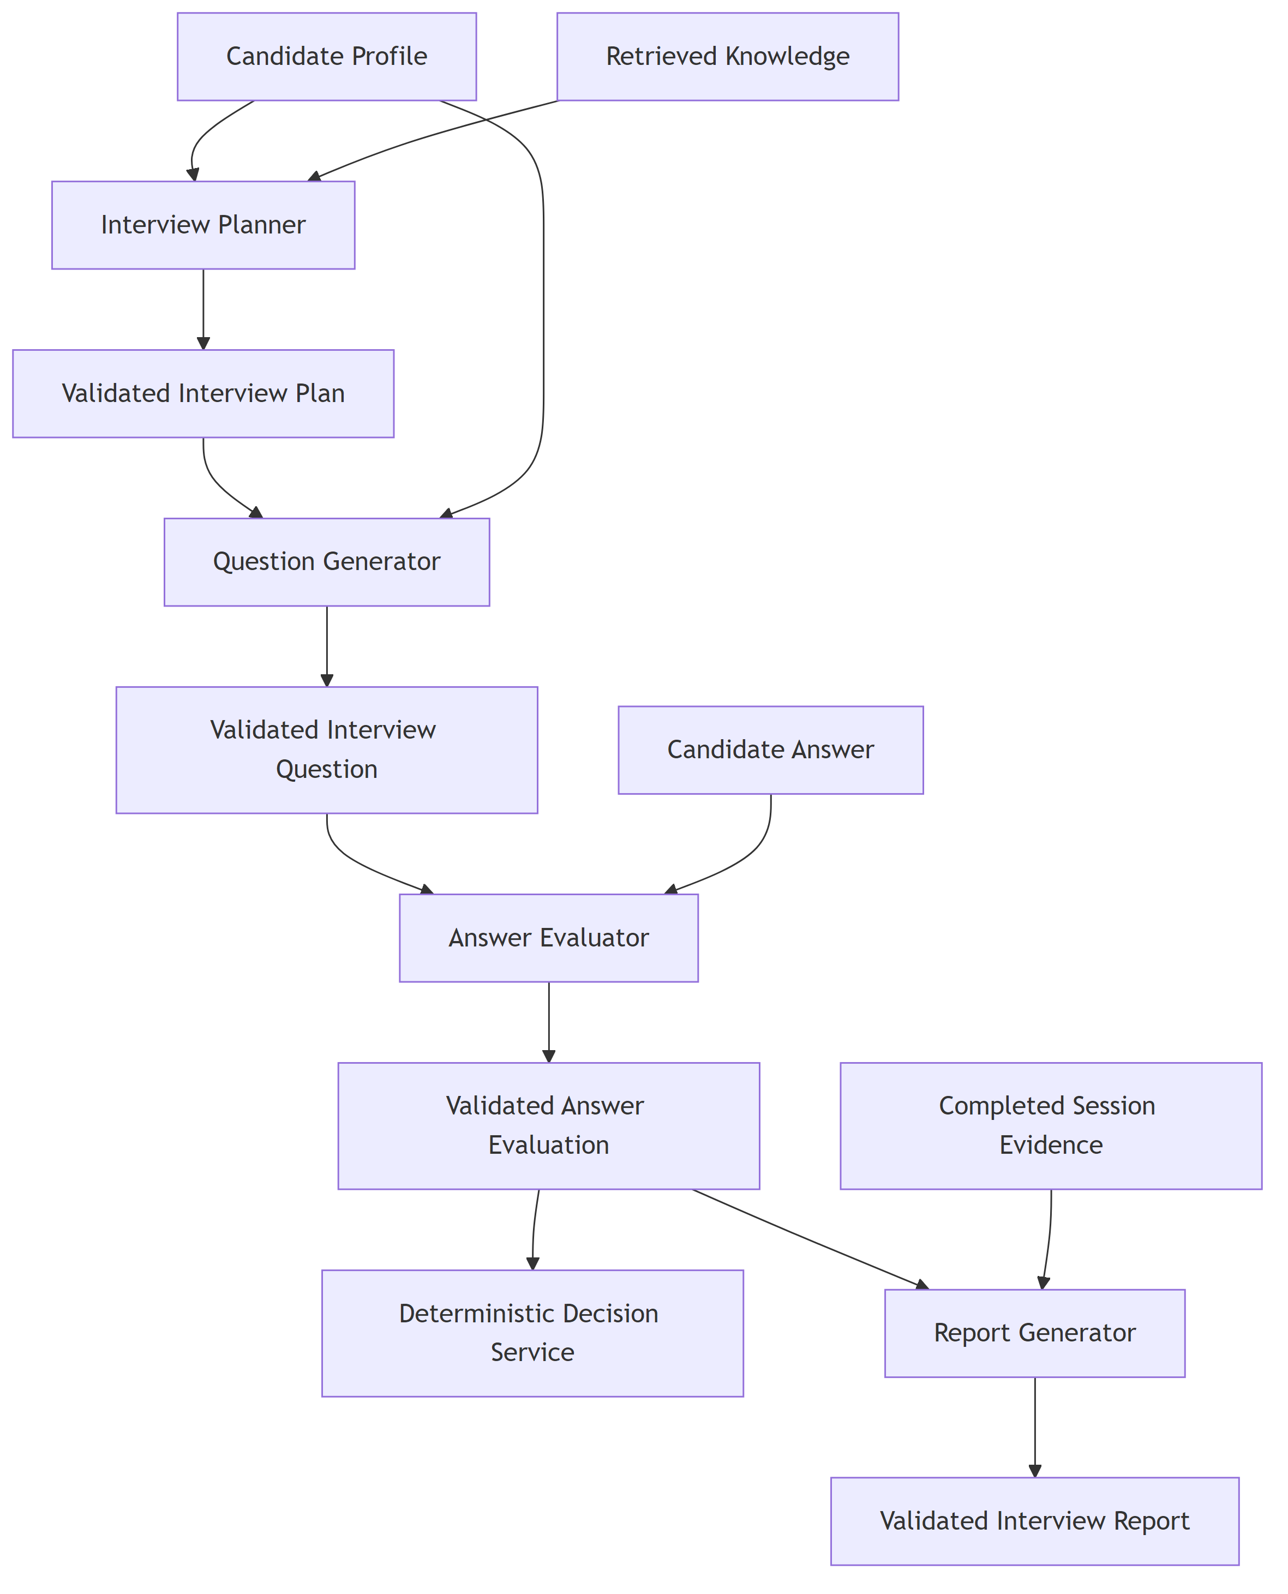
Figure IV.4: Model-assisted services and deterministic orchestration boundaries.

The plan separates session-level intent from individual wording. This means the application can persist progress, identify the current round, and request another question without asking a model to reconstruct the entire interview from free-form chat history. Question generation uses a slightly higher response variation than the profile, planner, evaluator, and report operations, while still requiring a structured response.
Table IV.2: Connected language-service operations.
Operation | Primary input | Validated output
Profile scanner | Extracted Resume text | Canonical Candidate Profile fields
Interview planner | Profile, configuration, selected knowledge | Ordered Interview Plan
Question generator | Active round and session history | One structured interview question
Answer evaluator | Question, answer, profile context, and round goal | Scores, feedback, and follow-up signal
Report generator | Completed session and associated profile data | Structured summary, strengths, gaps, and recommendations

IV.5 Answer evaluation and adaptive decisions
The evaluator assesses the submitted answer against the question and round goal. Its output contains structured dimensions and feedback rather than an unrestricted paragraph. The backend validates ranges and required fields. The evaluator can recommend a follow-up, but it does not directly mutate the session.
The decision service applies deterministic rules to the current state and accepted evaluation. It considers follow-up limits, round progress, and completion conditions. It selects the next action, after which the orchestrator persists the turn and, when required, invokes the question service for the next prompt.
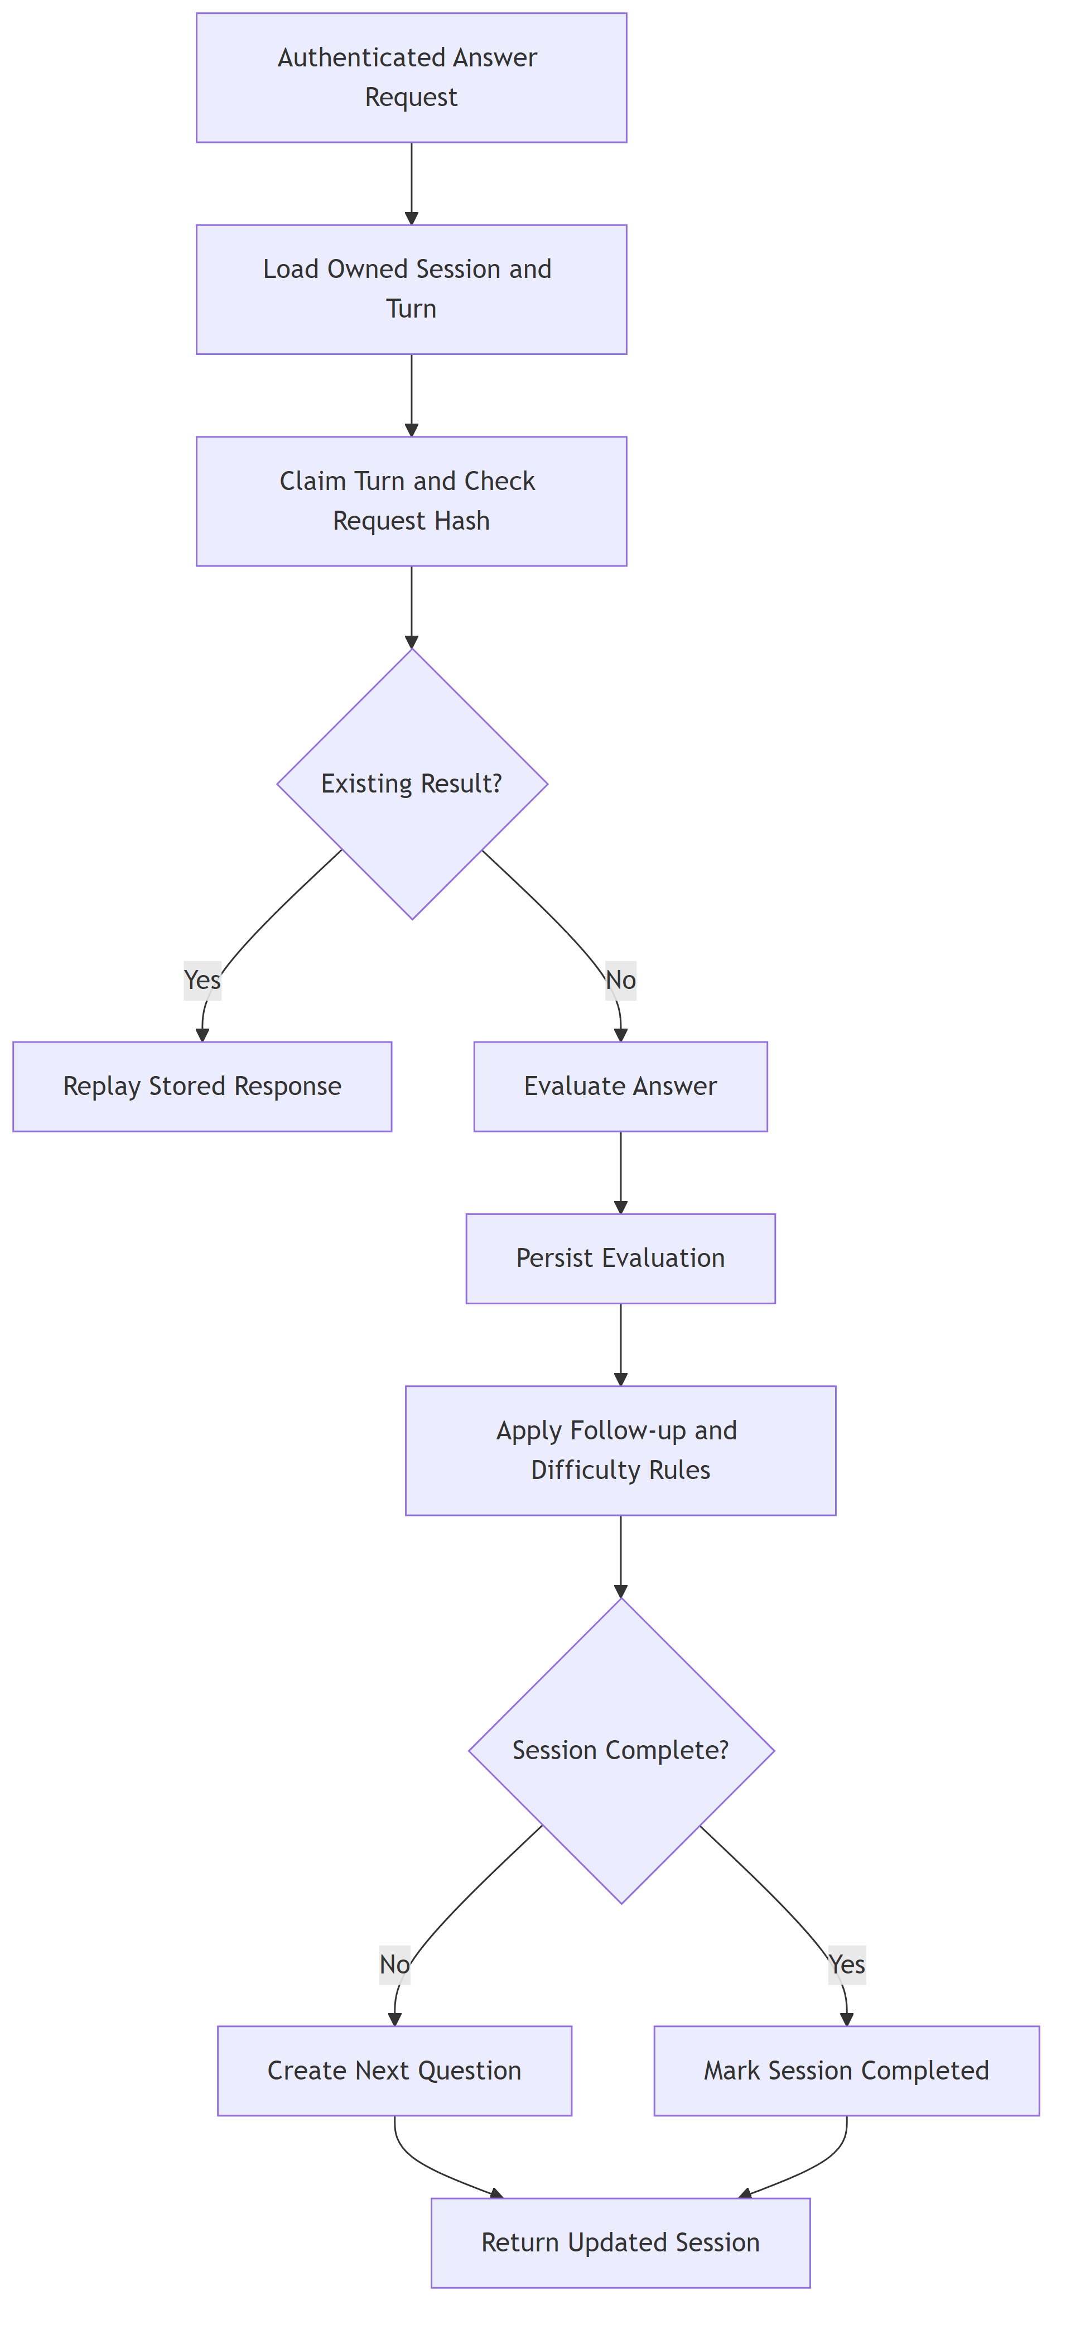
Figure IV.5: Shared answer processing for text submissions and voice transcripts.

Answer submission uses an idempotency key. The repository claim prevents concurrent repeats of the same logical answer from creating multiple turns. Once processing is complete, the stored result can be returned to a retrying client. This control is particularly important when an external language call completes after a client timeout.

IV.6 Report generation
At the end of a session, the report service collects the persisted interview state and generates a structured report. The report includes an overall assessment, strengths, improvement areas, and turn-level evidence available from the session. Reports are saved and displayed through the report route. Automated scores and suggestions remain advisory because model-based evaluation can be sensitive to wording, incomplete context, and provider behavior.

IV.7 Safety and reliability controls
The solution applies the following controls around language operations:
- typed schemas at every model boundary;
- fixed application prompts separated from user-provided document and answer data;
- bounded provider timeouts and error translation;
- repository-backed session state instead of model-owned state;
- deterministic retrieval and continuation decisions;
- authenticated, ownership-scoped access to profiles, sessions, and reports; and
- explicit UI errors instead of silent substitution when a required service fails.
These controls do not make model output infallible. They narrow its authority and provide software seams that can be verified independently.

CHAPTER V. SYSTEM DESIGN AND IMPLEMENTATION

V.1 Architectural style
FiPilot is a web application with a React client and a FastAPI backend. The active HTTP boundary is backend/gateway/main.py. The gateway composes authentication dependencies, application services, infrastructure adapters, and routers. Route handlers remain thin: they validate transport input, resolve the current user, call an application service, and return a canonical response.
The backend follows four main layers:
- gateway: REST and WebSocket transport, dependency resolution, and exception mapping;
- services and orchestrator: use cases for Resume handling, planning, questions, answers, reports, and interview progression;
- shared schemas: canonical request, response, and domain data contracts; and
- infrastructure: Firebase, document extraction, language, speech, SQLite, and Firestore adapters.
This direction keeps external APIs and storage details outside domain-facing service contracts. It also prevents the compatibility modules under backend/app from becoming a second active HTTP application.

V.2 Frontend design
Production routes are declared in frontend/src/App.tsx. React Router selects pages; TanStack Query manages server state; Zustand stores client session state where appropriate; and frontend/src/lib/api.ts centralizes authenticated API calls. Canonical TypeScript contracts live under frontend/src/types.
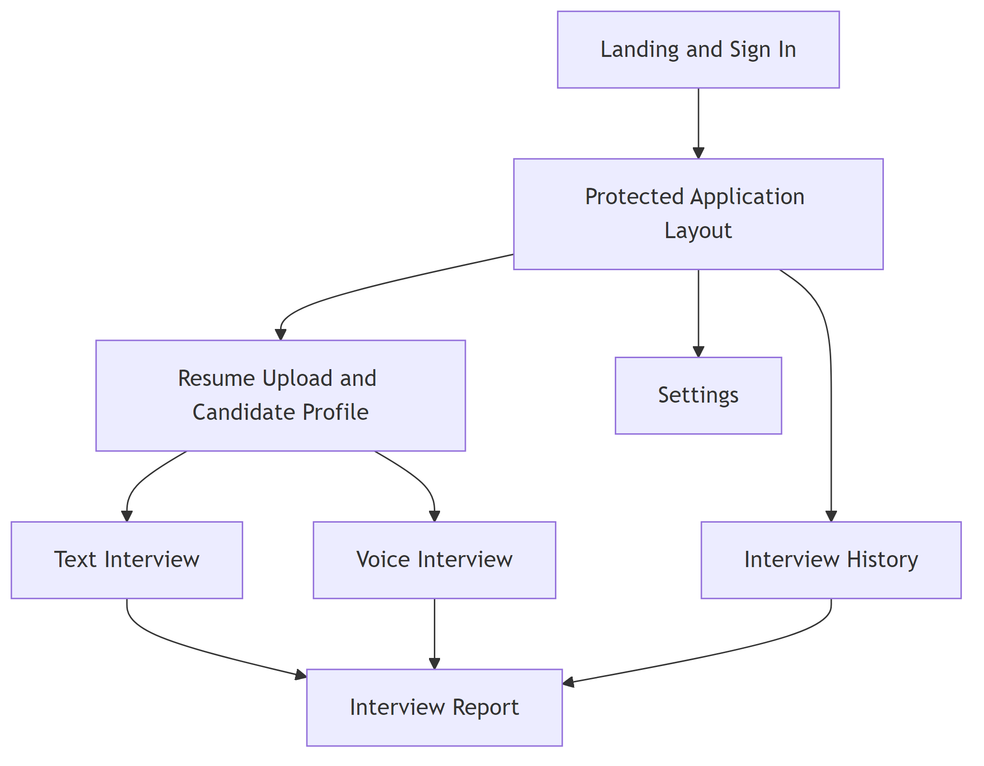
Figure V.1: Production frontend routes and their backend interactions.

The main user-facing areas are Candidate Profile review, text interview, voice interview, report, interview history, and settings. Authentication gates protected routes. The frontend retrieves a Firebase ID token from the current user and sends it as a bearer token. The server, rather than the browser, determines the authenticated user identifier.

V.3 Backend request composition
FastAPI dependencies construct repositories and services from environment settings. The storage implementation can be SQLite or Firestore while exposing the same public repository behavior. Language and speech integrations are also injected through application-facing interfaces. This composition supports local testing with deterministic substitutes without changing route contracts.
Health and readiness routes are separate. The health route indicates that the process is available. The readiness route performs configured dependency checks and can show whether the application is prepared to serve its connected integrations.

V.4 Text interview sequence
The text flow uses REST for preparation, session creation, answers, session reload, and report access. Preparation selects knowledge and creates a plan preview. Session start persists the interview and returns its first question. Each answer request includes the session identifier and an idempotency key.
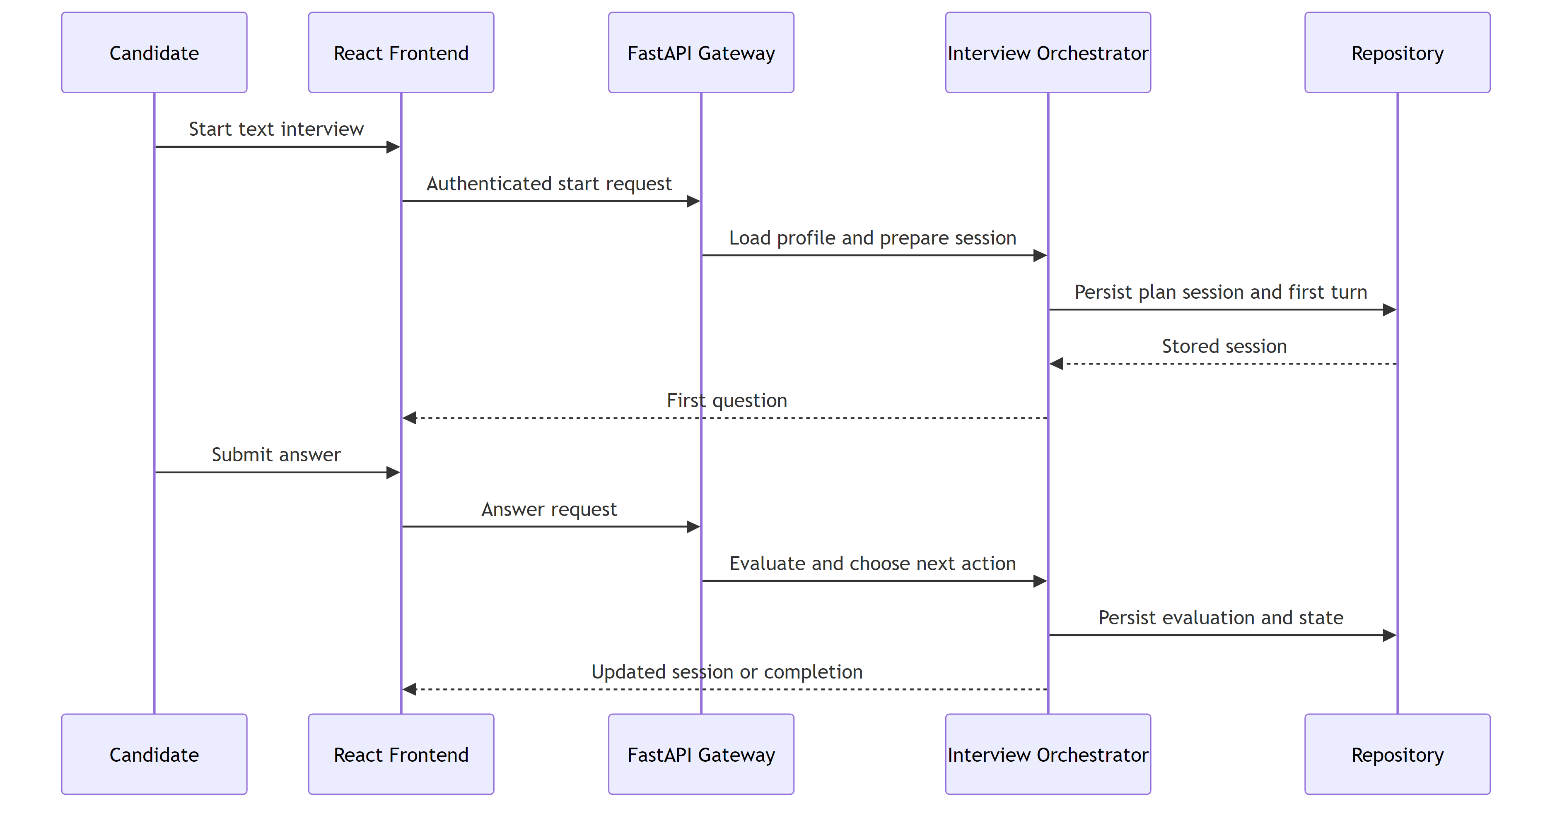
Figure V.2: Text interview request sequence.

On answer submission, the service resolves an owned session, claims the idempotency key, evaluates the answer, decides the next action, persists the updated state, and returns the session. A duplicate request does not create an additional turn. The browser can reload the persisted session after navigation or an interrupted response.

V.5 Voice interview sequence
Voice mode uses an authenticated WebSocket at /api/v2/voice/interview/:session_id. Authentication is provided through the negotiated subprotocol; the gateway also checks the request origin and session ownership before accepting an active connection. Binary PCM frames and bounded JSON control messages use the same socket.
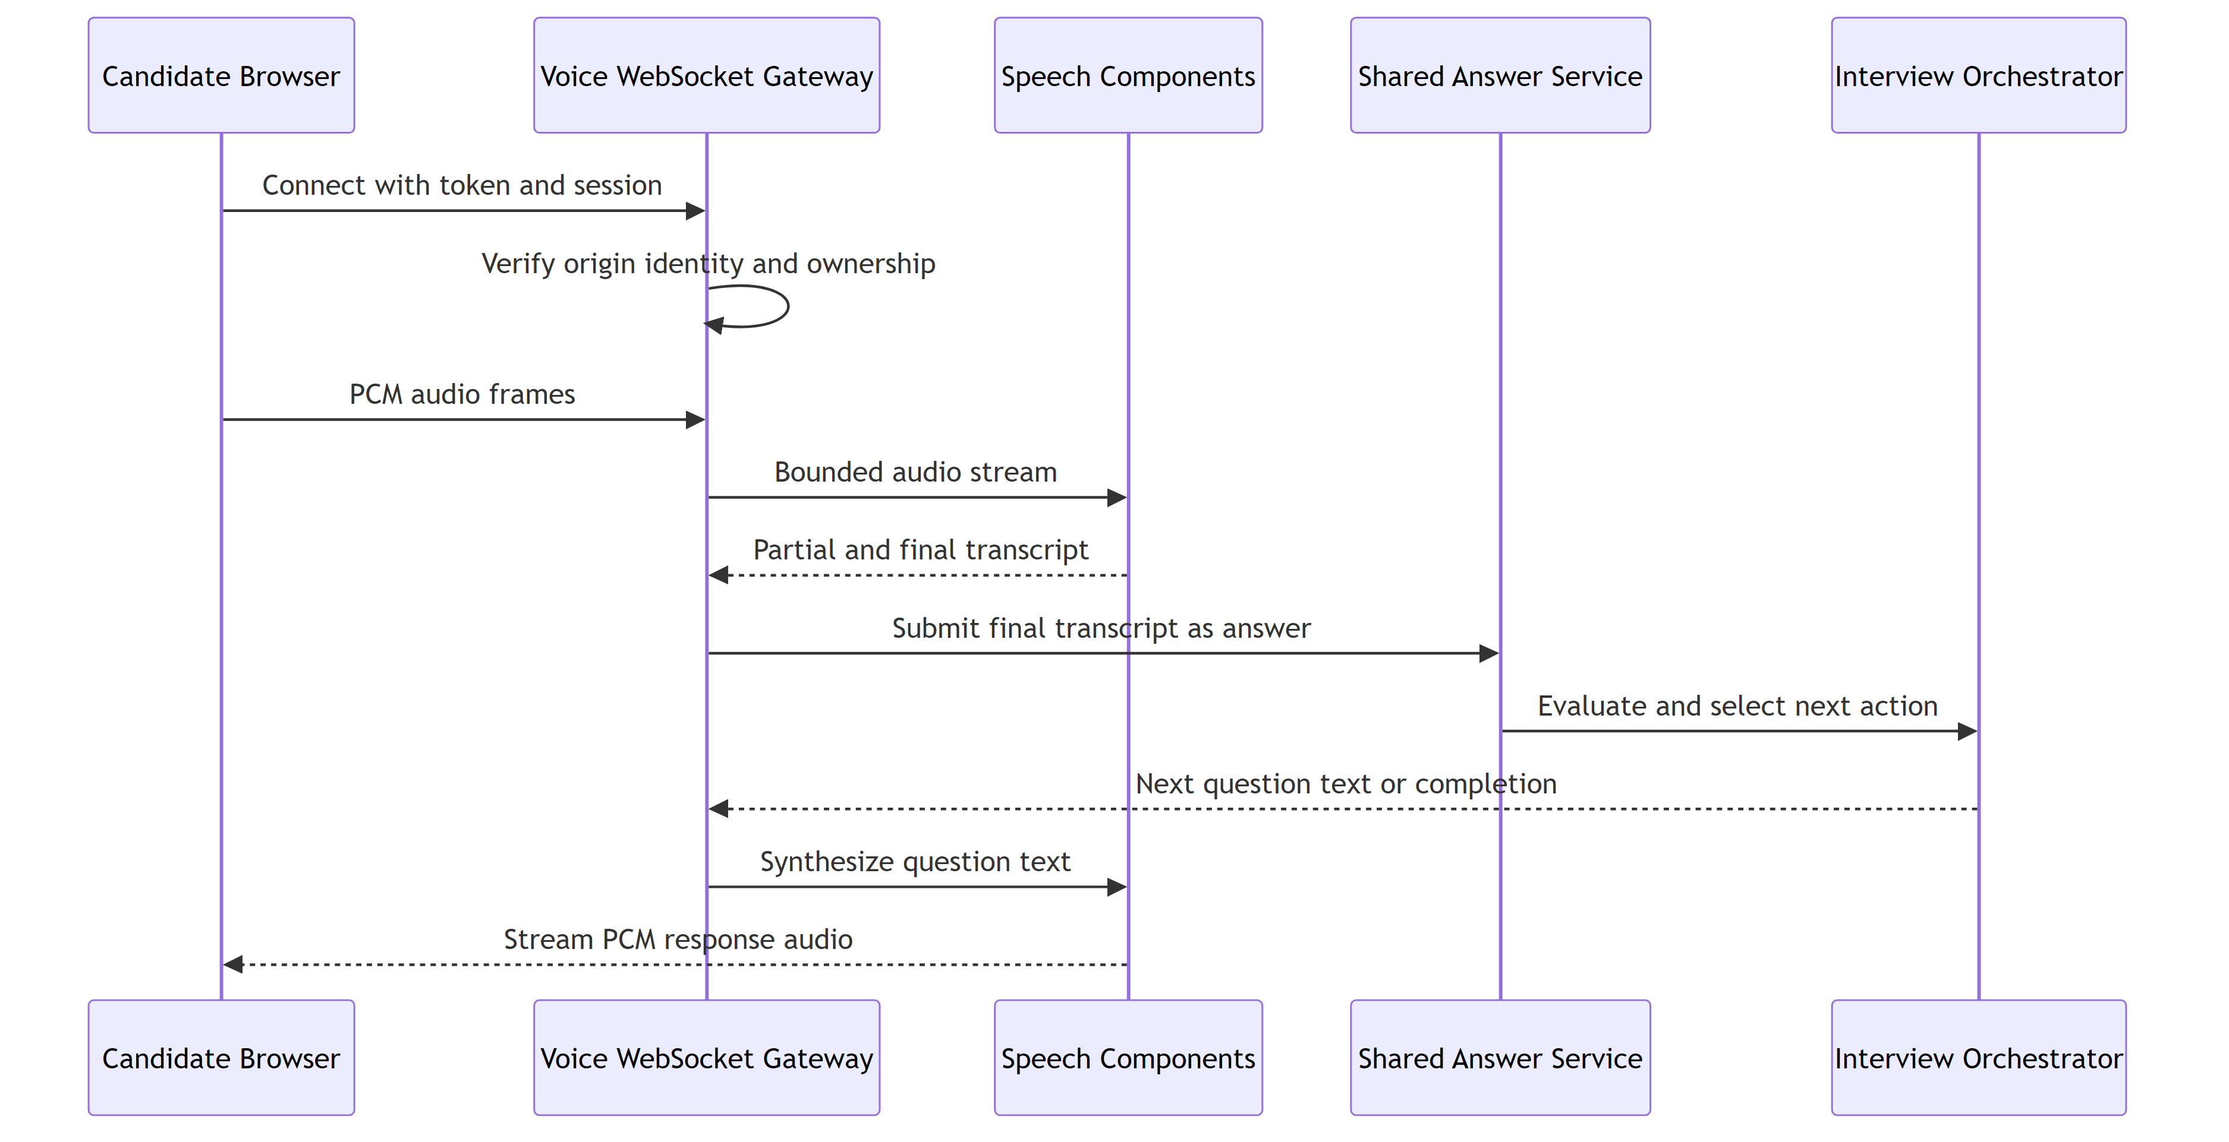
Figure V.3: Voice channel and convergence with the shared answer service.

The voice runtime detects speech, sends audio to the configured speech-to-text component, and receives transcript events. A final transcript becomes the answer input to the same application service used by the REST flow. The gateway streams question and feedback events to the client and can obtain synthesized speech for playback. Connection limits, message limits, and close codes protect the WebSocket boundary.

V.6 Persistence design
The repository contract stores candidates, Resumes, sessions, turns, reports, answer claims, and related status records. SQLite supports local operation and automated tests. Firestore supports document-oriented persistence in a Firebase environment. Both adapters are expected to preserve ownership filters and application invariants.
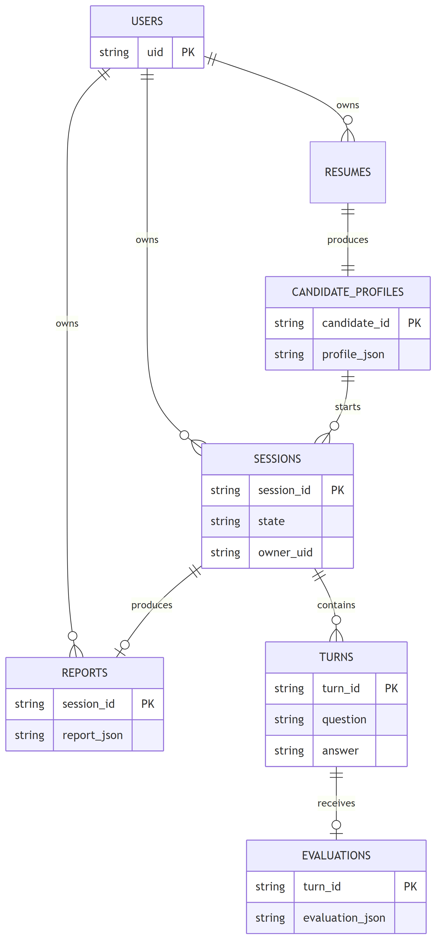
Figure V.4: Principal persisted resources and ownership relationships.

Candidate identifiers and session identifiers are resource locators, not proof of authorization. Repository calls receive the current user's identifier and return the same not-found behavior for missing and foreign resources. This avoids revealing whether another user's resource exists.

V.7 HTTP and WebSocket interfaces
Table V.1: Active application interfaces.
Method | Path | Purpose
GET | /api/v2/auth/me | Return the authenticated user contract.
POST | /api/v2/resume/upload | Validate, extract, and create candidate resources.
GET | /api/v2/candidates/:candidate_id/profile | Return the owned Candidate Profile and readiness data.
POST | /api/v2/interview/prepare | Retrieve knowledge and create an Interview Plan.
POST | /api/v2/interview/start | Create an interview session and first question.
POST | /api/v2/interview/:session_id/answer | Process one idempotent text answer.
GET | /api/v2/interview/:session_id | Reload an owned interview session.
POST | /api/v2/interview/:session_id/report | Generate and persist a report.
GET | /api/v2/interview/:session_id/report | Return the owned report.
GET | /api/v2/interviews | Return owned interview history.
WS | /api/v2/voice/interview/:session_id | Run the authenticated voice channel.
GET | /health, /ready | Process health and dependency readiness.

V.8 Authentication and ownership
Firebase Authentication establishes identity. For REST, the frontend sends Authorization: Bearer <token>; Firebase Admin verifies the token, and the gateway constructs the current-user dependency. Development authentication can be disabled through local settings, but this mode is not a production authorization mechanism.
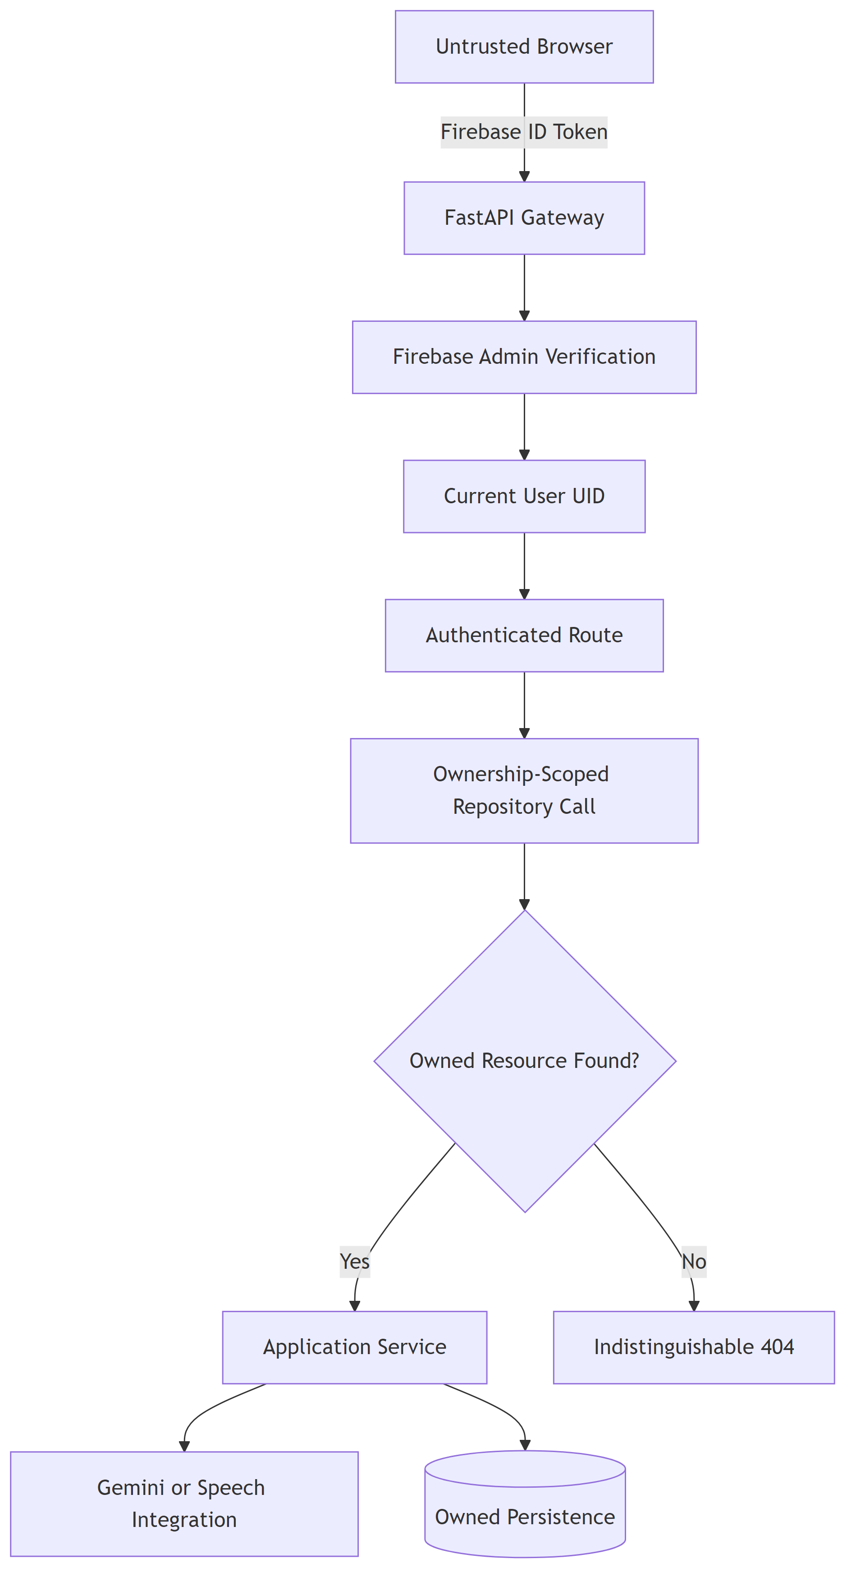
Figure V.5: Identity verification and ownership-scoped resource access.

The backend never accepts an owner identifier as authority from a request body. Profile, upload, interview, status, and report operations are scoped to the verified user. Voice connections apply the same ownership rule before session use.

V.9 Configuration and observability
Runtime settings cover authentication, Firebase, repository selection, Vertex AI, CORS origins, file limits, timeouts, and speech behavior. The repository helper loads backend/.env.local by default, or the path supplied through BACKEND_ENV_FILE. The open editor file backend/app/.env is not automatically loaded by the active helper.
The gateway uses structured logging and application-level exception handlers. Provider errors are translated into stable HTTP responses, while detailed internal messages remain in server logs. Request identifiers and explicit state values support diagnosis without placing application state inside prompt text.

CHAPTER VI. SOFTWARE REQUIREMENTS SPECIFICATION

VI.1 Product perspective
FiPilot is a browser-based application whose primary workflow begins with an authenticated user and a Resume. The frontend depends on the FastAPI gateway for all authoritative candidate and interview data. The backend depends on Firebase for production identity, a configured Vertex AI project for language operations, a repository adapter for persistence, and speech components for voice mode.
The specification in this chapter documents behavior observable in the connected application. It does not introduce proposed upload replacement, profile-edit mutation, or deployment behavior.

VI.2 Actors and external systems
Table VI.1: Actors and connected systems.
Actor or system | Responsibility
Candidate | Signs in, uploads a Resume, reviews the profile, configures an interview, answers questions, and reads the report.
Firebase Authentication | Issues the client identity token; Firebase Admin verifies it at the backend.
Vertex AI Gemini | Produces schema-constrained profile, plan, question, evaluation, and report content.
SQLite or Firestore | Stores user-scoped application resources through the repository contract.
Speech components | Convert voice audio to transcripts and generated text to audio in voice mode.
Local Knowledge catalog | Supplies reviewable technical topic context to the interview planner.

VI.3 Functional requirements
Table VI.2: Implemented functional requirements.
ID | Requirement
FR-01 | The system shall authenticate protected REST and voice operations and resolve the user identity on the server.
FR-02 | The system shall accept one PDF or DOCX Resume whose size is at most 10 MB and reject unsupported or structurally invalid files.
FR-03 | The system shall extract native document text and use OCR for a PDF when native text is insufficient.
FR-04 | The system shall convert accepted Resume text into the canonical Candidate Profile and persist it for the authenticated user.
FR-05 | The system shall return the owned Candidate Profile with a strong version tag and structured readiness information.
FR-06 | The system shall select relevant local Knowledge records using the candidate and interview configuration.
FR-07 | The system shall prepare a structured Interview Plan before an interview begins.
FR-08 | The system shall create a persisted text or voice Interview Session and return its current state.
FR-09 | The system shall generate a question for the active plan round.
FR-10 | The system shall accept a nonblank text answer or a finalized voice transcript and evaluate it through the shared answer service.
FR-11 | The system shall prevent the same logical answer submission from producing duplicate turns.
FR-12 | The system shall use deterministic workflow rules to continue, follow up, change round, or complete the session.
FR-13 | The system shall allow an authenticated owner to reload a session and list interview history.
FR-14 | The system shall generate, persist, and return a final report for an owned completed session.
FR-15 | The voice interface shall validate origin, authentication, session ownership, message type, and message size before processing audio.
FR-16 | Foreign and missing owned resources shall use an indistinguishable not-found response.

VI.4 Primary use cases

VI.4.1 Upload and review a Resume
Precondition: the candidate is authenticated. The candidate selects one PDF or DOCX file. The client sends it to the Resume endpoint. The backend validates and extracts the document, creates a Candidate Profile, persists the candidate resources, and returns the result. The profile page displays the structured fields and readiness issues. If validation, extraction, or provider processing fails, the system returns a structured error and does not present a successful profile.

VI.4.2 Complete a text interview
Precondition: an owned Candidate Profile exists. The candidate selects interview settings and asks the server to prepare the interview. The server selects knowledge and produces a plan. Start creates the session and first question. For each turn, the candidate submits an answer; the service evaluates it, stores the turn, and returns the next state. When the session is complete, the candidate requests and reads the report.

VI.4.3 Complete a voice interview
Precondition: an owned voice-mode session exists and the browser can access a microphone. The client opens the authenticated WebSocket and sends supported control and PCM audio messages. The server produces speech events and transcripts. Final transcripts use the shared answer flow. The candidate receives the question, feedback, and next session state through socket events.

VI.4.4 Review interview history
The authenticated candidate opens the history page. The client requests a paginated list of owned sessions. Selecting a session reloads its stored state or report. The server never uses a client-supplied owner identifier to broaden the query.

VI.5 Data requirements
All persisted candidate, session, and report resources have server-assigned identifiers and an owner. Candidate Profile fields use one canonical naming scheme. Session state contains its mode, plan, current round, turns, status, and timestamps required by the application. Answer claims bind a logical turn to its processing result. Reports are associated with a session and can be retrieved only through ownership-scoped access.
Strong profile versions are returned through the ETag response header. Model-generated data must pass the corresponding Pydantic schema before persistence. Transport schemas reject missing required fields and invalid enum values.

VI.6 Quality requirements
Table VI.3: Quality requirements and implementation mechanisms.
Attribute | Requirement | Mechanism
Security | Protected data is available only to its authenticated owner. | Token verification, current-user dependency, origin check, and ownership-scoped repositories.
Reliability | Retries must not duplicate an answer turn. | Repository-backed idempotency claim and replayed result.
Integrity | AI responses must match application contracts. | Structured generation plus Pydantic validation.
Maintainability | Transport, application logic, and infrastructure remain separable. | Gateway, services, shared schemas, and adapter boundaries.
Portability | Local and Firebase-backed persistence share behavior. | Common repository interface with SQLite and Firestore implementations.
Usability | Users can see progress, errors, current questions, and report output. | Route-specific UI state and structured backend responses.
Accessibility | Core interactions support semantic controls and keyboard operation. | Reusable UI controls, labels, focus treatment, and responsive layouts.
Observability | Failures can be traced without exposing internals to clients. | Request identifiers, structured logs, and stable error responses.

VI.7 Operational limits
The application requires network access for configured Firebase and Vertex AI operations. Voice mode additionally requires browser microphone permission and available speech services. Resume interpretation is limited by document quality and the information present in the file. Generated questions and assessments can contain model errors, so users must treat the report as interview-practice feedback rather than an employment decision.
The repository does not contain a checked-in continuous-integration workflow. Local commands therefore provide the verified software baseline. Environment-specific deployment, live provider quotas, latency at scale, and production availability are outside this report's verified claims.

CHAPTER VII. SOFTWARE TESTING

VII.1 Test strategy
Testing follows the public boundaries of the application. Schema tests protect data contracts. Service and orchestrator tests exercise use cases with controlled dependencies. Repository contract tests verify both ownership and persistence behavior. API tests send requests through FastAPI. Frontend tests use React Testing Library to exercise rendered user behavior. Build and compilation checks identify integration errors not covered by individual cases.
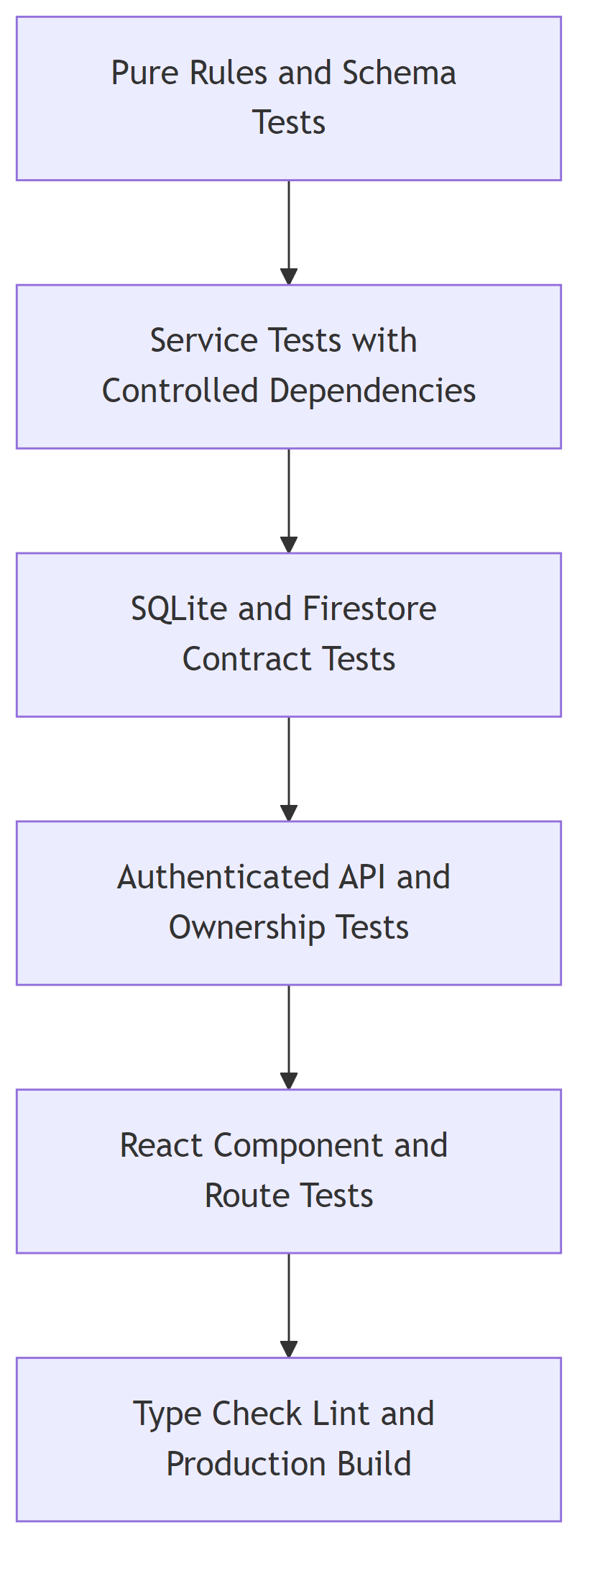
Figure VII.1: Software verification layers used by the project.

The project uses deterministic substitutes for language, authentication, and storage dependencies where a test is intended to verify application behavior. This keeps assertions focused on request contracts, orchestration, error handling, and persistence rather than external provider variability.

VII.2 Backend verification
Backend tests are located in backend/app/tests. They cover authentication, ownership, Resume upload, document extraction, repository behavior, Candidate Profile responses, interview preparation and start, answer idempotency, report access, history, voice protocol behavior, and error translation.
Table VII.1: Representative backend test areas.
Area | Verified behavior
Authentication | Missing, malformed, invalid, and accepted identity tokens; local authentication configuration.
Ownership | Owned, foreign, and missing candidates, sessions, reports, and voice connections.
Resume boundary | File type, file signature, maximum size, PDF/DOCX extraction, OCR fallback, and structured errors.
Candidate Profile | Canonical schema, strong ETag, and structured readiness response.
Interview workflow | Preparation, start, state transitions, follow-up decisions, completion, and reload.
Answer submission | Turn claim, concurrent duplicate handling, replay, evaluation failure, and stored result.
Persistence | SQLite and Firestore contract behavior at the application interface.
Voice | Authentication, origin, control messages, binary audio limits, transcript flow, and disconnect behavior.
Reports and history | Generation, retrieval, pagination, not-found behavior, and ownership.

Python compilation is also run over the active backend packages: core, gateway, infrastructure, orchestrator, services, shared, and speech_service. The repository does not configure a separate Python static type checker or linter, so this report does not claim such a result.

VII.3 Frontend verification
Frontend tests cover route access, Firebase token handling, API error presentation, upload interaction, Candidate Profile rendering, text interview state, voice state, history, reports, and shared UI behavior. TypeScript project compilation checks client contracts. ESLint checks configured source rules. The production Vite build checks bundling and asset generation.
Table VII.2: Frontend verification commands.
Command | Purpose
npm exec tsc – -b | Compile the TypeScript project graph.
npm run lint | Apply the configured ESLint rules.
npm test | Run the complete Vitest and React Testing Library suite.
npm run build | Produce the Vite production bundle.

VII.4 Current verification result
The verification run used for this report produced the results in the referenced table. Counts describe the repository at the time of the run and may change when tests are added.
Table VII.3: Current software verification result.
Check | Result | Evidence
Backend pytest collection | Pass | 286 tests passed.
Backend Python compilation | Pass | Active backend packages compiled without syntax errors.
Frontend TypeScript compilation | Pass | Project build completed without type errors.
Frontend lint | Pass | Configured lint command completed successfully.
Frontend test suite | Pass | 119 tests passed.
Frontend production build | Pass | Vite created the production bundle.

VII.5 Acceptance-oriented scenarios
Table VII.4: Selected acceptance scenarios.
ID | Scenario | Expected result
AT-01 | Authenticated user uploads a valid PDF. | Text is extracted, the profile is validated and persisted, and candidate identifiers are returned.
AT-02 | User uploads a DOCX with an invalid binary signature. | The request is rejected without invoking profile generation.
AT-03 | PDF contains insufficient native text. | The OCR path is invoked and its extraction status is represented in the result.
AT-04 | User requests another user's candidate profile. | The response is the same not-found shape used for a missing profile.
AT-05 | Candidate prepares and starts an interview. | Knowledge is selected, a plan is available, and a persisted session returns its first question.
AT-06 | Client repeats the same answer turn. | The stored result is replayed and no duplicate turn is created.
AT-07 | Voice connection has an invalid token or disallowed origin. | The gateway closes the connection with the documented protocol response.
AT-08 | Final transcript is accepted in voice mode. | It is evaluated through the shared answer service and advances the same session state.
AT-09 | Owner requests a completed report. | The service returns the report associated with the owned session.
AT-10 | History request uses pagination. | Only owned sessions within the requested page are returned with the total count.

VII.6 Testing limitations
The passing software suite establishes behavior for the checked-in test cases; it does not establish human-level assessment accuracy. The project has no checked-in browser end-to-end or visual-regression suite covering every production route and viewport. This report also makes no claim about load capacity, long-duration WebSocket stability, provider availability, broad Resume populations, or comparative model quality. Those areas require operational or user-study evidence beyond the current application suite.

CHAPTER VIII. DELIVERABLES AND USER GUIDE

VIII.1 Project deliverables
Table VIII.1: Repository deliverables.
Deliverable | Location and content
Frontend application | frontend/: React pages, components, client contracts, API client, styles, and tests.
Backend application | backend/gateway, backend/services, backend/orchestrator, backend/infrastructure, and backend/shared.
Backend tests | backend/app/tests: application boundary and regression coverage.
Knowledge catalog | backend/services/interview_knowledge: local catalog, level guide, loader, and retriever.
Speech service | backend/speech_service: optional speech runtime used by the voice integration.
Architecture and development documents | docs/, CONTEXT.md, and repository instructions.
Project report | report/Final_report.pdf with LaTeX sources, diagrams, and build scripts.

VIII.2 Local prerequisites
The supported local workflow uses Python 3.12, Node.js with npm, and PowerShell. Firebase and Vertex AI settings are required for connected provider behavior. Voice mode may require the optional speech-service environment described in docs/local-development.md.

VIII.3 Installation
From the repository root, create the backend environment and install dependencies:
Backend dependency installation.
cd backend
py -3.12 -m venv .venv
.\.venv\Scripts\Activate.ps1
python -m pip install -r requirements-dev.txt
Install the frontend dependencies:
Frontend dependency installation.
cd ..\frontend
npm ci

VIII.4 Environment configuration
Create local backend settings in backend/.env.local, or point BACKEND_ENV_FILE to an explicit settings file before using the repository helper. Configure authentication, Firebase project details, repository selection, Vertex AI location and model settings, allowed frontend origins, and speech settings required by the chosen mode. Secrets must not be committed.
The legacy path backend/app/.env is not loaded automatically by scripts/run_backend.ps1. Editing that file alone does not change the active gateway configuration.
The frontend Firebase values are supplied through its Vite environment settings. The browser and backend projects must refer to compatible Firebase authentication configuration.

VIII.5 Starting the application
Run the backend from backend/:
Start the active FastAPI gateway.
python -m uvicorn gateway.main:app --reload `
--host 127.0.0.1 --port 8000
Alternatively, from the repository root:
Start the backend with the repository helper.
powershell -ExecutionPolicy Bypass `
-File .\scripts\run_backend.ps1
Run the frontend from frontend/:
Start the Vite frontend.
npm run dev -- --host localhost
For voice mode, start the optional speech service from the repository root as documented in docs/local-development.md:
Start the optional speech service.
powershell -ExecutionPolicy Bypass `
-File .\scripts\run_speech_service.ps1

VIII.6 Candidate workflow

VIII.6.1 Sign in and upload
Open the frontend and sign in with the configured Firebase provider. Choose a single Resume in PDF or DOCX format. The maximum accepted size is 10 MB. Wait for validation, extraction, and profile creation to complete. If the application rejects the file, correct the indicated file type, file structure, size, or provider configuration before retrying.

VIII.6.2 Review the Candidate Profile
Open Candidate Profile review and inspect the name, recent role, specialization, skills, evidence, projects, experiences, and education displayed from the server response. Readiness issues identify missing information required by the profile-readiness rules. The displayed strong version belongs to the server resource.

VIII.6.3 Configure and start a text interview
Choose the interview settings available in the interface. Preparation selects Knowledge records and creates the Interview Plan. Start creates a new session. Read the current question, submit one answer, and wait for the returned feedback and next question. Avoid sending the same turn from multiple tabs; if a network retry occurs, the server's answer claim protects the stored turn.

VIII.6.4 Use voice mode
Grant browser microphone permission and open the voice interview route for the session. The status display indicates connection and speech state. Speak after the current question. The application sends audio, shows transcripts and feedback, and advances through the shared session workflow. If the connection closes, use the displayed error and server state to recover rather than starting unrelated submissions.

VIII.6.5 Read history and reports
The History page lists owned interview sessions. Open a completed session and request its report. Review the summary, strengths, improvement areas, and recommendations as practice guidance. Model-generated evaluation is not an employment decision or a verified measure of professional competence.

VIII.7 Developer verification
Before handing off a change, run the backend tests and compilation from backend/:
Backend verification.
python -m pytest
python -m compileall -q core gateway infrastructure `
orchestrator services shared speech_service
Run the frontend checks from frontend/:
Frontend verification.
npm exec tsc -- -b
npm run lint
npm test
npm run build
The repository does not include a checked-in continuous-integration workflow, so these local checks are required for the current project baseline.

CHAPTER IX. CONCLUSION

IX.1 Achieved result
FiPilot implements an authenticated CV-to-interview workflow across a React frontend and a FastAPI backend. It validates and extracts PDF or DOCX Resumes, uses OCR when a PDF lacks sufficient text, creates a canonical Candidate Profile, selects technical context from a local Knowledge catalog, prepares an Interview Plan, generates questions, evaluates text or transcribed voice answers, applies deterministic session decisions, persists interview history, and produces a final report.
The main architectural result is not a single prompt. It is the separation of responsibilities around probabilistic language operations. Schemas define accepted output. Repository state defines the interview. Firebase identity defines the user. Lexical retrieval defines the selected technical context. The decision service defines progression. REST and WebSocket channels converge before answer evaluation. These boundaries make the application understandable and testable as software.

IX.2 Technical contributions
The project contributes a cohesive implementation in the following areas:
- a guarded document-ingestion path for PDF and DOCX with OCR fallback;
- one Candidate Profile contract shared by Resume review and interview services;
- a reviewable, deterministic local knowledge-selection mechanism;
- schema-constrained language operations for profile, plan, question, evaluation, and report data;
- persisted multi-turn orchestration with idempotent answer submission;
- a shared answer boundary for text and voice interaction;
- ownership-scoped access implemented at gateway and repository seams; and
- interchangeable SQLite and Firestore persistence behind one application contract.

IX.3 Verified software status
The current repository verification passed 286 backend tests, backend Python compilation, frontend TypeScript compilation, configured lint, 119 frontend tests, and the production frontend build. These results support the implemented software contracts documented in this report. They do not establish broad Resume interpretation accuracy, speech accuracy, model-comparison quality, production scale, or service availability.

IX.4 Known limitations
Resume extraction remains sensitive to unusual layout and scan quality. Automated evaluation can be wrong or incomplete and must remain advisory. Profile readiness is returned by the backend, but the current start route does not yet use it as an authoritative rejection. Session creation and report-profile consistency do not yet provide the complete immutable profile snapshot behavior required for strong historical reproducibility. The active Resume route also does not provide the full replacement and persisted upload-idempotency lifecycle described in broader design documents.
Voice operation depends on microphone quality, connection stability, and configured speech services. Live provider status and deployment behavior vary by environment and were not used as evidence for this report. The repository has no checked-in browser end-to-end, visual-regression, load, or production-availability suite.

IX.5 Overall assessment
Within these limits, FiPilot is a complete application-level demonstration of governed language-service integration. It connects Resume evidence, curated technical knowledge, a persisted interview workflow, two interaction channels, and user-owned reports without assigning authentication or workflow authority to model output. The result is a credible foundation for interview practice and a concrete software-engineering case study in applying AI services through explicit contracts.

REFERENCES
[1] A. Vaswani et al., “Attention Is All You Need,” Advances in Neural Information Processing Systems, vol. 30, 2017.
[2] P. Lewis et al., “Retrieval-Augmented Generation for Knowledge-Intensive NLP Tasks,” Advances in Neural Information Processing Systems, vol. 33, 2020.
[3] L. Zheng et al., “Judging LLM-as-a-Judge with MT-Bench and Chatbot Arena,” Advances in Neural Information Processing Systems, vol. 36, 2023.

APPENDIX A. RUNTIME CONTRACT REFERENCE

A.1 Canonical profile structure
Table A.1: Candidate Profile nested structure.
Structure | Canonical fields
Candidate Profile | name, years_experience, recent_role, specialization, skills, skill_evidence, projects, experiences, education.
Project | name, description, technologies, role.
Experience | company, title, start_date, end_date, description, technologies.
Structured education | institution, degree, field_of_study, start_date, end_date.
Skill evidence | skill, evidence, and server-issued evidence_id for an existing entry.

A.2 Runtime source index
Table A.2: Principal source locations supporting the report.
Location | Responsibility
backend/gateway/main.py | Active FastAPI application and router composition.
backend/gateway/api | REST and WebSocket transport endpoints.
backend/core/dependencies.py | Authentication and application dependency composition.
backend/shared/schemas | Canonical backend transport and domain contracts.
backend/services/profile_scanner | Resume-to-profile language operation.
backend/services/interview_knowledge | Local catalog loading and lexical retrieval.
backend/services/interview_planner | Structured Interview Plan generation.
backend/services/question_generator | Turn-level question generation.
backend/services/answer_evaluator | Structured answer evaluation.
backend/services/interview_answer_service.py | Shared idempotent answer use case.
backend/orchestrator | Conversation progression and deterministic decisions.
backend/services/report_generator | Report generation and retrieval service.
backend/infrastructure/documents | PDF, DOCX, and OCR extraction.
backend/infrastructure/repositories | SQLite and Firestore persistence adapters.
backend/infrastructure/llm | Vertex AI Gemini integration.
backend/infrastructure/speech | Speech integration adapters.
frontend/src/App.tsx | Production route declaration.
frontend/src/lib/api.ts | Centralized backend API client.
frontend/src/types | Canonical frontend contracts.

A.3 Report build
The report sources are in report/. Mermaid sources under report/diagrams are rendered to high-resolution PNG files before XeLaTeX compilation. Each report figure is placed at a readable page width with a bounded height and an intervening float barrier, which prevents later text or figures from overlaying it.
From the repository root, build the report with:
Project report build command.
powershell -ExecutionPolicy Bypass `
-File .\report\scripts\build_report.ps1
The build performs diagram rendering, XeLaTeX and Biber passes, and log checks for unresolved references and material page overflow.

