CAN THO UNIVERSITY
COLLEGE OF INFORMATION TECHNOLOGY AND COMMUNICATION



THESIS
SOFTWARE ENGINEERING

WEB APPLICATION FOR DENTAL CLINIC APPOINTMENT MANAGEMENT

Student Group:
Quách Khoa Hiển B2203554
Phạm Hữu Hưng B2203557
Trần Nguyễn Khánh Quốc B2203576

Cần Thơ, 09/2025

SUPERVISOR’S EVALUATION

.………...………...………...………...………...………...………...…………………
.………...………...………...………...………...………...………...…………………
.………...………...………...………...………...………...………...………………………….………...………...………...………...………...………...………...………………………….………...………...………...………...………...………...………...………………………….………...………...………...………...………...………...………...………………………….………...………...………...………...………...………...………...………………………….………...………...………...………...………...………...………...………………………….………...………...………...………...………...………...………...………………………….………...………...………...………...………...………...………...………………………….………...………...………...………...………...………...………...………………………….………...………...………...………...………...………...………...………………………….………...………...………...………...………...………...………...………………………….………...………...………...………...………...………...………...………………………….………...………...………...………...………...………...………...………………………….………...………...………...………...………...………...………...………………………….………...………...………...………...………...………...………...………………………….………...………...………...………...………...………...………...………………………….………...………...………...………...………...………...………...………………………….………...………...………...………...………...………...………...………………………….………...………...………...………...………...………...………...………………………….………...………...………...………...………...………...………...………………………….………...………...………...………...………...………...………...……………………………………………

Cần Thơ, ngày … … tháng … … năm 2025

Supervisor

TABLE OF CONTENT

SUPERVISOR’S EVALUATION i
TABLE OF CONTENT ii
LIST OF TABLES v
LIST OF FIGURES vi
LIST OF ABBREVIATIONS vii
ABSTRACT ix
INTRODUCTION 1
1. Problem Statement 1
2. Background and Related Works 1
3. Research Objectives 2
4. Research Subjects and Scope 2
4.1. Research Subjects 2
4.2. Research Scope 2
5. Research Methods and Content 3
5.1. Research Methods 3
5.2. Research Content 4
5.2.1. Implementation Process 4
5.2.2. Technologies for Application Development 5
6. Key Contributions of the Project 6
7. Thesis Structure 6
MAIN CONTENT 8
CHƯƠNG 1. PROBLEM DESCRIPTION OF DEVELOPING A DENTAL CLINIC APPOINTMENT WEB APPLICATION 8
1. Introduction 8
2. Functional Requirements 9
2.1. Use cases for Patient 9
2.1.1. Use Case Diagram 9
2.1.2. Book Appointment 9
2.1.3. Chat with Chatbot 11
2.2. Use cases for Admin 12
2.2.1. Use Case Diagram 12
2.2.2. Manage Appointment 13
2.2.3. Manage Patient Record 14
2.2.4. Manage Billings and Payments 16
3. Non-Functional Requirements 17
3.1. Performance 17
3.2. Security 17
3.3. Reliability and Availability 18
3.4. Usability 18
3.5. Safety 18
CHƯƠNG 2. THEORETICAL FOUNDATION 19
1. Node.js 19
2. Express.js 19
3. React.js 19
4. MongoDB 19
5. GeminiAPI 20
6. WebSocket 20
CHƯƠNG 3. SOLUTION DESIGN AND IMPLEMENTATION 21
1. System Architecture 21
2. Data Design 22
2.1. Data Model 22
2.2. Data Dictionary 25
2.2.1. Collection appointments 25
2.2.2. Collection bills 26
2.2.3. Collection chats 28
2.2.4. Collection chatmessages 29
2.2.5. Collection clinicsetting 29
2.2.6. Collection inventories 30
2.2.7. Collection medicalrecords 31
2.2.8. Collection procedures 32
2.2.9. Collection treatmentplans 33
2.2.10. Collection users 34
3. Functional Design 36
3.1. Function Design for Patient 36
3.1.1. Book Appointment 36
3.1.2. Chat with Chatbot 37
3.2. Function Design for Admin 39
3.2.1. Manage Appointment 39
3.2.2. Manage Patient Record 43
3.2.3. Manage Billings and Payments 44
CHƯƠNG 4. TESTING AND EVALUATION 47
1. Testing Objectives 47
2. Testing Scope 47
2.1. Functions to Be Tested 47
2.2. Functions Not Tested 48
3. Testing Strategy 48
3.1. Testing Approach 48
3.2. Applied Testing Levels 49
3.3. Testing Environment 49
3.5.1. Minimum Hardware Configuration 49
3.5.2. Software Configuration 49
3.5.3. Mobile Devices and Emulators 50
3.5.4. Testing Support Tools 50
3.5.5. Other Setup Conditions 50
3.4. Test Data 50
4. Test Cases 52
4.1. Testing function Book Appointment 52
4.2. Testing function Chat with Chatbot 53
4.3. Testing the patient pipeline for admin/staff 54
4.4. Testing function Manage patient record 58
4.5. Testing function Manage Billings and Payments 59
5. Evaluation of Test Results 61
CONCLUSION 62
1. Results Obtained 62
1.1. Knowledge and Skills 62
1.2. Program and Practical Implementation 62
2. Limitations and Challenges 62
3. Future Works 63
REFERENCES 64

LIST OF TABLES

Table 1. Use Case Book Appointment 9
Table 2. Use Case Chat with Chatbot 11
Table 3. Use case Manage Appointment 13
Table 4. Use Case Manage Patient Records 14
Table 5. Use Case Manage Billings and Payments 16
Table 6. Collection appointments 25
Table 7. Collection bills 27
Table 8. Collection chats 28
Table 9. Collection chatmessages 29
Table 10. Collection clinicsetting 29
Table 11. Collection inventories 30
Table 12. Collection medicalrecords 31
Table 13. Collection procedures 32
Table 14. Collection treatmentplans 33
Table 15. Collection users 34
Table 16. Testing function Book Appointment 52
Table 17. Testing function Chat with Chatbot 53
Table 18. Testing the patient pipline for admin/staff 55
Table 19. Testing function Manage patient record 58
Table 20. Testing function Manage Billings and Payments 59

LIST OF FIGURES

Figure 1. Use Case Diagram for Patient 9
Figure 2. Use Case Diagram for Admin 12
Figure 3. Context Diagram 21
Figure 4. Container Diagram 22
Figure 5. Conceptual Data Modeling 23
Figure 6. Physical Data Modeling 24
Figure 7. Interface Book Appointment 36
Figure 8. Sequence Diagram for Book Appointment 37
Figure 9. Interface for Chat with Chatbot 38
Figure 10. Sequence Diagram for Chat with Chatbot 39
Figure 11. Interface of Manage Appointment 40
Figure 12. Sequence Diagram of Manage Appointment 42
Figure 13. Interface of Manage Patient Record 43
Figure 14. Sequence Diagram of Manage Patient Record 44
Figure 15. Interface for Manage Billings and Payments 45
Figure 16. Sequence Diagram for Manage Billings and Payments 46

LIST OF ABBREVIATIONS

No. | Term/ Abbreviation | Definition/ Explanation
1 | SRS | Software Requirements Specification – A document that describes the nature of a project, software, or application, including functional and non-functional requirements.
2 | MEVN | MongoDB, Express.js, React.js, Node.js – A collection of JavaScript-based technologies used to develop web applications.
3 | API | Application Programming Interface – A set of rules and protocols that allows different software applications to communicate with each other.
4 | RBAC | Role-Based Access Control – A method of restricting network access based on the roles of individual users within an enterprise (e.g., Admin, Dentist, Receptionist).
5 | LLM | Large Language Model – An AI model capable of understanding and generating human language, used in this project via the Gemini API.
6 | IDE | Integrated Development Environment – Software for building applications that combines common developer tools into a single GUI (e.g., Visual Studio Code).
7 | UI / UX | User Interface / User Experience – The visual elements of the application and the overall experience of the user when interacting with the system.
8 | SPA | Single-Page Application – A web application that interacts with the user by dynamically rewriting the current web page with new data from the web server, instead of loading entire new pages.
9 | JSON | JavaScript Object Notation – A lightweight data-interchange format that is easy for humans to read and write and easy for machines to parse and generate.
10 | BSON | Binary JSON – A binary-encoded serialization of JSON-like documents, used by MongoDB for data storage.
11 | SCM | Source Code Management – Tools used to track modifications to a source code repository (e.g., Git & GitHub).
12 | CDM | Conceptual Data Model – A structured view of the data required to support business processes, independent of any physical storage.
13 | PDM | Physical Data Model – A representation of a data design which takes into account the facilities and constraints of a given database system.
14 | DOM | Document Object Model – A programming interface for web documents that represents the page so that programs can change the document structure, style, and content.

ABSTRACT

Context: In the context of rapid digital transformation, applying information technology to healthcare management has become urgent to enhance service quality. While modern technology offers immense potential for optimization, a significant number of small and medium-sized dental clinics still operate using manual processes, paper-based logbooks, or fragmented software tools. This reliance on outdated administrative methods frequently results in operational inefficiencies, such as prone-to-error scheduling, difficulties in retrieving patient medical history, and communication bottlenecks between staff and patients. These limitations ultimately lead to scheduling conflicts, wasted resources, and a diminished patient experience due to unnecessary waiting times and a lack of accessible service information.
Objective: The objective of this project is to build and develop a "Web Application for Dental Clinic Appointment Management." The system focuses on solving the core problem of optimizing the appointment scheduling process, allowing patients to actively choose doctors and time slots. Simultaneously, it provides a centralized and intuitive management tool for clinic staff to minimize errors and improve operational efficiency.
Methodology: The system is developed as a web-based application, utilizing the React.js library to construct a user-friendly and highly interactive interface. The backend is built on the Node.js platform combined with the Express framework, employing the MongoDB NoSQL database to flexibly store complex data such as electronic medical records and schedules. Notably, the system integrates an AI Chatbot feature to support basic inquiries and automatically guide patients through the booking process.
Result: The result of this project is a complete system with role-based access control for four user groups: Patient, Receptionist, Dentist, and Administrator. The application successfully fulfills key functions, including convenient online appointment booking, electronic medical record management, and automatic appointment reminders. This serves as a significant foundation for dental clinics to modernize their workflows and enhance customer satisfaction.

INTRODUCTION

Problem Statement
The use of technology in healthcare (E-health) has become a critical need to improve service quality in the context of the Fourth Industrial Revolution's intense digital transformation. However, there is still a paradox in many small and medium-sized dental clinics: appointment management procedures still mostly rely on manual methods or disjointed instruments, despite patients' growing expectations for convenience. Serious software engineering issues including data conflicts, information bottlenecks, and a lack of real-time interactions result from the lack of a centralized management system. Additionally, the current solutions available on the market are frequently complex, expensive ERP systems that do not fully satisfy the unique requirements of appointment management in a flexible and user-experience-optimized manner.
In order to close this gap, it is imperative to develop a software solution that is both practically significant and scientifically rigorous. The selection of the topic "Web Application for Dental Clinic Appointment Management" aims not only to address the urgency of automating the scheduling process, thereby eliminating human errors, but also to leverage modern technologies (Node.js, React.js, AI Chatbot) to create a smart operational ecosystem. With the ultimate goal of giving clinics an efficient management tool and guaranteeing patients a convenient, proactive medical experience, this is the main driving force behind the research group's system development.

Background and Related Works
Article [1] focuses on a mobile solution designed to optimize management processes in specialized dental centers. The authors utilized the Scrum methodology to develop an application that directly addresses long waiting times and errors inherent in manual management. Experimental results demonstrated superior operational efficiency: appointment registration time decreased by 44.13%, patient attendance rates increased by 17.58%, and user satisfaction rose by 65%. While successful in enhancing user experience, the study suggests necessary future developments, such as integrating electronic medical records, automated payments, and telemedicine systems, to create a more comprehensive healthcare ecosystem.
Article [2] approaches the problem through an integrated web platform that combines online booking functionality with an e-commerce module for selling dental care products . This system was developed using the Waterfall model and evaluated based on ISO 25010 international software quality standards, featuring the application of predictive analytics to forecast future demand and revenue . However, the research also highlights certain technical limitations of the current system, including support for only a single-branch setup, the lack of an integrated online payment gateway, and the inability to function offline without network connectivity .

Research Objectives
General Objective:
The primary objective of this project is to fully develop the WebApp to assist dental clinics in transitioning from manual management methods (such as logbooks or Excel) to a modern software solution. The ultimate goal is to create a tool that makes it easier for patients to proactively book appointments, while simultaneously relieving clinic staff from the burden of scheduling, thereby minimizing errors such as double-booking or missed appointments.
Specific Objectives:
- Develop Appointment Booking and Management Features
- Digitalize Medical Records
- Integrate Automated Support (AI & Notifications)
- Provide Management Tools for Clinic Owners

Research Subjects and Scope

Research Subjects
Based on the objectives and scope of the project, the primary research subjects include:
- The DCAM-WebApp Software System: Focusing on researching the architecture and development of the web-based dental clinic operational application, with a specific emphasis on the online appointment booking subsystem and electronic medical record management.
- Clinic Business Workflows: Analyzing and modeling actual operational workflows, including the customer booking process, the staff approval/scheduling process (to avoid time conflicts), and the medical history storage process .
- System User Groups: Researching the characteristics, specific needs, and access permissions for the four main groups directly interacting with the system: Patients, Receptionists, Dentists, and Administrators.
- Technology and Integration Techniques: Researching the application of the MEVN stack (MongoDB, Express, React.js, Node.js) and the integration of an AI Chatbot to solve problems related to real-time interaction and automated customer support.

Research Scope
Functional Scope:
- The system focuses on developing core functionalities for a single dental clinic, including: Appointment Management (primary focus), Electronic Medical Record Management, Staff Management, and Basic Statistical Reporting.
- Out of scope: The project does not cover multi-clinic chain management, in-depth health insurance processing, or complex material supply chain management. Features such as online payment and SMS notifications will be implemented in a test/sandbox environment solely to simulate the workflow.
Technical Scope:
- The application is built on a Web-based platform, ensuring compatibility with common web browsers on both desktop and mobile devices.
- The project does not involve developing separate Native Apps for iOS or Android at this stage.
Geographical and Operational Scope:
- The system is specifically designed for the Vietnamese market, utilizing Vietnamese as the default display language and adhering to local standards for date/time (DD/MM/YYYY) and currency (VND) formatting .
- The target users are small to medium-sized dental clinics where current management processes are still largely manual or fragmented.

Research Methods and Content

Research Methods
During the implementation of this term project, the study was conducted based on three main research methods: literature review, observation and system analysis, and experimentation.
Theoretical Review Method
The group studied theories about software architecture, core technologies of MEVN Stack (MongoDB, Express.js, React.js, Node.js) to establish the technical foundation of the application and SRS standards and regulations for medical data security to ensure that the system meets the technical and operational standards of a medical application.
Observation and System Analysis Method
This method was employed to observe the business and technical operations of the dental clinics and to elicit functional and non-functional requirements. The business operations were then analyzed to model the processes of appointment booking and medical record management through the use of Use Case diagrams and specification analysis tables. At the same time, the team analyzed the four types of users (Patient/ Receptionist/ Dentist/ Administrator) in order to design suitable interfaces.
Experimentation Method
This method was employed in the database design, programming, and testing of the DCAM-WebApp. After the DCAM-WebApp was built and integrated with the AI Chatbot and notification modules, it was deployed on a local server to test its performance in terms of transactions and stability before release.

Research Content

Implementation Process
The development process of the WebApp follows the Waterfall Model [3]. This is a linear software development model where phases are executed sequentially, and the output of one phase serves as the input for the next. The process is divided into four main phases as follows:
Phase 1: Requirements Analysis
- Objectives: To understand the actual operational workflows at dental clinics and identify the needs of relevant stakeholders.
- Activities:
  - Gather information regarding appointment booking, medical record management, and staff management processes.
  - Analyze the SRS to define Functional and Non-functional requirements.
  - Identify four main user actors: Patient, Receptionist, Dentist, and Administrator.
- Expected Outcomes: A complete SRS document, including a detailed list of Use Cases and workflow diagrams.
Phase 2: System Design
- Objectives: To transform business requirements into a possible technical design.
- Activities:
  - Database Design: Construct the Logical Data Model and design the MongoDB Schema to store patient information, appointments, and invoices.
  - Architecture Design: Define the Client-Server architecture, utilizing RESTful APIs for communication between the Frontend (React.js) and Backend (Node.js).
  - Interface Design: Draft user interfaces to ensure user-friendliness and usability on both desktop and mobile devices.
- Expected Outcomes: System architecture diagrams, Database Schema, and Interface Mockups.
Phase 3: Implementation
- Objectives: To build the software source code based on the design specifications.
- Activities:
  - Backend Development: Develop APIs to handle business logic, integrate the AI Chatbot module, and manage user authentication.
  - Frontend Development: Program the website interface, incorporating features for booking, record viewing, and the administration dashboard.
  - Integration: Connect the Frontend with the Backend and integrate third-party services.
- Expected Outcomes: Complete source code and a functional application executable in a local server environment (Localhost).
Phase 4: Testing and Evaluation
- Objectives: To ensure the system operates stably, functions correctly, and is free of critical errors.
- Activities:
  - Perform Unit Testing for API functions.
  - Conduct Functional Testing focusing on critical flows: Appointment Booking, Conflict Handling, and Automated Chatbot Responses.
  - Evaluate performance and user experience.
- Expected Outcomes: Testing reports and a packaged software version ready for reporting.

Technologies for Application Development
To ensure the system is robust, scalable, and capable of real-time interaction, the following technologies and tools have been selected for the development of the project:
Frontend Technologies:
- React.js: A progressive JavaScript framework used for building the user interface. It is chosen for its component-based architecture and ease of integration.
- Axios: A promise-based HTTP client used to handle requests between the Frontend and the Backend APIs.
Backend Technologies:
- Node.js: A JavaScript runtime environment that executes JavaScript code outside a web browser, chosen for its non-blocking I/O model suitable for real-time applications.
- Express.js: A minimal and flexible Node.js web application framework used to build robust APIs and handle server-side routing.
- Gemini API: An external service integrated to power the AI Chatbot for automated patient support.
Database Management:
MongoDB: A NoSQL database used for its flexibility in handling unstructured data such as medical records and conversation logs.
Testing Tools:
Postman: A comprehensive API testing tool used to verify the functionality of RESTful endpoints during the backend development phase.
Version Control and Deployment Tools:
- Git & GitHub: Used for source code management (SCM) and version control to facilitate collaboration and track changes throughout the project.
- Visual Studio Code: The primary IDE used for coding.

Key Contributions of the Project
The research project delivers significant contributions to both the practical operation of dental clinics and the field of software engineering by providing a comprehensive solution known as the Dental Clinic Appointment Management WebApp. This system replaces fragmented manual management methods with a unified platform that tightly integrates appointment data, medical records, and staff information, thereby minimizing data redundancy and human errors . A key technical advancement is the implementation of automated conflict resolution logic within the scheduling process, which, along with automated notifications, significantly optimizes dentist workflows and reduces unannounced patient absences. Additionally, the project distinguishes itself through the integration of an AI Chatbot, an innovation that overcomes the time constraints of human staff by providing 24/7 real-time consultation and booking support, marking a substantial improvement over traditional legacy systems.

Thesis Structure
In addition to the standard sections such as the Table of Contents, List of Figures, List of Tables, and List of Abbreviations, the report is organized into the following main parts:
Part I: Introduction: Presents the problem statement and reviews existing solutions. Based on this analysis, the project objectives are defined, and a plan is established to develop the web application to resolve the identified problem. Furthermore, this section identifies the research subjects, the project scope, and the technologies utilized.
Part II: Content: Provides detailed information regarding the problem description, system design, solution implementation, and testing.
Chapter 1: Problem Description of Developing a Dental Clinic Appointment Web Application - Describes the current situation in dental clinics, outlines the problems caused by the use of manual scheduling and distributed management systems, such as overlapping of appointments or duplication of information, and establishes the functional and non-functional requirements that any new system would address in response to the problems identified above.
Chapter 2: Theoretical Foundation - Presents an overview of the technologies, tools, and algorithms employed in the development of the project. The content of this chapter provides the necessary theoretical foundation for the analysis, design, and development of the system.
Chapter 3: Solution Design and Implementation - Details the system architecture, database schema, and user interface design. It describes the step-by-step implementation of core modules, including the online booking system with conflict resolution logic, electronic medical records management, and the integration of the AI Chatbot.
Chapter 4: Testing and Evaluation - Outlines the testing strategies applied, including unit and functional testing, to verify system stability and reliability. It presents the results of critical test cases—specifically regarding appointment scheduling and real-time interactions—and concludes with an evaluation of the system's performance against the initial project objectives.
Part III: Conclusion: Presents the results achieved upon the completion of the project, outlining the system's strengths as well as its remaining limitations, and thereby proposing directions for future development.
References: The References section lists the sources and authors of the materials consulted for the construction and development of the system.

MAIN CONTENT

PROBLEM DESCRIPTION OF DEVELOPING A DENTAL CLINIC APPOINTMENT WEB APPLICATION

Introduction
The product developed within the scope of this research is the "Dental Clinic Appointment Management Web Application" (DCAM-WebApp). This is a newly developed independent software system, designed with the objective of completely replacing current cumbersome manual management processes, such as paper-based records or fragmented Excel spreadsheets. DCAM-WebApp does not function as a supplementary module but rather operates as a centralized "All-in-one" management platform, seamlessly integrating core functions ranging from online appointment scheduling and electronic medical record management to personnel coordination. The system operates independently on its own database while maintaining scalability by connecting with external services, such as the AI Chatbot and Email services, through standardized API.
The system is designed to facilitate interaction for four distinct user groups, each with specific characteristics and permissions. Patients serve as end-users with infrequent usage frequency, requiring an intuitive and simple interface to perform quick booking operations without necessitating advanced technical knowledge. Conversely, Receptionists and Dentists act as internal users with high and continuous usage frequency; while Receptionists require immediate system response to handle administrative workflows and payments, Dentists demand absolute accuracy and privacy when accessing medical records. Finally, Administrators hold the highest level of access rights to manage system configuration, user accounts, and statistical reporting, requiring a deeper understanding of the software's operational processes.
Regarding the technical environment, DCAM-WebApp operates based on a Client-Server architecture, and within the experimental scope of this project, the system is deployed in a local-hosted server environment. The server requires minimum hardware specifications of a 4-core CPU and 8GB RAM running on the Windows 11 operating system, along with a software platform that includes the Node.js Runtime and MongoDB database management system. On the client side, users can access the application via modern web browsers (Google Chrome, Microsoft Edge, Firefox) across cross-platform devices ranging from desktops to mobile phones. Communication between components is executed via secure HTTP/HTTPS protocols, and a stable Internet connection is mandatory to ensure the accurate functioning of AI integration and real-time notification features.

Functional Requirements

Use cases for Patient

Use Case Diagram
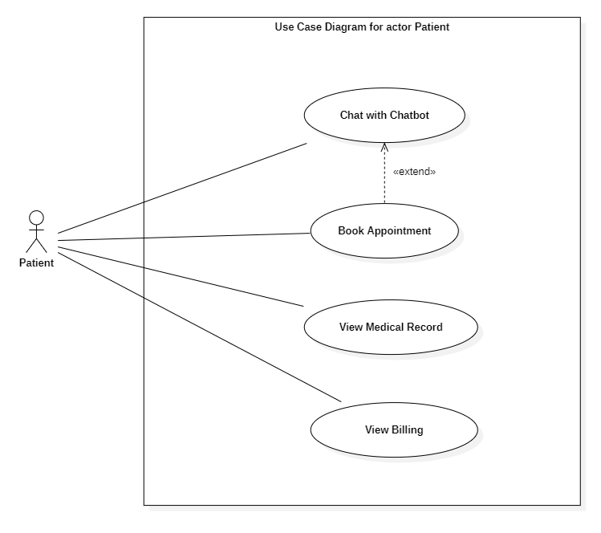
Figure 1. Use Case Diagram for Patient

Book Appointment
Table 1. Use Case Book Appointment
Use Case Name: Book Appointment | ID: UC_01
Primary Actor: Customer (Guest, Patient) | Priority: High
 | Category: Complex
Participants and Concerns:
- Customer: Wants to create a booking request quickly, providing medical symptoms and desired time slots.
- System/Clinic: Wants to collect complete information to organize the schedule and ensure appointments are verified via phone to prevent no-shows.
Brief Description: This use case describes how the customer generates booking requests. The goal is to ensure multiple sub-actors (Guest, Patient) to be able to create and edit appointment or appointment info.
Relationships:
+Association: Customer
+Include: Request an appointment, Edit appointment request detail
+Extend: Choose doctor, Cancel appointment
+Generalization: None
Normal Flow of Events:
  - Customer accesses the booking page on the system.
  - Customer inputs required information (Name, Phone number, Symptoms, Desired Date/Time).
  - The system generates an appointment with the status "Requested".
  - The customer waits for a confirmation call from the clinic staff.
  - Customer answer calls with these option:
    - Deny: Appointment is canceled. System set status that customer appointment status to “cancelled”.
    - Confirm: System set status to “scheduled”.
    - Change: Appointment detail is changed with the requested details.
Subflows: None
Alternate/Exceptional flows:
- Booking via Chatbot (Alternative):
- Customer begins to chat using the chatbox function.
- If no operator is available, the AI-Agent collects the required information.
- The AI sends information to the system to generate an appointment with status "Requested".
- Deny Confirmation (Alternative):
- During the confirmation call, the customer denies or cancels the request.
- The system updates the status to "Cancelled".
- Change Details (Alternative):
- During the confirmation call, the customer requests to change the time or details.
- The system updates the appointment with the requested changes.
- Server Down (Exception):
- The server encounters an issue or is down.
- The system denies every booking request and displays an error message.

Chat with Chatbot
Table 2. Use Case Chat with Chatbot
Use Case Name: Chat with Chatbot | ID: UC_03
Primary Actor: Customer (Patient, Guest) | Priority: High
 | Category: Complex
Participants and Concerns:
- Customer: Wants to get quick answers to FAQs or book appointments without making a phone call.
- Clinic (Operator/AI): Wants to automate basic support to reduce workload and ensure 24/7 availability.
Brief Description: This use case describes how the chatbox function handles customer messages and how the AI-Agent reacts to these messages. It covers automated AI responses.
Relationships:
+Association: Customer
+Include: Chatbox
+Extend: Join chat
+Generalization: None
Normal Flow of Events:
- Patient opens the chatbox on the website and types a message.
- AI-Agent responds and attempts to handle the request automatically.
- If it is an appointment request: AI collects necessary patient details.
- If it is a FAQ: AI provides the answer.
- AI confirms the action or information with the patient.
- Operator resolves the patient’s query.
- System stores the chat transcript for future reference.
Subflows:
- AI Handling FAQ:
- AI analyzes the intent.
- AI retrieves the answer from the knowledge base.
- AI displays the answer.
- AI Booking Support:
- AI prompts for Name, Phone, and Preferred Time.
- AI sends data to the system to create a "Requested" appointment.
Alternate/Exceptional flows:
- Incomplete Information (Alternative):
- Patient provides insufficient details for booking.
- AI prompts the patient again for the specific missing details.
- Invalid Input (Exception):
- Patient enters unrecognized text or invalid data format.
- AI replies with a clarification request.
- Network/System Error (Exception):
- Chatbox cannot connect to the server.
- System displays an error message and suggests trying again later.

Use cases for Admin

Use Case Diagram
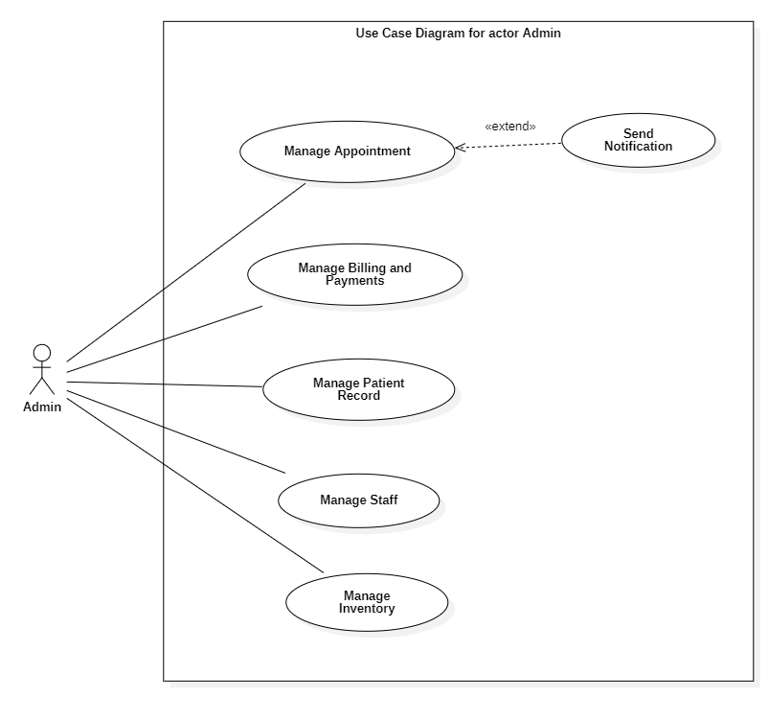
Figure 2. Use Case Diagram for Admin
Note: Dentist and Receptionist have partial access to selected use cases (see detailed use cases below).

Manage Appointment
Table 3. Use case Manage Appointment
Use Case Name: Manage Appointment | ID: UC_02
Primary Actor: Receptionist, Admin | Priority: High
 | Category: Complex
Participants and Concerns:
- Receptionist/Admin: Needs a flexible tool to handle appointments (create, update, cancel) ensuring human interaction and resolving scheduling conflicts.
- Patient: Wants their appointment status to be updated accurately and to receive notifications about any changes.
- Dentist: Needs to be informed about their schedule changes.
Brief Description: This use case describes how the Receptionist and Admin handle appointments and appointment requests. The goal is to ensure that every appointment is handled with human interaction and is flexible to changes.
Relationships:
+Association: Receptionist, Admin
+Include: View appointments, Schedule appointment, Edit appointment, Cancel appointment
+Extend: None
+Generalization: None
Normal Flow of Events:
- Actor logs into the dental clinic management system.
- Actor navigates to the "Appointments" module.
- System displays a list of existing appointments.
- Actor selects an action (Create, Update, or Cancel).
- If creating: Actor enters patient details, selects a dentist (optional), and chooses a date/time slot.
- If updating: Actor modifies the appointment details (confirm appointment, reschedule time, change assigned dentist).
- If canceling: Actor confirms the cancellation.
- System validates the request.
- System saves the changes to the appointment database.
- System confirms the action to the actor.
- System notifies the patient and dentist about the new, updated, or canceled appointment.
Subflows: None
Alternate/Exceptional flows:
- Patient Not Found (Alternative):
- Actor enters patient details.
- System cannot find the patient record.
- Actor is prompted to create a new patient profile before proceeding.
- Dentist Unavailable / Scheduling Conflict (Alternative):
- Actor selects a dentist and time slot.
- System detects that the dentist is already booked or unavailable.
- System suggests alternative available time slots or dentists.
- Actor either accepts a suggestion or cancels the request.
- Overlapping Appointments (Alternative):
- Actor tries to double-book the same patient or dentist at the same time.
- System prevents saving and displays a warning.
- Actor must resolve the conflict.
- Insufficient Permissions (Exception):
- Receptionist tries to perform an action only allowed for Admin.
- System denies the action and shows an error: “Permission denied. Contact Admin.”
- Database/Server Down (Exception):
- System cannot access the appointment database.
- Error message shown: “System unavailable. Please try again later.”

Manage Patient Record
Table 4. Use Case Manage Patient Records
Use Case Name: Manage Patient Records | ID: UC_04
Primary Actor: Dentist, Receptionist | Priority: High
 | Category: Complex
Participants and Concerns:
- Dentist: Needs to accurately record diagnosis, treatments, and prescriptions for each visit.
- Patient: Wants to view their verified medical history and prescriptions.
- Receptionist: Needs to add administrative notes or insurance details.
- Admin: Needs to audit records for compliance and oversight.
Brief Description: This use case allows clinic staff to create, update, and maintain medical records. Each record is tied to a specific visit and stores medical history, diagnosis, prescriptions, procedures, and follow-up information.
Relationships:
+Association: Dentist, Receptionist, Patient, Admin
+Include: Create Record, Update Record
+Extend: Add Diagnosis, Add Procedures, Add Prescriptions, Add Follow-up Instruction, Audit Record, View Record
+Generalization: None
Normal Flow of Events:
- Dentist accesses the patient’s profile and selects the current visit.
- System loads existing medical records.
- Dentist enters the diagnosis, procedures performed, and prescriptions.
- Dentist records follow-up appointment details if required.
- System saves the updated record with metadata (createdAt, updatedAt).
- Receptionist attaches additional notes (administrative or insurance) if necessary.
- Patient (after verification) views their updated medical record.
- Admin audits the record for compliance (if needed).
Subflows:
- Enter Medical Data:
- Dentist inputs diagnosis text.
- Dentist selects procedures from a predefined list.
- Dentist inputs drug names and dosages for prescriptions.
- Patient View:
- Patient logs in.
- System verifies patient identity.
- System displays read-only version of the record.
Alternate/Exceptional flows:
- Skip Prescriptions (Alternative):
- Dentist determines no medication is needed.
- Dentist skips the prescription entry step.
- No Follow-up (Alternative):
- No follow-up is required.
- System closes the visit record as final immediately.
- Patient Not Verified (Alternative):
- Patient tries to access the record but is not verified.
- System denies access.
- Visit Record Missing (Exception):
- Dentist tries to add a record but no visit exists.
- System prompts Receptionist to create the visit first.

Manage Billings and Payments
Table 5. Use Case Manage Billings and Payments
Use Case Name: Manage Billings and Payments | ID: UC_05
Primary Actor: Receptionist | Priority: High
 | Category: Complex
Participants and Concerns:
- Receptionist: Needs to generate accurate invoices based on services rendered and track payment status.
- Patient: Wants to receive a clear invoice and have flexible payment options.
- Admin: Needs financial records for revenue reporting.
- Clinic: Ensures timely collections and financial integrity.
Brief Description: This use case describes how the receptionist generates billing records after a dental service and processes patient payments. The goal is to ensure accurate invoices, track payments, and maintain financial records for the clinic.
Relationships:
+Association: Receptionist, Patient, Admin, Payment Gateway
+Include: Update Billing Status, Watch Billings History
+Extend: Refund Payment
+Generalization: None
Normal Flow of Events:
- Receptionist selects the completed appointment in the system.
- System displays services rendered with associated costs.
- Receptionist confirms or adjusts invoice details.
- System generates the invoice and displays the total amount due.
- Patient provides payment (via cash, card, or online gateway).
- Receptionist records the payment details into the system.
- System updates the invoice status to "Paid" and stores the payment record.
Subflows:
- Refund Payment:
- If a refund is required (due to error or cancellation after payment), Admin/Receptionist initiates a refund request.
- System processes the refund and updates the billing status.
- Watch Billing History:
- Actor views the history of past transactions for a specific patient.
Alternate/Exceptional flows:
- Payment Gateway Failure (Exception):
- The system attempts to process an online payment but the gateway fails.
- System logs the error and notifies the Receptionist.
- Receptionist asks for an alternative payment method.
- Payment Gateway Failure (Exception):
- Patient cannot settle the bill immediately.
- System keeps the invoice status as "Unpaid" or "Pending" for future follow-up.

Non-Functional Requirements

Performance
- The system must process common user transactions within 2 seconds under normal load conditions.
- Real-time communication features must maintain a message delivery latency of less than 1 second.
- The application must support up to 50 concurrent active users (including staff and patients) without noticeable performance degradation.
- Complex queries for reporting and analytics (e.g., monthly revenue) must complete execution within 5 seconds.

Security
- All data transmission between the client and server must be encrypted using secure protocols (HTTPS/TLS 1.2+) to ensure data confidentiality.
- Access to system functions is strictly regulated by Role-Based Access Control (RBAC), authorizing actions based on four defined user roles: Admin, Receptionist, Dentist, and Patient.
- The system must maintain audit logs for all critical to ensure accountability and facilitate debugging.

Reliability and Availability
- The system targets an availability rate of 99.9% during clinic operating hours, utilizing MongoDB replica sets to ensure database redundancy.
- Automated daily backups of the database must be performed and stored securely offsite or in a separate folder; disaster recovery procedures must ensure data restoration within 24 hours.
- Critical transactional operations (e.g., invoice generation, medical record updates) must be atomic to prevent partial data updates and ensure data integrity.

Usability
- The user interface (UI) must be consistent, intuitive, and responsive across various devices (Desktop, Tablet, Mobile) and modern web browsers.
- The system should allow new users to perform basic tasks with minimal training, while providing efficient workflows (shortcuts, quick views) for experienced staff.
- Error messages must be descriptive and constructive, guiding the user toward a resolution rather than just displaying error codes.

Safety
- Sensitive actions, such as deleting patient records or modifying finalized invoices, must trigger a confirmation prompt to prevent accidental data loss.
- The system must implement valid input checks (format validation, required fields) at both the client and server sides to prevent the entry of corrupted or malicious data.

THEORETICAL FOUNDATION

Node.js
Node.js [4] is a cross-platform JavaScript runtime environment built on Chrome's V8 JavaScript engine, distinguishing itself with a non-blocking I/O model and event-driven architecture. In the context of this project, Node.js was selected over traditional thread-based server-side languages (such as PHP or Java) due to its ability to efficiently handle thousands of concurrent connections with low system resource consumption, making it optimized for features requiring real-time response like instant appointment booking and the Chatbot system. Furthermore, using JavaScript uniformly for both the Frontend and Backend simplifies the development process, allowing for code reusability and seamless JSON data formatting throughout the application.

Express.js
Express.js [5] is a minimal and flexible web application framework built on the Node.js platform, serving as the backbone for developing robust web applications and APIs. The research team decided to utilize Express.js instead of more complex frameworks (like NestJS or Sails.js) because of its simplicity, accessibility, and high scalability through a rich middleware system. Express.js enables the rapid configuration of routing and handling of HTTP requests (GET, POST, PUT, DELETE), facilitating the construction of standard RESTful API architectures to ensure secure and effective communication between the MongoDB database and the React.js user interface.

React.js
React.js [6] is a declarative, efficient, and flexible open-source JavaScript library for building user interfaces, maintained by Meta (formerly Facebook). Distinct from other frameworks, React employs a component-based architecture and a Virtual DOM mechanism to optimize rendering performance by minimizing direct interactions with the actual DOM. In the context of this project, React.js was selected to build the client-side interface due to its modularity, which allows for the creation of reusable UI components such as the appointment scheduling calendar, patient record forms, and the interactive Chatbot window. This approach not only accelerates the development process but also ensures interface consistency across the application. Furthermore, React’s powerful state management and "One-way data flow" enable the application to efficiently handle dynamic data updates from the backend, ensuring a smooth and responsive experience for patients and clinic staff on both desktop and mobile devices.

MongoDB
MongoDB [7] is an open-source, document-oriented NoSQL database management system that stores data in flexible JSON/BSON formats rather than the rigid tables and rows used in traditional SQL. The research team decided to utilize MongoDB instead of Relational Database Management Systems (RDBMS) like MySQL or SQL Server because of its superior ability to handle unstructured data, which is particularly suitable for the specifics of dental medical records—where medical history, imaging data, and clinical notes vary significantly in length and format between patients. Furthermore, the combination of MongoDB and Node.js creates a unified ecosystem using JavaScript from end to end (Full-stack JavaScript), eliminating the complex data transformation processes (ORM impedance mismatch) often encountered in legacy systems.

GeminiAPI
The Gemini API [8] is an advanced multimodal Large Language Model (LLM) developed by Google, distinguished by its ability to process and generate natural language with high precision. The research team selected the Gemini API over rigid rule-based chatbot systems or other AI models due to its superior understanding of the Vietnamese context and optimal response speed in real-world environments. Integrating this technology enables the system to fully automate primary customer care processes, ranging from booking intent recognition to answering service inquiries 24/7, thereby relieving the workload on reception staff while ensuring patients receive immediate assistance.

WebSocket
WebSocket is a computer communications protocol providing full-duplex communication channels over a single TCP connection, fundamentally distinct from the traditional HTTP request-response model which requires the client to initiate every interaction. The research team selected WebSocket technology over traditional HTTP polling or long-polling methods due to its ability to maintain a persistent connection, allowing for bidirectional real-time data transmission with significantly reduced latency and network bandwidth overhead by eliminating repetitive header transmission. This architecture is particularly crucial for the DCAM-WebApp to ensure a seamless user experience, serving as the technical backbone for the AI-driven chatbot assistant to handle continuous conversation flows and enabling the system to push instant notifications to dentists and receptionists regarding appointment updates or emergency alerts without the need for manual page refreshes.

SOLUTION DESIGN AND IMPLEMENTATION

System Architecture
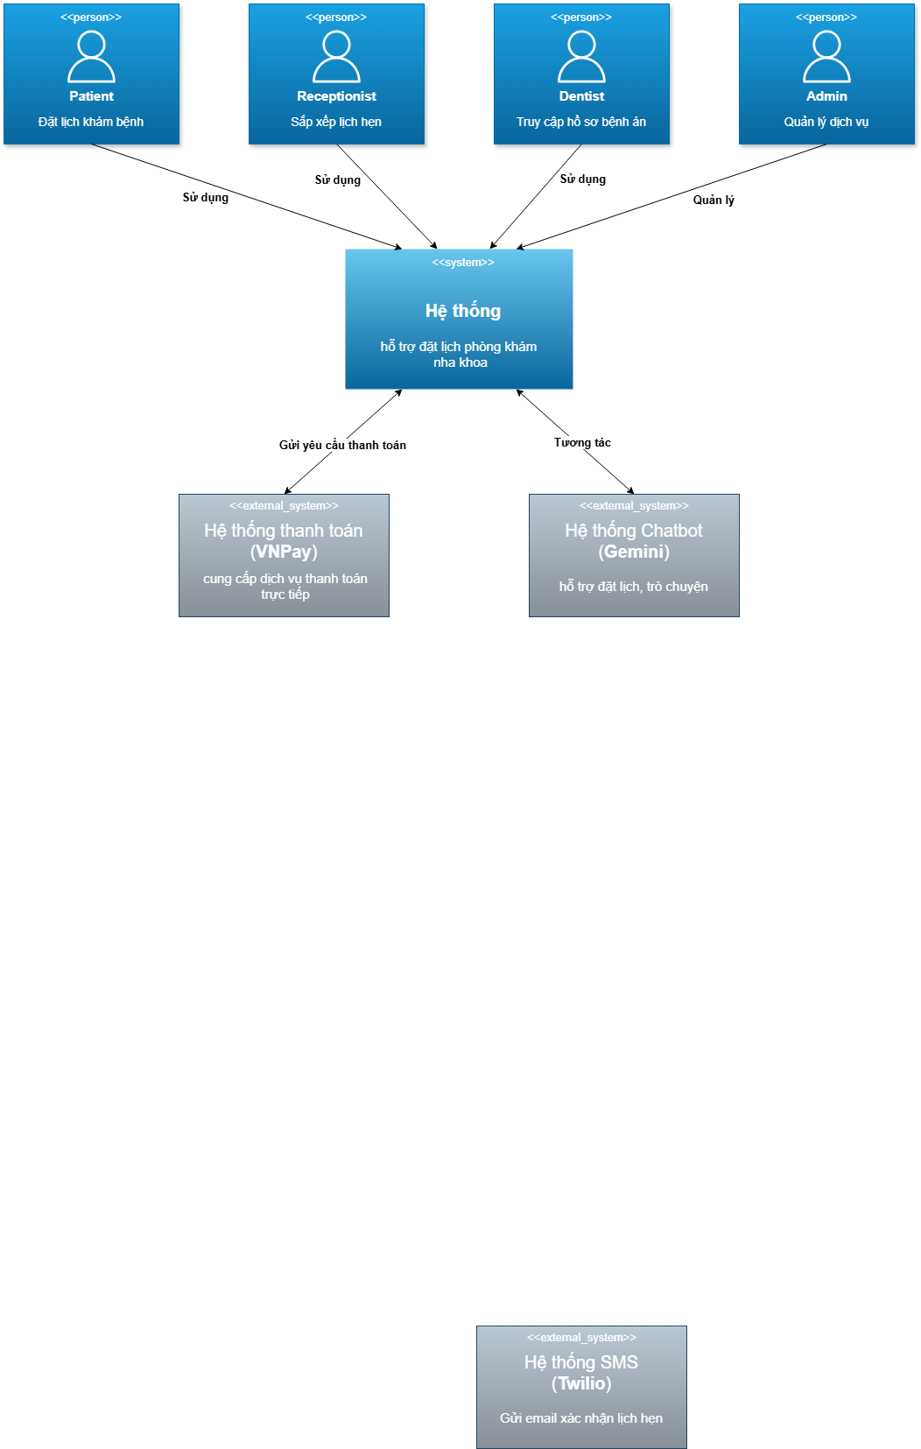
Figure 3. Context Diagram
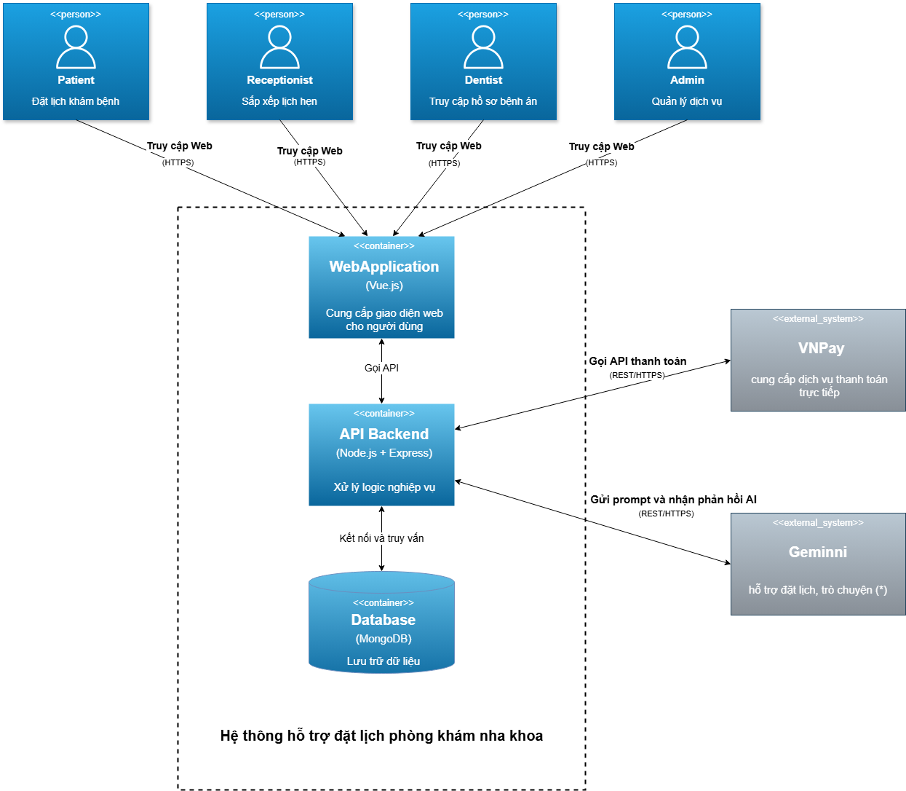
Figure 4. Container Diagram

Data Design

Data Model

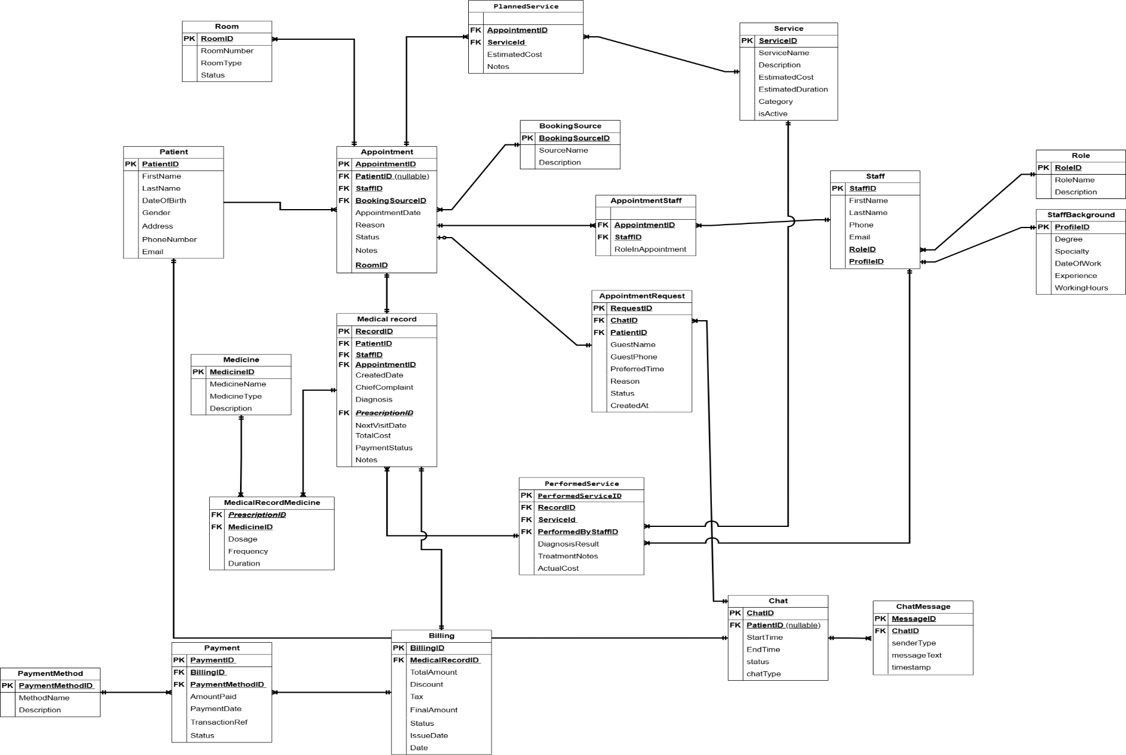
Figure 5. Conceptual Data Modeling
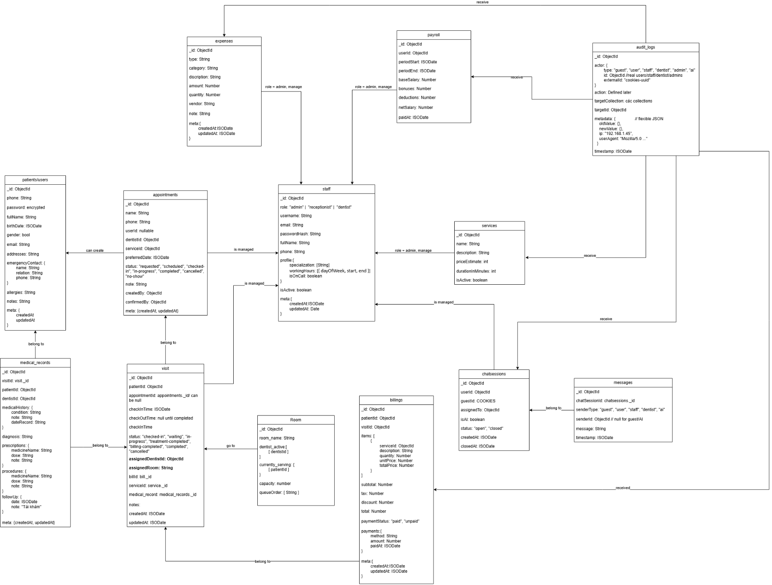
Figure 6. Physical Data Modeling

Data Dictionary

Collection appointments
Stores information about patient schedules, service details, and payment records, serving the mechanisms for appointment management, workflow tracking, and billing processing.
Table 6. Collection appointments
No | Field name | Data type | Nullable | PK/FK | Constraint | Description
1 | _id | ObjectId | No | PK | Unique | Unique identifier for the appointment.
2 | patientId | ObjectId | No | FK | Ref: Patients | Reference ID linking to the patient profile.
3 | patient | String | Yes | - | - | Cached name of the patient.
4 | dentistId | ObjectId | Yes | FK | Ref: Dentists | Reference ID linking to the assigned dentist.
5 | dentist | String | Yes | - | - | Cached name or details of the dentist.
6 | receptionistId | ObjectId | Yes | FK | Ref: Staff | Reference ID of the receptionist managing the record.
7 | date | String | No | - | Format: YYYY-MM-DD | The scheduled date of the appointment.
8 | time | String | No | - | Format: HH:MM AM/PM | The scheduled time slot.
9 | status | String | No | - | Enum: ["Requested", "Scheduled", "Done", "Cancelled"] | Current processing status of the appointment.
10 | serviceId | String | No | FK | Ref: Services | Unique code/ID of the selected dental service.
11 | service | String | Yes | - | - | Name of the dental service.
12 | reason | String | Yes | - | - | Symptom or reason for the visit provided by the patient.
13 | phone | String | No | - | - | Patient's contact phone number.
14 | requestId | String | No | - | Unique | Human-readable ID for tracking requests.
15 | notes | String | Yes | - | - | Additional administrative or medical notes.
16 | completedBy | ObjectId | Yes | FK | Ref: Staff | ID of the staff who marked the appointment as done.
17 | paymentProcessedBy | ObjectId | Yes | FK | Ref: Staff | ID of the staff who processed the payment.
18 | paymentAmount | Number | Yes | - | Min: 0 | Total cost charged for the appointment.
19 | paymentType | String | Yes | - | Enum: ["Direct", "Insurance"] | Category of the payment transaction.
20 | paymentMethod | String | Yes | - | Enum: ["Cash", "Card"] | Method used for payment.
21 | paymentDate | String | Yes | - | Format: YYYY-MM-DD | Date when the payment was finalized.
22 | createdAt | Date | No | - | - | Timestamp of record creation.
23 | updatedAt | Date | No | - | - | Timestamp of the last modification.

Collection bills
Stores invoice information and transaction details for dental services, serving the mechanisms for payment processing, revenue tracking, and financial auditing.
Table 7. Collection bills
No | Field name | Data type | Nullable | PK/FK | Constraint | Description
1 | _id | ObjectId | No | PK | Unique | Unique identifier for the bill/invoice.
2 | appointmentId | ObjectId | No | FK | Ref: Appointments | Reference ID linking to the specific appointment.
3 | patientId | ObjectId | No | FK | Ref: Patients | Reference ID linking to the patient profile.
4 | invoiceNumber | String | No | - | Unique | Human-readable unique invoice code.
5 | service | String | Yes | - | - | Name of the primary service rendered.
6 | date | String | No | - | Format: YYYY-MM-DD | The date the invoice was issued.
7 | dentist | ObjectId/String | Yes | FK | Ref: Dentists | Reference to the dentist performing the service (nullable).
8 | amount | Number | No | - | Min: 0 | Total monetary amount for the bill.
9 | status | String | No | - | Enum: ["Unpaid", "Paid", "Pending"] | Current payment status of the bill.
10 | items | Array | Yes | - | - | List of specific line items (treatments/products) included in the bill.
11 | paymentMethod | String | Yes | - | Enum: ["Cash", "Card", "Transfer"] | The method used by the patient to pay.
12 | lastPaymentDate | String | Yes | - | Format: YYYY-MM-DD | The date when the payment was last processed or completed.

Collection chats
Manages the lifecycle and metadata of communication sessions between patients and the system, tracking the duration, status, and type of interaction for monitoring and history purposes.
Table 8. Collection chats
No | Field name | Data type | Nullable | PK/FK | Constraint | Description
1 | _id | ObjectId | No | PK | Unique | Unique identifier for the chat session.
2 | patientId | ObjectId | No | FK | Ref: Patients | Reference ID linking to the patient involved in the chat.
3 | startTime | Date/String | No | - | - | Timestamp when the chat session was initiated.
4 | endTime | Date/String | Yes | - | - | Timestamp when the chat session was closed or resolved.
5 | status | String | No | - | Enum: ["open", "closed", "pending"] | Current operational status of the session.
6 | chatType | String | No | - | Enum: ["normal", "emergency", "bot", "agent"] | Classification of the chat session type.

Collection chatmessages
Stores the individual text messages exchanged within a specific chat session, recording the sender's role, content, and timing to maintain the full conversation history and context for AI analysis or staff review.
Table 9. Collection chatmessages
No | Field name | Data type | Nullable | PK/FK | Constraint | Description
1 | _id | ObjectId | No | PK | Unique | Unique identifier for the specific message.
2 | chatId | ObjectId | No | FK | Ref: Chats | Reference ID linking the message to a specific chat session.
3 | role | String | No | - | Enum: ["patient", "bot", "staff", "system"] | Identifies who sent the message (Sender).
4 | messageText | String | No | - | - | The actual textual content of the message.
5 | timestamp | Date/String | No | - | - | Precise timestamp when the message was sent.

Collection clinicsetting
Stores global configuration parameters for the system, including operating hours, clinic contact details, and notification templates, serving as the central reference for business rules and application customization.
Table 10. Collection clinicsetting
No | Field name | Data type | Nullable | PK/FK | Constraint | Description
1 | _id | ObjectId | No | PK | Unique | Unique identifier for the settings document.
2 | workingHours | Object | No | - | - | Structure defining opening and closing times for each day of the week.
3 | holidays | Array | Yes | - | - | List of specific dates when the clinic is closed.
4 | clinicInfo | Object | No | - | - | Object containing clinic details (name, address, phone, email).
5 | notificationTemplates | Object | No | - | - | Predefined text templates used for automated system notifications.
6 | timeSlotInterval | Number | No | - | Min: 15 | The duration (in minutes) for each standard appointment slot.
7 | updatedBy | ObjectId | Yes | FK | Ref: Staff | Reference ID of the administrator who last modified the settings.
8 | createdAt | Date/String | No | - | - | Timestamp when the settings were initially created.
9 | updatedAt | Date/String | No | - | - | Timestamp when the settings were last updated.

Collection inventories
Stores information about dental supplies and medical consumables, serving the mechanisms for stock tracking, supply chain management, and cost control within the clinic.
Table 11. Collection inventories
No | Field name | Data type | Nullable | PK/FK | Constraint | Description
1 | _id | ObjectId | No | PK | Unique | Unique identifier for the inventory item.
2 | name | String | No | - | - | Name of the supply or equipment item.
3 | category | String | No | - | Enum: ["Consumables", "Instruments", etc.] | Classification category of the item.
4 | quantity | Number | No | - | Min: 0 | Current quantity available in stock.
5 | unit | String | No | - | - | Unit of measurement (e.g., box, piece, bottle).
6 | minStockLevel | Number | No | - | Min: 0 | Minimum threshold to trigger a restock alert.
7 | maxStockLevel | Number | Yes | - | Min: 0 | Maximum desired quantity to prevent overstocking.
8 | supplier | String | Yes | - | - | Name or identifier of the item's supplier.
9 | costPerUnit | Number | Yes | - | Min: 0 | Cost price per single unit of the item.
10 | lastRestocked | Date/String | Yes | - | - | The date when the item was last replenished.
11 | isActive | Boolean | No | - | Default: true | Flag to indicate if the item is currently in use/active.
12 | createdAt | Date/String | No | - | - | Timestamp when the item was added to inventory.

Collection medicalrecords
Stores the comprehensive clinical history and health profile of patients, including treatment logs, prescriptions, allergies, and visit summaries, serving as the core reference for dentists to monitor patient health and ensure continuity of care.
Table 12. Collection medicalrecords
No | Field name | Data type | Nullable | PK/FK | Constraint | Description
1 | _id | ObjectId | No | PK | Unique | Unique identifier for the medical record document.
2 | patientId | ObjectId | No | FK | Ref: Patients | Reference ID linking to the specific patient.
3 | patient | String | Yes | - | - | Cached name of the patient for quick display.
4 | patientIdNumber | String | Yes | - | - | Citizen ID or Social Security Number of the patient.
5 | lastVisit | Date/String | Yes | - | - | The date of the patient's most recent visit.
6 | primaryDentist | String/ObjectId | Yes | - | - | Name or ID of the main dentist responsible for this patient.
7 | totalVisits | Number | No | - | Min: 0 | Counter tracking the total number of visits made by the patient.
8 | allergies | String/Array | Yes | - | - | Known medical allergies of the patient (e.g., Penicillin).
9 | treatments | Array | Yes | - | - | History list of treatments performed on the patient.
10 | notes | Array | Yes | - | - | List of clinical observations or administrative notes.
11 | prescriptions | Array | Yes | - | - | History list of medications prescribed to the patient.
12 | reports | Array | Yes | - | - | List of attached medical files, X-rays, or lab reports.
13 | visits | Array | Yes | FK | Ref: Appointments | List of references to past appointment IDs.

Collection procedures
Maintains the master catalog of dental services offered by the clinic, defining standard pricing, duration, and categories, serving as the foundational reference for appointment scheduling and invoice generation.
Table 13. Collection procedures
No | Field name | Data type | Nullable | PK/FK | Constraint | Description
1 | _id | ObjectId | No | PK | Unique | Unique identifier for the procedure.
2 | code | String | No | - | Unique | Short code or SKU identifying the service (e.g., "CLEANING").
3 | name | String | No | - | - | Full display name of the dental service.
4 | category | String | No | - | - | Classification/Type of the procedure (e.g., Preventive, Cosmetic).
5 | duration | Number | No | - | Min: 0 | Estimated time required for the procedure (in minutes).
6 | price | Number | No | - | Min: 0 | Standard cost/price of the service.
7 | description | String | Yes | - | - | Detailed explanation of what the procedure involves.
8 | isActive | Boolean | No | - | Default: true | Flag indicating if the service is currently offered.
9 | createdAt | Date/String | No | - | - | Timestamp when the procedure was added to the catalog.

Collection treatmentplans
Stores detailed proposals for patient care, outlining specific procedures, estimated costs, and durations, serving as a roadmap for clinical execution and financial agreement between the clinic and the patient.
Table 14. Collection treatmentplans
No | Field name | Data type | Nullable | PK/FK | Constraint | Description
1 | _id | ObjectId | No | PK | Unique | _id
2 | patientId | ObjectId | No | FK | Ref: Patients | patientId
3 | patientName | String | Yes | - | - | patientName
4 | appointmentId | ObjectId | Yes | FK | Ref: Appointments | appointmentId
5 | dentistId | ObjectId | No | FK | Ref: Dentists | dentistId
6 | dentistName | String | Yes | - | - | dentistName
7 | status | String | No | - | Enum: ["draft", "pending", "approved", "completed"] | status
8 | description | String | Yes | - | - | description
9 | procedures | Array | No | - | Min Items: 1 | procedures
10 | estimatedCost | Number | No | - | Min: 0 | estimatedCost
11 | estimatedDuration | Number | Yes | - | Min: 0 | estimatedDuration
12 | approvedBy | ObjectId | Yes | FK | Ref: Staff | approvedBy
13 | approvedAt | Date/String | Yes | - | - | approvedAt
14 | createdAt | Date/String | No | - | - | createdAt
15 | updatedAt | Date/String | No | - | - | updatedAt

Collection users
Serves as the centralized repository for all system accounts (Admins, Dentists, Receptionists, and Patients), managing authentication credentials, personal profiles, and role-based access control (RBAC) to ensure secure system operation.
Table 15. Collection users
No | Field name | Data type | Nullable | PK/FK | Constraint | Description
1 | _id | ObjectId | No | PK | Unique | _id
2 | username | String | No | - | Unique | username
3 | password | String | No | - | Hashed (Bcrypt) | password
4 | role | String | No | - | Enum: ["admin", "dentist", "receptionist", "patient"] | role
5 | name | String | No | - | - | name
6 | email | String | No | - | Unique, Email Format | email
7 | phone | String | Yes | - | - | phone
8 | address | String | Yes | - | - | address
9 | dateOfBirth | Date/String | Yes | - | - | dateOfBirth
10 | specialty | String | Yes | - | - | specialty
11 | licenseNumber | String | Yes | - | Unique | licenseNumber
12 | isActive | Boolean | No | - | Default: true | isActive
13 | createdAt | Date/String | No | - | - | createdAt

Functional Design

Function Design for Patient

Book Appointment
- Purpose: This function enables patients to conveniently schedule their own visits by selecting preferred services, dentists, and available time slots through a user-friendly interface.
- Interface:
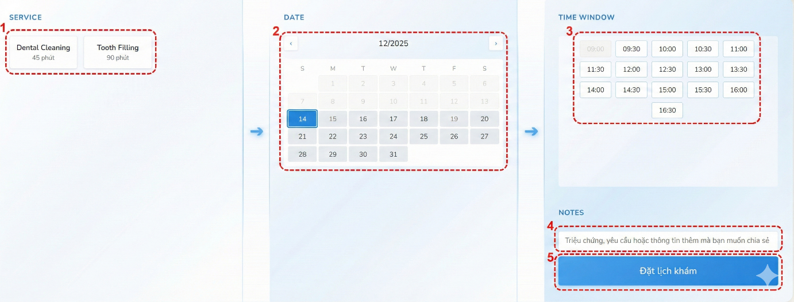
Figure 7. Interface Book Appointment
- Interface Components:
No | Control Type | Description | Note
1 | Select | Choose Service
2 | Select | Choose Date | Past dates cannot be selected
3 | Select | Choose Time | Choose Date before choose Time
4 | Input | Enter symptoms, requests, or information | Optional
5 | Button | Make an appointment

- Data Used:
STT | Table Name / Data Structure | Method
 |  | Add | Modify | Delete | Query
1 | appointments | X |  |  | X
2 | clinicsettings |  |  |  | X
3 | procedures |  |  |  | X

- Processing Logic:
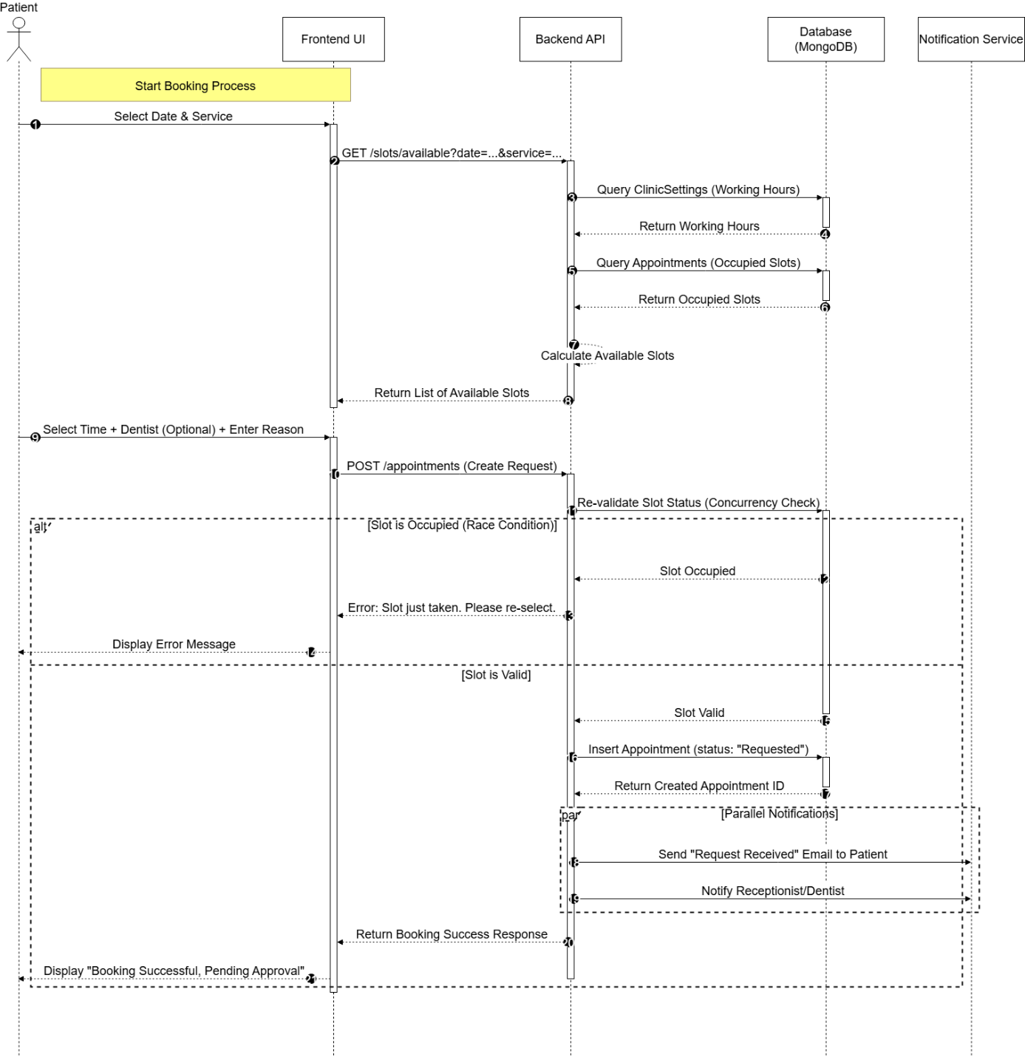
Figure 8. Sequence Diagram for Book Appointment

Chat with Chatbot
- Purpose: Provide an instant communication channel between patients and the clinic, utilizing an AI Agent for automated 24/7 support and seamless escalation to human operators for complex inquiries.
- Interface:
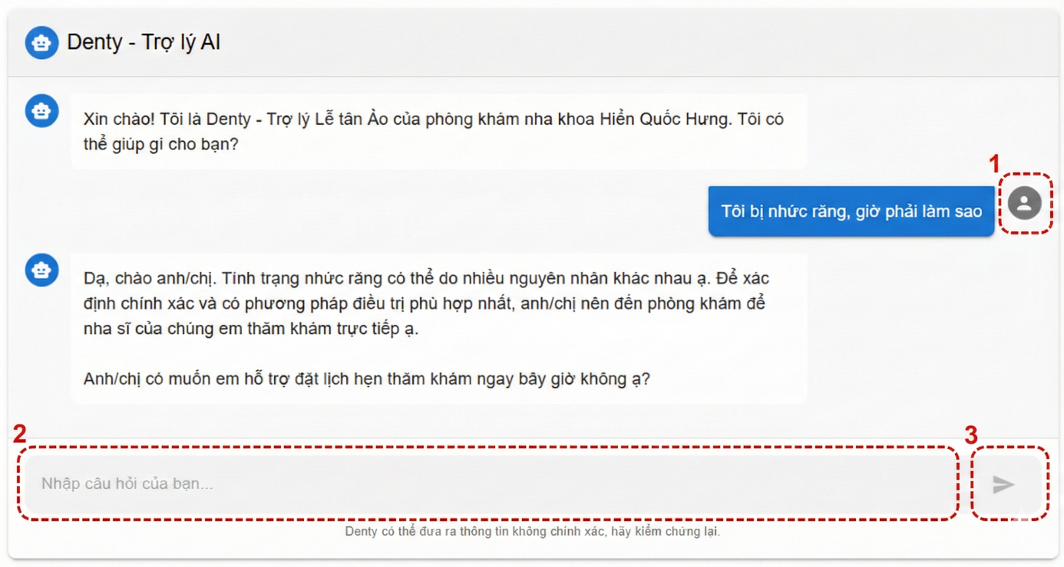
Figure 9. Interface for Chat with Chatbot
- Interface Components:
No | Control Type | Description | Note
1 | Image | Show patient’s avatar
2 | Input | Enter message
3 | Button | Send message

- Data Used:
STT | Table Name / Data Structure | Method
 |  | Add | Modify | Delete | Query
1 | chats | X
2 | chatmessages | X |  |  | X
3 | users |  |  |  | X
4 | appointments | X |  |  | X
5 | procedures

- Processing Logic:

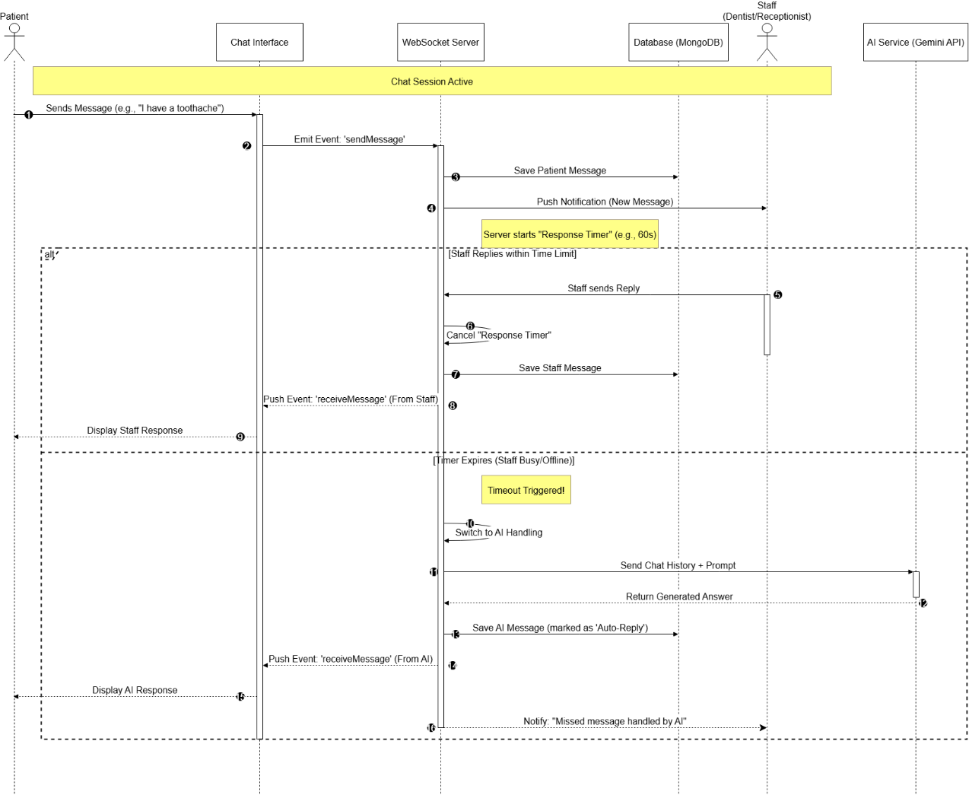
Figure 10. Sequence Diagram for Chat with Chatbot

Function Design for Admin

Manage Appointment
- Purpose: This function enables the Receptionist and Admin to efficiently handle the entire lifecycle of appointments, including scheduling, rescheduling, and cancellation, ensuring optimized resource allocation and minimizing scheduling conflicts.
- Interface:
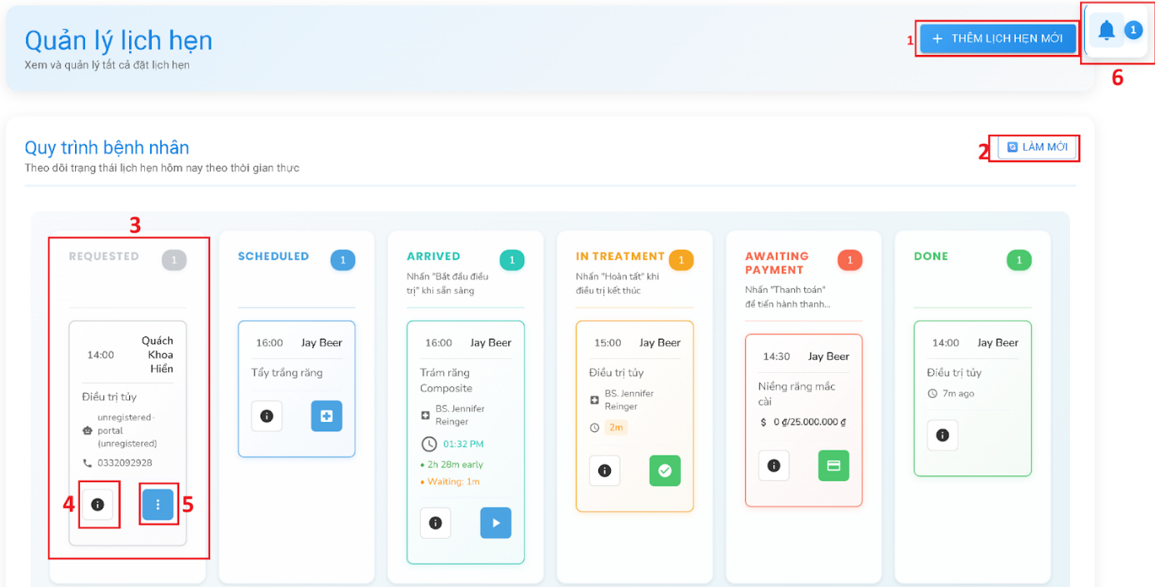
Figure 11. Interface of Manage Appointment
- Interface Components:
No | Control Type | Description | Note
1 | Image | Show patient’s avatar
2 | Input | Enter message
3 | Button | Send message
4 | Button | Show “Details” card view of that appointment
5 | Button | Show action depend on what that stage is:  - Requested: Action (Call/Accept/Deny)  - Scheduled: Open a modal for assigning dentist and marking patient arrival  - Arrived: Start a treatment with the related dentist and redirect to the treatment page  - In Treatment: fallback for when the in treatment failed to forward the data to the next stage  - Awaiting Payment: Open a payment modal which handle payments

- Data Used:
STT | Table Name / Data Structure | Method
 |  | Add | Modify | Delete | Query
1 | appointment | X | X |  | X
2 | chatmessages | X | X |  | X
3 | medicalrecords | X | X
4 | procedures |  |  |  | X
5 | treatmentplans | X | X |  | X
6 | users |  |  |  | X

- Processing Logic:
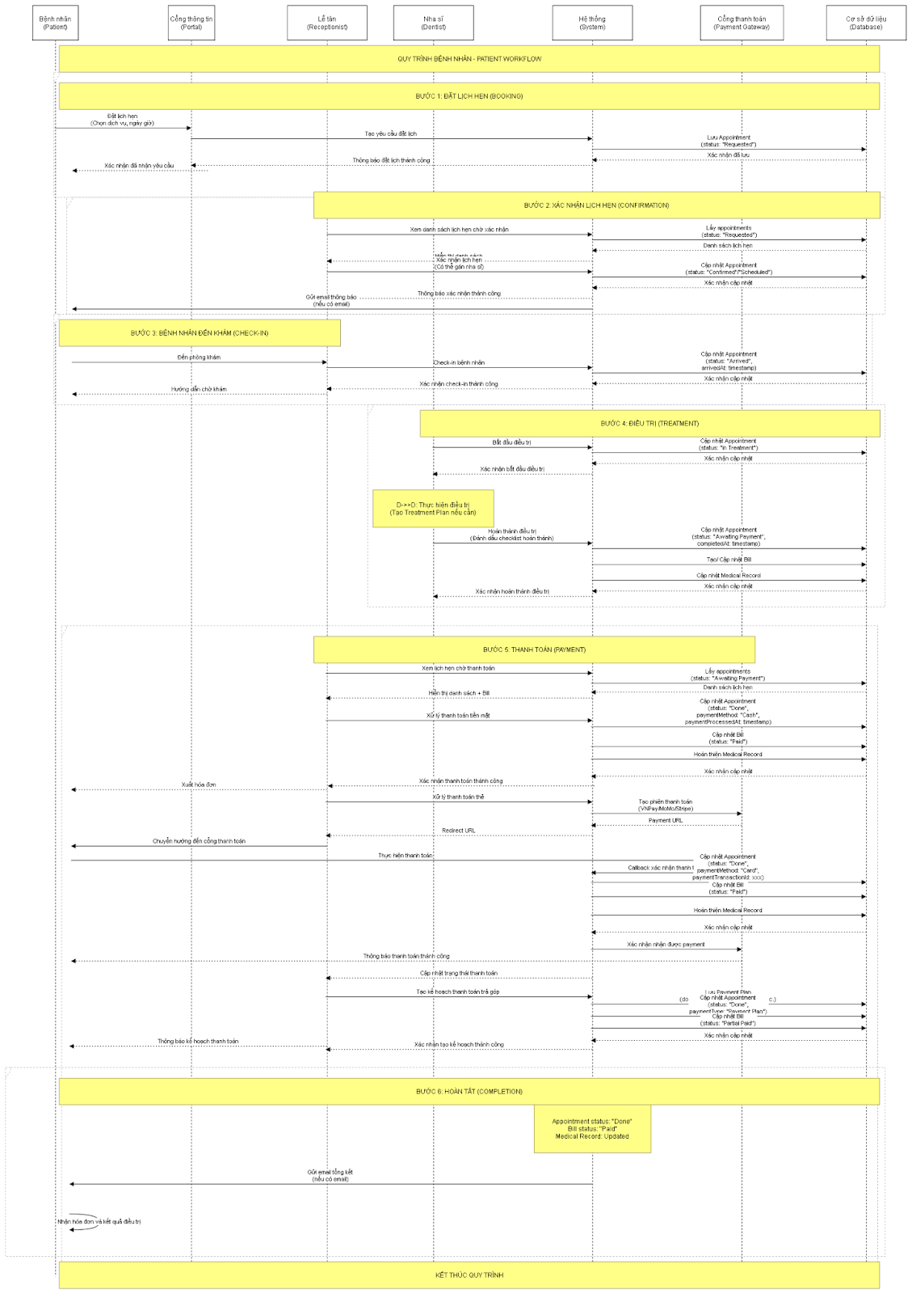
Figure 12. Sequence Diagram of Manage Appointment

Manage Patient Record
- Purpose: Maintain comprehensive and secure digital medical histories, allowing dentists to accurately record diagnoses and treatments while granting patients read-only access to their verified health records.
- Interface:
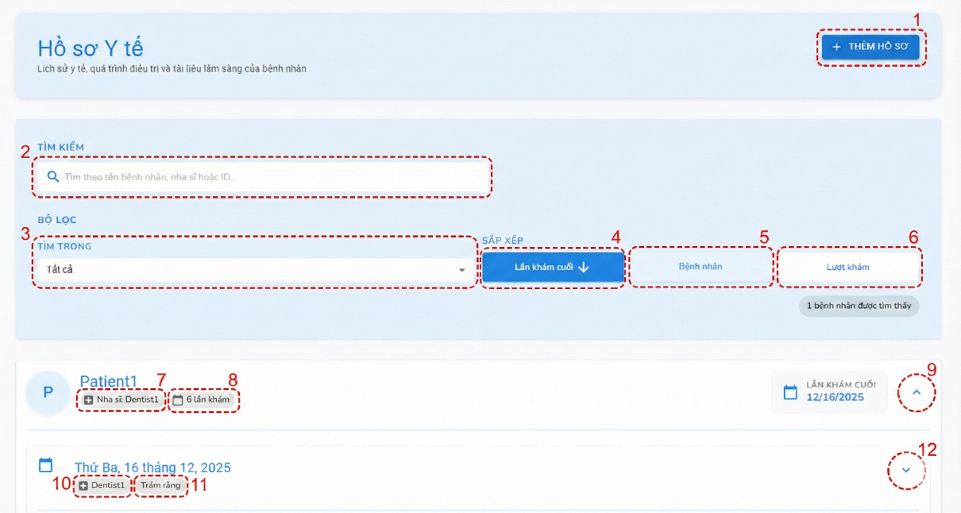
Figure 13. Interface of Manage Patient Record
- Interface Components:
No | Control Type | Description | Note
1 | Button | Add new medical record
2 | Input | Search medical record
3 | Select | Select by patient or dentist
4 | Button | Sort by Latest appointment
5 | Button | Sort by Patient
6 | Button | Sort by Number of appointment
7 | Label | Show treating dentist
8 | Label | Show total appointments
9 | Label | Hide/Show appointment list | Disable if no appointment
10 | Label | Show dentist of specific appointment
11 | Label | Show service of specific appointment
12 | Button | Hide/Show detailed appointment

- Data Used:
STT | Table Name / Data Structure | Method
 |  | Add | Modify | Delete | Query
1 | medicalrecord | X |  |  | X
2 | users |  |  |  | X

- Processing Logic:
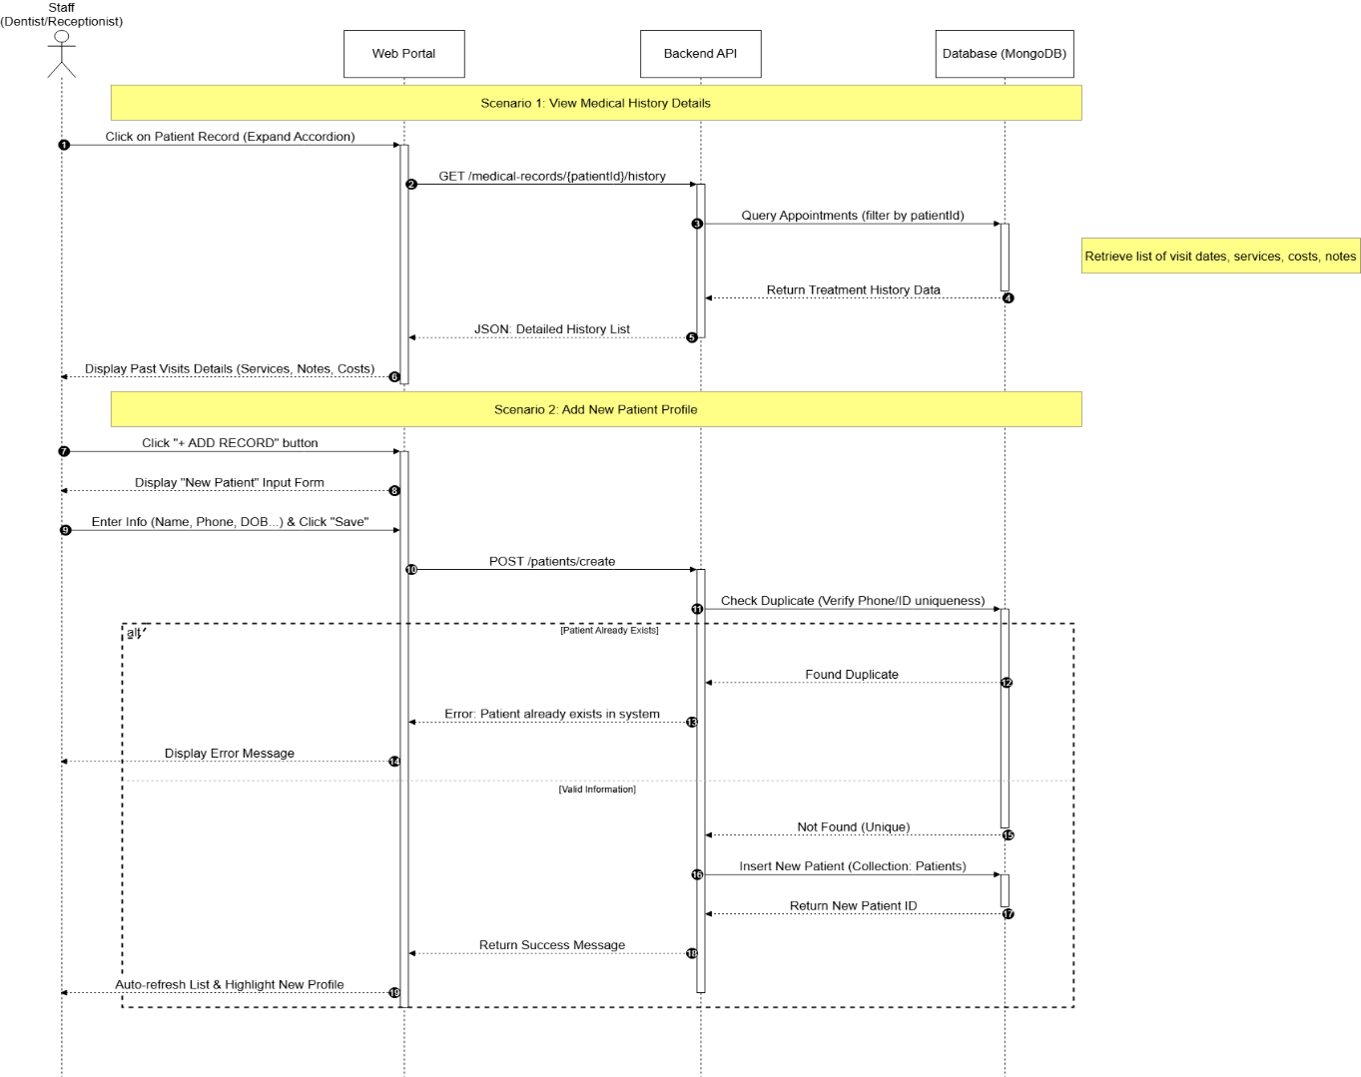
Figure 14. Sequence Diagram of Manage Patient Record

Manage Billings and Payments
- Purpose: Its purpose is to streamline the financial workflow by automatically generating accurate invoices based on services rendered, tracking payment statuses in real-time, and maintaining financial records for auditing.
- Interface:
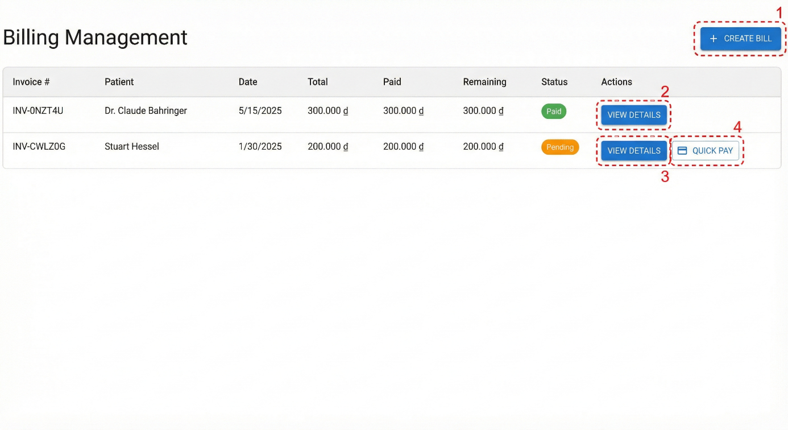
Figure 15. Interface for Manage Billings and Payments
- Interface Components:
No | Control Type | Description | Note
1 | Image | Open form Create bill
2 | Input | View bill detail
3 | Button | View bill detail
4 | Button | Open form Quick pay

- Data Used:
STT | Table Name / Data Structure | Method
 |  | Add | Modify | Delete | Query
1 | billings | X |  |  | X
2 | users |  |  |  | X

- Processing Logic:
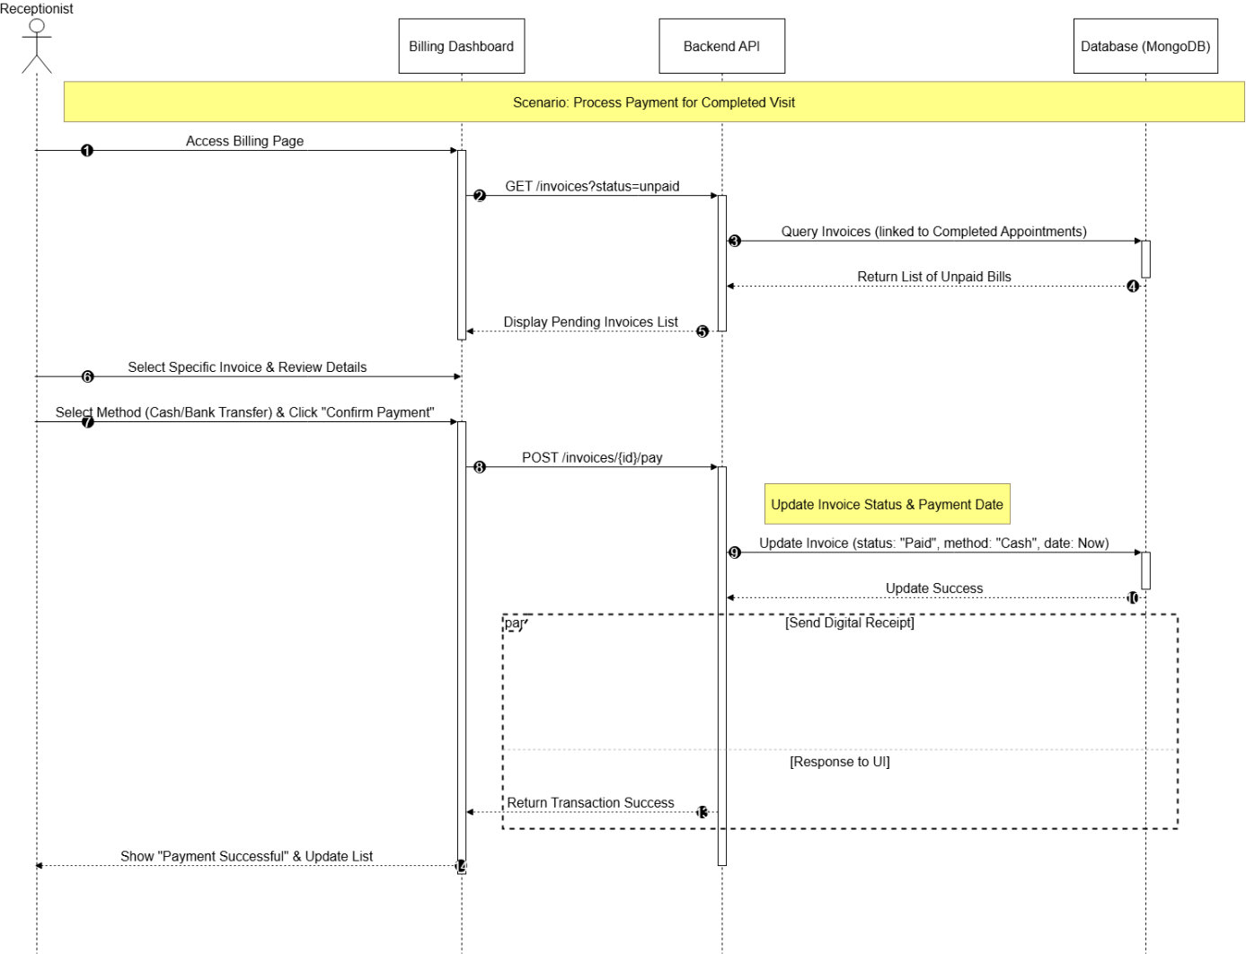
Figure 16. Sequence Diagram for Manage Billings and Payments

TESTING AND EVALUATION

Testing Objectives
Primary objective: Verify and validate that the DCAM-WebApp system operates in strict compliance with the SRS defined during the analysis and design phases. This process aims to ensure that the final product is a reliable solution that functions seamlessly and is free of critical defects that could disrupt the clinic's operational workflows.
Specific objective:
- Ensure the accuracy of core business workflows, such as appointment scheduling, medical record management, and the switching mechanism between AI and human staff in the Chatbot.
- Assess the user interface to guarantee a friendly, intuitive, and accessible experience for all user groups, ranging from non-technical patients to busy medical professionals.
- Verify the system's exception handling capabilities to ensure the application remains stable and does not crash when encountering invalid input data or network connectivity issues.
- Measure the response time of real-time functions, particularly the latency of message delivery and appointment notifications.

Testing Scope
The testing process is conducted through the following steps:
- Functional Testing: Execute test cases corresponding to the functional requirements detailed. The focus is on verifying the accuracy of input data and output results across core business workflows such as appointment booking, record management, and automated Chatbot responses.
- Design Testing (UI/UX Testing): Verify whether the implemented application interface aligns with the design specifications. This stage involves evaluating consistency in color schemes, layout, and typography, as well as ensuring responsiveness across different devices.
- Integration Testing: Examine the interaction and data flow between different system modules, specifically the connectivity between the Frontend, Backend API, and external services such as the Gemini AI or the Email notification system.
- Basic Security Testing: Verify authentication and authorization mechanisms to ensure that users can only access functions and data permitted by their specific roles.

Functions to Be Tested
Mandatory Testing:
- System Administration and Security: Registration, Login, Logout, and RBAC.
- Appointment Booking: New booking process, availability check, concurrency handling, and appointment cancellation.
- Smart Chatbot System: Real-time message sending/receiving, and the automated switching mechanism from Staff to AI (AI Fallback) upon response timeout.
- Medical Record Management: Viewing treatment history and adding new clinical notes (for Dentists).
- Notification System: Sending booking confirmation Emails and automated appointment reminders.
Recommended Testing:
- Statistics and Reporting: Displaying the overview Dashboard, revenue charts, and booking frequency graphs.
- Profile Management: Updating user profiles (Avatar, phone number) and changing passwords.
- Search and Filtering: Searching for patients by name/ID, filtering appointments by date range or status.
- UI Responsiveness: Display compatibility on specific screen sizes.

Functions Not Tested
- Integration with real-world online payment gateways.
- High-volume load/stress testing (simulating thousands of concurrent users).
- Direct interaction with specialized dental hardware (such as digital X-ray machines or sensors).
- Advanced security penetration testing against complex cyberattacks.

Testing Strategy

Testing Approach
- White Box Testing: This method was primarily applied during the development and Unit Testing phase. The focus was on verifying the correctness of the source code and the API functions handling the business logic on the Backend (Node.js/Express.js), as well as checking functions interacting with the MongoDB database.
- Black Box Testing / Functional Testing: This method was used to test critical business flows from the user's perspective (Patient, Receptionist, Dentist, Administrator). Test cases were designed based on the SRS document to ensure that key functionalities such as Appointment Booking, Schedule Conflict Handling, and Automated AI Chatbot Responses operated correctly and met the requirements.
- Performance Testing: Conducted after the system was fully integrated and deployed on a local server, to evaluate the transaction processing speed and the overall stability of the system before final acceptance.

Applied Testing Levels

Testing type | Description | Người thực hiện | Tool
Unit Testing | Test individual functions, methods, and classes to ensure they work correctly. Make sure the core logic of each component is correct. | Developer | Manual testing
Integration Testing | Check the interaction and data flow between modules or components (for example, between the user interface and the database, or between two functional modules). | Developer | Postman
System testing | Test the fully integrated system to ensure it meets the specified functional and non-functional requirements. | Entire dev team | Manual testing
Acceptance testing | Verify that the software meets the business needs of the end users. | Supervisor | Manual testing

Testing Environment

Minimum Hardware Configuration
Component | Minimum specification | Purpose
CPU | Intel Core i5 8th generation or higher | Ensure basic processing performance
RAM | 8 GB | To run IDE, local server and web server
Disk space | 100GB spare storage | Storage for database and related project contents
Screen resolution | 1920 x 1080 (recommended) | Correct displayment of the project UI/UX

Software Configuration
Software type | Details and Version
Operating system | Windows 10/11 Pro (64-bit), macOS
Web Browsers | Google Chrome (latest version), Firefox (latest version), Edge (latest version)
Developing environment | NodeJS (latest version), Visual Studio Code
Database | MongoDB
Local web server | Node.js with Epress.js

Mobile Devices and Emulators
Device type / Environment | Details and version | Purpose of testing
Actual device | Android: Any from 2020 going forward. | Patient UI/UX.
Resolution | Minimal from 6.5 - 6.8 inches screen size | UI/UX response to resolution changes.

Testing Support Tools
Testing purpose | Tools | Mô tả
API testing | Postman | API testing before integration into the frontend
Web interface testing | Chrome DevTools (Tab Network, Console, Responsive View) | Debugging for frontend API usage, and error catching.

Other Setup Conditions
- Internet Connection: A stable internet connection is required for the server. This is mandatory for the system to invoke the Gemini API (for the Chatbot function).
- Test Accounts: A set of user accounts representing all distinct roles must be prepared to verify RBAC:
  - 01 Administrator account for system configuration.
  - 01 Receptionist account and 01 Dentist account to test internal business workflows.
  - Mock Patient accounts to test booking and chat functionalities.
- Seed Data: The MongoDB database needs to be pre-populated with essential category data such as: Service lists, Price tables, Medicine inventory, and sample medical records to facilitate the testing of search and statistical functions.
- Environment Configuration: The system configuration file (.env) must be updated with valid API Keys for Google Gemini and Email service credentials before launching the application.

Test Data

Data type | Description | Application | Recommended storage method
Valid data | Completely valid data, used to test the main flow. | Test core functionality and successful creation and update workflows. | JS script
Invalid data | Data that violates constraints (format, data type, range). | Test the system’s error handling and the display of valid error messages. | JS script
Load data | A large amount of valid data | Test search performance and page load speed. | JS script
Configuration Data | System initialization data | Ensure the test environment is set up correctly. | JS script

Test Cases

Testing function Book Appointment
Table 16. Testing function Book Appointment
No | Description | Test Data | Step | Expected results | Actual results | Evaluate
TC_BA_01 | Verify successful appointment booking with valid information. | Date: [Tomorrow]  Service: Dental Cleaning  Dentist: Dr. Nguyen Van A Time Slot: 09:00 - 09:30  Note: "Check-up only" | - Log in as a Patient.  - Select the desired date and service.  - Select the available 09:00 time slot.  - Enter reason and click "Confirm Booking". | System displays "Booking Successful" message. Appointment status is "Requested". | System displays "Booking Successful" message. Appointment status is "Requested". | Pass
TC_BA_02 | Verify concurrency handling when two patients book the same slot simultaneously. | Account A and Account B.  Both select: Date [Tomorrow], Time 10:00, Dentist Dr. A.  Account A clicks confirm 1 second before Account B. | - Open two browsers with different accounts.  - Both select the exact same time slot.  - Account A clicks "Confirm".  - Account B clicks "Confirm" immediately after. | Account A: Success message.  Account B: Error message "Slot has just been taken. Please re-select" and reloads available slots. | Account A: Success.  Account B: Displays slot conflict error and requests re-selection. | Pass
TC_BA_03 | Verify data validation when selecting a past date/time. | Date: [Yesterday]  Time: Any | - On the Calendar interface, attempt to select a past date.  - Or manually modify the date in the URL/ API payload to a past date. | Past dates are disabled/ greyed out and unselectable. | Past dates are disabled on the UI. The system prevents selection. | Pass
TC_BA_04 | Verify validation for mandatory fields | Date: [Tomorrow]  Time: 14:00  Service: [Left Empty] | - Log in to the system.  - Select date and time slot.  - Intentionally leave the "Service" field unselected.  - Click "Confirm Booking". | System does not submit the request. Displays a red error message under the field: "Please select a service". | System displays error "Please select a service". Confirm button is disabled. | Pass
TC_BA_05 | Verify prevention of double booking by the same patient for the same time slot. | Account: Patient A  Appointment 1: Successfully booked at 09:00 tomorrow.  Appointment 2: Attempting to book another slot at 09:00 tomorrow (even with a different dentist). | - Ensure Patient A already has a confirmed booking at 09:00.  - Return to the booking page.  - Select the exact same date and 09:00 time slot.  - Click "Confirm". | System rejects the request and notifies: "You already have an appointment at this time. Please choose another slot or cancel the existing one." | System displays notification: "You have a conflicting appointment at this time". | Pass
TC_BA_06 | Verify system behavior when a date is fully booked. | Date: [Select a date simulated to have zero availability]  Service: Any | - On the booking interface, select the fully booked date.  - Observe the list of available time slots. | System displays "No slots available for this date" or all time slots are hidden/ disabled. Prevents the user from proceeding. | Displays message "No available slots for this date". | Pass

Testing function Chat with Chatbot
Table 17. Testing function Chat with Chatbot
No | Description | Test Data | Step | Expected results | Actual results | Evaluate
TC_CB_01 | Test sending a message to chatbot successfully | Tin nhắn: “Giờ làm việc của phòng khám là gì?” | 1. Open website  2. Open chatbox  3. Enter message  4. Send message | Chatbot displays an appropriate FAQ answer | Chatbot displays an appropriate FAQ answer | Pass
TC_CB_02 | Test FAQ handling by AI chatbot | Câu hỏi: “Phòng khám có làm việc cuối tuần không?” | 1. Open chatbox  2. Enter FAQ question  3. Send message | AI analyzes intent and returns correct answer from knowledge base | AI returns correct answer | Pass
TC_CB_03 | Test appointment request detection | Tin nhắn: “Tôi muốn đặt lịch khám răng” | 1. Open chatbox  2. Enter appointment request | AI recognizes booking intent and starts booking flow | AI recognizes booking intent | Pass
TC_CB_04 | Test collecting booking information successfully | Họ tên: Nguyễn Văn A  SĐT: 0909123456  Thời gian: 10/10/2025 09:00 | 1. Enter booking request  2. Provide name  3. Provide phone number  4. Provide preferred time | AI collects all required information successfully | AI collects all required information | Pass
TC_CB_05 | Test appointment creation with valid data | Họ tên: Trần Thị B  SĐT: 0988123456  Thời gian: 12/10/2025 14:00 | 1. Complete booking information | Appointment is created with status “Requested” | Appointment created successfully | Pass
TC_CB_06 | Test incomplete booking information | Họ tên: Lê Văn C | 1. Request booking  2. Enter name only | AI prompts user to provide missing details | AI asks for missing information | Pass
TC_CB_07 | Test invalid input handling | Tin nhắn: “@@@###” | 1. Open chatbox  2. Enter invalid text | AI asks user for clarification | AI asks for clarification | Pass
TC_CB_08 | Test invalid input handling | Tin nhắn: “@@@###” | 1. Open chatbox  2. Enter invalid text | AI asks user for clarification | AI asks for clarification | Pass

Testing the patient pipeline for admin/staff

Table 18. Testing the patient pipline for admin/staff
No | Description | Test Data | Step | Expected results | Actual results | Evaluate
TC_PPF_AS_01 | Test function for when a guest patient book an appointment | Service: Tooth Cleaning  Date: 16/12/2025  Hour: 09:00  Number: 0123456789  Name: Quách Khoa Hiển | Patient side:  1. Access the landing page.  2. Choose “Book Appointment”  3. Choose “Tooth Cleaning”, “16/12/2025”,”09:00”  4. Press “Đặt lịch khám”  5. Enter phone number, name in the modal.  6. Press “Xác nhận đặt lịch”  Admin side:  1. Login to admin/staff account  2. Navigate to page “Lịch hẹn”  3. Look at Requested card. | A new appointment with status “REQUESTED” appears | A new appointment with status “REQUESTED” appears | Pass
TC_PPF_AS_02 | Test the function to handle “requested” appointment to “scheduled” | Using the same appointment as PPF_AS_01 | 1. Login to admin/staff account  2. Navigate to page “Lịch hẹn”  3. Find the appointment in requested stage.  4. Press the “action” button  5. Press call  6. Press Accept | Related modal open up.  Call unlock accept/deny buttons.  After accepting the appointment status get updated to “scheduled” | Related modal open up.  Call unlock accept/deny buttons.  After accepting the appointment status get updated to “scheduled” | Pass
TC_PPF_AS_03 | Test the function to handle “scheduled” appointment to “arrived” | Using the same appointment as PPF_AS_01 | 1. Login to admin/staff account  2. Navigate to page “Lịch hẹn”  3. Find the appointment in scheduled stage.  4. Press the “action” button.  5. Select an dentist  6. Press “Confirm & Mark Arrival” button | Related modal open up.  The appointment gets update with the correct dentist and status is updated to “Arrived’ | Related modal open up.  The appointment gets update with the correct dentist and status is updated to “Arrived’ | Pass
TC_PPF_AS_04 | Test the function to handle “arrived” appointment to “In Treatment” | Using the same appointment as PPF_AS_01 | 1. Login to admin/staff account  2. Navigate to page “Lịch hẹn”  3. Find the appointment in arrived stage.  4. Press the “action” button.  5. Complete the checklist  6. Press “Send to Billing” | Page redirect to “Kế hoạch điều trị” page with the correct data.  “Send to billing” return to the “Lịch hẹn” and update the appointment correctly. | Page redirect to “Kế hoạch điều trị” page with the correct data.  “Send to billing” return to the “Lịch hẹn” and update the appointment correctly. | Pass
TC_PPF_AS_05 | Test the function to handle “In Treatment” appointment to “Awaiting Payment” using “Tiền mặt” as payment method. | Using the same appointment as PPF_AS_01 | 1. Login to admin/staff account.  2. Navigate to page “Lịch hẹn”.  3. Find the appointment in in-treatment stage.  4. Press the “action” button.  5. Select “Thanh toán trực tiếp”.  6. Select “Tiền mặt”  7. Press “Xử lý thanh toán”. | Related modal open up.  The modal display correct payment information.  The appointment gets handled and status update to “Done” | Related modal open up.  The modal display correct payment information.  The appointment gets handled and status update to “Done” | Pass
TC_PPF_AS_06 | Test the function to handle “In Treatment” appointment to “Awaiting Payment” using “Card” as payment method. | Using the same appointment as PPF_AS_01.  Card info  Bank: NCB  Bank number: 9704198526191432198  Card holder: NGUYEN VAN A  Expire date: 07/15  OTP: 123456 | 1. Login to admin/staff account.  2. Navigate to page “Lịch hẹn”.  3. Find the appointment in in-treatment stage.  4. Press the “action” button.  5. Select “Thanh toán trực tiếp”.  6. Select “Thẻ”  7. Select “VNpay”  8. Press “Xử lý thanh toán”  9. Press “OK”  10. Select “Thẻ nội địa và tài khoản ngân hàng”  11. Enter and select “NCB”.  12. Enter bank number  13. Enter card holder  14. Enter expire date  15. Press “Tiếp tục”  16. Press “Đồng ý và tiếp tục”  17. Enter OTP  18. Press thanh toán | Related modal open up.  Payment portal open up.  Auto redirect back to “Lịch hẹn” and the appointment gets handled and status update to “Done” | Related modal open up.  Payment portal open up.  Auto redirect back to “Lịch hẹn” and the appointment gets handled and status update to “Done” | Pass
TC_PPF_AS_07 | Test function for when a guest patient book an appointment with invalid data | Service: Tooth Cleaning  Date: 16/12/2025  Hour: 09:00  Number: 0123456789  Name: (NONE) | Patient side:  1. Access the landing page.  2. Choose “Book Appointment”  3. Choose “Tooth Cleaning”, “16/12/2025”,”09:00”  4. Press “Đặt lịch khám”  5. Enter phone number, name in the modal.  6. Press “Xác nhận đặt lịch”  Admin side:  1. Login to admin/staff account  2. Navigate to page “Lịch hẹn”  3. Look at Requested card. | No new appointment with “requested” appear | No new appointment with “requested” appear | Pass

Testing function Manage patient record
Table 19. Testing function Manage patient record
No | Description | Test Data | Step | Expected results | Actual results | Evaluate
TC_MPR_ 01 | Verify successfully creating a new patient profile with valid data. | Name: Nguyễn Văn Mười  Phone: 0988777666 (New)  DOB: 01/01/1990  Address: Cần Thơ | - Login as Receptionist/Dentist.  - Click the "+ THÊM HỒ SƠ" button on the top right.  - Fill in all fields in the popup form.  - Click "Save". | System closes the form and displays "Record added successfully". The patient list auto-refreshes, showing "Tran Van Moi" at the top. | Success message displayed. New profile appears immediately in the list. | Pass
TC_MPR_ 02 | Verify duplicate data prevention logic. | Phone: 0988777666 (Used in TC PRM 01)  Name: Any | - Click the "+ THÊM HỒ SƠ" button  - Enter information using a Phone Number that already exists in the system.  - Click "Save". | System does not save the data. Displays error message: "Patient with this phone number already exists". | System shows duplicate phone number error and requests verification. | Pass
TC_MPR_ 03 | Verify viewing detailed medical history. | Patient: Patient1 (Has existing records)  Target Date: Dec 16, 2025 | - In the patient list, locate the card for "Patient1".  - Click the arrow icon or the header area to expand the accordion.  - Observe the displayed data. | The card expands downwards. Displays full details: Date 16/12/2025, Service "Tooth Filling", Cost "300,000 VND", and Note "Visit completed". | Card expands smoothly, displaying correct and complete treatment details. | Pass
TC_MPR_ 04 | Verify Patient Search and Filter functionality. | Keyword: "Patient1"  Filter: All | - Enter keyword "Patient1" into the search bar.  - Press Enter or wait for auto-filter (debounce). | The list updates to show only the profile of "Patient1". Other records are hidden. | System filters correctly, showing only 1 matching result. | Pass

Testing function Manage Billings and Payments

Table 20. Testing function Manage Billings and Payments
No | Description | Test Data | Step | Expected results | Actual results | Evaluate
TC_BP_01 | Test generating invoice for a completed appointment. | Cuộc hẹn: Đã hoàn thành  Dịch vụ: Trám răng  Chi phí: 500.000 VNĐ | 1. Select completed appointment  2. View services rendered | System displays all services with correct costs | System displays all services correctly | Pass
TC_BP_02 | Test adjusting invoice details | Điều chỉnh chi phí: Giảm 50.000 VNĐ | 1. Select appointment  2. Edit invoice details  3. Confirm changes | Invoice details are updated correctly | Invoice updated correctly | Pass
TC_BP_03 | Test invoice generation | Tổng tiền: 450.000 VNĐ | 1. Confirm invoice details | System generates invoice and displays total amount | Invoice generated and displayed | Pass
TC_BP_04 | Test recording cash payment | Hình thức: Tiền mặt  Số tiền: 450.000 VNĐ | 1. Select cash payment  2. Enter payment details | Payment is recorded and invoice status is set to "Paid" | Payment recorded, status updated | Pass
TC_BP_05 | Test online payment via payment gateway | Cổng thanh toán: VNPay  Số tiền: 800.000 VNĐ | 1. Select online payment  2. Redirect to gateway  3. Confirm payment | Payment is completed and recorded in the system | Payment completed and recorded | Pass
TC_BP_06 | Test viewing billing history | Bệnh nhân: Nguyễn Văn A | 1. Search patient  2. View billing history | System displays past invoices and payment records | Billing history displayed | Pass

Evaluation of Test Results
No. | Classification | Tested Function | No. of Test Cases | Result
1 | Functional Testing | Book Appointment | 6 | 6/6 Pass
2 |  | Chat with Chatbot | 8 | 8/8 Pass
3 |  | Admin/Staff Patient Pipeline | 7 | 7/7 Pass
4 |  | Manage Patient Record | 4 | 4/4 Pass
5 |  | Manage Billings and Payments | 6 | 6/6 Pass
6 | Non-Functional Testing | Performance & Security | 3 | 3/3
7
8
Total |  |  | 34 | 100% Pass

The testing and evaluation process of the DCAM-WebApp system was conducted comprehensively based on the requirements defined in the SRS document, covering 5 main functional scenarios and non-functional criteria regarding performance and security. Through the execution of a total of 34 test cases (31 functional and 3 non-functional), the system recorded an absolute 100% pass rate, demonstrating stable operation in the local server environment. Core modules such as appointment booking with conflict resolution mechanisms, the AI-powered Chatbot (Gemini), as well as medical record management and billing workflows, all functioned correctly according to the design, ensuring data integrity and strict adherence to Role-Based Access Control (RBAC). Although high-volume load testing has not yet been performed due to time constraints, the current results confirm that the system meets reliability standards and is ready for pilot deployment in small to medium-sized dental clinics.

CONCLUSION

Results Obtained

Knowledge and Skills
Through the implementation of the "Dental Clinic Operational Web Application," the research team has accumulated significant academic and practical values:
Technical Proficiency: Gained deep understanding and hands-on experience with the MERN Stack (MongoDB, Express.js, React.js, Node.js). Specifically, the team mastered the implementation of RESTful APIs, real-time communication using Socket.io, and the integration of Large Language Models (LLMs) via the Google Gemini API.
Software Engineering Lifecycle: Comprehensively applied standard software development processes, from requirement analysis (SRS) and system design (UML) to coding, unit testing, and deployment.
Soft Skills Development: Enhanced essential skills such as teamwork, effective communication, time management under strict deadlines, and the ability to self-study and adapt to new technologies efficiently.

Program and Practical Implementation
The project successfully delivered a functional web-based management system that meets the core requirements of a modern dental clinic:
System Completeness: The application features a user-friendly interface with fully operational modules, including Real-time Appointment Booking, Patient Record Management, and an intelligent AI Chatbot capable of 24/7 support.
Practical Applicability: The system addresses the critical problem of manual scheduling and information management. It is ready for pilot deployment in small to medium-sized dental clinics to help streamline operations and reduce the administrative workload for receptionists.
User Experience: The separation of roles (Customer, Dentist, Admin) ensures a tailored experience, improving workflow efficiency and patient satisfaction.

Limitations and Challenges
Despite the achieved results, the project still faces certain limitations due to constraints in time and resources:
Technical Constraints: The current AI Chatbot relies on prompt engineering and external APIs, which may occasionally lead to latency or generic responses if the internet connection is unstable.
Testing Scope: Due to limited time, the system has not undergone extensive load testing to verify performance under high traffic (e.g., thousands of concurrent users). Mobile responsiveness, while implemented, requires further optimization for a seamless experience on all device types.

Future Works
To enhance the system's value and sustainability, the research team proposes the following directions for future development:
Feature Expansion: An automated SMS/Email Notification System to remind patients of upcoming appointments, thereby reducing no-show rates.
AI Enhancement: Fine-tune the Chatbot model with a specialized dental dataset to improve the accuracy of medical advice and context handling.
Platform Diversity: Develop a mobile application version (using React Native) to provide a more convenient experience for patients and doctors on smartphones.
Data Analytics: Implement a dashboard for statistical analysis (revenue, appointment trends) to support clinic owners in making data-driven business decisions.

REFERENCES

[1] | J. Urbina-Novoa, "Mobile application to optimize appointment management in a specialized dental center," Bulletin of Electrical Engineering and Informatics, vol. 14, no. 5, pp. 4050-4062, 2025.
[2] | J. M. J. Elicanal, I. J. M. Marcelino, J. M. T. Mangubat, E. A. T. Villafranca, C. Pamiloza and K. B. O. Adizas, "Wisdom Dental: A Digital Booking and E-Commerce Platform to Enhance Operational Efficiency, Predictive Analytics & Time Series Forecasting at Wisdom Dental Clinic in Pinagbuhatan, Pasig City," International Journal of Research and Innovation in Applied Science, vol. 10, no. 10, pp. 954-966, 2025.
[3] | GeeksforGeeks, "Waterfall Model - Software Engineering," 30 September 2025. [Online]. Available: https://www.geeksforgeeks.org/software-engineering/waterfall-model/. [Accessed 12 10 2025].
[4] | Node.js, "Node.js v25.2.1 Documentation," 2025. [Online]. Available: https://nodejs.org/api/all.html. [Accessed 21 Octobor 2025].
[5] | Express, "Getting Started," [Online]. Available: https://expressjs.com/en/starter/installing.html. [Accessed 21 October 2025].
[6] | React.js, "Introduction," 2025. [Online]. Available: https://Reactjs.org/guide/introduction.html. [Accessed 21 October 2025].
[7] | MongoDB, "MongoDB Documentation.," 2025. [Online]. Available: https://www.mongodb.com/docs/. [Accessed 21 October 2025].
[8] | Google, "Gemini API Quickstart," 2025. [Online]. Available: https://ai.google.dev/gemini-api/docs/quickstart?hl=vi. [Accessed 21 October 2025].

