

**<<E-Butler>>**

**Software Design Document**

– HoChiMinh, November 2022 –

**Table of Contents**

I. Overview 3

1. Code Packages/Namespaces 3

2. Database Schema 3

II. Code Designs 4

1. <Feature/Function Name1> 4

a. Sequence Diagram(s) 4

# I. Overview

## 1. Code Packages/Namespaces

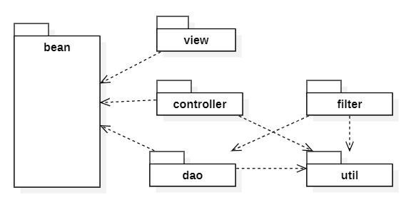

Figure Code Package

## 2. Database Schema

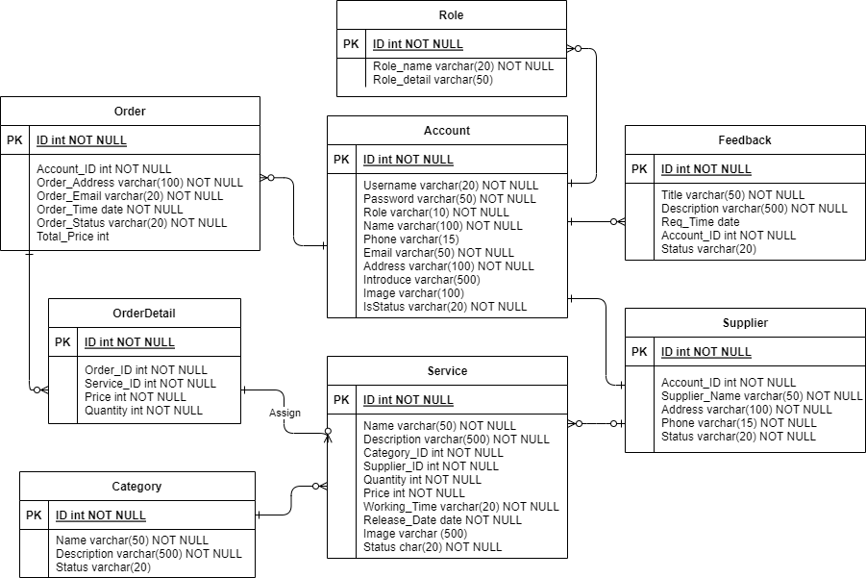

Figure Database Schema

# II. Code Designs

## 1. <Feature/Function Name1>

### a. Sequence Diagram(s)

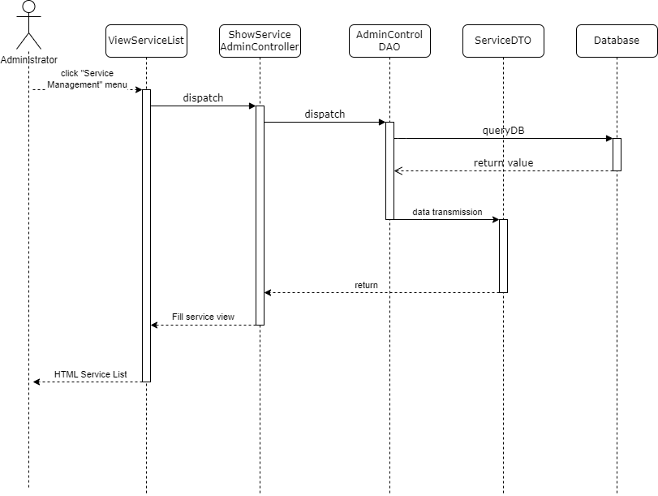

Figure Admin View Service List

------------------------END------------------------