

**<<E-BUtler>>**

**Software Requirement Specification**

– HoChiMinh, November 2022 –

**Table of Contents**

I. Overview 3

1. Introduction 3

2. System Functions 4

3. Common Requirements 4

# I. Overview

## 1. Introduction

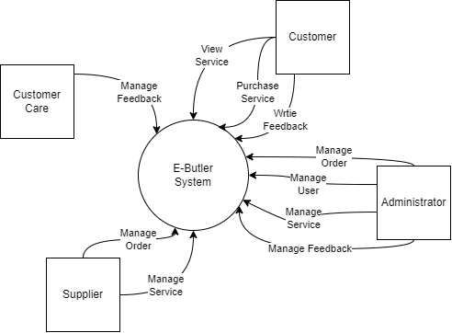

Figure Overview

## 2. System Functions

#### a. Screen Flow

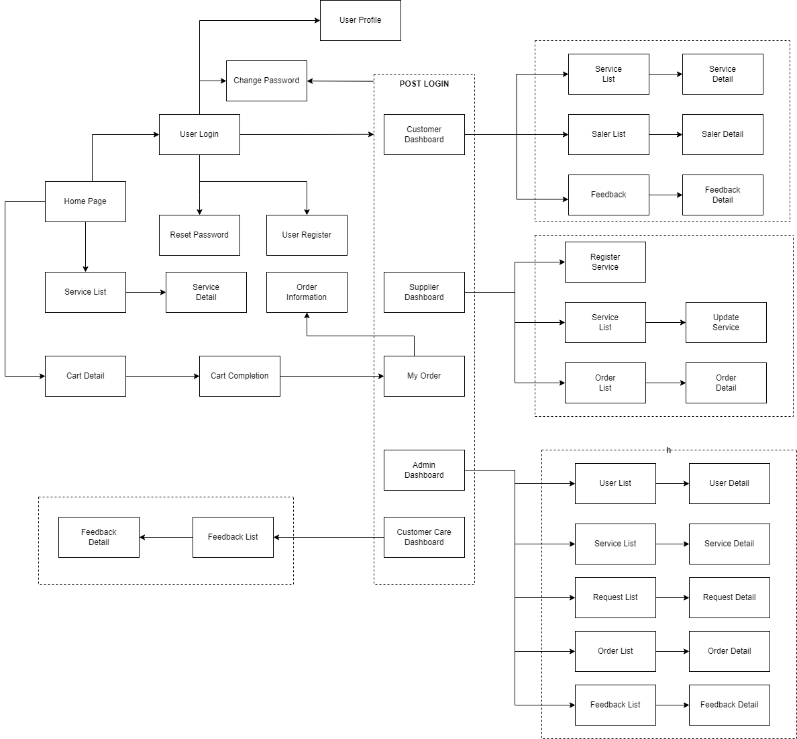

Figure Screen Flow

## 3. Common Requirements

This includes the screens used for system customers, as listed below

- My Orders: for customer to view his/her submitted orders.

- Order Information: to show customer’s order details, the customer can feedback or cancel the order when it is still in the submitted status.

- Customer Dashboard: for customer to view services, as listed below:

+ Service List: View a list of service.

+ Seller List: View seller page and list of service by that seller.

+ Feedback: Send a feedback to admin/seller.

- Supplier Dashboard: for supplier to view personal service and manage service, as list below:

+ Register Service: Register a service, send a request to admin to accept it.

+ Service List: View a list of personal service.

+ Order List: View a list of order from customer and manage those.

- Admin Dashboard: for administrator to manage everything, as listed below:

+ User List: View a list of all user and manage those.

+ Service List: View a list of service and manage those.

+ Request List: View a list of requested from supplier and manage those.

+ Feedback List: View a list of feedback from customer and manage those.

- Customer Care Dashboard: for customer care to manage all feedback, as list below:

+ Feedback list: View a list of feedback from customer and manage those.

------------------------------------END------------------------------------