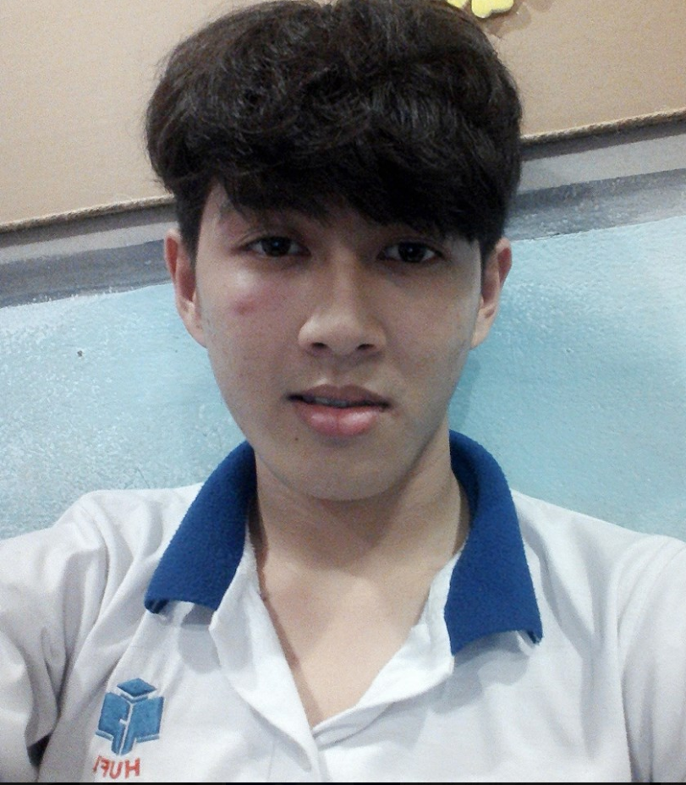

**2015-Present**

**NGUYEN CHI HUU**

**Some projects have done:**

-Build a website to support flight ticket sales by ASP.Net.

-Build a video watching application using youtube API on Android mobile devices.

-Build a program to support pharmacies using C#.

-Build a program to support bookstore using C#.

-Build a website by Framework CakePHP3.

Temawork



**REFERENCE**

*Ứng viên vui lòng điền thông tin Cá nhân mà Nhà tuyển dụng có thể liên hệ để tham khảo về ứng viên.*

Họ và tên:Nguyen Chi Huu

Chức vụ: Student tại đơn vị:

Email: huunc97@gmail.com Số điện thoại: 0931834001

PHP

15/12/1997

Male

23/15 B3 Street,Tay Thanh Ward,, Tan Phu District, HCM City

0931834001

huunc97@gmail.com

**Day of Birth**

**Sexual**

**Address**

**Phone**

**Email**

**ACTIVITIES**

-Join visit Dia Chi Do of HUFI active.

-Join IT CUP fooball tournament of HUFI university.

**Major : Information Technology**

Last year students

Study results 3 years: 1.96/4

**PROFESSIONAL EXPERIENCE**

**PERSONAL INFORMATION**

.NET/C#

jQuery

HTML/CSS

English 

**SKILLS**

**CAREER OBJECTIVES**

I hope that I can work at this company for a long time and I want to have a professional and dynamic working environment

By working hard, I expect to improve my professional ability. Besides, I can study more and more the knowledge of programming

**Ho Chi Minh City University of Food Industry (HUFI)**











**EDUCATION**