Name of Student:Husam Nour PRN:25070122086
Semester: III Year : AY 2026-27
Subject: Programming with Java
ASSIGNMENT No : 28
TITLE : Develop a Java application demonstrating Remote Method Invocation (RMI) using stub and skeleton components for remote communication.
Problem Statement
Develop a Java application demonstrating Remote Method Invocation (RMI) using stub and skeleton components for remote communication.
Learning Objectives
To understand Java RMI and demonstrate remote communication between a client and server using stub and skeleton components.
Theory
Remote Method Invocation (RMI) is a Java technology that enables an object running on one Java Virtual Machine (JVM) to invoke methods of an object running on another JVM located on a different machine. RMI simplifies distributed application development by allowing remote objects to behave like local objects. It consists of remote interfaces, remote object implementations, the RMI registry, and client-server communication. The registry maintains references to remote objects, allowing clients to locate and invoke them. RMI provides platform-independent communication, object serialization, and automatic network handling, making it suitable for distributed enterprise applications.
1. Create a remote calculator service using Java RMI
Programme:
- Calculator.java import java.rmi.Remote; import java.rmi.RemoteException; public interface Calculator extends Remote
{ int add(int a, int b) throws RemoteException; int subtract(int a, int b) throws RemoteException; int multiply(int a, int b) throws RemoteException; int divide(int a, int b) throws RemoteException;
}
CalculatorImpl.java import java.rmi.RemoteException; import java.rmi.server.UnicastRemoteObject; public class CalculatorImpl extends UnicastRemoteObject implements Calculator { public CalculatorImpl() throws RemoteException
{ super();
}
public int add(int a, int b) throws RemoteException
{ return a + b;
}
public int subtract(int a, int b) throws RemoteException
{ return a - b;
}
public int multiply(int a, int b) throws RemoteException
{ return a * b;
}
Output:

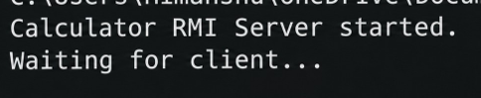
Programme:
1. CalculatorServer.java import java.rmi.registry.LocateRegistry; import java.rmi.registry.Registry; public class CalculatorServer {
public static void main(String[] args)
{ try {
CalculatorImpl calculator = new CalculatorImpl(); Registry registry = LocateRegistry.createRegistry(2000); registry.rebind("CalculatorService", calculator);
System.out.println("Calculator RMI Server started.");
System.out.println("Waiting for client...");
} catch (Exception e) {
System.out.println("Server Error: " + e.getMessage());
}
}
}
2. CalculatorClient.java import java.rmi.registry.LocateRegistry; import java.rmi.registry.Registry; public class CalculatorClient { public static void main(String[] args)
{ try {
Registry registry =
LocateRegistry.getRegistry("localhost", 2000);
Calculator calculator =
(Calculator) registry.lookup("CalculatorService"); int a = 20; int b = 10;
System.out.println("Addition = "
+ calculator.add(a, b));
System.out.println("Subtraction = "
+ calculator.subtract(a, b));
System.out.println("Multiplication = "
+ calculator.multiply(a, b));
System.out.println("Division = "
+ calculator.divide(a, b));
} catch (Exception e) {
System.out.println("Client Error: " + e.getMessage());
}
}
}
Output:
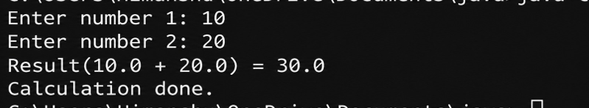
2. Create a Java application using RMI where the server converts temperature values between Celsius and Fahrenheit. The client sends input temperature and receives converted output.
Programme:
- Temperature.java import java.rmi.Remote; import java.rmi.RemoteException; public interface Temperature extends Remote
{ double celsiusToFahrenheit(double celsius) throws RemoteException; double fahrenheitToCelsius(double fahrenheit) throws RemoteException;
}
- TemperatureImpl.java import java.rmi.RemoteException; import java.rmi.server.UnicastRemoteObject;
public class TemperatureImpl extends UnicastRemoteObject implements Temperature { public TemperatureImpl() throws RemoteException
{ super();
}
public double celsiusToFahrenheit(double celsius) throws RemoteException {
return (celsius * 9 / 5) + 32;
}
public double fahrenheitToCelsius(double fahrenheit) throws RemoteException {
return (fahrenheit - 32) * 5 / 9;
}
}
Ouput:
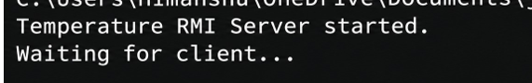
Programme: TemperatureServer.java import java.rmi.registry.LocateRegistry; import java.rmi.registry.Registry; public class TemperatureServer {
public static void main(String[] args)
{ try {
TemperatureImpl temperature =
new TemperatureImpl();
Registry registry =
LocateRegistry.createRegistry(1099); registry.rebind("TemperatureService", temperature);
System.out.println("Temperature RMI Server started.");
System.out.println("Waiting for client...");
} catch (Exception e) {
System.out.println("Server Error: " + e.getMessage());
}
}
}
TemperatureClient.java import java.rmi.registry.LocateRegistry; import java.rmi.registry.Registry; import java.util.Scanner; public class TemperatureClient { public static void main(String[] args)
{ try {
Registry registry =
LocateRegistry.getRegistry("localhost", 1099);
Temperature temperature =
(Temperature) registry.lookup("TemperatureService");
Scanner sc = new Scanner(System.in);
System.out.print("Enter temperature in Celsius: "); double celsius = sc.nextDouble(); double fahrenheit = temperature.celsiusToFahrenheit(celsius);
System.out.println(
"Temperature in Fahrenheit = "
+ fahrenheit
);
System.out.print("Enter temperature in Fahrenheit: "); double fahrenheitInput = sc.nextDouble(); double celsiusOutput = temperature.fahrenheitToCelsius(fahrenheitInput);
System.out.println( "Temperatur e in Celsius = "
+ celsiusOutput
); sc.close();
} catch (Exception e) {
System.out.println("Client Error: " + e.getMessage());
}
}
}
Output:
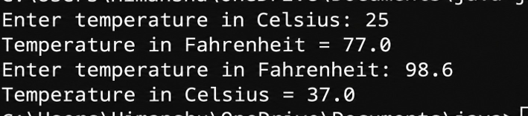
Conclusion:
The Java RMI applications successfully demonstrate remote communication between a client and server. The first application performs calculator operations remotely, while the second converts temperatures between Celsius and Fahrenheit. The programs demonstrate the use of remote interfaces, remote objects, RMI registry, client-side stubs, and remote method calls.

