

Name:Husa Ali Abdalla Nour
PRN: 25070122086
Branch: CSE (2025-29) Semester: 3

Subject: Programming with Java
ASSIGNMENT No.: 8
TITLE: Write a Java program to demonstrate the use of the super keyword in inheritance.

Problem Statement:

Write a Java program to demonstrate the use of the super keyword in inheritance.

Learning Objectives:

To demonstrate the use of the super keyword for accessing parent class members.

Theory:

The super keyword is used to refer to the immediate parent class in Java. It can invoke parent class constructors, access parent class variables, and call overridden methods. Super helps distinguish between parent and child class members with the same name. It ensures proper constructor chaining during object creation. It is an important concept in inheritance and method overriding.

Outcomes:
The super keyword was successfully used to invoke parent class constructors, access parent class variables, and call parent class methods that were overridden in the child class, as verified through the sample programs.

class Animal {
String name = "Animal";

Animal() {
System.out.println("Animal constructor called");
}

Animal(String name) { this.name = name;
System.out.println("Animal parameterized constructor called");
}
void sound() {
System.out.println("Animals make sounds");
}
}
class Dog extends Animal {
String name = "Dog";

Dog() {
super("Generic Animal");
System.out.println("Dog constructor called");
}
void sound() {
super.sound();
System.out.println("Dog barks");
}
void showNames() {
System.out.println("Child class variable (this.name) : " + this.name);
System.out.println("Parent class variable (super.name): " + super.name);
}
} public class JAVA_EXP_8 {
public static void main(String[] args) {
Dog d = new Dog();
System.out.println();

d.sound();
System.out.println();

d.showNames();
}
}

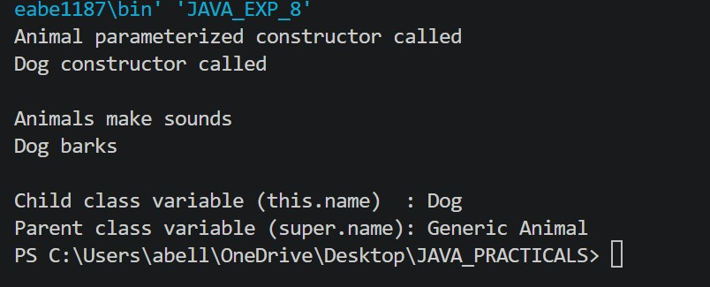

Conclusion:
The super keyword is essential in Java inheritance for maintaining a link between a subclass and its superclass. It enables constructor chaining, resolves naming conflicts between parent and child members, and allows reuse of parent class behaviour inside overridden methods, making code more modular and maintainable.

Exercise:

- Create an Employee and Manager program where Manager accesses Employee details using super keyword.

class Employee_ { String empName; int empId; double salary;

Employee_(String empName, int empId, double salary) { this.empName = empName; this.empId = empId; this.salary = salary;
}
void displayEmployeeDetails() {
System.out.println("Employee Name : " + empName);
System.out.println("Employee ID : " + empId);
System.out.println("Salary : " + salary);
}
}
class Manager extends Employee_ { String department; double bonus;

Manager(String empName, int empId, double salary, String department, double bonus) { super(empName, empId, salary); this.department = department; this.bonus = bonus;
} void displayManagerDetails() {
super.displayEmployeeDetails();
System.out.println("Department : " + department);
System.out.println("Bonus : " + bonus);
System.out.println("Total Pay : " + (super.salary + bonus));
}
} public class JAVA_EXP_8 {
public static void main(String[] args) {
Manager m = new Manager("Husam", 101, 55000, "Sales", 5000);
m.displayManagerDetails();
}
}

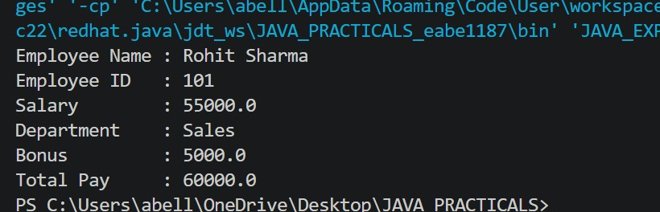

- Develop a Vehicle Insurance System where child insurance classes access parent vehicle information using the super keyword.

class Vehicle {
String vehicleNumber; String vehicleType; int manufactureYear;

Vehicle(String vehicleNumber, String vehicleType, int manufactureYear) { this.vehicleNumber = vehicleNumber; this.vehicleType = vehicleType;
this.manufactureYear = manufactureYear;
}
void showVehicleInfo() {
System.out.println("Vehicle Number : " + vehicleNumber);
System.out.println("Vehicle Type : " + vehicleType);
System.out.println("Manufacture Yr : " + manufactureYear);
}
} class CarInsurance extends Vehicle { double premiumAmount;
String coverageType;

CarInsurance(String vehicleNumber, int manufactureYear, double premiumAmount, String coverageType) { super(vehicleNumber, "Car", manufactureYear); this.premiumAmount = premiumAmount; this.coverageType = coverageType;
} void showPolicyDetails() {
super.showVehicleInfo();
System.out.println("Coverage Type : " + coverageType);
System.out.println("Premium Amount : " + premiumAmount);

if (2026 - super.manufactureYear > 10) { // Considering Year - 2026 System.out.println("Note: Additional premium applies for vehicles older than 10 years.");
}
}
} class BikeInsurance extends Vehicle { double premiumAmount; boolean thirdPartyOnly;

BikeInsurance(String vehicleNumber, int manufactureYear, double premiumAmount, boolean thirdPartyOnly) { super(vehicleNumber, "Bike", manufactureYear); this.thirdPartyOnly = thirdPartyOnly;
} void showPolicyDetails() {
super.showVehicleInfo();
System.out.println("Third Party Only: " + thirdPartyOnly);
System.out.println("Premium Amount : " + premiumAmount);
}
}
public class JAVA_EXP_8 {
public static void main(String[] args) {
CarInsurance car = new CarInsurance("MH12AB1234", 2012, 8500.0,
"Comprehensive"); car.showPolicyDetails();

System.out.println();

BikeInsurance bike = new BikeInsurance("MH14XY5678", 2021, 1200.0, true); bike.showPolicyDetails();
}
}

