|  |  |  |  |
| --- | --- | --- | --- |
| logo ngan.png | | **MINISTRY OF EDUCATION AND TRAINING** | |
| **FPT UNIVERSITY** | |
| **CAPSTONE PROJECT DOCUMENT** | |
| **BUILDING A WEBSITE SUPPORT THE ACTIVITIES “TIẾP SỨC MÙA THI” CAMPAIGN** | |
|  | |
| |  |  | | --- | --- | | **Group 22** | | | **Group Members** | |  |  | | --- | --- | | SE60769 | Nguyen Duy Khoa | | SE60687 | Le Nguyen Huu Tri | | 60358 | Nguyen Dinh Tuan | | 60325 | Tran Nguyen Kim Vinh | | 60339 | Nguyen Vinh Hien | | | **Supervisor** | Nguyen Trong Tai | | **Ext Supervisor** | N/A | | **Capstone Project Code** | TSMT | | |
| - Ho Chi Minh City, April 2014 - | |

***Acknowledgement***

# **TABLE OF CONTENTS**

**TABLE OF CONTENTS** 4

**TABLE OF FIGURE** 6

**1.** **REPORT NO.1: INTRODUCTION** 7

**1.1.** **Project Information** 7

**1.2.** **Acronym and Definition** 7

**1.3.** **Introduction** 7

**1.4.** **Overview of Existing Methods** 7

**1.5.** **Project Objective** 9

**1.6.** **Scope Definition** 9

**1.7.** **Main Project Success Criteria** 9

**1.8.** **Approach** 9

**1.9.** **Functions** 9

**1.9.1.** **Functions for guests** 9

**1.9.2.** **Functions for candidates** 9

**1.9.3.** **Functions for sponsors** 10

**1.9.4.** **Functions for charities** 10

**1.9.5.** **Functions for volunteers** 10

**1.9.6.** **Functions for system administration** 10

**1.10.** **Roles and Responsibility** 10

**2.** **REPORT NO.2: PROJECT MANAGEMENT PLAN (PMP)** 10

**2.1.** **Problem Definition** 10

**2.1.1.** **Name of this Capstone Project** 10

**2.1.2.** **Project Abstract** 10

**2.1.3.** **Project Overview** 11

2.1.3.1. The Current System 11

2.1.3.2. The Proposed System 11

2.1.3.3. Boundaries of System 11

2.1.3.4. Development Environment 11

**2.2.** **Project Organization** 12

**2.2.1.** **Software Process Model** 12

**2.2.2.** **Roles and Responsibilities** 13

**2.2.3.** **Tools and Techniques** 14

**2.3.** **Project Management Plan** 14

**2.3.1.** **Task** 14

2.3.1.1. Task 1: Initiating 14

2.3.1.2. Task 2: Planning 14

2.3.1.3. Task 3: Creating Software Requirement Specification 15

2.3.1.4. Task 4: Designing Database 15

2.3.1.5. Task 5: Designing User Interface 16

2.3.1.6. Task 6: Creating Software Design Description 16

2.3.1.7. Task 7: Create Coding Framework 17

2.3.1.8. Task 8: Implementing 17

2.3.1.9. Task 9: Preforming System Testing 17

2.3.1.10. Task 10: Deployment and Input Initial Data 18

2.3.1.11. Task 11: Writing User’s Manual 18

**2.3.2.** **Task Sheet: Assignments and Timetable** 18

**2.4.** **Convention Rules** 19

**3.** **REPORT NO.3: SYSTEM REQUIREMENT SPECIFICATION (SRS)** 20

**3.1.** **User Requirement Specification** 20

**3.1.1.** **Guest Requirements** 20

**3.1.2.** **Candidate Requirements** 20

**3.1.3.** **Sponsor Requirements** 20

**3.1.4.** **Charity Requirements** 20

**3.1.5.** **Volunteer Requirements** 20

**3.1.6.** **Administrator Requirements** 20

**3.2.** **System Requirement Specification** 20

**3.2.1.** **External Interface Requirement** 20

3.2.1.1. User Interfaces 20

3.2.1.2. Hardware Interfaces 20

3.2.1.3. Software Interfaces 20

**3.2.2.** **Main Flow Overviews** 20

**3.2.3.** **System Features** 21

3.2.3.1. Overall Use case diagram 21

**3.3.** **Software System Attributes** 21

3.3.1. Reliability 21

3.3.2. Availability 21

3.3.3. Security 21

3.3.4. Maintainability 21

3.3.5. Portability 21

3.3.6. Performance 21

**3.4.** **Entity Relationship Diagram** 22

**4.** **REPORT NO.4: SYSTEM DESIGN DESCRIPTION (SDD)** 23

**4.1.** **Design Overview** 23

**4.2.** **System Architectural Design** 23

**4.3.** **Component Diagram** 23

**4.4.** **Detailed Description of Components** 23

**4.5.** **Sequence Diagram** 23

**4.6.** **User Interface Design / Hardware Interface Design (if any)** 23

**4.7.** **Database Design or Data Structure or Algorithms** 23

**4.8.** **Other material (if any)** 23

**5.** **REPORT NO.5: SYSTEM IMPLEMENTATION & TEST (SIT)** 23

**5.1.** **Introduction** 23

**5.2.** **Database Relationship Diagrams/Hardware Charts (if any)** 23

**5.3.** **Screen shots/Performance measures/** 23

**5.4.** **Test Plan** 23

**5.5.** **Test Cases** 23

**5.6.** **Checklists** 23

**5.7.** **Other material** 23

**6.** **REPORT NO.6: SYSTEM USER’S MANUAL (SUM)** 23

**6.1.** **Installation Guide** 23

**6.2.** **User’s Guide** 23

**6.3.** **Other [Optional]** 23

**6.4.** **APPENDIX** 23

# **TABLE OF FIGURE**

Figure 1 - Software Lifecycle Model 13

# **REPORT NO.1: INTRODUCTION**

## **Project Information**

* Project Name: **Building a website to support the activities “Tiếp sức mùa thi” campaign**
* Project Code: **TSMT**
* Product Type: **Website**
* Start Date: **Jan 7th, 2014**
* End Date: **Apr 24th, 2014**

## **Acronym and Definition**

|  |  |
| --- | --- |
| Acronym | Definition |
| TSMT | TSMT system |
| SAC | Student Assistance Center of Ho Chi Minh City |

## **Introduction**

“Tiếp sức mùa thi” campaign is a social program, which support candidates in taking the entrance examination into colleges. It was organized for the first time since 1996 in Ho Chi Minh City and then spread through the country. The meaningful of campaign to help candidate solve the difficult problems such as: travel, eating, accommodation, etc… in new environment.

Moreover, “Tiếp sức mùa thi” campaign also get huge attention of volunteers and charities. Charities want to donate lodges, vehicles and funds and volunteers want to contribute their effort to help candidates make the dream come true. But there is not any website or tool to let them do that. Or if having, those activities took place entirely in manually and generate redundant time.

For example, when charities and volunteers want to contribute, then they will contact with The Student Support Center to register their information and wait for responding. If problem occurs, the Student Support Center need time to handles, such as charity don’t support any more, lodge is full, volunteer is busy in the examination date, etc…

To candidates, who need to support, also register to The Student Support Center and wait to get acceptance. If successful, candidates will receive support or candidates still wait. Expectations and pressures from exams make candidates become fatigue and depression. And the worst thing is candidate will receive the results that don’t as they desire.

So that, to solve all problem, we create TMST system. With TSMT, volunteers and charities can register and submit their sponsor information. Candidates can register into charities and lodge, belong to the management of that charity. Then system suggest the planning of pickup candidates, assign candidates into rooms into lodges, assign vehicles to shuttle candidates between lodges and examination sites, display routes on map, search friends to make groups, view enrollment news, etc…

## **Overview of Existing Methods**

Currently, there are some website also support candidates such as: “tiepsucmuathi.com.vn”, “hotrosinhvien.vn”, but they are not same ideas with TSMT

* **Website “tiepsucmuathi.com.vn”**

In overview, this website is easy to use with interactive interface, same ideas with us. It allows candidate find lodge, view news, view benchmark of university, etc.... But unfortunately, most function are not implemented, user only view news and the latest post from October 18th, 2013.

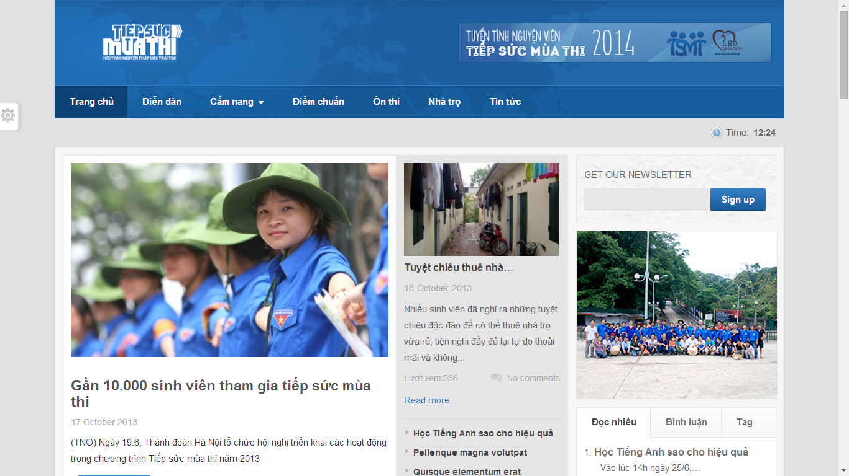

* **Advantages:**
  + Only support to candidates
  + Easy to view
* **Disadvantages:**
  + Most functions are not implemented.
  + Website is dead.
* **Website “hotrosinhvien.vn” of Student Assistance Center of Ho Chi Minh City**

That website support students, which are studying in universities, colleges. That provides student many information about lodge, scholarship, and jobs, etc…

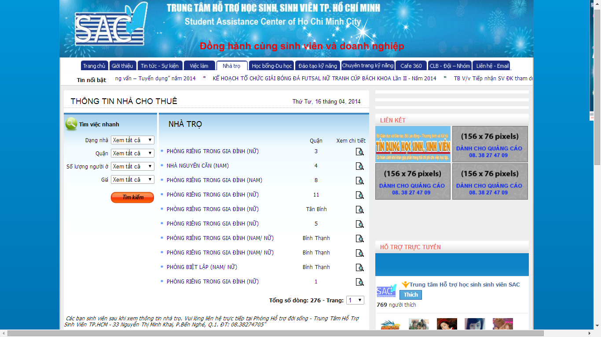

* **Advantages:**
* User can search lodges with detail information
* Providing many useful information for students in universities and colleges
* **Disadvantages:**
* Interface make user confuse because it is too many tabs.
* Not support for candidates
* Not automatically, for example, when user search lodges, then they want to choose that lodge and must contact with SAC to support.

## **Project Objective**

The project aims to develop a web-based application that

* Help volunteers and charities can register and submit their sponsor information.
* Help candidates can register and post their information and lodging request.
* The system can suggest the planning and scheduling for pickup candidates, sponsor management,

## **Scope Definition**

Following the description of project objectives, the scope of the project is constrained to the following statements:

* The users of the website should interact with the website itself through a friendly and attractive user interface.
* *For Candidates:* the website should provide functions such as: register their examination papers, find charities support, register into lodges, search friends, create groups, ask or invite friends into groups and view information about rooms, vehicles.
* *For Sponsor:* the website should allow to them create their sponsored information such as: information about lodge, vehicle, fund; give those resources to charities, and view statistic.
* *For Volunteer:* TSMT should allow them to register into charities; after charities assign candidate to pick up, they can view routes, candidate’s information
* *For Charity:* TMST should allow them to create their resources such as: lodge, vehicle; accept supported resources; assign candidates into rooms in lodges, vehicles; accept requests of volunteers.
* *For System Administrator:* TSMT should support them to monitor fundamental information about members, university, examination venue, examination schedule, and news.

## **Main Project Success Criteria**

The system meet all written specifications, be thoroughly tested and completed on time. Also, this project must be compatible with the current working process and model of FPT University.

## **Approach**

* Make survey to collect ideas from candidate, volunteer, charities which joined the campaign in the previous years.
* Use some current website to find out how it work.
* Brainstorm in our group.

## **Functions**

### **Functions for guests**

* Allow to register new account at TSMT system.
* Allow to view charities’ information, lodges
* Allow to view news about tips, lodges and new feeds from DanTri Newspaper.

### **Functions for candidates**

* Allow to manage their contest report cards in each exams.
* Allow to find and register into lodges, manage by charities, after registered contest report card in each exams.
* Allow to search friends, create groups, ask or invite friends to join group in each exams.
* Allow to view information about room in lodge, vehicle after charity assigned in each exams.

### **Functions for sponsors**

* Allow to manage information of their resources such as lodges, vehicles and funds.
* Allow to sponsor their resources to charities in each exams.
* Allow to view statistics about the status of using lodges, vehicles and funds.

### **Functions for charities**

* Allow to manage information about lodges, vehicles.
* Allow to register to assist and manage assistance in each exams.
* Allow to assign lodges, vehicles in each exams.
* Allow to manage volunteers, registered to support candidates.
* Allow to manage candidates, registered into lodges, sort rooms in lodges and vehicles.
* Allow to manage sponsored resources of sponsors.

### **Functions for volunteers**

* Allow to view charities’ information.
* Allow to register into charities to assist candidates in each exams.
* Allow to view route, view candidate’s information to shuttle during contest.

### **Functions for system administration**

* Allow to manage all relevant information about system.
* Allow to manage information about university, venue, and exams.
* Allow to manage news, manage categories.

## **Roles and Responsibility**

|  |  |  |  |  |
| --- | --- | --- | --- | --- |
| No. | Full Name | Role | Position | Contact |
| 1 | Nguyen Trong Tai | Supervisor | Instructor | TaiNT@fpt.edu.vn |
| 2 | Nguyen Duy Khoa | Developer, Tester | Team Leader | KhoaNDSE60769@fpt.edu.vn |
| 3 | Le Nguyen Huu Tri | Developer, Tester | Team Member | TriLNHSE60687@fpt.edu.vn |
| 4 | Tran Dinh Tuan | Developer, Tester | Team Member | TuanNDse60358@fpt.edu.vn |
| 5 | Tran Nguyen Kim Vinh | Developer, Tester | Team Member | VinhTNKSE60325@fpt.edu.vn |
| 6 | Nguyen Vinh Hien | Developer, Tester | Team Member | HienNVSE60339@fpt.edu.vn |

# **REPORT NO.2: PROJECT MANAGEMENT PLAN (PMP)**

## **Problem Definition**

### **Name of this Capstone Project**

|  |  |
| --- | --- |
| Official name | Building a website to support the activities “Tiếp sức mùa thi” campaign |
| Vietnamese name | Xây dựng website hỗ trợ các hoạt động cho chiến dịch “Tiếp sức mùa thi” |
| Abbreviation | TSMT |

### **Project Abstract**

The idea of the project is to develop a website that support candidates, which have difficult conditional in finding lodges in new environment, making group with friends, viewing support information. It also help sponsors manage their resources and assign them to charities in each exams, and know their resources are used how. It also helps volunteers know information about charities and register to assist in each exams. Finally, it help charities to manage all information about lodges, vehicles and volunteers and check all resources to support candidates in the best status.

### **Project Overview**

#### The Current System

There is not any current system. The “Tiếp sức mùa thi” campaign has some limitations like:

* Number of foundations are so much but they can’t find any easiest way to support candidates. Currently, foundations want to post their sponsor information, they must contact with SAC and wait for responding of SAC.
* The management completely done by hand-made based on a lot of paperwork, applications, and so on that lead to errors in the summary, statistics and searching.
* The most limitations is candidates can’t find any information about lodges, especially, near examination venue, if found, they also couldn’t go there easily. When candidates go to consultant locations, candidates will register their information with counselors. And volunteers will pick up candidates to the registered lodges. If lodge unfortunately is full, volunteers will take candidates to go to another lodges that spends lots of time. So, the effect of external factors will make candidates can’t focus completely on preparing for the university entrance exam.

#### The Proposed System

With TSMT System, we give users a new system that integrated the current activities process of the “Tiếp sức mùa thi” campaign by automating some functions of the traditional process.

TSMT system should support:

* Candidate can

#### Boundaries of System

* The main scope of this project is to provide an efficiently and easy-to-use website that facilitate manually process of the “Tiếp sức mùa thi” campaign.
* It manages users, allocates suitable roles for each kind of users.
* It is not designed for specific foundation, but for general structure management of all foundation.
* The website only support Vietnamese.

#### Development Environment

Below is the list of hardware and software requirement needed for the development environment of the project

**Hardware requirements:**

* Personal computers for developing with the minimum configuration: 2 Gb of RAM, 100Gb of hard disk, Core 2 Duo 2.0 Ghz;
* A server computer for testing with the minimum configuration: 4 Gb of RAM, 100Gb of hard disk, Core 2 Duo 2.0 Ghz;
* All computers must be connected to the internet.

**Software requirements:**

* Operating system: Windows 7 or above;
* Web Server: IIS Express 7 or above;
* Framework: .NET Framework 4.5;
* IDE: Visual Studio 2012;
* DBMS: SQL Server 2008 R2;
* Source Control: SVN, Google Code.
* Others: Software Ideas Modeler, StarUML, Microsoft Office (Word, Excel, Project, Visio)

## **Project Organization**

### **Software Process Model**

With the schedule of weekly reports for every stage, the software will be developed by using waterfall model which is very simple and require minimal resource for implementation. In the waterfall approach, the whole process of software development is divided into separate phases. These phases in the model are:

* Requirement specifications phase
* System and Software design
* Implementation and Unit Testing
* Integration and System Testing
* Operation and Maintenance

Requirement Specifications

System and Software Designs

Implementation and Unit Testing

Integration and System Testing

Operation and Maintenance

Figure 1 - Software Lifecycle Model

Stages of the software waterfall lifecycle model explained:

* **Requirement Analysis and Definition**: All possible requirements of the system to be developed are captured in this phase. The requirements are gathered from the end user at the start of the software development phase. These requirements are analyzed for their validity, and the possibility of incorporating the requirements in the system to be developed is also studied. Finally, a requirement specification document is created which serves the purpose of guideline for the next phase of model.
* **System and Software Design:** The requirement specifications from the first phase are studied in this phase and a system design is prepared. System design helps in specifying hardware and system requirements and also helps in defining the overall system architecture. The system design specifications serves the purpose of guideline for the next phase of the model.
* **Implementation and Unit Testing:** On receiving system design documents, the work is divided in modules/units and actual coding is started. Each unit is developed and tested for its functionality; this is referred to as unit testing. Unit testing mainly verifies if the modules/units meet their specifications.
* **Integration and System Testing:** Units from above phrase are integrated into a complete system during integration phase and tested to check if all modules/units coordinate with each other and the system as a whole behaves as per the specifications. After successfully testing the software, it is delivered to the customer.
* **Operation and Maintenance:** Generally, problems with the system developed (which are not found during the development life cycle) come up after its practical use starts, so the issues related to the system are solved after development of the system. Not all the problems come into picture directly but they arise from time to time and need to be solved; hence. This process is referred to as maintenance.

### **Roles and Responsibilities**

|  |  |  |  |
| --- | --- | --- | --- |
| No. | Full name | Roles in group | Responsibilities |
| 1 | Nguyen Trong Tai | Supervisor | * Give advices on business and technical problems * Review and approve of project documents and product deliverables * Assess the performance of team members |
| 2 | Nguyen Duy Khoa | Team Leader, Developer, Tester | * Distribute task to the other members * Monitor the development process and review the deliverables * Work on system architecture and detailed designs * Implement * Prepare documents * Perform unit testing * Deploy the final product |
| 3 | Le Nguyen Huu Tri | Team Member, Developer, Tester | * Create project management plan * Design user interfaces * Work on detailed design * Implement * Prepare documents * Perform unit testing, system testing and integration test |
| 4 | Nguyen Dinh Tuan | Team Member, Developer, Tester | * Work on detailed design * Implement * Prepare documents * Perform unit testing, system testing and integration test |
| 5 | Tran Nguyen Kim Vinh | Team Member, Developer, Tester | * Work on detailed design * Implement * Prepare documents * Perform unit testing, system testing and integration test |
| 6 | Nguyen Vinh Hien | Team Member, Developer, Tester | * Work on detailed design * Implement * Prepare documents * Perform unit testing, system testing and integration test |

### **Tools and Techniques**

The tools that will be used to develop the system includes:

* Developing tools: Microsoft Visual Studio 2012, Microsoft SQL Server 2008 R2
* Modelling tools: Software Ideas Modeller, StarUML
* Document tools: Microsoft Office 2013 (Word, Excel, Power Point, Visio, Project)
* Source control tools: SVN, Google Code

## **Project Management Plan**

### **Task**

Below are all the major tasks that need to be performed sequentially during the development of the system.

#### Task 1: Initiating

|  |  |
| --- | --- |
| Task Name | Initiating |
| Descriptions | Perform research on real situation, user’s need research; decide upon the technology that will be used to develop the system |
| Deliverables | Report 1 – Project Introduction |
| Resources needed | 6 days |
| Dependencies and constraints | N/A |
| Risks | * Team members did not know each other in advance and have a little background in term of “Tiếp sức mùa thi” campaign * Some users may not agree to spend time for making surveys * Strange requirement from users * Lack of technologies or chosen technologies are not feasible |

#### Task 2: Planning

|  |  |
| --- | --- |
| Task Name | Planning |
| Descriptions | Create the project management plan; break the system into modules and assign tasks to each member. |
| Deliverables | Report 2 – Software Project Management Plan |
| Resources needed | 6 days |
| Dependencies and constraints | Task 1 has finished |
| Risks | * Team leader has no experience in managing software projects; all members are still not acquainted with the new technology. * Dividing modules and planning tasks maybe unbalance, and unreasonable |

#### Task 3: Creating Software Requirement Specification

|  |  |
| --- | --- |
| Task Name | Creating Software Requirement Specification |
| Descriptions | Discuss and agree upon the software requirements, what is to be developed and what is not; generate detailed descriptions of all the functions to be developed. |
| Deliverables | * Planning process has to be finished * Follow the Software Requirement Specification template |
| Resources needed | 12 days |
| Dependencies and constraints | Task 2 has finished |
| Risks | * Many aspects of the problem are still unclear to team members * All requirements come from team members, so conflicts may happen regularly * Misunderstand between user requirements and receiving information from designer may make designing and developing phrases be failed. |

#### Task 4: Designing Database

|  |  |
| --- | --- |
| Task Name | Designing database |
| Descriptions | Design the database based on the requirements collected, through three major steps: Conceptual, Logical, and Physical Design |
| Deliverables | ERD and the physical database with sample data |
| Resources needed | All team members; 4 days |
| Dependencies and constraints | Finish the requirement and specification phrase |
| Risks | Some of the requirements specified are not clear and cannot be translated into corresponding entities; little experience in organizing data. |

#### Task 5: Designing User Interface

|  |  |
| --- | --- |
| Task Name | Designing User Interface |
| Descriptions | * Design layouts for each page in system * Design style for each page in the system. * Design connection between all pages in the system * Define some basic JavaScript for each file |
| Deliverables | Prototype which includes:   * HTML pages * CSS files * JavaScript file |
| Resources needed | 6 days |
| Dependencies and constraints | * Finish the requirement specification task * User Interface must be friendly, easy to see and suitable with all functions in the system and topic of this project. * Display well in screen resolution 1024 x 768 |
| Risks | User interface may completely satisfy all dependencies and constrains above. |

#### Task 6: Creating Software Design Description

|  |  |
| --- | --- |
| Task Name | Creating Software Design Description |
| Descriptions | Agree upon the system architecture; Work on the detailed design of each module; decide which techniques are appropriate to which modules; design the user interfaces for users to interact with. |
| Deliverables | Report 4 – Software Design Description |
| Resources needed | 12 days |
| Dependencies and constraints | * Finish Software Requirement Specification report * Follow Software Design Description (SDD) report template |
| Risks | * Some functions are difficult to find an appropriate methods to implement; initial development environment setup is also difficult. * SRS may not detailed enough in other to meet business logic * Designing work is not good which lead to occur problem when implement, such as spending much effort for coding, maintain hard. |

#### Task 7: Creating Coding Framework

|  |  |
| --- | --- |
| Task Name | Creating Coding Framework |
| Descriptions | * Mapping the architecture design into source code * Create project solution files with: * Common classes * Common functions |
| Deliverables | ASP.NET MVC4 project and solution files |
| Resources needed | 4 days |
| Dependencies and constraints | * Finish Software Design Description (SDD) report * Follow coding convention |
| Risks | * Having bugs when coding framework * Team members do not understand thoroughly framework * Problem about coding skill which is not follow coding convention * Actual time may be more time than estimated time |

#### Task 8: Implementing

|  |  |
| --- | --- |
| Task Name | Implementing |
| Descriptions | Each team member implement all the functions that he or she was assigned and regularly check in the code to the SVN into Google Code; regularly validate that the implementation is consistent with the system and detailed designs. |
| Deliverables | The implemented website |
| Resources needed | All team members; 27 days |
| Dependencies and constraints | Task 7 has finished |
| Risks | * Some design documents contain errors; implementation is not always consistent with the system and detailed designs. * Team members do not understand thoroughly framework * Problem about coding skill which is not follow coding convention |

#### Task 9: Preforming System Testing

|  |  |
| --- | --- |
| Task Name | Performing System Testing |
| Descriptions | Create and perform appropriate test cases for all main functions; record the test results for later reference; fix all the bugs found during the testing sessions. |
| Deliverables | Report 5 – Software Test Documentation |
| Resources needed | 12 days |
| Dependencies and constraints | Task 8 has finished |
| Risks | Lack of test cases for some non-critical functions; not enough time to intensively test all the functions. |

#### Task 10: Deployment and Input Initial Data

|  |  |
| --- | --- |
| Task Name | Deployment and Input Initial Data |
| Descriptions | Deploy system and input initial data for TSMT system |
| Deliverables | Complete TSMT project source code, up-to-date documentations. |
| Resources needed | 8 days |
| Dependencies and constraints | Task 9 has finished |
| Risks | * Update all documentations may need more time than schedule. * Team members may not familiar with input consistent data for all tables in database. * The program is not running properly in real environment. * Cannot release before the deadline. |

#### Task 11: Writing User’s Manual

|  |  |
| --- | --- |
| Task Name | Writing User’s Manual |
| Descriptions | Writing a user’s manual to instruct the users, including guest, travelers, hotel owners, and system administrators, how to use the system. |
| Deliverables | Report 6 – User’s Manual |
| Resources needed | 4 days |
| Dependencies and constraints | Task 9 has finished |
| Risks | * Some of the functions are not consistent with the user requirements, causing the user’s manual to be inconsistent with the user requirements. * User’s manual may be not easy to understand with the customer. * Team members may be not familiar with crating user’s manual which leads to behind schedule. |

### **Task Sheet: Assignments and Timetable**

|  |  |  |  |  |
| --- | --- | --- | --- | --- |
| Task Name | Duration | Start Date | End Date | Resource |
| Initiating | 5 days | Mon 06/01/2014 | Fri  10/01/2014 | KhoaND, TriLNH, TuanND, VinhNTK, HienNV |
| Planning | 5 days | Mon 13/01/2014 | Fri  17/01/2014 | KhoaND, TriLNH |
| Creating Software Requirement Specification | 5.5 days | Mon 20/01/2014 | Fri  24/01/2014 | TuanND, VinhNTK, HienNV |
| Designing Database | 1.5 days | Fri  24/01/2014 | Mon  27/01/2014 | KhoaND, TriLNH |
| Designing User Interface | 3 days | Mon  10/02/2014 | Thu  13/02/2014 | TriLNH, TuanND, VinhNTK |
| Creating Software Design Description | 3 days | Fri  14/02/2014 | Tue  18/02/2014 | TriLNH, TuanND, VinhNTK, HienNV |
| Creating Coding Framework | 3 days | Wed  19/02/2014 | Fri  21/02/2014 | KhoaND, HienNV |
| Implementing | 27 days | Fri  28/02/2014 | Mon  07/04/2014 | KhoaND, TriLNH, TuanND, VinhNTK, HienNV |
| Performing System Test | 3 days | Tue  08/04/2014 | Thu  10/04/2014 | TriLNH, TuanND, VinhNTK, HienNV |
| Creating Software User’s Manual | 4 days | Fri 11/04/2014 | Wed  16/04/2014 | TriLNH, TuanND, VinhNTK |
| Deploying and Inputting Initial Data | 2 days | Thu  17/04/2014 | Fri  18/04/2014 | KhoaND, HienNV |

## **Convention Rules**

The implantation of the system must strictly follow all the standard coding and naming convention specified by Microsoft, which can be found at <http://msdn.microsoft.com/en-us/library/ff926074.aspx>

# **REPORT NO.3: SYSTEM REQUIREMENT SPECIFICATION (SRS)**

## **User Requirement Specification**

### **Guest Requirements**

### **Candidate Requirements**

### **Sponsor Requirements**

### **Charity Requirements**

### **Volunteer Requirements**

### **Administrator Requirements**

## **System Requirement Specification**

### **External Interface Requirement**

#### User Interfaces

* The TSMT website should adopt an attractive and user-friendly interface so that the users of the system can get a good experience browsing the site.
* The pages should be well linked together to promote
* Client postbacks should be limited wherever possible, in order to boost performance and ease of use
* The languages of TSMT website is Vietnamese.

#### Hardware Interfaces

* The TSMT website can be reached by personal computers that support Internet connection and web browsers. In order to get the best experience, the following conditions should be satisfied:
* 512 Kbps Internet connection or faster
* 1 gigahertz (GHz) processor or faster
* 1 gigabytes (GB) RAM or more.

#### Software Interfaces

|  |  |  |  |
| --- | --- | --- | --- |
| Software Name | Version | Cost | Provider |
| Web Browser   * Internet Explorer * Mozilla Firefox * Google Chrome | 9.0 or higher  27.0 or higher  34 | Free  Free  Free | Microsoft  Mozilla  Google |
| SQL Server Express | 11.0 | Free | Microsoft |
| .NET Framework | 4.5 | Free | Microsoft |
| IIS Express | 8 | Free | Microsoft |

### **Main Flow Overviews**

There are main flows in the TSMT website as specified below

### **System Features**

#### Overall Use case diagram

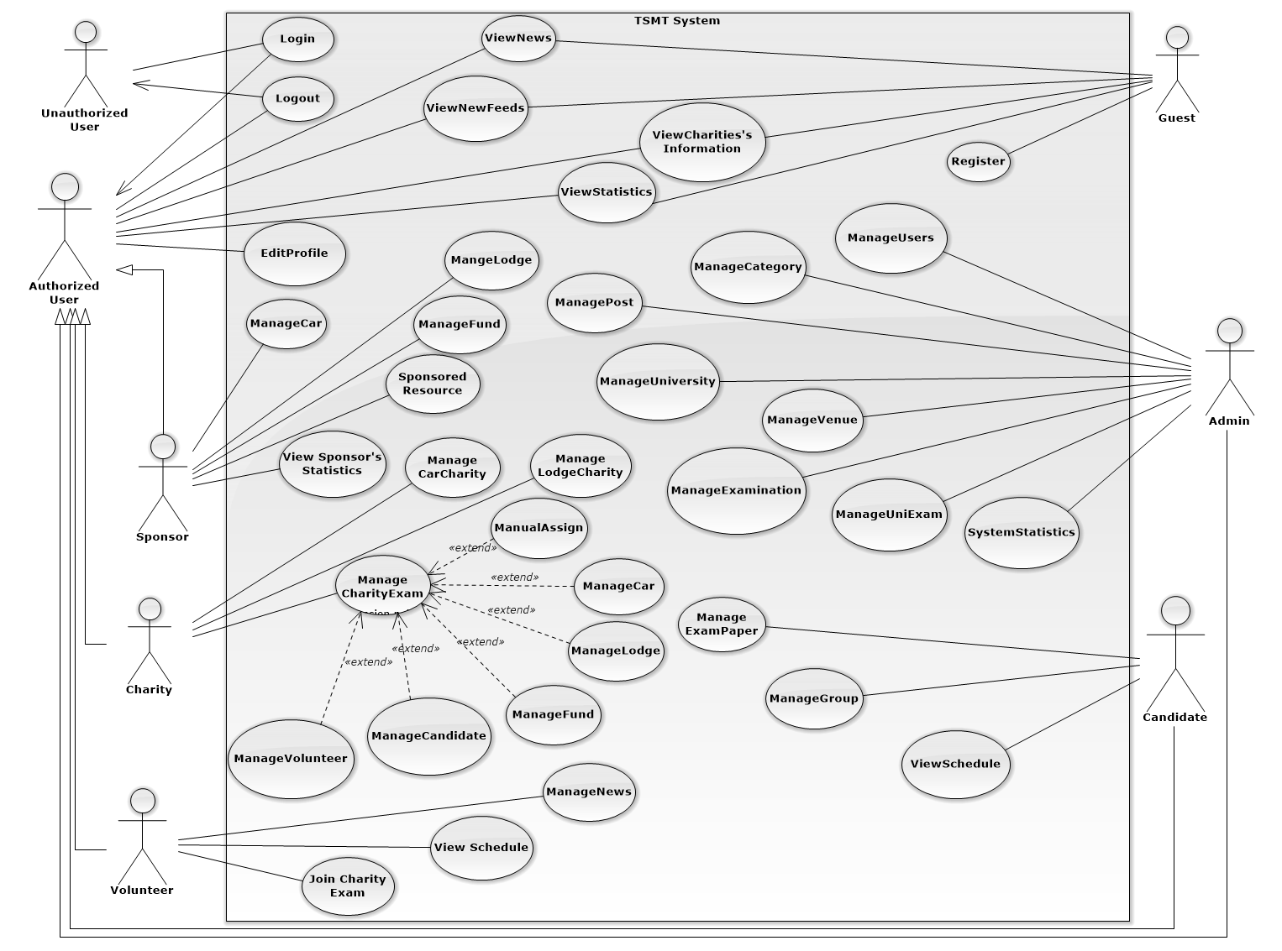Figure 2 - System Overview Usecase

#### (Guest) View Charity

#### (Guest) View Detail Charity

#### (Guest) View News

#### (Guest) View New Feed

#### (Guest) Register

#### (Guest) Login

#### (Guest) Edit Profile

#### (Authorized User) Change Password

#### (Authorized User) Logout

#### (Charity) View Candidate

#### (Charity) View Statistic

#### Overall Use case diagram

#### Overall Use case diagram

#### Overall Use case diagram

#### Overall Use case diagram

#### Overall Use case diagram

#### Overall Use case diagram

#### Overall Use case diagram

## **Software System Attributes**

### Reliability

* Accurate: 99%

### Availability

* N/A

### Security

* Each role of user has a specific permission to interact with system
* TSMT system always checks authorization and authenticated before do anything

### Maintainability

* All the errors should be logged, supporting for bug fixing and maintenance

### Portability

* TMST should be accessible to anyone, with a personal computer that connects to the Internet and has a web browser

### Performance

* N/A

## **Entity Relationship Diagram**

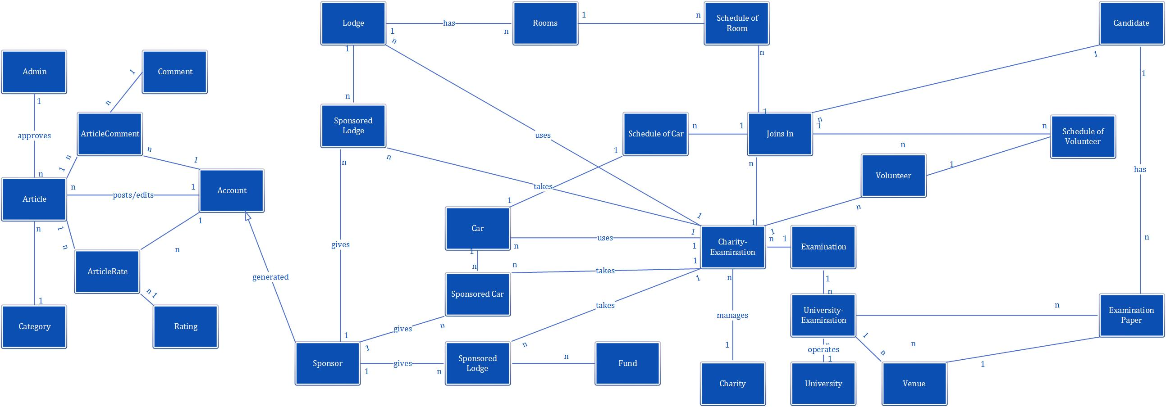

# **REPORT NO.4: SYSTEM DESIGN DESCRIPTION (SDD)**

## **Design Overview**

## **System Architectural Design**

## **Component Diagram**

## **Detailed Description of Components**

## **Sequence Diagram**

## **User Interface Design**

### **Home page**

### **Search Charity Page**

### **Charity Details Page**

## **Database Design**

### **Logical Database Design**

### **Physical Database Design**

## **Algorithms**

# **REPORT NO.5: SYSTEM IMPLEMENTATION & TEST (SIT)**

## **Introduction**

## **Database Relationship Diagrams/Hardware Charts (if any)**

## **Screen shots/Performance measures/**

## **Test Plan**

## **Test Cases**

## **Checklists**

## **Other material**

# **REPORT NO.6: SYSTEM USER’S MANUAL (SUM)**

## **Installation Guide**

## **User’s Guide**

# **APPENDIX**