|  |  |  |  |
| --- | --- | --- | --- |
| logo ngan.png | | **MINISTRY OF EDUCATION AND TRAINING** | |
| **FPT UNIVERSITY** | |
| **CAPSTONE PROJECT DOCUMENT** | |
| **BUILDING A WEBSITE SUPPORT THE ACTIVITIES “TIẾP SỨC MÙA THI” CAMPAIGN**  **Project Report #2 –** Software Project Management Plan | |
|  | |
| |  |  | | --- | --- | | **Group 22** | | | **Group Members** | |  |  | | --- | --- | | SE60769 | Nguyen Duy Khoa | | SE60687 | Le Nguyen Huu Tri | | 60358 | Nguyen Dinh Tuan | | 60325 | Tran Nguyen Kim Vinh | | 60339 | Nguyen Vinh Hien | | | **Supervisor** | Nguyen Trong Tai | | **Ext Supervisor** | N/A | | **Capstone Project Code** | TSMT Website | | |
| - Ho Chi Minh City, January 2014 - | |

## 

## Problem Definition

### Name of this Capstone Project

Building a website support the activities "Tiếp Sức Mùa Thi" campaign.

### Problem Abstract

Nowadays, when the exam season for [universities](http://en.wikipedia.org/wiki/Universities) and [colleges](http://en.wikipedia.org/wiki/Colleges) come, a lot of charities, volunteers want to use their houses, lodges, motorbike, or even money to support the candidates, especially whose not have good conditions. The volunteers will help the candidates to find a lodge and suggest them some place for good meals, and the route to the schools, etc. By then, the charities will manage the entire processes.

In fact, the number of existence system which have some functions really helpful for all roles above is so tiny that can be counted on the fingers.

### Project Overview

#### The Current System

……………………

#### The Proposed System

………………………

#### Boundaries of the System

* The system includes one Web Application.
* The system is mostly for users in Vietnam.
* The language of the system is Vietnamese.

#### Development Environment

##### Hardware requirements

**Server requirement**

* Operating System: Windows Vista/ 7/ 8
* CPU: Intel ® Core 2 Duo or more
* RAM: 1GB or more
* HDD: 40GB or more
* Internet connection required

**Client requirement**

* Computer with internet connection and a browser

##### Software requirements

* Microsoft Windows 7/ 8: development platform.
* SQL Server 2012 Enterprise Edition SP1: create and manage the database.
* Microsoft Visio 2013: create models and diagrams.
* Visual Studio 2012: implement the application.
* Google Code & Tortoise SVN: control source code and documents.
* Skype: used for communication and meeting

## Project organization

### Software Process Model

The project is developed using waterfall model.

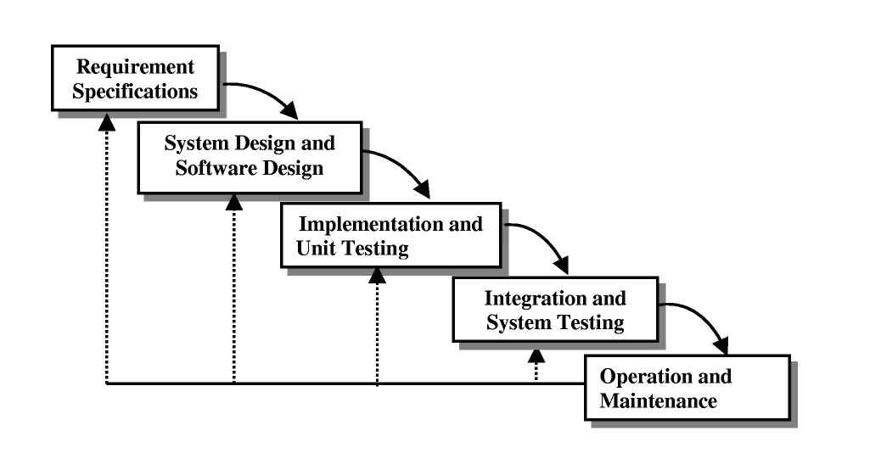

### Roles and responsibilities

|  |  |  |  |
| --- | --- | --- | --- |
| **No** | **Full name** | **Role in Group** | **Responsibilities** |
| **1** | Nguyễn Trọng Tài | Supervisor/ Project manager | * Specify user requirement * Control the development process * Support technique and business analysis. |
| **2** | Nguyễn Duy Khoa | Team Leader, Developer, Tester | * Managing process * Designing database * Clarifying requirements * Prepare documents * GUI Design * Create test plan * Coding * Testing |
| **3** | Lê Hữu Trí | Developer, Tester | * Designing database * Clarifying requirements * Prepare documents * GUI Design * Create test plan * Coding * Testing |
| **4** | Nguyễn Đình Tuấn | Developer, Tester | * Designing database * Clarifying requirements * Prepare documents * GUI Design * Create test plan * Coding * Testing |
| **5** | Trần Nguyễn Kim Vinh | Developer, Tester | * Designing database * Clarifying requirements * Prepare documents * GUI Design * Create test plan * Coding * Testing |
| **6** | Nguyễn Vinh Hiển | Developer, Tester | * Designing database * Clarifying requirements * Prepare documents * GUI Design * Create test plan * Coding * Testing |

### Tools and Techniques

- Front-end: CSS3, JavaScript, jQuery, AJAX.

- Back-end: ASP.NET Web Forms + Entity Framework 5.0

- Web Server: Microsoft IIS.

- Database Management System: Enterprise Edition SP1

## Project Management Plan

### Task

|  |  |  |  |  |  |
| --- | --- | --- | --- | --- | --- |
| **Phase** | **Description** | **Deliverables** | **Resource needed** | **Dependencies and Constrains** | **Risks** |
| **Preliminary Investigation**  **Analysis** | - Study similar existing systems from foreign websites.  -Identify and clarify requirements. | -Introduction the system.  -Main functions specification.  -Project Plan. | 12 man-days | N/A | Project may  not be feasible  for developing  because lack of technologies  and/or data |
| **Database Design and building GUI prototype** | -Define business entities involved in the system.  -Design ERD and implement the physical database. | -The physical database of the system. | 40 man-days | Business and work flows must be made clear. | The database design may need to be adjusted in the future, leads to major changes in the application. |
| **Implementation** | -Implement the Web Application | -The complete Web Application | 6 man-months | Finish implementing the database. | Shortage of technique to complete some difficult modules. |
| **Testing** | -Planning test cases  -Implement test plan  -Fixing bugs | -Test report.  -The debugged application. | 20 man-days | All modules have to be completed. | The amount of test can be very large.  Bugs can be missed out due to test case coverage. |
| **Deploy application for data collecting.** | -Students can view their own attendance rate.  -Instructor and admin can view reports. | -Attendance report function. | 12 man-days | Application must be finished and usable. | Lack of experience of making report. |
| **Collect and review documents** | -Review all reports and combine into one document. | -Capstone Project Document | 12 man-days | N/A | Document may fail to describe the system because the writer’s lack of skill. |

### Task Detail

#### Phase 1: Preliminary Investigation or Analysis

|  |  |  |
| --- | --- | --- |
| **Task** | **Description** | **Author** |
| **1. Identifying and studying existing systems** | Find which systems currently provide similar service, their strengths and weakness. | Dev Team |
| **2. Identifying and clarifying main functions** | Define main functions. | Dev Team |
| **3. Introduction** | Complete Introduction Report. | KhoaND |
| **4. Project Management**  **Plan** | Complete Project  Management Plan. | KhoaND |

#### Phase 2: Database Design and building GUI prototype

|  |  |  |
| --- | --- | --- |
| **Task** | **Description** | **Author** |
| **1. Define business processes and work flows** | List all functions the system has and describe the work flows. | Dev Team |
| **2. Design ERD** | Define all entities in the system and make ERD. | TriLNH,TuanND,VinhTNK |
| **3. Design Logical and Physical Database** | Make logical concept then implement the physical database. | KhoaND |
| **4. Build project’s skeleton** | Building the general architecture of the project | HienNV |
| **5. Build GUI prototype** | Building the main pages of the application’s interface | HienNV, TriLNH |
| **6. Complete Requirement Report** |  | TuanND, VinhTNK |
| **7. Complete Design Report** |  | KhoaND |

#### Phase 3: Implementation

|  |  |  |
| --- | --- | --- |
| **Task** | **Description** | **Author** |
| **1. Register/ Login** | Allow users to register an account in the system and login to use functions. | TriLNH |
| **2. View News** | User can view news on the home page | TriLNH |
| **3. Search Charities Info** | After login, users can search infomation of charities, and send request for them | TriLNH |
| **4. View Map** | Users can view map to search the university or motel | TriLNH |
| **5. Search Schedule** | See the plan, time | TriLNH |
| **6. View Statistic** | View the statistic from the other people used system | VinhTNK |
| **7. Candidate - Search Resource** | To find the motel, university and infomation | VinhTNK |
| **8. Cadidate - Manage Request** | Candidate can manage the request this send to charity | VinhTNK |
| **9. Candidate- View Schedule** | View time, address,destination, motel | VinhTNK |
| **10. Volunteer – Manager News** | Manager the news | VinhTNK |
| **11. Volunteer – View Schedule** | View time, address,destination, motel to meet and see off candidate | TuanND |
| **12. Volunteer – View Requests** | Volunteer can view the request this receive from charity | TuanND |
| **13. Charity – Manager REquest** | Receive request form cadidates, volunteer, sponsor, and feedback to them | TuanND |
| **14. Charity – Manger Schedule** | View all infomation about schedule | TuanND |
| **15. Charity - PayFees** | Pay fees for system | TuanND |
| **16. Charity - manageInfo** | Edit information of their organizations | HienNV |
| **17. Charity –manage Resource** | Edit resource and manage resource | HienNV |
| **18. Charity – view Statistic** | View statistic that others review | HienNV |
| **19. Sponsor – Manager Resource** | Edit resource and manage resource | HienNV |
| **20. Sponsor – Search Charities** | infomation of charities, and send request for them | HienNV |
| **21. Sponsor – view Statistic** | View statistic that others review | HienNV |
| **22. Admin – view System Stastic** | View statistic that user review all system | KhoaND |
| **23. Admin - User** | Report/ block user | KhoaND |
| **24. Admin – manage Exam Info** | Information about exam, university, motel, charity | KhoaND |
| **25. Admin – manage News** | Helpful Information | KhoaND |
| **26. Admin – manager Banner** | banner advertising | KhoaND |

#### Phase 4: Testing

|  |  |  |
| --- | --- | --- |
| **Task** | **Description** | **Author** |
| **1. Design test plan** | Planning for the testing process | KhoaND, TriLNH |
| **2. Writing Test Cases** | List all the module that need to test and write UTC. | TuanND, VInhTNK, HIenNV |
| **3. Execute test plan** | Runs test case and write test report. The modules will be cross-tested following the assignment of implementation. | Dev Team |
| **4. Bug fixes** | Fix all the bugs found. Each member is responsible for the modules which was assigned in the implementation phase. | Dev Team |
| **5. Perform integration and system test** | Test the system in the high level. | KhoaND |
| **6. Last-time bug fixing** | Fix bugs for the system before deployment | Dev Team |
| **7. Complete test report** | Complete the test report document | KhoaND |

#### Phase 5: Deploy application for data collecting.

|  |  |  |
| --- | --- | --- |
| **Task** | **Description** | **Author** |
| **1. Make deployment package.** | Pack the application. | KhoaND |
| **2. Deploy** | Deploy the website on server | TuanND, TriLNH |
| **3. Promote the system to the public.** | Use public relation technique to enhance the awareness of the application, in order to collect valuable and real data. | VinhTNK,HienNV |

#### Phase 6: Collect and review documents

|  |  |  |
| --- | --- | --- |
| **Task** | **Description** | **Author** |
| **1. Review report** | Review all the reports and suggest adjustments. | KhoaND |
| **4. Finalizing document** | Collect documents, write User manual, make adjustments and pack into Capstone Project Document | TuanND, TriLNH, VinhTNK, HienNV |

### All Meeting Minutes

Refer to Meeting Minutes folder.

## Coding Convention

Follow the C# Code Convention From:

<http://msdn.microsoft.com/en-us/library/vstudio/ff926074.aspx>

***FPT University, JAN 20th, 2014***