|  |  |  |  |
| --- | --- | --- | --- |
| logo ngan.png | | **MINISTRY OF EDUCATION AND TRAINING** | |
| **FPT UNIVERSITY** | |
| **CAPSTONE PROJECT DOCUMENT** | |
| **BUILDING A WEBSITE SUPPORT THE ACTIVITIES “TIẾP SỨC MÙA THI” CAMPAIGN**  **Project Report #1 – Project Introduction** | |
|  | |
| |  |  | | --- | --- | | **Group 22** | | | **Group Members** | |  |  | | --- | --- | | SE60769 | Nguyen Duy Khoa | | SE60687 | Le Nguyen Huu Tri | | 60358 | Nguyen Dinh Tuan | | 60325 | Tran Nguyen Kim Vinh | | 60339 | Nguyen Vinh Hien | | | **Supervisor** | Nguyen Trong Tai | | **Ext Supervisor** | N/A | | **Capstone Project Code** | TSMT | | |
| - Ho Chi Minh City, January 2014 - | |

TABLE OF CONTENTS

1. INTRODUCTION 3

1.1. Purpose 3

1.2. Acronyms And Definitions 3

1.3. Background 3

1.4. Literature Review 3

1.5. Proposal 4

1.5.1. The Idea 4

1.5.2. Brief Description About System 4

1.5.3. System Features 4

1.6. Objectives 4

1.7. Benefit From Project 4

1.7.1. For Charity Organizations 4

1.7.2. For Our Group 4

1.7.3. For Community 5

1.8. Potential risk and limitation 5

1.9. References 5

**TABLE OF FIGURES**

Figure 1-1: Tiepsucmuathi.com interface 5

Table 1-1: Definition and Acronyms 4

# INTRODUCTION

## Purpose

This document is prepared as the introduction for project “Building a website support the activities “Tiếp sức mùa thi” campaign”, in scope of Capstone Project at FPT University. It does not only explain the basic concept and idea for our project but also discuss what project’s benefits and threats are, what opportunities it offers and what existing reality problem it solves.

## Acronyms And Definitions

|  |  |  |
| --- | --- | --- |
| Acronym & Abbreviation | Definition | Note |
| TSMT | The website supports the activities “Tiếp sức mùa thi” campaign |  |
|  |  |  |
|  |  |  |
|  |  |  |
|  |  |  |
|  |  |  |
|  |  |  |

Table 1-1: Definition and Acronyms

## Background

“Tiếp sức mùa thi” campaign

## Literature Review

Currently, there are only few websites which support “Tiếp sức mùa thi” campaign that might help candidates ***look* *for*** lodge’s information, tips about examination, etc… such as: tiepsucmuathi.com,

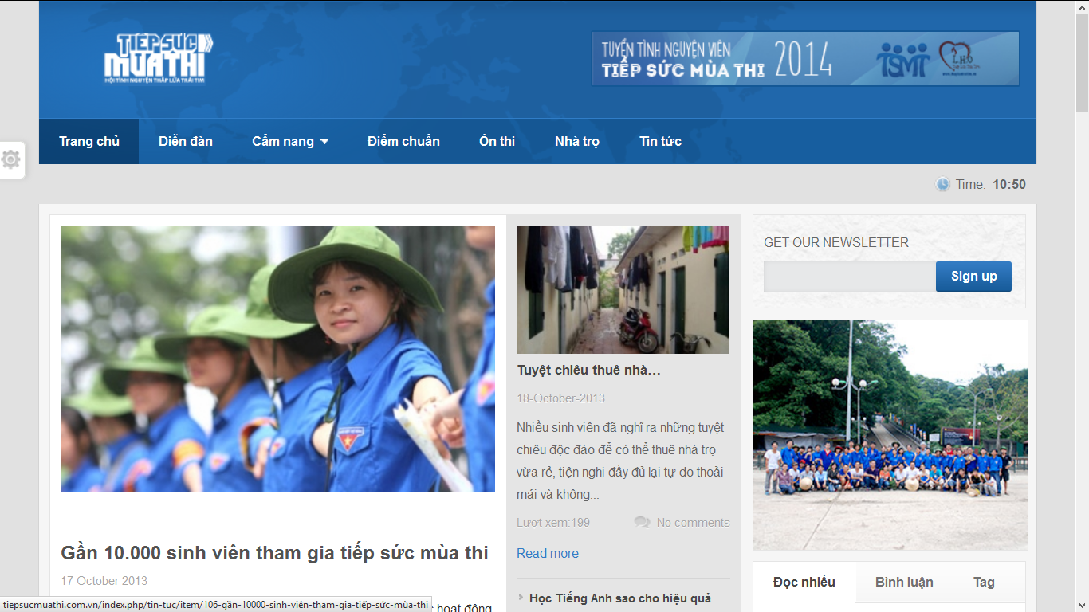

Figure 1-1: Tiepsucmuathi.com basic interface

**Advantages:**

**Disadvantages:**

## Proposal

### The **Idea**

The idea of creating TSMT website is totally new. The website will be a place where:

* The volunteers and charities can register and submit their sponsor information.
* The candidates can register and post their information and lodging request.

In addition, the system have ability to optimize planning and scheduling for pickup candidates and sponsor management, etc…

### Brief Description About System

<>

### System Features

* **Basic features:**
* Candidates can find lodges base on location on map.
* Charity can contribute money
* Volunteers can send request and join in a charity’s group.
* System can suggest **the nearest lodge** when candidates choose their examination’s location. Then it will display the instruction to help candidates easily reach to that lodge.
* With **Medical Diary** function, user can save their medicine taking schedule, dosage or set alarm to remind them to take medicine in time.
* Candidates can do advanced search for lodge with many criterias such as: medicine name, manufacture, indication, contraindication, ingredient, packaging or where that medicine is sold.
* Advanced search pharmacy
* The register form for pharmacy displays only on web version. It is easy to fill with general information, they can subscribe their location in the map or upload their picture, stock data to help user know more about them.
* Registered pharmacy will be provided an account that has role to edit, update or add new their database.
* Provide management feature for administrator to:
* Medicine management: search, add new, edit, delete, restore medicine
* Pharmacy management: accept or reject pharmacy registration, delete pharmacy information
* News control: Add, edit, delete news
* Provide news about medical and health

In near future, we might add another helpful function for user, that is diagnose the diseases online



## Objectives

This project is implemented as the capstone project for the team members. The first purpose is to fulfill the requirements from FPT University studying program. Our project use some new technology that we have not studied at the University such as: MVC4, test on simulator, etc… And it is also a chance for us to work as a real project team which is nearly to the environment that we will work after graduated. We have to learn how to control our time, our source code, hold a meeting, connect and communicate to other team members. Therefore, after get through that project, we can not only practice what we have studied but also have learned many new things to be ready to our furniture work.

The second purpose is to create a complete product to support “Tiếp sức mùa thi” campaign and people who concern with this campaign. TSMT can response the basic demand like search lodges information, charities and volunteers can post their information

## Benefit From Project

### For Charity Organizations

Charity Organization uses TMST will save time to contact

### For Our Group

After developing and implementing that project we will:

* Understand new technology like
* Have opportunity to experience, and improve working in group skill.
* Know how to manage project, limit risk, and control working time more effective.

### For Community

Just need to have a computer that connect to the internet, user can

## Potential risk and limitation

After studying about this project, we find out some problem that we may be encountered:

* We do not have much experience in exchange information, managing and controlling work so we might be missed the deadline or out of scope.
* We have not much knowledge in the framework and technique. Therefore, we have to study all of these things from the beginning. This work takes a lot of times. The project team may face with the difficult technical problems that may requires long time to resolve so that causes the project be delayed.
* In addition, we also have difficulty in using some tools such as: Microsoft Project, Visual Studio 2012, SQL Server 2012, and source code managing, etc… Therefore, our work management may be not good.

## References

[1] ?

[2] ?