**Pretest 2**

---------------------------------------------------------------------------------------------------------

**Question 1:**

Create the a website with the homepage looks exactly like the illustration in **Figure 1**.



**Figure 1**

When click on “Register”, the registration page appears as the figure 2.

**Question 2:**

* Create a form as shown in Figure 2:
* Fill the combo box with data :



* The program must take care of the following validations:

1. Fields Fullname, Email, Course must be entered.
2. The Email field must be in format [xxxx@xxx.xxx](mailto:xxxx@xxx.xxx) (example : abc@yahoo.com)
3. Start date must be greater than the current date
4. If the data is valid, when the user clicks on the Register button, field [**Your Information]**  
   (Figure 3) should be displayed the data entered by the user
5. When the Reset Button is clicked, all field on the form will be clear

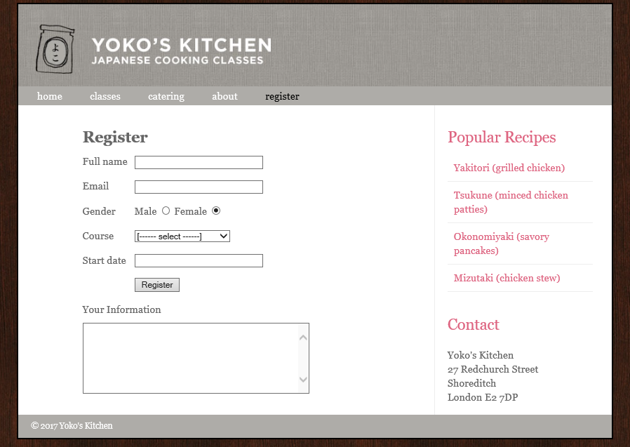

**Figure 2**

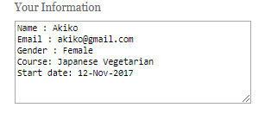

**Figure** 3

**---o0o---**