**INSTALL THE JDK - JAVA DEVELOPMENT KIT**

Install the following from the given link:

JDK 1.6.0_20 -

http://www.oracle.com/technetwork/java/javasebusiness/downloads/java-archive-downloads-javase6-419409.html#jdk-6u20-oth-JPR

After the installation is complete, set the JAVA_HOME environment variable. For Windows 7, go to Computer->Properties->Advanced System Settings, then select the Advanced tab and click on the Environment Variables button (Google "environment variables" if using other OS or other Windows version).

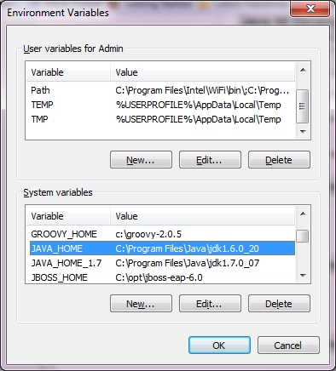

You will also need to edit the existing Path System Variables, and Append ";%JAVA_HOME%\bin" to it as shown below.

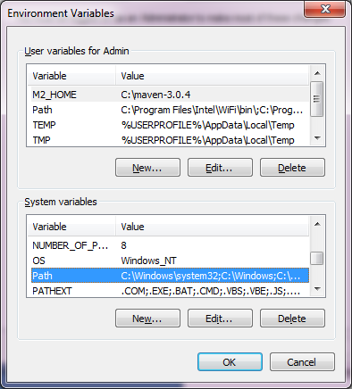

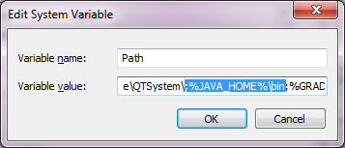

To test whether the instructions were followed, launch the command prompt and type "javac", and you should see something like the following:

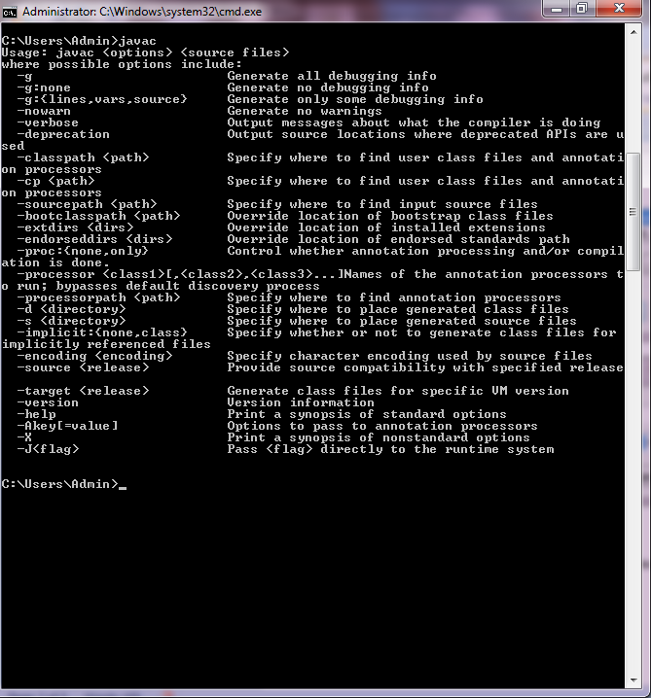

Congratulations, you have installed the SDK!

**INSTALLING MAVEN:**

Now, we download maven from the following link:

Maven 3.0.5 - http://apache.osuosl.org/maven/maven-3/3.0.5/binaries/apache-maven-3.0.5-bin.zip

Once this is done, unzip to your favorite location and you set the M2_HOME environment variable. For Windows 7, go to Computer->Properties->Advanced System Settings, then select the Advanced tab and click on the Environment Variables button (Google "environment variables" if using other OS or other Windows version).

You will notice that I set up JAVA_HOME as a system variable, and M2_HOME as a user variable. User variables apply to a single user whereas system variables apply to all users of your computer. It doesn't matter in my system since I have only one user. I'm demonstrating a pre-existing setup in my computer, and if I were starting from scratch, I would have been more consistent, so apologies for any confusion.

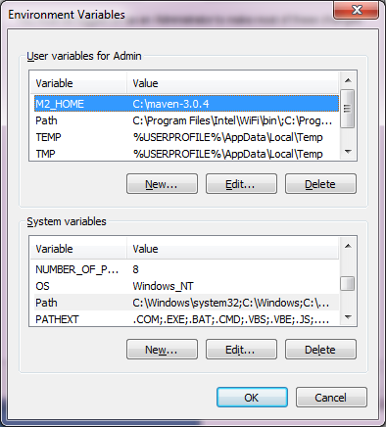

You will also need to edit the existing Path System Variables, and Append ";%M2_HOME%\bin" to it as shown below.

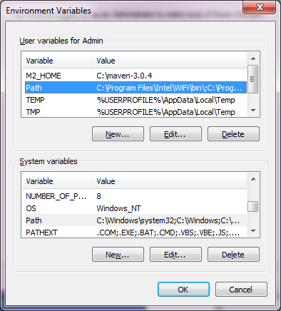

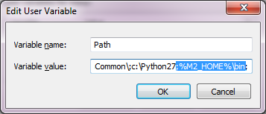

To test whether the instructions were followed, launch the command prompt and type "mvn", and you should see something like the following:

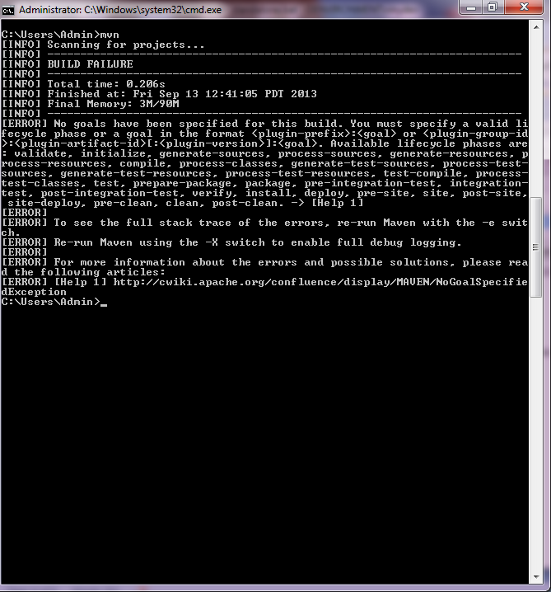

Congratulations, you have installed the Maven!

We will need to install one of the libraries to maven manually since it isn't in the global maven repository. Locate the Jama-1.0.3.jar (It's in Sean original stable.zip email and I have added it to C:\Users\Admin\Google Drive\Java Reservoir\lib\ shared folder). Assuming the jar is in the current directory, run "mvn install:install-file -Dfile=Jama-1.0.3.jar -DgroupId=jama -DartifactId=jama -Dversion=1.0.3 -Dpackaging=jar".

Download GIT and the GIT GUI from the following:

Follow the directions in the "Download & Install" section.

http://code.google.com/p/tortoisegit/

**IMPORTING THE PROJECT FROM GOOGLE DRIVE:**

Once this is complete, it's time to check out the project from our google drive remote master.

This will create a local master that you can happily commit to and branch out of, and can merge to remote master when your changes are completely ready.

Now choose where you want to save your project, and right click and select "Git Clone" as shown below (Note that GIT will prompt you for your name and email address initially - so fill that out if you haven't done so yet). Use the shared google drive as the URL and select OK.

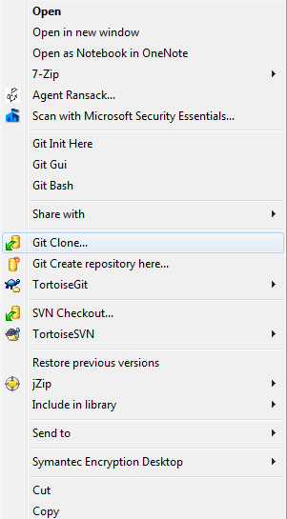

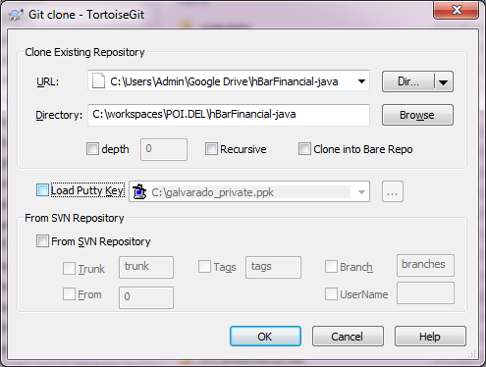

**INSTALLING THE ECLIPSE IDE:**

Now we download eclipse from the following link:

Eclipse IDE for Java EE Developers - http://www.eclipse.org/downloads/packages/release/indigo/sr2

Once this is done downloading, unzip to your favorite location and run the Eclipse.exe(eclipse.sh for Mac, I think ) to start up eclipse.

We will now install the Maven 2 Eclipse plugin.

In the Eclipse menu, go to Help->Install new software. Click the Add button and set Name="Maven" and URL="http://download.eclipse.org/technology/m2e/releases".

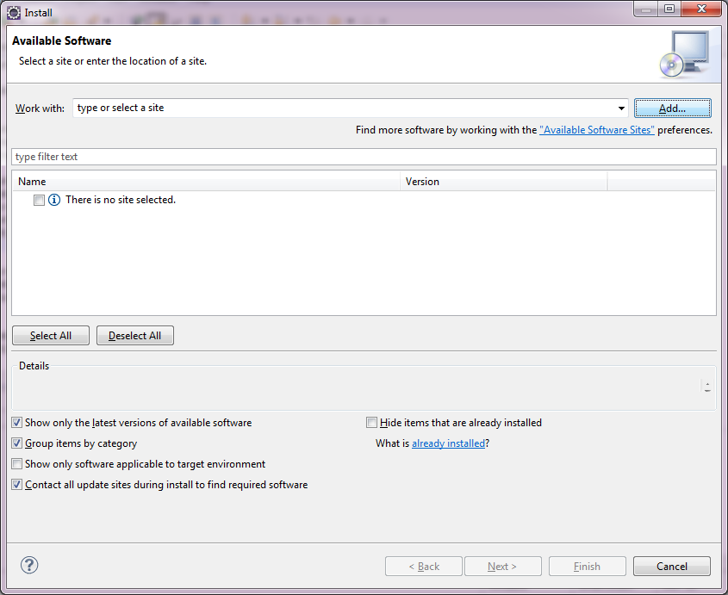

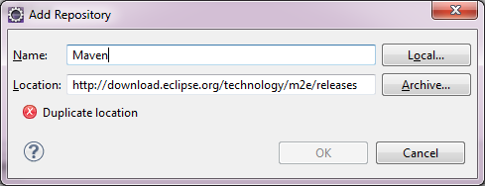

Select Maven Integration for Eclipse, and click Next to install (select defaults for any other prompts)...

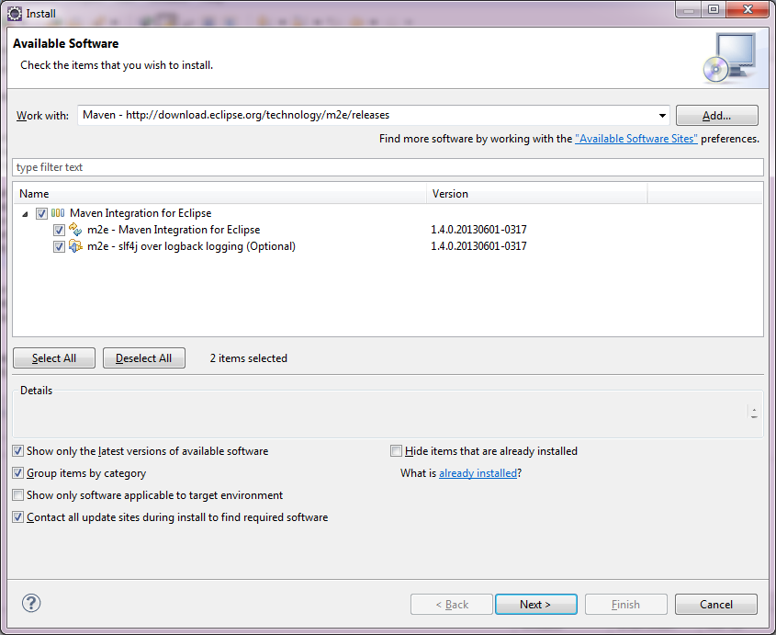

**IMPORTING THE PROJECT TO ECLIPSE:**

Now, we import the project that was cloned from the google drive in section "IMPORTING THE PROJECT FROM GOOGLE DRIVE:". In the Eclipse menu, go to File->Import , select General->Existing Projects into Workspace. Once this is done, right click the Project folder, select Configure->Convert to Maven Project.

Once this is done, right click on the Project, and select Run As->Maven Install.

Now let's make sure the project runs...

In the com.hbar.finance.neural package, open ReservoirFinance and in the main() function change the file name to where you have the sp500.csv file saved.

Now right click ReservoirFinance and select Run As->Java application. After about 30 seconds, you should see in the Console output something like:

Final Direction Guess=0.6666666666666666

Final RMSE=0.010203903663701289

time 2 taken:27282

**INSTALLING EXTERNAL MAVEN DEPENDENCIES:**

You will need to install an external maven dependency. The file is located in https://github.com/huvers/RC/external_maven_dependencies/

mvn install:install-file -Dfile=C:\Users\geemein80\roguefinance\external_maven_dependencies\mathematica.jlink-9.0.jar -DgroupId=mathematica.jlink -DartifactId=mathematica.jlink -Dversion=9.0 -Dpackaging=jar

Note that there may be other files in this location in the future which may need to be installed as well.