一、测试环境：
- 机器：Timi TM1613 (Sku Number) Notebook
- 显卡型号：GeForce 940MX
- OS版本：专业版
- 仓库配置
deb [by-hash=force] https://professional-packages.chinauos.com/desktop-professional eagle main contrib non-free

deb [trusted=yes] http://shuttle.corp.deepin.com/cache/repos/eagle-sp2/release-candidate/57O757uf57uEbnZpZGlhLXByaW1lMTI2MQ unstable main

- 安装
1 ) 将下列驱动加入黑名单
echo -e "blacklist nouveau\nblacklist nvidia-drm\nblacklist nvidia-modeset\nblacklist nvidia\nblacklist nvidiafb" > /etc/modprobe.d/deepin-blacklists-nvidia.conf

- 安装下列两个包
deepin-nvidia-prime
nvidia-driver

- 测试
- 机器重启
- 执行测试程序
sudo primusrun glxgears -info

- 运行结果
桌面出现下图所示的动画界面
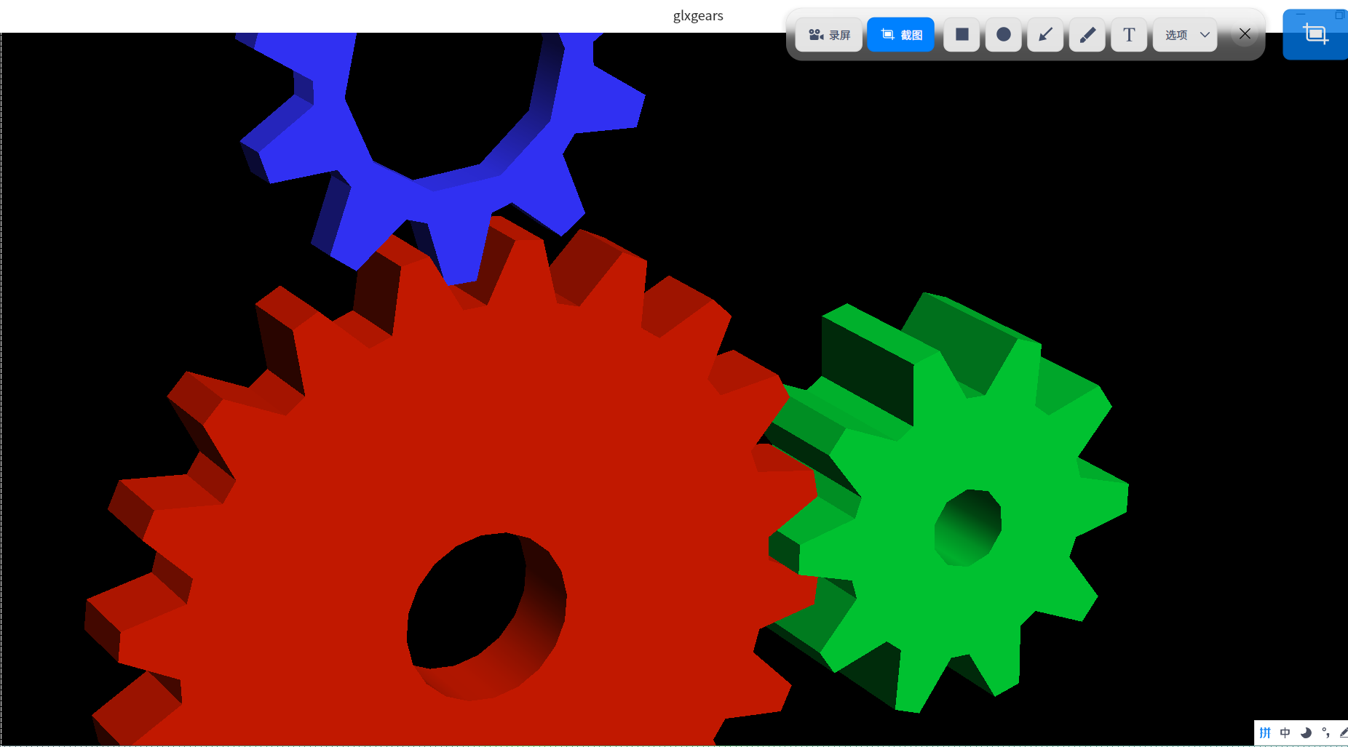

查看到N卡已经开启

