Prepare and Build an Environment

Environment

* Scratch Environmental preparation

1. operating system

Suitable for Win7、Win8.1、Win10

1. Download Tools

<https://github.com/huxinghuaCHN/ScratchXforSpresense>

* Tools Description

1. WinRAR，Windows 32-bit/64-bit installation package
2. Arduino Tools

【Arduino/Arduino.part1.exe】、【Arduino/Arduino15.part01.exe】

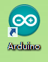

1. 【3_ScratchXAudioSpresense.rar】
   1. Audio File：AUDIO、BIN
   2. ScratchX Project File：Spresense_LED_Blink9.sbx
   3. Load Experimental Extension：spresense_extension.js
   4. Arduino IDE Project：

StandardFirmata/ StandardFirmata.ino、StandardFirmata/player.info

1. 【Firfox Browser/Mozilla Firefox.exe】

FireFox Browser，version：35.0.1

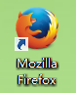

1. 【Plugin/flashplayer_install_cn.exe】

Flash Player：For FireFox Browser

After the installation is complete, you need to restart the browser.

1. 【Plugin/ScratchDevicePlugin.msi】

Scratcx and Firefox Browser plugin

After the installation is complete, you need to restart the browser.

1. 【server/7_hfs.rar】

Server

Build Environment

* Install the corresponding WinRAR tool and decompress the installation package.
* Arduino tool configuration

1. Open Arduino IDE Project：

Arduino IDE Project:

\3_ScratchXAudioSpresense.rar\3_ScratchXAudioSpresense\StandardFirmata\StandardFirmata.ino

1. Select your Spresense board from the Tools > Board menu
2. Select your serial port from the Tools > Port menu.

On Mac, it's something like /dev/tty.usbmodem-1511.

On Windows, it's probably the highest-numbered COM port.

(Or unplug the Spresense, check the menu, and then replug your Spresense and see what new port appears.)

1. Click the upload button

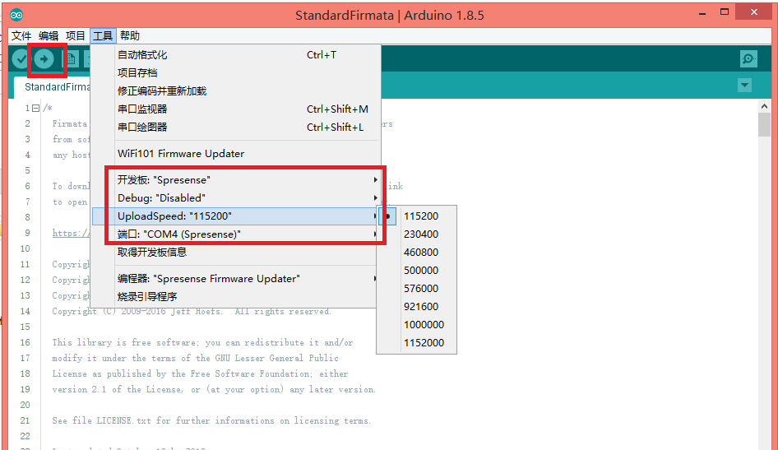

* Audio preparation

1. Put the AUDIO and BIN folders extracted from [3_ScratchXAudioSpresense.rar] into the SD card and install them on the Spresense board

* HFS server

1. Unzip [7_hfs.rar] and run hfs.exe
2. Drag and drop the file spresense_extension.js to [Virtual file system]

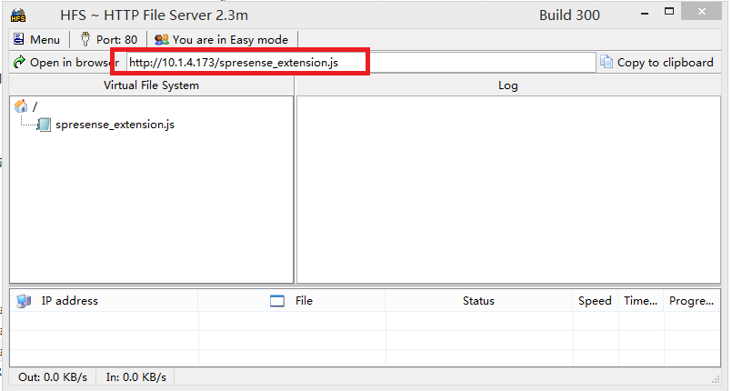

* Browser configuration

1. After the plug-in [flashplayer_install_cn.exe] and [ScratchDevicePlugin.msi] are installed, restart Firefox Browser.

* ScratchX Running

1. Run the Firefox browser and open：<http://scratchx.org/#extensions>
2. Select the Arduino module→【sample project】，Pop up the Warning window and select【I understood，continue】
3. click ，Set the plugin(Adobe Flash、Scratch Device) to [Long-term permission]
4. After entering the [scratchx.org/#scratch] page，Go to【File】→【Load Project】→【Select local file：Spresense_LED_Blink9.sbx】→【OK】
5. Connect the LED to the PIN9 of Spresense as shown below and connect the resistor to GND.

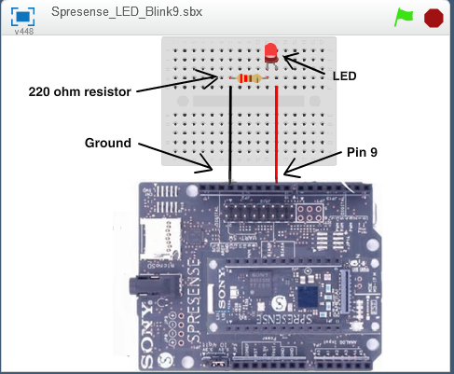

1. click【Load Experimental Extension】，Fill in the [spresense_extension.js] address in the tool HFS into the [Open an Extension URL] window. Example：http://10.1.4.173/spresense_extension.js；In the pop-up window, select：I understood，continue

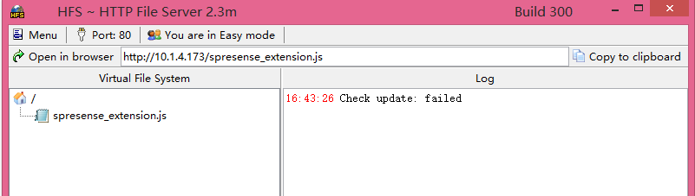

1. Waiting for the light to turn green indicates that the connection is successful and you can control the 【Spresense development board】

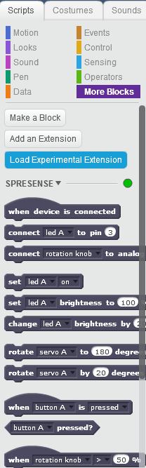

Abnormal situation：

If you cannot open the http://scratchx.org/#scratch webpage, always indicate [Disconnected], and the [Scratch Device] is not displayed in the plugin, you need to uninstall the installed Scratch Device Plugin and re-download and install it. After the installation is successful, restart the Firefox browser.