
-编程，始于黑马

Android课程同步笔记
Alpha 0.01版
By阳哥

Android手机卫士-07

短信备份（★★）
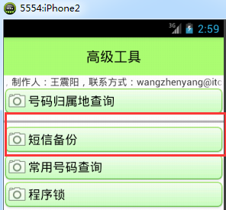
在高级工具中，我们实现短信备份功能。短信备份的时候我们添加了一个进度条，显示短信备份的进度。短信备份在Android基础的时候我们就学过，因此这里只给出布局和代码以及进度条的更新代码。
因为短信备份是经常用到的操作，因此我们编写SmsBackupUtil工具类用于完成短信的备份。
SmsBackupUtil类代码清单如下：

public class SmsBackupUtil {
public static void smsBackup(Context context,String path,ProgressBar progress){
ContentResolver contentResolver = context.getContentResolver();
Uri uri = Uri.parse("content://sms");
Cursor cursor = contentResolver.query(uri, new String[]{"address","date","type","body"}, null, null, null);
int count = cursor.getCount();
progress.setMax(count);
int prog = 0;
XmlSerializer serializer = Xml.newSerializer();
File file = new File(path);
FileOutputStream os = null;
try {
os = new FileOutputStream(file);
serializer.setOutput(os, "utf-8");
serializer.startDocument("utf-8", true);
} catch (Exception e) {
System.err.println(e);
}
try {
serializer.startTag(null, "smss");
} catch (Exception e) {
System.err.println(e);
}
while(cursor.moveToNext()){
String address = cursor.getString(0);
String date = cursor.getString(1);
String type = cursor.getString(2);
String body = cursor.getString(3);
try {
serializer.startTag(null, "sms");
serializer.startTag(null, "address");
serializer.text(address);
serializer.endTag(null, "address");
serializer.startTag(null, "date");
serializer.text(date);
serializer.endTag(null, "date");
serializer.startTag(null, "type");
serializer.text(type);
serializer.endTag(null, "type");
serializer.startTag(null, "body");
serializer.text(body);
serializer.endTag(null, "body");
serializer.endTag(null, "sms");
} catch (Exception e) {
System.err.println(e);
}
//为了看出备份效果我们故意休眠50毫秒
SystemClock.sleep(50);
prog++;
progress.setProgress(prog);
}
cursor.close();
try {
serializer.endDocument();
} catch (Exception e) {
System.err.println(e);
}
}
}

AToolsActivity对应高级工具界面，在改类中添加smsBackup(View view)方法，该方法是布局界面onClick的调用方法。
/*
* 短信备份功能
* 短信备份属于耗时操作，因此必须在子线程中进行
*/
public void smsBackup(View view) {
final File file = new File(Environment.getExternalStorageDirectory(), "smsbackup.xml");
new Thread(new Runnable() {

@Override
public void run() {
if (Environment.getExternalStorageState().equals(Environment.MEDIA_MOUNTED)) {
SmsBackupUtil.smsBackup(AToolsActivity.this, file.getAbsolutePath(),progressBar1);
Looper.prepare();
Toast.makeText(AToolsActivity.this, "短信备份成功", 0).show();
Looper.loop();
}

}
}).start();
}

程序锁功能的实现（★★★★）
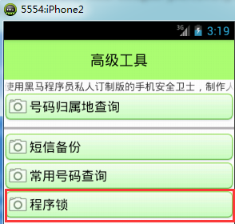
在本节中我们将实现程序锁功能。该功能位于高级工具菜单中。如左图所示。
点击进去程序锁后的界面如下图所示。

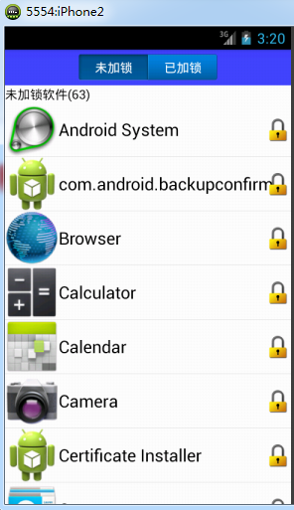
1、在AToolsActivity中添加如下方法，点击进入程序锁主界面。
//打开程序锁界面
public void entryAppLock(View view){
Intent intent = new Intent(this, AppLockActivity.class);
startActivity(intent);
}
- 创建AppLockActivity类以及其布局文件applock_activity.xml，布局文件清单如下：
<?xml version="1.0" encoding="utf-8"?>
<LinearLayout xmlns:android="http://schemas.android.com/apk/res/android"
android:layout_width="match_parent"
android:layout_height="match_parent"
android:orientation="vertical" >

<LinearLayout
android:layout_width="match_parent"
android:layout_height="wrap_content"
android:background="#4444ff"
android:gravity="center"
android:orientation="horizontal" >
<TextView
android:id="@+id/tv_unlock"
android:layout_width="wrap_content"
android:layout_height="wrap_content"
android:background="@drawable/tab_left_pressed"
android:gravity="center"
android:text="未加锁"
android:textColor="#ffffff" />
<TextView
android:id="@+id/tv_lock"
android:layout_width="wrap_content"
android:layout_height="wrap_content"
android:background="@drawable/tab_right_default"
android:gravity="center"
android:text="已加锁"
android:textColor="#ffffff" />
</LinearLayout>
<LinearLayout
android:id="@+id/ll_unlock"
android:layout_width="match_parent"
android:layout_height="match_parent"
android:orientation="vertical" >
<TextView
android:id="@+id/tv_unlock_count"
android:layout_width="wrap_content"
android:layout_height="wrap_content"
android:gravity="center"
android:text="未加锁软件"
android:textColor="#000000" />
<ListView
android:id="@+id/lv_unloack_list"
android:layout_width="match_parent"
android:layout_height="match_parent" >
</ListView>
</LinearLayout>

<LinearLayout
android:id="@+id/ll_lock"
android:layout_width="match_parent"
android:layout_height="match_parent"
android:orientation="vertical"
android:visibility="gone"
>
<TextView
android:id="@+id/tv_lock_count"
android:layout_width="wrap_content"
android:layout_height="wrap_content"
android:gravity="center"
android:text="已加锁软件"
android:textColor="#000000" />
<ListView
android:id="@+id/lv_loack_list"
android:layout_width="match_parent"
android:layout_height="match_parent" >
</ListView>
</LinearLayout>
</LinearLayout>

- 创建AppLockDao类，用于将App对象存储在数据库中
public class AppLockDao {
private AppLockOpenHelper openHelper;
private Context context;
public AppLockDao(Context context){
this.context = context;
openHelper = new AppLockOpenHelper(context);
}
/**
*
* @param number
* @param model
*/
public void add(String number){
Uri uri = Uri.parse("content://com.itheima.mobileSafe.dbchange");
context.getContentResolver().notifyChange(uri , null);
SQLiteDatabase database = openHelper.getWritableDatabase();
ContentValues values = new ContentValues();
values.put("packname", number);
database.insert("applock", null, values );
database.close();
}
public void delete(String number){
SQLiteDatabase database = openHelper.getWritableDatabase();
database.delete("applock", "packname=?", new String[]{number});
database.close();
}
public void update(String number,String model){
SQLiteDatabase database = openHelper.getWritableDatabase();
ContentValues values = new ContentValues();
database.update("applock", values, "packname=?", new String[]{number});
database.close();
}
public boolean find(String number){
SQLiteDatabase database = openHelper.getReadableDatabase();
Cursor query = database.query("applock", null,"packname=?" , new String[]{number}, null, null, null);
if (query.moveToNext()) {
database.close();
return true;
}else {
database.close();
return false;
}
}
public List<String> findAll(){
SQLiteDatabase database = openHelper.getReadableDatabase();
List<String> list = new ArrayList<String>();
Cursor cursor = database.query("applock", new String[]{"packname"}, null, null, null, null, null);
while(cursor.moveToNext()){
String packname = cursor.getString(0);
list.add(packname);
}
cursor.close();
database.close();
return list;
}
public List<BlackNumberInfo> findPart(int index){
SQLiteDatabase database = openHelper.getReadableDatabase();
List<BlackNumberInfo> list = new ArrayList<BlackNumberInfo>();
String sql = "select number,model from blacknumber order by _id desc limit 20 offset ? ";
Cursor cursor = database.rawQuery(sql , new String[]{index+""});//("blacknumber", new String[]{"number","model"}, null, null, null, null, null);
while(cursor.moveToNext()){
String number = cursor.getString(0);
String model = cursor.getString(1);
BlackNumberInfo info = new BlackNumberInfo(number,model);
list.add(info);
}
cursor.close();
database.close();
return list;
}
public int getTotal(){
int total = 0;
SQLiteDatabase database = openHelper.getReadableDatabase();
Cursor cursor = database.rawQuery("select count(*) from applock ", null);
if (cursor.moveToNext()) {
total = cursor.getInt(0);
}
cursor.close();
database.close();
return total;
}
}

- 在上面的代码中我们用到了AppLockOpenHelper类，其代码清单如下
public class AppLockOpenHelper extends SQLiteOpenHelper {

public AppLockOpenHelper(Context context) {
super(context, "applock.db", null, 1);
}

@Override
public void onCreate(SQLiteDatabase db) {
String sql = "create table applock(_id integer primary key autoincrement,packname varchar(20))";
db.execSQL(sql);
}

@Override
public void onUpgrade(SQLiteDatabase db, int oldVersion, int newVersion) {
}
}
5、创建com.itheima.mobileSafe.engine包，在该包下创建AppInfoProvider类。
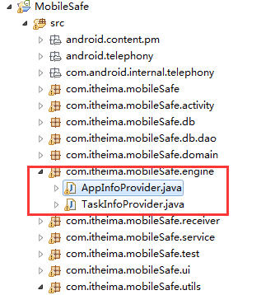
在该类中我们实现了核心功能--获取应用程序信息。

public class AppInfoProvider {
public static List<AppInfo> getAllAppInfos(Context context) {
// 获取PackageManager对象
PackageManager pm = context.getPackageManager();
// 获取所有安装包信息
List<PackageInfo> packages = pm.getInstalledPackages(0);
// 创建AppInfo集合用于存储应用信息
List<AppInfo> appInfos = new ArrayList<AppInfo>();
for (PackageInfo info : packages) {
// 获取应用的显示名称
String name = info.applicationInfo.loadLabel(pm).toString();
// 获取应用的图标
Drawable icon = info.applicationInfo.loadIcon(pm);
// 获取应用的包名
String packageName = info.applicationInfo.packageName;
//获取应用的标识
int flags = info.applicationInfo.flags;
AppInfo appInfo = new AppInfo();
appInfo.setIcon(icon);
appInfo.setName(name);
appInfo.setPackName(packageName);
if ((flags & info.applicationInfo.FLAG_SYSTEM) == 0) {
//如果应用标识跟系统标识求与运算为0，那么该应用就属于用户应用
appInfo.setUser(true);
} else {
appInfo.setUser(false);
}
if ((flags & info.applicationInfo.FLAG_EXTERNAL_STORAGE) == 0) {
//如果应用标识跟系统标识求与运行为0，那么该应用为存储在ROM中
appInfo.setRom(true);
} else {
appInfo.setRom(false);
}
appInfos.add(appInfo);
}
return appInfos;
}
}

- 创建AppLockActivity类，在该类中实现数据的显示与删除等核心操作
public class AppLockActivity extends Activity implements OnClickListener {
private TextView tv_lock;
private TextView tv_unlock;
private LinearLayout ll_lock;
private LinearLayout ll_unlock;
private ListView lv_lock_list;
private ListView lv_unlock_list;
private List<AppInfo> appInfos;
private List<AppInfo> unloackappInfos;
private List<AppInfo> lockedappInfos;
private ApplockAdapter adapter;
private TextView tv_unlock_count;
private TextView tv_lock_count;
private AppLockDao dao;
private ApplockAdapter lockAdapter;
private ApplockAdapter unlockAdapter;

@Override
protected void onCreate(Bundle savedInstanceState) {
super.onCreate(savedInstanceState);
setContentView(R.layout.applock_activity);
//初始化控件、集合、dao
tv_lock = (TextView) findViewById(R.id.tv_lock);
tv_unlock = (TextView) findViewById(R.id.tv_unlock);
ll_lock = (LinearLayout) findViewById(R.id.ll_lock);
ll_unlock = (LinearLayout) findViewById(R.id.ll_unlock);
tv_lock.setOnClickListener(this);
tv_unlock.setOnClickListener(this);
lv_lock_list = (ListView) findViewById(R.id.lv_loack_list);
lv_unlock_list = (ListView) findViewById(R.id.lv_unloack_list);
appInfos = AppInfoProvider.getAllAppInfos(this);
lv_unlock_list.setAdapter(adapter);
tv_lock_count = (TextView) findViewById(R.id.tv_lock_count);
tv_unlock_count = (TextView) findViewById(R.id.tv_unlock_count);
unloackappInfos = new ArrayList<AppInfo>();
lockedappInfos = new ArrayList<AppInfo>();
dao = new AppLockDao(this);
for(AppInfo info : appInfos){
boolean find = dao.find(info.getPackName());
if (find) {
lockedappInfos.add(info);
}else {
unloackappInfos.add(info);
}
}
unlockAdapter = new ApplockAdapter(true);
lockAdapter = new ApplockAdapter(false);
lv_unlock_list.setAdapter(unlockAdapter);
lv_lock_list.setAdapter(lockAdapter);
}

private class ApplockAdapter extends BaseAdapter {
private boolean isFlag = true;//未加锁
public ApplockAdapter(boolean isFlag){
this.isFlag = isFlag;
}
@Override
public int getCount() {
if (isFlag) {
tv_unlock_count.setText("未加锁软件("+unloackappInfos.size()+")");
return unloackappInfos.size();
}else {
tv_lock_count.setText("已加锁软件("+lockedappInfos.size()+")");
return lockedappInfos.size();
}
}

@Override
public Object getItem(int position) {
return null;
}

@Override
public long getItemId(int position) {
return 0;
}

@Override
public View getView(int position, View convertView, ViewGroup parent) {
final View view;
ViewHolder holder;
if (convertView != null) {
view = convertView;
holder = (ViewHolder) view.getTag();
} else {
view = View.inflate(AppLockActivity.this, R.layout.list_applock_item, null);
holder = new ViewHolder();
holder.iv_icon = (ImageView) view.findViewById(R.id.iv_icon);
holder.tv_name = (TextView) view.findViewById(R.id.tv_name);
holder.iv_status = (ImageView) view.findViewById(R.id.iv_status);
view.setTag(holder);
}
final AppInfo appInfo;
if (isFlag) {
appInfo = unloackappInfos.get(position);
holder.iv_status.setImageResource(R.drawable.lock);
}else {
appInfo = lockedappInfos.get(position);
holder.iv_status.setImageResource(R.drawable.unlock);
}
holder.tv_name.setText(appInfo.getName());
holder.iv_icon.setImageDrawable(appInfo.getIcon());
holder.iv_status.setOnClickListener(new OnClickListener() {
boolean canClick = true;
@Override
public void onClick(View v) {
if (!canClick) {
return ;
}
if (isFlag) {//点击未加锁的
canClick = false;
//添加动画效果
TranslateAnimation animation = new TranslateAnimation(Animation.RELATIVE_TO_SELF, 0, Animation.RELATIVE_TO_SELF, 1.0f, Animation.RELATIVE_TO_SELF, 0, Animation.RELATIVE_TO_SELF, 0);
animation.setDuration(500);
view.startAnimation(animation);
dao.add(appInfo.getPackName());
unloackappInfos.remove(appInfo);
lockedappInfos.add(appInfo);
new Handler().postDelayed(new Runnable() {

@Override
public void run() {
lockAdapter.notifyDataSetChanged();
unlockAdapter.notifyDataSetChanged();
canClick = true;
}
}, 500);
}else {//点击加锁的
canClick = false;
TranslateAnimation animation = new TranslateAnimation(Animation.RELATIVE_TO_SELF, 0, Animation.RELATIVE_TO_SELF, -1.0f, Animation.RELATIVE_TO_SELF, 0, Animation.RELATIVE_TO_SELF, 0);
animation.setDuration(500);
view.startAnimation(animation);
dao.delete(appInfo.getPackName());
lockedappInfos.remove(appInfo);
unloackappInfos.add(appInfo);
new Handler().postDelayed(new Runnable() {

@Override
public void run() {
lockAdapter.notifyDataSetChanged();
unlockAdapter.notifyDataSetChanged();
canClick = true;
}
}, 500);
}

}
});

return view;

}

}

static class ViewHolder {
ImageView iv_icon;
TextView tv_name;
ImageView iv_status;
}
//切换两个LinearLayout
@Override
public void onClick(View v) {
switch (v.getId()) {
case R.id.tv_unlock:
tv_unlock.setBackgroundResource(R.drawable.tab_left_pressed);
tv_lock.setBackgroundResource(R.drawable.tab_right_default);
ll_unlock.setVisibility(View.VISIBLE);
ll_lock.setVisibility(View.GONE);
break;
case R.id.tv_lock:
tv_lock.setBackgroundResource(R.drawable.tab_right_pressed);
tv_unlock.setBackgroundResource(R.drawable.tab_left_default);
ll_lock.setVisibility(View.VISIBLE);
ll_unlock.setVisibility(View.GONE);
break;
}
}
}

- 在上面的代码中，ListView对象每一条目的布局文件list_applock_item.xml清单如下：
<?xml version="1.0" encoding="utf-8"?>
<RelativeLayout xmlns:android="http://schemas.android.com/apk/res/android"
android:layout_width="match_parent"
android:layout_height="wrap_content" >

<ImageView
android:id="@+id/iv_icon"
android:layout_width="60dp"
android:layout_height="60dp"
android:src="@drawable/app" />
<TextView
android:id="@+id/tv_name"
android:layout_width="wrap_content"
android:layout_height="wrap_content"
android:layout_centerVertical="true"
android:layout_toRightOf="@id/iv_icon"
android:text="应用名称"
android:textColor="#000000"
android:textSize="19sp" />

<ImageView
android:layout_alignParentRight="true"
android:id="@+id/iv_status"
android:layout_width="30dp"
android:layout_height="30dp"
android:layout_centerVertical="true"
android:src="@drawable/unlock" />

</RelativeLayout>

设置指定应用安装在手机内存中还是外部存储卡中（★）
应用程序既可以安装在手机内存中也可以安装在外部存储卡中。如何制定安装位置呢？
在功能清单根节点处添加如下属性：
android:installLocation="auto"
该属性值有三种：
- auto：自动安装，优先安装在手机内存里面 ，可以切换；
- internalOnly：只安装在手机内存里面，不可以切换；
- preferExternal：安装在外包存储，可以选切换；

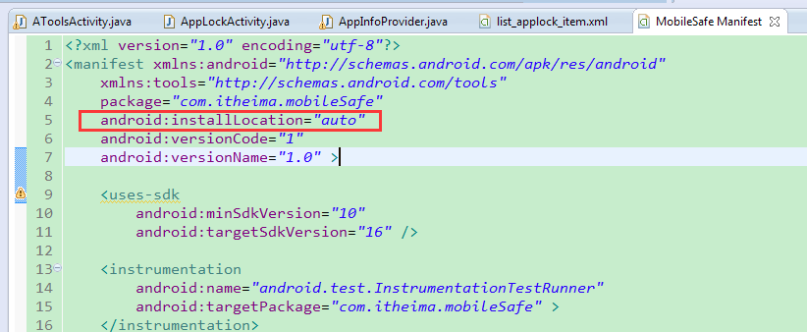

ListView的状态栏（★★）
知识拓展，在ListView中增加快速滚动条，用户通过该滚动条可以迅速拖动ListView内容。用法很简单，只需要在布局文件中的ListView控件中添加如下属性：
android:fastScrollEnabled="true"
加上属性后再滚动我们的ListView发现有一个蓝色（与主题有关）的滚动条，可以直接上下拖动。效果如下图。
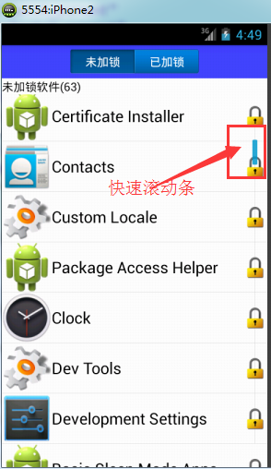

软件管理（★★★★）
在本节中我们将实现软件管理功能，在软件管理界面我们可以查看手机中的用户程序和系统程序，当点击某一个程序的时候弹出一个窗体对象，如下图所示。通过该窗体对象我们可以对程序进行卸载、启动、分享等操作。在本节中我们将学到ListView的状态栏、PopupWindow的使用。
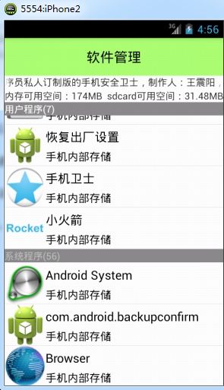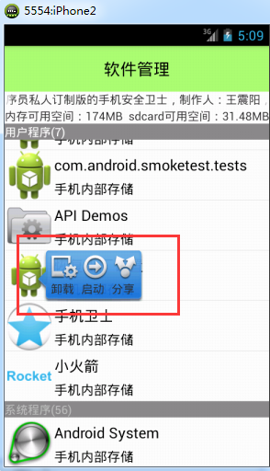

5.1 编写布局文件
activity_app_manager.xml布局文件清单如下：
<?xml version="1.0" encoding="utf-8"?>
<LinearLayout xmlns:android="http://schemas.android.com/apk/res/android"
android:layout_width="match_parent"
android:layout_height="match_parent"
android:orientation="vertical" >
<TextView
android:layout_width="match_parent"
android:layout_height="55dp"
android:background="#8866ff00"
android:gravity="center"
android:text="软件管理"
android:textColor="#000000"
android:textSize="20sp" />

<RelativeLayout
android:layout_width="match_parent"
android:layout_height="wrap_content" >

<TextView
android:id="@+id/tv_storage"
android:layout_width="wrap_content"
android:layout_height="wrap_content"
android:layout_alignParentLeft="true"
android:text="内存卡剩余空间：" />

<TextView
android:id="@+id/tv_sdcard"
android:layout_width="wrap_content"
android:layout_height="wrap_content"
android:layout_alignParentRight="true"
android:text="sdcard剩余空间：" />
</RelativeLayout>

<FrameLayout
android:layout_width="match_parent"
android:layout_height="match_parent" >

<ListView
android:id="@+id/lv_app_item"
android:layout_width="match_parent"
android:layout_height="match_parent" />

<TextView
android:id="@+id/tv_list_status"
android:layout_width="match_parent"
android:layout_height="wrap_content"
android:background="#888888"
android:text="用户程序(8)"
android:textColor="#ffffff" />
<LinearLayout
android:id="@+id/ll_loading"
android:layout_width="match_parent"
android:layout_height="match_parent"
android:gravity="center"
android:orientation="vertical" >

<ProgressBar
android:layout_width="wrap_content"
android:layout_height="wrap_content" />

<TextView
android:layout_width="wrap_content"
android:layout_height="wrap_content"
android:text="数据加载中" />
</LinearLayout>
</FrameLayout>
</LinearLayout>

5.2 编写AppManagerActivity类
在该类中实现核心业务逻辑功能：
public class AppManagerActivity extends Activity {
private TextView tv_sdcard;
private TextView tv_storage;
private ListView lv_app_item;
private LinearLayout ll_loading;
private AppAdapter adapter;
private List<AppInfo> appInfos;
private List<AppInfo> userappInfos;
private List<AppInfo> systemappInfos;
private TextView tv_list_status;
private PopupWindow popupWindow;
private LinearLayout ll_uninstall;
private LinearLayout ll_start;
private LinearLayout ll_share;
private AppInfo appInfo;
private final int UNINSTALL = 1;
Handler handler = new Handler() {
public void handleMessage(android.os.Message msg) {
ll_loading.setVisibility(View.INVISIBLE);
if (adapter == null) {
adapter = new AppAdapter();
lv_app_item.setAdapter(adapter);
} else {
adapter.notifyDataSetChanged();
}
};
};

@Override
protected void onCreate(Bundle savedInstanceState) {
super.onCreate(savedInstanceState);
setContentView(R.layout.activity_app_manager);
//初始化控件
tv_sdcard = (TextView) findViewById(R.id.tv_sdcard);
tv_storage = (TextView) findViewById(R.id.tv_storage);
//获取SDcard可用空间
tv_sdcard.setText("sdcard可用空间：" + getSpaceAvai(Environment.getExternalStorageDirectory().getAbsolutePath()));
//获得内存可用空间
tv_storage.setText("内存可用空间：" + getSpaceAvai(Environment.getDataDirectory().getAbsolutePath()));
lv_app_item = (ListView) findViewById(R.id.lv_app_item);
ll_loading = (LinearLayout) findViewById(R.id.ll_loading);
tv_list_status = (TextView) findViewById(R.id.tv_list_status);
//给ListView的item设置点击事件
lv_app_item.setOnItemClickListener(new OnItemClickListener() {

@Override
public void onItemClick(AdapterView<?> parent, View view, int position, long id) {
//获取点击的某一个条目对象
Object object = lv_app_item.getItemAtPosition(position);
//对获取的对象进行判断 如果该对象是AppInfo则弹出popupWindow,之所以要判断是因为我们在ListView中加入了TextView对象用于显示用户程序和系统程序
if (object instanceof AppInfo) {
//用打气筒将popupWindow布局填充为LinearLayout对象
LinearLayout layout = (LinearLayout) View.inflate(AppManagerActivity.this, R.layout.popupwindow_item, null);
//获得LinearLayout中的控件对象
ll_share = (LinearLayout) layout.findViewById(R.id.ll_share);
ll_start = (LinearLayout) layout.findViewById(R.id.ll_start);
ll_uninstall = (LinearLayout) layout.findViewById(R.id.ll_uninstall);
//给卸载按钮添加点击事件监听
ll_uninstall.setOnClickListener(new OnClickListener() {

@Override
public void onClick(View v) {
//如果是用户应用则卸载否则提示无法卸载
if (appInfo!=null&&appInfo.isUser()) {
//卸载应用是通过发送隐式意图实现的，调用的还是系统的功能
Intent intent = new Intent();
intent.setAction("android.intent.action.DELETE");
intent.addCategory("android.intent.category.DEFAULT");
intent.setData(Uri.parse("package:"+appInfo.getPackName()));
startActivityForResult(intent, UNINSTALL);
}else {
Toast.makeText(AppManagerActivity.this, "系统应用无法卸载", 0).show();
}
// <intent-filter>
// <action android:name="android.intent.action.VIEW" />
// <action android:name="android.intent.action.DELETE" />
// <category android:name="android.intent.category.DEFAULT" />
// <data android:scheme="package" />
// </intent-filter>
}
});
//给开启按钮添加事件监听
ll_start.setOnClickListener(new OnClickListener() {

@Override
public void onClick(View v) {
//获取包管理器
PackageManager packageManager = getPackageManager();
try {
//通过PackageManager获取包信息
PackageInfo packageInfo = packageManager.getPackageInfo(appInfo.getPackName(), PackageManager.GET_ACTIVITIES);

ActivityInfo[] activities = packageInfo.activities;
if (activities!=null&&activities.length>0) {
//通过显示意图开启一个Activity
ActivityInfo activityInfo = activities[0];
String name = activityInfo.name;
Intent intent = new Intent();
intent.setClassName(appInfo.getPackName(), name);
startActivity(intent);
}else {
Toast.makeText(AppManagerActivity.this, "该软件无法启动", 0).show();
}
} catch (NameNotFoundException e) {
e.printStackTrace();
}
}
});
//给分享按钮添加事件监听 当点击的时候发送短信
ll_share.setOnClickListener(new OnClickListener() {

@Override
public void onClick(View v) {
// <intent-filter>
// <action android:name="android.intent.action.SEND" />
// <category android:name="android.intent.category.DEFAULT" />
// <data android:mimeType="text/plain" />
// </intent-filter>
//通过隐式意图发送短信
Intent intent = new Intent();
intent.setAction("android.intent.action.SEND");
intent.addCategory("android.intent.category.DEFAULT");
intent.setType("text/plain");
intent.putExtra(Intent.EXTRA_TEXT, "推荐你一款软件，挺不错的。");
startActivity(intent);
}
});
//给LinearLayout的显示添加动画集
AlphaAnimation alphaAnimation = new AlphaAnimation(0.5f, 1.0f);
alphaAnimation.setDuration(1000);
//动画集
AnimationSet animationSet = new AnimationSet(false);
//添加渐变动画
animationSet.addAnimation(alphaAnimation);
//添加缩放动画
ScaleAnimation scaleAnimation = new ScaleAnimation(0.5f, 1.0f, 0.5f, 1.0f);
scaleAnimation.setDuration(1000);
animationSet.addAnimation(scaleAnimation);
//给控件设置启动动画集
layout.startAnimation(animationSet);
//如果当前popupWindow处于显示状态则隐藏
if (popupWindow!=null&&popupWindow.isShowing()) {
popupWindow.dismiss();
}
//创建一个新的popupWindow对象并在指定位置显示
popupWindow = new PopupWindow(layout, -2, -2);
popupWindow.setBackgroundDrawable(new ColorDrawable(Color.TRANSPARENT));
int[] location = new int[2];
view.getLocationInWindow(location);
popupWindow.showAtLocation(parent, Gravity.TOP + Gravity.LEFT, 60, location[1]);
}
}
});
//给ListView添加滚动监听
lv_app_item.setOnScrollListener(new OnScrollListener() {

@Override
public void onScrollStateChanged(AbsListView view, int scrollState) {
//滚动的时候如果popupWindow显示则隐藏
if (popupWindow != null && popupWindow.isShowing()) {
popupWindow.dismiss();
}
}

@Override
public void onScroll(AbsListView view, int firstVisibleItem, int visibleItemCount, int totalItemCount) {
if (systemappInfos == null || userappInfos == null) {
return;
}
//如果第一个可见脚标已经大于用户应用的个数则显示系统程序的个数，否则显示用户程序的个数
if (firstVisibleItem > userappInfos.size()) {
tv_list_status.setText("系统程序(" + systemappInfos.size() + ")");
} else {
tv_list_status.setText("用户程序(" + userappInfos.size() + ")");
}
}
});
//初始化数据
fillData();
}
//获取可用空间
private String getSpaceAvai(String path) {
StatFs statFs = new StatFs(path);
long blockSize = statFs.getBlockSize();
long availableBlocks = statFs.getAvailableBlocks();
return Formatter.formatFileSize(this, blockSize * availableBlocks);
}

class AppAdapter extends BaseAdapter {

@Override
public int getCount() {
return appInfos.size() + 2;
}

@Override
public Object getItem(int position) {
appInfo = null;// appInfos.get(position);
if (position == 0) {
return null;
} else if (position == userappInfos.size() + 1) {
TextView textView = new TextView(getApplicationContext());
textView.setText("系统程序(" + systemappInfos.size() + ")");
textView.setBackgroundColor(Color.GRAY);
return null;
} else if (position <= userappInfos.size()) {
appInfo = userappInfos.get(position - 1);
} else {
appInfo = systemappInfos.get(position - userappInfos.size() - 2);
}
return appInfo;
}
@Override
public long getItemId(int position) {
return 0;
}

@Override
public View getView(int position, View convertView, ViewGroup parent) {
AppInfo appInfo = null;// appInfos.get(position);
if (position == 0) {
TextView textView = new TextView(getApplicationContext());
textView.setText("用户程序(" + userappInfos.size() + ")");
textView.setBackgroundColor(Color.GRAY);
return textView;
} else if (position == userappInfos.size() + 1) {
TextView textView = new TextView(getApplicationContext());
textView.setText("系统程序(" + systemappInfos.size() + ")");
textView.setBackgroundColor(Color.GRAY);
return textView;
} else if (position <= userappInfos.size()) {
appInfo = userappInfos.get(position - 1);
} else {
appInfo = systemappInfos.get(position - userappInfos.size() - 2);
}
if (appInfo == null) {
Toast.makeText(getApplicationContext(), "appInfo 为null", 0).show();
return convertView;
}
// int newPostion = position-1;
// if (position<userappInfos.size()) {
// appInfo = userappInfos.get(position);
// }else {
// appInfo = systemappInfos.get(position-userappInfos.size()-1);
// }
View view = null;
ViewHolder holder;
if (convertView != null && convertView instanceof RelativeLayout) {
view = convertView;
holder = (ViewHolder) view.getTag();
} else {
view = View.inflate(AppManagerActivity.this, R.layout.list_app_item, null);
holder = new ViewHolder();
holder.tv_app_location = (TextView)
view.findViewById(R.id.tv_app_location);
holder.tv_app_name = (TextView) view.findViewById(R.id.tv_app_name);
holder.iv_icon = (ImageView) view.findViewById(R.id.iv_icon);
view.setTag(holder);
}
holder.iv_icon.setImageDrawable(appInfo.getIcon());
holder.tv_app_name.setText(appInfo.getName());
boolean rom = appInfo.isRom();
if (rom) {
holder.tv_app_location.setText("手机内部存储");
} else {
holder.tv_app_location.setText("手机外部存储");
}
return view;
}

}

static class ViewHolder {
TextView tv_app_name;
TextView tv_app_location;
ImageView iv_icon;
}
//在线程中获取数据
private void fillData() {
new Thread(new Runnable() {

@Override
public void run() {
appInfos = AppInfoProvider.getAllAppInfos(AppManagerActivity.this);
userappInfos = new ArrayList<AppInfo>();
systemappInfos = new ArrayList<AppInfo>();
for (AppInfo info : appInfos) {
if (info.isUser()) {
userappInfos.add(info);
} else {
systemappInfos.add(info);
}
}
handler.sendEmptyMessage(RESULT_OK);
}
}).start();
}
@Override
protected void onActivityResult(int requestCode, int resultCode, Intent data) {
super.onActivityResult(requestCode, resultCode, data);
switch (resultCode) {
case UNINSTALL:
//当有应用被卸载的时候重新加载数据
fillData();
break;

default:
break;
}
}
}

在上面的代码中我们用到了popupWindow，期对应的布局popupwindow_item.xml文件清单如下：
<?xml version="1.0" encoding="utf-8"?>
<LinearLayout xmlns:android="http://schemas.android.com/apk/res/android"
android:layout_width="match_parent"
android:layout_height="match_parent"
android:background="@drawable/local_popup_bg"
android:orientation="horizontal" >

<LinearLayout
android:id="@+id/ll_uninstall"
android:layout_marginLeft="3dp"
android:layout_width="wrap_content"
android:layout_height="wrap_content"
android:orientation="vertical" >
<ImageView
android:src="@drawable/img1"
android:layout_width="wrap_content"
android:layout_height="wrap_content" />
<TextView
android:text="卸载"
android:layout_width="wrap_content"
android:layout_height="wrap_content" />
</LinearLayout>
<LinearLayout
android:id="@+id/ll_start"
android:layout_marginLeft="3dp"
android:layout_width="wrap_content"
android:layout_height="wrap_content"
android:orientation="vertical" >

<ImageView
android:src="@drawable/img2"
android:layout_width="wrap_content"
android:layout_height="wrap_content" />
<TextView
android:text="启动"
android:layout_width="wrap_content"
android:layout_height="wrap_content" />
</LinearLayout>
<LinearLayout
android:id="@+id/ll_share"
android:layout_marginLeft="3dp"
android:layout_width="wrap_content"
android:layout_height="wrap_content"
android:orientation="vertical" >

<ImageView
android:src="@drawable/img3"
android:layout_width="wrap_content"
android:layout_height="wrap_content" />
<TextView
android:text="分享"
android:layout_width="wrap_content"
android:layout_height="wrap_content" />
</LinearLayout>
</LinearLayout>

至此，本文档完！

2015年1月9日 星期五 17:36:26
北京市海淀区中关村软件园国际软件大厦

