
-编程，始于黑马

Android课程同步笔记
Beta 0.01版
By阳哥

Android手机卫士-10手机杀毒

手机杀毒（★★★★）

1.1 手机杀毒简介
在功能列表中点击，进入手机杀毒界面，如下图所示。自动对系统进程扫描。
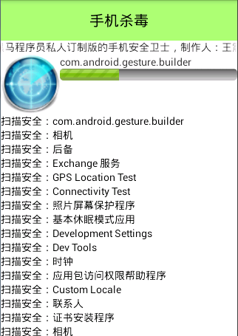

1.2 手机杀毒原理
对于本地查杀，首先我们得有个病毒库，病毒库是事先存在好的，在安装软件的时候安装在相应目录下，如果服务器端病毒库更新了，则我们对应的升级病毒库即可。病毒库存储的是所有病毒软件签名的md5码，我们的杀毒软件可以获取手机系统中所有软件签名的md5码，将从手机软件中获取的每个md5码去数据库中查找，如果发现有，则代表该软件是病毒软件。
对于联网查杀，我们只需将从手机获取的软件签名md5码上传到服务器端，然后由服务器查找病毒库即可。

1.3 手机杀毒布局
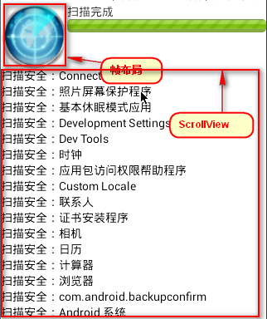
布局整体采用LinearLayout，其中的帧布局是两张重叠的图片，一个是底图（背景图片），
另一个是扇形图，，在进行扫描的时候不停的让扇形图进行RotateAnimation即可看到雷达在扫描的效果。
将扫描后的结果添加到ScrollView中即可。进度条的最大值是手机中所有软件个数，然后每扫描一个软件，进度就增加1步，这样当全部扫描完后进度条正好走到头。
布局文件名anti_virus_activity.xml，布局清单如下：
<?xml version="1.0" encoding="utf-8"?>
<LinearLayout xmlns:android="http://schemas.android.com/apk/res/android"
android:layout_width="match_parent"
android:layout_height="match_parent"
android:orientation="vertical" >

<TextView
android:layout_width="match_parent"
android:layout_height="55dp"
android:background="#8866ff00"
android:gravity="center"
android:text="手机杀毒"
android:textColor="#000000"
android:textSize="20sp" />
<LinearLayout
android:layout_width="match_parent"
android:layout_height="80dp"
android:orientation="horizontal" >

<FrameLayout
android:layout_width="80dp"
android:layout_height="80dp" >

<ImageView
android:layout_width="80dp"
android:layout_height="80dp"
android:src="@drawable/ic_scanner_malware" />

<ImageView
android:id="@+id/iv_scanning"
android:layout_width="80dp"
android:layout_height="80dp"
android:src="@drawable/act_scanning_03" />
</FrameLayout>

<LinearLayout
android:layout_width="match_parent"
android:layout_height="wrap_content"
android:gravity="center_vertical"
android:orientation="vertical" >

<TextView
android:id="@+id/tv_status"

android:layout_width="wrap_content"
android:layout_height="wrap_content"
android:text="正在快速扫描" />

<ProgressBar
android:id="@+id/progressBar1"
style="?android:attr/progressBarStyleHorizontal"
android:layout_width="match_parent"
android:layout_height="wrap_content"
android:progressDrawable="@drawable/progress_horizontal" />
</LinearLayout>
</LinearLayout>

<ScrollView
android:layout_width="match_parent"
android:layout_height="match_parent" >
<LinearLayout
android:id="@+id/ll_container"
android:layout_width="match_parent"
android:layout_height="wrap_content"
android:orientation="vertical" >
</LinearLayout>
</ScrollView>

</LinearLayout>

1.4 手机杀毒业务逻辑的实现

1.4.1 手机杀毒知识点清单
1）手机杀毒简单原理
2）RotateAnimation动画的使用
3）软件卸载（发现病毒软件的时候卸载软件）
3）获取软件签名
4）md5加密
5）ScrollView的使用
6）SQLiteDatabase的使用

1.4.2 手机杀毒代码清单
public class AntiVirusActivity extends Activity {
// 扫描状态
protected static final int SCANNING = 1;
protected static final int SCANNING_FINISH = 2;
private ImageView iv_scanning;
private TextView tv_status;
private ProgressBar progressBar1;
private LinearLayout ll_container;
// 将扫描结果封装在ScanInfo中
private List<ScanInfo> virusList;
private Handler handler = new Handler() {
public void handleMessage(Message msg) {
TextView view = new TextView(AntiVirusActivity.this);
// 如果是扫描状态发送来的消息，则将扫描的当前结果添加到ScrollView中的LinearLayout中
if (msg.what == SCANNING) {
ScanInfo scanInfo = (ScanInfo) msg.obj;
tv_status.setText(scanInfo.getName());
if (scanInfo.isVirus()) {// 如果是病毒
view.setTextColor(Color.BLACK);
view.setText("发现病毒：" + scanInfo.getName() + ":" + scanInfo.getDesc());
virusList.add(scanInfo);
} else {
view.setTextColor(Color.BLACK);
view.setText("扫描安全：" + scanInfo.getName());
}
ll_container.addView(view, 0);
// 如果扫描完发送来的消息，判断是否有病毒，如果有病毒通过AlertDialog提示用户是否删除
} else if (msg.what == SCANNING_FINISH) {
iv_scanning.clearAnimation();
tv_status.setText("扫描完成");
if (virusList.size() > 0) {
AlertDialog.Builder builder = new Builder(AntiVirusActivity.this);

builder.setTitle("发现病毒");
builder.setMessage("发现了(" + virusList.size() + ")个病毒！");
builder.setNegativeButton("", new OnClickListener() {
@Override
public void onClick(DialogInterface dialog, int which) {
// <intent-filter>
// <action android:name="android.intent.action.VIEW"
// />
// <action
// android:name="android.intent.action.DELETE" />
// <category
// android:name="android.intent.category.DEFAULT" />
// <data android:scheme="package" />
// </intent-filter>
for (ScanInfo info : virusList) {
// 删除病毒软件，是通过系统自带的Activity实现的
Intent intent = new Intent();
intent.setAction("android.intent.action.DELETE");
intent.addCategory("android.intent.category.DEFAULT");
intent.setData(Uri.parse("package:" + info.getPackname()));
startActivity(intent);
}
}
});
builder.setPositiveButton("不怕病毒", new OnClickListener() {

@Override
public void onClick(DialogInterface dialog, int which) {
dialog.dismiss();
}
});
builder.show();

} else {
Toast.makeText(AntiVirusActivity.this, "您的手机十分安全。", 0).show();
}

}
};
};
@Override
protected void onCreate(Bundle savedInstanceState) {
super.onCreate(savedInstanceState);
setContentView(R.layout.anti_virus_activity);
virusList = new ArrayList<ScanInfo>();
iv_scanning = (ImageView) findViewById(R.id.iv_scanning);
tv_status = (TextView) findViewById(R.id.tv_status);
progressBar1 = (ProgressBar) findViewById(R.id.progressBar1);
/*
* 定义一个动画
* 第一个参数fromDegrees Rotation offset to apply at the start of the
* animation. 开始角度
* 第二个参数toDegrees Rotation offset to apply at the end of the
* animation.目标角度
* 第三个参数pivotXType Specifies how pivotXValue should be
* interpreted. One of Animation.ABSOLUTE, Animation.RELATIVE_TO_SELF,
* or Animation.RELATIVE_TO_PARENT.相对于X坐标类型
* 第四个参数 pivotXValue The X coordinate of the
* point about which the object is being rotated, specified as an
* absolute number where 0 is the left edge. This value can either be an
* absolute number if pivotXType is ABSOLUTE, or a percentage (where 1.0
* is 100%) otherwise.相对于X坐标值
* 第五个参数pivotYType Specifies how pivotYValue should be
* interpreted. One of Animation.ABSOLUTE, Animation.RELATIVE_TO_SELF,
* or Animation.RELATIVE_TO_PARENT.相对于Y坐标类型
* 第六个参数pivotYValue The Y coordinate of the
* point about which the object is being rotated, specified as an
* absolute number where 0 is the top edge.This value can either be an
* absolute number if pivotYType is ABSOLUTE, or a percentage (where 1.0
* is 100%) otherwise.相对于Y坐标值
*/
RotateAnimation ra = new RotateAnimation(0, 360, Animation.RELATIVE_TO_SELF, 0.5f, Animation.RELATIVE_TO_SELF, 0.5f);
//2秒执行完
ra.setDuration(2000);
//一直循环播放
ra.setRepeatCount(Animation.INFINITE);
iv_scanning.startAnimation(ra);
progressBar1.setMax(100);
ll_container = (LinearLayout) findViewById(R.id.ll_container);
// 扫描病毒显示是耗时操作，因此在子线程中操作
new Thread(new Runnable() {
@Override
public void run() {
// 获取PackageManager对象
PackageManager pm = getPackageManager();
// 通过pm获取所有的安装包，包括已经安装的和没有安装的，同时获取安装包的签名信息
List<PackageInfo> packages = pm.getInstalledPackages(PackageManager.GET_UNINSTALLED_PACKAGES + PackageManager.GET_SIGNATURES);
// 给ProgressBar设置最大值为获取到的安装包的个数
progressBar1.setMax(packages.size());
int progress = 0;
// 遍历安装包
for (PackageInfo info : packages) {
// 获取应用程序名称
String label = info.applicationInfo.loadLabel(pm).toString();
// 获取应用签名信息
Signature signature = info.signatures[0];
// 通过md5工具将签名信息进行加密
String md5String = MD5Utils.encode(signature.toCharsString());
// 通过查询数据库判断是否是病毒，如果是返回病毒信息
String virus = AntiVirusQueryDao.isVirus(md5String);
// 将扫描结果封装在ScanInfo中
ScanInfo scanInfo = new ScanInfo();
scanInfo.setName(label);
if (TextUtils.isEmpty(virus)) {// 没有
scanInfo.setVirus(false);
} else {
scanInfo.setVirus(true);
scanInfo.setDesc(virus);
scanInfo.setPackname(info.packageName);
}
// 从消息队列中获取消息对象，如果没有则创建
Message msg = Message.obtain();
msg.what = SCANNING;
msg.obj = scanInfo;
handler.sendMessage(msg);
progress++;
progressBar1.setProgress(progress);
// 因为扫描软件过程太快了，为了方便 演示效果而让系统每扫描一个软件暂停200毫秒
SystemClock.sleep(200);
}

// 循环结束以后发送一个结束消息
Message msg = Message.obtain();
msg.what = SCANNING_FINISH;
handler.sendMessage(msg);

}
}).start();
}
}

1.4.3 MD5Utils工具类的实现
public class MD5Utils {
//将字符串进行md5加密
public static String encode(String password) {
MessageDigest digest;
try {
//通过加密工具，并创建一个md5算法加密对象
digest = MessageDigest.getInstance("md5");
//将密码的字节码加密成字节数组
byte[] result = digest.digest(password.getBytes());
StringBuffer buffer = new StringBuffer();
for (byte b : result) {
//对每一个字节跟255进行和操作，转换为int类型
int number = b & 0xff;
//将int类型转换为16进制字符串类型
String numberStr = Integer.toHexString(number);
//如果16进制的长度只有一位（0~9）只有一位，在前面补0
if (numberStr.length() == 1) {
buffer.append("0");
}
//添加16进制字符串
buffer.append(numberStr);
}
return buffer.toString();
} catch (NoSuchAlgorithmException e) {
e.printStackTrace();
return "";
}
}}

1.4.4 AntiVirusQueryDao类的实现
private static String path = "/data/data/com.itheima.mobileSafe/files/antivirus.db";
public static String isVirus(String signatures) {
SQLiteDatabase database = SQLiteDatabase.openDatabase(path, null, SQLiteDatabase.OPEN_READONLY);
String sql = "select desc from datable where md5=?";
Cursor cursor = database.rawQuery(sql, new String[]{signatures});
String desc = null;
while(cursor.moveToNext()){
desc = cursor.getString(0);
break;
}
cursor.close();
return desc;
}
}

Antivirus.db是一个病毒库，打开其中的datable表，观察其中的数据如下图所示。
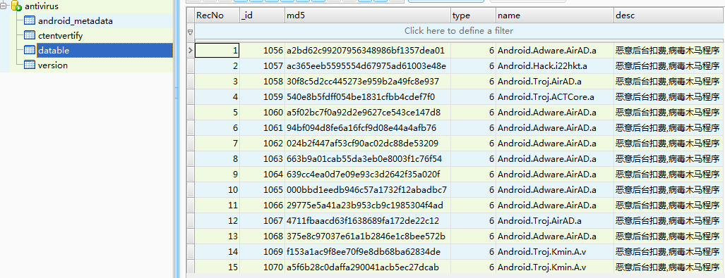
在开发的时候我们需要将该数据库在assets目录中，然后在SplashActivity的onCreate方法中添加copyDB("antivirus.db");将该数据库文件拷贝到
/data/data/com.itheima.mobileSafe/files/antivirus.db目录下。

缓存清理（★★★★）

2.1 缓存清理简介
在功能列表界面点击，进入缓存清理主界面，如下图所示。
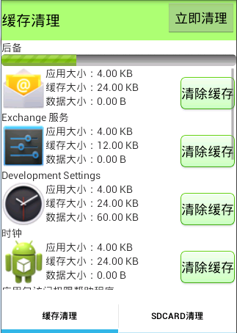
点击清除缓存按钮，可以将对应程序的缓存清除掉。

2.2 缓存清理布局
该布局整体是一个TabHost布局，TabHost是一款比较老的布局方式，其用法比较固定。在TabHost中整体式LinearLayout。
clean_activity.xml是清理缓存的主布局文件，该文件演示了TabHost节点的使用方式。布局清单如下：
<?xml version="1.0" encoding="utf-8"?>
<TabHost xmlns:android="http://schemas.android.com/apk/res/android"
android:id="@android:id/tabhost"
android:layout_width="match_parent"
android:layout_height="match_parent" >
<RelativeLayout
android:layout_width="match_parent"
android:layout_height="match_parent" >
<TabWidget
android:layout_alignParentBottom="true"
android:id="@android:id/tabs"
android:layout_width="match_parent"
android:layout_height="wrap_content" >
</TabWidget>
</RelativeLayout>
<FrameLayout
android:id="@android:id/tabcontent"
android:layout_width="match_parent"
android:layout_height="match_parent"
android:layout_marginBottom="60dp" >
</FrameLayout>
</TabHost>
上面布局预览图如下所示：
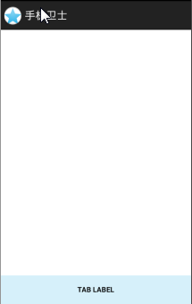
上面布局只是整体布局的一个大的框架，具体布局文件名为clean_cache_activity.xml，其布局清单如下：
<?xml version="1.0" encoding="utf-8"?>
<LinearLayout xmlns:android="http://schemas.android.com/apk/res/android"
android:layout_width="match_parent"
android:layout_height="match_parent"
android:orientation="vertical" >
<RelativeLayout
android:layout_width="match_parent"
android:layout_height="wrap_content"
android:background="#8866ff00" >
<TextView
android:layout_width="wrap_content"
android:layout_height="55dp"
android:gravity="center"
android:text="缓存清理"
android:textColor="#000000"
android:textSize="20sp" />
<Button
android:id="@+id/bt_clear"
android:layout_width="wrap_content"
android:layout_height="wrap_content"
android:layout_alignParentRight="true"
android:onClick="clear"
android:text="立即清理" />
</RelativeLayout>

<TextView
android:id="@+id/tv_status"
android:layout_width="wrap_content"
android:layout_height="wrap_content"
android:text="扫描状态" />
<ProgressBar
android:id="@+id/progressBar1"
style="?android:attr/progressBarStyleHorizontal"
android:layout_width="match_parent"
android:layout_height="wrap_content"
android:progressDrawable="@drawable/progress_horizontal" />
<ScrollView
android:layout_width="match_parent"
android:layout_height="match_parent" >
<LinearLayout
android:id="@+id/lv_container"
android:layout_width="match_parent"
android:layout_height="match_parent"
android:orientation="vertical" >
</LinearLayout>
</ScrollView>
</LinearLayout>

2.3 缓存清理业务逻辑的实现

2.3.1 缓存清理知识点清单
1）TabHost的使用
2）获取软件缓存
3）使用系统清理软件缓存
4）aidl的使用

2.3.2 TabHost实现代码
清理缓存对应的Activity为CleanActivity.java，其代码清单如下所示：
//定义一个Activity继承TabActivity类
public class CleanActivity extends TabActivity {
@SuppressWarnings("deprecation")
@Override
protected void onCreate(Bundle savedInstanceState) {
super.onCreate(savedInstanceState);
setContentView(R.layout.clean_activity);
//获取TabHost对象
TabHost tabHost = getTabHost();
//用tabHost创建一个TabSpec,其实就是一个类似选项卡的东西 这里的名字仅仅是作为一个TabSpec的唯一标识，不会显示在界面
TabSpec tabSpec = tabHost.newTabSpec("缓存清理");
//用tabHost创建sdcard清理选项卡
TabSpec tabSpec2 = tabHost.newTabSpec("sdcard清理");
//给tabSpec设置显示名称
tabSpec.setIndicator("缓存清理");
//给tabSpect设置一个Intent对象，Intent指向一个Activity，我们可以理解为TabHost
里面嵌套Activity对象
tabSpec.setContent(new Intent(this, CleanCacheActivity.class));
//这里仅仅作为演示TabHost的用法，因此sdcard清理用的Activity和缓存清理是一致的
tabSpec2.setContent(new Intent(this, CleanCacheActivity.class));
tabSpec2.setIndicator("sdcard清理");
//将tabSpec添加到tabHost中
tabHost.addTab(tabSpec);
tabHost.addTab(tabSpec2);
}
}

2.3.3清理缓存代码清单
清理缓存用到了类为CleanCacheActivity,其代码清单如下所示：
public class CleanCacheActivity extends Activity {
protected static final int SCANNING = 0;
protected static final int SCANNING_FINISH = 1;
private static final int FIND_CACHE = 2;
private TextView tv_status;
private ProgressBar progressBar1;
private Button bt_clear;
private PackageManager pm;
private List<PackageInfoMy> infos;
private LinearLayout lv_container;
private Handler handler = new Handler() {
public void handleMessage(android.os.Message msg) {
switch (msg.what) {
case SCANNING:
// 扫描状态
PackageInfoMy packageInfoMy = (PackageInfoMy) msg.obj;
tv_status.setText(packageInfoMy.getLabel());
break;
case SCANNING_FINISH:
// 扫描结束
tv_status.setText("扫描完毕");
break;
case FIND_CACHE:
// 发现缓存
PackageInfoMy packageInfoMy2 = (PackageInfoMy) msg.obj;
findCache(packageInfoMy2);

break;
default:
break;
}
}

//发现缓存
private void findCache(final PackageInfoMy packageInfoMy) {
//填充一个布局
View view = View.inflate(CleanCacheActivity.this, R.layout.clean_cache_list_item, null);
//初始化布局中的控件
ImageView iv = (ImageView) view.findViewById(R.id.iv);
TextView tv_cacheSize = (TextView) view.findViewById(R.id.tv_cacheSize);
TextView tv_codeSize = (TextView) view.findViewById(R.id.tv_codeSize);
TextView tv_dataSize = (TextView) view.findViewById(R.id.tv_dataSize);
TextView tv_name = (TextView) view.findViewById(R.id.tv_name);
Button bt_clear = (Button) view.findViewById(R.id.bt_clear);
//给清除缓存按钮添加点击事件
bt_clear.setOnClickListener(new OnClickListener() {

@Override
public void onClick(View v) {
//这里的清除缓存是通过隐式意图打开系统软件设置界面进行清除
Intent intent = new Intent();
intent.setAction("android.settings.APPLICATION_DETAILS_SETTINGS");
intent.setData(Uri.parse("package:" + packageInfoMy.getPackName()));
startActivity(intent);
}
});
//给控件设置属性值
iv.setImageDrawable(packageInfoMy.getIcon());
tv_cacheSize.setText(packageInfoMy.getCacheSize());
tv_codeSize.setText(packageInfoMy.getCodeSize());
tv_dataSize.setText(packageInfoMy.getDataSize());
//将视图添加到ListView中
lv_container.addView(view, 0);
tv_name.setText(packageInfoMy.getLabel());
};
};
@Override
protected void onCreate(Bundle savedInstanceState) {
super.onCreate(savedInstanceState);
setContentView(R.layout.clean_cache_activity);
//初始化控件
tv_status = (TextView) findViewById(R.id.tv_status);
progressBar1 = (ProgressBar) findViewById(R.id.progressBar1);
bt_clear = (Button) findViewById(R.id.bt_clear);
/*
* 给立即清理添加点击事件
* 这里是清除所有应用的缓存，使用aidl+反射的方式调用PackageManager的freeStorageAndNotify方法
*/
bt_clear.setOnClickListener(new OnClickListener() {

@Override
public void onClick(View v) {

try {
//通过反射获取freeStorageAndNotify Method
Method freeStorageAndNotify = pm.getClass().getMethod("freeStorageAndNotify", new Class[] { long.class, IPackageDataObserver.class });
//遍历应用信息
for (PackageInfoMy my : infos) {
//获取包名
final String packName = my.getPackName();
//调用freeStorageAndNotify方法
freeStorageAndNotify.invoke(pm, Integer.MAX_VALUE, new IPackageDataObserver.Stub() {
//回调函数，当缓存清理成功会被调用
@Override
public void onRemoveCompleted(String packageName, boolean succeeded) throws RemoteException {
System.out.println(packName + "的缓存已经清除完" + succeeded);
}
});

}
} catch (Exception e) {
Toast.makeText(CleanCacheActivity.this, e.toString(), 1).show();
System.out.println(e);
e.printStackTrace();
}
}
});
pm = getPackageManager();
infos = new ArrayList<PackageInfoMy>();
lv_container = (LinearLayout) findViewById(R.id.lv_container);
//开始扫描应用缓存
scan();
}

private void scan() {
new Thread(new Runnable() {

@Override
public void run() {
//获取所有的安装包（安装过的和未安装过的，参数中是获取未安装包，是因为在获取为安装的软件时也会安装已经安装的）
List<PackageInfo> packages = pm.getInstalledPackages(PackageManager.GET_UNINSTALLED_PACKAGES);
progressBar1.setMax(packages.size());
int progress = 0;
//遍历包信息
for (PackageInfo info : packages) {
SystemClock.sleep(50);
progress++;
progressBar1.setProgress(progress);
//获取包信息并将这些信息封装到自定义的PackageInfoMy bean中
final PackageInfoMy packageInfo = new PackageInfoMy();
String label = info.applicationInfo.loadLabel(pm).toString();
packageInfo.setLabel(label);
Drawable icon = info.applicationInfo.loadIcon(pm);
packageInfo.setIcon(icon);
packageInfo.setPackName(info.packageName);

try {
//通过反射获取PackageManager的getPackageSizeInfo方法
Method getPackageSizeInfoMethod = pm.getClass().getMethod("getPackageSizeInfo", new Class[] { String.class, IPackageStatsObserver.class });
getPackageSizeInfoMethod.invoke(pm, packageInfo.getPackName(), new IPackageStatsObserver.Stub() {
//当获取完应用信息后回调该方法
@Override
public void onGetStatsCompleted(PackageStats pStats, boolean succeeded) throws RemoteException {
long cacheSize = pStats.cacheSize;
System.out.println("cacheSize=" + cacheSize);
long codeSize = pStats.codeSize;
long dataSize = pStats.dataSize;
//格式化字节
packageInfo.setCacheSize("缓存大小：" + Formatter.formatFileSize(CleanCacheActivity.this, cacheSize));
packageInfo.setCodeSize("应用大小：" + Formatter.formatFileSize(CleanCacheActivity.this, codeSize));
packageInfo.setDataSize("数据大小：" + Formatter.formatFileSize(CleanCacheActivity.this, dataSize));
//如果缓存存在则发送消息
if (cacheSize > 0) {
infos.add(packageInfo);
Message msg = Message.obtain();
msg.what = FIND_CACHE;
msg.obj = packageInfo;
handler.sendMessage(msg);
System.out.println("发现缓存：" + packageInfo);
}
}

});
} catch (Exception e) {
e.printStackTrace();
System.out.println(e);
}
//扫描完成后发送消息
Message message = Message.obtain();
message.obj = packageInfo;
message.what = SCANNING;
handler.sendMessage(message);
}
Message message = Message.obtain();
message.what = SCANNING_FINISH;
handler.sendMessage(message);
}
}).start();
}}

：在上面的代码中我们有两个地方使用了aidl。
1）freeStorageAndNotify
/**
* Free storage by deleting LRU sorted list of cache files across
* all applications. If the currently available free storage
* on the device is greater than or equal to the requested
* free storage, no cache files are cleared. If the currently
* available storage on the device is less than the requested
* free storage, some or all of the cache files across
* all applications are deleted (based on last accessed time)
* to increase the free storage space on the device to
* the requested value. There is no guarantee that clearing all
* the cache files from all applications will clear up
* enough storage to achieve the desired value.
* @param freeStorageSize The number of bytes of storage to be
* freed by the system. Say if freeStorageSize is XX,
* and the current free storage is YY,
* if XX is less than YY, just return. if not free XX-YY number
* of bytes if possible.
* @param observer call back used to notify when
* the operation is completed
*
* @hide
*/
public abstract void freeStorageAndNotify(long freeStorageSize, IPackageDataObserver observer);
有了源码以后我们还需要aidl文件，在本地源码中搜索IPackageDataObserver.aidl，搜索如下图所示：
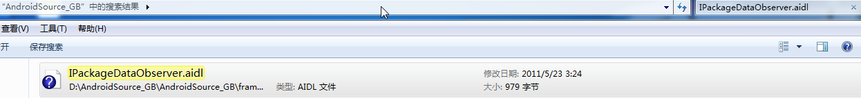
然后右击文件，打开文件位置：
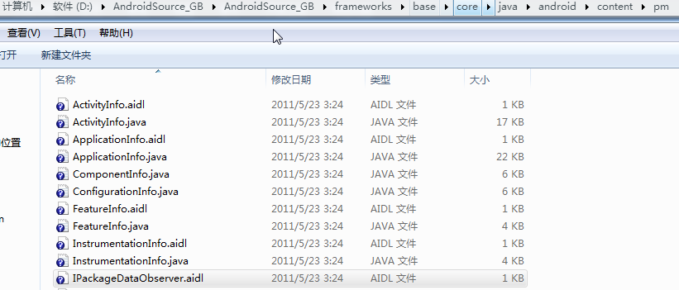
将IPackageDataObserver.aidl拷贝到我们工程中，工程目录(android.content.pm包名必须这样写，也就是必须保证aidl的包名跟提供者严格一致)如下所示：
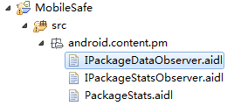
2）freeStorageAndNotify
/**
* Retrieve the size information for a package.
* Since this may take a little while, the result will
* be posted back to the given observer. The calling context
* should have the {@link android.Manifest.permission#GET_PACKAGE_SIZE} permission.
*
* @param packageName The name of the package whose size information is to be retrieved
* @param userHandle The user whose size information should be retrieved.
* @param observer An observer callback to get notified when the operation
* is complete.
* {@link
android.content.pm.IPackageStatsObserver#onGetStatsCompleted(PackageStats, boolean)}
* The observer's callback is invoked with a PackageStats object(containing the
* code, data and cache sizes of the package) and a boolean value representing
* the status of the operation. observer may be null to indicate that
* no callback is desired.
*
* @hide
*/
public abstract void getPackageSizeInfo(String packageName, int userHandle,
IPackageStatsObserver observer);
/**
* Like {@link #getPackageSizeInfo(String, int, IPackageStatsObserver)}, but
* returns the size for the calling user.
*
* @hide
*/
public void getPackageSizeInfo(String packageName, IPackageStatsObserver observer) {
getPackageSizeInfo(packageName, UserHandle.myUserId(), observer);
}

同样的步骤我们将IPackageStatsObserver.aidl也拷贝到工程中。

至此，本文档完！
2015年2月19日 星期四 11:15:28
河南省济源市梨林镇

