**39Q. . Draw a Class diagram for Online Voting System using CASE tools**

**Aim:** To draw a class diagram for online voting system.

**Software Used:** Umbrello.

**Diagram**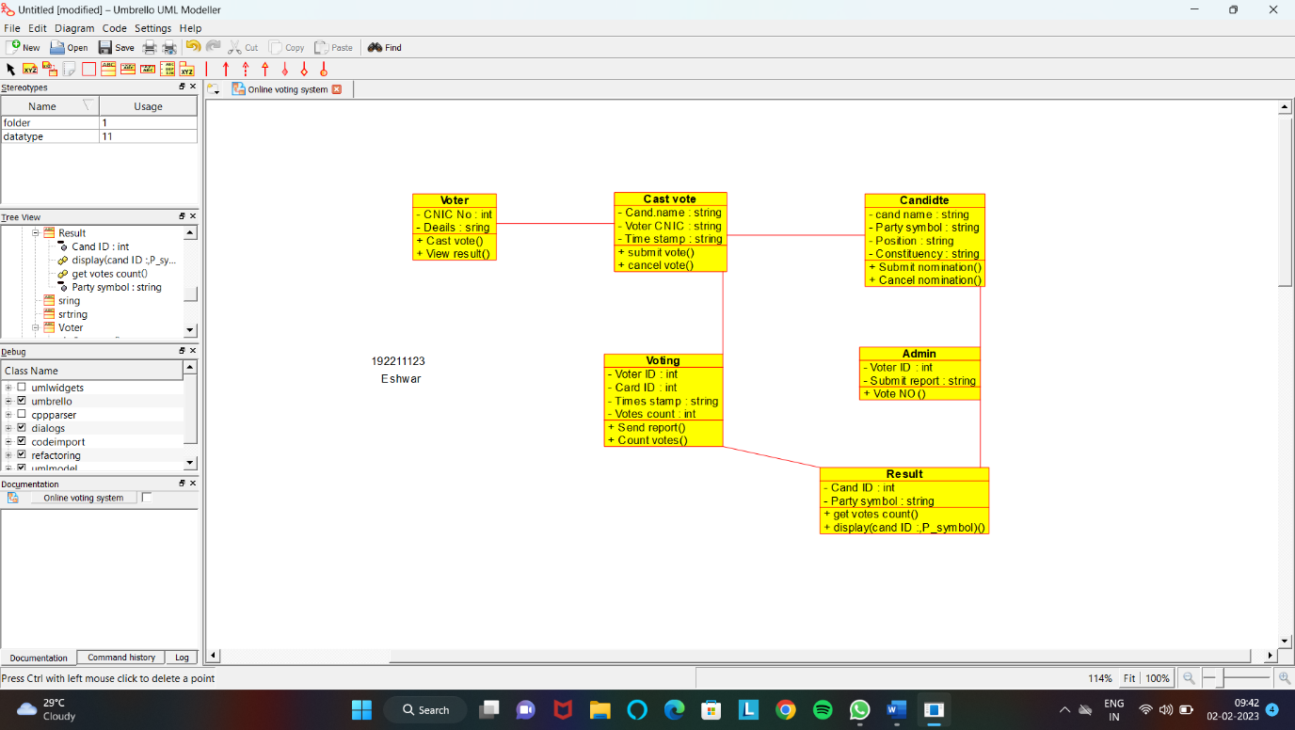

**Result:** Class diagram for online voting system was successfully completed.

**40Q. Using Raptor- Draw the flowchart to check whether the given number is a palindrome or not.**

**Aim:** To draw the flowchart to check whether the given number is a palindrome or not.

**Software used:** Raptor.

**Diagram:**

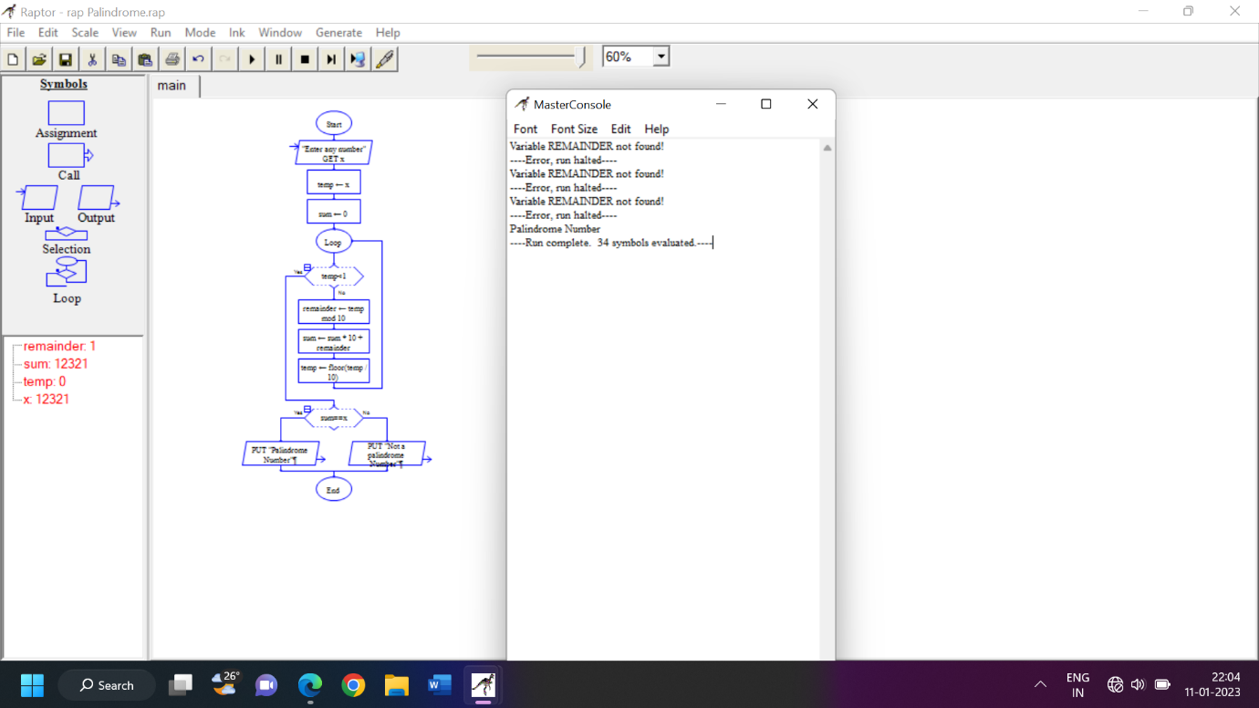

**Result:** Flowchart to check whether the given number is palindrome or not was completed and output verified.