**Point Finder User Manual**

**Introduction:**

Point Finder allows users to import a csv file of 3D points and query specific points among that collection of points.

**Importing a CSV**

To import a csv file of points, simply paste the location in the text box to the left of *File Path* and click *Open Points Csv*.

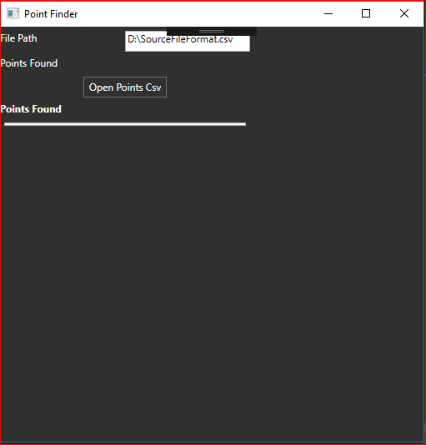

The csv file must have the following columns:

|  |  |  |  |  |
| --- | --- | --- | --- | --- |
| X | Y | Z | ID | Description |

Once the csv has been successfully opened, more options will be visible (discussed later):

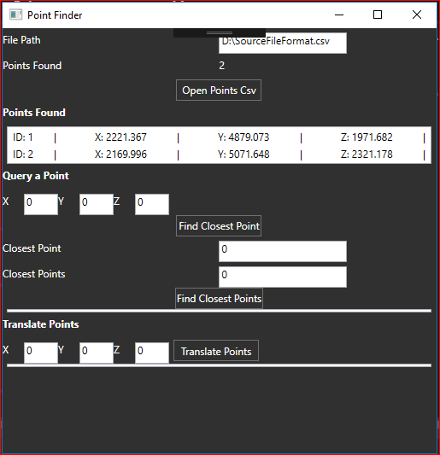

**Finding the closest point in a list to the given point**

To query a point to find the closest in the list, simply type the coordinates in the *Query a Point* section and click *Find Closest Point*.

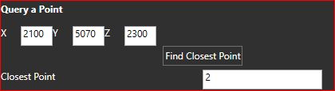

The ID of the closest point is returned, in this case ID 2.

**Returning a list of x number closest points**

Enter the number of points and that number of the closest points will be displayed in a grid once clicking *Find Closest Points*.

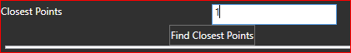

As one point was requested, only one was displayed in the list:

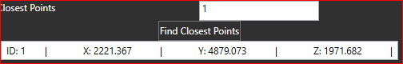

Entering 2 and clicking *Find Closest Points* again, the two closest points are now displayed:

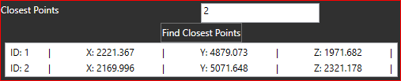

**Translating Points**

In order to translate all the points in the csv file to a given coordinate, simply enter the respected values in the boxes labelled X, Y and Z accordingly and click *Translate Points*.



Once the points have been translated to the given coordinates, a list will be populated containing the newly translated points will be displayed. Please note, this does not alter the coordinates in the imported csv.

