Software Requirements Specification
For
MASHAALLAH ORGANIZER
(Event Organizer App)

Version 1.0
Prepared by: Al Haseeb Zafar F-19BCSE108
Muhammad Haris F-19BCSE133
Hamza Shamir F-19BCSE118
Group: C10
19/10/2022
Table of Contents
Table of Contents ii
Revision History iii
1. Introduction 1
1.1 Purpose 1
1.2 Document Conventions 2
1.3 Intended Audience and Reading Suggestions 2
1.4 Product Scope 3
1.5 References 3
2. Overall Description 3
2.1 Product Perspective 3
2.2 Product Functions 4
2.3 User Classes and Characteristics 6
2.4 Operating Environment 6
2.5 Design and Implementation Constraints 6
2.6 User Documentation 7
2.7 Assumptions and Dependencies 7
3. External Interface Requirements 8
3.1 User Interfaces 8
3.2 Hardware Interfaces 9
3.3 Software Interfaces 9
3.4 Communications Interfaces 9
4. System Features 10
4.1 System Feature 1 10
5. Other Nonfunctional Requirements 22
5.1 Performance Requirements 22
5.2 Safety Requirements 22
5.3 Security Requirements 22
5.4 Software Quality Attributes 22
5.5 Business Rules 23
6. Other Requirements 24
Appendix A: Glossary 24

Revision History
Name | Date | Reason For Changes | Version
Al Haseeb Zafar | 12/5/22 | Amendment in use case and in diagrams | Version 1.1

Introduction

Purpose
MA organizer is a web based application that covers all the aspects of event organizing, management catering and services.it is a platform where customer deal with the provided services i.e. decor, food, caters etc. .It provided ease to the customers to order online instead of visiting halls to place order. Admin panel can get and analyze all the data of bookings and history.
MA organizer Version 1.0

Document Conventions
NAME | FORMATING CONVENTIONS
FONT | Times New Roman
TEXT | Single spaced
SIZE | 12
ORIENTATION | Portrait
MARGIN | Normal
ALIGNMENT | Justified
LINE SPACING | 1.15

MNEMONICS MEANING
DB | Database
DDB | Distributed Database
DFD | Data Flow Diagram
ER | Entity Relationship
SS | Screenshot

Intended Audience and Reading Suggestions
The SRS document is intended for all the stakeholders to confirm on all the requirements and features before initiating development. Stakeholders include the sponsors, Management team, Q/A staff. The document states project scope with detail explanation of features and specifications. It will help for all the users to understand about the project and Q/A staff to prepare testing cases accordingly. The document also includes some limitations and constraints the operating requirement in which the system would work.

Product Scope
Web-based Event Management System is used to create a dedicated website to manage and organize events. The accessibility of the system should facilitate communication between users, vendor, and managers. It will allow users to request events be made. It should then allow site managers to create an event that includes the host, type of event, time, place, cost, and staff list. End users should be able to sign up and book event. The core of the system will reside on a server connected to the internet and the primary interface for the system will be via an internet browse.

Overall Description

Product Perspective
The software will be a new independent product, that it, it is not a component of another program. It is intended for the administration of the management and other concerned users. The product will import its data from Firebase Database .

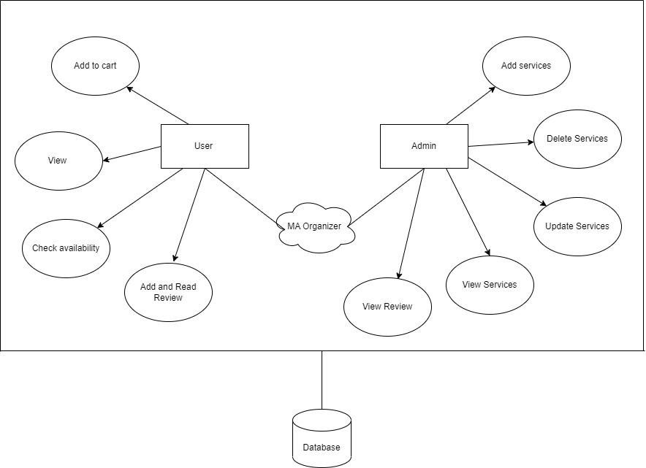
Users can get access to this software by logging and for login they first have to register. User can search for halls, decorations, menus, timings. Admin has the information of bookings, orders, available timings. This information can only be accessed by the staff members and the manager/supervisor aside from the developers. All the forms used in the product follows a clear and logical structure. Errors will be minimized through the use of drop-down buttons and command buttons to eliminate the excessive use of text input. Management of data includes searching, adding, modifying and deleting. The product specified will be developed for chrome and other browsing software . It does not also require any new hardware to function.

Product Functions
Feature No | Feature | FR No | Functional Requirement | Description
F-1 | Profile | FR01 | Registration | User and admin will register to the system
F-1 | Profile | FR02 | Login | User and admin will login to the system
F-2 | Dashboard | FR03 | Admin Panel | Admin can add and delete item through admin panel
F-3 | Checkout | FR04 | Add to cart | User will select all item and put it into add to cart
F-4 | AI search | FR05 | Dynamic Search | User will only tell the no.of people and system will provide all services
F-5 | Notifications | FR06 | Offers | System will give the offers on menus and services
F-6 | Tracking | FR07 | Track Order | User can see the order processing
F-7 | Feedback | FR08 | Review | user can see and add review about the services
F-8 | Data Selection | FR09 | Menus | User can select food, decor and cater services

2.2.2 Core Features

- Profile
User will be able to register and login easily.
- Dashboard
Admin will be able to check monitor through dashboard.
- Checkout
User will be able to pay for the booking or order.
- AI Search
User will get suggestions according to their desires on runtime.
- Notifications
User will be notified about new offers.
- Tracking
Admin will track the orders and booking.
- Feedback
User will be able to give reviews and comments about services and orders online.
- Data Selection
User can check the menus and select what to order.

User Classes and Characteristics
Users of the software system include researchers, practicing engineers, and software developers. All users should be familiar with web technology. Users are knowledgeable of software-development processes or manufacturing processes but may not be knowledgeable of both. However, users should have a good understanding of the tasks, activities, and artifacts of either process in which they may be interested.
There will be two types operating the specified system. The types are:
User: will book online all the services
Admin: will manage DB and will upload items

Operating Environment
The essential program in a computer that maintains disk files, runs applications, and handles devices such as the mouse and printer
The server-side components of the software system must operate within a Linux operating system environment.
The client-side components of the software system must operate within common web browser environments using Secure Sockets Layer (SSL) / Transport Layer Security (TLS) protocols.
The minimum set of browsers that must be supported is:
- Google Chrome
- Microsoft Internet Explorer
- Mozilla Firefox

Design and Implementation Constraints
- The application shall be implemented as a web-based application.
- Data will be retrieved from database.
- Website will be started through homepage.
- Website will be implemented on React and Firebase.
- Logo will be displayed on left side of page.

User Documentation
Any user of the software system is the target audience for user documentation generated about the software system. Hyper Text Markup Language (HTML) and/or Portable Document Format (PDF) format must describe the use of the software system.

Assumptions and Dependencies
- Network and data availability
- Web Browser
- Better connection for exchanging data over network
- Availability of management

External Interface Requirements

User Interfaces

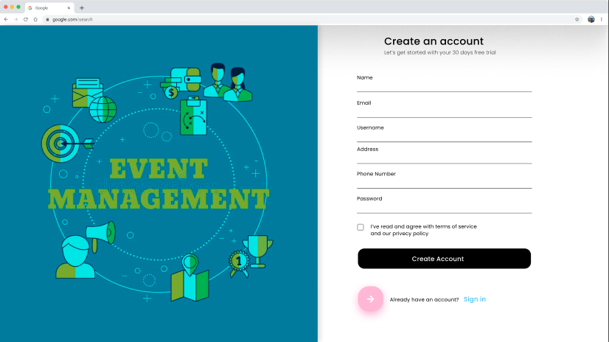
3.1 Register Interface

This is the prototype of registeration page. User have to register first. They have to enter all fields.

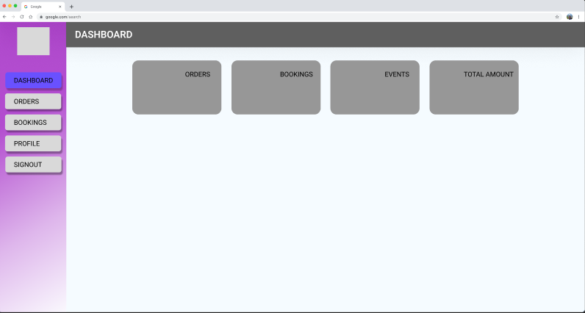

Admin Panel
This is a prototype of admin panel. Admin will see dashboard and other features. He can see orders, bookings and other features.

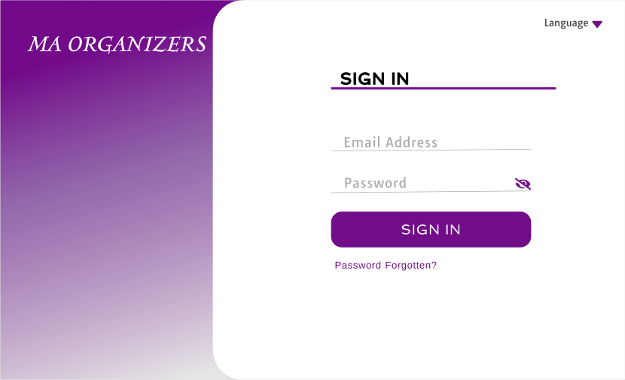
3.3 User Login
This is a prototype for user login. User first register to have access and credentials for login.
Then user will be able to use the system services.

Hardware Interfaces
Since the application will run on Browser. For the admin and user, it may require internet via Wi-Fi, Modem, WAN – LAN. Whereas, a user who is using a smartphone or pc to access the application, would need internet.

Software Interfaces
1. The API that shall be used for website is Shopify and Big Commerce API

Communications Interfaces
1. The system shall use the FTP for transferring media, HTTP for database connection.

System Features

System Feature 1
Identifier | FR-01
Title | Register
Requirement | The system shall allow the registered users to be able to access several features by signing up.
Source | Users.
Rationale | Users should be registered in order to perform several actions which can only be accessed by registered users.
Restrictions and Risk | The existing account against the same Email of a user should not exist for that user to register.
Dependencies | -
Priority | High

Identifier | FR-02
Title | Login
Requirement | The user shall be able to access several features provided by the system once they log in.
Source | Users.
Rationale | Users should get access to the system after successful login.
Restrictions and Risk | Users must provide authentic credentials.
Dependencies | FR-01
Priority | High

Identifier | FR-03
Title | Admin Panel
Requirement | The admin shall be able to access several features provided by the system once they log in.
Source | Admin.
Rationale | Admin should get access to the system after successful login.
Restrictions and Risk | Admin must provide authentic credentials.
Dependencies | FR-01, FR-02
Priority | High

Identifier | FR-04
Title | Add to cart
Requirement | The user shall be able to checkout the items .
Source | Users.
Rationale | Users should get access to the system after successful login.
Restrictions and Risk | Users must select items from menu to order.
Dependencies | FR-01,02,09
Priority | High

Identifier | FR-05
Title | Dynamic Search
Requirement | The user will be able to add information and get result .
Source | Users.
Rationale | Users should get access to the system after successful login.
Restrictions and Risk | Users must provide correct information.
Dependencies | FR-01,02
Priority | High

Identifier | FR-06
Title | Offers
Requirement | The user will get offers after successfully registering.
Source | Users.
Rationale | Users should get access to the system after successful login.
Restrictions and Risk | Users must be registered.
Dependencies | FR-01,02
Priority | High

Identifier | FR-07
Title | Track Orders
Requirement | The admin shall be able to tack orders, pending orders etc.
Source | Admin.
Rationale | Admin should get access to the system after successful login.
Restrictions and Risk | Admin must be logged in.
Dependencies | FR-01,02,04
Priority | High

Identifier | FR-08
Title | Reviews
Requirement | The user shall be able to give feedback or review regarding the order or services provided.
Source | Users.
Rationale | Users should get access to give review after successfully received order .
Restrictions and Risk | Users must order or book .
Dependencies | FR-01,02,04
Priority | High

Identifier | FR-09
Title | Menus
Requirement | The user shall view menus and select for order.
Source | Users.
Rationale | Users should get access to the system after successful login.
Restrictions and Risk | Users must provide internet to system.
Dependencies | FR-01,02
Priority | Medium

Use-Case Description
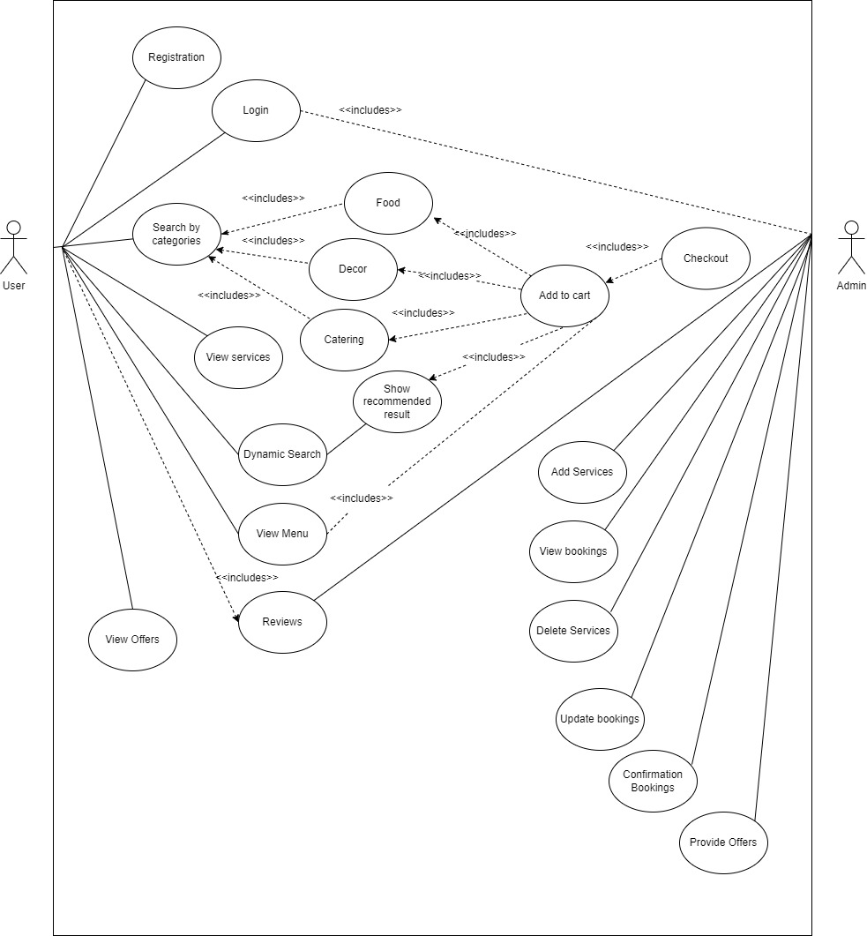
4.1.1.1 Registration
Use Case Id: UC-1
Use-case Name: Registration

Goal: To register the user successfully in MA Organizer.

Primary Actor: User

Secondary Actor: Admin

Pre-condition: Internet is available to the visit website

Post-condition: User registered successfully.

Main Success Scenario:

Actor Action | System Response
1. User enters the name.
2. User enters the password

 | 4. System registers the user

Exceptional Scenario:

Actor Action | System Response
1. User does not provide the required information.
 | 2. System returns an error message.

Post-condition: User does not registered successfully

Sign In:

Use Case Id: UC-2
Use-case Name: Sign In

Goal: Sign in the user successfully in MA Organizer.

Primary Actor: User

Secondary Actor: Admin

Pre-condition: Internet is available to the visit website

Post-condition: User successfully signs in MA Organizer.

Main Success Scenario:

Actor Action | System Response
1. User enters name.
2. User enters a password.
 | 3. System validates the user.

Exceptional Scenario:

Actor Action | System Response
1. User does not provide the correct name
or password.
 | 2. System returns an error message.
 | 3. System does not let the user access dashboard.

Post condition: User is unable to access the website

Search by Categories:

Use Case Id: UC-3
Use-case Name: Search By Categories

Goal: View different services

Primary Actor: User

Secondary Actor: Admin

Pre-condition: Successfully login to the website

Post-condition: User successfully search the different menus

Main Success Scenario:

Actor Action | System Response
1. User click on the menus
 | 2. System view the different services

Exceptional Scenario:

Actor Action | System Response
1. User click on the wrong button

 | 2. System will show result according to the button

Post condition: User will see different result

AI Based Search:

Use Case Id: UC-4
Use-case Name: Dynamic search
Goal: To view estimate of all services according to the number of people

Primary Actor: User

Secondary Actor: Admin

Pre-condition: Successfully login to the website

Post-condition: User is successfully able to see the estimate

Main Success Scenario:

Actor Action | System Response
1. User click on the Dynamic Search Button
2.User will enter the number of people
 | 3.System will generate the result according to the number of people

Exceptional Scenario:

Actor Action | System Response
1. User provide float value

 | 2. System will generate error message

Feedback:

Use Case Id: UC-5
Use-case Name: Feedback

Goal: View and provide Feedback

Primary Actor: User

Secondary Actor: Admin

Pre-condition: Successfully login to the website

Post-condition: User successfully view and added review

Main Success Scenario:

Actor Action | System Response
1. User click on the review button
2.User is able to view all the review
3.User add review
 | 2. System stores the review of the user

Exceptional Scenario:

Actor Action | System Response
1. User exceeded the review character length
 | 2. System will generate the error message

Post condition: User is unable to add the review

Add to Cart

Use Case Id: UC-6
Use-case Name: Add to Cart

Goal: To successfully items in the cart for payment

Primary Actor: User

Secondary Actor: Admin

Pre-condition: Successfully login to the website

Post-condition: User successfully added items to cart and payment successful.

Main Success Scenario:

Actor Action | System Response
1. User click on the menus
 | - System view the different menus
- User select item and add to cart
 | - System added item to cart
- User select payment method
- User added payment credentials.
 | - Payment Successful.

Exceptional Scenario:

Actor Action | System Response
1. User click on the wrong button

 | - System will show result according to the button
- User enters wrong payment credentials
 | - Payment failed.

Tracking Orders and bookings

Use Case Id: UC-7
Use-case Name: Tracking Orders and Bookings

Goal: To successfully track orders

Primary Actor: Admin

Secondary Actor: User

Pre-condition: Successfully login to the website

Post-condition: Admin successfully updated orders and viewed orders.

Main Success Scenario:

Actor Action | System Response
1. Admin enter into panel
 | - System view panel
- Admin click on Orders
 | - System give access to orders page.
- Admin cancels order
 | - System canceled orders.
- Admin update bookings
 | - System updated booking.

Exceptional Scenario:

Actor Action | System Response
1. User cancels wrong order

 | - System will double check to cancel first.

Admin Panel

Use Case Id: UC-8

Use-case Name: View Admin Panel

Goal: To successfully view panel of admin

Primary Actor: Admin

Secondary Actor: User

Pre-condition: Successfully login to the website

Post-condition: Admin successfully viewed Panel.

Main Success Scenario:

Actor Action | System Response
1. Admin enter credentials to login first.
 | - System logged in.
- Admin views whole panel

Exceptional Scenario:

Actor Action | System Response
1.Admin enters wrongs credentials.

 | - System will show wrong credentials error message.

Other Nonfunctional Requirements

Performance Requirements
The application should be able to operate on all major web browsers with all of its fundamental functions .it should not slow-down the system even at peak hours without affecting the quality of service of the system. Response to queries shall take no longer than approximately 1 minute to load after the user submits them.

Security Requirements
The system shall provide a secure login to the user and provide access only to the authorized users ad security is the key requirement of this system.

Software Quality Attributes
The software quality attributes of the system are as follows:

Availability Requirements
MA Organizers will be available for all users 24/7, so users can access it at any time of the week using internet

Maintainability Requirements
The system shall not be shut down for maintenance more than once in a 24 hour period

Re-usability Requirements
Each of the module of the system is designed apart from each other and coded individually .For future purposes, these modules can be reused to design a new system.

Business Rules
- A user should be registered for using the application.
- Application should not allow any user to access dashboard and other features if the user is not register.
- Before OTP verification no user is allowed to use the system.
- Menu and feedback can’t be updated or deleted by the user.

6. Other Requirements
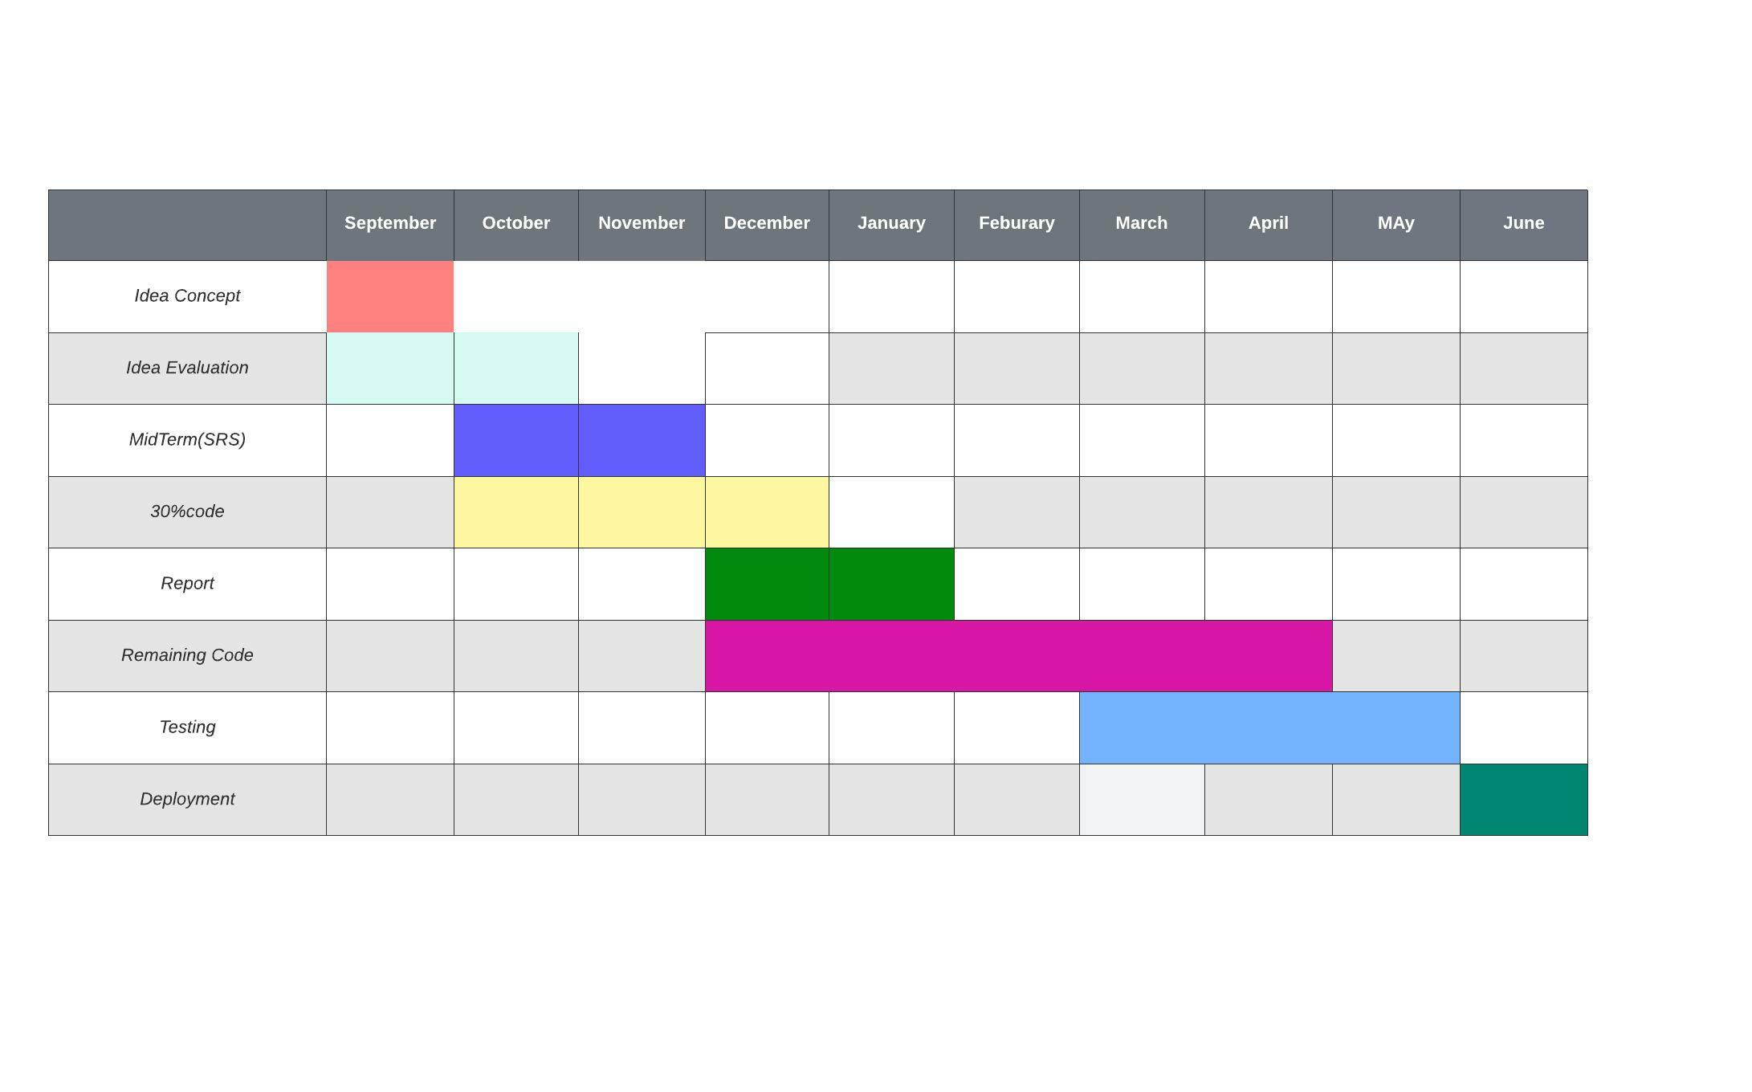
  - Gantt Chart:

  - Class Diagram:
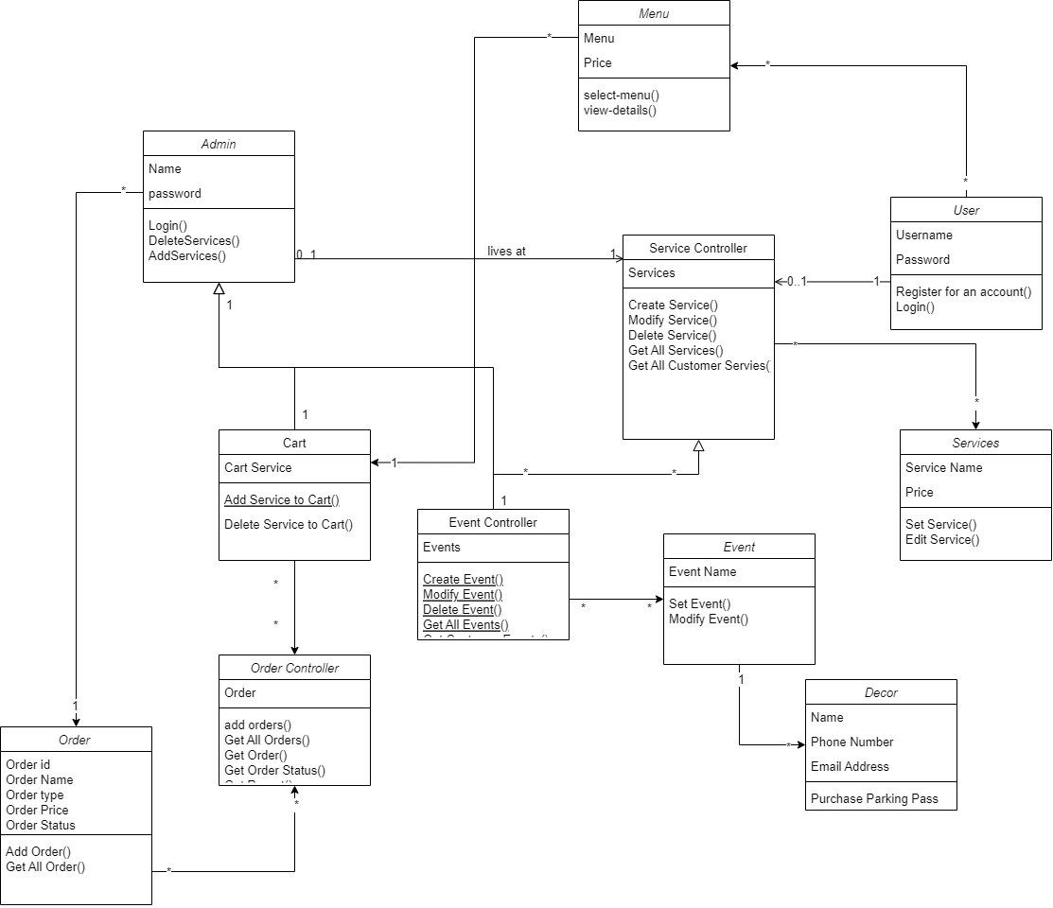

  - System Sequence Diagram:

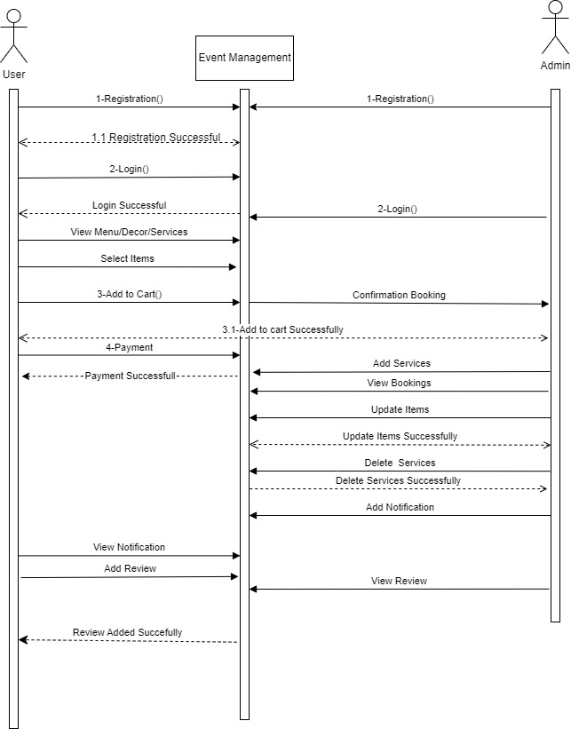
  - Sequence Diagram

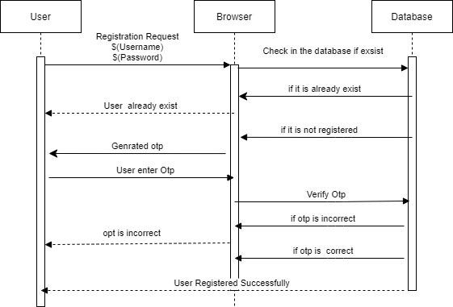

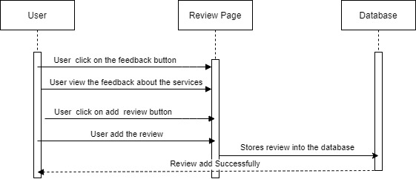
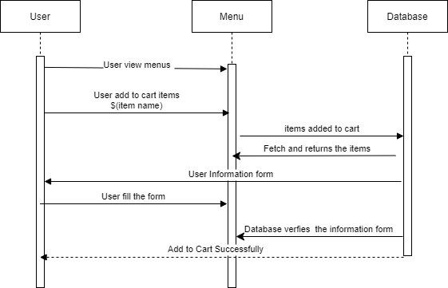

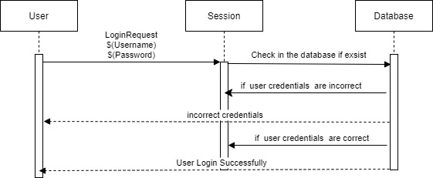
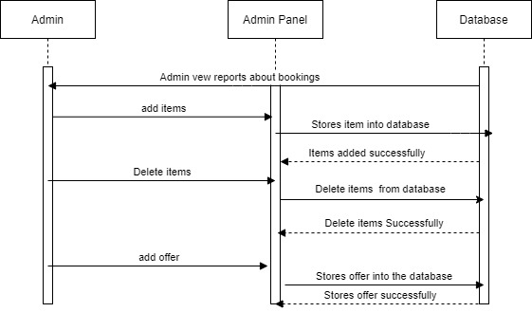

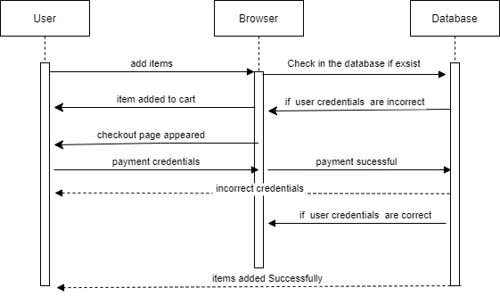

References
https://www.coursehero.com/file/9850698/SRS-Web-Based-Event-Management-System/

http://info-tech-saad.blogspot.com/2012/04/event-management-system-description.html

Appendix A: Glossary

Acronyms | Description
MA | MashaAllah
GUI | Graphical User Interface
SRS | Software Requirements Specifications
FYP | Final Year Project
DB | Database

