Abstract- This paper presents a compact wideband leakage canceller module (WLCM) operating across a range of 300 MHz, which employs a novel negative capacitance circuit (NCAP). The module consisting of the LC network, a directional coupler, a power combiner, and a 3-port circulator exhibits a significant cancellation of leakage signal up to 54 dB at 2.5 GHz. The bandwidth is expanded to 300 MHz with more than 15 dB leakage suppression capability. The newly canceller prototype is verified and designed by using a Samsung LR6LP 65 nm RF CMOS Low Power technology. This canceller occupied an area of 1.19mm x 0.89 mm. The overall module draws a current of 13 mA by a 3 V power supply.

A Wideband On-chip Leakage Canceller

for Retro-directive Wireless Power Transfer System
Tan–Binh Ngo, Sang-Woong Yoon
Department of Electronics Engineering, Kyung Hee University
E-mail: binhnt_ee@khu.ac.kr, sangwyoon@khu.ac.kr
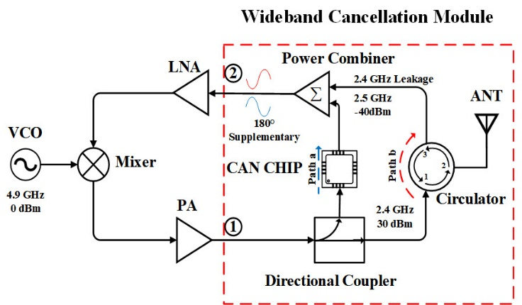
Fig. 1 A Wideband Leakage Cancellation Module in Retro-directive array RF System for Wireless Power Transfer

Index Terms Wideband Leakage Cancellation Module (WLCM), negative capacitance (NCAP), Canceller, Retro-directive Arrays (RDAs), Noise Figure (NF).

Introduction
I
n the past few years, a short-range wireless power transfer (WPT) study has been conducted and obtained some promising outcomes [1]. Due to the compact and cost-effective features, the Retro-directive arrays (RDAs) have been widely used for beamforming in WPT systems. Nevertheless, the jitter which potentially ruins the beam steering error acts as the most critical parameter to decide the merit of any RDAs system. To tackle with high jitter problem appearing at output of the power amplifier (PA) (Fig.1), there should be a technique to minimize interferers stemming from the mixer ‘s feedthrough as well as the returning leakage signal via the circulator’s low isolation route, which hugely prevails against the mixer ‘s one in degrading the overall RDAs performance.
To combat the challenge deriving from the imperfect circulator, one leakage cancellation module resides crossing 2 ports of circulator as a door of the RDAs system to enhance isolation capability, which is first introduced as feedforward embedding method [2] for single-frequency approaching 1 GHz.
Upon that preceding concept, this paper exhibits a method to accommodate a wider frequency range from 2.24 GHz reaching to 2.54 GHz by deploying a negative capacitance circuit [1] and this method becomes, essentially, beneficial to apply to Wireless Power Transfer System where the received signal ‘s strength is relatively low compared to that of the transmitted signal.

Analysis and Design

Negative Capacitance Circuit Design
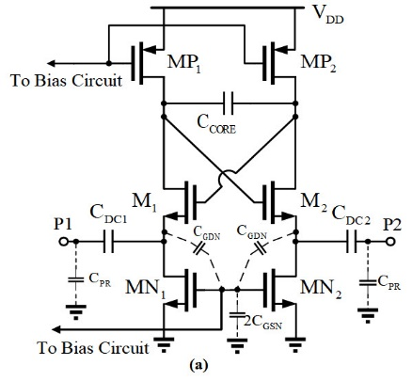

Fig. 2 (a) NCAP schematic

The NCAP circuit in this study referring to [1] is realized in Fig.2a (bias circuit not included), where M₁, M₂ is the primary cross-coupled differential pairs loading the C_{CORE.}
MP_{1,2}, MN_{1,2} provides bias current, whose the on-resistance must follow up the stability condition proved by [3] Consequently, it provides the circuit an impedance equivalent to an inductor when looking into port 1-2 as well as generate a positive phase slope that has never been seen in other lumped components of circuit design (conventional R, L, C).
By setting parameters in Fig. 2a as follows: (W/L)_{M1,2} = 200, (W/L)_{MP1,2} = 240, (W/L)_{MN1,2} = 48 and C_{CORE} = 0.8 pF, the NCAP circuit is equivalent to a -2 pF capacitor. The circuit is supplied by a VDD = 3 V while drawing nearly 13 mA. The parasitic components in Fig.2 are absorbed into C_{CORE} making the self-frequency of the circuit lower. Hence, connections with Gate and Source/Drain of M_{1,2} should be carefully minimized during the layout design. Moreover, C_{DC1,2} are not only the DC blocking cap but considered as if the matching components at a frequency of interest. In this circuit, to get a reflection lower than 20 dB at 2.45 GHz, C_{DC1,2} are designed with 15 pF.

Power combiner (PC) and Directional Coupler design (DC)
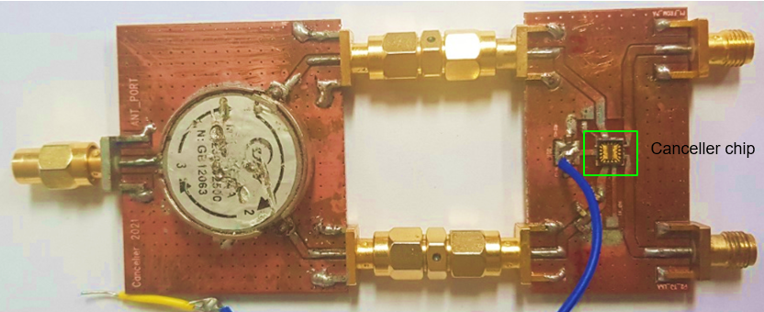
Fig. 6. A complete Cancellation PCB Module

The signal from PA is extracted a small amount of power forwarded to the Canceller circuit by a directional (couple line) coupler (DC). In this work, the DC is designed completely by lumped component (transformer and capacitor), whose design technique is fully characterized in [4]. At 2.45 GHz, values in Fig.3 (a) are determined: C₀ = C₁ = 0.3 pF, C₄ = C₅ = 0.7 pF, C₂ = 1.18 pF, C₃ = 0.91 pF and a transformer on-chip provided by PDK.
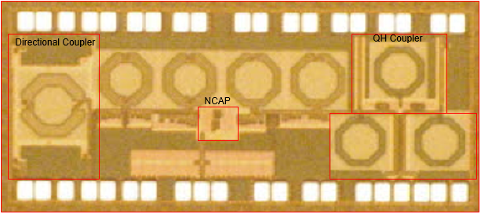
Fig. 9 Microphotograph of the fabricated Canceller (1.19mm x 0.89 mm)

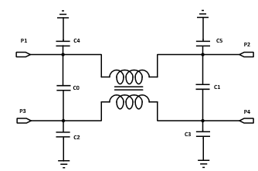
(a)
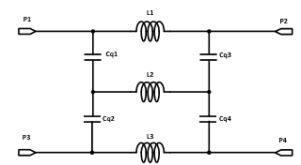
(b)
Fig. 3 Geometry of (a) Coupled Line Coupler (b) Quadrature Hybrid Coupler

In addition, the power combining function is implemented by a quadrature hybrid coupler as seen in Fig.3 (b) thanks to [5] for their first contribution. This approach based on a high pass and low pass lumped elements enables a compact on-chip quadrature hybrid as well as expresses a wider bandwidth and low insertion loss in band as compared to that of transmission line counterpart. The parameters in Fig.3 (b) are designed as follows at 2.45 GHz: L_{1,2,3} = 3.3 nH, C_{q1,2,3,4} = 1.52 pF.

Wideband Circulator with High Isolation Canceller
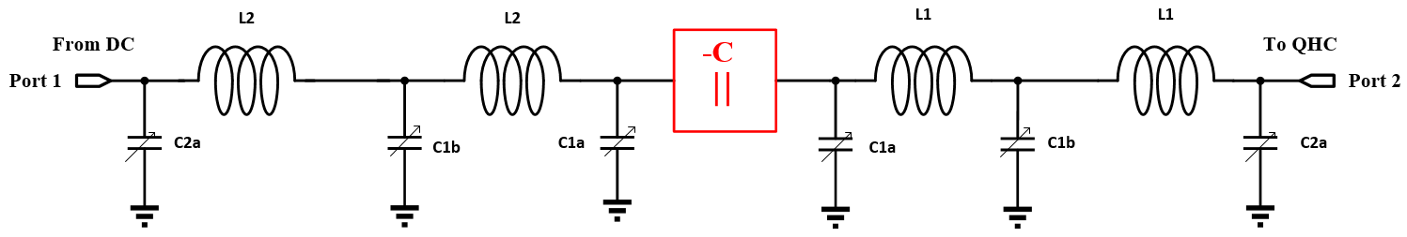
Fig. 4 LC network combines with a central NCAP circuit

The canceller is established by joining 3 blocks together: DC, LC network, and QHC as described in block diagram Fig.1. Power coupled from P3 of DC and feed into an LC network as seen in Fig.4. Herein, the extracted phase and magnitude are manipulated with the help of NCAP and the LC network itself. Subsequently, the resulting signal at port 2 is fed into QHC for combining with the inherent leakage signal of the circulator. As a result, after the canceller module, the theoretical cancellation possessed by the circulator increases significantly, which primarily features to release burden for filtering load and improve sensitivity for the overall system.
The lumped elements in Fig.4 are designed with PDK by showing values as follows: L₁ =1.5 nH, C_{1a} = 6.2 pF, C_{1b} =1.07 pF, L₂ = 2. 8nH, C_{2a} = 1.07 pF.

Implementation and Measurement Results
First, exploring properties of magnitude and phase on the isolation route of the circulator component (left part in Fir.6), which is used as the observant data for designing canceller chip, plays a major role in the whole process. In this study, UIYSC25A2300T2500 surface mount circulator working from 2.3 GHz to 2.5 GHz is employed with a 50 Ohm matching load as a spurious antenna terminated at port 3. A photograph of PCB consisting of Canceller chip (right part) and Circulator, which composed of 2 ports connected to VNA for S-parameter measurement, is presented in Fig.6. The PCB prototype is about 6.7 cm x 4.6 cm in size.
Second, the canceller chip is fully designed on 65nm RF Samsung PDK. Fig.9 shows a micrograph of assembled canceller chip which occupied an area of 1.19 mm x 0.89 mm (including PADs). The canceller S-Parameters, subsequently, are verified using probe station and Rohde & Schwarz ZNLE6 VNA (1MHz-6GHz). Considering the cancellation measurement in Fig.9, there are 3 tuning cases in comparison with the inherent isolation of circulator, which corresponds to bias variations and cap bank solution as illustrated in Fig.4. This minor technique is essential to guarantee performance due to PVT (process, voltage, temperature) unpredicted variations. Among cases, tuning 1 line goes over the range of 2.24 GHz to 2.54 GHz, by suppressing leakage greater than 15 dB throughout the band of 300 MHz, the chip proves an extensive enhancement as compared to the inherent isolation of circulator. Additionally, at the receiving frequency of 2.5 GHz, the module offers a good rejection capability reaching down to -54 dB, which reveals a 34 dB of improvement versus that of using circulator only. Moreover, noise disturbing the RX path due to the circulator itself and canceller chip is about 5 dB, which reveals the resulting system obtaining the sensitivity improvement of 29 dB – not a trivial number.

Conclusions
A wideband Canceller on-chip module possessing an extended bandwidth up to 300 MHz is presented. By manipulating phase and magnitude thanks to NCAP, the canceller chip validates the role of NCAP in deploying its phase property to produce a circulator with high isolation and wideband. That is capable of suppressing greater than 15 dB over 300 MHz from 2.24 GHz to 2.54 GHz. For those given, this canceller chip demonstrates a promising possibility of enhancing sufficiently the performance of Retro-directive array RF System in wireless power transfer application. In future work, it is pretty nice to design an on-chip circulator working with our canceller module, which makes the retro-directive array compacted and commercial-oriented product.

Reference
[1] Y. Li and V. Jandhyala, “Design of retrodirective antenna arrays for short-range wireless power transmission,” IEEE Trans. Antennas Propag., vol. 60, no. 1, pp. 206–211, 2012, doi: 10.1109/TAP.2011.2167897.
[2] S. L. Karode and V. F. Fusco, “Feedforward embedding circulator enhancement in transmit/receive applications,” IEEE Microw. Guid. Wave Lett., vol. 8, no. 1, pp. 33–34, 1998, doi: 10.1109/75.650980.
[3] N. D. H. Lai, N. T. Doan, H. Kim, and S. W. Yoon, “A 2-port stable negative capacitance circuit design with unilateral gain boosting technique,” IEEE Trans. Microw. Theory Tech., vol. 65, no. 12, pp. 4953–4959, 2017, doi: 10.1109/TMTT.2017.2747540.
[4] R. C. Frye, S. Kapur, and R. C. Melville, “A 2-GHz quadrature hybrid implemented in CMOS technology,” IEEE J. Solid-State Circuits, vol. 38, no. 3, pp. 550–555, 2003, doi: 10.1109/JSSC.2002.808287.
[5] J. A. Hou and Y. H. Wang, “A compact quadrature hybrid based on high-pass and low-pass lumped elements,” IEEE Microw. Wirel. Components Lett., vol. 17, no. 8, pp. 595–597, 2007, doi: 10.1109/LMWC.2007.901775.
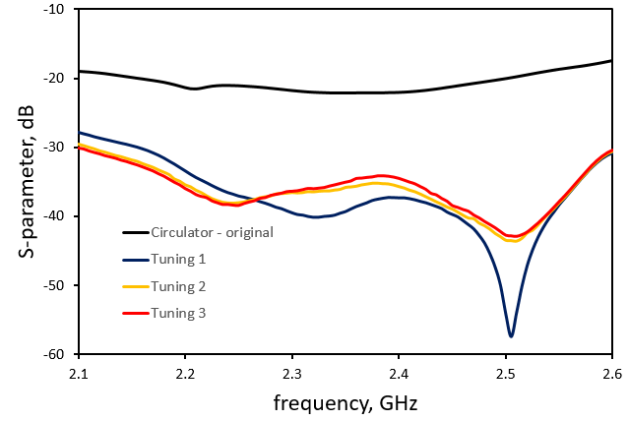
Fig.10 Canceller measurement results

