**Chapter 1: Function and Grap**

1. 

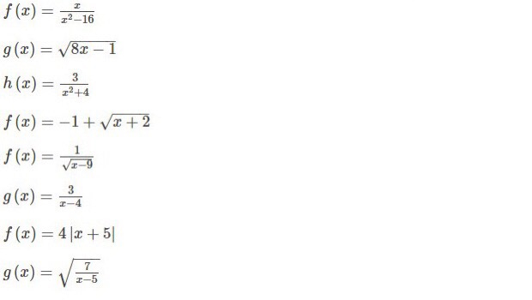

1. Find i.and ii. 

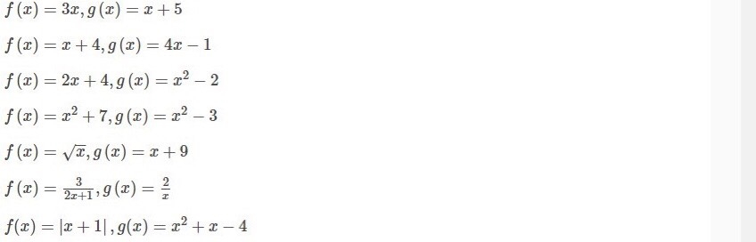

1. i. From the graph of y = f(x), how do we obtain the graph of y = f(x+1) - 4?

ii. From the graph of y = f(x), how do we obtain the graph of y = f(x-2) +3?

1. Simplify [f(x+h)-f(x)] / h for  
     
   f(x) = 1/(2x)

**Chapter 2: Limits**

1. Find the number m such that the function is continuous on its domain.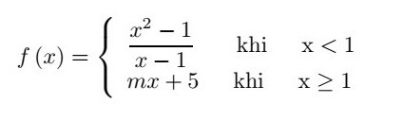
2. Find the number a such that the function is continuous on its domain.

[f(x) =\left\{\begin{array}{cc}\frac{5-\sqrt{x}}{25-x} & if \,\,\, x\neq 25\\ a & if \,\,\, x = 25\end{array}\right.](https://cmshn.fpt.edu.vn/filter/tex/displaytex.php?texexp=f(x)%20%3D\left\%7b\begin%7barray%7d%7bcc%7d\frac%7b5-\sqrt%7bx%7d%7d%7b25-x%7d%20%26%20if%20\,\,\,%20x\neq%2025\\%20a%20%26%20if%20\,\,\,%20x%20%3D%2025\end%7barray%7d\right.)

**Chapter 3: Derivatives**

1. The displacement (in feet) of a certain particle moving in a straight line is given by s = t3/8 where *t* is measured in seconds. Find the average velocity over the interval [1, 1.8].
2. The displacement of a particle on a vibrating string is given by the equation [s(t)=8+\frac{1}{7}\sin (4\pi t)](https://cmshn.fpt.edu.vn/filter/tex/displaytex.php?texexp=s(t)%3D8%2B\frac%7b1%7d%7b7%7d\sin%20(4\pi%20t))  
   where *s* is measured in centimeters and *t* in seconds. Find the velocity of the particle after *t* seconds
3. Find the equation of the tangent to the curve [[y = \sqrt{1+ x^2+6\sin x}](https://cmshn.fpt.edu.vn/filter/tex/displaytex.php?texexp=y%20%3D%20\sqrt%7b1%2B%20x%5e2%2B6\sin%20x%7d)](https://cmshn.fpt.edu.vn/filter/tex/displaytex.php?texexp=y%20%3D%20%5Csqrt%7B1%2B%20x%5E2%2B6%5Csin%20x%7D" \o "TeX)at the point (0, 1).
4. Derivative y’

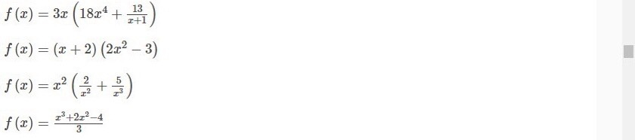

1. Derivative y’

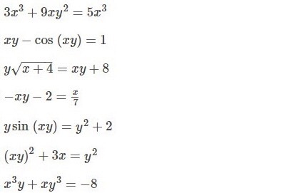

**Chapter 4 | Applications of Derivatives**

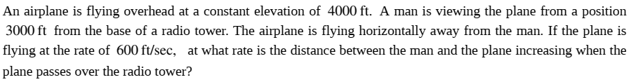



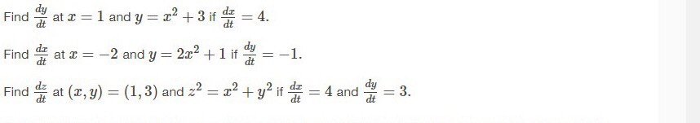

1. Find the point on the line y = 4x+5 that is closest to the origin.
2. Use Newton's method with the specified initial approximation x1 to find x3, the third approximation to the root of the given equation.

x5-x-10=0, x1=1.6.

(Give your answer to 4 decimal places)

1. Find the minimum of the product of two numbers with the property that the first minus 3 times the second is 10.

**Chapter 5: INTEGRATION**

1. Use the Left-endpoint Rule with *n* = 3 to approximate the integral.

[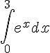](https://cmshn.fpt.edu.vn/filter/tex/displaytex.php?texexp=%5Cdisplaystyle%5Cint_0%5E3%20e%5Ex%20dx)

The choices are rounded to 2 decimal places.

1. Evaluate the integral if it exists.

[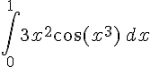](https://cmshn.fpt.edu.vn/filter/tex/displaytex.php?texexp=%5Cint_0%5E1%203x%5E2%5Ccos%28x%5E3%29%5C%2C%20dx)



