**PROJECT WEATHER FORECAST**

PROJECT CLOSING REPORT VERSION 0.01

THE VERSION HISTORY OF THE DOCUMENT

|  |  |  |  |
| --- | --- | --- | --- |
| VERSION No. | DATE | REASON FOR CHANGE | AUTHOR/ACCEPTOR |
|  |  |  |  |
| 1.0 | 29.5.2015 | Approved | MEST |
| 0.1 | 28.5.2015 | Initial version | MEST |

LIST OF CONTENTS

LIST OF CONTENTS 3

1 THE DESCRIPTION OF THE PROJECT 4

2 RESULTS OF THE PROJECT 4

2.1 Description of the System 4

2.2 Description of the Hardware 5

2.3 Description of the Software 7

3 GENERAL EVALUATION OF THE PROGRESSION OF THE PROJECT 10

4 THE EXPERIENCES OF THE USED TOOLS AND METHODS 10

5 PERSONAL EXPERIENCES AND LEARNING 10

5.1 Agent J's experiences 10

5.2 Agent K's experiences 11

5.3 Agent L's experiences 11

6 SELF-EVALUATION OF THE STUDY MODULE 11

6.1 Agent J's self-evaluation 11

6.2 Agent K's self-evaluation 11

6.3 Agent L's self-evaluation 11

REFERENCES 12

# THE DESCRIPTION OF THE PROJECT

The aim of this project is to build your own product which is a website or a game on your choice. For me , it was a website which will update for you the weather condition of cities on all over the world : weather forecast website

# RESULTS OF THE PROJECT

## Description of the Web

Like any other website, it will consist of 3 programming language: JavaScript , HTML , and CSS. It will display basic weather data like general description, temperature , pressure and wind speed. 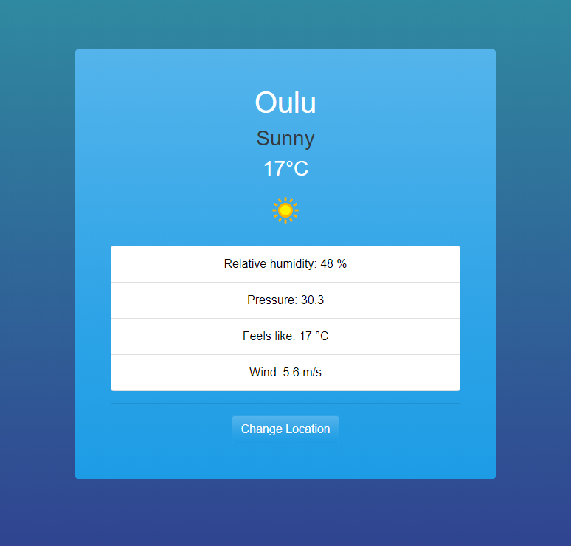

## Description of the UI

The UI was built using boostrap and a bit of css. I will leave the reference below



## Description of the code

The template was built base on some guide videos on You tube. It took me long time find out a thing which suitable for myself. That is the HTML is. About the JavaScript part , it consist of 4 files : app.js , weather,js , storage,js , ui,js . The first one app,js will have functions in it to run the website. It included an async function in order to fetch the data from the api and a getWeather function to get weather and return it as a promise. The 3 left were used for OOP.

Weather,js will use to create weather object to create parameter and set up api key as one of the parameter in the constructor

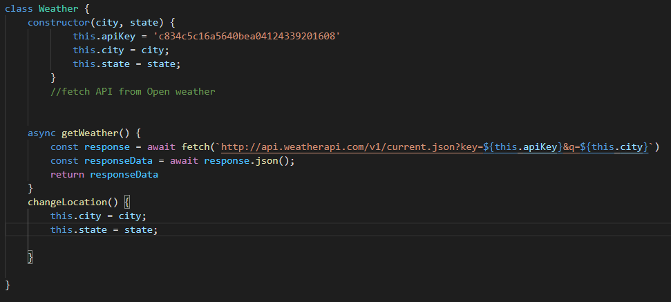

Next is the ui,js to render the data to html using DOM property

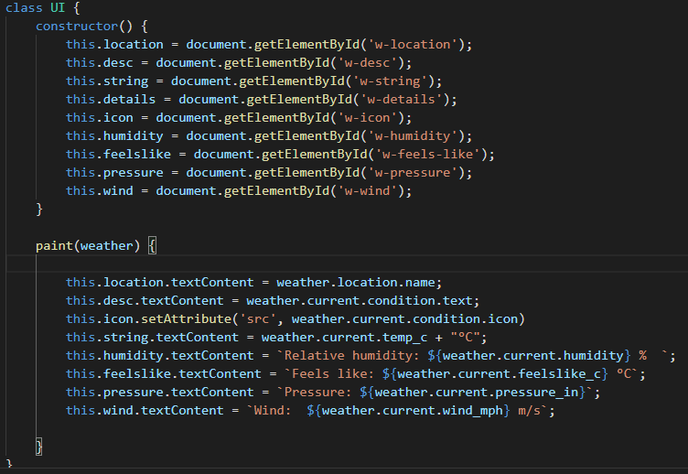

And the final one use to save data in local storage in order to save the data when reloading the page



# GENERAL EVALUATION OF THE PROGRESSION OF THE PROJECT

To be honest, I went for a strawberries pick in June and July. The project started in May , it went half of the plan then it was delay for about a month. I tried to read the book during the trip despite no internet there so I can hardly reach my supervisor for this project. But in the end , I manage to complete it right on plan and ready to hand in before deadline

# THE EXPERIENCES OF THE USED API AND METHODS

At first , I though pulling API is an easy job. Ever since I continue working with API , I realized it is easy to pull actually . In contrast , you will have to be very conscious to handle with the data you pulled. I was confused at first actually cause some API used difference unit and standard. Finally , I was able to pulled and handled the data, it took me a while to figure out how it work. APIs have a lot of use and great thing you can do with it.

# PERSONAL EXPERIENCES AND LEARNING

To be honest , it was a bit hard for new programmer to read a book like Eloquent JavaScript. I took a long time to think what to build. I ended up with a weather forecast website. I though I couldn’t make it but I done it. I know it not big for everyone else as it seem simple.

# SELF-EVALUATION OF THE STUDY MODULE

I think it was the right way when entered this summer project. I studied a lot from here. I think I just want a grade which above average is for me if possible

REFERENCES

1. <https://www.youtube.com/watch?v=wPElVpR1rwA&t=1214s>
2. <https://www.youtube.com/watch?v=GXrDEA3SIOQ&t=638s>
3. <https://www.weatherapi.com/>