Sơ đồ ERD:

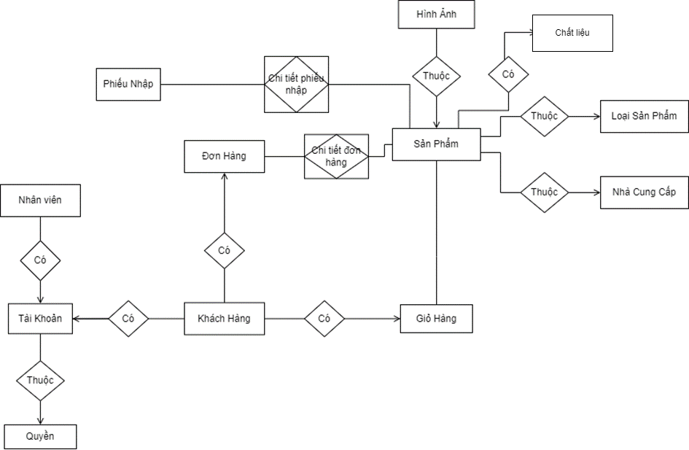

Chi tiết thực thể:

**- Customers** (id, name, email, phone, address)

**- Employees** (id, name, gender, email, phone, address, image)

**- Accounts** (email, password, role)

**- Manufactures** (id, name, email, phone, address, description)

**- Categories** (id, name, description)

**- Products** (id, name, categoryid, number, price, status, description, manufactureid, capacity, cost)

**- Cart** (customerid, productid, number)

**- Orders** (id, totalprice, customerid, employeeid, createday, address, status, namecustomer, phone, ispaid)

**- Import_Note** (id, createday, employeeid, totalprice, status)

**- Fragrances** (id, name, description)

**- Order_Detail** (orderid, productid, number, price)

**- Import_Note_Detail** (importnoteid, productid, number, price)

**- Images** (id, productid, path)

**- Role** (id, name)