 | 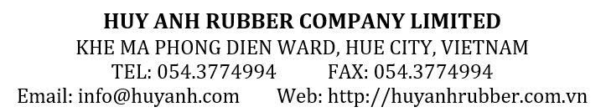

PROFORMA INVOICE
No: {contract_no}/PR.CI
Date: {contract_date}
THE SELLER: HUY ANH RUBBER COMPANY LIMITED
KHE MA , PHONG DIEN WARD, HUE CITY, VIETNAM
Tel: +84-0234 3774994 Fax: +84-0234 3774995

THE BUYER: {buyer_name}
ADDRESS: {buyer_address}

No of Containers | Description of Goods | Quantity (MTs) | Unit Price (USD/MT) | Total Amount (USD)
No of Containers | Description of Goods | Quantity (MTs) | {incoterm} – {pod}
{containers} x {cont_type} | NATURAL RUBBER {grade}  ({packing_desc}) | {quantity} | {unit_price} | {amount}
Total: |  | {quantity} |  | {amount}
Words: {amount_words}.
-Payment: {payment}.
{#is_lc_payment}The L/C draft must be opened within five (5) days from the contract signing date.{/is_lc_payment}
Ben’s Bank detail:
ACCOUNT NAME: {bank_account_name}
ACCOUNT NO: {bank_account_no}
AT BANK’S NAME: {bank_full_name}
ADDRESS: {bank_address}
SWIFT CODE: {bank_swift}

{buyer_name} | HUY ANH RUBBER COMPANY LIMITED

