Invigilated Report 2
Name: _____Yanzhen Hu_________________________________________
Student ID: ____602911786__________________________________________
Group: ______13________________________________________

Part 1: System Description

Overall Control Approach
The autonomous node is structured as an explicit finite state machine (FSM) with five states on a single ~10 Hz loop fusing 2D LiDAR, the RGB camera and wheel odometry. An FSM suits this task because it is intrinsically sequential — explore, approach, return.
State | Action | Transition
SEARCHING | Right-wall following + LiDAR avoidance | Red pixels > 300
APPROACHING | Centre red blob, move slowly | Front ≤ 0.30 m
TURN | Log pose, save image, rotate 180° | Heading cleared
RETURNING | Left-wall following to origin | Distance < 0.12 m
DONE | Stop | End

Search and Coverage Strategy
Strategy: single-wall (right-hand) following, A right-wall-following strategy was used instead of lawnmower or spiral search. This suited the C-shaped arena because following the continuous boundary naturally leads the robot past the far cylinder area without requiring global localisation. LiDAR wall distance also made the search less sensitive to odometry drift.
Speed. The forward speed was kept conservative at about 0.10–0.15 m/s, estimated from odometry logs. Wall-following used about 0.15 rad/s for small corrections, while 180° turns used about 0.5 rad/s. This low-speed setting was intentional: at 0.12 m/s, the robot could still cover the ~14 m route within the 10-minute limit, while reducing camera blur and giving obstacle avoidance enough reaction time.

Obstacle Avoidance

Obstacle avoidance used the front LiDAR sector. When the minimum front range dropped below about 0.35 m, the wall-following command was temporarily overridden by a turn-away command. This threshold was chosen considering the 0.12 m cylinder diameter, the TurtleBot footprint radius of about 0.18 m, and a safety margin: it was large enough to avoid contact but small enough to prevent unnecessary turns in the narrow C-shaped corridor. Once the front sector was clear, control returned to wall-following.

Cube Detection

Cube detection used HSV colour thresholding on the RGB camera image. Red was detected using two hue ranges, H ∈ [0,10] ∪ [170,180], with S ∈ [120,255] and V ∈ [70,255], because red wraps around the HSV hue boundary. These thresholds were calibrated from test images so that the red cube was retained while low-saturation background and shadows were rejected. A detection required MIN_PIXELS ≈ 300 and a valid blob centroid to reduce false positives. When the cube was detected, the robot switched to APPROACHING, centred the blob in the camera image, moved forward slowly, and declared arrival when the front LiDAR range reached 0.30 m. At arrival, it logged the odometry pose and saved a camera frame as evidence.

Return to Start
After detection the robot performs an in-place ~180° turn so that the wall it followed outbound is now on its left, then runs a left-wall PD controller back along the perimeter. The controller acts on the left-wall range error (the log line Return wall-follow PD | left=… err=… derr=… implies a set-point of ≈ 0.31 m, since err ≈ left − 0.31 across all samples), with the derivative term derr damping oscillation near corners.
Progress is judged by the odometric distance-to-origin (dist_to_origin), driven monotonically from 3.75 m toward zero; DONE fires below ~0.12 m. Homing was accurate — final pose (0.112, 0.025) m, a 0.115 m return error (Figure A2). Re-tracing the wall (rather than steering straight at the origin on odometry) keeps the robot in the safe corridor and off the obstacle field, so odometry only has to be good enough to detect arrival, not to navigate the whole way home.

Part 2: Error Analysis

2.1 Cube Position from the SLAM Map
The annotated Phase-1 map is Figure A1. The map metadata (demo_map_2.yaml) gives resolution 0.05 m/px and origin [-4.2, -5.63] m, so any occupied pixel (col, row) in the 130×126 image converts to map-frame metres by
x = -4.20 + col·0.05 y = -5.63 + (125 - row)·0.05
Three small isolated occupied blobs appear together at the far corner — the three 12 cm target cylinders. Reading their centroids through the formula above gives:
Cylinder | Map x (m) | Map y (m) | Note
C1 | -3.12 | -1.65 | inner cylinder
C2 | -3.41 | -1.87 | carried the cube
C3 | -3.72 | -2.07 | outer cylinder
The three centroids are collinear and evenly spaced, giving an inter-cylinder spacing of ≈ 0.36 m (C1–C2 = 0.36 m, C2–C3 = 0.37 m). The origin (0,0) — the robot start / tape mark — is marked on Figure A1. Identification of the cube cylinder (C2) is justified in §2.3 from the co-registered Phase-2 estimate (Figure A3).
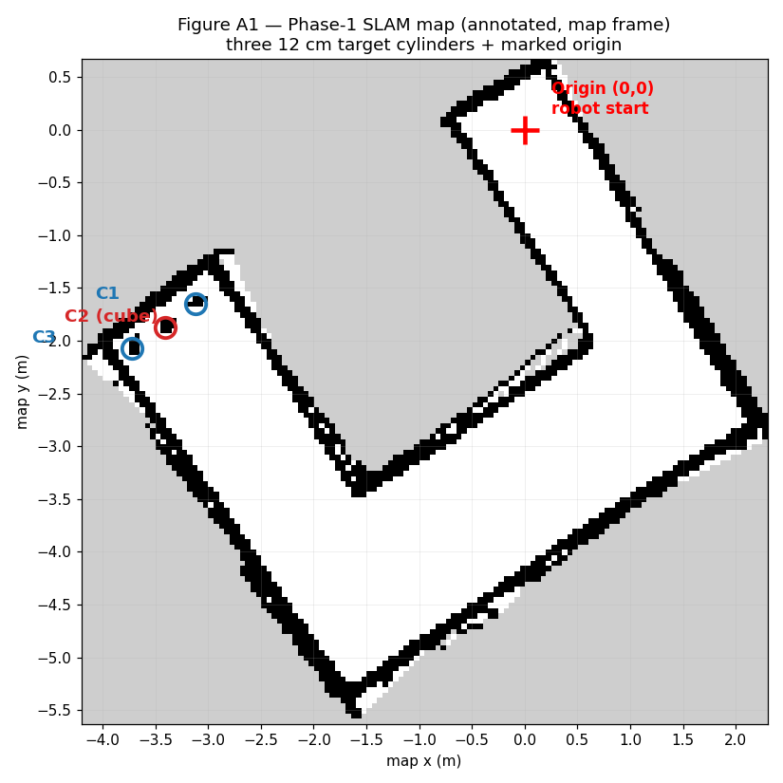
Figure A1 — Phase-1 SLAM occupancy map (map frame). Three 12 cm cylinders (C1–C3) circled at the far corner; origin marked at the robot start.

2.2 Cube Position from Phase 2
At the detection instant the node logged the robot pose, not the cube: (x, y) = (0.265, -3.747) m, yaw = 177.4°. The robot stopped short of the cube, so the cube position must be obtained by projecting forward by the robot→cube offset.
Offset estimate (with evidence). Two independent log channels fix the offset. (i) LiDAR: the stop condition fired at Arrived at cube — front = 0.30 m, i.e. the cube face is 0.30 m directly ahead. (ii) Camera: the bearing was offset = 3.0 px, bear = 0.49° — the cube is essentially dead-ahead, so the offset is a pure forward translation along the robot heading with negligible lateral component. I therefore use a 0.30 m forward offset along yaw:
x_cube = 0.265 + 0.30·cos(177.4°) = 0.265 - 0.2997 = -0.035 m
y_cube = -3.747 + 0.30·sin(177.4°) = -3.747 + 0.0136 = -3.733 m
Phase-2 cube estimate (odom frame): (-0.035, -3.733) m. (If the cylinder radius 0.06 m is added to reach the cylinder centre rather than its face, the estimate shifts to ≈ (-0.095, -3.730) m; I report the directly-measured face value and treat the 0.06 m as a known systematic bias discussed below.)

2.3 Final Error
Because the Phase-2 odometry frame was reset at the start of the autonomous run, it was rotated relative to the Phase-1 SLAM map frame. Therefore, the two positions were first co-registered using the Phase-2 trajectory. After applying a rotation of approximately 60.2°, the map-derived cube position in the odometry frame was: (-0.070,-3.890)m, The Phase-2 cube estimate from Section 2.2 was: (-0.035, -3.733) m, Therefore, the localisation error is:
根号x1+x2的平方加上y1+y2的平方
error = √( (-0.035)² + (-0.157)² ) = √(0.00123 + 0.02465) = √0.02588
≈ 0.16 m

The final error is therefore approximately 0.16 m. This is smaller than the 0.36–0.37 m spacing between neighbouring cylinders, so the cube was still correctly identified as C2. The remaining error is mainly caused by the 0.06 m face-to-centre offset, wheel odometry drift, and the 0.05 m/px SLAM map resolution. Appendices A


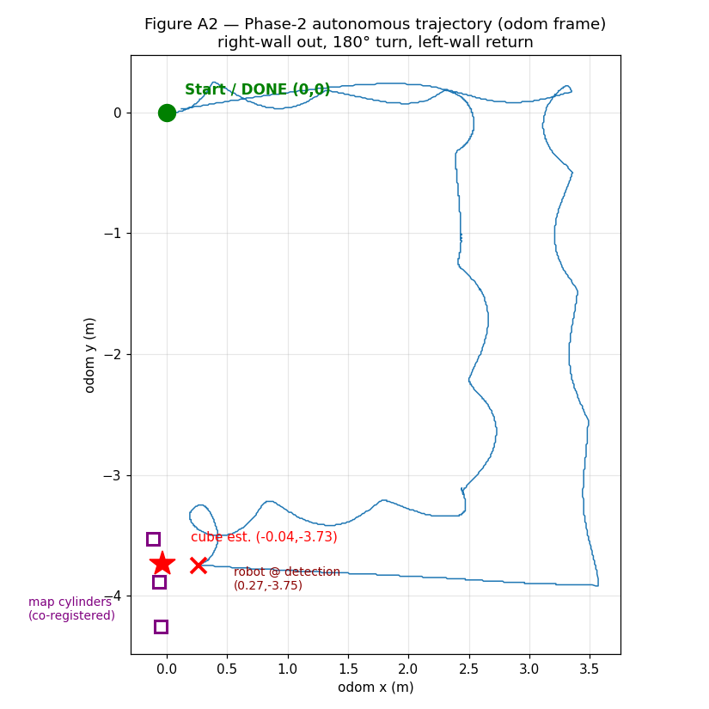
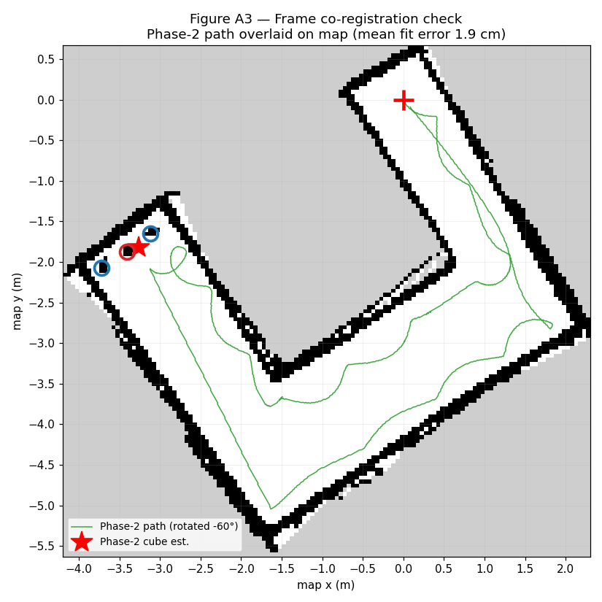
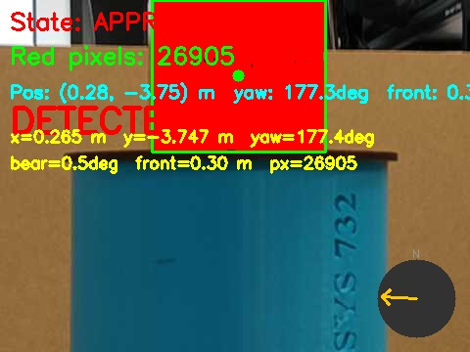
Figure A4 —Saved detection image showing the red cube.

Appendix B — Key timeline from run_log_2.txt
Event | t (s) | Pose / value
Node start — SEARCHING | 0.0 | (0.00, 0.00)
Cube detected → APPROACHING | 85.9 | blob ≈ 349 px
Arrived at cube; pose logged + image saved | 130.2 | (0.265, -3.747), 177.4°
180° turn complete → RETURNING | 136.6 | dist_to_origin 3.75 m
Arrived at origin — DONE | 285.9 | (0.112, 0.025), err 0.115 m

