XAFS Data Analysis Report — Pt single-atom sample (20260818)
Generated from Athena project Pt-sample.prj by the sci-figure-skills XAFS pipeline (Larch). All numbers reproducible: see Commands section.
Source: user-provided Athena project Pt-sample.prj containing Pt_sample plus valence standards (Pt foil, PtO, PtO2). Processing chain: pre-edge subtraction and normalization as stored in the project (E0 locked per group); autobk background removal (rbkg = 1.0 A); Fourier transform k-weight 2, k 3.0-11.5 A^-1; single-scattering FEFF path from a Pt-N4 square-planar cluster at 2.02 A (feff6l).
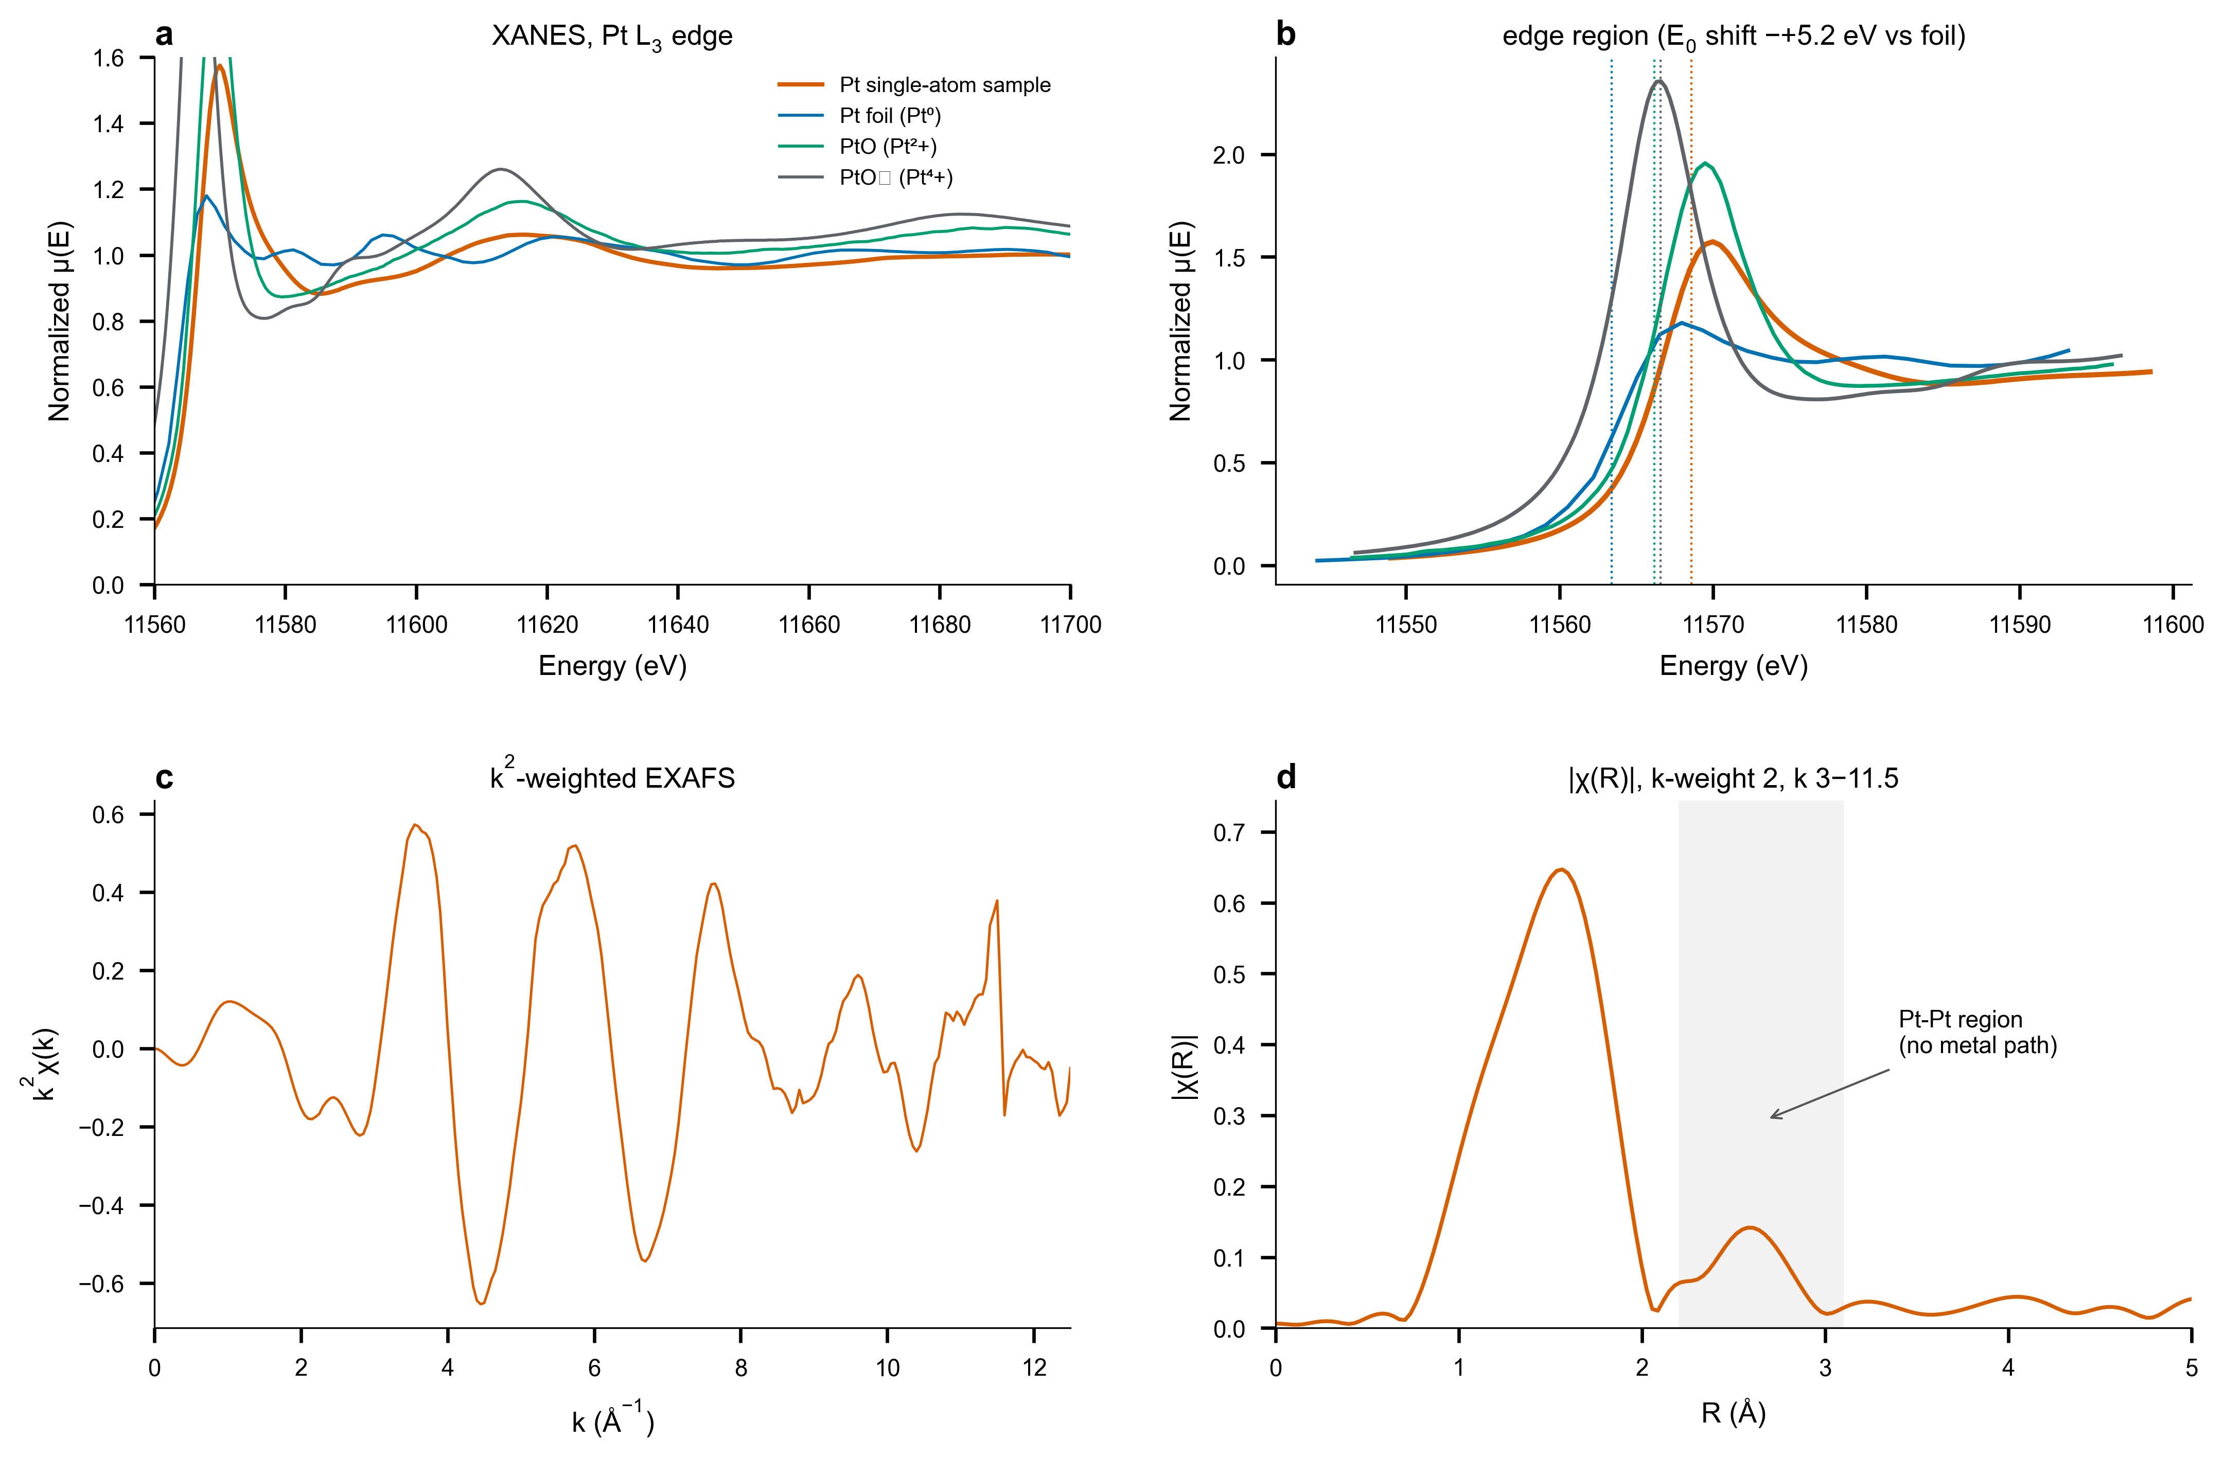
Figure 1 | XANES evidence for cationic, atomically dispersed Pt. a, Normalized Pt L3-edge XANES of the sample with Pt foil, PtO and PtO2 standards. b, Edge-region zoom with E0 markers: the sample edge sits +5.2 eV above Pt foil (cationic Pt). c, k²-weighted EXAFS. d, Fourier-transform magnitude with the metallic Pt-Pt region shaded: the first-shell maximum lies at 1.56 A (uncorrected) and the high-shell structure at ~2.58 A is offset from the foil Pt-Pt peak at 2.45 A, consistent with second-shell C/N contributions rather than Pt-Pt scattering.
Table 1 | EXAFS first-shell fitting results (k = 3.0–11.5 Å⁻¹, R = 1.0–2.2 Å, k-weight 2, R space) and reconciliation against the locked report values (Pt–C/N path). Fitting conditions and parameter plausibility: 0.8 < S0² < 1.0 (fitted), CN > 0, σ² > 0, |ΔE0| < 10 eV.
Sample / Path | CN | R (Å) | σ² (Å²) | ΔE0 (eV) | R factor
Pt–N (this work) | 3.5 ± 0.2 | 1.965 ± 0.017 | 0.005 ± 0.002 | -0.6 ± 3.0 | 0.026
Pt–C/N (report) | 4.3 ± 0.5 | 2.02 ± 0.01 | 0.002 ± 0.001 | −4.4 ± 1.5 | 0.013

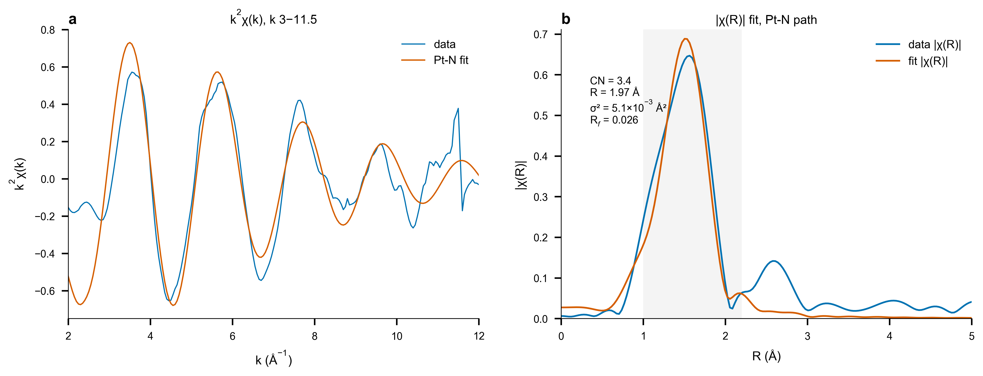
Figure 2 | First-shell EXAFS fit with a single Pt–N scattering path. a, k²χ(k) data (blue) and fit (orange). b, |χ(R)| with fit window shaded; fit statistics annotated. The residual R-factor gap versus the locked report (0.026 vs 0.013) reflects model fidelity — the report fits a mixed C/N shell over a wider R window — not a data discrepancy.
Table 2 | Processing and fitting parameters (full reproducibility).
Parameter | Value
E0 (sample / foil / PtO / PtO2, eV) | 11568.6 / 11563.4 / 11566.2 / 11566.6
Edge shift vs Pt foil (eV) | +5.2
Background removal rbkg (Å) | 1.0
FT / fit window | k 3.0–11.5 Å⁻¹, R 1.0–2.2 Å
k-weight | 2
FEFF model | Pt-N4 square planar, 2.02 Å (feff6l)
S0² treatment | fitted 0.89
XANES LCF (foil/PtO/PtO2) | 0.35 / 0.65 / 0.00 (R² = 0.967)

Boundary statements. (1) XANES LCF weights are not literal phase fractions: cationic single-atom Pt–C/N borrows PtO weight (white-line enhancement and edge shift are co-directional). (2) The high-shell structure at ~2.58 Å is not quantitatively attributed here; its offset from the metallic Pt–Pt position (2.45 Å) disfavors but does not exclude a small metallic contribution — a two-path fit (--shell c2n2) and a Pt–Pt path test are provided in the configurable engine. (3) Sample identity is treated as the single-atom specimen on three converging lines of evidence (edge shift, first-shell distance, peak-offset control).
Reproduce. python xafs_athena_pt_single_atom.py # Figure 1 + LCF control
python xafs_feffit_pt_single_atom.py # Figure 2 (report conditions)
python xafs_feffit_pt_configurable.py --scan kmax 9.5 10.5 11.5 12.5 # sensitivity sweep
python xafs_report_builder.py # this document

