|  |  |  |  |  |
| --- | --- | --- | --- | --- |
| |  | | --- | | **Siri Maley** | | RadPiper-01_0253_42CalVer_2019-03-20-12-57-08.zipMar 28, 2019, 10:16 PM (21 hours ago) |  | IMG_257  IMG_258 |
| |  | | --- | | to me  IMG_259 | | | |

That'd be great, maybe it'll be something simple with fresh eyes. I'm gonna toss you a couple files of a random bag here, all you need is the spectrum in qc\_spectrum (2048 | separated values in the "counts" header for "start" and "end" QC checks). Heather is implementing [findpeaksG.m from PeakFinder from here](https://terpconnect.umd.edu/~toh/spectrum/PeakFindingandMeasurement.htm" \t "/home/yyhu/Documents\\x/_blank) in [her python code here (GitHub)](https://github.com/PipeDreamRobotics/Post-Processing/blob/master/RadProcessing/peak_finder.py" \t "/home/yyhu/Documents\\x/_blank). I've forgotten how much you like or dislike Matlab, but if you have it installed, first step is just a matter of calling the function with the parameters listed in the GitHub code. (It's not clear what "smoothtype" best matches but any is acceptable if it works.) We're looking for the start QC spectrum's full width at half max = 5.4987 and end = 4.2231 (and few sig digits is fine). It might be ok to be off by a constant factor depending on what it is, right now I don't even have that going for me so I'd love it if you're off by a constant.

I think findpeaksG is supposed to output the FWHM directly, though for reference the rule USDOE approved just says this:

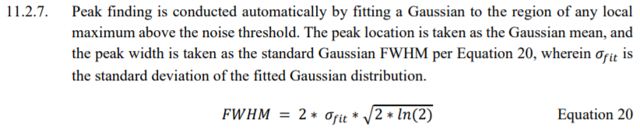

Thank you so much for stepping in again. I can't believe we're still doing this...