TECHNICAL PROPOSAL
Phase 2 — Technical Submission

Team / Project Name | Connect — On-device Vietnamese→English simultaneous speech translation
Submission Date | 21 / 08 / 2026
Version | v1.1
Confidentiality | Restricted — Challenge Review Only

Evaluation Criteria & Scoring Rubric

Read this before writing your proposal. Every section you complete maps to one or more criteria below.

Criterion | Weight | What Judges Look For
1. AI Approach & Technical Design | 35% | Pipeline completeness, model choices, on-device optimisation strategy, accuracy targets and evaluation plan
2. Hardware & Device Concept | 25% | Platform justification, BOM feasibility, power budget, form-factor suitability for the target environment
3. Business Solution | 15% | How the solution addresses the industry gap, differentiation from existing tools, innovation strength, real-world applicability
4. Problem Definition & Impact | 15% | Clarity of problem, real-world relevance, target user insight, design constraints identified
5. Team and Execution Plan | 10% | Complementary skills, realistic timeline, milestone feasibility  Early demo is a plus
TOTAL | 100%

📌 Your proposal is evaluated holistically. Strong AI design cannot compensate for missing business differentiation or weak hardware justification. Aim for depth and specificity in every section.
1. Executive Summary

Provide a 200–300 word overview of your entire proposal — the first section judges read.

📌 Cover: (1) the communication problem, (2) your solution and its business case, (3) target users, (4) key technical differentiator. 3–4 short paragraphs.

1.1 Problem Overview

Vietnamese speakers face a daily real-time communication gap with English speakers: travellers, business teams, clinicians, and emergency responders cannot hold fluid conversations across the language divide. Cloud translation apps need connectivity, add multi-second round trips, and upload private conversations to remote servers. Turn-based tools force users to speak, stop, and wait, breaking conversational rhythm, and their synthetic voices erase the speaker's identity. What is needed is translation that begins while the speaker is still talking, works fully offline, and preserves the speaker's voice. Kyutai's Hibiki-Zero is the first open model to make simultaneous speech-to-speech translation possible; our project makes it run entirely on phones with Vietnamese supported.

1.2 Proposed Solution

Connect is a free, open-weight system for offline simultaneous speech-to-speech translation. Today, the repository includes a native macOS POC that runs file and live-microphone inference through our Apple Silicon MLX engine. A separate native MLX Swift mobile POC runs the 1B French-to-English path without a network inference service. The next gated step is to qualify Vietnamese on the 3B teacher, distil it into a 1B mobile artifact, and measure it on Apple and Qualcomm phones. At runtime, no conversation audio needs to leave the device.

1.3 Key Value Proposition

• Offline and private: the current Mac POC runs locally; the native mobile path has no network inference service.
• Simultaneous, not turn-based: Hibiki advances at 12.5 Hz, with one 80 ms model frame at a time.
• Open data contribution: 696,243 VI-source / EN-target voice-and-text pairs are public; the duration-filtered Mimi cache contains 694,422 rows and 1,114 Vietnamese hours.
• Voice data with explicit provenance: about 357,000 pairs (roughly 51%) carry cross-lingual timbre-match metadata; full voice preservation remains a release gate.
• Measured headroom: the 1B q4 model runs 4.1× real-time on an M4 Pro at 15.06 ms per 80 ms LM frame; phone performance remains to be measured.

2. Problem Definition & Target Users

↗ Scoring weight: 15% — Problem Definition & Impact

2.1 Problem Statement

The people most affected are those who must communicate now, in person, without reliable internet: Vietnamese staff working with English-speaking supervisors on factory floors, travellers navigating airports and hospitals, clinicians treating foreign patients, and responders in emergencies. Real-time matters because conversation is turn-taking; a tool that waits for a full sentence, uploads it, and returns audio seconds later destroys the natural flow and fails in exactly the environments (rural sites, roaming, aircraft, crisis zones) where it is needed most. Current solutions fail on three axes at once: connectivity (cloud-required), latency (multi-second round trips plus turn-based interaction), and trust (private audio sent to third-party servers). An on-device simultaneous translator removes all three failure modes simultaneously.

2.2 Impact Analysis

Impact Area | Current Pain Point | Consequence
Safety / Operations | Misunderstood verbal safety or medical instructions between Vietnamese speakers and English-speaking staff | Workplace incidents, compliance failures, delayed emergency response
Productivity | Turn-based translation apps force stop-and-wait cycles in meetings and support | Conversations take 2–3× longer; misinterpretation causes rework
Connectivity | Cloud translation unusable offline — rural sites, aircraft, roaming, crisis zones | No working tool exactly where the conversation happens

2.3 Target Users & Use Cases

User Segment | Language Need | Primary Context | Priority
Travellers and tourists | VI → EN | Airports, hotels, transport, street navigation | Critical
Business and manufacturing teams | VI → EN | Factory floors, site visits, client meetings | Critical
Healthcare and emergency responders | VI → EN | Clinics, triage, emergency response | High

2.4 Key Design Constraints

Constraint | Target / Requirement
Internet dependency | Zero — fully offline at runtime
End-to-end translation latency | Streaming 80 ms compute frames; English text/audio begins ~2–3 s behind the speaker
Target deployment environment | Everyday mobile use — travel, workplace, public spaces; standard handheld phone form factor
Language pairs required | VI → EN at launch (FR/ES/PT/DE → EN retained from upstream); further pairs via the same recipe
Additional constraints | ≤3 GB spare RAM for the 1B model (any ≥8 GB device qualifies); voice preservation; iOS and Android

3. Business Solution & Innovation

↗ Scoring weight: 15% — Business Solutions

3.1 Industry Problem & Solution Fit

Google Translate (conversation mode) and cloud meeting translators such as Microsoft Teams interpreter represent today's state of the art — and share three failure modes. First, connectivity: audio is uploaded for processing, so they fail offline and in low-bandwidth environments. Second, latency: cloud round trips add multiple seconds and the interaction is turn-based, not simultaneous. Third, privacy and cost: every conversation minute is sent to third-party servers and carries a marginal cloud cost. Connect addresses each gap directly: the entire Hibiki-Zero pipeline runs locally on phone GPUs/NPUs, translation streams at 12.5 Hz while the speaker is still talking, generated English preserves the source speaker's timbre, and the marginal cost per conversation minute is zero because there is no server.

3.2 Innovation & Competitive Strengths

Dimension | Existing Solutions | Your Solution
Connectivity | Cloud-required; fails in offline or low-bandwidth environments | Fully offline — no internet required at runtime
Latency | >5 s cloud round trip; turn-based speak-stop-wait interaction | Simultaneous streaming; English begins ~2–3 s behind the speaker
Domain Accuracy | Generic sentence-by-sentence MT; no true speech-to-speech, no voice preservation | End-to-end S2ST; measured 1B FR→EN gate: BLEU 28.4 (n=30). VI→EN is under qualification on the public 1,114 h cache.
Data Privacy | Audio and text transmitted to external cloud servers | All processing on-device; no data leaves the hardware

📌 Be specific — vague claims like "faster" or "more accurate" score low. Quantify the gap: e.g., "Cloud apps return in >5 s; our solution in <3 s at zero connectivity."

Connect's core innovation is making a frontier simultaneous speech-to-speech model run on consumer devices: we ported Hibiki-Zero from its NVIDIA-only reference stack to Apple Silicon, cut the 3B model from 5.8 GB to about 2.2 GB with q4 quantisation, and reached about 3× real-time through a three-stage CPU/GPU scheduler. We also published the Vietnamese adaptation substrate: paired speech, Mimi codebooks, CTC-timed English text, explicit end boundaries, frozen receipts, and failed-run evidence. This reduces duplicated data work and lets the community test, correct, and extend the same training boundary.
3.3 Open Data Contribution & Community Call
OPEN DATA RELEASE — READY TO USE
Published now: 696,243 VI-source / EN-target voice-and-text pairs (about 1,228 VI hours before filtering); 694,422 Mimi-cached rows / 1,114 VI hours after the duration filter; and 690,067 grounded-v2 PhoMT rows with CTC-timed English text plus EOS and explicit Vietnamese codec EOS. About 357,000 pairs, or roughly 51%, carry timbre-match metadata. We do not label the unmatched half as voice preserving.
Resources: speech pairs · grounded-v2 CTC-aligned Mimi cache · source and experiment records
CALL TO ACTION: Use the public cache instead of repeating the 34-day data and Mimi-preprocessing campaign. Audit licenses and provenance, add licensed multi-speaker hours or verified timbre matches, and publish reproducible results and corrections through the source repository.

4. AI Approach & Technical Design

↗ Scoring weight: 35% — Highest weighted criterion

4.1 System Pipeline Overview

Describe your end-to-end AI pipeline and justify each stage. Include a pipeline diagram in your final submission.

Connect uses Kyutai's end-to-end hierarchical Transformer rather than a cascaded ASR→MT→TTS chain, eliminating cascade error accumulation and stacked latency. One 80 ms frame of processing: (1) the Mimi encoder converts 24 kHz source PCM into audio codebooks (CPU thread); (2) the main Transformer (1B production / 3B teacher, q4-quantised) fuses source codebooks, previously generated audio, and text feedback into one hidden state (GPU/NPU); (3) a text head emits English tokens and a depformer codebook head emits target-audio codebooks; (4) the Mimi decoder reconstructs English speech (CPU thread). Encoder, LM, and decoder run as three concurrent state machines joined by ordered queues — overlapping CPU and GPU work moved the 3B path from 1.35× to 3.0× real time with no model approximation. Generated codebooks feed back autoregressively, which is what makes the translation simultaneous rather than turn-based.
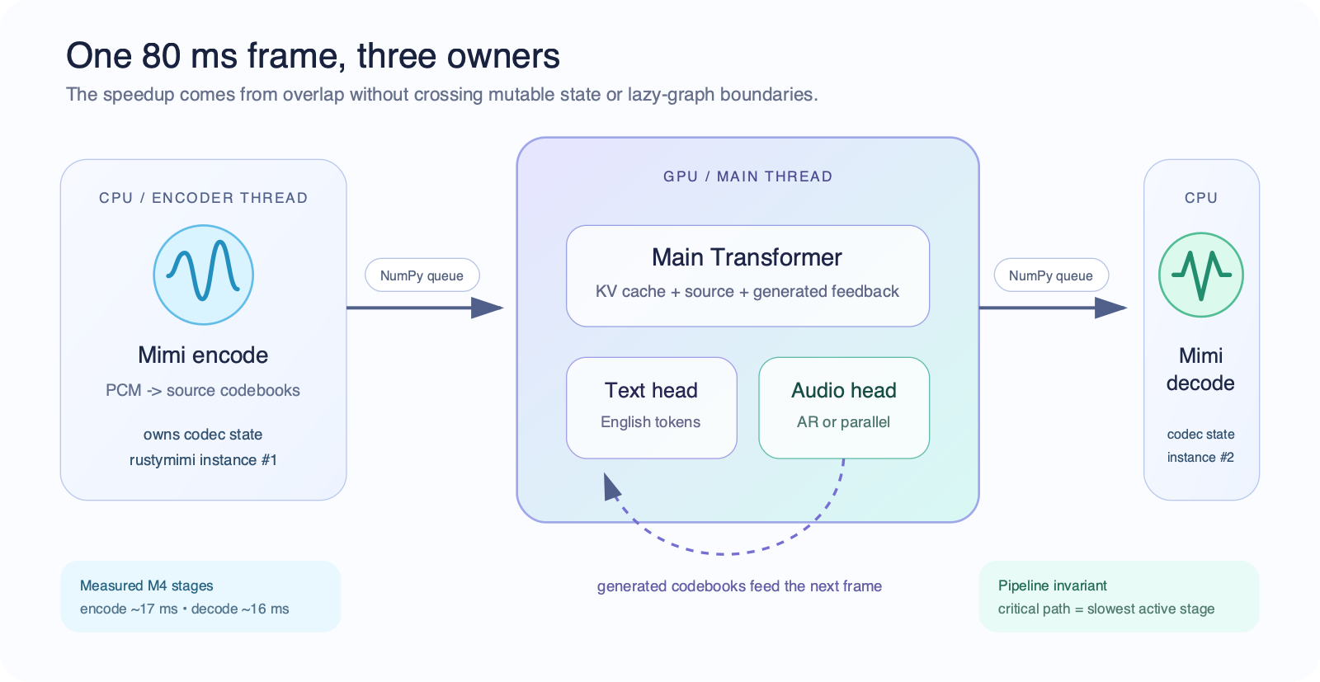
Figure 1 — Streaming architecture: one 80 ms frame, three owners (measured M4 stages: encode ~17 ms, decode ~16 ms).

4.2 Module-by-Module Design

Module | Model / Framework | Size (est.) | Latency Target | Key Technique
Audio codec (input) | Mimi neural codec (rustymimi / MLX Swift) | ~150 MB | ~17 ms/frame (M4) | Streaming 12.5 Hz at 24 kHz; one tokenizer per thread
S2ST backbone | Hibiki-M 1B Transformer, q4 group-32 | 1.13 GB artifact | 15.06 ms LM frame (M4); ~30 ms projected on phone | q4 quantisation, capped KV cache, compiled fixed-shape steps
Codebook head | AR depformer (parallel head in R&D) | included in artifact | 7.02 ms (M4); parallel variant 5.28 ms (−58%, smoke) | Per-codebook projections; parallel head predicts all codebooks in one pass
Audio codec (output) | Mimi decoder | shared runtime | ~16 ms/frame (M4) | Pipelined overlap with encoding; NumPy queue handoff

4.3 On-Device Optimisation & Memory Management

All weights ship as 4-bit quantised safetensors (group size 32 — the stock MLX/Swift loader contract, verified by a strict 7/7 reload-compatibility gate). The 1B artifact is 1.13 GB on disk with ~1.8 GB peak runtime memory; the 3B teacher was reduced from 5.8 GB bf16 to 2.41 GB. Memory stays bounded by capping the KV cache at the model's true attention context (live-window memory cut from 537 MB to 66 MB on the 1B model), streaming 80 ms frames instead of buffering whole utterances, and running codec encode/decode on CPU worker threads so only one model instance is ever resident. Target RAM ceiling: ≤3 GB of spare memory for the 1B model — satisfied by any ≥8 GB-RAM device (iPhone 15 Pro/16 class, Snapdragon 8 Gen 3 flagships), leaving the operating system ample headroom.

4.4 Robustness & Edge Case Handling

(a) Acoustic: the model consumes raw 24 kHz PCM through the Mimi codec; device capture uses the OS audio stack, and headphone or half-duplex modes control speaker-to-microphone feedback.
(b) Linguistic: the current 719,120-row training receipt uses 683,164 unique PhoMT rows plus repeated FLEURS sampling. About 51% of PhoMT has timbre-matched targets. The next recipe applies target-audio loss only to verified matches and keeps text loss on other valid pairs.
(c) Generation: silence-tail handling prevents truncated endings, while correct-source free-running gates measure nonempty output, EOS, repetition, length, content, audio quality, and speaker similarity. A checkpoint cannot ship on teacher-forced loss alone.
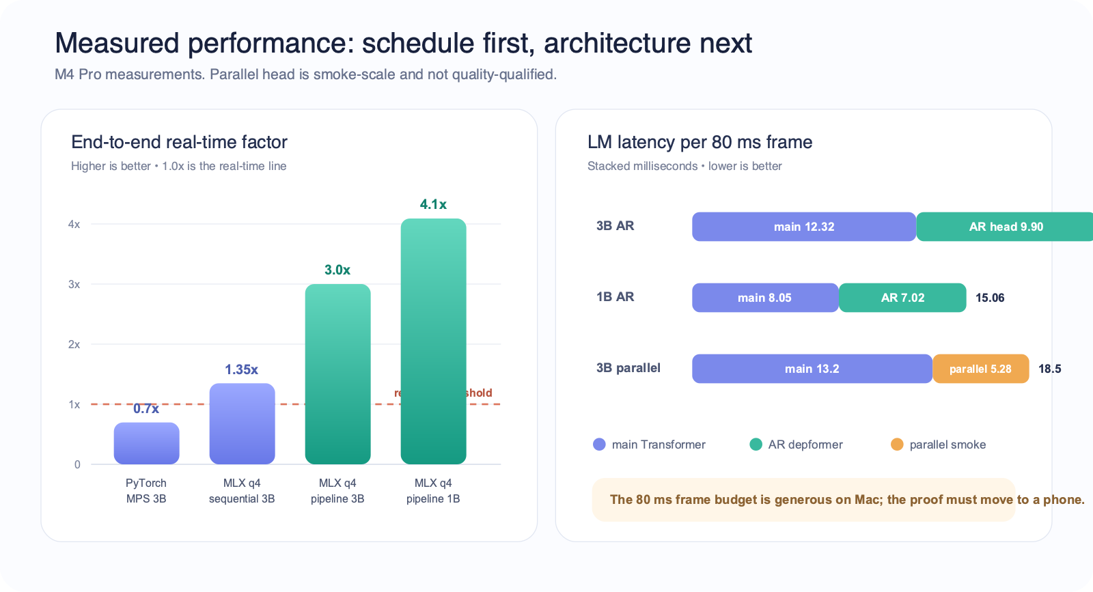
Figure 2 — Measured performance on M4 Pro: end-to-end real-time factor and per-frame LM latency.

5. Hardware & Device Concept

↗ Scoring weight: 25% — Hardware & Device Concept

5.1 Platform Selection & Justification

Compare at least one SoC / compute platform options and justify your choice.

Criteria | Apple A17/A18 (iPhone 15 Pro+) | Snapdragon 8 Gen 3 (Android flagship) | Selected?
NPU Performance (TOPS) | ~35 TOPS Neural Engine + GPU (MLX-native) | ~45 TOPS HTP + Adreno GPU | Both qualify
Power Consumption (TDP) | ~4–5 W sustained SoC package during inference | ~5–7 W sustained | Both qualify
RAM / Storage Support | 8 GB unified memory, ≥128 GB storage | 12–16 GB LPDDR5X, 256 GB UFS 4.0 | Both qualify
AI SDK / Toolchain | MLX Swift / Core ML — proven in our native iOS prototype | Qualcomm QNN / AI Hub official conversion path | Both qualify
Form Factor Suitability | Standard handheld phone; no custom hardware | Standard handheld phone; no custom hardware | Both qualify

We use a dual-platform strategy with one hard requirement: enough memory for the accepted 1B artifact and the operating system. Apple is the primary path because the runtime is MLX-native and the public Hibiki Edge POC implements a clean MLX Swift graph plus offline 1B FR→EN file translation. This establishes the native architecture, but it does not yet provide a physical-iPhone speed, memory, battery, or thermal receipt. Qualcomm is the Android path through QNN and AI Hub after the Vietnamese 1B artifact passes quality gates. The product uses a standard phone; no custom hardware is required.

5.2 Key Hardware Components & Power Budget

Component | Specification | Peak Power | Notes
SoC | Apple A17 Pro or Snapdragon 8 Gen 3 (≥8 GB RAM) | ~5.0 W | GPU/NPU active, 1B q4 inference
Microphone | Device MEMS, 16–24 kHz | ~0.05 W | OS AEC/noise-suppression pipeline
Speaker / Audio Out | Device speaker or wired/BT headphones | ~0.3 W | 24 kHz playback
Battery | Phone battery (≥3,000 mAh) | — | Target: >4 h continuous translation at <2 W average system draw
Storage | Model artifact 1.13 GB + app <200 MB | ~0.1 W | Downloaded once; runs offline
Display | Device OLED (live transcript UI) | ~0.4 W
Total System Budget |  | ~6 W peak | Well within phone thermal envelope; no custom BOM required

6. System Architecture & Integration

↗ This section bridges your AI pipeline (Section 4) and your hardware platform (Section 5). Judges assess whether the software and hardware layers work coherently as a complete system.

6.1 Software Stack

Layer | Component / Framework | Role
OS | iOS 17+ / Android 14+ | Base runtime & audio I/O
AI Runtime | MLX Swift (Apple) / Qualcomm QNN + ONNX Runtime (Android) | On-device model execution
Audio Processing | OS audio stack: AVAudioSession / AAudio with AEC-NS | Capture, playback, echo & noise handling
Model Serving | HibikiCore (MLX Swift) / QNN compiled graphs | Streaming S2ST inference, KV-cache state
App Layer | SwiftUI / Kotlin | App UI, session control, transcript display

6.2 System Architecture



Figure 3 — Connect system architecture: Mimi encode → Transformer (text + audio heads) → Mimi decode, pipelined across CPU and GPU threads.

6.3 Offline-First Design Principles
Offline-first principles:
- All AI models stored on-device; no API calls at runtime — full inference works in airplane mode
- Language packs are downloadable artifacts (1B q4 ≈ 1.13 GB); VI→EN preloaded on first setup
- Bounded KV caches and streamed 80 ms frames keep memory flat and p99 frame compute inside the 80 ms budget
- Fail-safe output: if audio generation degrades, the English text stream still renders as live subtitles
6.4 Working Prototypes & Demo Evidence
Two working POCs cover the desktop integration boundary and the native mobile architecture boundary.
Prototype | Current evidence | Scope and public link
Desktop — macOS | Repository-built SwiftUI shell; local file and live-microphone workflows through the Python/MLX engine. | Integration POC. The shown VI checkpoint is research-only and not production qualified.
Mobile — iOS | Hibiki Edge: independent HibikiCore MLX Swift runtime and SwiftUI app; offline 1B FR→EN file translation without Python or a network inference service. | Architecture POC; VI artifact and physical-device receipt remain open. Public GitHub repository
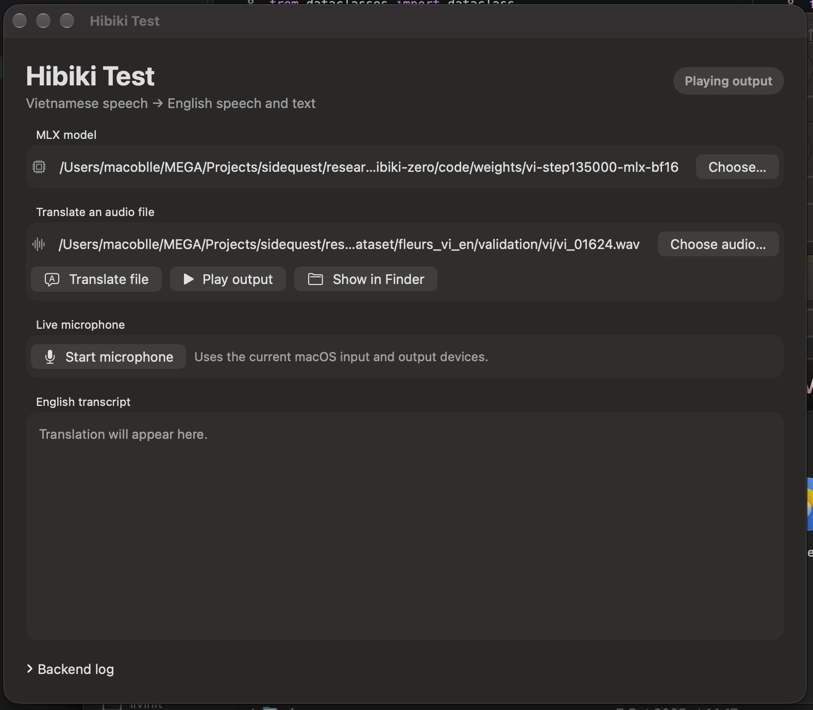
Figure 4 — Native macOS desktop POC. Open the attached 16-second live-microphone recording (MOV)

7. Team Profile & Project Timeline

↗ Scoring weight: 10% — Team and Execution Plan

7.1 Team Members

Name | Role | Expertise | Contribution Area
Nguyen Huy Hoang Huy | Team Lead | ML systems, on-device inference (MLX/CUDA), speech-model training | Apple Silicon runtime port, q4 quantisation, Vietnamese SFT program
Quach Thoai An | ML Engineer | Data engineering, TTS/speech synthesis, mobile deployment | 696k-pair speech dataset campaign, native iOS MLX Swift prototype

7.2 Project Status & Next Gated Plan

Stage | Milestone | Key activities and exit gate | State
Complete | Apple runtime & desktop POC | q4 MLX, three-stage scheduler, measured M4 headroom, file and live-microphone shell | Done
Complete | Open data & native mobile POC | Publish paired speech and grounded Mimi caches; prove the 1B FR→EN graph in native MLX Swift | Done
1 | Data scale-up | Validate the scripted-English pipeline on a 1k h tranche, then scale total VI source speech toward 40k h; verify timbre, QA, dedupe, and holdouts | Next
2 | Controlled supervised SFT | Train the upstream-start 3B model; keep domains separate; validate every 3k steps; promote only with correct-source free-running gates | Gate: qualified 3B
3–4 | Voice-matched fine-tune + GRPO | Apply audio loss only to verified matches; run 1–2k fine-tune steps, then 500–1000 initial GRPO updates; hold EOS, repetition, content, and speaker gates | Gate: VI parity
5 | Mobile qualification | Distil the accepted VI teacher into 1B, train and quantise the parallel head, then record p99 <80 ms, memory, battery, and 30-minute thermals on Apple and Qualcomm devices | Gate: release
Detailed plan: vi_en_parity_plan.md. Phases run in order; no Vietnamese mobile release claim is made before the quality and device gates pass.

8. Submission Checklist

All items must be completed before final submission. Missing sections score zero on the relevant rubric criterion.

# | Checklist Item | Status
1 | Executive Summary written (200–300 words) | [x] Done
2 | Problem Statement, Target Users, and Design Constraints completed | [x] Done
3 | Business Solution completed — industry gap, solution fit, and competitive differentiation described | [x] Done
4 | AI pipeline documented with model specs, latency targets, and optimisation strategy | [x] Done
5 | Hardware platform justified; form factor, BOM and power budget filled in | [x] Done
6 | Team profiles and project timeline filled in | [x] Done
7 | All placeholder text replaced; pipeline/architecture diagram inserted (Section 6.2) | [x] Done
8 | Desktop demo video and desktop/mobile prototype evidence attached or linked; PDF export pending | [x] Done

