TECHNICAL PROPOSAL
Phase 2 — Technical Submission

Team / Project Name | Connect — On-device Vietnamese→English simultaneous speech translation
Submission Date | 21 / 08 / 2026
Version | v1.2
Confidentiality | Restricted — Challenge Review Only

Evaluation Criteria & Scoring Rubric

Read this before writing your proposal. Every section you complete maps to one or more criteria below.

Criterion | Weight | What Judges Look For
1. AI Approach & Technical Design | 35% | Pipeline completeness, model choices, on-device optimisation strategy, accuracy targets and evaluation plan
2. Hardware & Device Concept | 25% | Platform justification, BOM feasibility, power budget, form-factor suitability for the target environment
3. Business Solution | 15% | How the solution addresses the industry gap, differentiation from existing tools, innovation strength, real-world applicability
4. Problem Definition & Impact | 15% | Clarity of problem, real-world relevance, target user insight, design constraints identified
5. Team and Execution Plan | 10% | Complementary skills, realistic timeline, milestone feasibility  Early demo is a plus
TOTAL | 100%

📌 Your proposal is evaluated holistically. Strong AI design cannot compensate for missing business differentiation or weak hardware justification. Aim for depth and specificity in every section.
1. Executive Summary

Provide a 200–300 word overview of your entire proposal — the first section judges read.

📌 Cover: (1) the communication problem, (2) your solution and its business case, (3) target users, (4) key technical differentiator. 3–4 short paragraphs.

1.1 Problem Overview

Vietnamese speakers face a daily real-time communication gap with English speakers: travellers, business teams, clinicians, and emergency responders cannot hold fluid conversations across the language divide. Cloud translation apps need connectivity, add multi-second round trips, and upload private conversations to remote servers. Turn-based tools force users to speak, stop, and wait, breaking conversational rhythm, and their synthetic voices erase the speaker's identity. What is needed is translation that begins while the speaker is still talking, works fully offline, and preserves the speaker's voice. Kyutai's Hibiki-Zero is the first open model to make simultaneous speech-to-speech translation possible; our project makes it run entirely on phones with Vietnamese supported.

1.2 Proposed Solution

Connect is a free, open-weight system for offline simultaneous speech-to-speech translation. Today, the repository includes a native macOS POC that runs file and live-microphone inference through our Apple Silicon MLX engine. A separate native MLX Swift mobile POC runs the 1B French-to-English path without a network inference service. The next gated step is to qualify Vietnamese on the 3B teacher, distil it into a 1B mobile artifact, and measure it on Apple and Qualcomm phones. At runtime, no conversation audio needs to leave the device.

1.3 Key Value Proposition

• Offline and private: the current Mac POC runs locally; the native mobile path has no network inference service.
• Simultaneous, not turn-based: Hibiki advances at 12.5 Hz, with one 80 ms model frame at a time.
• Open data contribution: 696,243 VI-source / EN-target voice-and-text pairs are public; the duration-filtered Mimi cache contains 694,422 rows and 1,114 Vietnamese hours.
• Voice data with explicit provenance: about 357,000 pairs (roughly 51%) carry cross-lingual timbre-match metadata; full voice preservation remains a release gate.
• Measured headroom: the 1B q4 model runs 4.1× real-time on an M4 Pro at 15.06 ms per 80 ms LM frame; phone performance remains to be measured.

2. Problem Definition & Target Users

↗ Scoring weight: 15% — Problem Definition & Impact

2.1 Problem Statement

The people most affected are those who must communicate now, in person, without reliable internet: Vietnamese staff working with English-speaking supervisors on factory floors, travellers navigating airports and hospitals, clinicians treating foreign patients, and responders in emergencies. Real-time matters because conversation is turn-taking; a tool that waits for a full sentence, uploads it, and returns audio seconds later destroys the natural flow and fails in exactly the environments (rural sites, roaming, aircraft, crisis zones) where it is needed most. Current solutions fail on three axes at once: connectivity (cloud-required), latency (multi-second round trips plus turn-based interaction), and trust (private audio sent to third-party servers). An on-device simultaneous translator removes all three failure modes simultaneously.

2.2 Impact Analysis

Impact Area | Current Pain Point | Consequence
Safety / Operations | Misunderstood verbal safety or medical instructions between Vietnamese speakers and English-speaking staff | Workplace incidents, compliance failures, delayed emergency response
Productivity | Turn-based translation apps force stop-and-wait cycles in meetings and support | Conversations take 2–3× longer; misinterpretation causes rework
Connectivity | Cloud translation unusable offline — rural sites, aircraft, roaming, crisis zones | No working tool exactly where the conversation happens

2.3 Target Users & Use Cases

User Segment | Language Need | Primary Context | Priority
Travellers and tourists | VI → EN | Airports, hotels, transport, street navigation | Critical
Business and manufacturing teams | VI → EN | Factory floors, site visits, client meetings | Critical
Healthcare and emergency responders | VI → EN | Clinics, triage, emergency response | High

2.4 Key Design Constraints

Constraint | Target / Requirement
Internet dependency | Zero — fully offline at runtime
End-to-end translation latency | Streaming 80 ms compute frames; English text/audio begins ~2–3 s behind the speaker
Target deployment environment | Everyday mobile use — travel, workplace, public spaces; standard handheld phone form factor
Language pairs required | VI → EN at launch (FR/ES/PT/DE → EN retained from upstream); further pairs via the same recipe
Additional constraints | ≤3 GB spare RAM for the 1B model (any ≥8 GB device qualifies); voice preservation; iOS and Android

2.5 User Workflow and Acceptance Conditions
The product flow has four steps. First, the user installs one signed application and downloads a language pack once. Second, the user selects Vietnamese-to-English, chooses the microphone or a local audio file, and can then put the phone in airplane mode. Third, the application captures short PCM blocks and shows partial English text while it plays generated English audio. Fourth, the user stops the session and can review or export the local transcript. The application does not require an account, an API key, or a cloud connection during translation.
The main user benefit is continuity. The user does not record a full sentence and wait for a reply. The model emits one result frame every 80 ms and starts translated output after its learned translation delay. The current target is about two to three seconds behind the speaker. This delay is not the same as compute time. It includes the information that the model needs before it can translate word order correctly.
Acceptance conditions: a complete file and microphone session works in airplane mode after the language pack is installed; audio, text, and model state stay on the device unless the user exports them; partial English text and audio start before the Vietnamese speaker finishes; and a 30-minute run has no memory growth, queue underflow, state error, or audible gap. If audio output degrades, the English text stream remains available as subtitles and the application shows a clear warning.
3. Business Solution & Innovation

↗ Scoring weight: 15% — Business Solutions

3.1 Industry Problem & Solution Fit

Google Translate (conversation mode) and cloud meeting translators such as Microsoft Teams interpreter represent today's state of the art — and share three failure modes. First, connectivity: audio is uploaded for processing, so they fail offline and in low-bandwidth environments. Second, latency: cloud round trips add multiple seconds and the interaction is turn-based, not simultaneous. Third, privacy and cost: every conversation minute is sent to third-party servers and carries a marginal cloud cost. Connect addresses each gap directly: the entire Hibiki-Zero pipeline runs locally on phone GPUs/NPUs, translation streams at 12.5 Hz while the speaker is still talking, generated English preserves the source speaker's timbre, and the marginal cost per conversation minute is zero because there is no server.

3.2 Innovation & Competitive Strengths

Dimension | Existing Solutions | Your Solution
Connectivity | Cloud-required; fails in offline or low-bandwidth environments | Fully offline — no internet required at runtime
Latency | >5 s cloud round trip; turn-based speak-stop-wait interaction | Simultaneous streaming; English begins ~2–3 s behind the speaker
Domain Accuracy | Generic sentence-by-sentence MT; no true speech-to-speech, no voice preservation | End-to-end S2ST; measured 1B FR→EN gate: BLEU 28.4 (n=30). VI→EN is under qualification on the public 1,114 h cache.
Data Privacy | Audio and text transmitted to external cloud servers | All processing on-device; no data leaves the hardware

📌 Be specific — vague claims like "faster" or "more accurate" score low. Quantify the gap: e.g., "Cloud apps return in >5 s; our solution in <3 s at zero connectivity."

Connect's core innovation is making a frontier simultaneous speech-to-speech model run on consumer devices: we ported Hibiki-Zero from its NVIDIA-only reference stack to Apple Silicon, cut the 3B model from 5.8 GB to about 2.2 GB with q4 quantisation, and reached about 3× real-time through a three-stage CPU/GPU scheduler. We also published the Vietnamese adaptation substrate: paired speech, Mimi codebooks, CTC-timed English text, explicit end boundaries, frozen receipts, and failed-run evidence. This reduces duplicated data work and lets the community test, correct, and extend the same training boundary.
3.3 Open Data Contribution & Community Call
OPEN DATA RELEASE — READY TO USE
Published now: 696,243 VI-source / EN-target voice-and-text pairs (about 1,228 VI hours before filtering); 694,422 Mimi-cached rows / 1,114 VI hours after the duration filter; and 690,067 grounded-v2 PhoMT rows with CTC-timed English text plus EOS and explicit Vietnamese codec EOS. About 357,000 pairs, or roughly 51%, carry timbre-match metadata. We do not label the unmatched half as voice preserving.
Resources: speech pairs · grounded-v2 CTC-aligned Mimi cache · source and experiment records
CALL TO ACTION: Use the public cache instead of repeating the 34-day data and Mimi-preprocessing campaign. Audit licenses and provenance, add licensed multi-speaker hours or verified timbre matches, and publish reproducible results and corrections through the source repository.

3.4 Public Resources and Reuse Contract
The project publishes code, source speech pairs, model-ready caches, and research checkpoints as separate resources. This separation lets a trainer start from cached Mimi and text streams, lets an auditor start from source speech, and lets an inference developer use the runtime with the correct artifact. These resources have different purposes and qualification states.
• Connect / Hibiki-Zero MLX source repository — Main public code for Apple MLX inference, q4 conversion, the macOS test application, H100 training, evaluation, cache tools, and experiment records. The Vietnamese mobile model is not yet qualified.
• Native Swift macOS build path — SwiftUI application package, source, configuration, and build script under macos/HibikiTestApp.
• PhoMT-en-vi-speech dataset — 696,243 Vietnamese-source and English-target speech and text pairs, with about 1,228 Vietnamese hours before the training duration filter. About 51% has cross-lingual timbre-match metadata. Users must audit upstream terms and provenance before redistribution or commercial use.
• Vietnamese SFT cache repository — Collection of preprocessed training assets, manifests, and cache families. It prevents repeated audio encoding and alignment work. Each run must record the selected cache prefix and receipt.
• Grounded-v2 CTC-aligned Mimi cache — Current model-ready cache. Each row contains Vietnamese Mimi source codes with codec EOS, CTC-timed English text with tokenizer EOS, and English target Mimi codes. It accepted 690,067 PhoMT rows before the 280-frame training cap. It includes matched and unmatched target voices.
• Vietnamese checkpoint repository — Model checkpoints, recovery assets, run metadata, and logs for Vietnamese full-model SFT experiments. These are research artifacts. Lower teacher-forced loss does not by itself show safe free-running generation.
• Direct-SFT step-135k checkpoint — Preserved 3B checkpoint from the direct grounded-v2 run. It improved teacher-forced PhoMT fit and supports failure analysis and controlled comparisons. It failed correct-source free-running generation health and is not production-qualified.
• Hibiki Inference / Hibiki Edge iOS application — An Quách's independent native MLX Swift runtime and SwiftUI application for offline Hibiki 1B French-to-English file translation. It proves the iOS graph and application boundary without Python or a network inference service. It is not yet a Vietnamese application and has no preserved physical-device performance receipt in this proposal.
The release contract requires a source commit, exact base and data revisions, SHA-256 hashes, commands, metrics, and remote download verification. Failed experiments remain evidence. A later model can replace a decision, but it must not change the historical record.
4. AI Approach & Technical Design

↗ Scoring weight: 35% — Highest weighted criterion

4.1 System Pipeline Overview

Describe your end-to-end AI pipeline and justify each stage. Include a pipeline diagram in your final submission.

Connect uses Kyutai's end-to-end hierarchical Transformer rather than a cascaded ASR→MT→TTS chain, eliminating cascade error accumulation and stacked latency. One 80 ms frame of processing: (1) the Mimi encoder converts 24 kHz source PCM into audio codebooks (CPU thread); (2) the main Transformer (1B production / 3B teacher, q4-quantised) fuses source codebooks, previously generated audio, and text feedback into one hidden state (GPU/NPU); (3) a text head emits English tokens and a depformer codebook head emits target-audio codebooks; (4) the Mimi decoder reconstructs English speech (CPU thread). Encoder, LM, and decoder run as three concurrent state machines joined by ordered queues — overlapping CPU and GPU work moved the 3B path from 1.35× to 3.0× real time with no model approximation. Generated codebooks feed back autoregressively, which is what makes the translation simultaneous rather than turn-based.
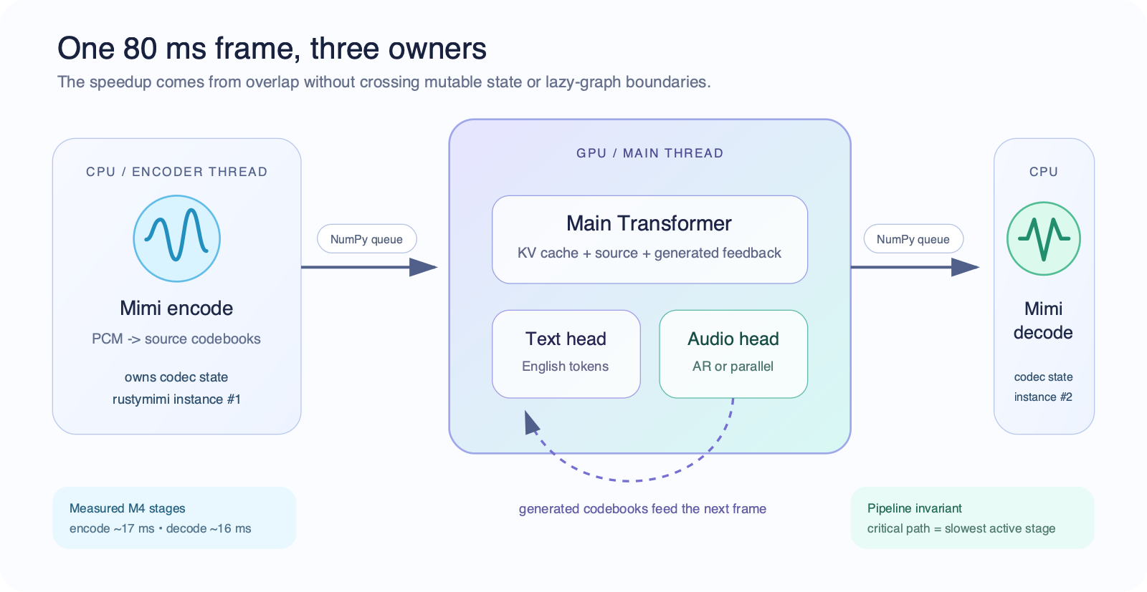
Figure 1 — Streaming architecture: one 80 ms frame, three owners (measured M4 stages: encode ~17 ms, decode ~16 ms).

4.2 Module-by-Module Design

Module | Model / Framework | Size (est.) | Latency Target | Key Technique
Audio codec (input) | Mimi neural codec (rustymimi / MLX Swift) | ~150 MB | ~17 ms/frame (M4) | Streaming 12.5 Hz at 24 kHz; one tokenizer per thread
S2ST backbone | Hibiki-M 1B Transformer, q4 group-32 | 1.13 GB artifact | 15.06 ms LM frame (M4); ~30 ms projected on phone | q4 quantisation, capped KV cache, compiled fixed-shape steps
Codebook head | AR depformer (parallel head in R&D) | included in artifact | 7.02 ms (M4); parallel variant 5.28 ms (−58%, smoke) | Per-codebook projections; parallel head predicts all codebooks in one pass
Audio codec (output) | Mimi decoder | shared runtime | ~16 ms/frame (M4) | Pipelined overlap with encoding; NumPy queue handoff

4.3 On-Device Optimisation & Memory Management

All weights ship as 4-bit quantised safetensors (group size 32 — the stock MLX/Swift loader contract, verified by a strict 7/7 reload-compatibility gate). The 1B artifact is 1.13 GB on disk with ~1.8 GB peak runtime memory; the 3B teacher was reduced from 5.8 GB bf16 to 2.41 GB. Memory stays bounded by capping the KV cache at the model's true attention context (live-window memory cut from 537 MB to 66 MB on the 1B model), streaming 80 ms frames instead of buffering whole utterances, and running codec encode/decode on CPU worker threads so only one model instance is ever resident. Target RAM ceiling: ≤3 GB of spare memory for the 1B model — satisfied by any ≥8 GB-RAM device (iPhone 15 Pro/16 class, Snapdragon 8 Gen 3 flagships), leaving the operating system ample headroom.

4.4 Robustness & Edge Case Handling

(a) Acoustic: the model consumes raw 24 kHz PCM through the Mimi codec; device capture uses the OS audio stack, and headphone or half-duplex modes control speaker-to-microphone feedback.
(b) Linguistic: the current 719,120-row training receipt uses 683,164 unique PhoMT rows plus repeated FLEURS sampling. About 51% of PhoMT has timbre-matched targets. The next recipe applies target-audio loss only to verified matches and keeps text loss on other valid pairs.
(c) Generation: silence-tail handling prevents truncated endings, while correct-source free-running gates measure nonempty output, EOS, repetition, length, content, audio quality, and speaker similarity. A checkpoint cannot ship on teacher-forced loss alone.
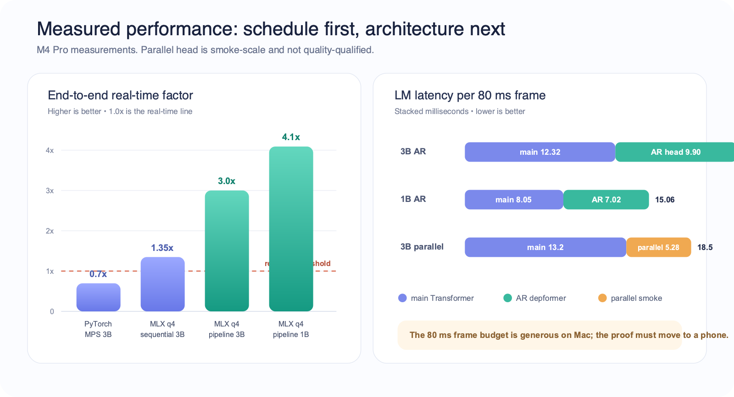
Figure 2 — Measured performance on M4 Pro: end-to-end real-time factor and per-frame LM latency.

4.5 Runtime Ownership and Measured Design Decisions
The first Apple baseline used PyTorch on MPS. It produced coherent output but translated a 64-second clip at about 0.7× real time. We selected MLX because it provides Apple-Silicon-native arrays, unified memory, quantisation, compiled execution, and a direct Swift route. The q4 conversion reduced the 3B language-model weights from 5.8 GB bf16 to about 2.2 GB.

The first q4 model loaded and produced coherent text, but its audio babbled. The stock runtime did not implement four Hibiki architecture invariants: configurable hidden scaling, grouped-query attention with two KV repeats, concatenated rotary positions, and learned output normalisation for each depformer slice. The learned depformer normalisation was the decisive audio fix. A silence input produced about 0.13 RMS and 1.23 peak without it. After the correct learned norms were loaded at the codebook output boundary, the silence test passed. A model load is therefore valid only when strict tensor reload, silence, known text, and known audio pass together.

The encoder, language model, and decoder are three concurrent state machines connected by ordered queues. Each codec thread owns its own mutable tokenizer. Queues contain evaluated NumPy arrays because lazy MLX graphs cannot move safely across the thread that created them. These rules removed a Rust mutable-borrow panic and cross-thread MLX stream errors. The runtime also adds up to eight seconds of silence after file input and stops after text EOS or 12 consecutive text-pad frames so delayed output can finish.

Measured on M4 Pro, the 3B q4 autoregressive path uses 12.32 ms for the main Transformer and 9.90 ms for the codebook head, for 22.21 ms per LM frame and about 3.0× file real time. The 1B q4 path uses 8.05 ms plus 7.02 ms, for 15.06 ms per LM frame and about 4.1× file real time. On one 30-clip French engineering set, the 3B scored BLEU 25.7 and chrF 49.4, while the 1B scored BLEU 28.4 and chrF 54.6. This small set is an engineering gate, not a publication-scale benchmark.

The q4 format keeps group size 32 because the stock MLX and Swift loaders use this contract. The staged 1B phone candidate passes 7 of 7 strict loader checks. This proves format compatibility, not phone speed. A q3 experiment also showed a clear module boundary: depformer slice Transformer blocks tolerated q3, but embeddings and output projections caused babble, repetition, and bad termination. Those modules remain q4.
The bounded KV cache cut the 1B live-window allocation from 537 MB to 66 MB and the 3B allocation from 470 MB to 344 MB. It removes retained state beyond the actual attention context. Fixed-shape compilation reduced the measured 3B depformer from about 12.4 ms to 10.2 ms. A parallel codebook-head smoke test reduced head latency from 12.70 ms to 5.28 ms and total LM time from 25.9 ms to 18.5 ms. That head was trained on only 30 clips, so it proves the mechanism and speed but not audio quality.

4.6 Vietnamese Data Boundary and Training Evidence
Vietnamese is a new source acoustic domain for the upstream model. The unsupported upstream model scored about 0.26 BLEU on the original Vietnamese FLEURS test. A language flag or a new output head cannot solve this. The main Transformer must learn how Vietnamese speech maps to English content.

The published PhoMT speech artifact contains 696,243 pairs and about 1,228 Vietnamese hours before the 25-second filter. The first Mimi cache contains 694,422 rows and 1,114 hours after 1,821 long rows were removed. Grounded-v2 accepted 690,067 PhoMT rows after 4,364 CTC-alignment failures. The 280-frame training cap left 684,232 eligible PhoMT rows. The frozen direct-run membership selected 683,164 unique PhoMT rows.
FLEURS contributed 1,392 eligible real-speech training rows and 138 validation rows. The frozen direct epoch contained 35,956 FLEURS presentations, but these were repeated samples, not unique clips. Each FLEURS row appeared about 25.8 times per epoch and about 77 times by step 135,000. The final frozen epoch had 719,120 presentations. This reuse is why PhoMT and FLEURS results must stay separate.

Each grounded row has Vietnamese source Mimi codes with explicit codec-card EOS, CTC-timed English text with tokenizer EOS, and English target Mimi codes with a validity mask. Mimi encoding runs once during cache creation. The H100 optimizer reads these arrays directly and does not run an audio codec during training.
Rank-32 LoRA reduced loss and overfit small examples, but it did not ground the frozen backbone in Vietnamese acoustics. Full-model SFT on about 147,000 cached examples established Vietnamese routing and reached 19.61 chrF on a 128-row validation set. A later warm start on the full cache used a high learning rate and fell into a pad and silence attractor. Teacher-forced metrics improved during this collapse because reference history bypassed the model's bad self-generated history. This result made deterministic free-running output a mandatory promotion gate.

The direct grounded-v2 run started from upstream weights with batch 16, a 280-frame cap, fixed learning rate 1e-6, fused AdamW with betas 0.9 and 0.95, weight decay 0.1, bf16 matrix compute, and fp32 model and optimizer state. It planned five epochs but stopped at step 135,000 after about three epochs. FLEURS teacher-forced loss was best at step 18,000 and then became worse for 13 saved checkpoints. Unseen PhoMT teacher-forced loss improved from 3.68 at step 18,000 to 3.13 at step 135,000. This was stable optimization with the wrong stopping rule, not numerical collapse.

Free-running evaluation showed the limit. The 18k checkpoint had better FLEURS BLEU and chrF than the 135k checkpoint, but it still failed the repetition gate. On six row-ID-disjoint PhoMT examples, step 135k returned nonempty text for all six, found EOS for only four, and scored BLEU 2.07, chrF 18.85, and WER 159%. Several outputs started with a related phrase and then became repetitive, corrupted, or incomplete. Step 18k is preserved as the FLEURS-selected artifact. Step 135k is preserved as teacher-forced PhoMT-specialized evidence. Neither is a production Vietnamese model.

4.7 Vietnamese-to-English Parity Program
The goal is parity with the upstream French, Spanish, Portuguese, and German paths in translation quality, simultaneous latency, voice preservation, and free-running generation health. The largest gap is training scale and variation. This project has about 1,114 hours of synthetic PhoMT source speech and 1,392 unique real FLEURS training clips. The Hibiki-Zero supervised recipe used about 40,000 hours of real multi-speaker audio for each source language.

The new data pipeline starts from licensed scripted English audio. Common Voice is the first source. Each English clip supplies a real target recording and gold English text. The pipeline translates the sentence to Vietnamese, generates Vietnamese source speech with voice transfer from the original English speaker, and writes a grounded cache row. This direction gives Vietnamese audio as source, English text and real English audio as targets, and one speaker identity across the pair. The first 1,000 hours are a stop/go tranche before work scales toward about 40,000 total Vietnamese hours.

Data quality gates: a random 1,000-row translation audit must reach at least 95% acceptance; Vietnamese ASR on a random 1,000-row TTS sample must have WER below 15%; rows with clipping, more than 50% silence, or more than 280 frames are removed; speaker-embedding similarity must pass the existing cross-lingual threshold; normalized text is deduplicated before TTS; and held-out speakers and rows must be absent from training. Real FLEURS stays in the mix exactly once per epoch and remains a separate validation domain.

Phase 1 — Data. Validate the scripted-English pipeline, freeze row-disjoint manifests, record corpus mixture and reuse, and pass longest-row load, save, and resume smoke tests.
Phase 2 — Controlled supervised SFT. Start from upstream Hibiki-Zero. Keep batch 16, the 280-frame cap, and AdamW unchanged. Begin with the former 27k–36k step budget, validate every 3,000 steps on each domain, and stop after two consecutive primary-domain regressions. Test learning-rate decay only after the fixed 1e-6 result is reproduced.
Phase 3 — Voice-matched fine-tune. Apply target-audio cross-entropy only to verified timbre matches. Unmatched valid rows keep text cross-entropy only. Fine-tune for about 1,000–2,000 steps at batch 16 and learning rate 1e-6, and add source-to-output speaker similarity to evaluation.
Phase 4 — GRPO free-running training. Generate four candidates per input at temperature 0.8 and top-k 250. Use a process reward that combines partial-prefix BLEU and full-output BLEU with full-output weight 0.4. Start with 500–1,000 updates at learning rate 2e-7. Keep all prior content, EOS, repetition, length, audio, and speaker gates as hard filters.

4.8 Evaluation and Checkpoint Promotion
No single score represents the product. Text can stay coherent when the audio head is broken, and teacher-forced loss can improve when free-running output collapses. A checkpoint must pass artifact integrity, silence, a known clip, separate domain losses, deterministic free-running health, translation content, waveform quality, speaker similarity, upstream-language retention, and device tests.
The 128-row free-running gate requires at least 122 nonempty outputs, at least 116 outputs with EOS, no more than 12 repeated four-gram failures, mean length ratio at most 2.0, and no material chrF regression. The parity exit requires EOS in at least 90% of held-out outputs, repeated four-gram outputs at most 10%, stable source-to-output speaker similarity, and translated output before source speech ends. Test sets remain sealed until one checkpoint passes selection.

5. Hardware & Device Concept

↗ Scoring weight: 25% — Hardware & Device Concept

5.1 Platform Selection & Justification

Compare at least one SoC / compute platform options and justify your choice.

Criteria | Apple A17/A18 (iPhone 15 Pro+) | Snapdragon 8 Gen 3 (Android flagship) | Selected?
NPU Performance (TOPS) | ~35 TOPS Neural Engine + GPU (MLX-native) | ~45 TOPS HTP + Adreno GPU | Both qualify
Power Consumption (TDP) | ~4–5 W sustained SoC package during inference | ~5–7 W sustained | Both qualify
RAM / Storage Support | 8 GB unified memory, ≥128 GB storage | 12–16 GB LPDDR5X, 256 GB UFS 4.0 | Both qualify
AI SDK / Toolchain | MLX Swift / Core ML — proven in our native iOS prototype | Qualcomm QNN / AI Hub official conversion path | Both qualify
Form Factor Suitability | Standard handheld phone; no custom hardware | Standard handheld phone; no custom hardware | Both qualify

We use a dual-platform strategy with one hard requirement: enough memory for the accepted 1B artifact and the operating system. Apple is the primary path because the runtime is MLX-native and the public Hibiki Edge POC implements a clean MLX Swift graph plus offline 1B FR→EN file translation. This establishes the native architecture, but it does not yet provide a physical-iPhone speed, memory, battery, or thermal receipt. Qualcomm is the Android path through QNN and AI Hub after the Vietnamese 1B artifact passes quality gates. The product uses a standard phone; no custom hardware is required.

5.2 Key Hardware Components & Power Budget

Component | Specification | Peak Power | Notes
SoC | Apple A17 Pro or Snapdragon 8 Gen 3 (≥8 GB RAM) | ~5.0 W | GPU/NPU active, 1B q4 inference
Microphone | Device MEMS, 16–24 kHz | ~0.05 W | OS AEC/noise-suppression pipeline
Speaker / Audio Out | Device speaker or wired/BT headphones | ~0.3 W | 24 kHz playback
Battery | Phone battery (≥3,000 mAh) | — | Target: >4 h continuous translation at <2 W average system draw
Storage | Model artifact 1.13 GB + app <200 MB | ~0.1 W | Downloaded once; runs offline
Display | Device OLED (live transcript UI) | ~0.4 W
Total System Budget |  | ~6 W peak | Well within phone thermal envelope; no custom BOM required

5.3 Mobile Frame Budget and Measurement Plan
Hibiki emits at 12.5 Hz, so recurrent work must complete within 80 ms. The measured M4 Pro LM frame is 15.06 ms for the 1B q4 model and 22.21 ms for the 3B q4 model. If a phone sustains 40–60% of the relevant M4 throughput, the projected 1B frame is 25.1–37.7 ms, with a midpoint of 30.1 ms. The 3B midpoint is 44.4 ms. These values show a possible margin, but they are projections and not phone results.

The codec stages measure about 17 ms for encode and 16 ms for decode on M4. The scheduler can hide these stages only if the mobile runtime preserves CPU and GPU overlap. A single-threaded implementation can miss the 80 ms limit even when the LM alone is fast enough.

The device receipt records cold and warm model load, first text, first audio, per-frame p50/p95/p99, memory high-water, queue underruns, battery change, surface temperature, and 30-minute clock stability. Release requires p99 below 80 ms, no memory growth after warm-up, zero underruns, and desktop/device quality parity on the same artifact.

Apple starts with MLX Swift because it is closest to the working graph. Core ML becomes an option only after MLX Swift is measured. Conversion should occur by module because the model has explicit state and a serial audio head. Qualcomm uses explicit-state ONNX or TorchScript modules, then Qualcomm AI Hub and QNN for conversion, numerical checks, physical-device profiling, and packaging.

5.4 Form Factor, BOM, and Product Boundary
Connect needs no custom electronic hardware. The bill of materials is the user's phone, its microphone and speaker, and optional wired or Bluetooth headphones. This removes enclosure, radio, certification, repair, and manufacturing work from the first release and gives the application access to operating-system echo cancellation and noise suppression.

The application must handle acoustic feedback. Safe first modes are headphones, operating-system echo cancellation, or half duplex. Live inference runs outside the audio callback. The callback only moves bounded PCM blocks so one slow model frame cannot block device audio I/O.

The six-watt value is a peak planning envelope, not a measured sustained result. The target of more than four hours at less than two watts average system draw remains open until a qualified 1B Vietnamese artifact runs on a physical phone. The project will report measured values by device and operating-system version instead of using SoC TOPS as a substitute for application performance.

6. System Architecture & Integration

↗ This section bridges your AI pipeline (Section 4) and your hardware platform (Section 5). Judges assess whether the software and hardware layers work coherently as a complete system.

6.1 Software Stack

Layer | Component / Framework | Role
OS | iOS 17+ / Android 14+ | Base runtime & audio I/O
AI Runtime | MLX Swift (Apple) / Qualcomm QNN + ONNX Runtime (Android) | On-device model execution
Audio Processing | OS audio stack: AVAudioSession / AAudio with AEC-NS | Capture, playback, echo & noise handling
Model Serving | HibikiCore (MLX Swift) / QNN compiled graphs | Streaming S2ST inference, KV-cache state
App Layer | SwiftUI / Kotlin | App UI, session control, transcript display

6.2 System Architecture



Figure 3 — Connect system architecture: Mimi encode → Transformer (text + audio heads) → Mimi decode, pipelined across CPU and GPU threads.

6.3 Offline-First Design Principles
Offline-first principles:
- All AI models stored on-device; no API calls at runtime — full inference works in airplane mode
- Language packs are downloadable artifacts (1B q4 ≈ 1.13 GB); VI→EN preloaded on first setup
- Bounded KV caches and streamed 80 ms frames keep memory flat and p99 frame compute inside the 80 ms budget
- Fail-safe output: if audio generation degrades, the English text stream still renders as live subtitles
6.4 Runtime State, Errors, and Session Data
The application owns one inference session per conversation. The session contains the main Transformer KV cache, text history, generated-audio feedback, source and target codec states, sequence counters, and bounded audio queues. A new session resets all state. Pause, interruption, and audio-route changes are explicit events. The application does not reuse stale state after a route change or model error.
The session reports structured events for warm-up, first input, partial text, audio availability, frame time, queue depth, backpressure, EOS, interruption, and failure. The present macOS proof of concept reads combined process output. The product contract replaces that parsing with typed events so the UI can separate a slow frame, an audio-device fault, an invalid artifact, and a generation-health warning.
Session data is local by default. The application does not send audio or transcripts to analytics. If crash reporting is added, it must exclude audio, decoded text, source tokens, target tokens, and user-selected file paths. Transcript or WAV export occurs only after a user action and uses the operating-system share boundary.
6.5 Working Prototypes & Demo Evidence
Two working POCs cover the desktop integration boundary and the native mobile architecture boundary.
Prototype | Current evidence | Scope and public link
Desktop — macOS | Repository-built SwiftUI shell; local file and live-microphone workflows through the Python/MLX engine. | Integration POC. The shown VI checkpoint is research-only and not production qualified.  Repository: hibiki-zero-mlx  Swift build: macos/HibikiTestApp (includes Package.swift, the Swift source, and build.sh).
Mobile — iOS | Hibiki Edge: independent HibikiCore MLX Swift runtime and SwiftUI app; offline 1B FR→EN file translation without Python or a network inference service. | Architecture POC; VI artifact and physical-device receipt remain open. Public GitHub repository
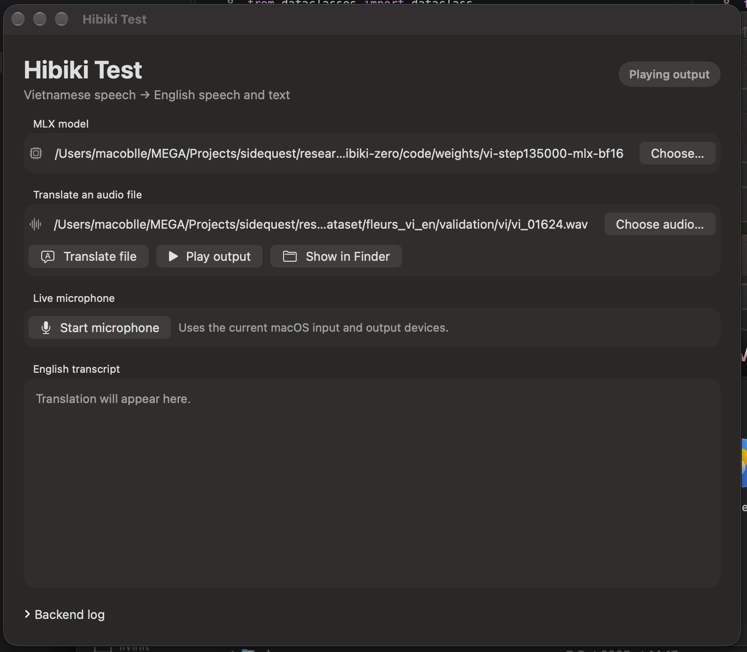
Figure 4 — Native macOS desktop POC. View the 16-second live-microphone demo on GitHub

7. Team Profile & Project Timeline

↗ Scoring weight: 10% — Team and Execution Plan

7.1 Team Members

Name | Role | Expertise | Contribution Area
Nguyen Huy Hoang Huy | Team Lead | ML systems, on-device inference (MLX/CUDA), speech-model training | Apple Silicon runtime port, q4 quantisation, Vietnamese SFT program
Quach Thoai An | ML Engineer | Data engineering, TTS/speech synthesis, mobile deployment | 696k-pair speech dataset campaign, native iOS MLX Swift prototype

7.2 Project Status & Next Gated Plan

Stage | Milestone | Key activities and exit gate | State
Complete | Apple runtime & desktop POC | q4 MLX, three-stage scheduler, measured M4 headroom, file and live-microphone shell | Done
Complete | Open data & native mobile POC | Publish paired speech and grounded Mimi caches; prove the 1B FR→EN graph in native MLX Swift | Done
1 | Data scale-up | Validate the scripted-English pipeline on a 1k h tranche, then scale total VI source speech toward 40k h; verify timbre, QA, dedupe, and holdouts | Next
2 | Controlled supervised SFT | Train the upstream-start 3B model; keep domains separate; validate every 3k steps; promote only with correct-source free-running gates | Gate: qualified 3B
3–4 | Voice-matched fine-tune + GRPO | Apply audio loss only to verified matches; run 1–2k fine-tune steps, then 500–1000 initial GRPO updates; hold EOS, repetition, content, and speaker gates | Gate: VI parity
5 | Mobile qualification | Distil the accepted VI teacher into 1B, train and quantise the parallel head, then record p99 <80 ms, memory, battery, and 30-minute thermals on Apple and Qualcomm devices | Gate: release
Phases run in order. No Vietnamese mobile release claim is made before the quality and device gates pass.

7.3 Detailed Execution Plan
Phase 1 — Data scale-up. Build one scripted-English pipeline that accepts English audio and text, translates the text to Vietnamese, creates Vietnamese speech with source-speaker conditioning, validates the result, and writes the grounded stream contract. Common Voice is first. Use other licensed corpora only after the first tranche passes. The data receipt records corpus, license, speaker, normalized sentence, duration, translation version, TTS version, voice reference, speaker score, ASR score, cache version, and rejection reason.
Phase 2 — Controlled SFT. Initialize the 3B model from upstream weights. Keep physical batch 16, no accumulation, the 280-frame cap, bf16 matrix compute, fp32 state, and fused AdamW. Validate every 3,000 steps on PhoMT, FLEURS, and every new holdout. Keep losses separate and promote only after the 128-row correct-source free-running suite passes.
Phase 3 and 4 — Voice and free-running control. Use text loss on all semantically valid pairs and audio loss only on verified speaker matches. Then run a small GRPO stage on reliable references. Keep the accepted pre-RL checkpoint and reject any candidate that has worse EOS, repetition, length, waveform, speaker, or multilingual-retention results.
Phase 5 — Student and parallel head. Freeze the qualified 3B teacher. Start a Vietnamese 1B student from Hibiki-M 1B and compare full SFT with teacher-distilled SFT under the same data and gates. After the 1B main model is frozen, train the parallel codebook head at real scale, compare one to four refinement passes, quantise it, and require audio, content, and speaker parity with the autoregressive teacher.
Phase 6 — Mobile qualification. Import the qualified 1B artifact into the native iOS contract and run fixed files on physical iPhones before live capture. In parallel, export explicit-state modules for Qualcomm QNN and measure at least one flagship and one thermally limited Snapdragon device. The release gate is p99 below 80 ms, zero underruns, stable memory, 30-minute thermal stability, and the same quality gates as desktop.
7.4 Main Risks and Controls
Synthetic source domain: keep real FLEURS as a separate single-pass stratum and add licensed real Vietnamese speech if FLEURS stops improving. Translation noise: audit 1,000 random translations and require at least 95% acceptance. Voice mismatch: gate each row by cross-lingual speaker similarity and apply audio loss only to passing pairs.
Metric failure: use teacher-forced loss only for diagnosis and require correct-source free-running output. Real-speech overfit: report unique rows and presentations and stop on separate domain regression. GRPO instability: start with a small update budget and low learning rate and keep the pre-RL artifact. Language forgetting: run the frozen French, Spanish, Portuguese, and German suite before release.
Device uncertainty: label all phone values as projections until measured, and require device-specific latency, memory, battery, and thermal receipts. License limits: preserve source licenses and provenance. Hibiki-Zero-derived weights remain subject to CC BY-NC-SA 4.0 unless the upstream owner grants different terms.
7.5 Deliverables and Review Evidence
Each phase ends with a review package: source commit, environment manifest, exact model and data revisions, hashes, command and configuration, seeds, row receipt, raw and derived metrics, device identity where applicable, and a go/no-go decision. Recovery assets contain a same-run model, optimizer state, manifest, receipt, run identity, and source commit. Hub upload is complete only after a remote download reproduces the hashes.
Data approval unlocks supervised training. A qualified 3B teacher unlocks voice and free-running optimization. Vietnamese parity unlocks the 1B student. A qualified 1B artifact unlocks device integration. Physical-device evidence unlocks the release claim. This sequence prevents an application demonstration from hiding a weak model and prevents a good desktop model from being described as a mobile result.
8. Submission Checklist

All items must be completed before final submission. Missing sections score zero on the relevant rubric criterion.

# | Checklist Item | Status
1 | Executive Summary written (200–300 words) | [x] Done
2 | Problem Statement, Target Users, and Design Constraints completed | [x] Done
3 | Business Solution completed — industry gap, solution fit, and competitive differentiation described | [x] Done
4 | AI pipeline documented with model specs, latency targets, and optimisation strategy | [x] Done
5 | Hardware platform justified; form factor, BOM and power budget filled in | [x] Done
6 | Team profiles and project timeline filled in | [x] Done
7 | All placeholder text replaced; pipeline/architecture diagram inserted (Section 6.2) | [x] Done
8 | Desktop demo video and desktop/mobile prototype evidence attached or linked; PDF export pending | [x] Done

