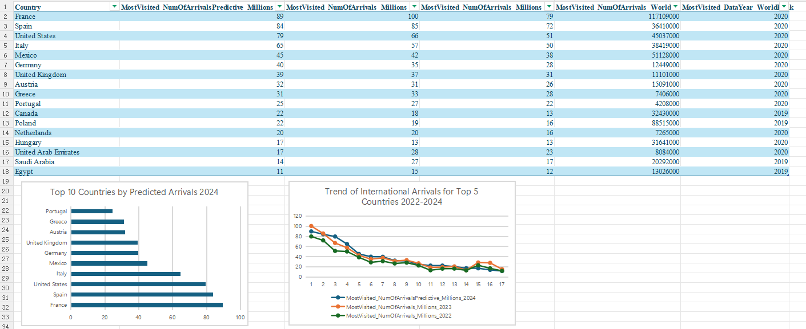
The screenshot Submission 1

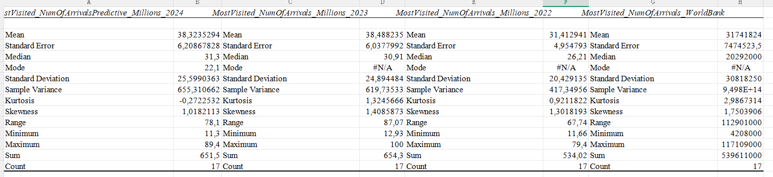
The screenshot Submission 2

