

**ANGULAR JS WORKSHOP REPORT**

* Author: Huy Chenh
* Email: [huy.chenhchi@nashtechglobal.com](mailto:huy.chenhchi@nashtechglobal.com)
* Technologies:
  + Database: SQL Server
  + Backend: Visual Studio (.Net 5 Entity Framework Core, Identity Server 4, Swagger UI)
  + Frontend: Visual Studio Code (AngularJS version 12, oidc-client)

# **Introduction**

This report is the document that helps us go through all functionalities of this Angular JS practice. I’d like to say many thanks chi Le that helped me so much for all the useful knowledge about this course.

# **Download code and run the projects**

* Link: <https://github.com/huychenh/angular_workshop>

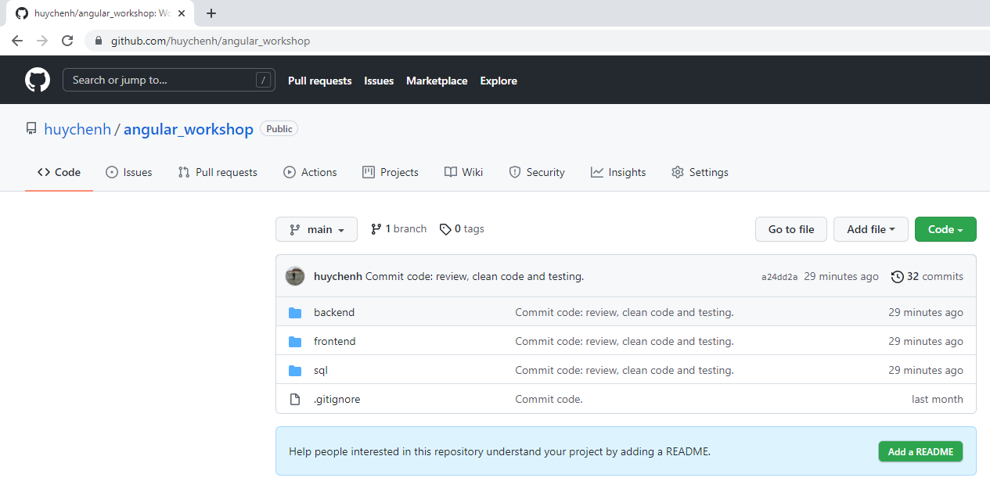

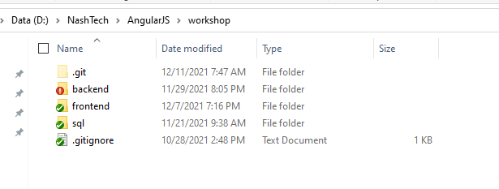

* Database: Open and run the script as the below image to have the full database.

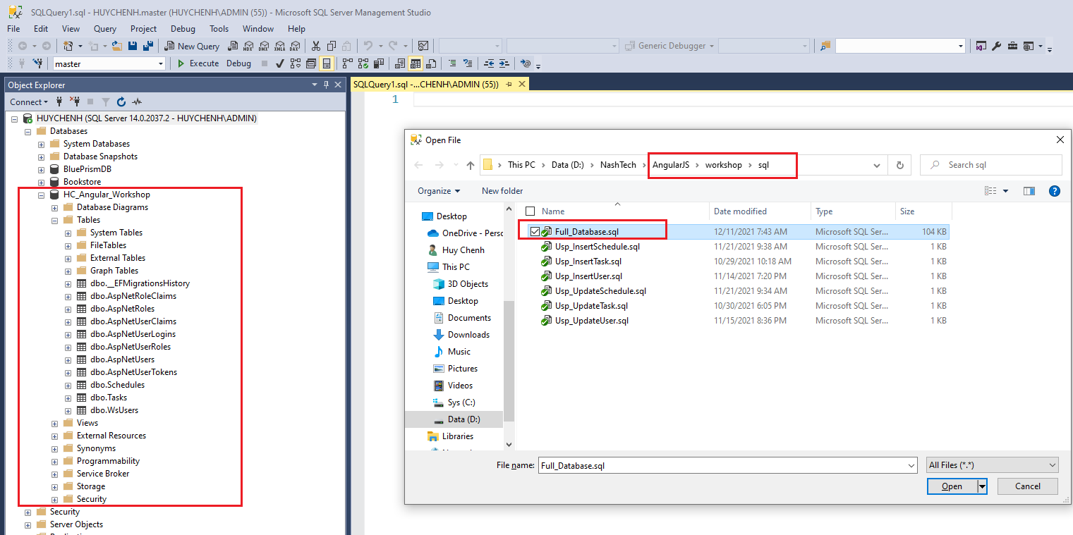

* Backend: Open and run the backend project with Visual Studio

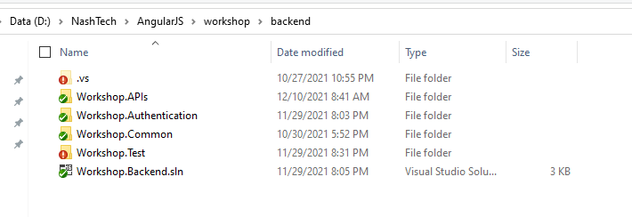

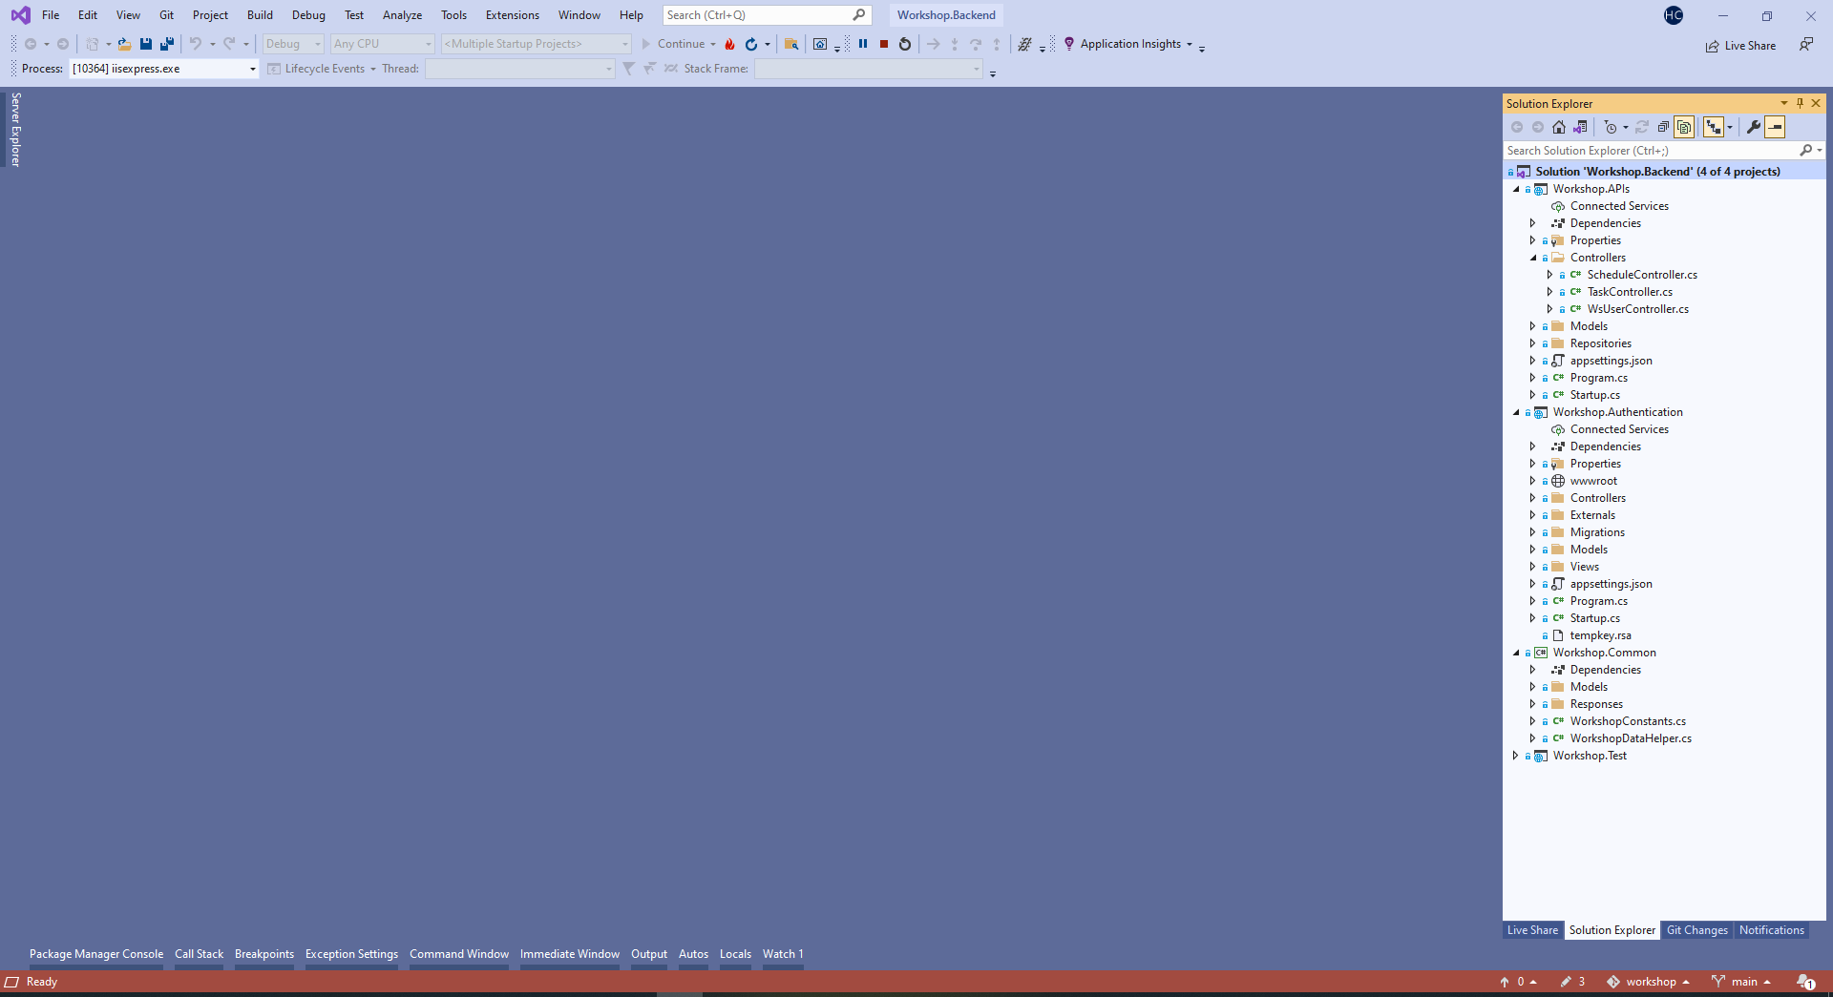

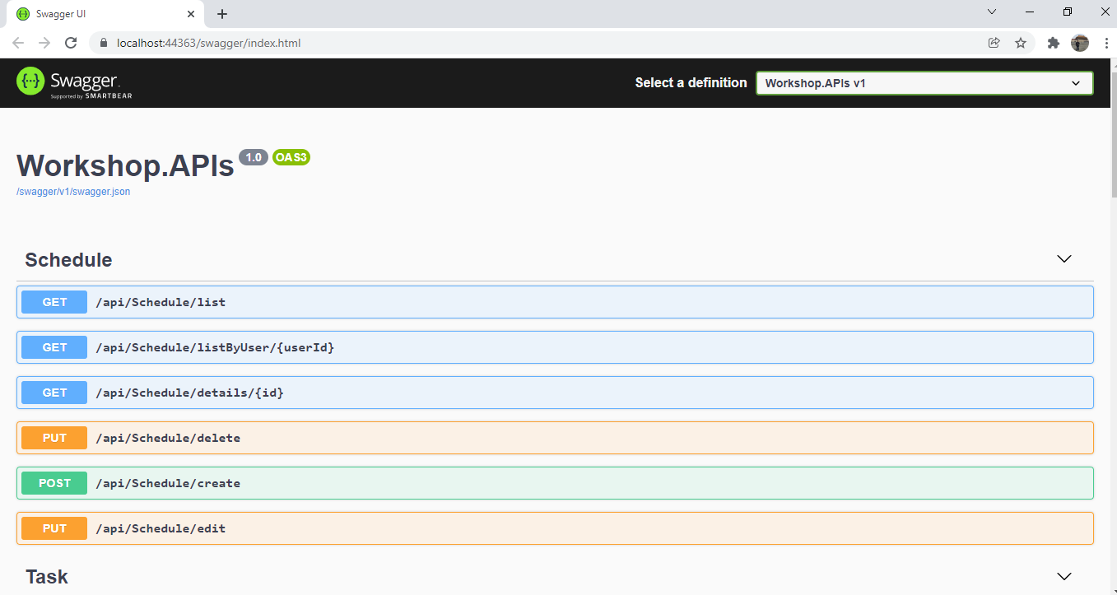

* Frontend: Open and run the frontend project with Visual Studio Code

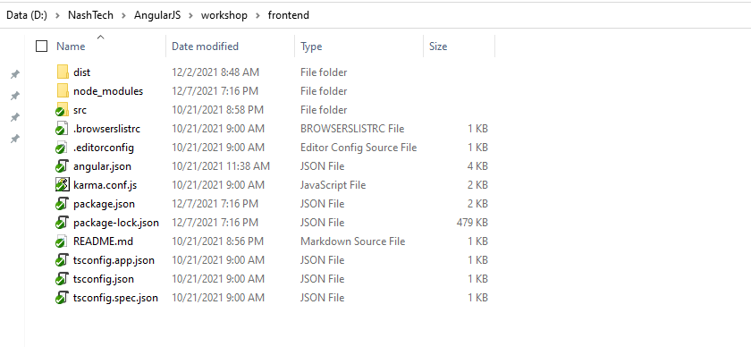

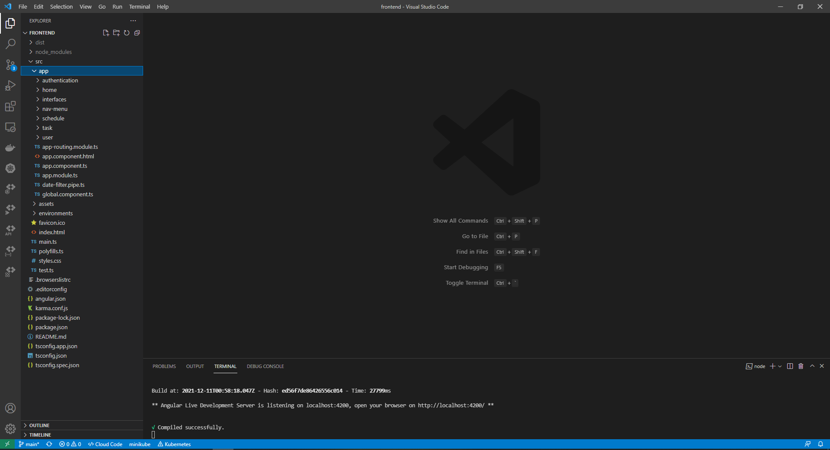

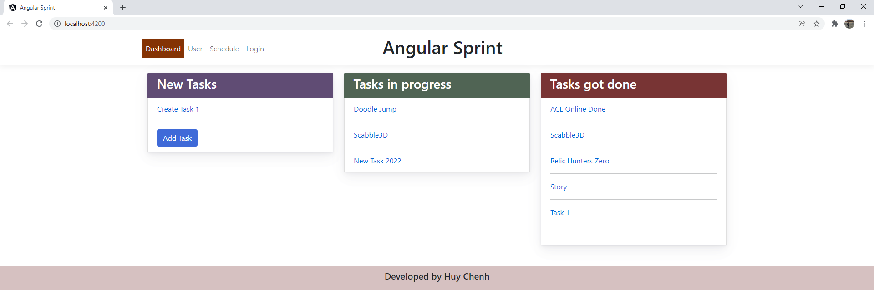

# **Functionalities**

* 1. Dashboard
     1. Home
* Load all tasks: New, Progress, Done tasks

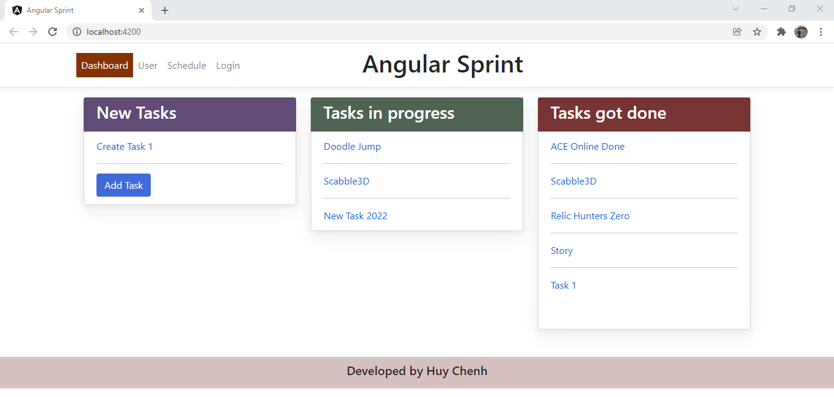

* + 1. Add tasks
* Users click “Add Task” button to navigate to the Add page.

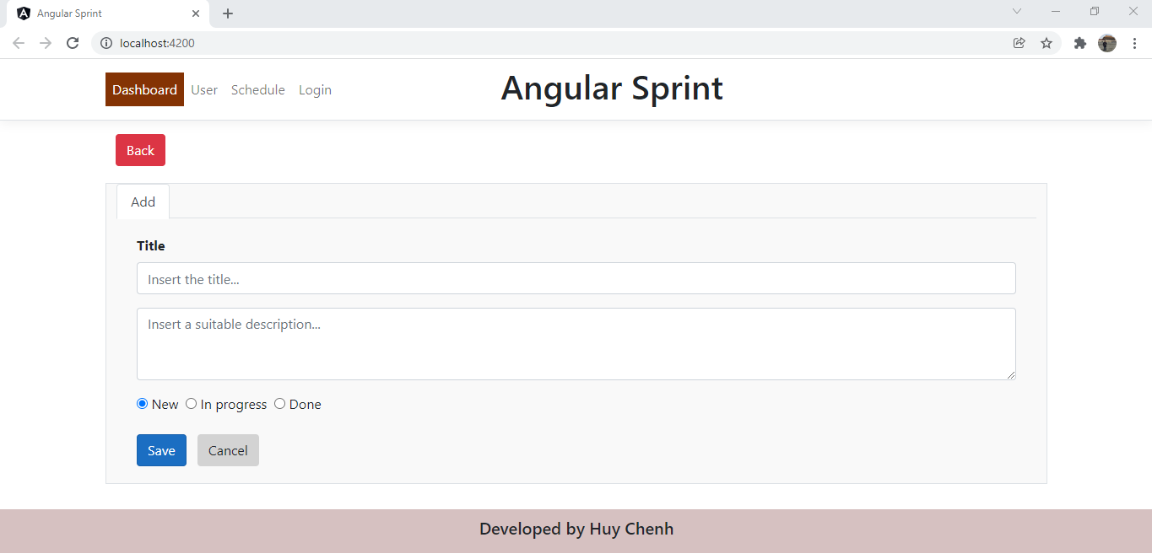

* Business rules: Title is required

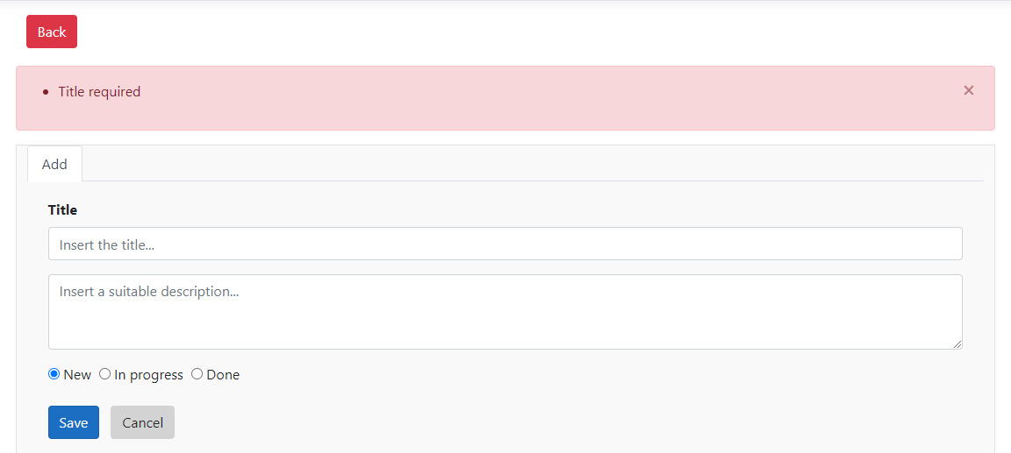

* Business rules: A success message will be displayed after saving successfully.

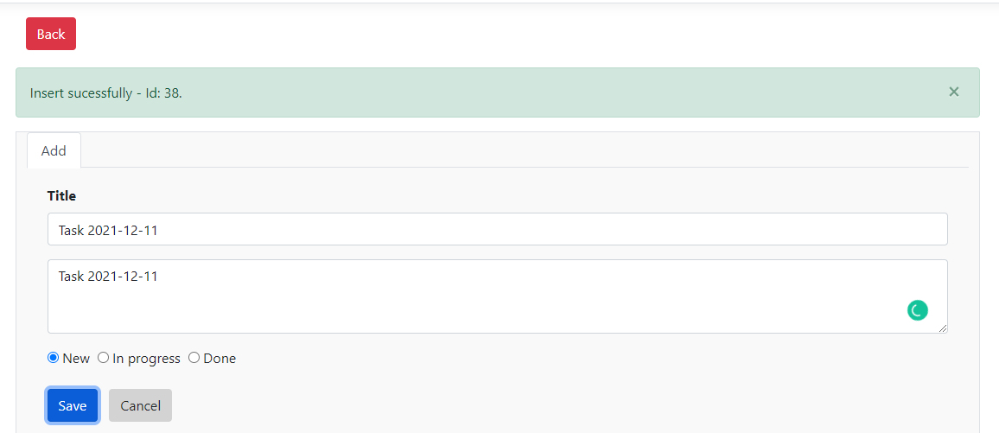

* + 1. Edit tasks
* Users click “Task” links to navigate to the Edit page.

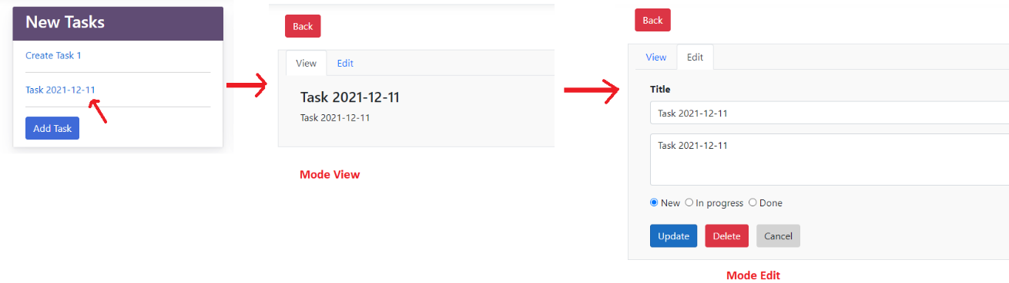

* + 1. Delete tasks
* Users click “Task” links to navigate to the Edit page 🡪 Click Edit mode 🡪 Click Delete button.
* Business rules: A warning popup will be displayed and a success message will be displayed after deleting successfully.

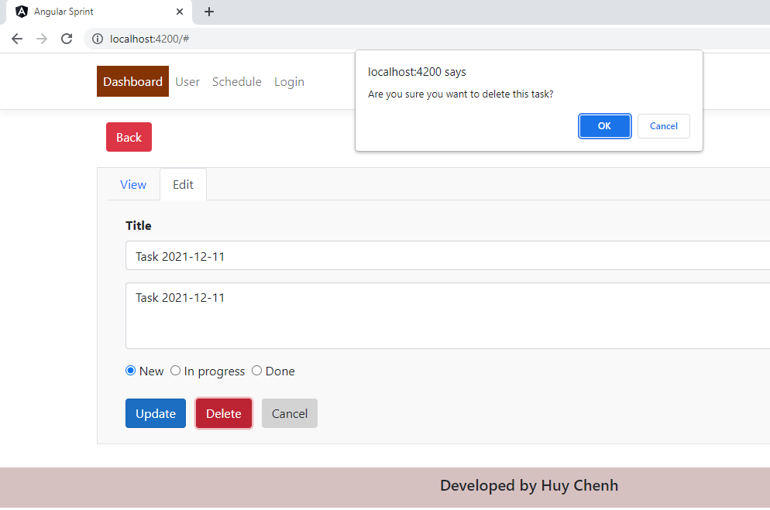

* + 1. View details tasks “Done”
* Users click “Task” links in Done area to view task details.

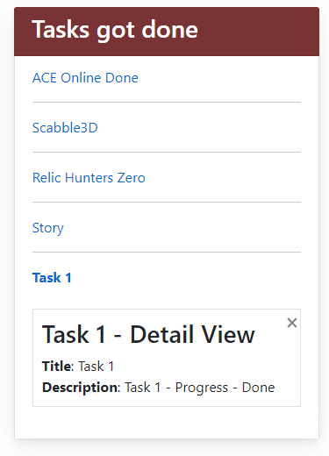

* 1. User
     1. Home:
* Users click the “User” menu and requested login if unauthenticated.

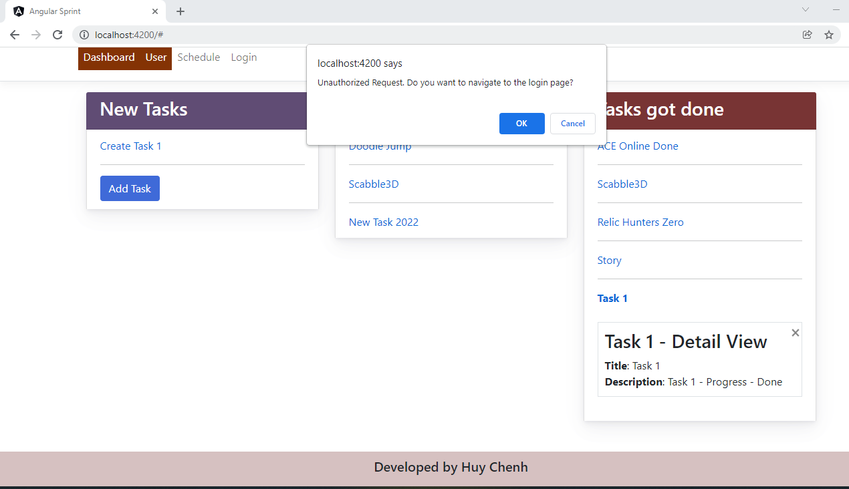

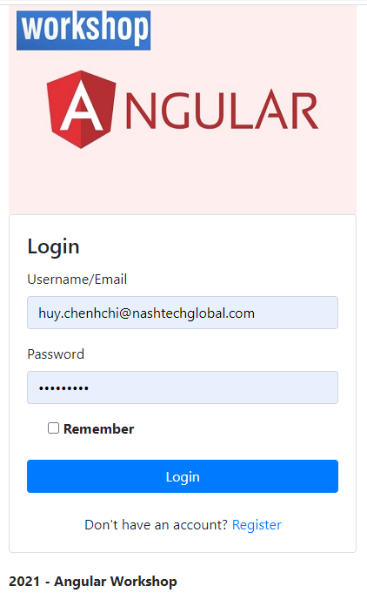

* Load all users

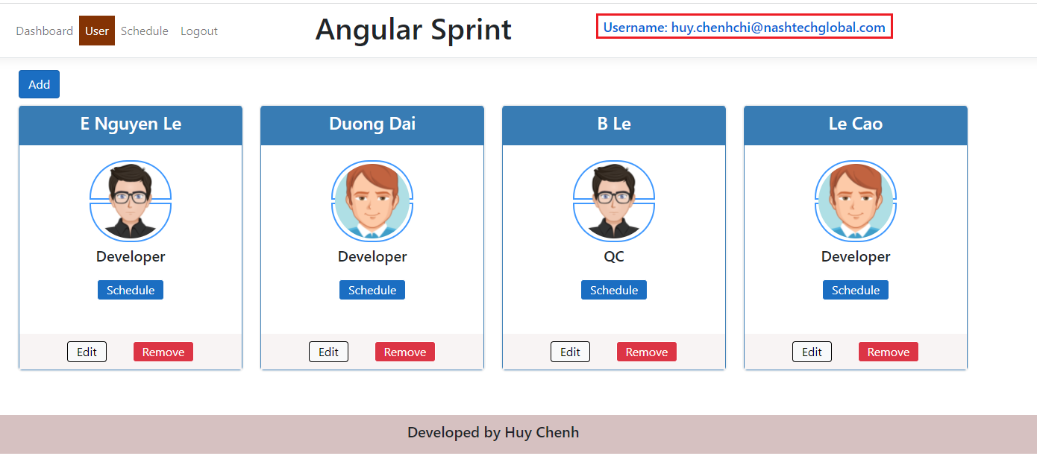

* + 1. Add User

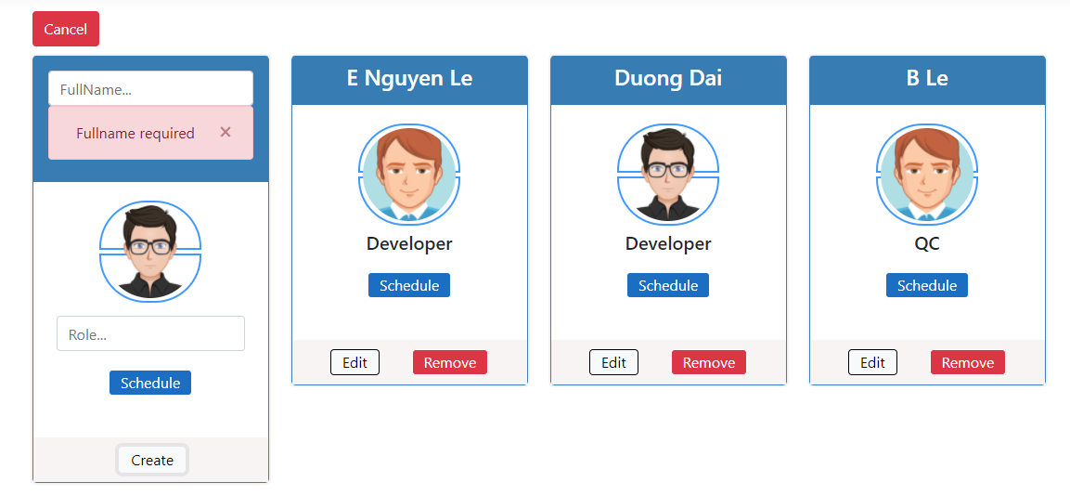

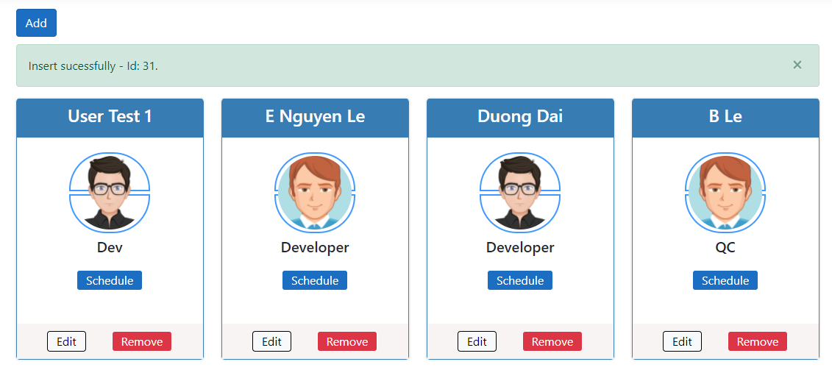

* + 1. Edit User

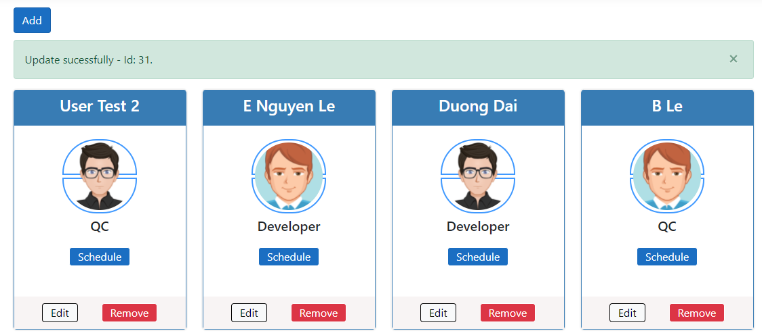

* + 1. Delete User

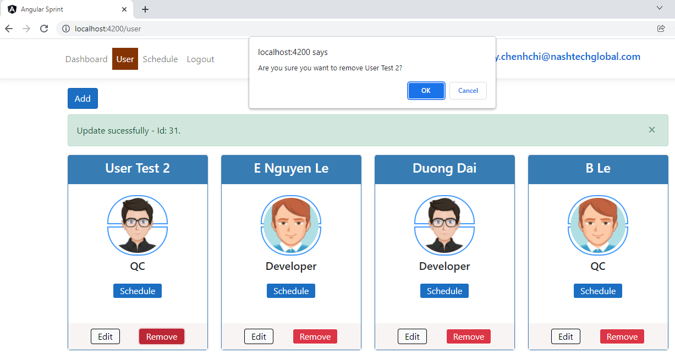

* 1. Schedule
     1. Home
* At the User page, users click “Schedule” button and navigate to the schedule page.
* The system will display all schedules by users.

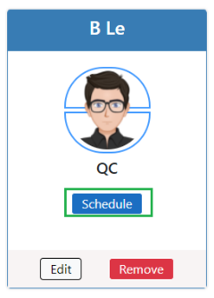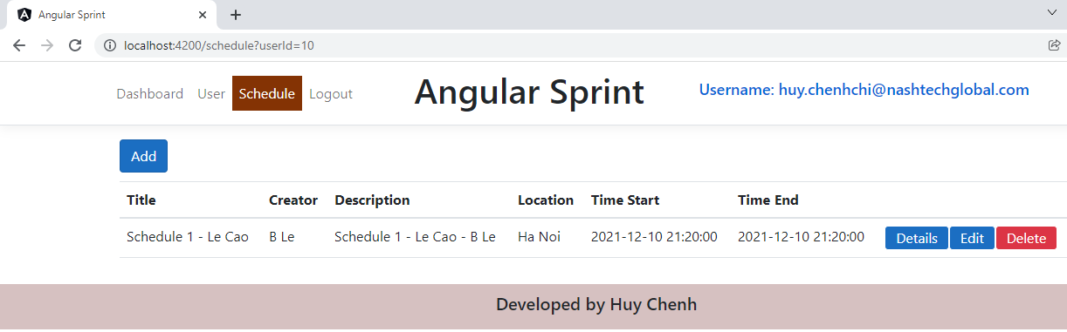

* + 1. Add Schedule

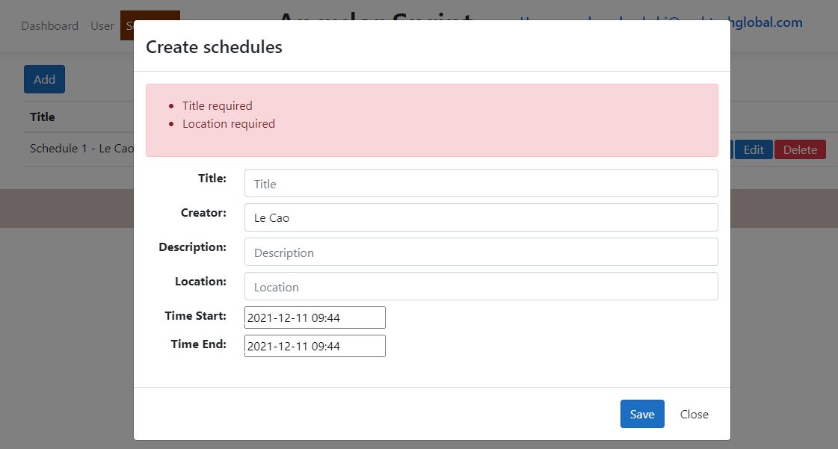

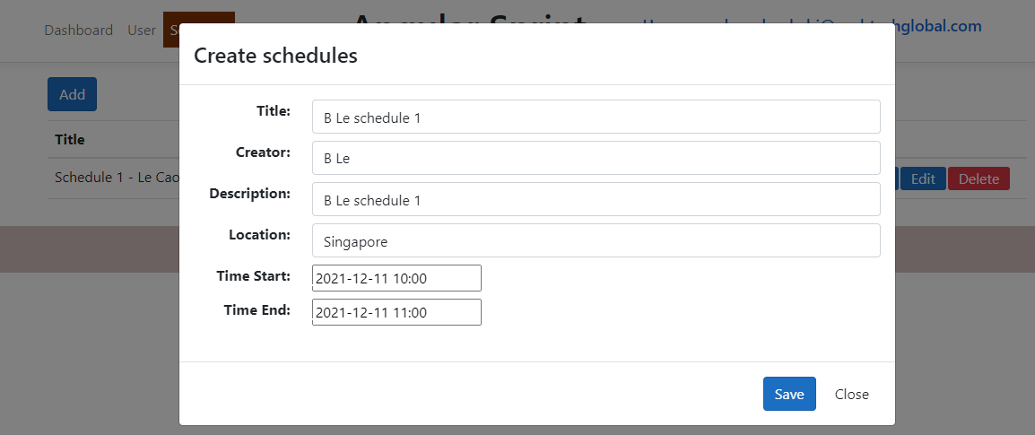

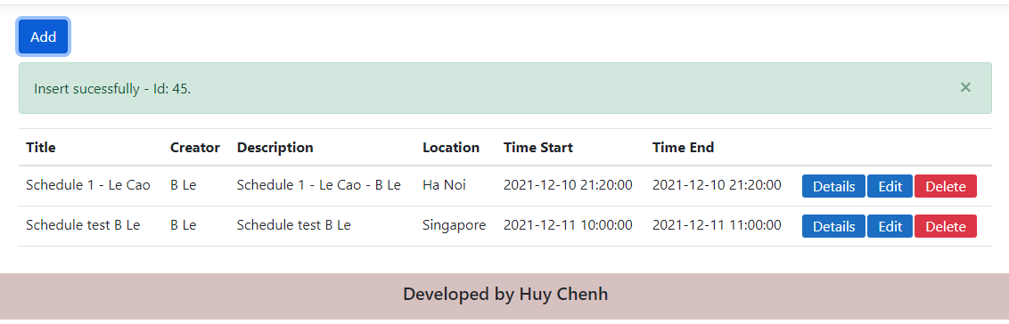

* + 1. Detail Schedule

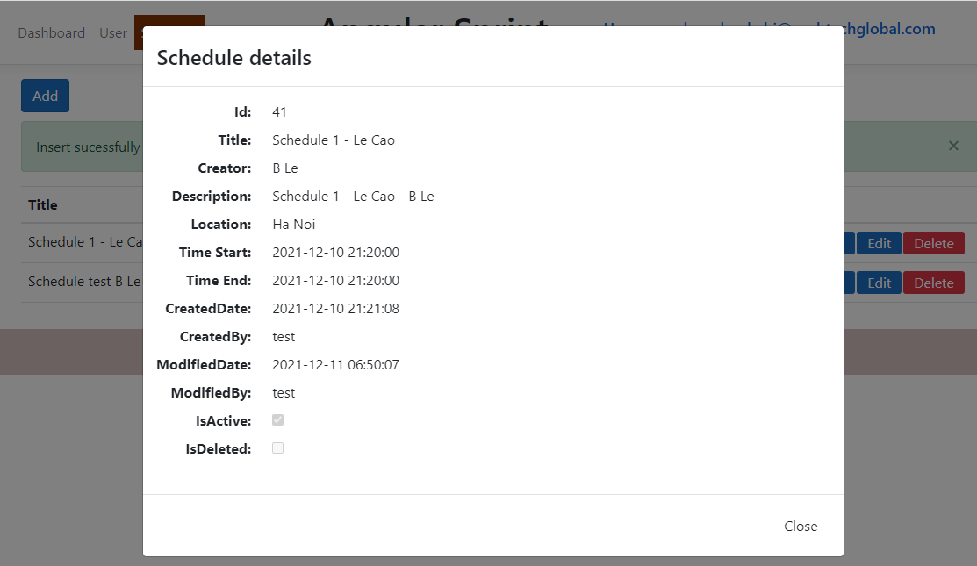

* + 1. Edit Schedule

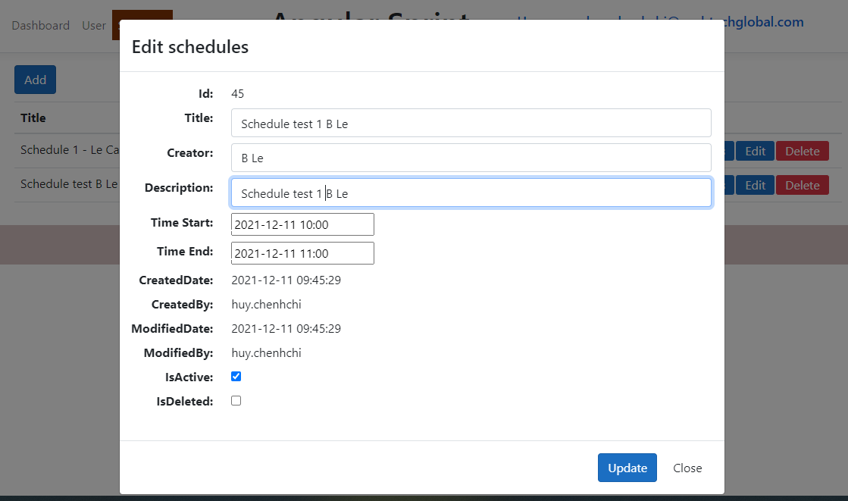

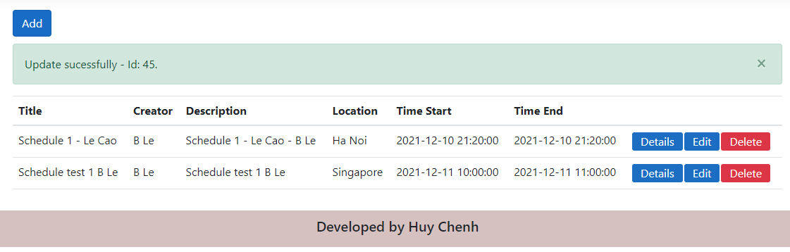

* + 1. Delete Schedule

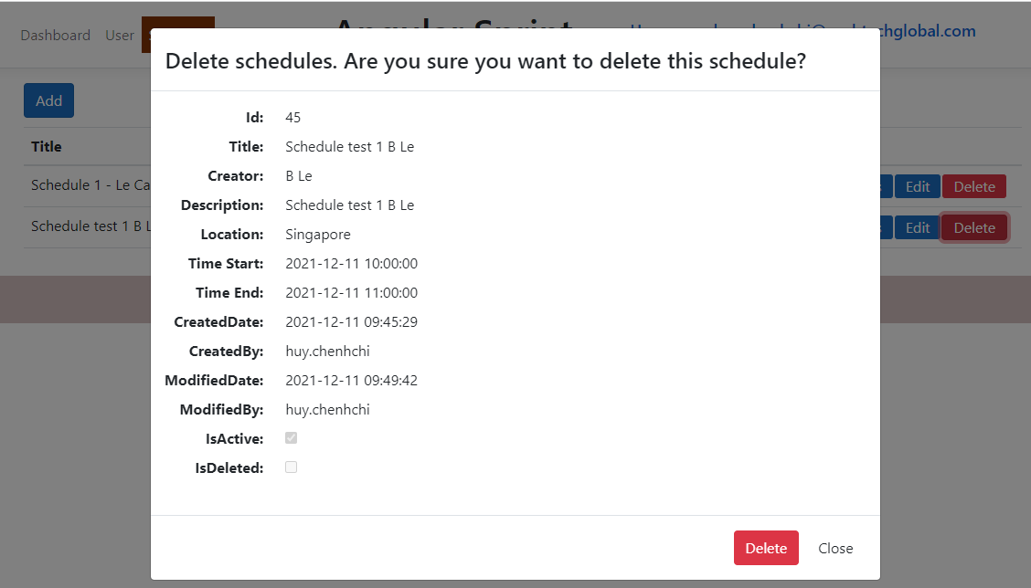

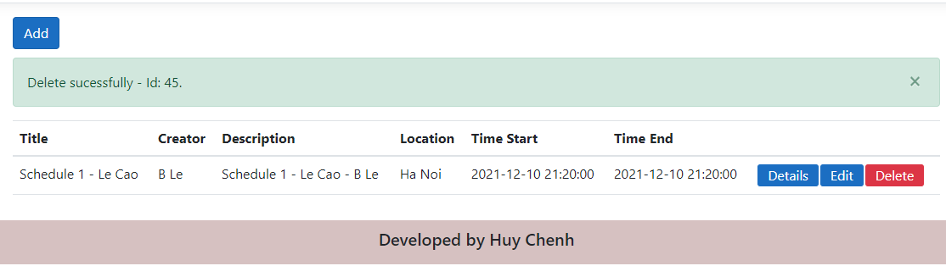

* 1. Login
* Users click the login menu to navigate to the login page
* In the login page, we can register an account

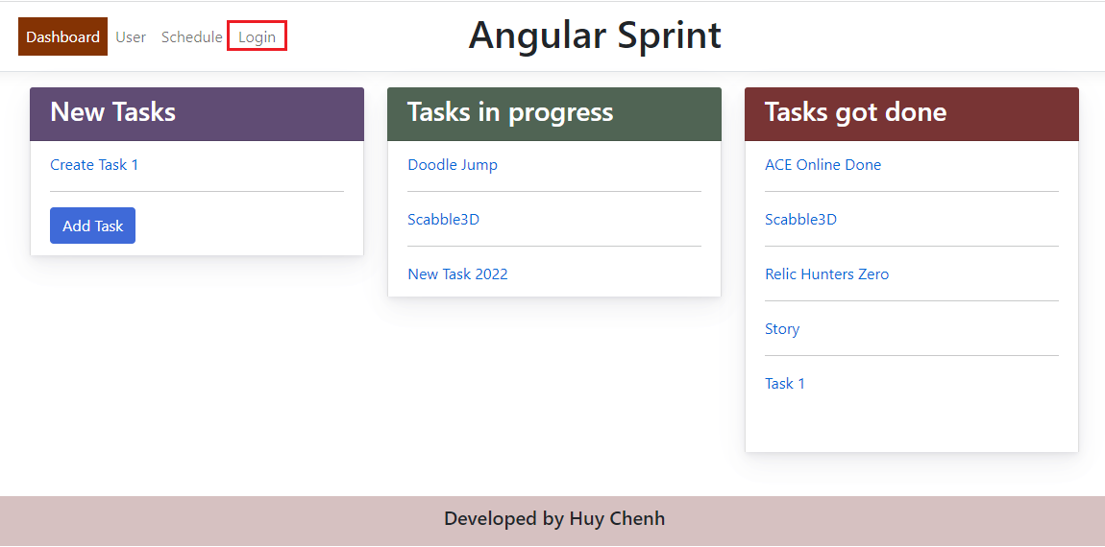

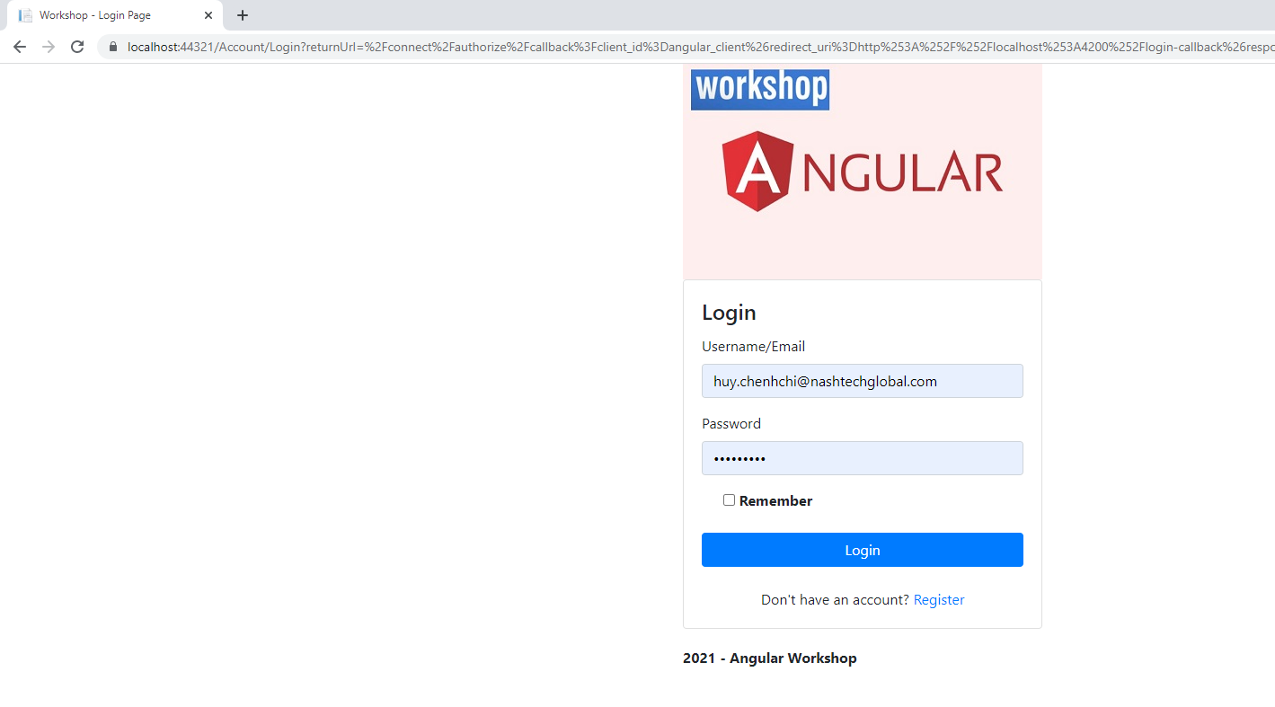

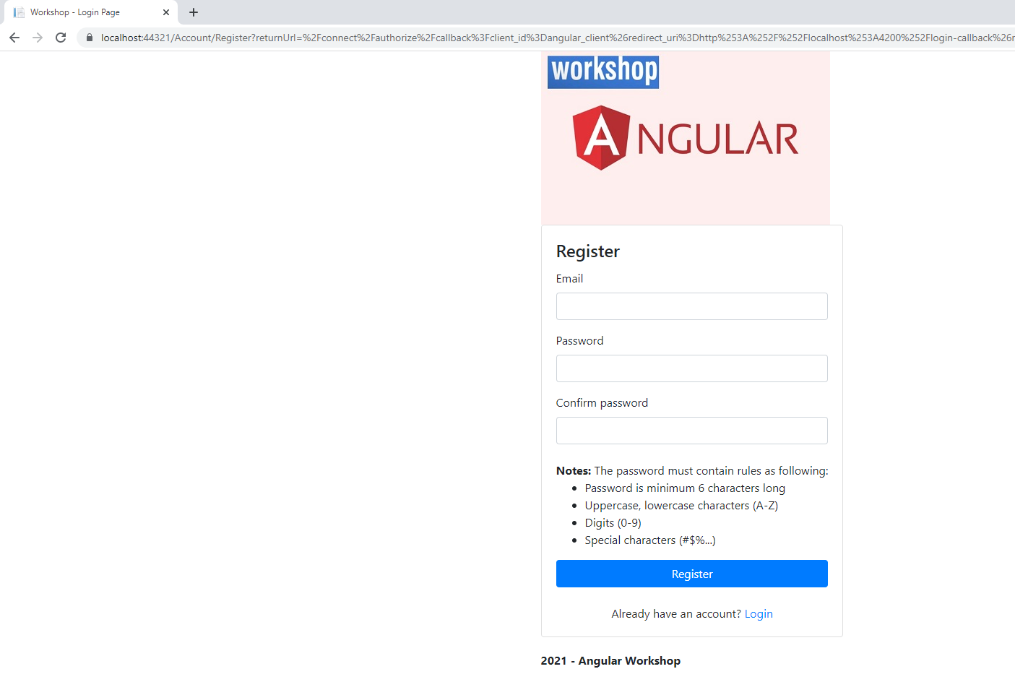

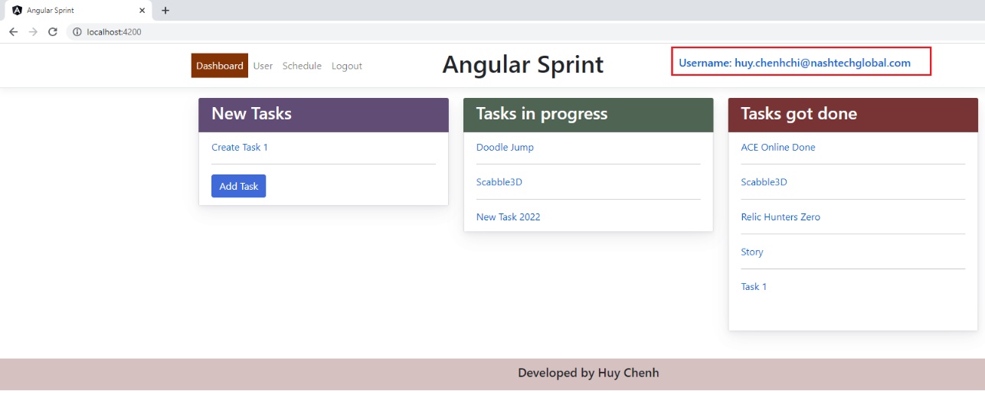

# Self-Assessment

|  |  |  |  |
| --- | --- | --- | --- |
| **No.** | **Functions** | **Marks** | **Comments** |
| 1 | Dashboard - List | 8/10 | Meet expectation |
| 2 | Dashboard - Add | 8/10 | Meet expectation |
| 3 | Dashboard - Edit | 8/10 | Meet expectation |
| 4 | Dashboard - Delete | 8/10 | Meet expectation |
| 5 | Dashboard - Detail | 8/10 | Meet expectation |
| 6 | User - List | 7/10 | There is an issue in the User list page regarding UI. |
| 7 | User - Add | 8/10 | Meet expectation |
| 8 | User - Edit | 8/10 | Meet expectation |
| 9 | User - Delete | 8/10 | Meet expectation |
| 10 | Schedule - List | 8/10 | Meet expectation |
| 11 | Schedule - Add | 8/10 | Meet expectation |
| 12 | Schedule - Edit | 8/10 | Meet expectation |
| 13 | Schedule - Delete | 8/10 | Meet expectation |
| 14 | Schedule - Detail | 8/10 | Meet expectation |
| 15 | Authentication - Login | 8/10 | Meet expectation (Using Identity Server 4 & oidc-client) |
| 16 | Authentication - Register | 8/10 | Meet expectation (Using Identity Server 4 & oidc-client) |

**Total self-assessment: 8/10**

# **Conclusion**

Because of my lack of knowledge about Angular JS, so I may have some missing in coding. Please give me your assessments. I appreciate that so much.

**--- End ---**