
REACTJS WORKSHOP REPORT

- Author: Huy Chenh
- Email: huy.chenhchi@nashtechglobal.com
- Technologies:
  - Backend: DummyJSON API
  - Frontend: Visual Studio Code (React version 19.2.0)

Introduction
This report provides a comprehensive review of all functionalities in this ReactJS practice. I sincerely thank the company trainers for their guidance and for sharing valuable knowledge throughout the course.

Download code and run the projects
- Link: https://github.com/huychenh/huyc_react_workshop

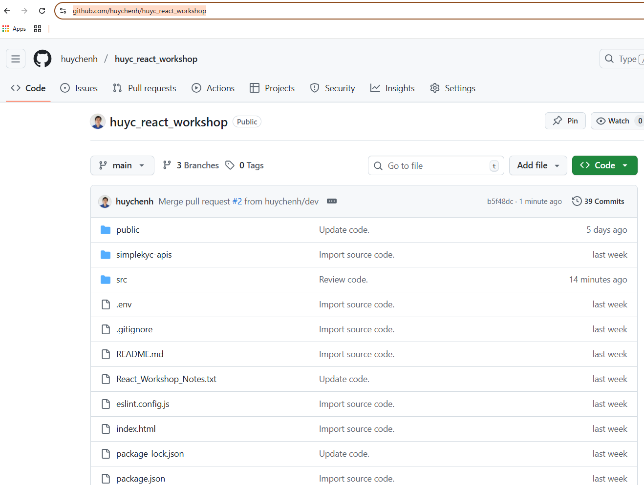
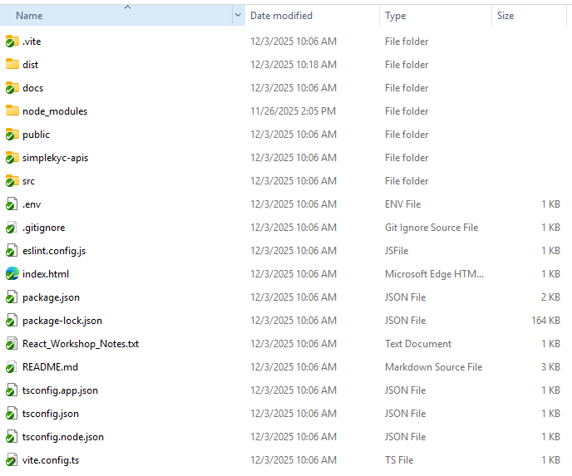

- Backend: DummyJSON API (https://dummyjson.com)

- Frontend: Open and run the frontend project using Visual Studio Code

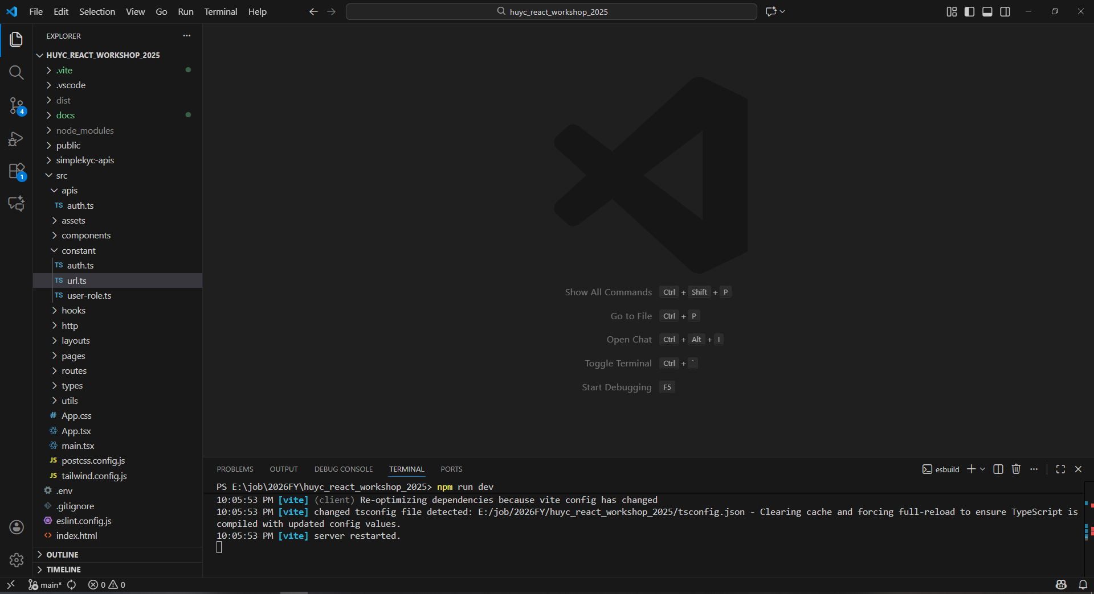

- Build project: npm run build
- Run project: npm run dev

Functionalities
  - Login
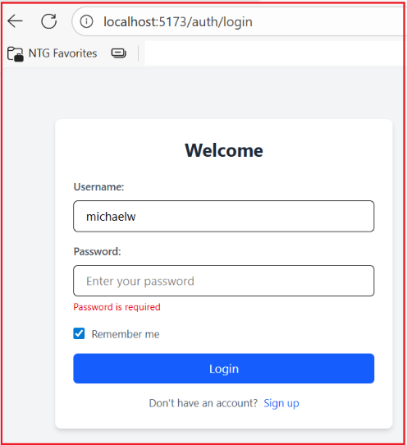

To log in, please use the three example accounts below:
Username | Password | Role
michaelw | michaelwpass | officer
emilys | emilyspass | user
sophiab | sophiabpass | user

  - SignUp
From the Login screen, users can select the Sign Up hyperlink to go to the Register screen.
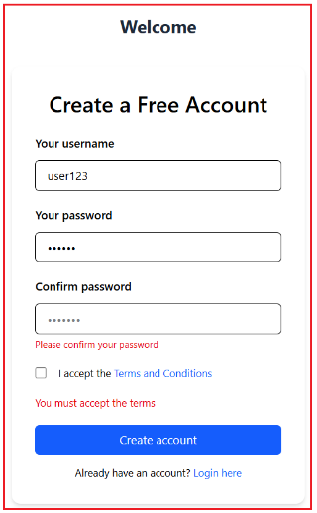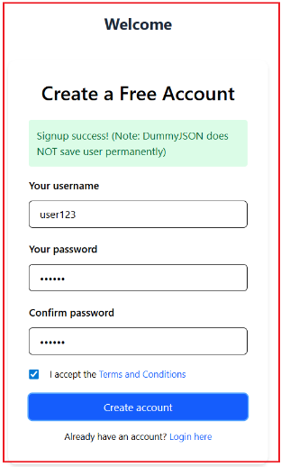

  - Dashboard screen (role officer)
After successfully logging in as an officer, the system navigates to the dashboard page, displaying the Client List.

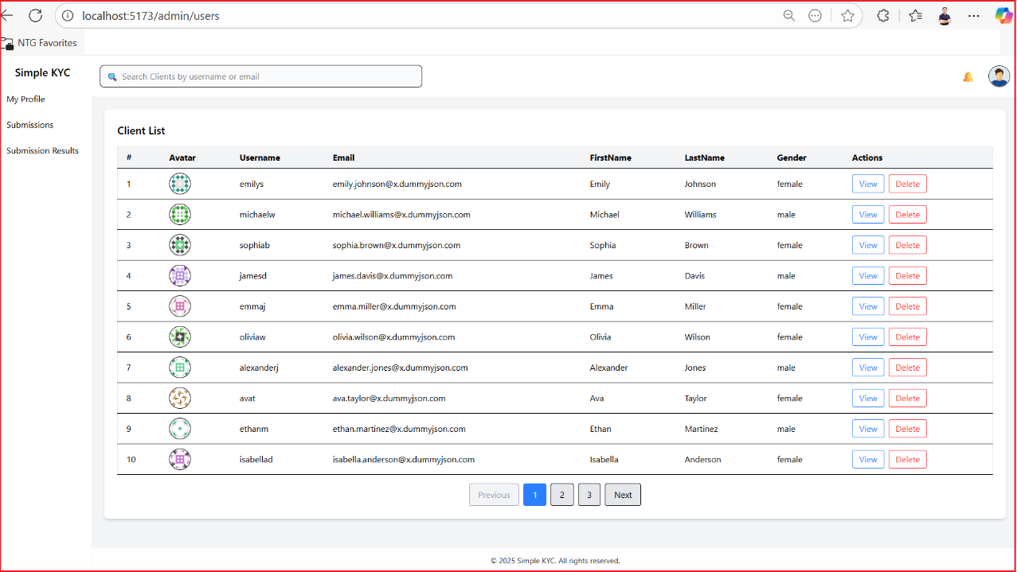

- Officers can enter text in the Search box to filter the Client List.
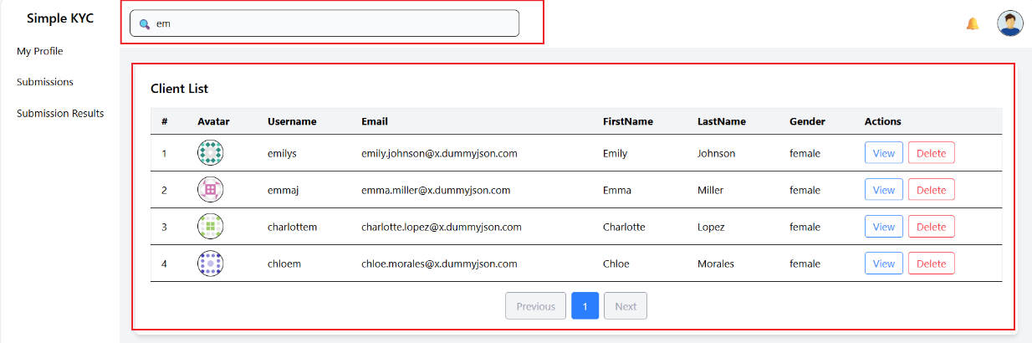

- Officers can click Delete to remove a client record. Yes and No buttons will be displayed in-line.
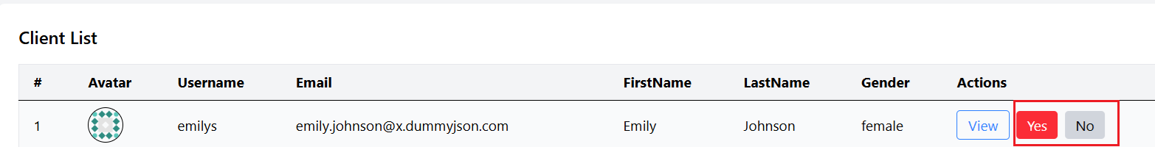

- Officers can use the pagination numbers to move between pages.
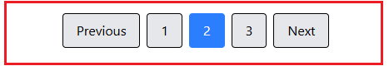

- Officers can view the Profile page in read-only mode by clicking View.
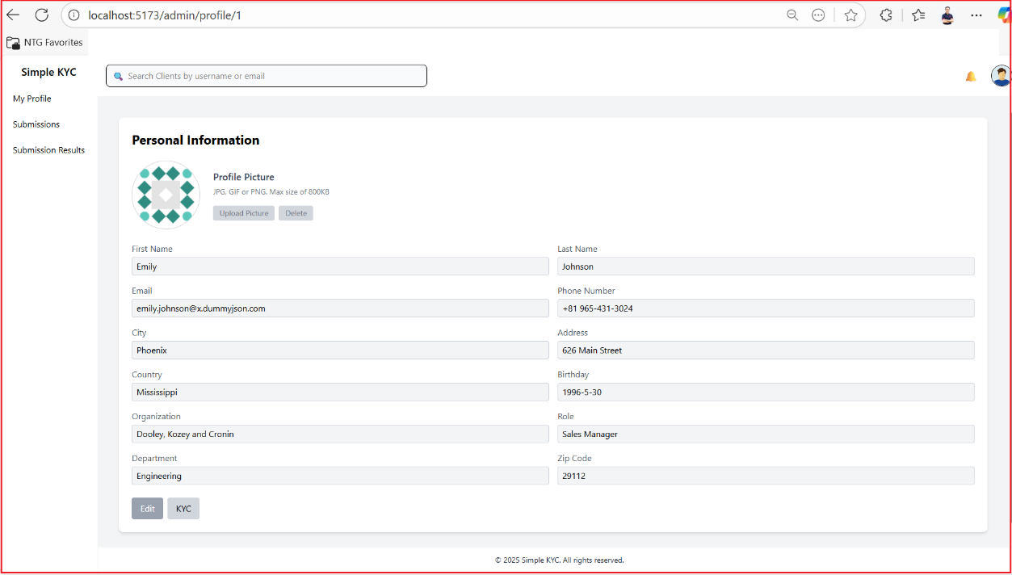

- Officers can access the KYC page in read-only mode by clicking the KYC button.
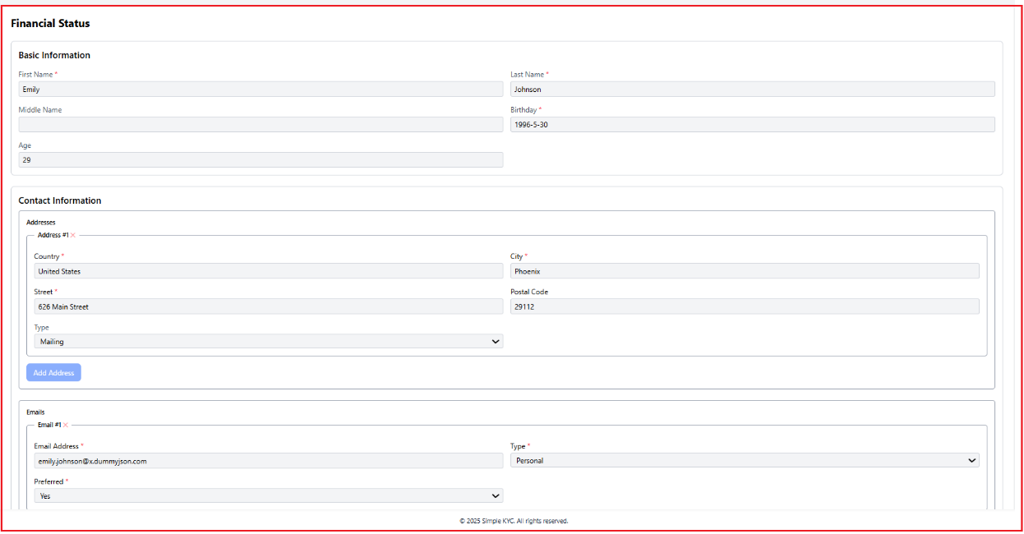

  - My Profile screen (role officer)
Officers can click the Edit button to update their Profile or click KYC to navigate to the KYC page. Since the data on these screens belongs to the officers, they have the rights to update it.
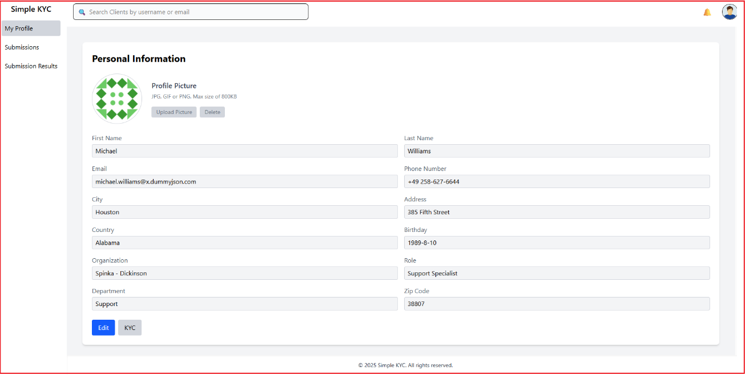

  - Submissions screen (role officer)
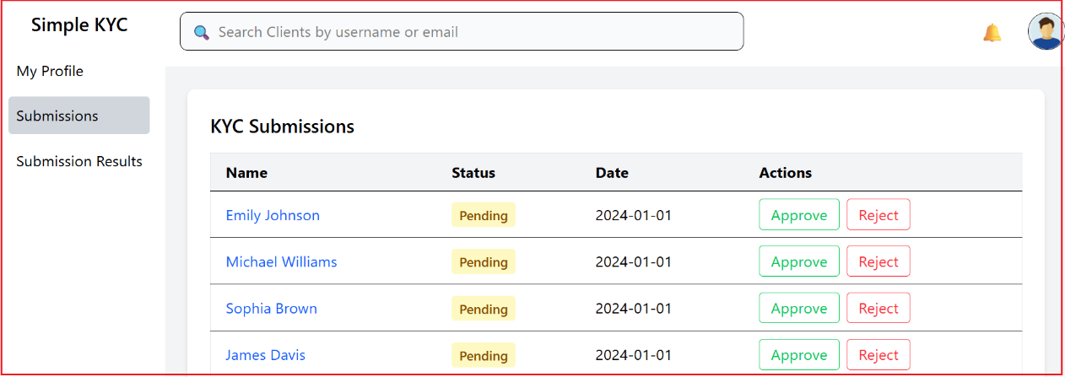

Officers can click the Approve/Reject buttons to approve or reject submissions. A confirmation message will be displayed in-line.

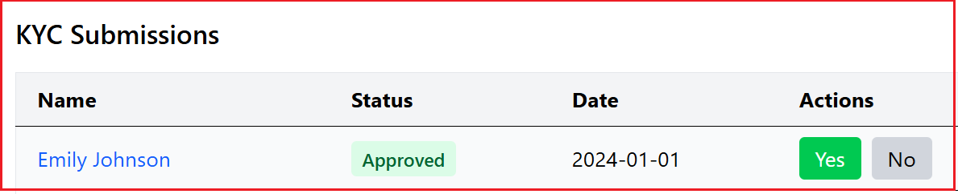

Officers can click on the Name hyperlink to access the submission result.

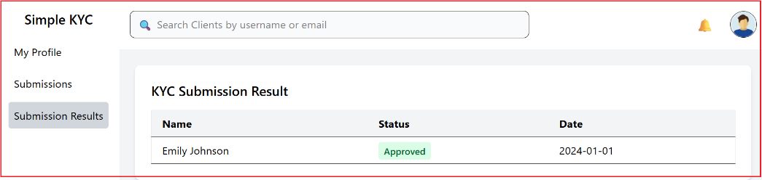

  - Submission Results screen (role officer)
Officers can access Submission Results to see their results.

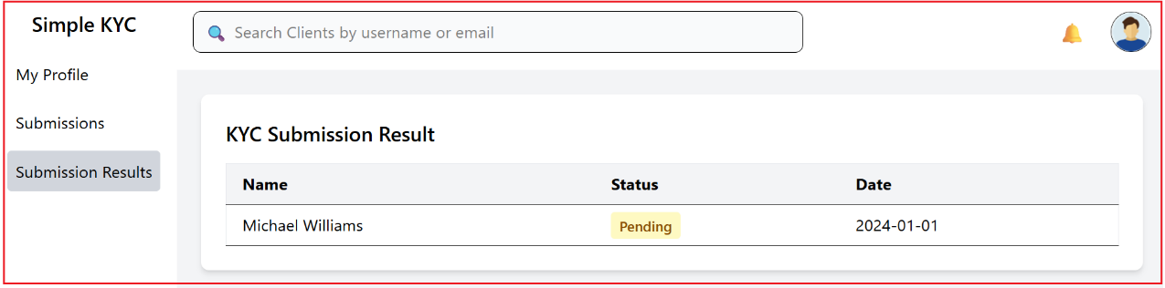

  - User Menu (role officer)
Officers can click the User Menu to access their Profile, Client List, or log out.

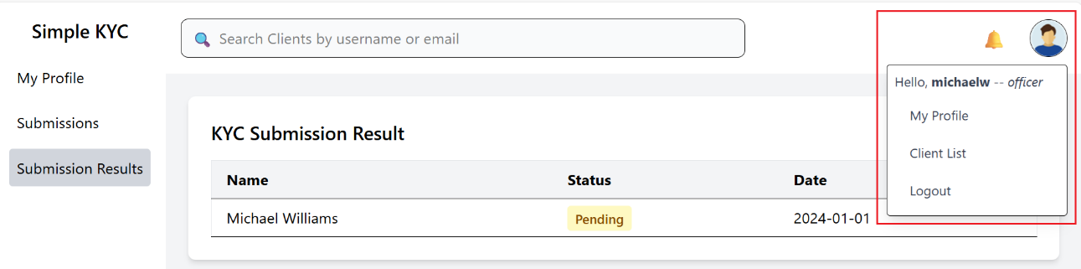

  - Dashboard (role user)
After logging in successfully with the user role, the system navigates to the Profile screen. Users can click the Edit button to update their profile, or the KYC button to navigate to the KYC screen, just like the officer role.

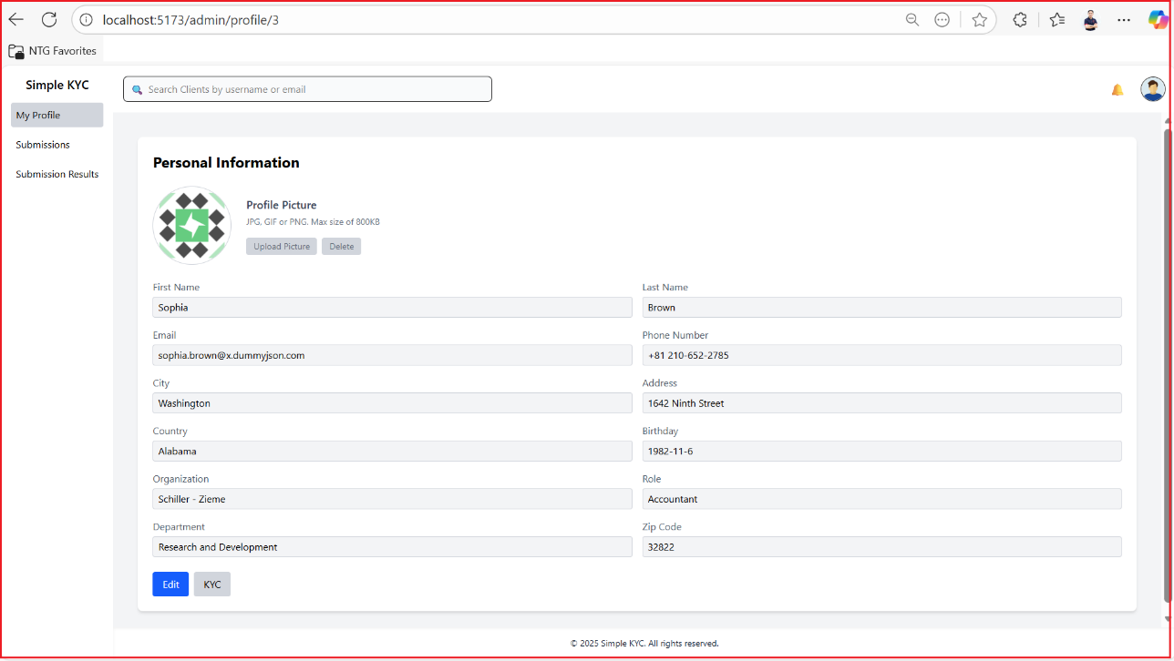

  - Submissions screen (role user)
Users do not have access to the data on the Submission screen.

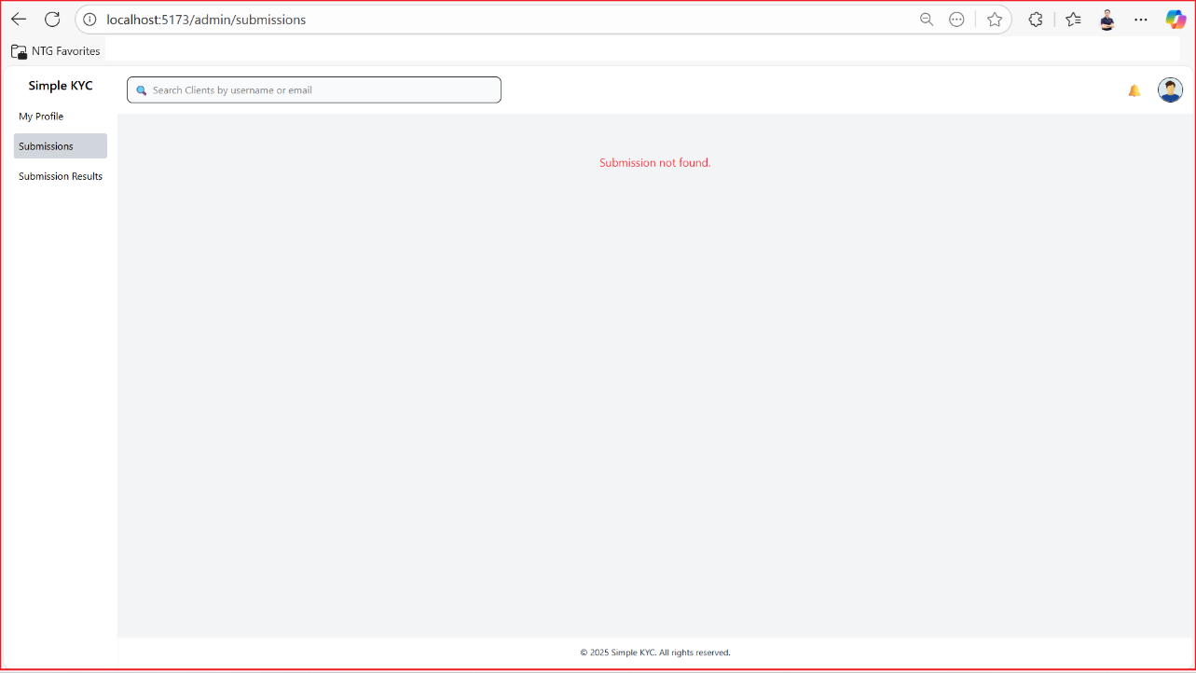

  - Submission Results screen (role user)
Users can click Submission Results to access their result data, similar to the officer role.
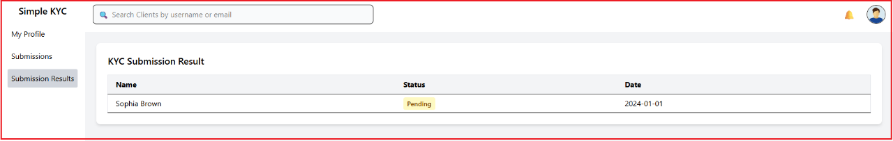

  - User Menu (role user)
Users can open the User Menu to access their profile or log out.

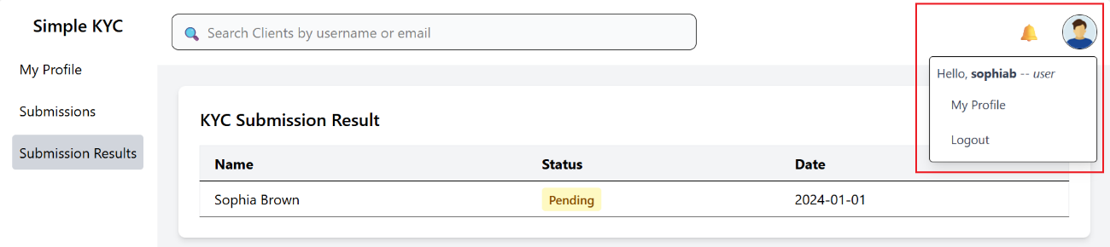

Self-Assessment
This practice has been completed with some basic functionalities such as Login, Sign Up, Load Client List, and Approve/Reject Submission. My self-assessment score is 8/10.

Conclusion
Because of my lack of knowledge about ReactJS, I may have made many mistakes in my code. I would really appreciate your assessment.

--- End ---

