1. Overview
This document describes the end-to-end authentication flow for the full-stack application deployed on Azure Kubernetes Service (AKS).

The application uses OpenID Connect (OIDC) with the identity provider:

https://id-dev.mindx.edu.vn
Authentication is handled through a frontend-driven login flow and a backend token validation mechanism, following modern industry best practices.

Architecture Overview
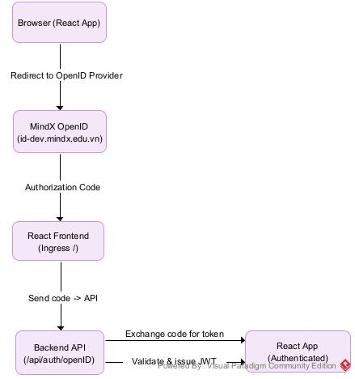

Components Involved

Frontend (React)
-Handles login & logout UI

-Initiates OpenID login redirect

-Stores authentication state

-Sends JWT token with API requests

Backend (Node.js API)
-Handles OpenID callback

-Exchanges authorization code for tokens

-Validates tokens

-Protects API endpoints using middleware

OpenID Provider
-Authenticates users

-Issues authorization codes & identity tokens

Ingress Controller

Routes:
/ → React frontend

/api/* → Backend API

4. Authentication Flow (Step-by-Step)

Step 1: User clicks Login
Frontend redirects user to OpenID provider:
GET https://id-dev.mindx.edu.vn/authorize
?client_id=xxx
&redirect_uri=https://your-domain/auth/callback
&response_type=code
&scope=openid profile email

Step 2: User authenticates
-User logs in via MindX identity system
-On success, OpenID redirects back:
https://your-domain/auth/callback?code=AUTH_CODE

Step 3: Frontend sends code to backend
React sends authorization code to API:
POST /api/auth/openid
{
"code": "AUTH_CODE"
}

Step 4: Backend exchanges code for token
-Backend calls OpenID token endpoint:
POST https://id-dev.mindx.edu.vn/token

-Receives:

+id_token

+access_token

+expires_in

Step 5: Backend issues application JWT
-Backend:

+Validates OpenID response

+Extracts user info

+Issues internal JWT

Step 6: Frontend stores token
-Frontend stores JWT securely

5.Authenticated API Requests
GET /api/dashboard
Authorization: Bearer <JWT_TOKEN>
-Backend middleware:

+Verifies JWT signature

+Checks expiration

+Attaches user context to request

Route Protection

Frontend
Protected routes using React Router

Redirect unauthenticated users to /login

Backend
authMiddleware → verify JWT → allow / deny

Logout Flow
Frontend:

+Clears stored JWT

+Redirects to login page

8. Security Considerations

- HTTPS enforced via Ingress + cert-manager
- Tokens never exposed in URL
- JWT expiration enforced
- Backend validates all protected requests
- No sensitive secrets stored in frontend

9.Troubleshooting Checklist

Issue | Check
Login redirect fails | Redirect URI mismatch
Token invalid | Clock skew / wrong secret
API returns 401 | Missing Authorization header
Frontend logout fails | Token not cleared
HTTPS issues | Ingress TLS / cert-manager

