|  |  |  |
| --- | --- | --- |
| **LAB211 Assignment** | **Type:** | **Short Assignment** |
| **Code:** |  |
| **LOC:** | **250** |
| **Slot(s):** | **6** |

1. Define class Address with properties and methods as picture below:

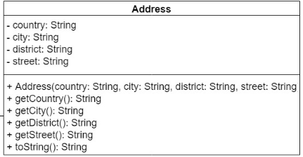

1. Using the Address class, define the Student class. Design a class diagram of the Student management program in 2 departments of IT and Biz

Know that:

➢ Information of IT students including: Id, Full name, address, Java score, CSS score and average score;

➢ Student information of Biz faculty includes: Id, Full name, address, accounting score, marketing score and average score.

In there:

➢ Average score of IT students = (3* diemJava + diemCss)/4;

➢ Average score of Biz students= (keToan*2 + marketing)/3;

2. Enter the information of 10 students, each faculty has 5 students. (Each faculty has 3 students with addresses in Da Nang city and 2 students from any province).

3. Export Student list including name and GPA.

4. Sort and print the list of Students by name.

5. Count and print out the number of students in the same city of 2 faculties.

6. **Update/Delete**: The program allows user find a student by ID. After finding a student by Id, a question is displayed (Do you want to update (U) or delete (D) student. If user chooses U, the program allows user updating. Choose D for deleting student.

**7. Report**: Total passed subjects of student. Information display include: Student name, total passed subjects, list of subject name passed, grade of ever subject.(The GPA of Pass subjects has grade point average greater than or equal to 5)