**Online Shopping Cart Project**

1. **Team Introduction:**

**Member:**

Full Stack: BUI ANH HUY – SE140028 – huybase140028@fpt.edu.vn

1. **Case Study:**

Unlike others online shopping cart project. Because of unhealthy food, polluted environment, it causing health problem to human. So my **One Man Sale** sell health products to handle these problem. With features:

-User Login/Logout.

-Different Page for Admin/User.

-CRUD Products.

-Add to Cart/Remove from Cart/View Cart.

-Checkout.

1. **Database Design:**

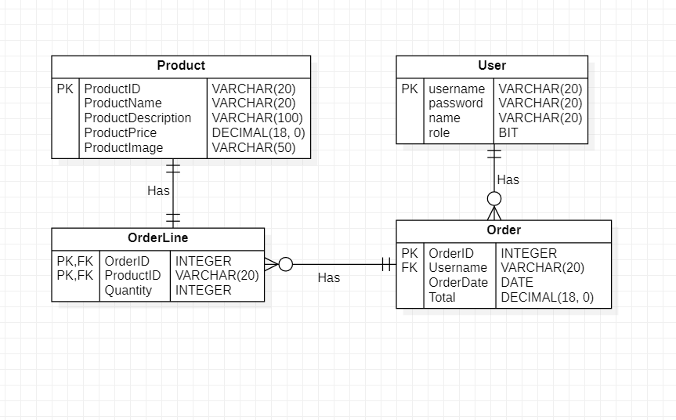

Figure . ER Diagram

1. **System Design:**

I design the system based on MVC Model 2 with:

Product/User/Order DTO, DAO as Model

JSP as View

Java Servlet/ Filter as Controller

SQL JDBC as Database Management System

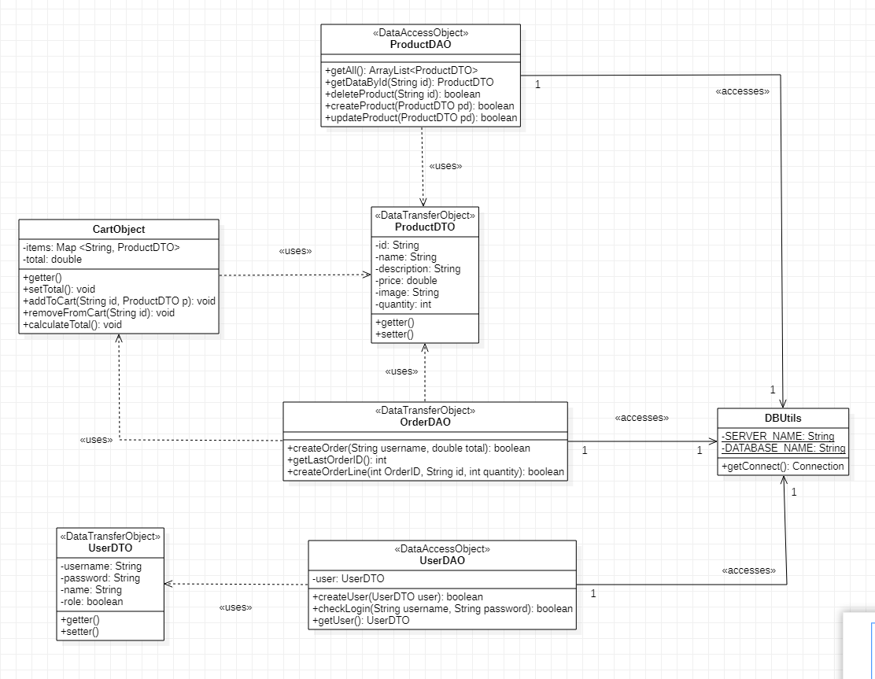

Figure 2. Class Diagram

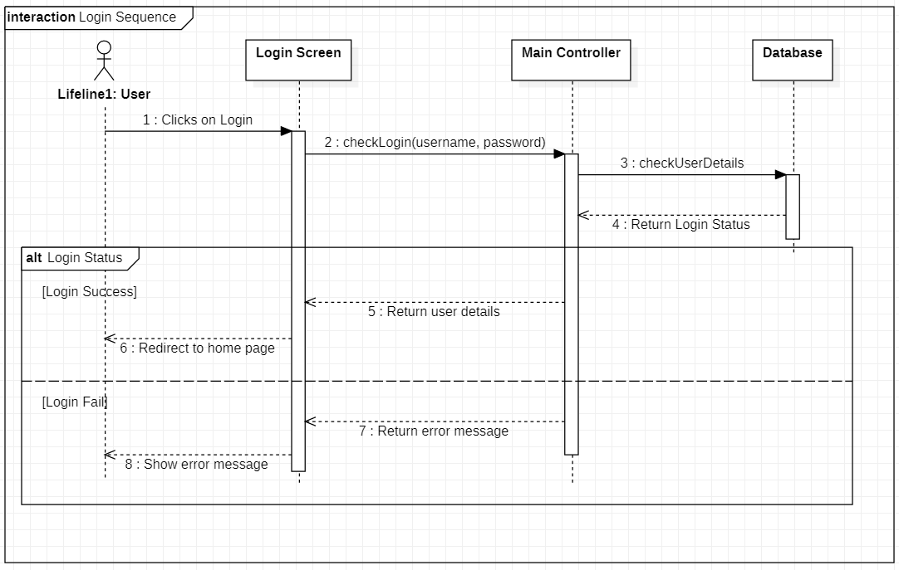

Figure 3. Login Sequence Diagram

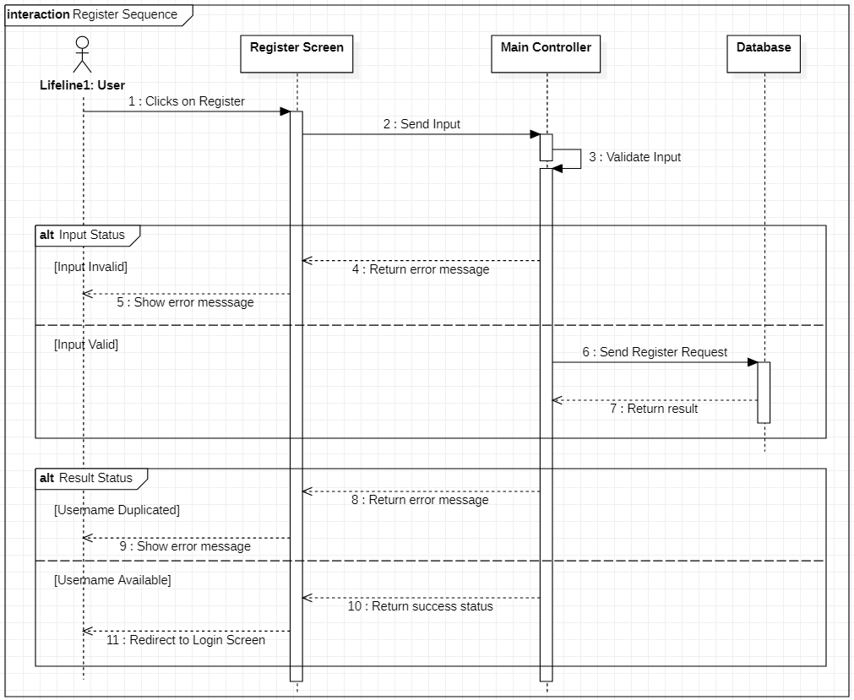

Figure 4. Register Sequence Diagram

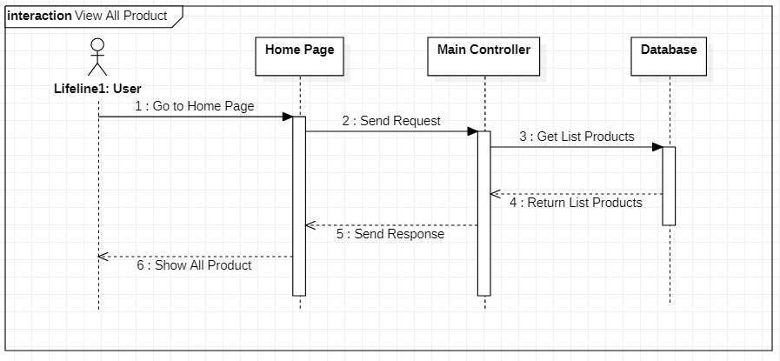

Figure 5. View All Product Sequence Diagram

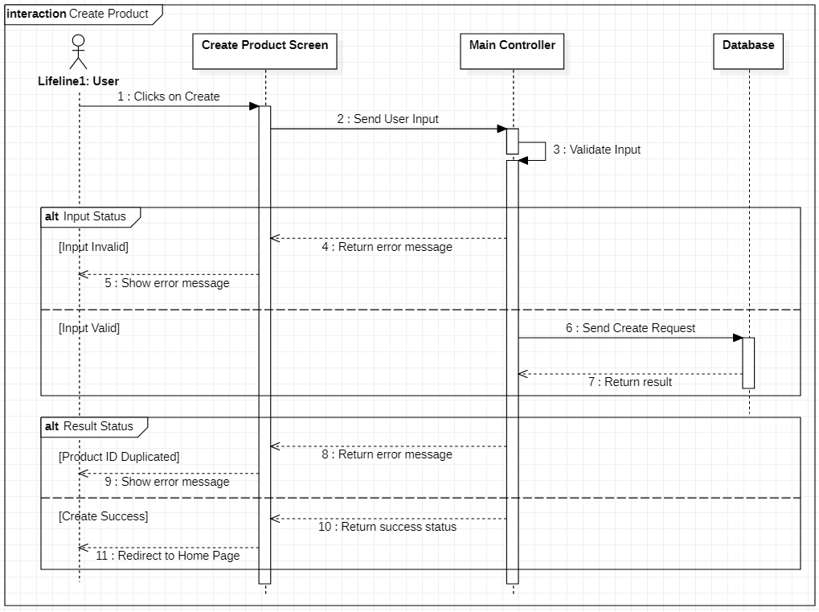

Figure 6. Create Product Sequence Diagram

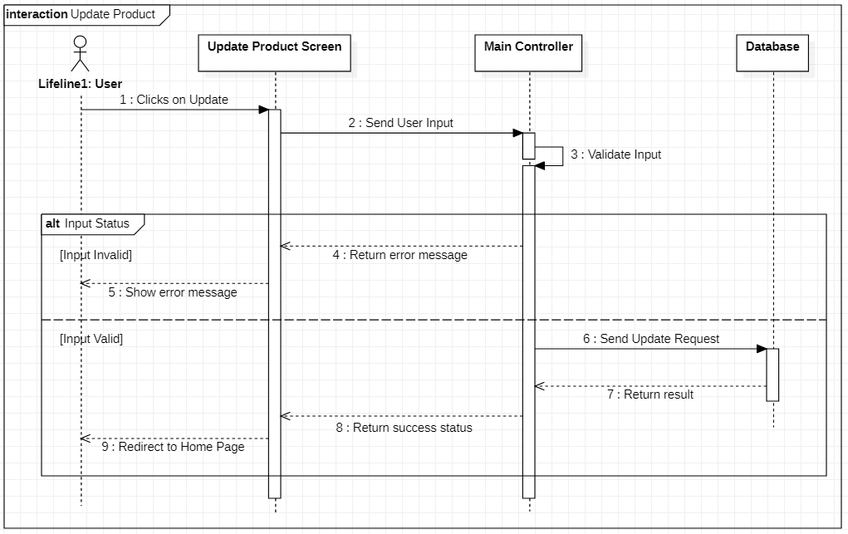

Figure 7. Update Product Sequence Diagram

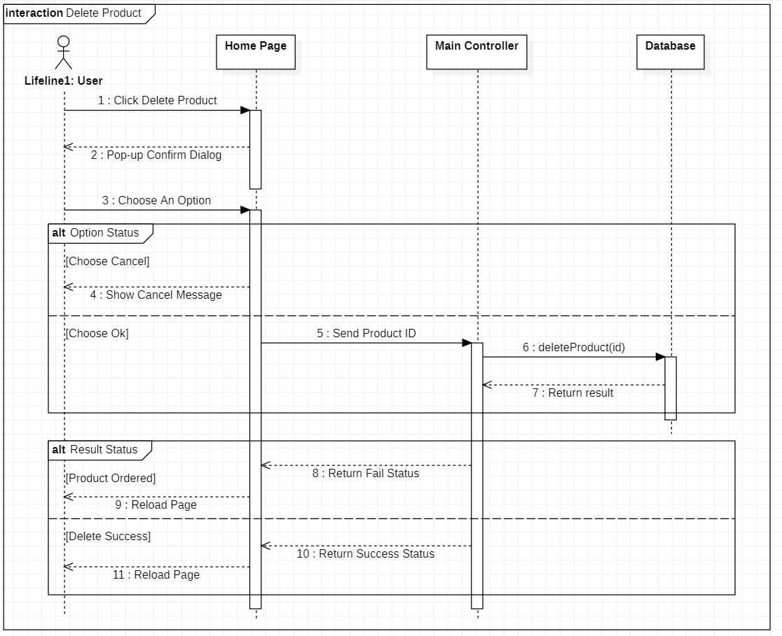

Figure 8. Delete Product Sequence Diagram

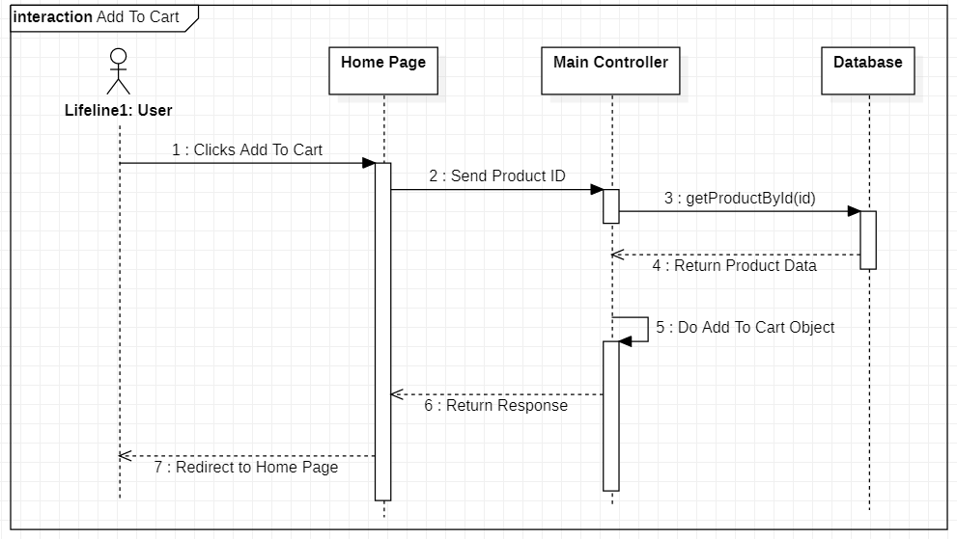

Figure 9. Add to Cart Sequence Diagram

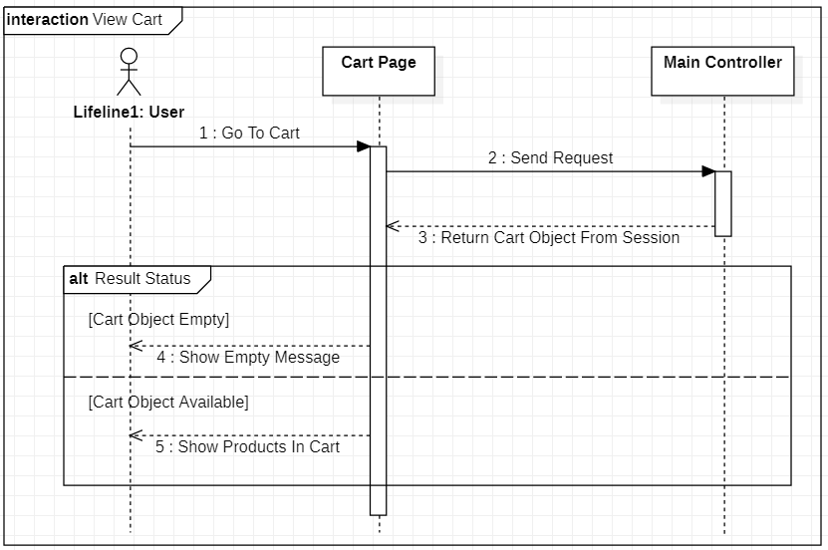

Figure 10. View Cart Sequence Diagram

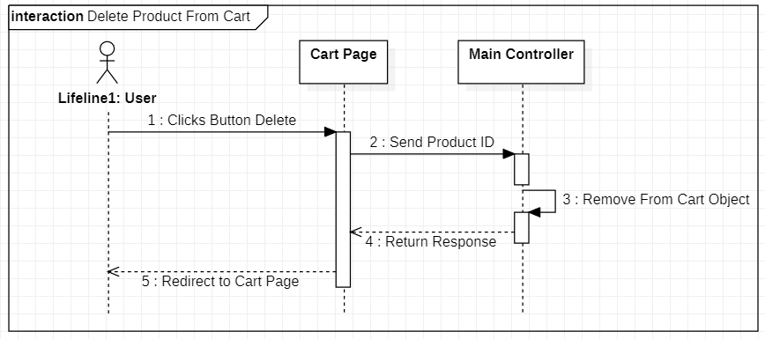

Figure 11. Delete Product from Cart Sequence Diagram

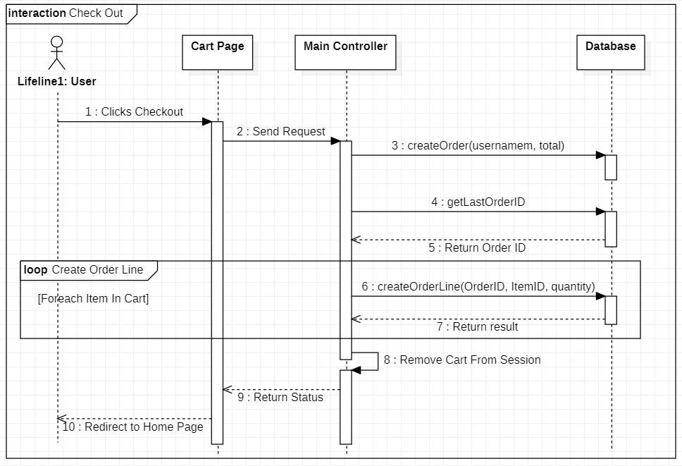

Figure 12. Check Out Sequence Diagram

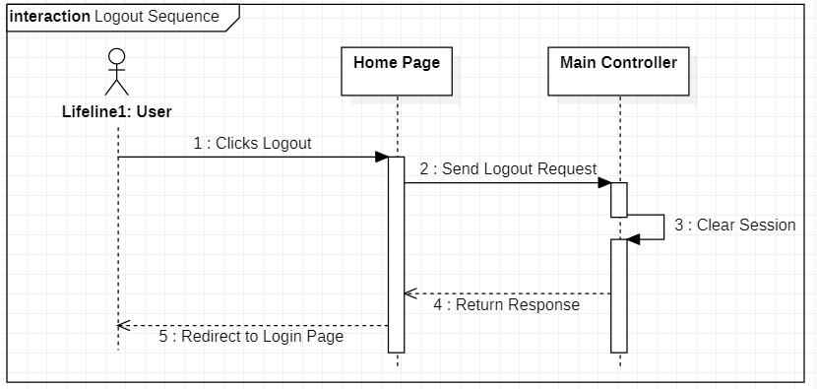

Figure 13. Logout Sequence Diagram

1. **Screenshot:**

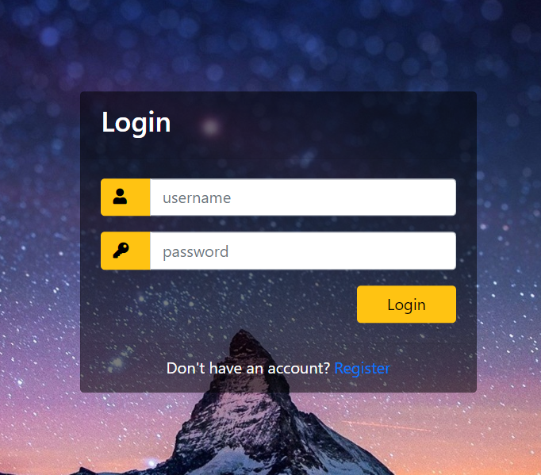

Figure 14. Login Page

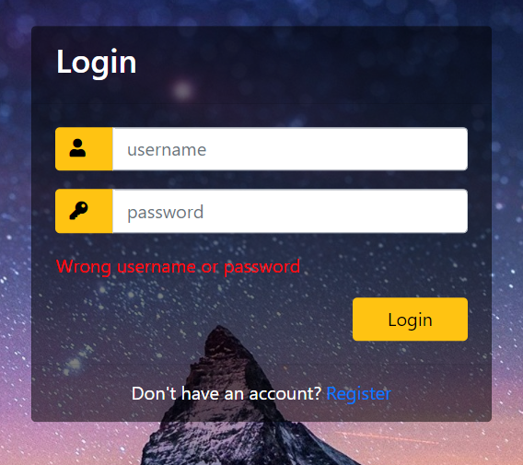

Figure 15. Login Page Error Message

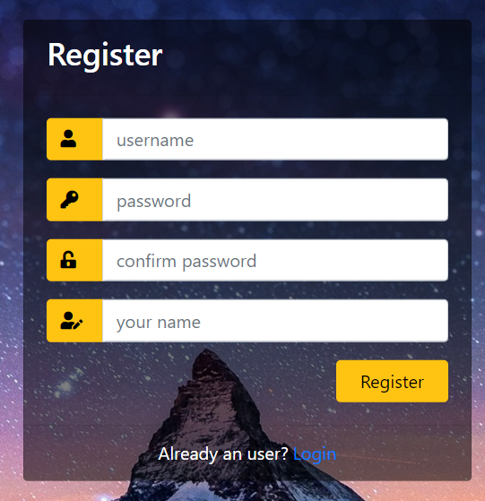

Figure 16. Register Page

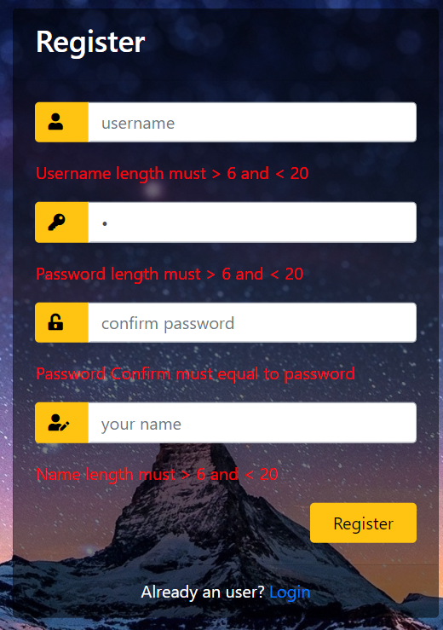

Figure 17. Register Page Error Message

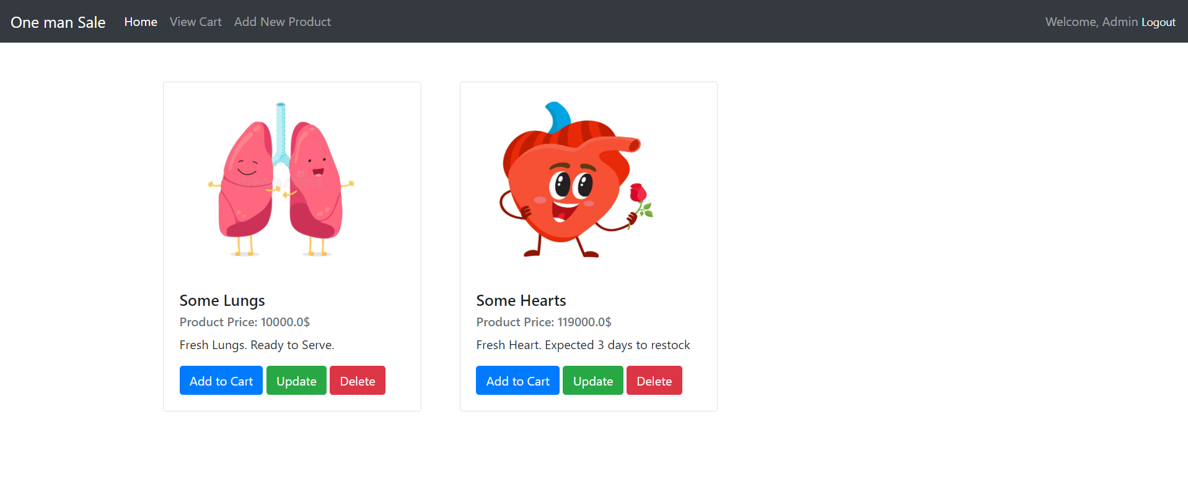

Figure 18. Home Page as Admin

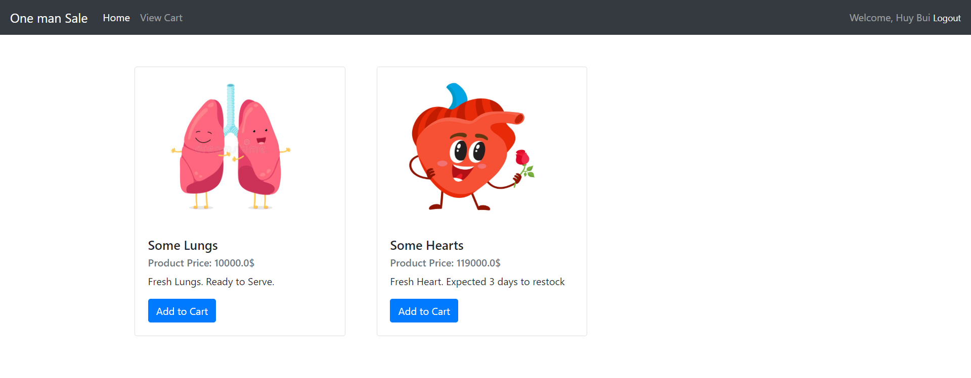

Figure 19. Home Page as User

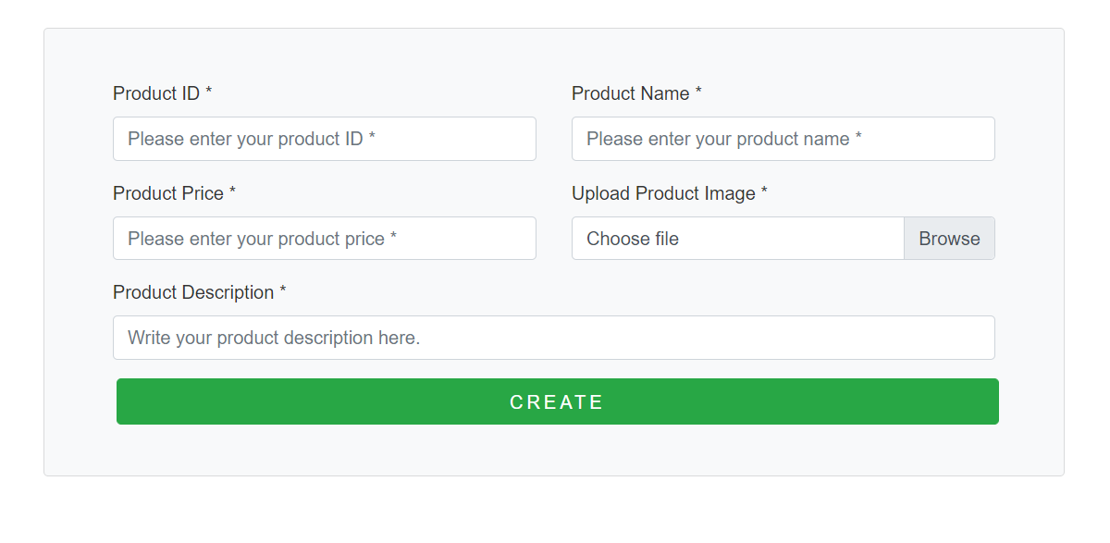

Figure 20. Create Page

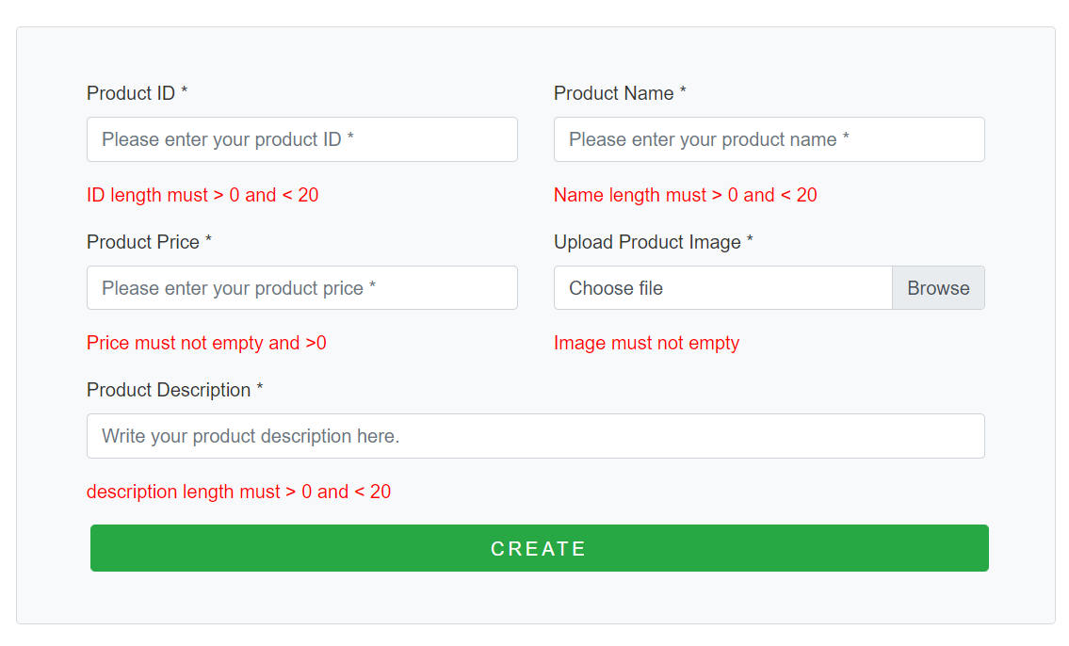

Figure 21. Create Page Error Message

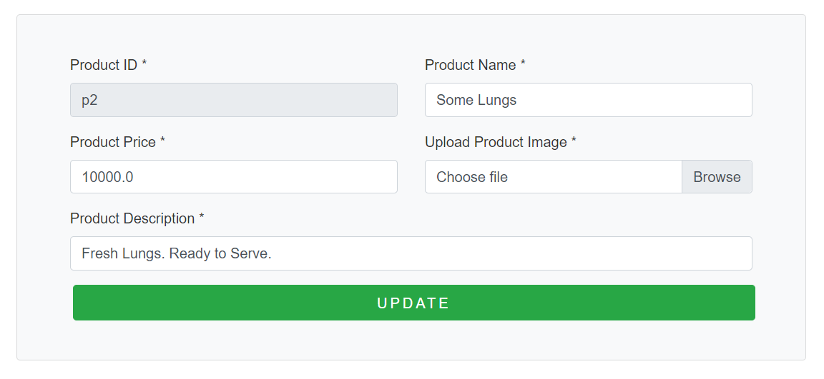

Figure 22. Update Page

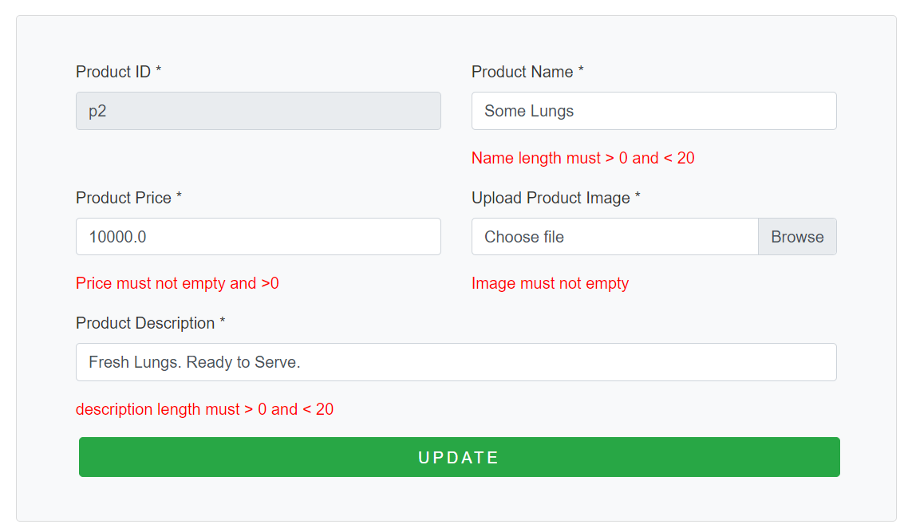

Figure 23. Update Page Error Message



Figure 24. Cart Page when no product added

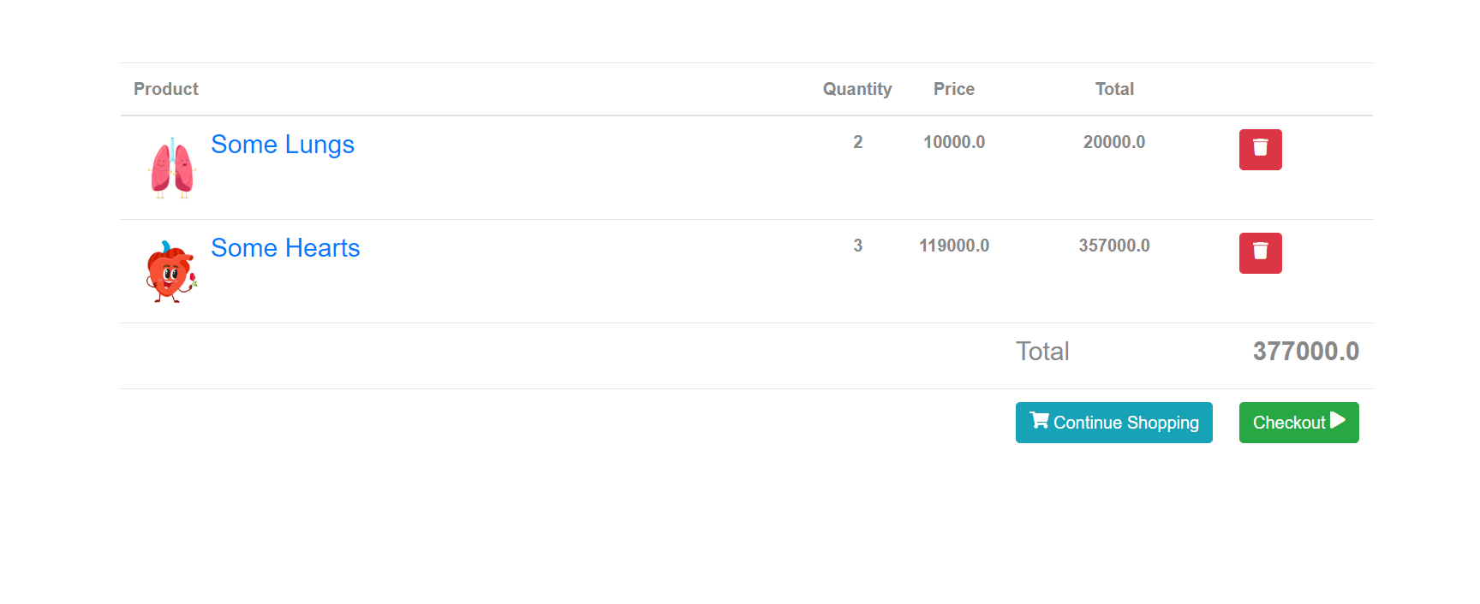

Figure 25. Cart Page with products added

1. **Conclusion and Discussion:**

Pros: Easy to use, maintain, scale project.

Cons: Lack of security implementation, might be attacked by hackers.

I learned how to build web app from 0, using MVC model 2 with Servlet Controller. Learned how to write the specification of my project.

If having more time, I will improve the UI/UX, add more features, secure my web app.

1. **Contribution:**

|  |  |  |
| --- | --- | --- |
| **Topic** | **Team**  **Effort** | **HuyBA – SE140028** |
| **Case Study Analysis** | 100% | 100% |
| **Database design** | 100% | 100% |
| **System design** | 100% | 100% |
| **Implementation** | 100% | 100% |
| **Documentation** | 100% | 100% |