224:

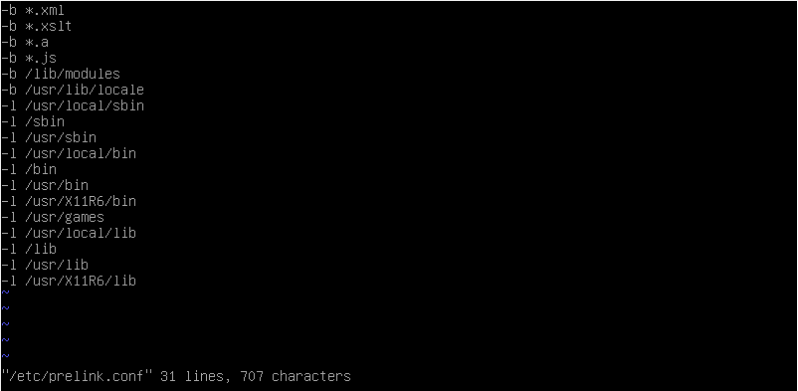





240:



241:



System doesn’t reboot after 60s

246:

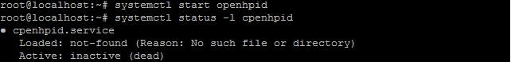

249: