**Data Sources:**

We use Yelp API (<https://www.yelp.com/developers/documentation/v3/get_started>) and Nextbus API (<http://www.nextbus.com/xmlFeedDocs/NextBusXMLFeed.pdf>) to retrieve information about restaurants and shuttle-UM routes. The data are originally in JSON and XML formats. We convert them into Excel format in order to apply pre-processing processes. Our data include data of 2793 restaurants in 15 cities nearby University of Maryland with information of 7980 reviews and 5525 customers; and data of 25 Shuttle-UM route schedules with 315 bus stops.

**Installation:**

Please install the following:

1. Python 3.0 +
2. Jupyter Notebook
3. R Studio
4. R
5. Tableau
6. Python libraries -> Pandas, Numpy, re, regex, pprint, string, nltk
7. ArcGIS 10.3

**Results and Output:**

Restaurant Review Text Analysis:

(Run [Final Sentiment Analysis.ipynb](http://localhost:8888/notebooks/Final%20Sentiment%20Analysis.ipynb) )

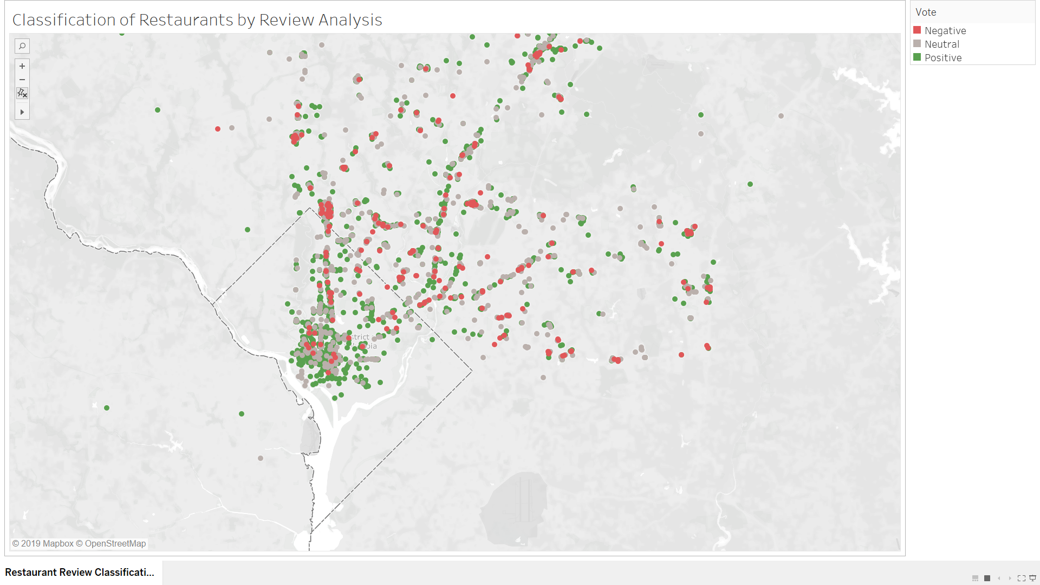

**Selecting the appropriate location:**

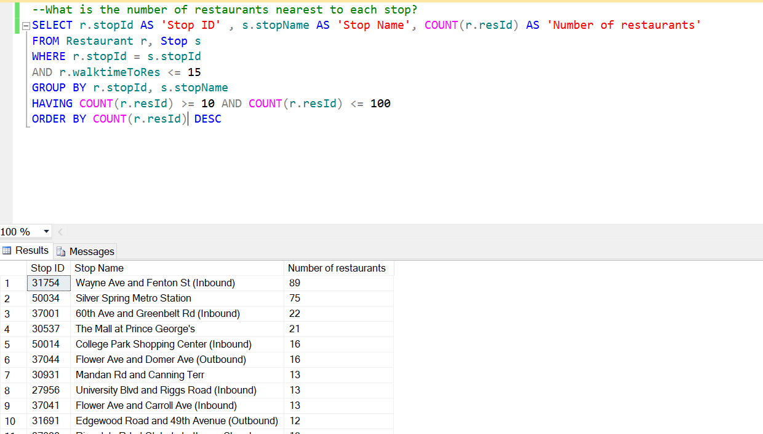

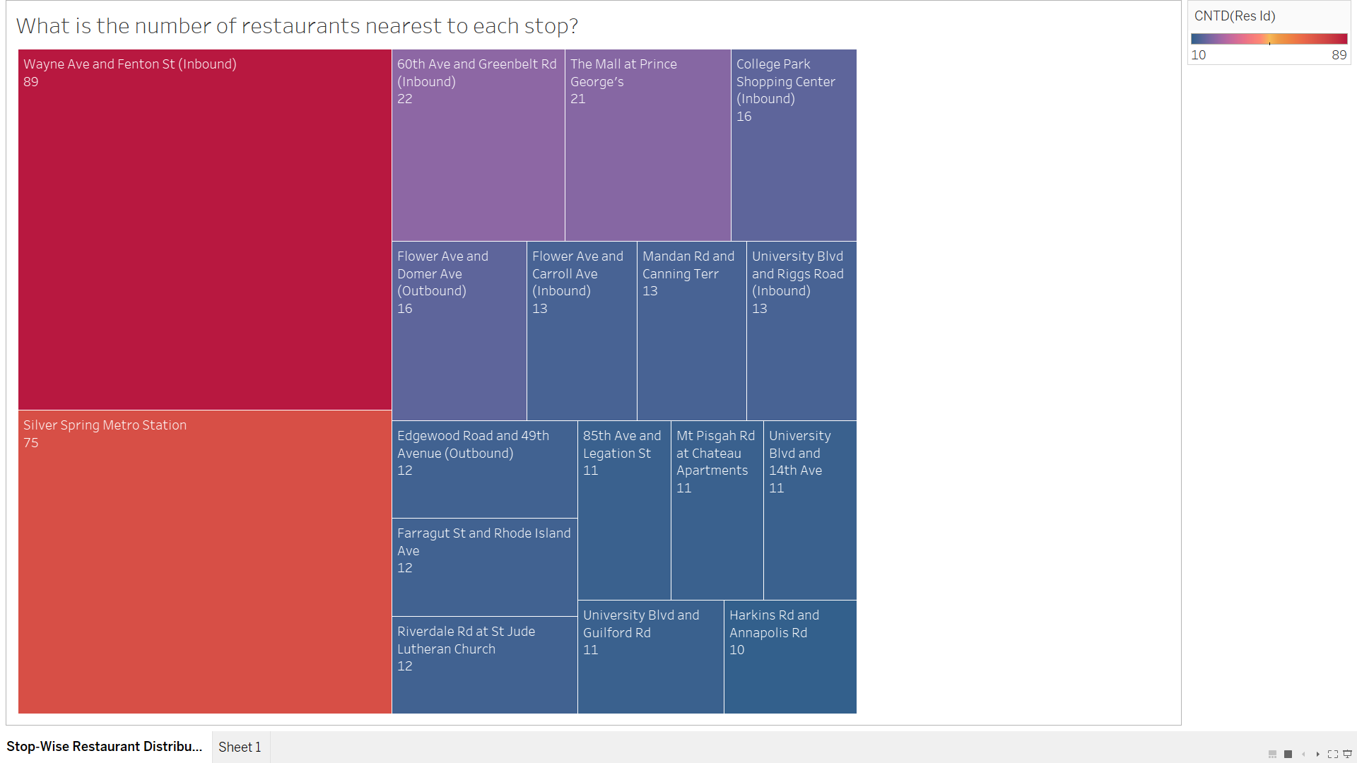

**Selecting the appropriate Restaurant Theme:**

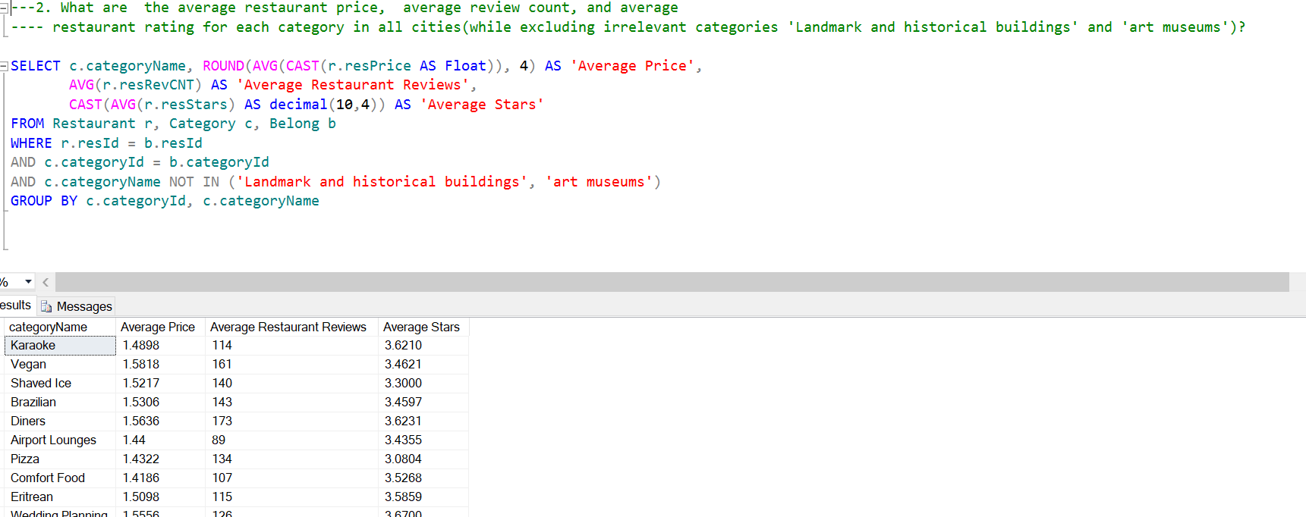

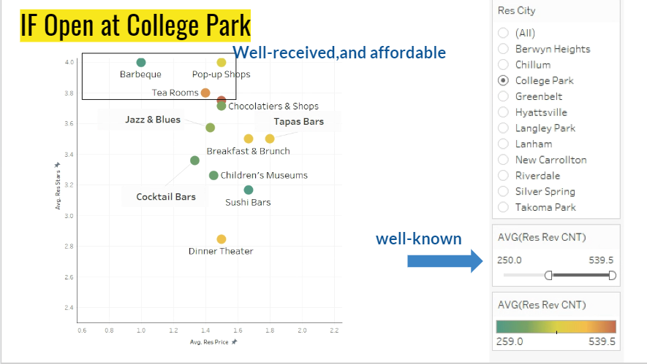

**City-Wise Restaurant Division:**

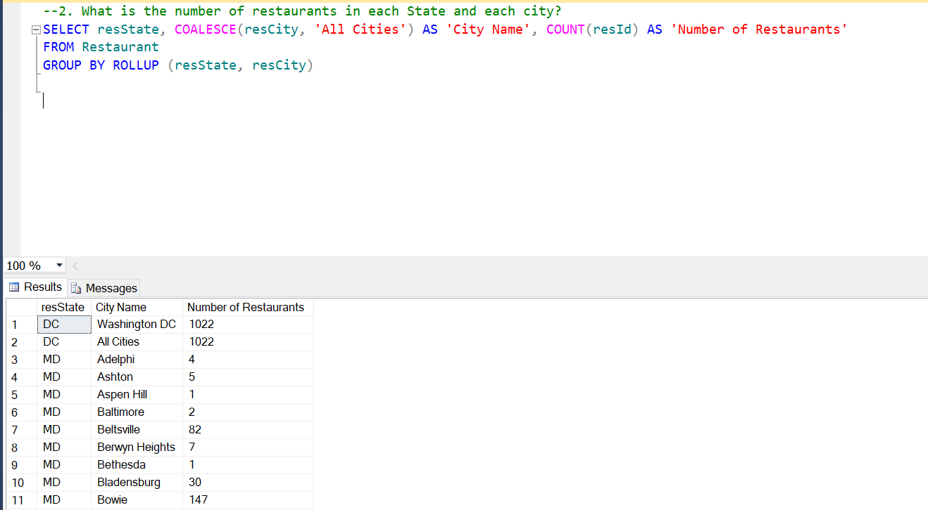

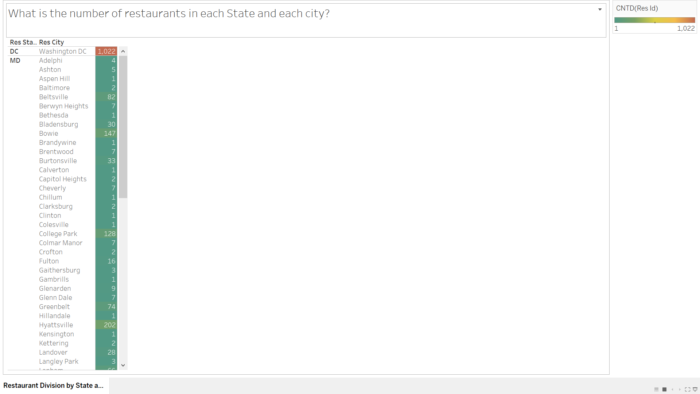

**City-Wise Category and Restaurant Division**

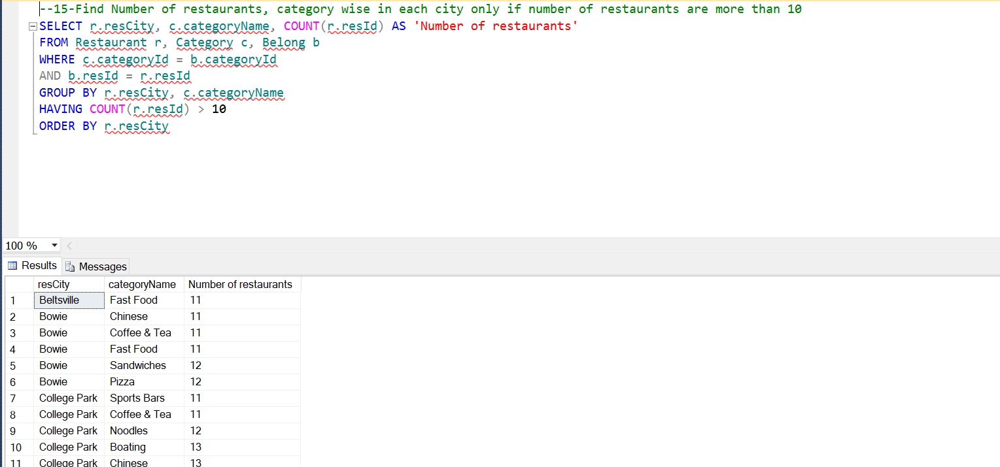

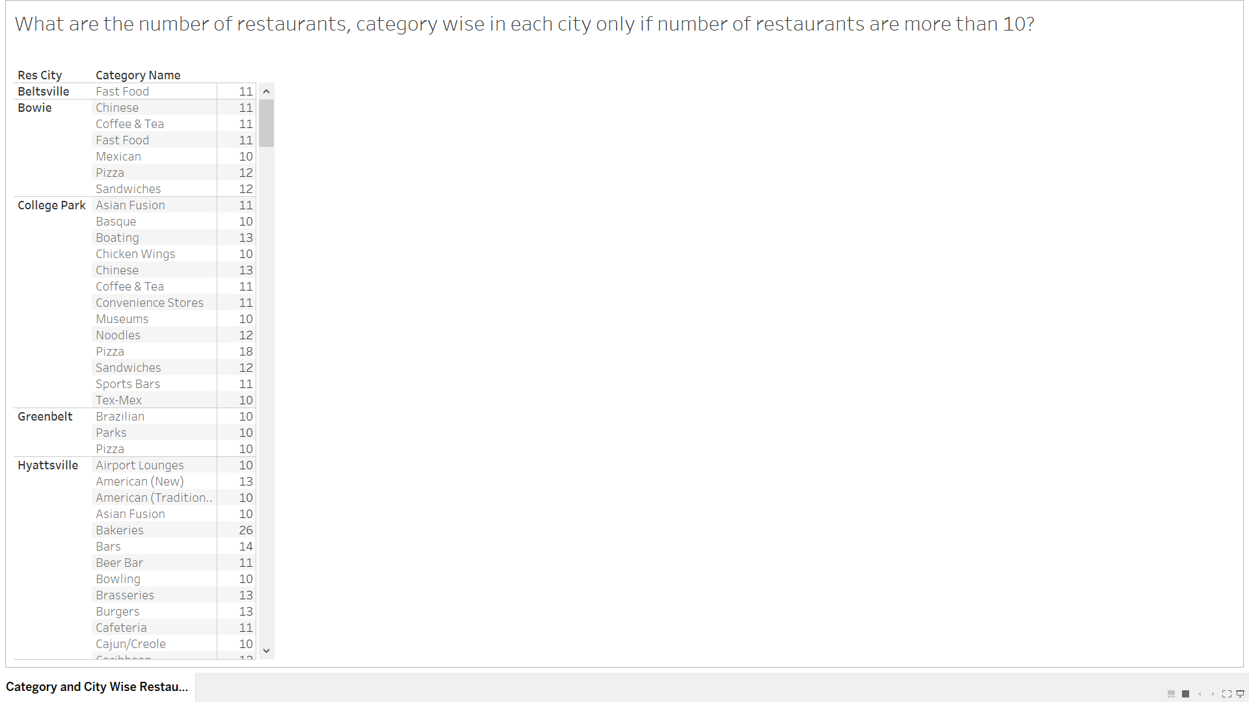

**Delivery Providing City Wise Restaurant Division**

