**VIETNAM NATIONAL UNIVERSITY**

INTERNATIONAL SCHOOL

---o0o---

**FINAL EXAMINATION**

***Big Assignment***

**Course Title: DATABASES**



Course Code: INS208001

Group: 14 – Hotel management system

Leader: Doãn Văn An - 21070236

Member: Lê Thúy Huyền - 21070410

Hoàng Ngọc Khoa – 21070330

Đỗ Linh Chi - 20070905

Total mark (written in number):

Total mark (written in words):

Marker’s signature:

Table of content

I. INTRODUCTION 3

***1.*** ***Brief information of group*** 3

***2. Brief information of the project*** 3

II. DATABASE DESIGNING 3

III. Defined tables: Design the tables, column and relationship 5

IV. WRITING QUERIES AND TRIGGERS AND VIEWS: 11

**1.** **Trigger for insert** 11

**2.** **Trigger for delete** 11

**3.** **View details of all employees** 11

**4.** **View details of all guests** 12

**5.** **How many distinct guests have made bookings for a particular month?** 12

**6.** **How many total rooms, total room booked, available rooms are in a particular hotel for a given date?** 12

**7.** **How many hotels are in a hotel chain?** 12

**8.** **How many books has a customer made in one year?** 12

**9.** **How many rooms are booked in a particular hotel on a given date?** 12

**10.** **List all the unique countries hotels are located in.** 12

**11.** **How many rooms are available in a given hotel?** 12

**12.** **List all the hotels that have a URL available.** 12

**13.** **List the rate for a room at a given time during the year.** 12

V. CHALLENGES FACED: 13

VI. SUMMARY: 13

VII. INDIVIDUAL CONTRIBUTION: 13

1. **INTRODUCTION**
2. ***Brief information of group***

***Group’s Name:*** Group 14

***Topic:*** Hotel Database Management System

***Mentor:*** Mr. Truong Cong Doan, VNU–International School course’s lecturer of Database

***Progression:*** With the guidance from Mr. Doan, we developed the project to calculate the fees and salaries for the school's students and teachers or staff. From the lessons of Database, we learned how to use functions to write this project. Finally, after working together as a team and the advice from our lecturer, we have improved our project and combined our results in this report

## ***2. Brief information of the project***

In developed countries, the hotel and restaurant industry has developed very strongly and has high profits because of the support of IT. In our country in recent years, the tourism industry has really developed in terms of scale as well as its impact on socio-economic fields. However, the application of IT in the industry is still limited, so the application of IT in the hotel management program for the tourism industry is extremely necessary to improve business efficiency and quality.

Hotel management is a very complex business, requiring a massive management system. Within the framework of this large exercise, we will dive into creating a database management system for a hotel.

The hotel can have multiple chains, which can further have multiple hotels. Therefore, we need an organized management system, which can easily manage all the operations and data of the hotel chains and hotels respectively including:

- The hotel chains, and their details.

- The hotels in each chain and their details and other information like the rooms and their description and discounts, etc.

- Information about employees and departments they work in.

- Information about guests.

- Managing bookings and other services used by the guests

**II.** **DATABASE DESIGNING**

Starting with designing the structure of the database, we have drawn ERD Sketch of how hotel management data is organized to record all necessary data types in an easy and straightforward way. The diagram is generated as follows:

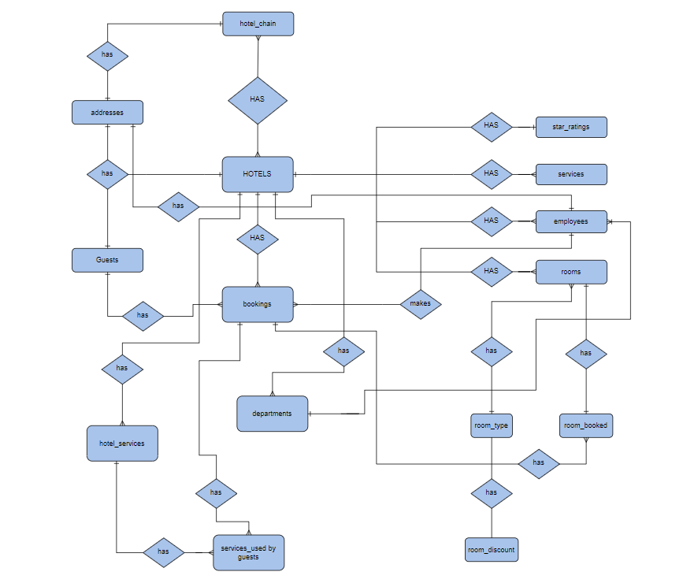

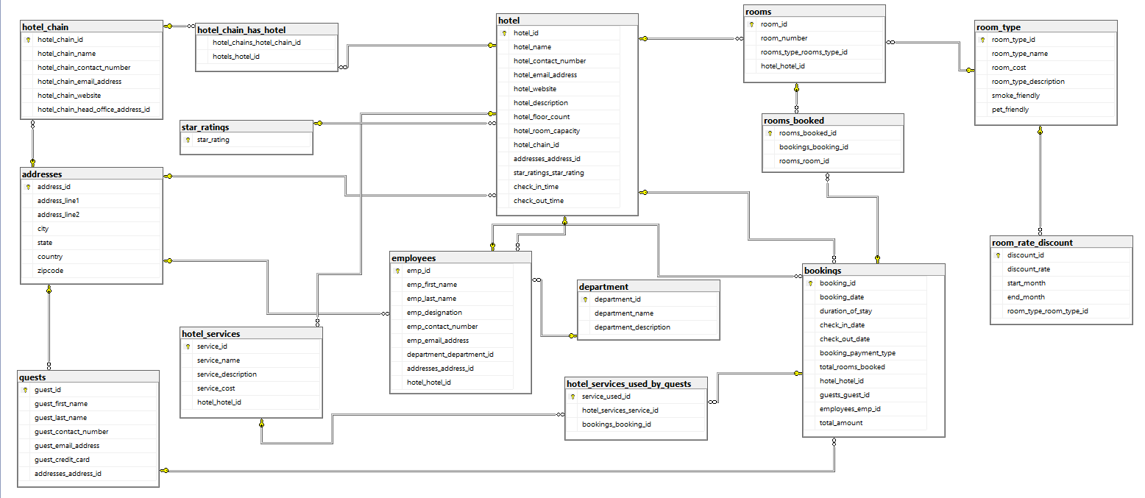After plotting the related ERD we convert it to the corresponding Relational Schema

**III. Defined tables: Design the tables, column and relationship**

We started with designing the structure of the database. We drew the ERD diagram on paper, noting down all the tables required. We designed each table with columns and attributes respectively. I have designed the below tables:

*Booking* table contains data about the booking made for rooms. The primary key for this table is booking_id

The table has the following foreign keys:

hotel_hotel_id which has a many-to-one relationship with the hotel table.

guests_guest_id which has a many-to-one relationship with the guests table. employees_emp_id which has a many-to-one relationship with the employees table.

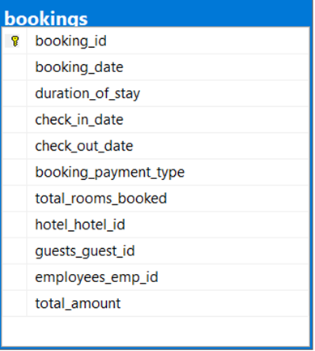

Hotel services table contains info about the services. Primary key for this table is service_id & foreign key is hotel_hotel_id which related to hotel table

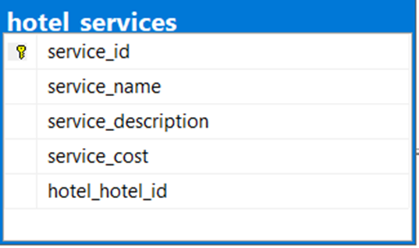

Hotel services used by the guests table contains info about the services used by guests. Primary key for this table is service_used_id

The foreign keys are hotel_services_service_id and bookings_booking_id which relates to hotel_services table & bookings_booking_id relates to bookings table.

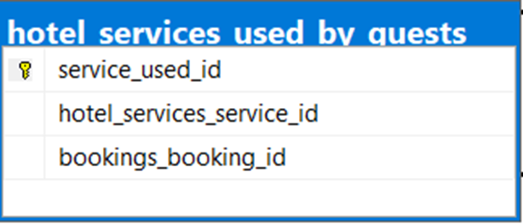

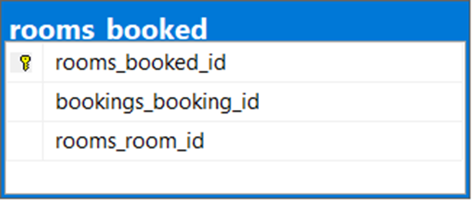

The primary key for the room booked table is rooms booked_id. The booking_id and room_id foreign keys in this table have many-to-one relationships with the bookings table and a one-to-one relationship with the rooms table, respectively.

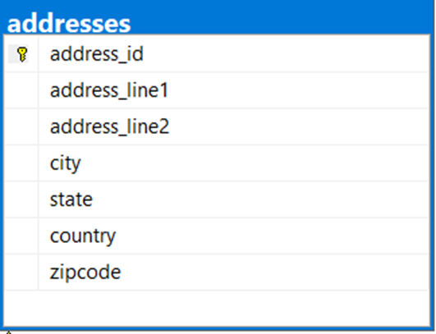

The information about the addresses of guests, hotels, hotel chains, and employees is defined in the addresses table. Address-id serves as the table's primary key. It keeps up a one-to-one connection with tables, hotel, employees, and guests.

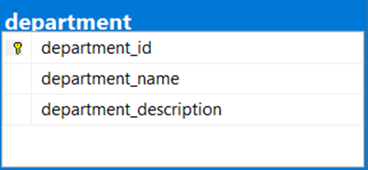

Department : The department table contains details on the various hotel departments. The primary key, department_id, creates a one-to-many relationship with the employees table.

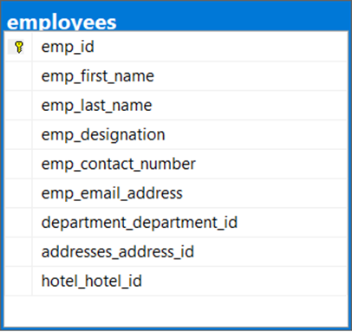

employees: The information in the employees table relates to the employees.

The employee_id is the primary key. There are three foreign keys: Department_department_id indicates many-to-one relationships with the department table. A one-to-one link with the addresses table is indicated by the address_id. Hotel_id, which indicates a many-to-one connection to the hotel table.

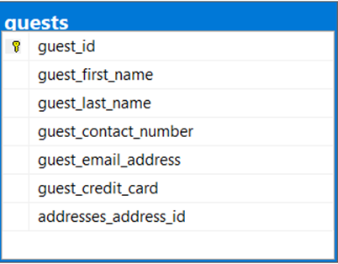

guests table has the data about the guests that check in to the hotel. The primary key of this table is guest_id. There is one foreign key in this table, address_id that has a one-to-one relationship with the address table.

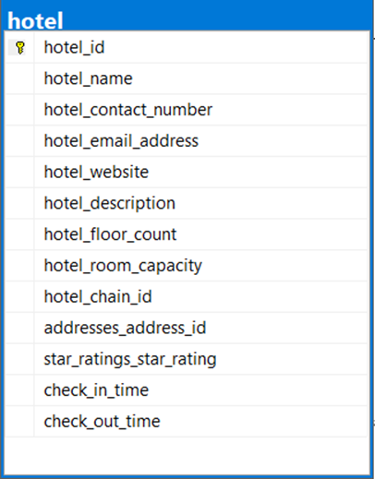

Hotel table has the data about the information of the hotel. The primary key is hotel_id and two foreign keys: Addresses_address_id which has a many-to-one relationship with the address table, star_ratings_star_rating which has a many-to-one relationship with the star ratings table

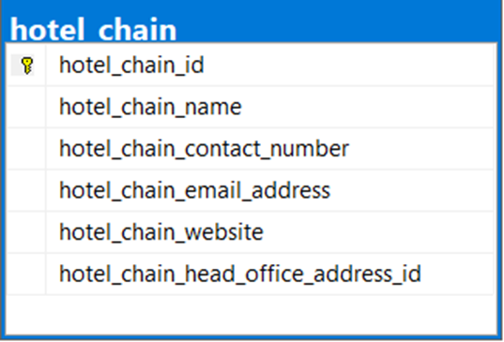

Hotel chain table contains data about the information of the hotel chain. The primary key of this table is hotel_chain_id and one foreign key has one-to-one relationship with the address table

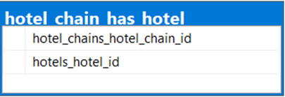

hotel chain has hotel table has two foreign keys: hotel_chains_hotel_chain_id which has a one-to-one relationship with the hotel chain table, hotels_hotel_id has a one-to-one relationship with the hotel table

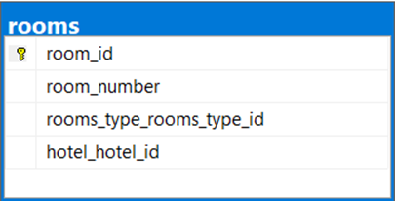

rooms table contains data about room’s information has one primary key is room_id, there are two foreign keys: room_hotel_id has many-to-one relationship with the hotel table, rooms_type_rooms_type_id has many-to-one relationship with the room type table

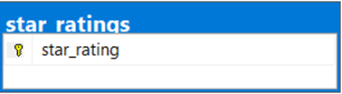

star ratings table has one primary key is star_ratings create a one-to-many relationship with a hotel table

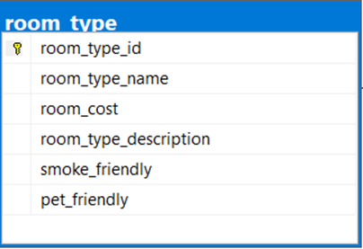

room type table has one primary key is room_type_id. It maintain one-to-one relationship with room and room rate discount table

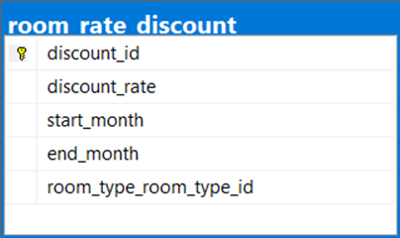

room rate discount table has one primary key is discount_id and one foreign key is room_type_room_type_id has one-to-one relationship with room type table

**Normalization:** Tables should be normalized till 3rd norm

In order to eliminate data redundancy and increase data integrity, a relational database is restructured in line with a number of so-called normal forms. A database is often regarded as normalized if it has been normalized up to the third normal form. Up until the third normal form, we attempted to normalize the database.

# **IV. WRITING QUERIES AND TRIGGERS AND VIEWS:**

Writing down the queries was the easiest part for us. As we put a lot of effort in designing the database and creating relationships in a manner that, it will be easier to fetch the data from two or more tables. We wrote the queries as per the requirements and check in twice with valid as well as invalid data.

1. **Trigger for insert**

For revenue to exceed depreciation expense, the total amount greater or equal 200. Hence, we use TRIGGER, DECLARE, INSERT, FOR, INSERT, FROM, WHERE, IF, PRINT, ROLLBACK TRAN to create Trigger not to insert total amount smaller 200. When we try to insert a booking that have the total amount smaller than 200, the system will print “Can’t insert tenant with total amount < 200”

1. **Trigger for delete**

Customers with total money greater than average total amount are VIP Customers. Hence, we use TRIGGER, ON, FOR, DELETE, DECLARE, INT, SELECT, COUNT, FROM, GROUP BY, HAVING, IF, PRINT, ROLLBACK TRAN to creat Trigger not to delete the VIP Customer. When we delete try to VIP customer, system will print “Can’t delete VIP customer”

1. **View details of all employees**

We use VIEW, SELECT, FROM, JOIN, ON to connect table employees and department to take information from them. Then, we create a view to show all information of employees.

1. **View details of all guests**

We use VIEW, SELECT, FROM, JOIN, ON, WHERE, DISTINCT to create a view to show all information of guests.

1. **How many distinct guests have made bookings for a particular month?**

We use SELECT, FROM, WHERE, SELECT DISTINCT, IN and MONTH to show the distinct guests have made bookings for a particular month.

1. **How many total rooms, total room booked, available rooms are in a particular hotel for a given date?**

We use SELECT, FROM, JOIN ON, WHERE, GROUP BY, SUM to show total rooms, total room booked, available rooms are in a particular hotel for a given date.

1. **How many hotels are in a hotel chain?**

We use SELECT, FROM, WHERE, COUNT to count hotels are in a given hotel chain.

1. **How many books has a customer made in one year?**

We use SELECT, COUNT, FROM, WHERE, YEAR, AND to count books has a given customer made in one given year.

1. **How many rooms are booked in a particular hotel on a given date?**

We use SELECT, SUM, FROM, WHERE, AND to count total room booked in a particular hotel and on a given date.

1. **List all the unique countries hotels are located in.**

We use SELECT, DISTINCT, FROM, WHERE, IN to show all the unique countries hotels are located in.

1. **How many rooms are available in a given hotel?**

We use SELECT, SUM, FROM, JOIN ON, WHERE, GROUP BY to count rooms are available in a given hotel on a given date

1. **List all the hotels that have a URL available.**

We use SELECT, FROM, WHERE, IS NOT NULL to show all the information of hotels which have URL available.

1. **List the rate for a room at a given time during the year.**

We use SELECT, ROUND, FROM, ON, WHERE, IN, AND, BETWEEN to show the the rate for given room at a given time during the year.

# **V. CHALLENGES FACED:**

We faced most of the challenges in creating relationships among tables. We need to make sure that all the relationships created among tables are logical and follow the normalization rules. The most challenging part was creating the booking and the rooms table and its relationships with other respective tables.

# **VI. SUMMARY:**

This was an attempt to create a database management system for hotel where a DBA can easily manage the hotels, rooms, bookings, guests, employees, departments, services, etc. and other things as well, easily and quickly. Overall, it is huge area and we tried to cover few of the parts of it. Thank you

# **VII. INDIVIDUAL CONTRIBUTION:**

|  |  |  |  |
| --- | --- | --- | --- |
| **No** | **Name** | **ID Student** | **Contribution** |
| 1 | Doãn Văn An  (Leader) | 21070236 | * Main coder * Assign tasks. * Navigate to ERD and relation schema. * Test and fix bugs of team member codes * Check and revise the report * Guide team members to code their own work |
| 2 | Lê Thúy Huyền | 21070410 | * Do report * Create tables and attributes in database * Draw ERD * Check and revise the final report |
| 3 | Hoàng Ngọc Khoa | 21070330 | * Do report * Create primary key and foreign key * Create relation schema |
| 4 | Đỗ Linh Chi | 20070905 | * Do report * Create tables and attributes in database |