From Database to Dashboard: Northwind Lab (GitHub Submission)
Student Name: ……Pham Thuy Huyen………………………………………………………………..
Student ID: …….2132309006.……………….…………………………………………………………….
🎯 Objective
Students will learn how to:
- Create a database in pgAdmin
- Load a sample database using an SQL script
- Write basic SQL queries
- Connect PostgreSQL to Microsoft Power BI
Link: https://github.com/pthom/northwind_psql
🛠 Part 1 — Setup Database
Step 1: Create the Database
- Open pgAdmin
- Right-click Databases → Create → Database
- Database name: Northwind
- Click Save
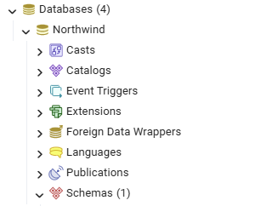
Here is result
Step 2: Load the Northwind Data
- Select the newly created Northwind database
- Click Tools → Query Tool
- Open the file northwind.sql (downloaded from the provided GitHub link)
- Click Execute (▶) to run the script
- Refresh Schemas → Tables to confirm all tables are created
You should now see tables like:
customers, orders, order_details, products, employees, suppliers, etc.
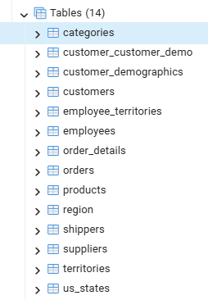
Here is result with 14 tables
🧠 Part 2 — SQL Practice Questions
Question 1 — Simple SQL (Single Table)
👉 Show all products that cost more than $20
Expected skills: SELECT, WHERE
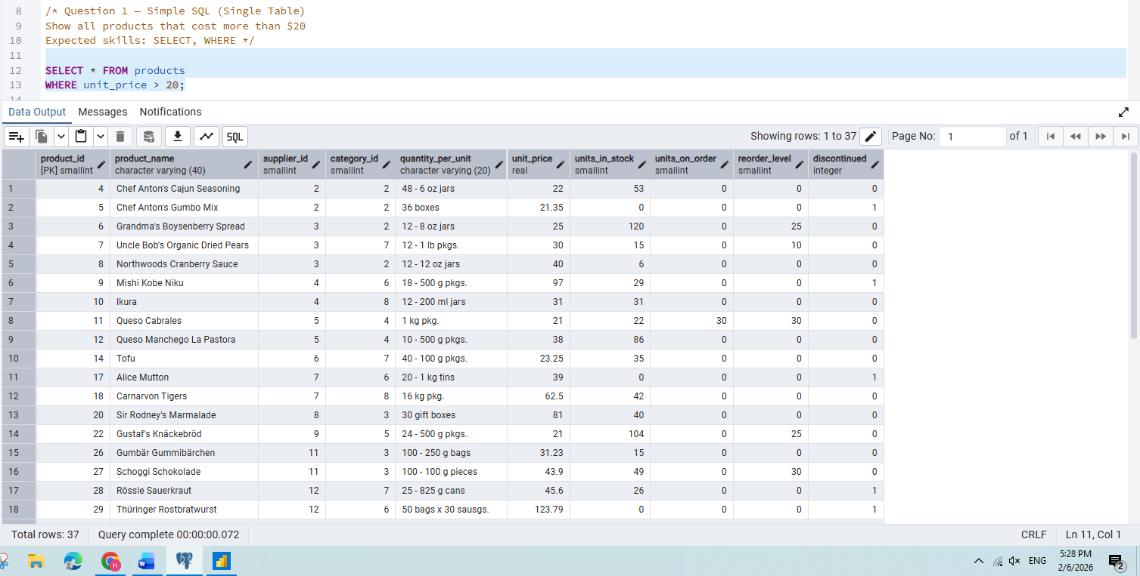
Here is result with products that cost more than $20 equals 37 records
Question 2 — JOIN Two Tables
👉 Display the Order ID, Customer Company Name, and Order Date
You must join:
- orders
- customers
Expected skills: INNER JOIN, foreign keys
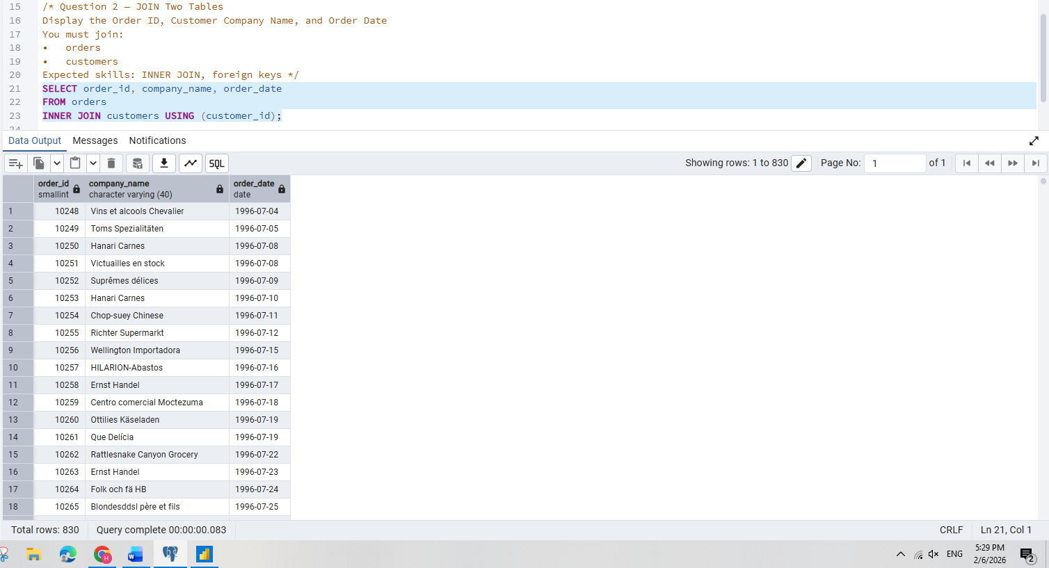
Here is result Display the Order ID, Customer Company Name, and Order Date from orders and customers tables with 830 records.
Question 3 — Connect to Power BI
👉 Import the orders table into Power BI and create a simple visualization.
Steps students should perform:
- Open Power BI Desktop
- Click Get Data → PostgreSQL database
- Server: localhost
- Database: Northwind
- Load the orders table
- Create a simple chart:
  - X-axis: Order Date (Year or Month)
  - Y-axis: Count of Order ID
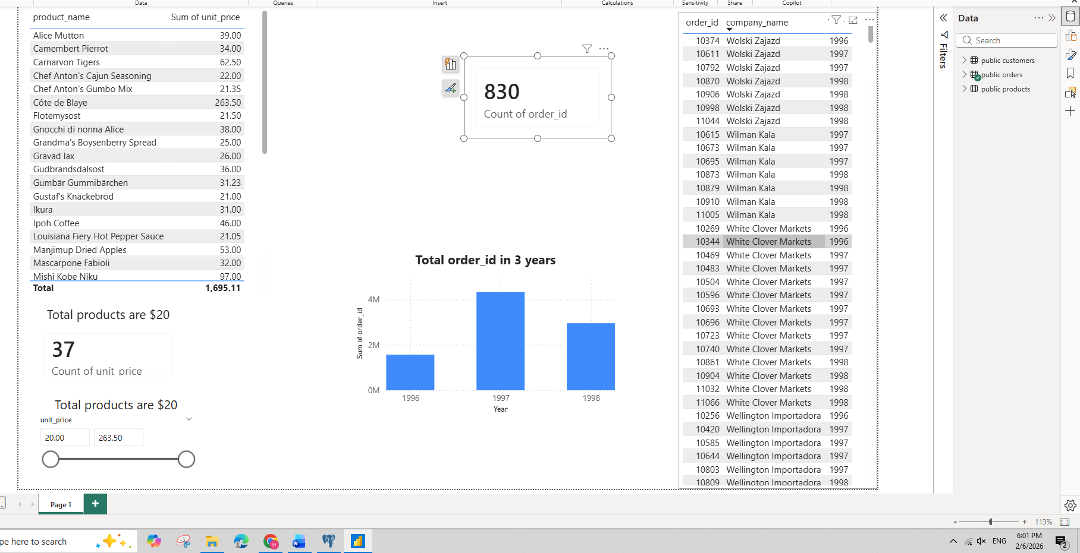
Here is result when visual in PowerBI
📤 Submission Requirement – Northwind Database Lab
You must upload your work to your GitHub account.
📁 Repository Structure
Create a folder named exactly:
MIS443/
Inside that folder, include the following files:

🧾 1️⃣ SQL Answers File
File name: northwind_queries.sql
This file must contain:
- Your answers for Question 1 and Question 2
- Clear comments explaining each query

🗂 2️⃣ Dataset File
Upload the original database script:
File name: northwind.sql

📊 3️⃣ Output / Results File
File name: northwind_results.docx or northwind_results.pdf
This file must include:
- Screenshot of pgAdmin showing the Northwind tables
- Output result of Query 1
- Output result of Query 2
- Screenshot of your Power BI visualization

📈 4️⃣ Power BI File
File name: northwind_powerbi.pbix
This file must contain:
- The imported orders table
- At least one visualization

✅ Final GitHub Folder Example
MIS443/
│── northwind.sql
│── northwind_queries.sql
│── northwind_results.pdf
│── northwind_powerbi.pbix

⚠️ Important Notes
- Your GitHub repository must be public
- Make sure files open correctly before submitting
- Missing files = incomplete submission

End

