# Settings

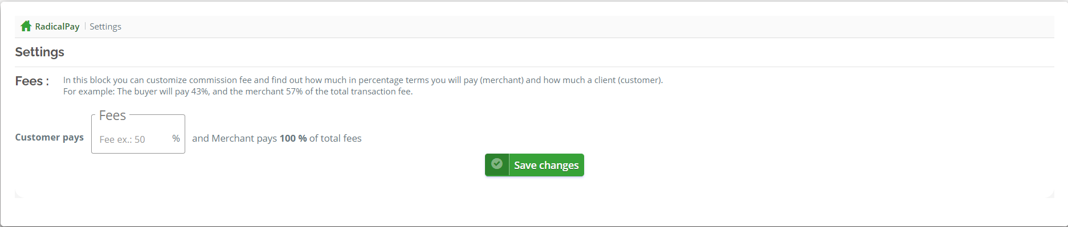

**Fees**: (commission fee)

You can customize commission fee and find out how much in percentage terms you will pay (merchant) and how much a client (customer).  
For example: The buyer will pay 43%, and the merchant 57% of the total transaction fee.

# My Statement

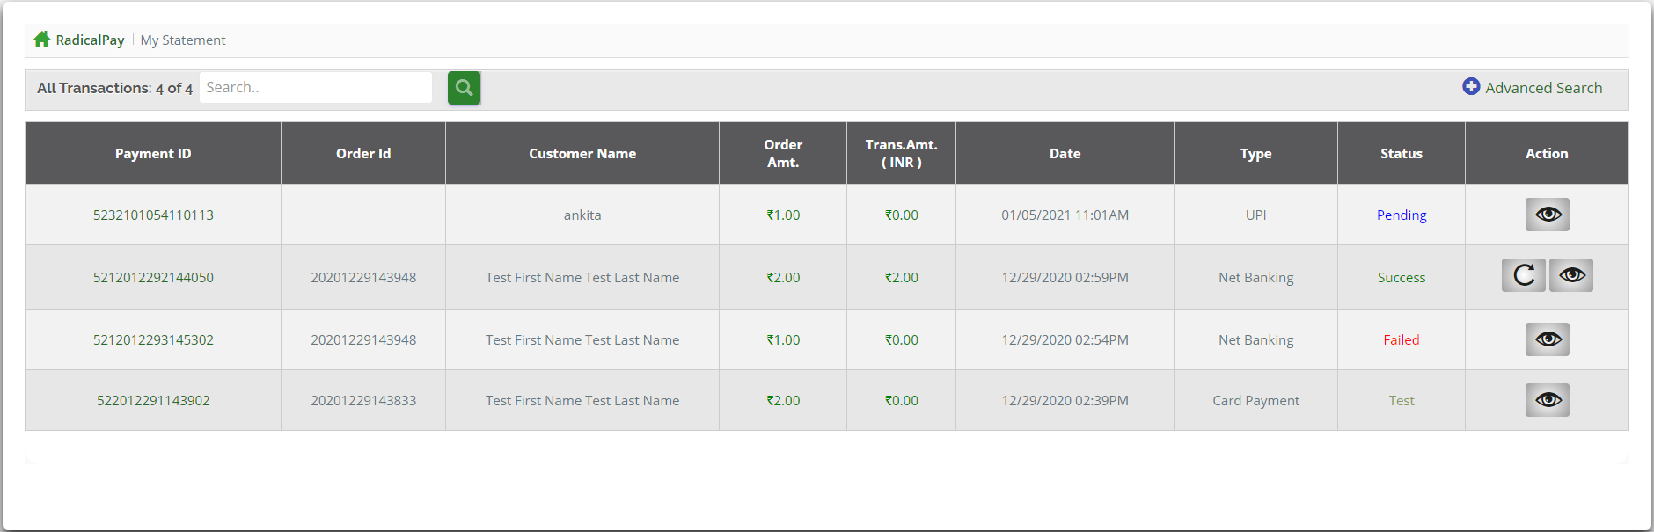

Statement includes colummns:

* **Payment ID** and **Order ID** is random number generated by developer for saving and managing customer data easier and these number is unique , that means every transactions have its own **unique** ID for that payment. **OrderID** helps Acquirer keeps track of your payment. **Customer name** of course describe customer’s name who made a transaction .
* **Order Amt. :** is the amount of money they need to be transferred or withdrawn.
* **Trans. Amt.** : the amount have already transferred ,only when the payment success to this filed be displayed the amount equals to **Order Amt**.
* **Date:** the exact-time customer required transaction.
* **Type:** transaction type
* **Status:** includes status:
  + Pending
  + Refund Pending
  + Success
  + Failed
  + Refunded
  + Chargeback
  + Returned
  + Reversed
  + Scrubbed
  + Predispute
  + Partial Refund
  + Withdraw Requested
  + Withdraw Rolling
  + Fund
  + Received Fund
  + Test
* **Action**: includes actions:
  + View 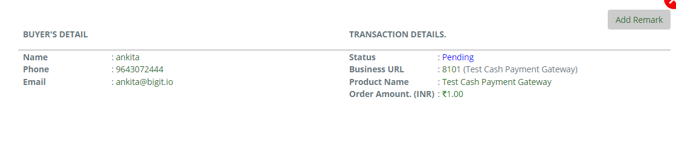
    - Buyer’s detail: name, phone, email.
    - Transaction details: status, business url, Product name, order amount.
    - Add remark.
  + Refund   
    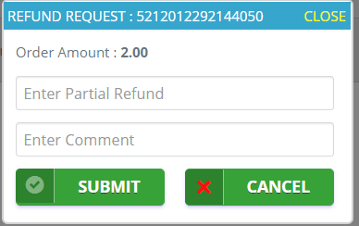

Refund request includes :

* Refund request ID: is random number generated by developer for saving and managing customer data easier and these number is unique.
* Partial refund: the amount you want to refund, The refund amount must be less than or equal to **Order Amount.**
* Comment: the reason for the refund request.

# Security Settings

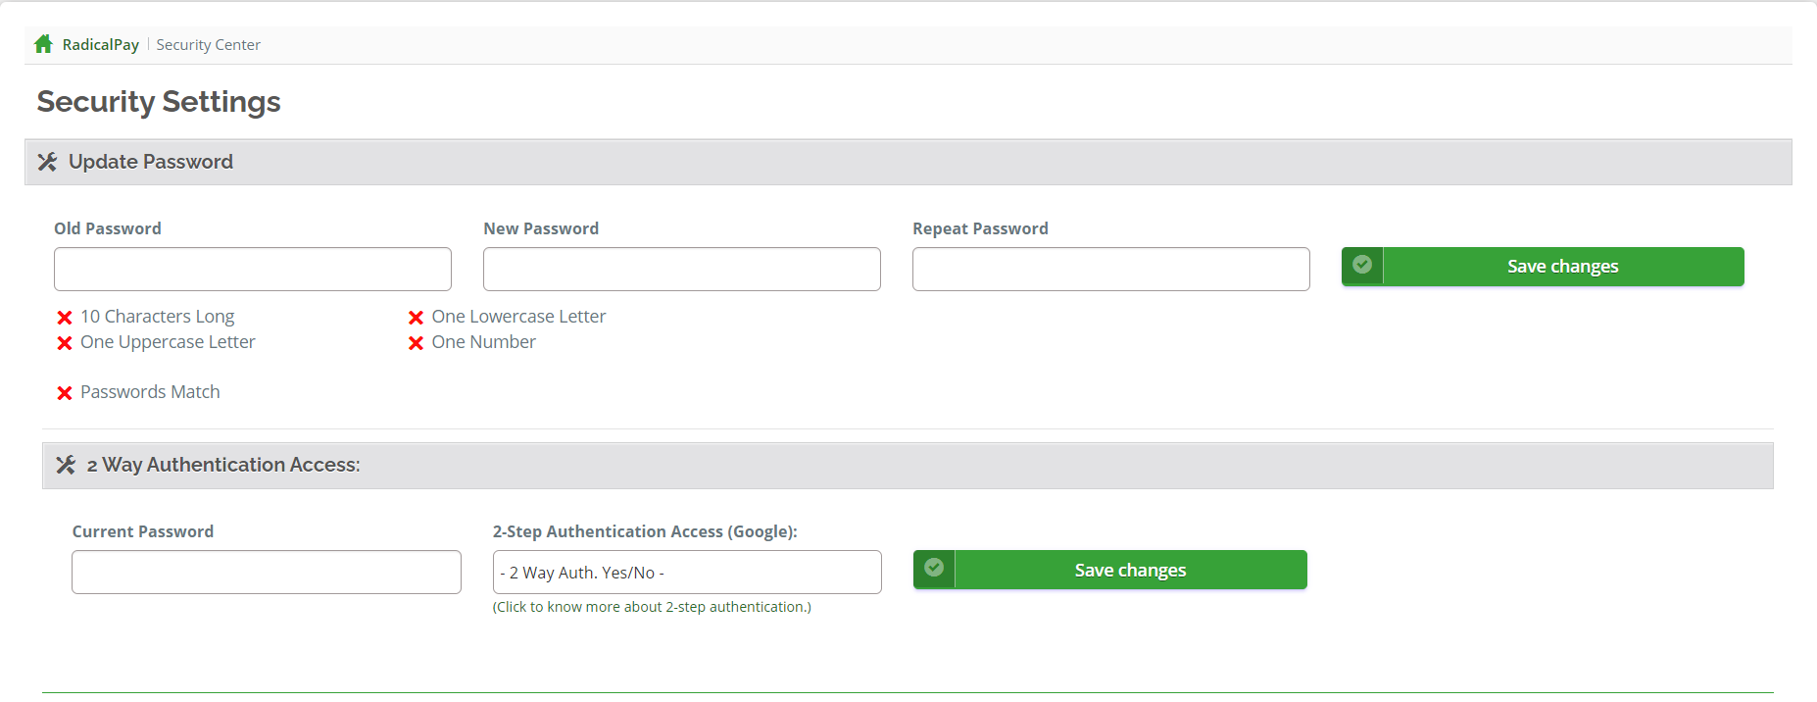

* **Update Password:**
  + **Old Password**
  + **New Password:** 
    - New password must contain at least one number digit (ex: 0, 1, 2, 3, etc.).
    - New password must contain at least one uppercase letter.
    - New password must contain at least one lowercase letter.
    - New password must contain at least 10 characters long.
  + **Repeat Password:** matchesthe new password.
* **2 Way Authentication Access:**
  + **Current Password:** enter to current password.
  + **Step Authentication Access (Google):** activate or de-activate.
* **Save change:**

# Message Center

At this we can read messages sent from another person to us , write a message and send to someone by providing ID or Email , Remember messages you sent and re-read , Draft for messages you wrote but have’t send yet.

**Message includes types:**

* Inbox
* Write Message
* Sent
* Draft

1. **Inbox:** 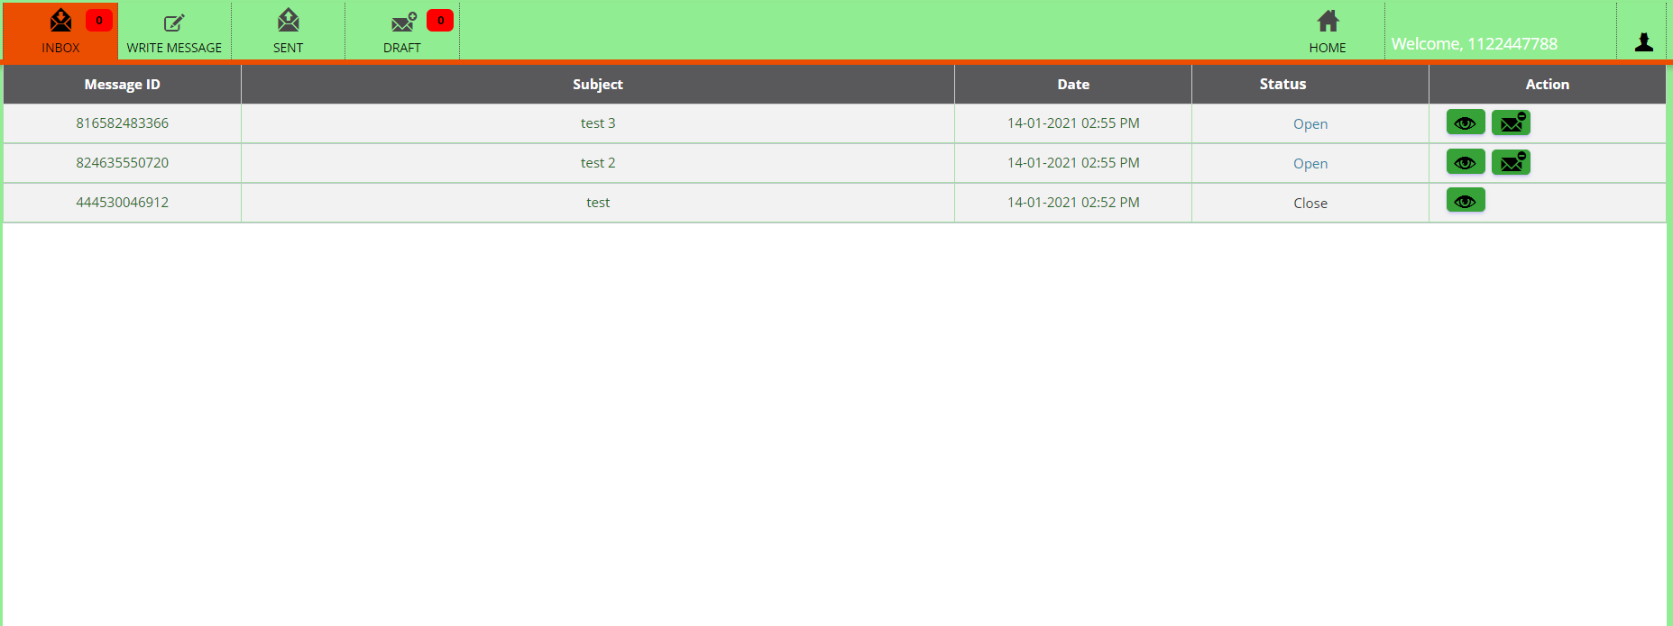

**Inbox** includes columns:

* Message Id: is random number generated by developer for saving and managing customer data easier and these number is unique.
* Subject: Subject of message.
* Date: date of sending or receiving mail.
* Status:
  + Open
  + Close
  + Process
  + Read
  + New Mail
* Action:
  + View:
  + Close:

# My Bank Account