**GROUP 12 MINI PROJECT**

**DEMONSTRATION OF SORTING ALGORITHMS ON ARRAY**

***(BUBBLE SORT, QUICK SORT, INSERTION SORT)***

**I. Assignment of members.**

|  |  |
| --- | --- |
| Nguyễn Huy Hoàng – 20194433 | Lê Đức Anh - 20194416 |
|  |  |

**II. Mini-project description.**

- Description:

Array is the most basic structure of computer science. Most operations as well as other data structures are built and performed on array. In this project, we will make an application in order to explain three sorting algorithms on array: bubble sort, quick sort and insertion sort.

- Requirements:

+ Must use pure array for the main data structure.

+ On the main menu:

* 3 types of sort algorithms to select.
* Help menu show the basic usage and aim of the program.
* Quit exits the program (must ask for confirmation).

+ In the demonstration:

* User can choose to input an array or create an array randomly.
* A back button to return to the main menu at any time.

- Use case diagram:

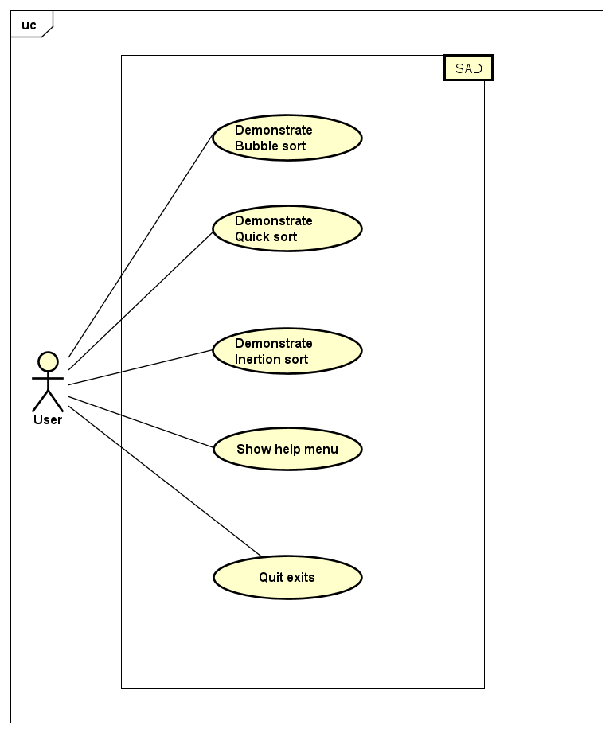

The user will have 5 options in the main menu. He/she can choose to see the information about the program and how to use it in the Help menu. They can also close the program by choosing Exit. After understand how the program works, user can pick the type of algorithm he/she want to have a clearer understanding. Then, they can choose from create an array randomly or input an array manually. Finally, the demonstration will start.

**III. Design.**

1. General class diagram:

2. Detailed class diagram:

**IV. References:**

|  |  |  |
| --- | --- | --- |
| Name | Purpose | Link |
| VisualAlgo (website) | Design idea, graphic idea | https://www.notion.so/VisualAlgo-website-918de1237ff948ddb2eebf20b3881914 |
| Animation (Zetcode) | Animation implementation | https://zetcode.com/javagames/animation/ |
| Sort-Algorithm-Visualizer (Hopson97) | Graphic design, algorithms and animation (source code) | https://github.com/Hopson97/Sort-Algorithm-Visualiser |